BOARD MEETING
JEFFERSON COUNTY PUBLIC LIBRARY BOARD OF TRUSTEES
July 16, 2026

  Mixed Media Art Garage |   Cybersecurity Awareness
  Teen Shark Workshop |   Art Around the World Camp/ Campamento Arte Alrededor del Mundo at  Deer Creek



APPROVAL OF AGENDA

BOARD MEETING AGENDA - AMENDED
Jefferson County Public Library Board of Trustees

ITEM# / ACTION | Thursday, July 16, 2026 – 5:30 pm – HYBRID MEETING  - UONLINE MEETING VIA ZOOM  - In-Person at Lakewood Library meeting room, 10200 W. 20th Avenue, Lakewood 80215
1. | Call to order & attendance (4.5.8)  A. Verbal roll call – Each Trustee announces their presence by stating their  name.
2. | Pledge of Allegiance
3. Agenda  Action | Approve Agenda  Chair: Call for motion and second
4. Public Comment | Public Comment  The Board values public participation. Those who would like to address the Library Board can do so virtually, in-person, or online. The opportunity to address the Library Board does not include a question-and-answer session or response. Additionally, the Library Board does not respond to anonymous questions or comments. Comments will be acknowledged in the minutes of the meeting.  For more information on public comment policy please refer to Board Governance Policy 4.3.7: May 2026 Board Governance Policy Manual
5.CONSENT AGENDA  Action | Approval of Consent Agenda Chair: Call for motion and second  - Approve Minutes of June 11, 2026 Board Study Session  - Approve Minutes of June 18, 2026 Board Meeting  - Authorize Midwest Tape Audio/Visual Contract Renewal
6. Foundation | Foundation Update
7.Operational Updates Action as Needed | Executive Director  - Executive Director Report  - 2026 Annual Plan Updates  Strategy & Operations  Finance and Budget  - Financial Report (June 2026)  - Lakewood Restroom Project Cost Update  People and Culture  - Executive Director Recruitment/Search Committee Update Action as needed  Libraries & Inclusion and Communications & Engagement  - Wheat Ridge Library Service Area Market Analysis

BOARD MEETING AGENDA - AMENDED
Jefferson County Public Library Board of Trustees

B. Wheat Ridge Library Services Community Engagement Report Guests: Clermont Eliot
Libraries & Inclusion
A. Summer Reading
8.Action as Needed | Items Removed From Consent Agenda (4.3.4): The Board may address and/or vote on any items that were removed from the Consent Agenda
9. Emerging Issues
Action as Needed
10. Ends  Action as Needed | Ends: No items.
11. Board Governance | Board Governance
12.Suggest Agenda Items  Action as Needed | BOARD SCHEDULE – NEXT MEETINGS –  Location of meetings of the Library Board of Trustees are being determined in cooperation with guidelines from Jefferson County. Information on meeting location will be posted at least one week prior to the scheduled meeting date. 2026 Board Meeting Schedule  - August 13, 2026 – Study Session – 5:30 pm Hybrid: Virtual via ZOOM. In-Person Location: Lakewood Library Meeting Room  - August 20, 2026 – Board Meeting – 5:30 pm Hybrid: Virtual via ZOOM. In-Person Location: Lakewood Library Meeting Room  - September 10, 2026 – Study Session – 5:30 pm Hybrid: Virtual via ZOOM. In-Person Location: Lakewood Library Meeting Room  - September 17, 2026 – Board Meeting – 5:30 pm Hybrid: Virtual via ZOOM. In-Person Location: Lakewood Library Meeting Room
13. Discussion | Board Questions or Comments Related to Items on the Meeting Agenda
14. Discussion | Evaluate Board Meeting (4.1.9)
15. Information | Announcements/General Information Sharing  - Report of the Chair – Correspondence, Other  - Other Announcements
16. EXECUTIVE SESSION | EXECUTIVE SESSION:  Guest Eric Butler, County Attorney’s Office  Call for Motion and Second to recess the special meeting of the Library Board of Trustees and reconvene in executive session.  Topic: Executive Director Recruitment. Statutory citations authorizing an executive session are:  - Pursuant to 24-6-402(4)(e)(I) for discussion of strategy and instructions to negotiators.  - Pursuant to 24-6-402(4)(b) Conferences with an attorney for the local public  body for the purposes of receiving legal advice on specific legal questions.

BOARD MEETING AGENDA - AMENDED
Jefferson County Public Library Board of Trustees

 | - Pursuant to 24-6-402(4)(f) Personnel Matters.
17.Reconvene Regular Meeting  Action as needed | Executive Session Summary
18. ADJOURNMENT | Adjournment

CONSENT AGENDA

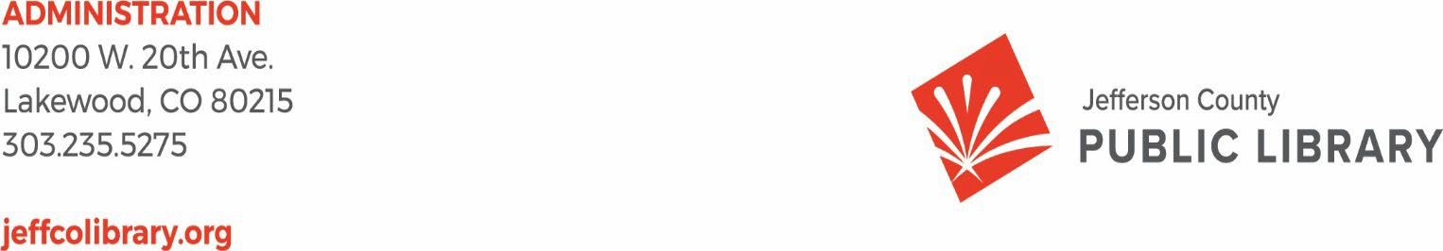

TO: Library Board of Trustees

FROM: Emelda Walker, Chair and Donna Walker, Executive Director DATE: July 16, 2026
RE: Consent Agenda for the July 16, 2026 Library Board Meeting

- Library Board of Trustees Approve Minutes of the June 11, 2026 Board Study Session.
- Library Board of Trustees Approve Minutes of the June 18, 2026 Board Meeting.
- Library Board of Trustees Authorize the Midwest Tape Audio/Visual Contract Renewal

Jeﬀerson County Public Library Board of Trustees Study Session June 11, 2026- 5:30pm
Hybrid Meeting held online via ZOOM
and in-person in the Lakewood Library meeting room.

TOPICS:
Strategy & Operations - Finance & Budget
  - Review DRAFT letter to the Board of County Commissioners certifying the mill levy necessary to maintain and operate the library
  - Review DRAFT 2027 5-Year Capital Plan
  - Review DRAFT 2027 Proposed Budget Plan
  - Review Golden Urban Renewal Authority Intergovernmental Agreement
Communications & Engagement
- Northwest Jeﬀco Library Naming

Board Governance
- Nominating Committee
Call to Order
Emelda Bing Walker, Chair, called the Study Session to order at 5:30 p.m.

Other Trustees present: Charles Jones (Secretary), Pam Anderson, Kim Johnson, Jill Fellman, Renny Fagan and Nikki Jain Brown

Absent:. All Trustees were present.
Staff present: Donna Walker, Executive Director; Bernadette Berger, Chief Information Officer; Cynthia Kiyotake, Chief Libraries and Inclusion Officer; Kirsten Ruiz, Chief Strategy and Operating Officer; Lisa Smith, Chief People and Culture Officer; Elise Pennington, Director of Communications and Engagement; Julianne Rist, Library Planning and Policy Senior Advisor; Lizzie Gall, Assistant Director of Public Services for Resources and Programs; Padma Polepeddi, Assistant Director of Libraries & Inclusion for Community Outreach; Amy Bentz, Assistant Director of Library Design Projects & Planning; Brad Green, TDI Systems and Security Manager; Cheryl Murphy, TDI Service Manager; Bryan Kratish, Northwest Jeffco Library Manager; Amber Fisher, Executive Assistant; Kelci Rude, Administrative Coordinator Supervisor, Ryan Turch, Technology and Innovation Operations Supervisor.

There were additional Library staff members attending the meeting.

Strategy & Operations - Finance & Budget
- Review DRAFT letter to the Board of County Commissioners certifying the mill levy necessary to maintain and operate the library
Kirsten Ruiz, Chief Strategy and Operating Oﬃcer presented the draft letter to the Board of County Commissioners certifying the mill levy necessary to maintain and operate the library.

In response to a question the Board was advised that the priorities listed in the letter come in large part from the mil levy ballot language continuing to point out to the public that JCPL is using the mil levy the way they intended.
- Review DRAFT 2027 5-Year Capital Plan
- Review DRAFT 2027 Proposed Budget Plan

Kirsten Ruiz presented information on the library’s draft 5-year capital plan and 2027 Proposed Budget plan including:
  - Key Assumptions
  - County Property Tax Revenue Methodology
  - 2027 Property Tax Revenue Update
  - Fund balance forecasts at 5%, 4% and 3%
  - 5-Year Capital Improvement Plan
  - 10-year Capital Outlook
  - Project Cost Estimates, Deer Creek and Northwest Jeﬀco
  - Project Contingency, Deer Creek and Northwest Jeﬀco

- Review DRAFT 2027 Proposed Budget Plan
Kirsten Ruiz presented information on the 2027 preliminary budget with the following recommendations:
  - Revenue forecast: assume 5% property tax increase
  - Project Budgets:
    - Deer Creek Library authorize Total Project Cost of $33,650,228
      - Increase authorized baseline project cost from $30,849,540 to $32,700,286
      - Increase contingency from $652,450 to $ 1,602,392
    - Northwest Jeffco Library authorize Total Project Cost of $32,609,036
      - Increase authorized baseline project cost from $25,970,270 to $29,947,898
      - Increase contingency from $765,000 to $ 2,661,138
      - Hold additional management reserve at Board up to $35.3M Total Project Cost
  - FTE Request:
    - 5 additional FTE for current operations
    - 11.5 additional FTE for Deer Creek operations between September and December
  - Contingency: Increase appropriated contingency from $500K to up to $3.3M
After some discussion the Chair asked for and received consensus from the Board to accept the recommendations. The Library will bring back the letter to the Board of County Commissioners,

the 2027 5-Year Capital Plan and the 2027 Proposed Budget Plan based on the recommendations to the June 18, 2026 Board meeting for formal votes to submit.
- Review Golden Urban Renewal Authority Intergovernmental Agreement
Kirsten Ruiz presented information on the Golden Urban Renewal Authority Intergovernmental Agreement. The Board reached consensus to place this item on the consent agenda for the June 18, 2026 Board meeting.

Communications & Engagement
A. Northwest Jeﬀco Library Naming
Elise Pennington, Director of Communications and Engagement and Bryan Kratish, Northwest Jeﬀco Library Manager, presented information on the naming recommendation for the Northwest Jeﬀco Library.

The Board expressed appreciation to Elise and Bryan for their excellent work. The Board will have a formal vote to name the Northwest Jeﬀco Library the Coal Creek Library at the June 18, 2026 Board meeting.

Board Governance
A. Nominating Committee
The Chair advised the Board that according to the Bylaws, Section 4 Vacancies, a vacancy occurring in the office of Vice Chair shall be filled for the unexpired term by a trustee elected at a Regular meeting, notice of such election having been given five days in advance of the meeting by the highest-ranking officer. The Chair noted that she is reconvening the Nominating Committee, Pam Anderson and Kim Johnson. The committee will provide the Chair with their nomination for Vice-Chair for the term June 19, 2026 to March 2027 by tomorrow June 12. The Library will hold the posting of the June 18 meeting until June 12 to include the nomination in the information packet and meet the 5-day requirement. The Board will vote to elect a Vice-Chair at the June 18, 2026 Regular Board Meeting.

The Chair adjourned the Study Session at 6:38 pm.

Charles Jones, Secretary

Minutes of the Regular Meeting of the JEFFERSON COUNTY PUBLIC LIBRARY BOARD OF TRUSTEES
June 18, 2026
CALL TO ORDER – REGULAR MEETING
The regular meeting of the Jefferson County Public Library Board of Trustees was held online via ZOOM and in-person in the Lakewood Library meeting room on June 18, 2026. Library Board of Trustees Chair, Emelda Walker, called the meeting to order at 5:30 p.m.

Other Trustees present: Charles Jones (Secretary), Renny Fagan, Jill Fellman, Nikki Jain Brown and Kim Johnson.

Absent: Trustee Pam Anderson joined the meeting at 5:35 pm as noted below in the minutes.

Staff present: Donna Walker, Executive Director; Bernadette Berger, Chief Information Officer; Cynthia Kiyotake, Chief Libraries and Inclusion Officer; Kirsten Ruiz, Chief Strategy and Operating Officer; Lisa Smith, Chief People and Culture Officer; Bernadette Berger, Chief Information Officer; Elise Pennington, Director of Communications and Engagement; Julianne Rist, Library Planning and Policy Senior Advisor; Lizzie Gall, Assistant Director of Public Services for Resources and Programs; Padma Polepeddi, Assistant Director of Libraries & Inclusion for Community Outreach; Amy Bentz, Assistant Director of Library Design Projects & Planning; Brad Green, TDI Systems and Security Manager; Cheryl Murphy, TDI Service Manager; Amber Fisher, Executive Assistant; Kelci Rude, Administrative Coordinator Supervisor, Ryan Turch, Technology and Innovation Operations Supervisor.

There were additional Library staff members attending the meeting.
APPROVAL OF AGENDA
MOTION: Jill Fellman moved that the Library Board of Trustees approve the agenda as presented. Seconded by Nikki Jain Brown the motion passed by unanimous vote of all Trustees present.
PUBLIC COMMENT
The Chair advised the Board that four online form public comments were received and sent to the Board. Two comments were on the use of AI, one on the CD collection and one on Pride month. No one signed up for in-person or virtual public comment and the Chair closed the public comment portion of the meeting at 5:35 pm.

Trustee Pam Anderson joined the meeting at 5:35 pm.

SERVICE ACKNOWLEDGEMENT
A. Proclamation Honoring Trustee Kim Johnson

The Chair addressed the Board and read the following proclamation acknowledging Trustee Kim Johnson. The Board of County Commissioners appointed Kim Johnson to the Jefferson County Public Library Board of Trustees in 2016. Johnson was elected as Board Secretary in 2017, Vice Chair in 2019 and Chair in 2021. Trustee Johnson helped govern the library through both challenging and exciting times. During her 10-year Board tenure, she has provided leadership and support for many notable and impactful Library initiatives and helped guide them to fruition. These include:
- Expanded library hours
- Increased staffing levels
- Expanded alternative services through holds lockers, returns bins, curbside service and JCPL’s new bookmobile
- Reduced barriers to library services by going fine free, eliminating replacement costs for children’s materials, implementing auto renewals and launching free printing in our libraries
- Increased digital library access, offerings and ease of use
- Launched curbside services, after-hours phone support and MyJCPL library app
- Constructed the Edgewater Library in partnership with the City of Edgewater and created a new stand-alone library in Conifer
- Remodeled the Columbine, Belmar and Evergreen Libraries, as well as the underway Arvada Library remodel
- Purchased land for a new library in northwest Jeffco, as well as an existing building in southern Jeffco for the future Deer Creek Library
- Created the nation’s first free-standing, self-service Express Library in West Arvada
- Installed EV Charging stations at five Library locations
- Supported the implementation of creative technology programming and resources, including the Belmar Create Space and Digital Media Studio
- Launched assistive technology and digitization workstations at five library locations
- Expanded JCPL’s fundraising development efforts
- Governed through a global pandemic and recovery
- Launched PowerOn Jeffco Digital Literacy program
- Created and updated JCPL’s Facility Master Plan
- Played a key role in advancing the staff compensation study to align staff pay with market rates
- Guided JCPL’s inaugural Collective Bargaining Agreement to approval
- Fiscal stewardship leadership

Trustee Johnson took on the additional responsibilities of Chair, Vice Chair, Secretary and serving on the Bylaws and Nominating Committees.
We would like to acknowledge the progress of the Library during Trustee Johnson’s tenure and thank her for her volunteer service to the Library and community. We will miss her leadership, experience and persistent pursuit of creating place, supporting equity of access and empowering our people.

Under Trustee Johnson’s leadership, JCPL truly has enriched lives and our community by providing equitable and free access to information, experiences and opportunities. Our libraries are essential places in our community for connection, learning, discovery and creation where everyone belongs and feels welcome. Her dedicated service will truly leave a lasting legacy.
B. Naming Agreement
In addition, JCPL’s Naming Rights Guidelines allow for naming rights and name recognition opportunities when the Library Board desires to honor an individual, foundation or corporation for outstanding service contributions that are consistent with the mission and vision of the Library.

We recommend that JCPL demonstrate our utmost respect, deepest gratitude and heartfelt wishes for Trustee Johnson with a recognition naming of the Teen Art Wall in the redesigned Arvada Library.

The Trustees individually expressed appreciation to Kim Johnson for her service.

MOTION: Charles Jones moved that the Library Board of Trustees authorize the Name Recognition Agreement between Kim Johnson, the Jefferson County Public Library Board of Trustees and the Jefferson County Public Library. Seconded by Pam Anderson, the motion passed by unanimous vote of all Trustees present.

Kim Johnson addressed the Board and expressed appreciation for the honor.
APPROVAL OF CONSENT AGENDA
The Chair asked the Trustees if any of the items should be removed from the consent agenda. There were no requests for items to be removed.

Items on the Consent Agenda
- Approve Minutes of May 14, 2026 Special Meeting
- Approve Minutes of May 21, 2026 Board Meeting
- Approve 2027 Governance Budget 4.8.2
- Adopt 2027 Board Meeting Schedule
- Golden Urban Renewal Authority Intergovernmental Agreement
MOTION: Nikki Jain Brown moved that the Library Board of Trustees approve the items on the consent agenda as presented. Seconded by Jill Fellman the motion passed by unanimous vote of all Trustees present.

FOUNDATION UPDATE

Jo Schantz Hall provided highlights of her report including the Spring Whale of a Book Sale that raised $115,000. The Books on Film benefit is July 17 featuring the Odyssey and the Volunteer Appreciation event is July 31 at the Wheat Ridge Recreation Center.

EXECUTIVE DIRECTOR
A. Executive Director Report
The Executive Director advised the Board that on Tuesday evening, the City of Arvada presented JCPL with a proclamation in honor of the Library’s programming around Juneteenth. The Executive Director thanked the trustees and staff who attended and expressed appreciation to staff who provide the services and programming that created this opportunity.

The Executive Director acknowledged Kim Johnson and expressed appreciation for her leadership at JCPL.

B. 2026 Annual Plan Update
The Executive Director advised the Board that the patron survey went out on the radically welcoming experience. The team is working on Deer Creek pricing. This Saturday is the Juneteenth event from 1:30 to 3:00 at Deer Creek featuring a Colorado jazz band. There is a Pride event Saturday at the Arvada Center. The Executive Director thanked the Trustees who attended the Arvada dusty boots tour. Summer Reading is going gang busters and JCPL’s summer camp experience provides an opportunity for access to discovery and creation. NW Jeffco naming is on the agenda for this evening. Administration restroom construction restarted this week and the project to reintegrate staff is moving forward. The Board will hear more about Wheat Ridge in executive session. JCPL completed the in-market community engagement. Collective Bargaining implementation continues with lots of activity over the last week. Progress continues to be made and the staffing analysis starts in July.
Strategy & Operations
Finance and Budget
- Financial Report (May 2026)
Kirsten Ruiz, Chief Strategy and Operating Officer provided an overview on the May 2026 monthly financials. Property tax revenue of $4.28 million was reported with approximately
$19.4 million still expected to be collected. Revenue compares fairly even to prior years at this point in May. A grant of $64,000 was received and another large grant is expected in September. Investment income is tracking as expected. Operating is running according to plan. May financials have not closed yet so we will see some adjustments. Capital outlay overall is underspending. Carryforward is in the budget and fully implemented. The supplemental request is still pending and that salary line item has not been adjusted yet. The Board was advised that the Lakewood restroom project overspend is being reviewed and more information will be brought to the Board.
- Letter to the Board of County Commissioners certifying the mill levy necessary to maintain and operate the library

MOTION: Kim Johnson moved that the Library Board of Trustees authorize the Chair to sign the letter to the Board of County Commissioners certifying the mil levy necessary to maintain and operate the Library in 2027. Seconded by Nikki Jain Brown the motion passed by unanimous vote of all Trustees present.

- 2027 5-Year Capital Plan
MOTION: Charles Jones moved that the Library Board of Trustees authorize the Executive Director to submit the 2027 5-Year Capital Plan request to the Board of County Commissioners. Seconded by Jill Fellman the motion passed by unanimous vote of all Trustees present.

In response to a request, the Board was advised that the contingencies allows the Library to quickly respond to emerging needs through the year and for this board to approve if needed. If not in the budget it would require the Library to go through the supplemental request process. The contingency adjustments are:
  - Deer Creek Library increase contingency from $652,450 to $1,602,392
  - Northwest Jeffco Library increase contingency from $765,000 to $2,661,138
  - Operating contingency increase from $500,000 to up to 3,300,000
- 2027 Proposed Budget Plan
MOTION: Jill Fellman moved that the Library Board of Trustees authorize the Executive Director to submit the 2027 Proposed Budget Plan to the Board of County Commissioners. Seconded by Kim Johnson the motion passed by unanimous vote of all Trustees present.

People and Culture
- Executive Director Recruitment Update
Lisa Smith, Chief People and Culture Officer introduced the topic and noted that the recruitment process was presented to the Board last month by Bradbury Miller. The recruitment timeline was presented and after some discussion the Board reached consensus on the timeline. The Board was advised that Bradbury Miller is running focus groups and sent a survey out to staff to gather input on the qualities staff would like to see in an executive director. The Board reviewed the draft job description. There was wide ranging discussion on the job description including:

- Minimum qualifications including MLIS from an ALA accredited program
- Commitment to DEI
- Excellent customer service
- Demonstrated innovation and technology experience
- Alternative qualifications and experience vs. MLIS, MLIS preferred and working toward MLIS
- Years of leadership experience including on a national level

The search committee will provide the Board’s job description input to Bradbury Miller.

Communications & Engagement
A. Northwest Jeffco Library Naming
Elise Pennington, Director of Communications and Engagement, introduced the topic and noted that last week the Board was presented with the recommended name for the Northwest Jeffco Library. The Board was asked to officially approve the name Coal Creek Library.

MOTION: Kim Johnson moved that the Library Board of Trustees authorize the Executive Director to name the Library to be located at Candelas Parkway and West 92nd Drive, Arvada, Colorado the Coal Creek Library. Seconded by Jill Fellman the motion passed by unanimous vote of all Trustees present.

ITEMS REMOVED FROM THE CONSENT AGENDA
No items were removed from the consent agenda.

EMERGING ISSUES
No issues.
ENDS
There were no items.

Trustee Pam Anderson left the meeting 7:05 pm
Board Governance
A. Trustees elect Vice-Chair for the term June 19, 2026 – March 2027
MOTION: Charles Jones moved that the Library Board of Trustees elect Renny Fagan as Vice-Chair for the term June 19, 2026 – March 2027. Seconded by Kim Johnson the motion passed by unanimous vote of all Trustees present.

BOARD SCHEDULE – NEXT MEETINGS
2026 Board Meeting Schedule
- July 9, 2026 – Board Meeting – 5:30 pm Hybrid: Virtual via ZOOM. In-Person Location: Lakewood Library Meeting Room
- July 16, 2026 – Study Session – 5:30 pm Hybrid: Virtual via ZOOM. In-Person Location: Lakewood Library Meeting Room
- August 13, 2026 – Board Meeting – 5:30 pm Hybrid: Virtual via ZOOM. In-Person Location: Lakewood Library Meeting Room
- August 20, 2026 – Study Session – 5:30 pm Hybrid: Virtual via ZOOM. In-Person Location: Lakewood Library Meeting Room
ANNOUNCEMENTS/GENERAL INFORMATION SHARING
The Chair announced that the board did receive eight emails regarding pride month and they were sent to Board. The Evergreen Library was recognized by the Jeffco Sheriff’s Department

for their response and support during a critical incident at Evergreen High School.

At 7:10 pm, the Chair called for a motion to recess the regular meeting and reconvene in Executive Session.
MOTION: Kim Johnson moved to recess the Regular meeting of the Library Board of Trustees and reconvene in Executive Session. Topics and statutory citations authorizing an executive session are:
Topic: (1) Library Services for the Wheat Ridge Community, Senior Resource Center Lease. Statutory citations authorizing an executive session are:
- Pursuant to 24-6-402(4)(b) Conferences with an attorney for the local public body for the purposes of receiving legal advice on specific legal questions.
- Pursuant to 24-6-402(4)(e)(I) for discussion of strategy and instructions to negotiators.
- Pursuant to 24-6-402(4)(a) Concerning the purchase, acquisition, lease, transfer or sale of Property.
Topic: (2) Executive Director Recruitment. Statutory citations authorizing an executive session are:
- Pursuant to 24-6-402(4)(e)(I) for discussion of strategy and instructions to negotiators.
- Pursuant to 24-6-402(4)(b) Conferences with an attorney for the local public body for the purposes of receiving legal advice on specific legal questions.
Topic: (3) Executive Director Position. Statutory citation authorizing an executive session are:
- Pursuant to 24-6-402(4)(f) Personnel Matters.

Seconded by Nikki Jain Brown the motion passed by unanimous vote of all Trustees present.
The Chair announced a 10 minute break to allow the Board and staff to celebrate Kim Johnson, clear the room, leave the existing ZOOM meeting and then join the Executive Session.

The Chair called the Executive Session to order at 7:28 pm with the following Trustees present: Kim Johnson, Renny Fagan, Nikki Jain Brown, Charles Jones and Jill Fellman. Also present were Donna Walker, Executive Director; Kurt Behn, County Attorney’s Office; Lisa Smith, Chief People & Culture Officer; Kirsten Ruiz, Chief Strategy and Operating Officer; Cynthia Kiyotake, Chief Libraries and Inclusion Officer; Elise Pennington, Director of Communications & Engagement; and Amber Fisher, Executive Assistant.
It is noted that the session was recorded and that the recording will be retained for the required 90 days.
CALL FOR ADJOURNMENT OF EXECUTIVE SESSION

MOTION: Kim Johnson moved to adjourn the executive session and reconvene the regular meeting. Seconded by Jill Fellman the motion passed by unanimous vote of all Trustees present.
The Chair adjourned the executive session at 8:24 pm. The Chair reconvened the regular meeting at 8:27 pm. EXECUTIVE SESSION SUMMARY
The Chair noted that the Library Board of Trustees met in Executive Session regarding Library
Services for the Wheat Ridge Community, Senior Resource Center Lease, Executive Director Recruitment and the Executive Director Position. The Trustees held those discussions, and this summary is provided as required by Colorado Statute.

The meeting was adjourned at 8:28 pm.

Charles Jones, Secretary


ADMINISTRATION
10200 W. 20th Ave.
Lakewood, CO 80215
303.235.5275
jeffcolibrary.org

TO: Donna Walker, Executive Director

FROM: Cynthia Kiyotake, Chief Libraries and Inclusion Officer
Lizzie Gall, Assistant Director of Libraries & Inclusion for Resources and Programs DATE: July 16, 2026
RE: Fourth Annual Renewal of Midwest Tape Contract

History of Contract: Midwest Tape Audiovisual Contract
In July of 2022 the Board of Trustees authorized Jefferson County Public Library to make Midwest Tape our primary vendor for media, DVDs and audiobooks. The approved contract allows us to renew with Midwest Tape annually for four additional years. This would be the fourth renewal.
Midwest Tape continues to provide us with quality products under the services outlined in the contract and we would like to renew the contract. The fourth renewal would run from August 14th, 2026 to August 13th, 2027.

Total Cost:
The anticipated expenditure for this renewal period is $525,000 and is within the approved 2026 Collections Books and Materials budget. The total amount of the entire contract is not to exceed
$2,000,000.

Action Requested:
We request that the Library Board of Trustees authorize the Executive Director to sign a one-year contract renewal with Midwest Tape as our primary physical audiovisual materials vendor.

Foundation Update


- JULY 2026

JCLF Executive Director Report
By Jo Schantz Hall, MNM, CFRE, GPC


Our 2026 Books On Film Benefit
We are expecting a blockbuster crowd for this year's blockbuster film
-- The Odyssey, starring Matt Damon, Anne Hathaway, Tom Holland, Charlize Theron, Lupita Nyong'o, and Robert Pattinson.

The movie screening will take place on Friday, July 17, at Harkins 14 Cinemas in Arvada. Doors open at 6 pm and the film starts at 6:30 pm.

We are pleased to once again welcome Denver7 chief meteorologist Lisa Hidalgo as our event emcee, plus the post-film audience discussion will be led by Dr. Laurialan Reitzammer, Associate Professor of Classics at CU-Boulder.

Tickets are $50 per person and include the film shown in a reserved theatre for our guests, popcorn and a beverage, a door prize drawing and participation in the interactive audience discussion.



This year's event sponsors include: Thrivent, Keller Williams -- The McDonald Group, IX Power Clean Water, Rocky Mountain Safety & Security, Sally Reed, and the Taurus Fund.


Fundraising Update

REQUESTS PENDING

- Mabel Y. Hughes Charitable Fund -- $20,000 general operations

- PNC Foundation -- $4,260 for Babies First Books

- Comprecare Foundation -- $13,268 for PowerOn Digital Literacy

- Anschutz Family Foundation -- $20,000 general operations
FUNDS APPROVED/RECEIVED

- IX Power Clean Water -- $250 Books On Film sponsor

- Sally Reed -- $250 Books On Film sponsor

- Keller Williams - The McDonald Group -- $250 Books On Film sponsor

- Mountain Foothills Rotary Club -- $12,000 Friends Community Partner


PAGE TWO
'
BRAY FOU -
JEFFERSO C

JULY2026

JCLF Executive Director Report

Community Connections
- June 23 - Planned giving seminar at Colorado Gives Foundation
- June 24 - Combined Management Team, JCPL
- June 24 - Foundation Search online training
- June 25 - "Beyond Grants" online training
- June 29 - Teams meeting with Bridget Beatty
- June 29 - Wheat Ridge Rotary Club dinner
- July 1 - Lunch meeting with Board Secretary Jeannie Mann
- July 2 - Meeting at Center for the Arts Evergreen (Mountain Stories)
- July 8 - Meeting with Donna Walker and donor Al Kasliinski at Belmar Library
- July 8 - New JCLF Board member orientation
- July 9 - Applewood Business Assn. luncheon
- July 9 - JCLF staff meeting
- July 13 - Wheat Ridge Rotary Club meeting
- July 14 - Walk-thru at Harkins Cinemas for Books On Film event
- July 15 - CSU Extension Advisory Board meeting
- July 16 - Golden Pantry & Thrift Board meeting
- July 16 - Sponsorship meeting, Mountain Stories committee

Save The Date!
September 25 + 26, 2026
Center for the Arts Evergreen


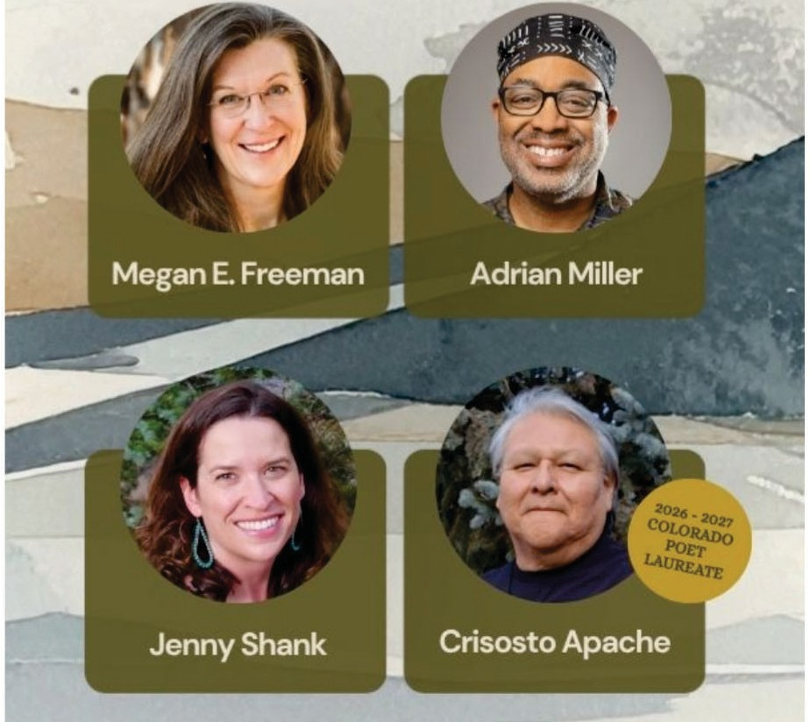
Mountain Stories brings our community together through the power of books, storytelling, nature, and creative expression-connecting readers and writers while expanding access to literacy and fostering a shared love of the arts.



Volunteer Appreciation Luncheon
On Friday, July 31, JCLF will be pleased to honor ALL our volunteers and -- at the same time -- recognize four key volunteers who have shown outstanding support throughout this past year.
The luncheon will be held from 11:30 am to 1:30 pm at the Wheat Ridge Rec Center in Wheat Ridge. Our theme for

�<-1/2,f»
L:J L:J • Book signings ,
--�·�·�......
� . • • . � • Boxed lunch incl�ded
�'I� • Author presentations &

l� l!J

2026 is Africa, and we have arranged singing and
•
r=,
panel discussion ��
. . • VIP Happy Hour with

drumming entertainment by Afrocentric Entertainment. Lunch will be catered by the African Grill in Lakewood.
L:J _ • . . presenting authors

EVERGREENARTS.ORG
� �
CENTER FOR THE ARTS EVERGREEN

Executive Director


JULY 2026 EXECUTIVE DIRECTOR REPORT ANNUAL PLAN PROGRESS
OBJECTIVE: INCREASE COMMUNITY USE OF THEIR LIBRARY
Jeffco residents feel a genuine pull to regularly use the library. What we offer as the library enriches their lives.
Annual Plan Progress:
  - Radically Welcoming New Patron Experience: Deploy updated onboarding emails.
  - Deer Creek Library: Continue Construction Document phase. Onboard owner’s representative. Provide interim library services.
Library Initiatives:
  - Deer Creek Library and Bookmobile programming.
  - Free Bicycle Repair Clinic with local bike shops at Lakewood Library
  - Plant Swap at the Golden Library
OBJECTIVE: BRIDGE GAPS TO ACCESS
Each element of JCPL service is designed, delivered and promoted to create the opportunity for everyone to participate. Our tax-supported services are provided free of charge.
Annual Plan Progress:
  - Digital Accessibility: Continue project planning. Publish Q2 Compliance Report.
  - Arvada Redesign: Advance construction toward completion. Provide interim services during closure.
Library Initiatives:
  - Art Around the World Camp – 3 day bilingual visual arts camp with the Arvada Center at the Deer Creek Library.

  - Visual Art Workshop for Deaf and Hard of Hearing Youth with the Arvada Center at the Columbine Library.
OBJECTIVE: MAKE EVERY VISIT AN EXCEPTIONAL EXPERIENCE
We treat patrons as welcome guests at every point of contact, creating experiences and spaces that meet or exceed their needs. Individually and as a community, patrons recommend their library as a safe and trusted resource.
Annual Plan Progress:
    - Coal Creek Library: Continue community outreach. Establish updated project timeline.
    - Lakewood Library and Administration Refresh: Continue construction on Administration restrooms.
    - New Integrated Library System (ILS): Library Initiatives:
  - Continue Evergreen Library roof replacement.
OBJECTIVE: SHAPE SERVICES AND SPACES TO ENCOURAGE LEARNING AND DISCOVERY
We approach service and space design with a focus on learning for all ages, backgrounds and abilities. JCPL is known to be a safe place to explore and incubate ideas together.
Annual Plan Progress:
  - Wheat Ridge Library Services: Provide Community Engagement Report. Define Library Service Needs. Continue partner discussions.
  - Expand Creative Technology Learning:
  - AI Innovation and Engagement Strategy:. Offer patron programs.
Library Initiatives:
  - Raised in Silence: A Conversation with Maia Gallucci at Conifer Library
  - Everyday Artificial Intelligence at the Standley Lake Library

OBJECTIVE: JCPL IS AN EMPLOYER OF CHOICE
JCPL understands and takes action on what draws people to work here. Together, we intentionally build a culture of belonging for all.
Annual Plan Progress:
- Collective Bargaining Agreement (CBA): This project is complete. All deliverables met by Feb 11, 2026.
  - Collective Bargaining Agreement (CBA) Implementation: Complete 2026 supplemental budget request to BCC. Continue required committees. Establish a supervisor training plan.
OBJECTIVE: EMPLOYEES ARE EQUIPPED TO DELIVER ON OUR PROMISES TO THE COMMUNITY
JCPL staff are trained, supported and encouraged to succeed in their role, with a team focus on meeting the library’s mission.
Annual Plan Progress:
  - Staffing Analysis: Launch project.
Library Initiatives:
Rosalie Rodriguez, Kids and Families Core Librarian, is attending the Fred Rogers Institute Conference in Latrobe, PA.
Padma Polepeddi, Libraries and Inclusion Assistant Director, attended the PLA (Public Library Association) Board meeting in Chicago, IL.
Cheryl Murphy, Assistant Director of TDI, Innovative Technical Services, and Francisco Sanchez, TDI Training and Communications Specialist, are coordinating a dedicated "Tech at the Library" table at the 2026 Jeffco Tech Showcase.
Bernadette Berger, Chief Information Officer (CIO), will serve as a judge for the 2026 Jeffco Innovation & Technology Awards.

EXECUTIVE DIRECTOR SUMMARY OF ACTIVITIES
  - Front Range Public Library Directors meeting
  - Jeffco Elected/Appointed Officials Personnel Board meeting

  - Meet with Colorado State Library Rural & Small Library Senior Consultant
  - Jeffco EDC Board of Governors meeting
  - Library Foundation Board of Directors meeting
  - Meet with Senior Resource Center community partners
  - Meet with interim County Manager
  - Meet with Library Foundation Executive Director
  - Meet with potential donor
  - Meet with former CASA Executive Director
  - Urban Libraries Council CEO meetings
  - Meet with Westminster Public Library leadership
  - Tour Express Library with Douglas County Library leadership

OPPORTUNITIES FOR BOARD ADVOCACY & ENGAGEMENT

  - CALCON 2026 The Colorado Association of Libraries Annual Conference
is Colorado’s premier event for library staff from libraries of all types throughout the state. Attendees learn from one another and hear from current experts in trending fields.. Sept 9-11 Hyatt Regency Aurora. Information provided for planning purposes. Registration is open. Let Amber know if you would like to attend.
- Trustee Track Day, Thursday, September 10
  - A Survey of CO Laws Affecting Libraries and What's New for 2026
  - Awards Luncheon
  - Step Inside the Board Room: How to build and grow a great fundraising foundation
  - On the Path to the Ballot: Preparing your community for successful library funding measure

  - 2026 ULC Annual Leadership Forum, September 30-October 2, 2026 | Las Vegas, Nevada. Information provided for planning purposes. Registration is open. Let Amber know if you would like to attend.

Strategy and Operations

TO: Donna Walker, Executive Director

FROM: Kirsten Ruiz, Chief Strategy & Operating Officer DATE: July 16, 2026
RE: Finance Monthly Report

Budget to Actual Tables – June 2026
Please see the enclosed Budget to Actual Tables for June 2026. Financial records have been closed through May 2026; therefore, June results are preliminary and subject to normal month-end adjustments.
In June, JCPL recorded $17.3 million in Real Property Tax revenue. Year-to-date property tax collections total $60.8 million, representing 96.7% of the annual budget, which is consistent with expected collection patterns. Total revenues through June are $63.5 million, or 96.3% of budget.
Operating expenditures remain generally consistent with management expectations. Salary and benefit expenditures are trending modestly above the original adopted budget due primarily to compensation adjustments associated with the Collective Bargaining Agreement ratified earlier this year. The Board-approved supplemental budget request is progressing through the Jefferson County approval process and is currently awaiting final action by the Board of County Commissioners at the end of July. The revised budget is expected to be reflected in JCPL financial reporting beginning in August.
Capital spending remains below the annual budget as several major projects continue to advance through planning, design, and construction phases. The Library expects to receive key budget and schedule information for the Deer Creek and Coal Creek projects during the second half of the year. The Arvada Library Redesign continues to progress generally as expected.
The Jefferson County Library Foundation has provided $64,711 in funding to JCPL year-to-date. During the same period, the Library has provided approximately $46,415 in in-kind support, resulting in a ratio of approximately 0.72:1, meaning the Library has provided approximately $0.72 in support for every $1.00 received from the Foundation. June in-kind support totaled approximately $7,794.
Management continues to monitor revenues, operating expenditures, and capital project activity. Operating results are expected to remain generally consistent with the amended 2026 budget. As is typical with multi-year capital projects, a portion of budgeted capital expenditures is expected to be carried forward to future years as project schedules and expenditures are finalized. Other than the Lakewood Restrooms project discussed below, management is not aware of any additional financial matters requiring Board attention at this time.
Lakewood Restroom Project Cost Update

As of May 2026, the Lakewood Restrooms project had incurred approximately $619K in project-related costs, exceeding the Board-approved budget of $500K by approximately $119K. Management's review determined that the variance is primarily attributable to three factors: design costs that were not included in the original project budget, costs associated with the asbestos spill and resulting building impacts, and operational costs incurred during the extended facility closure.
Of the costs incurred to date, approximately $343K relates to restroom project scope, including design and construction completed to date with an additional $80K estimated to complete the administration restroom. An additional $276K of reported costs is associated with asbestos-related response and operational impacts that are being reviewed for potential reclassification outside of the restroom project.

Description | Amount
Design | $36,554
Administration Restroom Construction (through May 2026) | $306,574
Estimated Cost to Complete Administrative Restroom | $80,000
Total Project Scope Costs | $423,128
Asbestos-Related and Operational Impact Costs Under Review | $266,715
Below Materiality Threshold | $9,464
Costs under review | $276,179

In addition, the original project scope included a second phase of patron restroom improvements. Based on current estimates, this remaining scope cannot be completed within the current Board-approved project budget. Management is evaluating options for the remaining scope and will return to the Board with recommendations regarding project priorities, scope, and budget requirements.
Management is also reviewing project cost classifications and strengthening project budgeting and financial controls to ensure future capital project budgets more fully reflect total project lifecycle costs.

TABLE 1
JEFFERSON COUNTY PUBLIC LIBRARY TOTAL FUND SUMMARY
2026 BUDGET TO ACTUAL
Revenue and Expenditure | 2026  Budget | YTD Preliminary Actual 06/30/2026 | $ Variance 2026 Budget | YTD %  2026 Budget
Revenues
Property Taxes (net adjustments) | 62,855,736 | 60,757,416 | (2,098,320) | 97%
Grants, Funds & Donations | 375,000 | (59,829) | (434,829) | -16%
Investment Income | 2,655,549 | 2,267,778 | (387,771) | 85%
Other Revenue | - | 503,232 | 503,232
Total Revenues | 65,886,285 | 63,468,597 | (2,417,688) | 96%
Expenditures
Operating | 47,338,461 | 23,566,125 | (23,772,336) | 50%
Financial & Debt Service | - | - | -
Capital Outlay | 47,029,007 | 3,756,609 | (43,272,399) | 8%
Total Expenditures | 94,367,468 | 27,322,734 | (67,044,734) | 29%

TABLE 2
JEFFERSON COUNTY PUBLIC LIBRARY OPERATING EXPENDITURES
2026 BUDGET TO ACTUAL
Operating Expenditure | 2026  Budget | YTD Preliminary Actual 06/30/2026 | $ Variance 2026 Budget | YTD %  2026 Budget
Salaries & Employee Benefits
Salaries | 19,933,531 | 10,213,239 | 9,720,292 | 51%
Awards & Bonuses | 275,000 | 203,483 | 71,517 | 74%
Other | 7,641,936 | 3,658,603 | 3,983,333 | 48%
Total Salaries & Employee Benefits | 27,850,467 | 14,075,325 | 13,775,142 | 51%
Library Collections
Library Books & Materials | 8,368,421 | 3,269,410 | 5,099,011 | 39%
Library Periodicals | 229,000 | 117,463 | 111,537 | 51%
Total Library Collections | 8,597,421 | 3,386,872 | 5,210,549 | 39%
Supplies and Other
Supplies | 2,560,849 | 1,210,147 | 1,350,702 | 47%
Services & Charges | 8,615,650 | 3,432,852 | 5,182,798 | 40%
Interdepartmental Direct Charges | 1,764,030 | 1,296,698 | 467,332 | 74%
Treasurers Fees | 946,847 | 911,361 | 35,486 | 96%
Interdepartmental Indirect Charges | 1,538,750 | 769,375 | 769,375 | 50%
Total Supplies and Other | 14,479,279 | 6,709,072 | 7,770,207 | 46%
Total Expenditures | 50,927,167 | 24,171,269 | 26,755,898 | 47%

TABLE 3
JEFFERSON COUNTY PUBLIC LIBRARY CAPITAL IMPROVEMENT PROJECTS 2026 BUDGET TO ACTUAL
Capital Project Expenditure | 2026  Budget | YTD Preliminary Actual 06/30/2026 | YTD  Encumbrances | YTD Actual + Enc | Remaining 2026 Budget | Total Project Actual + Encumbrances | Approved Total Project Cost
Annual Replacement and Maintenance
ARM-01 Capital Maintenance | 325,000 | 122,902 | - | 122,902 | 202,098 | n/a | n/a
ARM-02 Furniture & Equipment | 40,500 | - | - | - | 40,500 | n/a | n/a
ARM-03 Computer Replacement Plan | 1,129,000 | 328,185 | 154,085 | 482,270 | 646,730 | n/a | n/a
ARM-04 Book Sorter Replacement | - | - | - | - | - | n/a | n/a
ARM-05 IT Infrastructure Replacement | 360,000 | 78,628 | 42,833 | 121,461 | 238,539 | n/a | n/a
Capital Projects
Northwest County Library | 7,651,569 | 16,750 | 1,186,009 | 1,202,759 | 6,448,810 | 5,573,387 | 32,609,036
Conifer Library Tenant Finish | - | (16,102) | - | (16,102) | 16,102 | 2,340,936 | 2,500,400
Arvada Library Redesign | 13,825,415 | 2,046,062 | 125,692 | 2,171,755 | 11,653,660 | 3,242,121 | 14,895,781
Evergreen Library Roof Repair | 1,023,959 | 155,734 | - | 155,734 | 868,226 | 302,775
Library Interiors Refresh Project | 750,000 | 509,532 | - | 509,532 | 240,468 | 509,532 | 750,000
Admin Office Reconfiguration | 151,126 | 38,732 | - | 38,732 | 112,394 | 38,732 | 250,000
Lakewood Restrooms | 115,284 | 207,719 | 12,703 | 220,422 | (105,138) | 632,010 | 500,000
Library Integrated Library System (ILS) | 1,750,000 | - | - | - | 1,750,000 | - | 3,500,000
Deer Creek Library | 17,348,893 | 593,776 | 906,214 | 1,499,990 | 15,848,903 | 12,715,037 | 33,650,228
Total Capital Project Expenditures | 44,470,746 | 4,081,917 | 2,427,537 | 6,509,454 | 37,961,292 |  | 88,655,445

TABLE 4
JEFFERSON COUNTY PUBLIC LIBRARY GRANTS, FUNDS & DONATIONS
2026 BUDGET TO ACTUAL
 | 2023 Actual | 2024 Actual | 2025 Actual | 2026 Budget | YTD Preliminary Actual 06/30/2026 | $ Variance 2026 Budget | YTD %  2026 Budget
JCPL Grants
Books & Materials - American Rescue Plan
Books & Materials - State | 140,462 | 134,124 | 116,214 | 150,000 | (102,041) | (252,041) | -68%
Columbine Roof Repair - State | - | 99,624 | - | - | - | -
Columbine Roof Repair - Federal | - | 597,743 | - | - | - | -
Evergreen Roof Repair - State | - | - | - | - | - | -
Evergreen Roof Repair - Federal | - | - | - | - | - | -
Car Charging Station - Evergreen | 16,500 | 1,984 | - | - | - | -
Car Charging Station - Columbine | - | - | 30,000 | - | - | -
Car Charging Station - Standley Lake | - | - | 27,000 | - | - | -
Car Charging Station - Lakewood | - | - | 30,000 | - | - | -
Total JCPL Grants | 156,962 | 833,475 | 203,214 | 150,000 | (102,041) | (252,041)
JCPL Private Donations
Private Donations up to $200 |  | 250 | 100 | - | - | -
Private Donations $201-$999 |  |  | 669 | - | - | -
Rena Fowler | - | - | 1,000 | - | - | -
Colorado Gives - Naumer Family Fund EV Remodel | 5,000 | - | - | - | - | -
Anonymous Donor | 2,000 | - | - | - | - | -
JCLF - For Evergreen Library (Naming Rights) | - | 5,000 | - | - | - | -
Colorado Gives - Hard Times Writing | - | 24,509 | - | - | - | -
Colorado Gives - Early Care & Education | - | - | 60,000 | - | - | -
El Pomar Foundation | - | - | 25,000 | - | - | -
Total Private Donations | 7,000 | 29,759 | 86,769 | - | - | -
Other Funds Received
Payroll Funding - American Rescue Plan | 856,591 | - | - | - | - | -
E-Rate Reimbursement | 149,901 | 60,471 | 97,171 | 125,000 | (22,500) | (147,500) | -18%
Laptop Lending | 183,427 | 33,325 | 2,676 | - | - | -
Insurance Recovery - Evergreen Roof | - | - | 117,581 | - | 439,176 | 439,176
Stadium Funds - Imagination Library | - | 50,000 | - | - | - | -
Stadium Funds - Young Authors | - | 42,350 | - | - | - | -
Total Other Funds Received | 1,189,918 | 186,146 | 217,428 | 125,000 | 416,676 | 291,676 | 333%
Jefferson County Library Foundation | 127,180 | 141,576 | 102,614 | 100,000 | 64,711 | (35,289) | 65%
Total Jefferson County Library Foundation | 127,180 | 141,576 | 102,614 | 100,000 | 64,711 | (35,289) | 65%
Total Grants, Funds & Donations | 1,481,060 | 1,190,956 | 610,024 | 375,000 | 379,347 | 4,347 | 101%
Other Funds Received Outside of Library Fund
Digital Equity - American Rescue Plan (FD181) | 8,826 | 622,374 | 9,188 | - | (916) | (916)
Digital Equity - Rescue Plan (FD036) | - | - | - | 50,078 | 6,587 | (43,491)

PJ1000621 Lakewood Restrooms through May 2026
Description | Correctly charged | Immaterial | Investigate | Make correctionGrand Total
Building Maintenance |  |  | 3,812.00 |  | 3,812.00
SC534300 - Building Maintenance |  |  | 1,186.00 |  | 1,186.00
SC534313 - Plumbing Maintenance |  |  | 2,626.00 |  | 2,626.00
Construction | 306,574.21 |  |  |  | 306,574.21
SC526121 - Janitorial Supplies | 16,598.26 |  |  |  | 16,598.26
SC534150 - Water, Irrigation, & Sanitation Services | 536.50 |  |  |  | 536.50
SC557281 - Building Construction & Design | 289,439.45 |  |  |  | 289,439.45
Design | 36,553.77 |  |  |  | 36,553.77
SC557281 - Building Construction & Design | 36,553.77 |  |  |  | 36,553.77
Inventory Inaccessible |  | 2,347.52 |  | 5,473.10 | 7,820.62
SC526121 - Janitorial Supplies |  | 277.14 |  |  | 277.14
SC526137 - Office Supplies |  | 81.10 |  |  | 81.10
SC526200 - General Supplies (Other) |  | 130.85 |  | 1,563.51 | 1,694.36
SC526210 - Special Events Supplies |  | 658.92 |  |  | 658.92
SC526935 - Office Equipment |  | 1,143.55 |  | 2,961.59 | 4,105.14
SC526960 - Telephone & Network Equipment |  | 55.96 |  |  | 55.96
SC534326 - Equipment Maintenance |  |  |  | 948.00 | 948.00
Spill Response |  | 159.98 |  | 31,560.00 | 31,719.98
SC526935 - Office Equipment |  | 159.98 |  | 3,690.00 | 3,849.98
SC533090 - Professional & Technical Services (Other) |  |  |  | 3,350.00 | 3,350.00
SC557250 - Building Improvements |  |  |  | 24,520.00 | 24,520.00
Spill/Building Repair |  |  |  | 122,532.95 | 122,532.95
SC526200 - General Supplies (Other) |  |  |  | 6,026.82 | 6,026.82
SC557281 - Building Construction & Design |  |  |  | 116,506.13 | 116,506.13
Spill/Container Rental |  | 2,956.99 |  | 2,331.44 | 5,288.43
SC534420 - Equipment Rental |  | 2,956.99 |  | 2,331.44 | 5,288.43
Spill/Printing |  | 1,425.03 |  | 14,270.86 | 15,695.89
SC535130 - Printing Services |  | 1,425.03 |  | 14,270.86 | 15,695.89
Spill/Replace Equipment |  | 1,523.19 |  | 85,551.79 | 87,074.98
SC526134 - Furniture & Equipment - Non Capital |  |  |  | 5,972.84 | 5,972.84
SC526200 - General Supplies (Other) |  |  |  | 2,542.39 | 2,542.39
SC526210 - Special Events Supplies |  | 149.00 |  |  | 149.00
SC526927 - Computer Parts & Supplies |  | 417.00 |  | 5,745.00 | 6,162.00
SC526935 - Office Equipment |  | 867.44 |  | 6,011.56 | 6,879.00
SC534326 - Equipment Maintenance |  |  |  | 711.00 | 711.00
SC535130 - Printing Services |  | 89.75 |  |  | 89.75
SC557440 - Computer Equipment (CAPITAL) |  |  |  | 64,569.00 | 64,569.00
Spill/Supplies |  | 1,051.46 |  | 1,182.46 | 2,233.92
SC526121 - Janitorial Supplies |  |  |  | 1,182.46 | 1,182.46
SC526134 - Furniture & Equipment - Non Capital |  | 328.00 |  |  | 328.00
SC526200 - General Supplies (Other) |  | 89.99 |  |  | 89.99
SC526210 - Special Events Supplies |  | 215.55 |  |  | 215.55
SC526390 - Food Supplies |  | 255.96 |  |  | 255.96
SC526935 - Office Equipment |  | 161.96 |  |  | 161.96
Grand Total | 343,127.98 | 9,464.17 | 3,812.00 | 262,902.60 | 619,306.75

Detailed Revenue and Expenditure Report from Workday

 | Actuals YTD Jun-2026 | Budget FY2026 | Variance FY2026 | YTD %  Budget  FY2026 | YTD %  Actual  FY2025 | YTD  Estimated %
Variance

Jun-26
Revenue & Expenditures
Total Revenue | 63,468,597 | 65,886,285 | 2,417,688 | 96% | 92% | 4.80%
Total Expenditures | 27,322,734 | 94,367,468 | 67,044,734 | 29% | 57% | 49.50%
Revenue Detail
Property Tax | 60,757,416 | 62,855,736 | 2,098,320 | 97% | 97% | -0.49%
Intergovernmental Grants & Reimbursements | (124,541) | 275,000 | 399,541 | (45%) | (10%) | 353.21%
Charges for Services | 48,211 | - | (48,211) |  | 51% | NA
  Investment Income | 2,267,778 | 2,655,549 | 387,771 | 85% | 41% | 109.76%
Other Revenue | 519,733 | 100,000 | (419,733) | 520% | 21% | 2416.58%
- Private Donations | 64,711 | 100,000 | 35,289 | 65% | 33% | 96.60%
- Insurance Claim | 439,176 | - | (439,176) |  |  | NA
- Additional Other Revenue | 15,845 | - | (15,845) |  |  | NA
Total Revenues | 63,468,597 | 65,886,285 | 2,417,688 | 96% | 92% | 4.80%
Expenditure Detail
Operating Expenditures
Salaries & Related Costs | 14,075,325 | 27,850,467 | 13,775,142 | 51% | 48% | -4.43%
- Salaries | 10,416,722 | 20,208,531 | 9,791,809 | 52% | 48% | -6.46%
- - Awards & Bonuses | 203,483 | 275,000 | 71,517 | 74% |  | NA
- Taxes & Benefits | 3,658,603 | 7,641,936 | 3,983,333 | 48% | 48% | 0.97%
Supplies | 3,991,876 | 7,569,564 | 3,577,688 | 53% | 48% | -10.77%
- Book & Material Supplies | 2,664,266 | 4,779,715 | 2,115,449 | 56% |  | NA
- Periodicals | 117,463 | 229,000 | 111,537 | 51% |  | NA
- Other Supplies | 1,210,147 | 2,560,849 | 1,350,702 | 47% |  | NA
Other Services & Charges | 3,432,852 | 8,615,650 | 5,182,798 | 40% | 51% | 21.86%
Interdepartmental Expenditure | 2,066,073 | 3,302,780 | 1,236,707 | 63% | 63% | 0.80%
- Interdepartmental Direct Charges | 1,296,698 | 1,764,030 | 467,332 | 74% | 76% | 3.83%
- -Treasurer's Fee | 911,361 | 946,847 | 35,486 | 96% | 97% | 0.91%
- Interdepartmental Indirect Charges | 769,375 | 1,538,750 | 769,375 | 50% | 50% | 0.00%
Total Operating Expenses | 23,566,125 | 47,338,461 | 23,772,336 | 50% | 49% | -2.43%
Capital Expenditures
Capital Outlay | 3,756,609 | 47,029,007 | 43,272,399 | 8% | 79% | 89.88%
- Building Design & Construction | 2,741,370 | 39,842,287 | 37,100,917 | 7%
- Book & Material Capital Expense | 605,144 | 3,588,706 | 2,983,562 | 17%
- Other Capital Expenses | 410,095 | 3,598,014 | 3,187,919 | 11%
Total Expenses | 27,322,734 | 94,367,468 | 67,044,734 | 29% | 57% | 49.50%

Detailed Revenue and Expenditure Report from Workday

 | Actuals YTD Jun-2026 | Budget FY2026 | Variance FY2026 | YTD %  Budget  FY2026 | YTD %  Actual  FY2025 | YTD  Estimated %
Variance

Jun-26
PJ1000519 Library ARM01 Bldg Mx Exp | 122,902 | 325,000 | 202,098 | 38% | 55% | 30.64%
PJ1000520 Library ARM02 Copier & Equip Exp | - | 40,500 | 40,500 | - | 100% | 100.00%
PJ1000521 Library ARM03 T&I Operations | 328,185 | 771,130 | 442,945 | 43% | 64% | 33.63%
PJ1000522 Library ARM03 T&I Services | - | 357,870 | 357,870 | - | - | NA
PJ1000524 Library ARM05 Infrastructure | 78,628 | 130,000 | 51,372 | 60% | 81% | 24.87%
PJ1000525 Library ARM05 Network Security | - | 230,000 | 230,000 | - | 100% | 100.00%
Total Annual Repair and Maintenance | 529,715 | 1,854,500 | 1,324,785 | 29% | 57% | 50.18%

Detailed Capital Project report from Workday
Approved Total Project Cost manually added due to data limitations

 |   Prior Year Actuals |  |  |  |  |  |  | YTD Actuals | Encum-brances | Budget | 2026  Remaining Budget | Approved Total Project Cost | Remaining Project Budget
 | FY2019 | FY2021 | FY2022 | FY2023 | FY2024 | FY2025 | Prior Year  Total | Jun-26 | FY2026 | FY2026 | FY2026 | Approved Total Project Cost | Remaining Project Budget
PJ770034 Lib-Library Deer Creek Library | 11,800 | 63,919 | 10,077 | 416 | 235,631 | 10,893,204 | 11,215,047 | 593,776 | 906,214 | 17,348,893 | 15,848,903 | 33,650,228 | 20,935,191
PJ1000168 Lib-Library Northwest Jefferson County Library | - | - | 9,127 | 90,749 | 3,779,195 | 491,556 | 4,370,628 | 16,750 | 1,186,009 | 7,651,569 | 6,448,810 | 32,609,036 | 27,035,649
PJ1000309 Lib-Library Conifer Opportunity | - | - | - | - | 139,810 | 2,217,227 | 2,357,038 | (16,102) | - | - | 16,102 | 2,500,400 | 159,464
PJ1000517 LIB-Arvada Library Redesign | - | - | - | - | 143,348 | 927,018 | 1,070,367 | 2,046,062 | 125,692 | 13,825,415 | 11,653,660 | 14,895,781 | 11,653,660
PJ1000619 Library Refresh | - | - | - | - | - | - | - | 509,532 | - | 750,000 | 240,468 | 750,000 | 240,468
PJ1000594 LIB-Evergreen Library Roof Repair / Replacement | - | - | - | - | 29,460 | 117,581 | 147,041 | 155,734 | - | 1,023,959 | 868,226 | 1,023,959 | 721,185
PJ1000620 Admin Office Reconfiguration | - | - | - | - | - | - | - | 38,732 | - | 151,126 | 112,394 | 250,000 | 211,268
PJ1000621 Lib-Library Lakewood Restrooms | - | - | - | - | - | 411,588 | 411,588 | 207,719 | 12,703 | 115,284 | (105,138) | 500,000 | (132,010)
PJ1000739 Lib-Library Integrated Library System (ILS) | - | - | - | - | - | - | - | - | - | 1,750,000 | 1,750,000 | 3,500,000 | 3,500,000

Libraries & Inclusion and Communications & Engagement

TO: Donna Walker, Executive Director

FROM: Cynthia Kiyotake, Chief Libraries and Inclusion Officer DATE: July 16, 2026
RE: Wheat Ridge Library Services Update – Wheat Ridge Market Analysis
Background
Jefferson County Public Library (JCPL) has a project underway to evaluate and recommend library services for the Wheat Ridge Library. The project will clarify how the library system will deliver services in Wheat Ridge, guided by community priorities and long-term sustainability, to inform future decisions about access, partnerships and service delivery. As part of this work, JCPL has completed a market analysis for the Library Service Area (LSA) and an extensive community engagement campaign.

Market Analysis
This market analysis seeks to understand our current usage data, the current population and future growth rate, and basic demographics.
The Wheat Ridge LSA is geographically small with a high population density in much of the LSA. Data indicates that the Wheat Ridge Library is primarily used as a neighborhood library. Most users live close to the library, and usage is concentrated within the immediate service area. Although the City of Wheat Ridge population is forecasted to grow by approximately +20% through 2040, the Wheat Ridge Library Service Area population is only expected to grow by +6.5%, which is in line with and slightly lower than the predicted overall County growth of +6.7%.

Growth is expected outside the current library service area boundaries; the current library service area is almost fully developed. Any potential increased library usage will be primarily driven by increasing opportunities to access library services, and potential future demand from adjacent redevelopment areas.

Market Engagement
Market engagement calculates the Library’s active reach throughout the community. It is the percentage of households in the Library Service Area that have at least one active library card. Wheat Ridge Library has a market engagement of 41.1%, which is slightly higher than the JCPL average.

Wheat Ridge Library usage and engagement continue to grow. The 2025 visits reaching a six-year high of 69,273 (+12% over 2024).
Next Steps
The market analysis helps to create a snapshot of who is currently using library services and what opportunities might exist for increasing library use by identifying future needs through current trends. JCPL completed our community engagement simultaneously with our market analysis. This combined process sets a solid foundation for our additional phases of work.

A full market analysis will be presented to the Board at the July 16 regular meeting for trustee input and discussion. All insights will be aggregated and used to inform our service recommendations.

TO: Donna Walker, Executive Director

FROM: Elise Penington, Director of Communications and Engagement DATE: July 16, 2026
RE: Wheat Ridge Library Services Community Engagement Report Summary

The Wheat Ridge Library Services Project provides JCPL with the opportunity to evaluate new or different opportunities and approaches to providing library services in the Wheat Ridge community. The Wheat Ridge Library is included in the 2022 Facilities Master Plan as a needs-based priority in the central region of JCPL’s service area.

JCPL retained a local firm, Clermont Eliot, to partner with our staff on the facilitated community engagement portion of this project which took place March through June 2026. Along with attendance at five community and neighborhood events, an in-library feedback activity and a staff engagement session, JCPL offered community surveys in Spanish and English, with both paper and online versions available. The team widely publicized opportunities for community engagement, resulting in more than 1,000 feedback participants.

In addition, the JCPL leadership team interviewed community partners, including elected officials, community leaders and other influencers. These combined efforts helped JCPL gain a comprehensive understanding of the Wheat Ridge community’s needs and expectations for library services.

Clermont Eliot used the information gathered to create a comprehensive Community Engagement Report Summary for Wheat Ridge Library Services. The high-level insights from this report will be presented to the Board at the July 16 Board of Trustees meeting.

As a formal project deliverable, this report is intended to capture community feedback for JCPL leadership and to engage our Library Trustees in a discussion about community engagement outcomes.


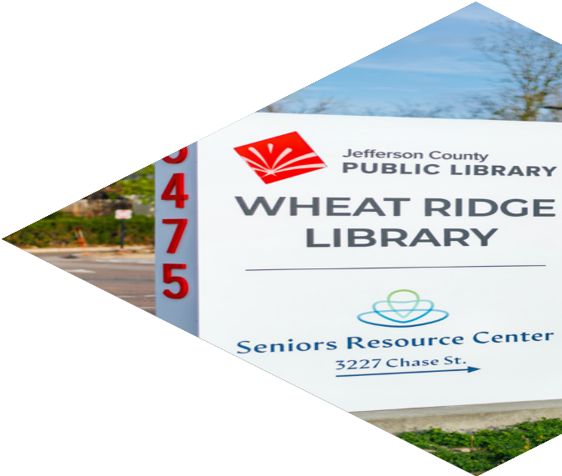
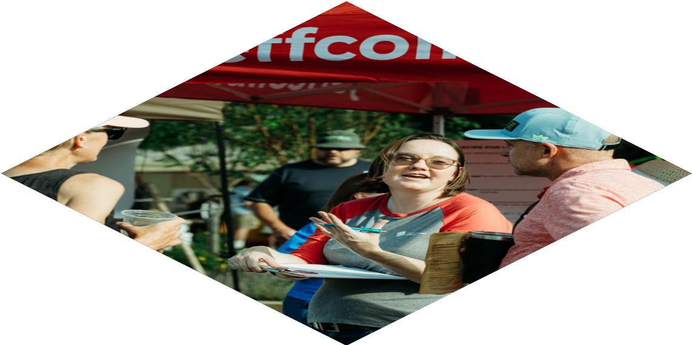
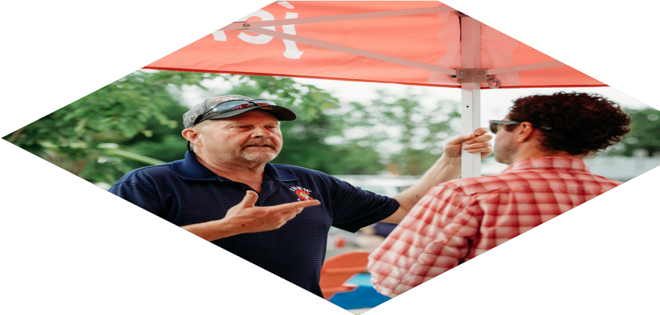


W H E A T R I D G E L I B R A R Y

INFORMING THE FUTURE OF LIBRARY SERVICES
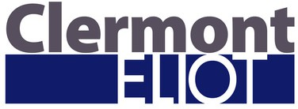

P r e p a r e d B y :
P r e s e n t e d To :

TABLE OF CONTENTS

- Project Overview & Objectives 03
- Methodology 04
- Executive Summary 05
- Focused Findings 07
  - Demographics 08
  - Perceptions of Wheat Ridge Library 09
  - How Residents Use (or Don’t) the Library 10
  - User Satisfaction 11
  - Community-Identified Opportunities 12
  - Spaces 13
  - Location and Accessibility 14
  - Staff: The Key Ingredient 15

- Appendix A: Survey Instrument and Data Tables
- Appendix B: Community Activation Data Sets
- Appendix C: 1:1 Community Interviews Summary



PROJECT OVERVIEW

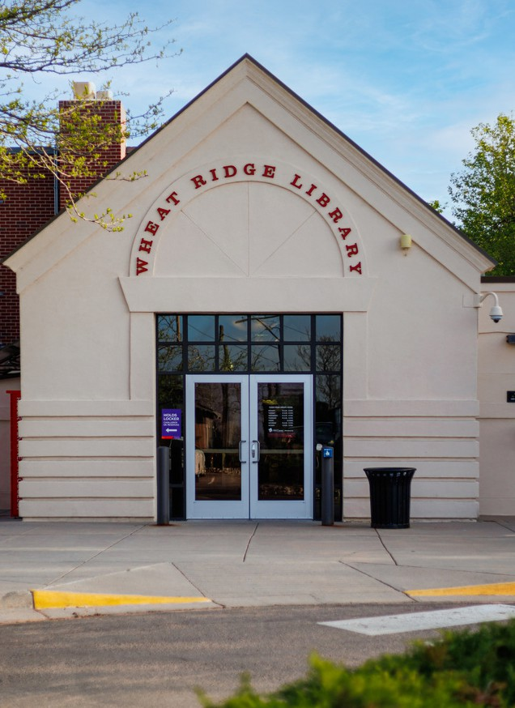
In 2026, Jefferson County Public Library (JCPL) engaged the Wheat Ridge community to understand how the Library is serving residents today and discover community priorities for future services.
Through robust community engagement that included in-person activations, a survey and a staff input session we listened to more than 1,000 voices across Wheat Ridge and the surrounding area.

The result is a clear picture of a library that residents genuinely value—and in some ways that's ready for more. This report presents what we heard from the community, what the data shows and what it means for the future of Wheat Ridge Library.

The Wheat Ridge Library holds a distinctive place in JCPL’s system: it functions as a true neighborhood library, where proximity matters and the relationship between staff and patrons is personal.

Community engagement was conducted to evaluate how well the current Wheat Ridge Library location and services meet community needs, identify desired library amenities and space priorities, and gather data to inform future facility and service decisions. With this in mind the community engagement process looked to answer the following questions:

Is the Wheat Ridge Library delivering on what this community needs?
Who's using the Library, who's not and where are they going instead?
What does the community think of the Library’s current location?
If the Library could do more, what would the community ask for first?

METHODOLOGY

An English-language survey instrument was created jointly by Clermont Eliot and JCPL. The finalized instrument was translated to Spanish by JCPL. Surveys in both languages were then deployed online 4/13–5/22, with printed versions also available from JCPL. This mode was intended for broad audience reach. It contained multiple choice, ranking and open response questions.

Five (5) community activation events and a Wheat Ridge Library-specific activation were designed to capture qualitative insights. These events were executed by Clermont Eliot with support by JCPL staff, including language access support, on the following timeline:

Stylus + Crate 4/30/26
Edwards Meats 5/9/26
RidgeFest 6/6/26

Wheat Ridge Rec Center 4/27/26
In-Library Display 5/5/26—5/22/26
Concert at the Green 5/15/26

To understand the Library from the inside out Clermont Eliot facilitated a listening session with 80% of staff participating in early April. This focused on how they serve patrons within the space and programming constraints.

For additional depth, community engagement included key interviews with 15 community leaders completed in 2025–2026 by JCPL staff and incorporated into the comprehensive dataset.
706
Survey Respondents
313
Community Activation Respondents
*Includes WR Library activation
15
1:1 Interviews with Community Leaders

EXECUTIVE SUMMARY
KEY FINDING: AWARENESS GAP
“Where is the Wheat Ridge Library, exactly?”

Awareness, not satisfaction, is the first theme this data surfaces. Among community activation participants who named a current library:
24%
named Wheat Ridge as their current library
76%
named another JCPL location or neighboring system instead
36%
of all event contacts had never been or didn’t know enough about the location to describe it

KEY FINDING: CONSTRAINTS VS. COMFORT
Size is a two-way street

Space was the single most-cited barrier in the survey. Yet even as they’re asking it to do more, a small footprint produces an atmosphere some patrons value:
44%
of survey responses about barriers to visiting cited “too small or crowded”
40%
identified “Gathering space” as something needing improvement
*only item where dissatisfaction was higher than satisfaction
~50%
activation participants who mentioned size framed it positively

Continued on the following page

EXECUTIVE SUMMARY
KEY FINDING: NO CLEAR PRIORITY IN LIBRARY FEATURES
More is better, but not substantially so

Asked what would bring them back more often, residents spread their feedback across a wide menu of selections, rather than rallying around one or two:
38%
of survey respondents said a “library of things” would encourage more visits
*no item surveyed > 50%
94%
of library aspects received more “Meets Expectations” ratings than “Needs Improvement” ratings on survey
98%
of survey respondents said space for physical materials is a priority

KEY FINDING: STAFF IS THE SPECIAL SAUCE

“Tiny but mighty makes interactions more personal.” (WR Staff Session)

One finding crosses every engagement method without contradiction. People return to the Wheat Ridge Library because of the connection and environment cultivated by the staff:
95%
of survey respondents said staff helpfulness “Meets Expectations”
Top 3
experiences that survey respondents rated as “Meets Expectations” were related to staff
20%
community conversations praised staff, without prompting

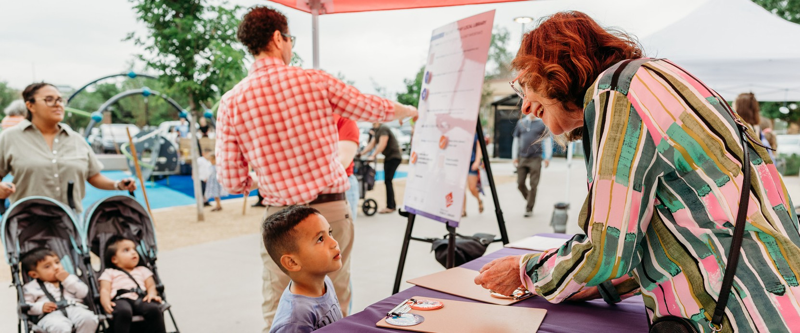



FOCUSED FINDINGS

This report provides an analysis of findings of how Wheat Ridge residents perceive and use their library, where they are satisfied and where they aren't, and what quieter signals in the data add to louder ones.

Perceptions, usage behaviors, satisfaction with programming and spaces and location input was gathered across community engagement modes. This analysis summarizes the core findings for each topic.

As question formats varied between feedback modes, stated percentages and ratios are based on total responses obtained for a specific mode and/or question.

Complete data sets are provided as appendices to this report.

DEMOGRAPHICS

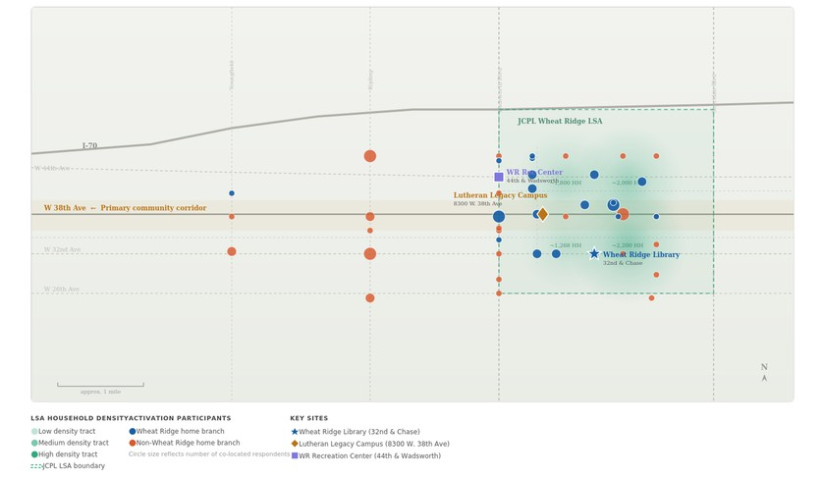





NOT TO SCALE
I-70

DENSITY OF ACTIVATION PARTICIPANTS HOUSEHOLDS KEY SITES

Low density tract
Wheat Ridge home library
Wheat Ridge Library

Medium density tract High density tract JCPL LSA boundary
SURVEY
94%
53
Visited Wheat Ridge Library
Median Age
COMMUNITY
ACTIVATIONS
24%
38
Visited Wheat Ridge Library
Median Age
Wheat Ridge 2024 American Community Survey Median Age: 42



Other home library

*Circle size reflects number of co-located respondents

Lutheran Legacy Campus
WR Recreation Center

CLUSTERS & CORRIDORS
Individuals engaged at community activations were asked to provide the nearest cross-streets of where they live. This map charts concentrations of responses based on those who identified Wheat Ridge as their current library, and those who use a different library.

TOP ZIP CODES
S u r v e y o n l y

53% | 80033 (Wheat Ridge Library ZIP)
19% | 80212
11% | 80214

8

PERCEPTIONS OF
WHEAT RIDGE LIBRARY






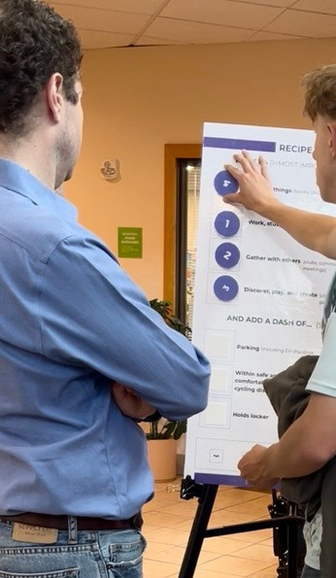
Staff helpfulness was the Library’s highest-rated feature

“ We love our l ittle l ibrary, but the size and hours often push us to go to a different location.”
Respondents say gathering space needs improvement

The top five aspects of the Wheat Ridge Library that meet expectations include staff helpfulness (95%), welcoming environment (89%), ease of finding materials (86%), location and access (84%) and parking availability (83%). Conversely, the aspects most cited as needing improvement in the survey were gathering space (40%), Children's Area (26%), materials such as books and movies (25%), clean and comfortable furniture (23%) and open hours (21%). This data pattern suggests it’s a library to swing by rather than linger.
”Space feels too small or crowded” was the most-cited barrier (17%) to more frequent visits. Limited collection (15%) and inconvenient hours (14%) were the other commonly identified barriers preventing more frequent visits.
The Library’s small footprint isn't experienced only as a limitation. Among community activation participants who had visited the Library, roughly 50% described the atmosphere the space produces as “cozy,” “convenient” and “quaint.” Each came up multiple times. Patrons like what the space feels like, even as they're asking it to do more than its current size allows.
COMMUNITY PARTNER INTERVIEWS
In 2025–26 one-on-one interviews with elected officials, municipal leaders and community partners, two themes stood out: strong, consistent support for maintaining library services in Wheat Ridge, paired with a shared perception that the current facility doesn't meet community needs. Several partners noted residents travel to other locations for space and resources the existing library can't provide. There is a strong desire to commit to a path forward.
9

HOW THE LIBRARY IS (OR ISN’T) USED


SURVEY SAYS...

Borrow items 92%

Get help from staff | 77%
Borrow digital items | 54%
Use public computers, copiers or printers | 39%

ALSO REPORTED:
WiFi — 30%
Attend a program — 29%
Story Time/activities — 29%
Read papers/magazines — 28%

SURVEY
( o p e n - e n d e d r e s p o n s e s )
~50% reference accessing collection
25% describe quick check out/return
20% describe “work/study/browse”

COMMUNITY ACTIVATIONS
“Borrow Things”
rated the most important use
“Work, Study or Read”
rated the second-most important use

Study or work remotely — 24%
Meet people — 18%
Use Children’s Area computers — 14%

TOP MENTIONS
C o m m u n i t y a c t i v a t i o n s
( o p e n - e n d e d r e s p o n s e s )

Access to physical collections
#1

Kids, family & youth programs/materials
#2

#3 Computers & technology

10

USER SATISFACTION

“ I love this branch and have been coming here for years with my family.”

MEETS EXPECTATIONS
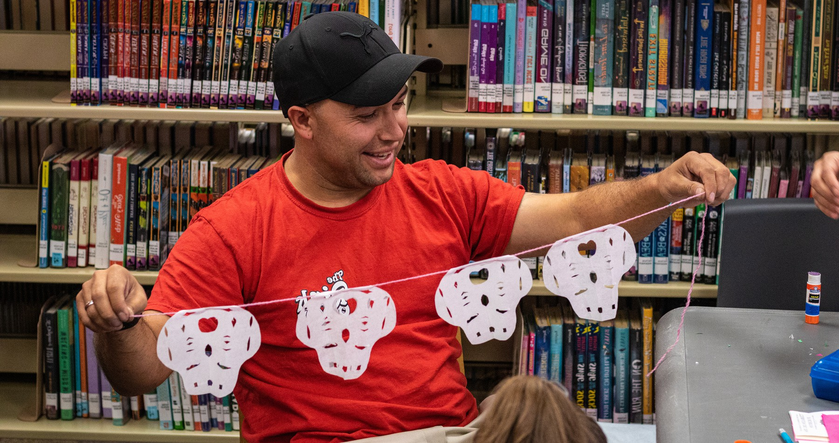
94%
LEAST FAMILIAR ASPECTS
P e r c e n t o f “ N o O p i n i o n ”
r e s p o n s e s o n s u r v e y
aspects of the Wheat Ridge Library that received more “Meets Expectations” ratings than “Needs Improvement” from survey respondents

Gathering space
Holds Locker
Accessibility for disabilities Programs and events
56%
45%
40%
only aspect where “Needs Improvement” was top response by survey respondents

Overall sentiment was strongly positive: 90% of community activation participants who offered a description of the Wheat Ridge Library used positive or neutral terms, as did 73% of open-ended responses on the survey. Of the 48 survey comments with negative sentiment, most cited the Library’s small size, space, building and overall property aesthetics.

11

COMMUNITY-IDENTIFIED
OPPORTUNITIES

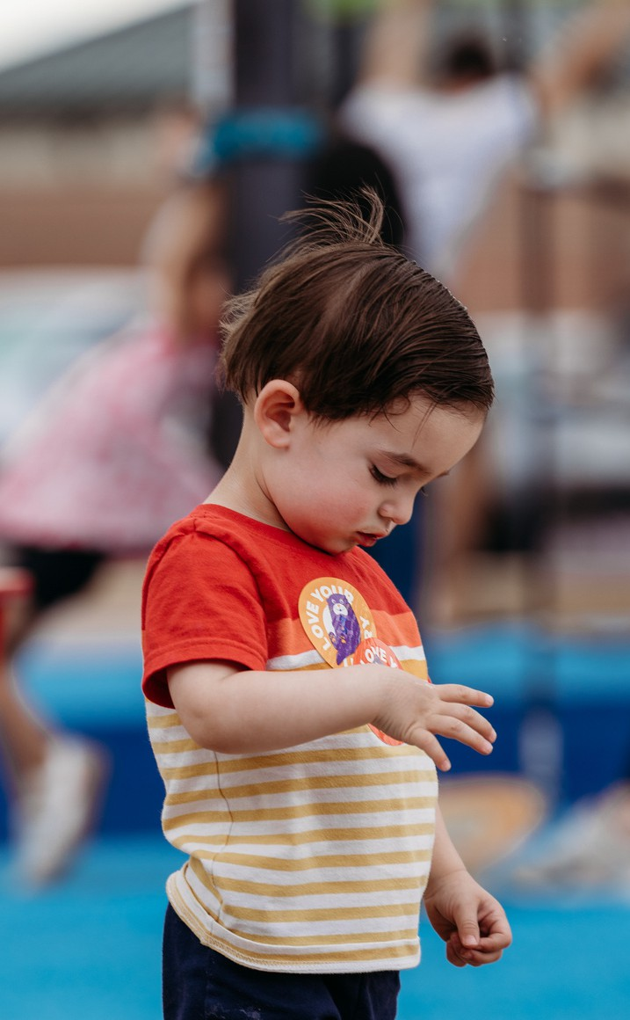
When asked what would encourage them to visit more often, survey respondents most frequently selected access to a “library of things” (38%), more books and physical materials (33%), opportunities to learn new skills or make things (32%), convenient hours (31%) and more adult programs and classes (31%). The top two priorities point to physical collections; two of the next three point to expanded programming.

“ I love a l ibrary if it has everything I want.
If it' s close, it’ s the greatest place on earth.”
~66%
ratio of activation participants who said location matters more than inventory
38%
of survey respondents said access to a “library of things” would make them visit more often
Open-ended responses converged on a smaller, more specific set of ideas: dedicated focus and Study Rooms, comfortable seating and lounging layouts, expanded physical materials and adult skill-building or learning programs. These themes sharpen the ranked list above into something closer to a design brief than a wish list.
Approximately 66% of activation participants ranked location over inventory. Still, some said they'd travel further for programming or collections that felt genuinely relevant to them.
COMMUNITY PARTNER INTERVIEWS
One-on-one interviews with elected officials and community partners in 2025–26 also surfaced three strategic threads: the Library's current lease carries favorable lease terms for JCPL, but mixed views exist on staying in this location; relocation opportunities (Lutheran Legacy Campus) were raised as a way to anchor broader development; narrowing window to align the Library and partner organizations’ timelines to capture these opportunities.

SPACES

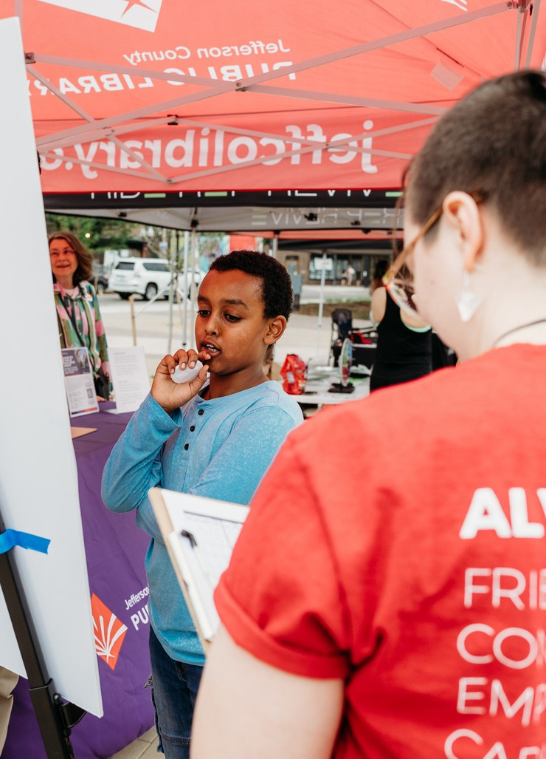
Space was a consistent theme across all feedback collected. Gathering space was the only feature in the survey where the number of “Needs Improvement” ratings (40%) exceeded the number of “Meets Expectations” ratings (33%).

“ I honestly go to Lakewood l ibrary more because the kids area is bigger.”
40%
survey respondents said “Limited collection or materials” is a barrier
44%
of survey respondents said the Library feels too small or crowded
Study Rooms were named at every community activation site, by staff and in open-ended survey responses. The Library’s Children's Area drew the second-highest amount of “Needs Improvement”' responses. Multiple families cited larger Children's Areas at Lakewood and Belmar Libraries as the reason they go elsewhere. Natural lighting, flexible seating and a dedicated Teen Area were also named as desired spaces across multiple channels.
DESIRED SPACES
(Top unprompted mentions)

Study Rooms Children’s Area
Computers & technology
Among activation participants, “Work, study and read,” and “Discover, play and create,” were seen as higher priorities than generally “Gathering with others.” Similarly, “Meeting Rooms” received the highest amount of “Not Important” ratings by survey respondents. No Meeting Room exists at Wheat Ridge Library.
Space for books and physical materials remained a top priority. Survey respondents rated it as the second highest factor that would encourage them to visit the Library more, and materials in general tied with “Welcoming Environment” as the most important aspects of a library.

“ My kids had a BLAST at the fort- building evening
— would love more creative programming”

LOCATION
AND ACCESSIBILITY

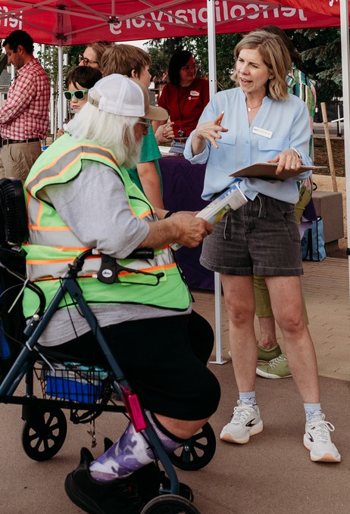
Driving was the most common way survey respondents reported getting to the Library (80%), with walking (34%) and bicycle/e-bike/scooter (18%) being the other most common transportation modes. Parking availability was also rated a top-five “Meets Expectations” item by respondents.

“ Being near Panorama Park creates a community feel for many young families.”
20%
survey respondents say open hours need improvement
Drive
most common way survey respondents get to the Library
Community activation participants, who were more likely to be potential or lapsed library users, rated “Within walking or cycling distance” and “Near other places I often visit” as the two most important access factors if they were to visit a library. The 38th Avenue Corridor, and Wadsworth corridor to a lesser degree, were the most common areas participants said they often went when out and about in Wheat Ridge.
Open hours were the third most-cited barrier to visiting the Library among survey respondents (37%). However, 73% of respondents also said current hours meet expectations. Friday closures were referenced specifically in open-ended responses and community conversations mentioned working families and school-age patrons’ may have limited availability during current open hours.
LUTHERAN LEGACY CAMPUS
Neither the survey nor community activations asked about potential new locations for the Wheat Ridge Library. However, the Lutheran Legacy Campus was mentioned, unprompted, a total of 26 times across all modes. Its centrality, civic co-location and proximity to places residents already go were noted as possibly encouraging more library use.

STAFF:
THE KEY INGREDIENT
95%
of survey respondents said staff helpfulness meets expectations

This was the highest-rated aspect of the Library in the survey + 20% community activation participants gave this feedback unprompted
“ Your staff are your greatest resource.”

Across every engagement channel, respondents consistently pointed to a single factor that influenced their patronage of the Wheat Ridge Library: the staff.
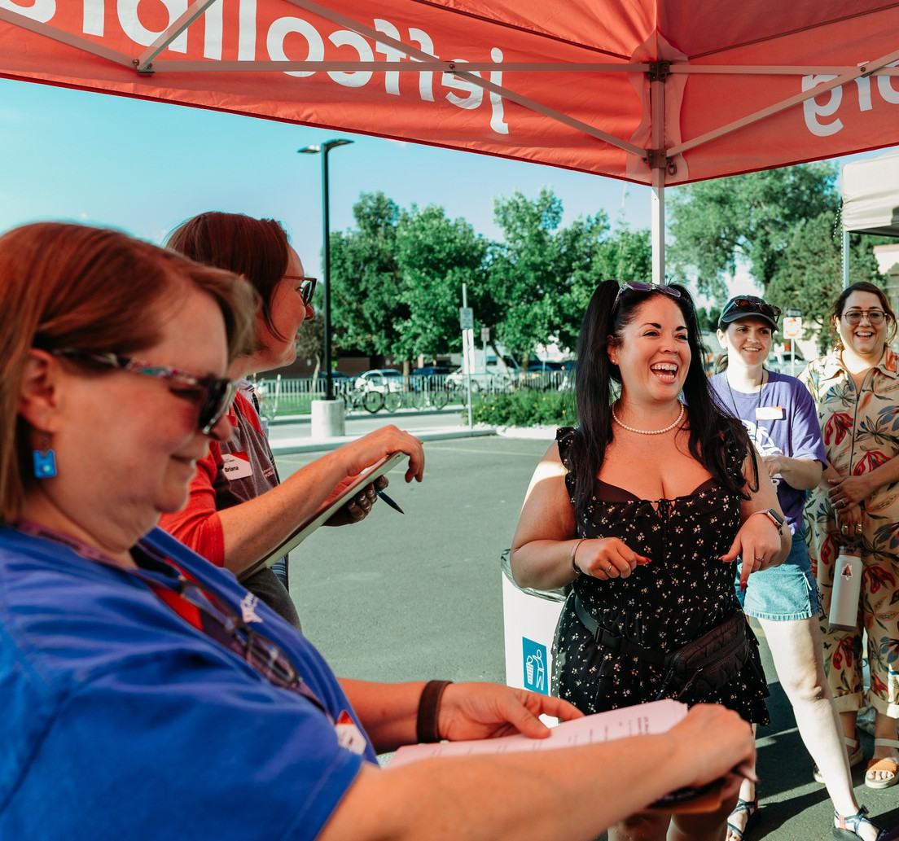
“Staff helpfulness,” “Welcoming environment” and “Ease of finding materials” are three aspects of the Wheat Ridge Library that are entirely or significantly influenced by staff. They also received the most “Meets Expectations” votes from survey respondents. Community activation participants who identified other locations as their main library still named Wheat Ridge staff as a differentiator when describing the location. In open-ended survey responses, 31 people praised staff unprompted. It was among the most frequent unprompted themes in the datasets.
This patron-focused mentality also came through during the staff feedback session. While staff noted several aspects related to their work experience (no dedicated staff bathroom and challenges posed by the shared Seniors Resource Center space), responses largely focused more on what would enhance the patron experience.
Staff prompt: Without space constraints,
what would improve staff workflow?
“More collection highlights / top picks / lucky
day / features; All spaces [accessible]”

APPENDIX OVERVIEW

APPENDICES
Supporting materials and research information

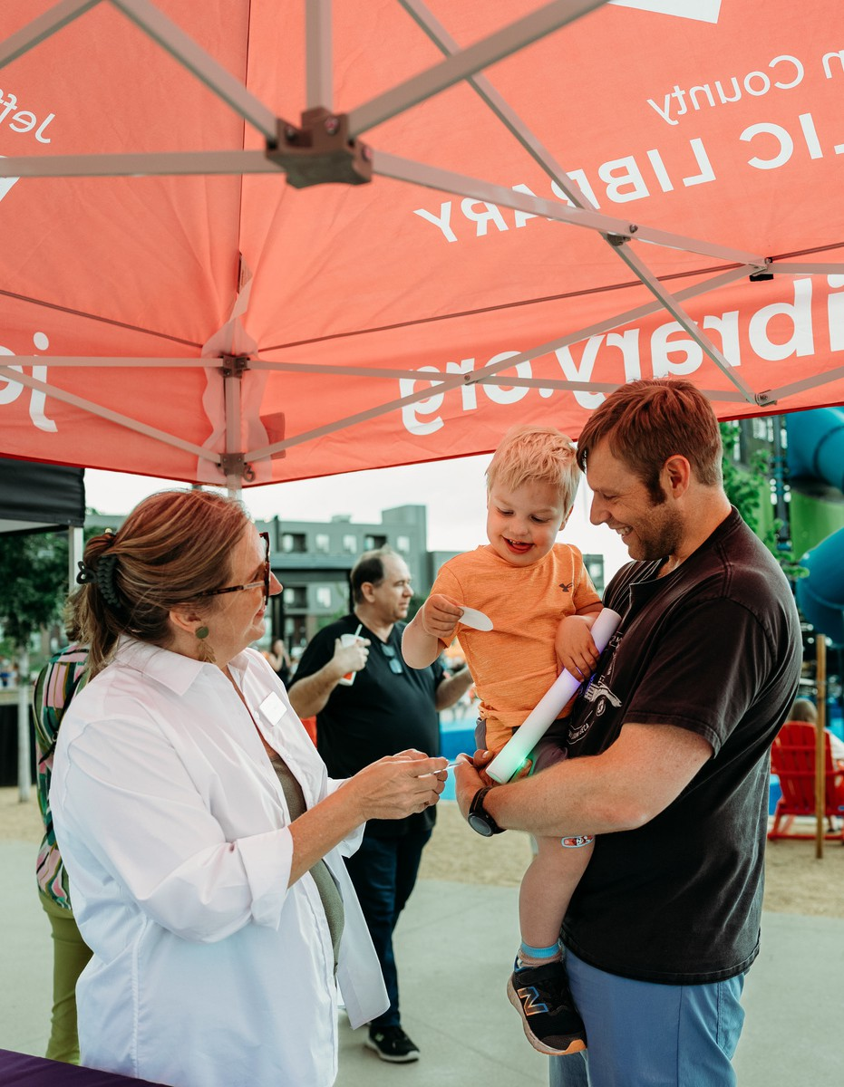
These appendices contain important supporting materials that enhance the understanding of and add context to the Wheat Ridge Library community engagement report.
Inside, you'll find detailed references, including community survey and community activation response data that provide clarity and context for the engagement strategies implemented in Spring 2026. The results and outcomes were jointly tabulated by JCPL and Clermont Eliot.

APPENDIX A

SUPPORTING METHODS AND SOURCES
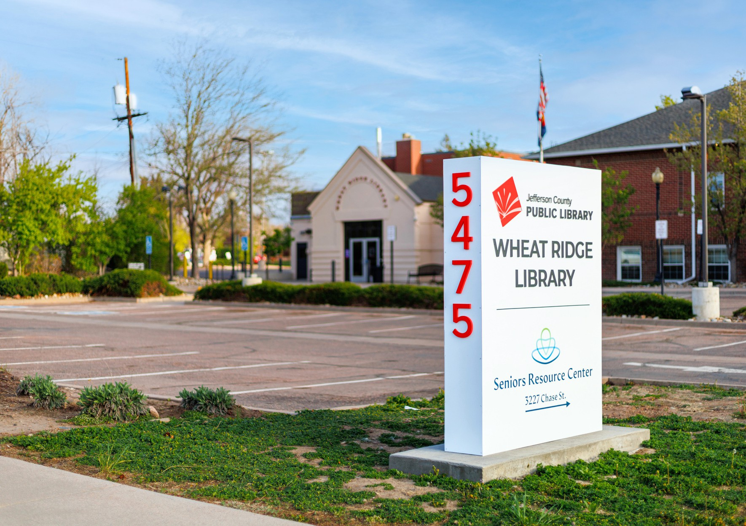
Community Survey — Instrument & Data Tables

FINAL
Wheat Ridge Library Community Survey
About This Survey
Jeﬀerson County Public Library (JCPL) is seeking community input to help guide planning for the future of library services in Wheat Ridge. The feedback collected in this survey will help us beCer understand how residents currently use the library and what services, spaces and resources would best serve the community in the years ahead.
The current Wheat Ridge Library is a neighborhood locaEon serving residents of Wheat Ridge and nearby communiEes. As the area evolves and community needs change, JCPL is exploring ways to ensure library spaces and services conEnue to support residents of all ages and those with diﬀerent needs.
Your responses will help inform planning decisions about future library spaces, programs, and services. The survey takes approximately 8–10 minutes to complete.
ParEcipaEon is voluntary and JCPL will share the survey results in aggregate in our ﬁnal community engagement report.
About You and Your Library Use
- What do you typically do when you visit a library?

- What word(s) would you use to describe what a library means to you?

- Complete this statement: When I visit a library, I want to feel like I’m in a place that…

Your Experiences with Library Services
- Have you visited the Wheat Ridge Library (32nd & Chase)?
  - Yes
  - No (skip to Q8)
- Please rate your experience with the following Wheat Ridge Library services or features.

 | Meets ExpectaEons | Needs Improvement | No Opinion
Staﬀ helpfulness
Computer access
Wireless internet access

Programs and events
Materials (books, movies, music, etc)
Welcoming environment
Children's area
Holds locker
Gathering space
Noise level
Clean and comfortable furniture
Ease of ﬁnding materials
Open hours
LocaEon and ease of access
Safety and comfort
Parking availability
Accessibility for those with disabiliEes
Other (please specify below)
Other:

- Please let us know how important the following services or features are to you.

 | Important | Not Important | No Opinion
Staﬀ helpfulness
Computer access
Wireless internet access
Programs and events
Materials (books, movies, music, etc)
Welcoming environment
Children's area
Holds locker
Gathering space

MeeEng rooms
Quiet spaces for reading or working independently
Clean and comfortable seaEng
Accessible restrooms
Convenient open hours
LocaEon and proximity to home
Safety and comfort
Parking availability
Accessibility for people with disabiliEes
Other (please specify below)
Other:
How You Use the Library
- Which of the following acXviXes, if any, have you done at the Wheat Ridge Library?
Please check all that apply.
  - Borrow items (books, DVDs, audiobooks, magazines)
  - Borrow digital items (books, magazines, music, video, streaming)
  - Use public computers, copiers or printers
  - Use wireless internet
  - Use the computers in the children’s area
  - Get help from staﬀ
  - Bring children for Story Time or acEviEes
  - ACend a program
  - Use to study or work remotely
  - Meet people, including friends or neighbors
  - Sit and read newspapers or magazines
  - Other (please specify)
Barriers to VisiXng the Library
- Which of the following things, if any, have prevented you or might prevent you from visiXng the Wheat Ridge Library?
Please check up to 5 that aﬀect you the most.
  - Inconvenient hours
  - LocaEon is diﬃcult to access
  - Limited parking
  - Library space feels too small or crowded

  - Limited seaEng or study space
  - Limited collecEon or materials
  - Noise level
  - Limited programming space
  - Lack of meeEng rooms
  - Accessibility challenges (mobility, restrooms, etc.)
  - I use online resources instead
  - I prefer another library locaEon
  - Safety concerns
  - TransportaEon challenges
  - Other (please specify)
What Would Encourage You to Visit More O^en
- Which of the following would encourage you to visit the Wheat Ridge Library more o^en?
Please select up to 5.
  - Convenient hours
  - Easy parking
  - EV charging staEon(s)
  - Safe and welcoming spaces
  - More quiet study or reading spaces
  - Sensory area
  - More meeEng or community gathering space
  - Dedicated space for teens
  - More kids’ programs
  - Programs for teens
  - More adult programs and classes
  - More programs for older adults
  - More programs for families
  - OpportuniEes to learn new skills, create or make things
  - Access to computers, printers, copiers, scanners
  - More books and physical materials
  - Technology support and digital literacy help
  - Co-working or ﬂexible workspaces
  - Access a “library of things” (outdoor equipment, hand tools, games, etc.)
  - Other (please specify) Other:
Library Spaces and Services
- What kinds of spaces would you most like to see in current or future JCPL library locaXons?

- What services or resources would be most helpful for helping you reach your personal, educaXonal, or work goals?

- Is there anything else you would like us to consider as we plan for the future of library services in Wheat Ridge?

Gecng to the Library
- How do you typically travel to the library?
Check all that apply.
  - Walk
  - Bicycle/E-bike/Scooter
  - Drive
  - Public transportaEon
  - Ride with someone else
  - Other (please specify)

About You
Do you currently have a library card?
- Yes
- No
How o^en do you use the library?
- 3 Emes a year or less
- 4–11 Emes a year
- About once a month
- About once a week
- More than once a week

Please select your age range:
- 12 or under
- 13–15
- 16–18
- 19–29
- 30–45
- 46–60
- 61–75
- 76 or over
What zip code do you live in?

How did you hear about the survey?

- Library website
- Library staﬀ
- Email newsleCer
- Social media
- Community event
- Flyer or poster
- Word of mouth
- Other (please specify)

Wheat Ridge Library 2026 Survey Results

Demographics: By ZIP Code

ZIP CODE | Number of Respondents | Percent of Total
80033 | 292 | 53%
80212 | 103 | 19%
80214 | 59 | 11%
80215 | 14 | 3%
80204 | 6 | 1%
80003 | 6 | 1%
80002 | 5 | 1%
80026 | 5 | 1%
80401 | 5 | 1%
Other ZIP CODES listed with less than 1% of responses: 80004, 80005, 80010, 80030, 80031,
80099, 80123, 80127, 80128, 80203, 80205, 80221, 80222, 80228, 80230, 80232, 80260,
80403, 80439, 80465

Demographics: By Age

Age Range | Number of Respondents | Percent of Total
12 or under | 2 | Less than 1%
16-18 | 1 | Less than 1%
19-29 | 20 | 4%
30-45 | 208 | 37%
46-60 | 109 | 19%
61-75 | 165 | 29%
76 or over | 58 | 10%

Demographics: Have A Library Card

Have a library card? | Number of Respondents | Percent of Total
No | 4 | 1%
Yes | 571 | 99%

Demographics: Visited the Wheat Ridge Library

Visited the Wheat Ridge Library? | Number of Respondents | Percent of Total
No | 36 | 6%
Yes | 599 | 94%

Demographics: Frequency of Library Use

Frequency of Use | Number of Respondents | Percent of Total
3 times a year or less | 38 | 6%
4-11 times a year | 121 | 21%
About once a month | 203 | 35%
About once a week | 167 | 28%
More than once a week | 58 | 10%

Q5: Please rate your experience with the following Wheat Ridge Library services or features

Service or Feature | Meets Expectations | Needs Improvement | No Opinion | Total
Staff helpfulness | 548 | 11 | 19 | 578
Computer access | 338 | 74 | 164 | 576
Programs and events | 233 | 110 | 225 | 568
Materials (books, movies, music, etc.) | 411 | 143 | 21 | 575
Welcoming environment | 510 | 57 | 9 | 576
Children’s area | 204 | 146 | 222 | 572
Holds locker | 226 | 23 | 311 | 560
Gathering space | 184 | 225 | 157 | 566
Noise level | 465 | 56 | 57 | 578
Clean and comfortable furniture | 368 | 136 | 77 | 581
Ease of finding materials | 503 | 54 | 27 | 584
Open hours | 422 | 119 | 36 | 577
Location and ease of access | 481 | 78 | 15 | 574
Safety and comfort | 469 | 69 | 35 | 573
Parking availability | 478 | 79 | 21 | 578
Accessibility for those with disabilities | 261 | 52 | 261 | 574

Q6: Please let us know how important the following services or features are to you

Service or Feature | Important | Not Important | No Opinion | Total
Staff helpfulness | 525 | 3 | 10 | 538
Computer access | 328 | 132 | 72 | 532
Wireless internet access | 383 | 92 | 57 | 532
Programs and events | 357 | 64 | 111 | 532
Materials (books, movies, music, etc.) | 531 | 5 | 6 | 542
Welcoming environment | 531 | 7 | 5 | 543
Children’s area | 353 | 51 | 126 | 530
Holds locker | 220 | 127 | 180 | 527
Gathering space | 342 | 99 | 95 | 536
Meeting rooms | 230 | 149 | 146 | 525
Clean and comfortable seating | 494 | 16 | 30 | 540
Accessible restrooms | 420 | 19 | 91 | 530
Convenient open hours | 513 | 12 | 12 | 537
Location and proximity to home | 490 | 28 | 25 | 543
Safety and comfort | 524 | 1 | 14 | 539
Parking availability | 446 | 56 | 35 | 537
Accessibility for those with disabilities | 386 | 22 | 124 | 532

Q7: Which of the following activities, if any, have you done at the Wheat Ridge Library (check all that apply)

Activity | Number of Responses
Borrow items | 528
Borrow digital items | 311
Use public computers, copiers or printers | 225
Use wireless internet | 170
Use the computers in the children’s area | 78
Get help from staff | 443
Bring children for Story Time or activities | 165
Attend a program | 165
Use to study or work remotely | 138
Meet people | 103
Sit and read newspapers or magazines | 161

Q8: Which of the following things, if any, have prevented you or might prevent you from visiting the Wheat Ridge Library (check up to 5 that affect you the most)

Barriers | Number of Responses
Inconvenient hours | 159
Location is difficult to access | 28
Limited parking | 67
Library space feels too small or crowded | 193
Limited seating for study space | 115
Limited collection of materials | 0
Noise level | 38
Limited programming space | 48
Lack of meeting rooms | 62
Accessibility challenges | 15
I use online resources instead | 67
I prefer another library location | 115
Safety concerns | 34
Transportation challenges | 13

Q9: Which of the following would encourage you to visit the Wheat Ridge Library more often (select up to 5)

Aspect | Number of Responses
Convenient hours | 190
Easy parking | 92
EV charging station(s) | 25
Safe and welcoming spaces | 82
More quiet study or reading spaces | 122
Sensory area | 25
More meeting or community gathering space | 97
Dedicated space for teens | 30
More kids programs | 105
Programs for teens | 28
More adult programs and classes | 189
More programs for older adults | 103
More programs for families | 70
Opportunities to learn new skills, create or make things | 195
Access to computers, printers, copiers, scanners | 87
More books and physical materials | 203
Technology support and digital literacy help | 47
Co-working or flexible workspaces | 107
Access a “library of things” (outdoor equipment, hand tools, games, etc.) | 232

Q13: How do you typically travel to the library (select all that apply)

Transportation Mode | Number of Responses
Walk | 200
Bicycle/E-bike/Scooter | 108
Drive | 480
Public transportation | 20
Ride with someone else | 16

Results of open response questions, in which respondents provided short answers, have not been included here in order to reduce document length. Full responses to these questions can be provided by JCPL upon request.

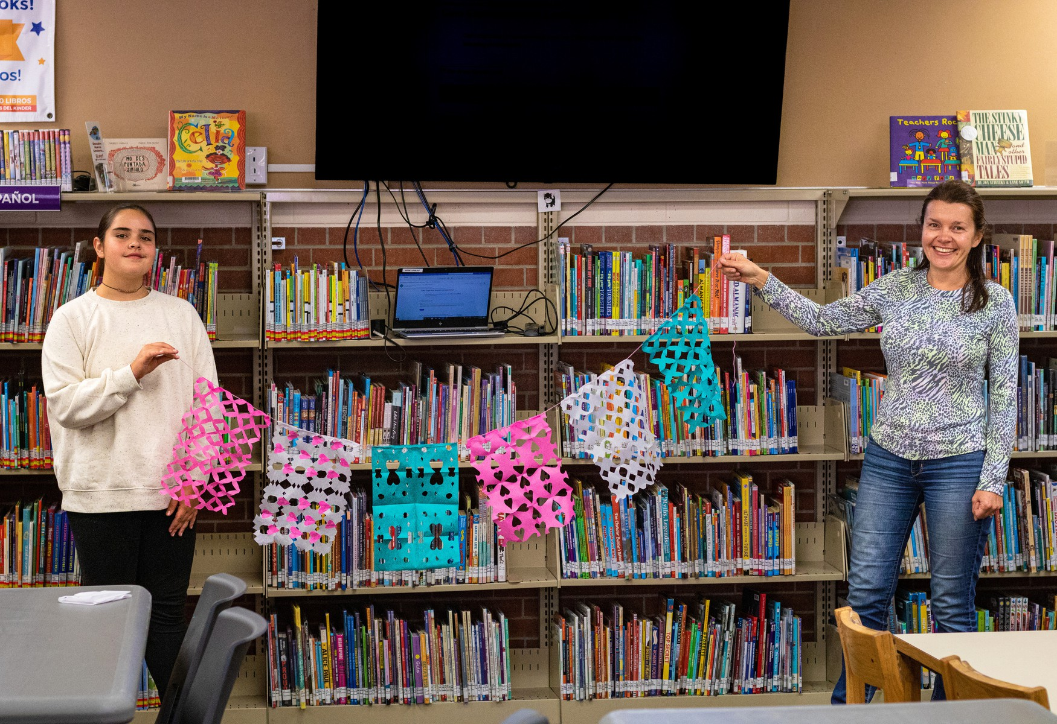
APPENDIX B

SUPPORTING METHODS AND SOURCES
Qualitative Insights — In-Community Activations Data Sets

JCPL Wheat Ridge Public Outreach Activation Questionnaire
(Target Completion Time: 5 minutes or less)
AGE:

CURRENT LIBRARY (IF ANY):

ADDRESS (OR NEAREST MAIN CROSS STREETS):

- How would you describe the Wheat Ridge Library to someone who just moved into the community?

- What would you say you ﬁnd most useful about the Wheat Ridge Library, or if you don’t visit that library in particular, what do you ﬁnd most useful about libraries in general?

- In addition to those things you just mentioned, what might be one or two other things—spaces, services, programs—that you might take advantage of at a local library?

- What areas of Wheat Ridge do you most frequently visit?

- How does the importance of a library’s physical location compare to the ability to easily ﬁnd the books, spaces, and services that are most relevant to you?

Community Activation Questionnaire Responses Wheat Ridge Recreation Center (4/27/26)
Participants | Age(s) | Current Library | Nearest Cross Streets | Question 1: Describe WR Library | Question 2: Most Useful / General Value | Question 3: Future Spaces / Programs | Question 4: Frequently Visited Areas of WR | Question 5: Library Physical Location vs Relevance
1 | 74 | Lakewood | 20th & Longery | Haven't been, but always went to Denver Libraries when living over there | Materials: books, movies, lucky day | Programs for seniors, computer literacy | Off of 32nd (near library) / Parks and open space | Important to have nearby, driving is a hassle
2 | 35, 33 | Edgewater | 26th & Wadsworth | Don't know | App, holds | Mostly books, printing | Gold's, over here by rec center | I like to walk / I like to be able to find what I need
1 | 75 | Wheat Ridge | [no response] | Small, very edge of town | Checking out books, access to tech | Gathering Space: small conference, larger meeting space; central to community | Rec center, 38 & Wadsworth corridor | Co-located w/ other civic locations; Lutheran
2 | 43, 4 | Lakewood / Arvada | 34th & Kipling | I couldn't | Kids activities, family section, home school | Quiet space | 38th & Wadsworth | Location isn't super important, willing to travel
1 | 60 | Arvada | 58th & Kipling | [no response] | Get books and sources of credible info | Meeting spaces and ability to book well in advance | Rec center / center area | Location not as important, 10-15 minute drive as I mostly use online services
1 | 63 | Belmar | Ohio & Alameda | Don't know of it | Kids section, I take my grandkids | Programs for seniors and citizenship | At Wadsworth | Important that it's close; will drive 20 minutes if it has good things for kids

2 | 14, 13 | Lakewood | Applewood | Awesome and go get a million books, don't feel bad asking for help | Fast and easy checkout of stocks of books | Kids area, teen area, times for homework help, programs, book backup, Summer programs | Mostly just the rec center | Love it if it has everything I want, I'll love it. If it's close it is the greatest place on earth
1 | 73 | Lakewood | 32nd & Youngfield | [no response] | Going up w/ grandkids. Pick out books, movies, programming | 3 yr. old tumbling / Kitchen | Rec Center and by Youngfield | Finding things helps
1 | 70 | Lakewood | 44th & Wadsworth | [no response] | Study rooms and Meeting Rooms (JCPL), Online periodicals | Activate spaces, Meeting spaces (25 ppl capacity), Digital, Reading spaces for kids | Rec Center or parks / Crown Hill / Anderson | Destination library is a nice thing
2 | 56, 35 | Lakewood | Colfax & Oak / 38th & Pierce | "My library is a cute little library", Pretty small, Friendly +1 | Go once a week, everyone at Wheat Ridge is very nice. Copies, HOLDS, My husband likes to reserve books & pickup, Good for kids  +1 | Learning to check out / find books / Computers, School / Academic space, "I love doing stuff online at library... they email me!!" | Rec Center, Safeway (38th/Wadsworth), or 44th/Wadsworth or Walmart | Convenience of neighborhood library, Location
1 | 50 | Denver Woodbury | [no response] | [no response] | Books-order online (20 years or so), Online research / periodicals, Access for free | Quiet nooks, Spaces for everyone | Rocky Mnt Vet / coach swim | Convenience of Location, Connectivity w/ Libraries +1

1 | 12 | Wheat Ridge | 41st & Vance | Respectful / Quiet / Staff helps | Staff / people | Open spaces / good collection in stacks | 38th & Wadsworth, 38th & Kipling, Wheat Ridge Rec, The Green on 38th | Location / Layout! Easy to recognize where things are, community feel / vibe
2 | 36, 4 | Wheat Ridge | 35th & Everett | Outdated, carpeted, intimate space | Librarians / collection, Animal Books | Storytime & family time, Emails re: Earth Day / Dino Party, Belmar Family Area and dividers = Activated Spaces +1 | 38th corridor / Stylus Crate | Location is important; parents w/ kids meet up there!
1 | 45 | [no response] | 35th & Parfet | [no response] | Collections, Fiction | Quiet nooks, communal spaces | Kipling - 38th/Wadsworth | Finding what you want when you get there
1 | 32 | [no response] | 20th & Kipling | [no response] | Helpful staff, rave books | Big Open | Rec Center / Kipling | Ability / convenience of finding what I need
1 | 33 | Edgewater | 22nd & Ames | I don't know, it's there | Services | Working / quiet | Sloan's Lake, Rec Cent. | Physical location - don't have a reason to go
2 | 45, 10 | Arvada | 44th & Pierce | Small but good children's section, staff | EBooks / Autobiography, Staff is super helpful | Chapter books | Rec Center, Discovery Park | Services / spaces
1 | 28 | Wheat Ridge | 33rd & Marshall | Nice / Resources / Spice Club | Printing one off, Community space, elder programs, connections | Computer lab settings, children area, outdoor parking (we walk because we're close) | Crown Hill Park, Paramount, 38th (coffee) | Location - walking 1-2 miles

3 | 2, 7, 49 | Lakewood | Kipling & Colfax | Have to google | Kids program, Bilingual Story time | Audiobooks is on my list, Computers - gaming play area | Rec Center, Business Area, Youngfield / 32nd | Aisles - I know where it is! Ability to easily find, established & has what I need
1 | 72 | Wheat Ridge | 41st & Zephyr | Good library. I've gone to events there. Movie selection is excellent. Staff is helpful | Research librarians is really useful, Help navigating things | Facilitated events - need event room, Comfy seating w/ less traffic | Rec Center / Sprouts, Kipling / Costco, Crown Hill Park, restaurants, P.O. Wheat Ridge at Youngfield | Ability to easily find books - use online services (*Waiting lists are often long)
1 | 60 | Berkeley Denver | 44th & Wadsworth | [no response] | Periodically, my wife & kids study there, storytime when little | Meeting spot, onsite navigator | Rec Center, Anderson Park | [no response]
1 | 12 | Wheat Ridge | 32nd & Chase | Easily calm environment to read and get away - Weekends! | Environment is great. YA / Teen Selection, I like the selection, it was really easy I told them the book, two weeks... they got it | People reaching and low-volume: social. I've read a lot more books living close | Rec Center - swimming; Library; Parks | Location; Most of the time I'm not sure what I'm looking for... I just find
1 | 35 | Standley Lake | 64th & Quaker | [no response] | Book Collection - Diary  / Fiction, We go through a lot of books, Programming - Summer series | Sit down and read the newest in series, Destination | Rec Center | Ability to easily find what we're looking for, like SILKS!

Stylus + Crate (4/30/26)
Participants | Age(s) | Current Library | Nearest Cross Streets | Question 1: Describe WR Library | Question 2: Most Useful / General Value | Question 3: Future Spaces / Programs | Question 4: Frequently Visited Areas of WR | Question 5: Library Physical Location vs Relevance
 |  |  |  |  |  | Innovative events w/
 |  |  |  |  |  | coffee options / Author |  | Location w/ easy
 |  |  |  |  | Programming collabs | Talks / Events for |  | parking / It is a
 |  |  |  |  | w/ Parks/Rec / Staff | Bookclub / Quiet | Rec Center, Civic | connector and is
 |  | Denver |  |  | are helpful / Printers / | reading w/ comfy | Center Campus at | connected to community
1 | 48 | Library | Montview & Newport | Hidden Gem | Bookdrop | furniture | Lutheran | assets
 |  |  |  |  |  |  |  | I would say if the
 |  |  |  |  |  |  |  | library's location is
 |  |  |  |  |  | I would want some |  | around the spot where
 |  |  |  |  |  | space for spending |  | there is an outreach
 |  |  |  |  |  | time / I would suggest |  | community could attract
 |  |  |  |  |  | to encourage younger |  | more people to join.
 |  |  |  |  |  | children to the library / |  | Moreover having a
 |  |  |  |  | If the library offers a | A service to public |  | location where public
 |  |  |  |  | private room to read a | event where people |  | transportation is
 |  |  |  | I would say it is a library | book / Also a headset | can gather about the |  | accessible is good as
 |  |  |  | with different kinds of | which link to the book | book they are | Not local but plan to | people from anywhere
1 | 24 | [no response] | [no response] | book to explore. | where it reads for you. | interested in | move here !!! | can come.

1 | 30 | [no response] | [no response] | [no response] | Provide varieties of books. Shared working space or private working group space that people can reserve or go there and use it. | I think if we have a biweekly workshop that would be good, it can be drawing or hand craft workshop. | [no response] | I think it is very important because in these days people spend more time working from home, sometime they might want to work somewhere else that is close to their place, convenient and less travel time. If that library is far from you they might not go there.
2 | 76, 80 | Denver Public Library / Wheat Ridge | [no response] | Quaint & cute / Little building behind Senior Resource Center "follow the signs" | Collections - I used the card catalogue / Old card catalogue w/ QR codes | Wheat Ridge Library! Accessibility - free books, periodicals, research / Physical access w/ ramps, wider  / I like comfort. I like the tactile nature of books. | Move to Lutheran! / Active Adult Center / 35th & Marshall / 38th & Wads / It's an asset. | Ability to find what I want when I need it. Location - I go a lot and gas costs a lot!
1 | 85 | Lakewood | 38th & Kipling | N/A | Computer TA; current magazines (previously)  / LARGE PRINT  BOOKS, Audio Books / Hold books - "I have a backlog a mile long" | A reader device so I can see it (for visually impaired) / Headphones or booth for audio book accessibility / (Art League) Artist slides - like in Boulder (Denver Library has rotating artist gallery) | Art Center / Sprouts / King Soopers / Lowes  / Lakewood Library | Both - Nothing nicer than finding a good space to read and easily getting in / out.

1 | 65 | Wheat Ridge | 41st & Dover | A very small library. Cozy. Great service | Books pickup. / Librarians' willingness to help, book recs, etc.  / Databases - Ancestry, etc. | Programs like book clubs, resources and trainings. / Technology support. IT for Library / Quiet spaces where I can read, meeting rooms (calm, etc.) | 41st/Dover / all over Wheat Ridge / A lot of space @ Wheat Ridge / Not private / Noisy w/ kids / Computer space | Find books services most relevant
2 | 61, 63 | Golden | [no response] | [no response] | Books, research, real estate / Fiction (libby app) | Spaces / services; use it to do talks, meeting rooms, maybe up to supplemental capacity  / Projection screen. | UPS / Business Center | Location - parking
1 | 60 | Wheat Ridge | 38th & Marshall | Warm, friendly, tiny | Librarians - so helpful / Printers | "Lucky Finds" / "Suggested Readings" | Stylus Crate / Belmar  / MORE! Arvada Library & Stanley Lake are bigger. | Both. It's easy to go to other branches.
1 | 35 | [no response] | 38th & Wadsworth | [no response] | Being able to find what I'm looking for very easily | Jazz / Live music events on weekends / Video game tournaments (older consoles); have coffee sponsors | 38th & Wadsworth | Within a 5 minute drive. If it was about events I'd be willing to drive further
1 | 41 | Aurora | Havana & Parker Road | Never Been | Language learning online resources | Family Place, Storytimes, Family Centers / 38th Corridor | 38th Corridor | Direct public transportation. Good for others to get to.
1 | 30 | [no response] | [no response] | I wouldn't be able to give particular details. I am not local. | Libraries are great places for communities. They provide nice place to read & study | I would use all of the above if they were convenient / The thing is the inconvenience of driving 30+ min. | I am not local | I prefer the physical location to be easy to access. Next would be services, spaces, books in that order.

1 | 29 | Denver Public Library | 11th & Corona | [no response] | Books, open feel, lots of sun, community resources, outdoor / outdoor area to hang | Open nice space to work / Craft workshops, financial workshops, open conference rooms. | 38th & Wadsworth | If very out of the way I won't go. If facilities are nice it doesn't have to be huge.
1 | 32 | Arvada Express | 52nd & Ward | [no response] | Rent most up-to-date books & DVDs | Working space w/ wifi / Open area, trusted place for news | 38th & Wadsworth | Location is most important, used to ride my bike there.
1 | 34 | Denver Public Library | 29th & Wolff | [no response] | Access to free resources and audio books, research databases | Children's programming, a nice 3rd space, low-cost to take kids | 38th from Wadsworth to Sheridan | If I have to travel far I make look for an alternative that's closer even if it's not exactly what I'm looking for.
3 | 74, 75, 59 | Wheat Ridge  / Golden / Standley / Lakewood | [no response] | Need to use it. Holds locker is great. | Books, meeting | Meeting spaces (need more), outdoor activities for helpful librarians, tech tutorials, GPS, social media scam-avoidance materials. | Rec Center / 40th & Kipling | Inventory is most important / Nice if bikeable
2 | 64, 58 | [no response] | 37th & Wyandot / 30th & Tejon | [no response] | Order books: Travel books and magazines / Manga line swaps of old issues | Kids books programming, Yoga class, community events, computer tips and tricks | Vance & Wadsworth / 38th Avenue | Location / If it had what I needed I would travel further
2 | 65, 65 | Clement / Columbine | Belleview & Kipling | N/A | I've always loved them. Go online & put it on hold. / Periodicals. | Openness is best but w/ dynamic seating. Cubbies / Sit down and read quietly. / Walk through and enjoy environment. | Crown Hill / I-70 | Location - Access to it / I just want to be able to browse again and More Books.

1 | 35 | [no response] | 56th & Wads | [no response] | A community hub | Bookclubs, community events, youth programs (6-16) | 38th Ave corridor | Needs to be central, walkable, and parking is important
1 | 52 | Standley Lake | 84th & Indiana | [no response] | E-books, a place to work | Study room, quiet place to take calls; e-book; small  conference rooms for meetings / 3D printing wait / ways way / Movies, DVDs, streaming / way too long | 38th Ave. corridor. | Within five miles would be most ideal

Edwards Meats (5/09/26)
Participants | Age(s) | Current Library | Nearest Cross Streets | Question 1: Describe WR Library | Question 2: Most Useful / General Value | Question 3: Future Spaces / Programs | Question 4: Frequently Visited Areas of WR | Question 5: Library Physical Location vs Relevance
1 | 81 | Lakewood | Simms & 29th | Lakewood | Reference resource for those who don't have access | Consumer Reports / Open spaces with things you want—periodicals | 38th & Kipling, Sheridan | Location
2 | 63 | Golden | 32nd & Youngfield | [no response] | Check out books / like the one next to Fatima  / Summer reading, youth-focused programs / Accessibility | Welcoming / Libraries important part of community | Vinolas / 32nd,38th, 26th corridors | Dynamic branches that serve a community's needs is most important
3 | 36, 8, 4 | Standley Lake | Indiana & 82nd | [no response] | Quiet spaces of kid section / Reading fiction/dinosaurs / Online access | Jeffco schools-summer reading programs / Prizes—Lemonade / Room to spread out | I-70 & Ward | Kids—find what I want / Mom—location

1 | 43 | Westminster | 80th & Kipling | [no response] | Kids classes, reading, computer access, audiobooks / Go with grandparents twice/week | Classes | I-70 & Ward | Easy to find what I'm looking for
1 | 45 | Lakewood / bigger than Wheat Ridge | 32nd & Kipling | Very small community library / Easy to find | Third space for people; great space for kids to discover who they are; affordable | Makerspaces—place for training for life (jobskills) / Everyone is welcome; magical part of my life is joys of learning; algorithm isn't choosing it for you. | Everywhere, generational / staying central is  important-Youngfield is too far | Equal - you have to be able to get there (park or walk!)
3 | 9, 11, 45 | Golden | Youngfield & 32nd | Cottage-sized | Chapter books / graphic novels / Manga  / Online holds /shelf holds | Scavenger hunt / librarians / Seating-comfy  chairs/couches/low chairs | Lifetime | Location
2 | 30, 72 | Lakewood | 30th & Wadsworth | older building I drive by it | Libby is great / Community spot! / Access to information & tools / Quiet / Welcoming | Comfort / study areas chairs / Kids programs to increase literacy | Lutheran Hospital | Location!
2 | 30, 32 | Standley Lake | Quaker & 64/Westwoods & MacIntyre | [no response] | Access to books / Printer Tools | Quiet / clean / Spaces to read | Lifetime | Location and parking
1 | 30 | NA | 62nd & Wadsworth | [no response] | Quiet / studying / tables | Learning spaces-dynamic  spaces / Programs | Crown Hill Park
1 | 74 | Arvada | 83rd & Flora | [no response] | Use it for printing/ tools  / information / Open spaces | Book club spaces; business section | [no response] | Location

1 | 45 | Anythink | 50th & 168th | [no response] | Computer services / printers | Quiet rooms | Home/ Edwards Meats | Location
2 | 26, 22 | Standley Lake | 72nd & Simms | [no response] | Borrowing & printing / Fourth Wing / Thorn & Roses | Computer labs / Computer pods w/ separation / Quiet | I-70 & Ward | Easy to find what I'm looking for
2 | 6, 41 | Standley Lake | Coal Creek Canyon | [no response] | Collections | ease of getting in & out  / We don't linger or read there | Edwards Meats | Easy to find what I'm looking for
3 | 8, 75, 38 | Standley Lake / Anythink | [no response] | [no response] | Chapter Books / Wings of Fire / Order books drop off Large Print books / Libby | Computer spaces / Swivel chairs | Wheat Ridge Cyclery: jewelry shop | Location!

Concert at the Green (5/15/26)
Participants | Age(s) | Current Library | Nearest Cross Streets | Question 1: Describe WR Library | Question 2: Most Useful / General Value | Question 3: Future Spaces / Programs | Question 4: Frequently Visited Areas of WR | Question 5: Library Physical Location vs Relevance
2 | 14, 43 | [no response] | 38th & Wadsworth | [no response] | Makes reading accessible, trip guides, movies | Book rave, anything for teens events | 38th & Wadsworth | Would drive a distance, but most important is being able to find things inside. The layout is hugely important.
1 | 46 | Belmar | 35th & Kipling | Not worth visiting | Kids programs | Coffee shops | 38th corridor, all the parks and some better restaurants | I'll travel further if the library has what I need. I currently live close to Wheat Ridge but go to Belmar.

1 | 43 | Wheat Ridge | Harlan & 36th | Closest. Small. We can bike. Great librarians | Proximity | MS and late elementary programs. Language class for families. | 38th & Wadsworth, 20th & Wadsworth, 38th corridor | Physical location is more important, like walking. If out of the way we probably won't go.  Walk & bike to it.
1 | 50 | [no response] | I-76 & 88th | [no response] | Their programs and services | If library could partner w/ schools to bring books for curriculum, Adult programs classes on homeownership. | 38th & Wadsworth | I'd drive to a different town to get what I needed.
1 | 25 | Not yet | 38th & Teller | [no response] | Ability to read what you want for free; renting, puzzles, circulation | Enough chairs; private spaces; outside space; seed bank; snacks | 38th & Wadsworth | Location/walkability of high users is important. But easily find is up there too.
2 | 40, 3 | Lakewood | 20th & Simms | [no response] | Kids books;  Theme-bag of books; Toy Kitchen | Spaces for kids - Lakewood has big open spaces and it meets needs | The Green at 38th | Location
1 | 75 | Edgewater | 38th & Vance | [no response] | Genealogy research; Audiobooks: Harry Potter | Edgewater layout seating - dynamic for kids and for adults; open on Sundays | 38th & Wadsworth shopping centers | Location!
1 | 33 | Golden | 32nd & Moore | [no response] | Kids programming; Things you can borrow or rent | Revolving times of storytimes JCPL | 38th Corridor | Ease of finding
1 | 42 | Arvada | 62nd & Lamar | [no response] | Tech, Audiobook, Libby, Kobo reading; Nonfiction & Fiction for kids; Arvada seed pocket giveaway | MS - we do Smiley programs in DPL; Activities well beyond reading - experiential | Rec Center & Skate Park / splash pad Youngfield | Location

1 | 40 | Stanley Lake  - Wheat Ridge | 38th & Teller | Kind of small | Printers - 2x/month; Resources like storytime, kid activities | Quiet spaces in kids' section; Kid activities spaces | 38th & Wadsworth, The Green at 38th | Easy access
1 | 39 | Wheat Ridge | 45th & Teller | Sits on corner 32nd & Chase; once you go in it's nice, small, kids space in back. | Kids toys & books numbers / letters / shapes; I go to Arvada for "my books" Fiction & nonfiction, cookbooks; Libby app | Art space; Comfy place; Lakeside DPL Picasso Room; Place to sit! I don't want to go to coffee shop; All over the building dynamic areas; Play Group I love the "Youth Area" - safe and also theirs. | The Green for the playground, restaurants on 38th; Anderson Park; Rec Center | If I can ride my bike safely and get what I want that's ideal.
1 | 41 | Wheat Ridge (Edgewater) | 39th & Lamar | [no response] | Quiet place to work w/ WIFI; Get books; storytime; experiential going in and packing | Book readers; Quiet Conference room / meeting room; Bean bags for kids / displays w/ themes; yoto cards  - Tome - walkman/discman | 38th & Wadsworth; the Green; Hopper Park | 2 miles; Location is as important as ease of finding; easy relevant; Bike/Walk to it is better.
2 | 11, 11 | Lakewood / Arvada / one by Wood | 38th & Wadsworth | [no response] | Books in collection - graphic novels; Harry Potter Fiction | Somewhere where my brother is not; comfy chairs | The green; School | Location
2 | 34, 49 | Smiley | 44th & Sheridan | Tucked back in there | Layout - things are organized by section; Art books | At Smiley - the summer reading program | 38th & Wadsworth | Insides are more important - classic/old traditional
2 | 7, 40 | Wheat Ridge | 38th & Kendall | Smaller, quiet, relaxing compared to others; Fun! | Check out books - Harry Potter; Location! Spend down time; Libby | Programs = storytime / summer reading; Kid's seating in environment  - Future users | [no response] | Easily found, but for mom (me) ride our bikes there; Lakewood is too far

2 | 40, 50 | Wheat Ridge | 30th & Depew | Good place to go; easy to maneuver | Audiobooks; We used to do movies | Access to digital resources; Quiet/comfortable space | Around here | Location / ease of finding things
1 | 13 | Denver Public but used Lakewood | 34th & Wyndam | [no response] | Being able to ask librarians accessible help; Hunger Games | Creative writing - services/programs; Comfy chairs where I can go after school | The Green | Ease of finding what I need

RidgeFest (6/06/26)
Participants | Age(s) | Current Library | Nearest Cross Streets | Question 1: Describe WR Library | Question 2: Most Useful / General Value | Question 3: Future Spaces / Programs | Question 4: Frequently Visited Areas of WR | Question 5: Library Physical Location vs Relevance
1 | 30 | Wheat Ridge | N/A | Small, helpful, versatile, lots of resources, friendly, loan + 1 | printing, fax | Check out | N/A | easy to find - guide you
1 | 31 | N/A | N/A | Open, Community based | Resources / Spaces for community gathering | Community building books / Audio books | 38th & Wadsworth area | Services
1 | 31 | N/A | N/A | Never been to physical library | N/A | N/A | N/A | N/A
3 | 28, 26, 24 | DPL /  Edgewater | Pierce & 26th | N/A | Printing, arts & crafts / crafts rooms, 3D screen printer | Study rooms w/ mix of sizes for individuals to small groups, community services, tools, local gov meetings, legal assistance | 38th corridor | Location is important; probably won't go as far for printing, parking is important
1 | 67 | Wheat Ridge | Eaton & 36th | helpful, friendly | Location and convenience | Magazines, more reading areas | 38th & Wadsworth area | Location is #1

1 | 48 | Wheat Ridge | N/A | Quaint, welcoming | Hours are great | Free printing services | N/A | Physical location #1
1 | 48 | Wheat Ridge | N/A | Small and lovely | Picking up books on hold / Free printing, story time | Kids got to K | Kids section / lucky day shelv | Services
1 |  | DPL | N/A | Welcoming, easy going | Books / Resources | Digital offerings | 38th & Wadsworth | 50:50 / Need to be accessible / Services are equally
1 | 46 | Wheat Ridge | Sheridan | Small w/ amazing staff | Great of my older mother | Memory cafes, are amazing online / online access | Sheridan corridor | Being in close proximity is huge, I don't drive
1 |  | Wheat Ridge | N/A | Reading & Accessibility  - Staff are wonderful / Small & tiny but mighty  - great place to support | Proximity / my library / friend's staff | Bigger space / More gathering space / More chairs / how to engage  + 1 | 38th / 44th corridors | very tied, I would use it if it were a Bigger facility + 1
1 | 45 | N/A | 23rd | N/A | Able to study rooms to concentrate; easier to find books | Spread out printers and docs and slideshow software | 38th corridor | Chase is important; don't drive yet so travel is hard
1 | 59 | N/A | N/A | N/A | Computer and printing | N/A | Wadsworth & Kipling corridors | Location is most important
2 | 41, 40 | Wheat Ridge | 38th & Wadsworth | welcoming, quaint, helpful | Staff, accessibility - it's welcoming even to loud kids | Separate area for programs, like DPL Branch on 46th & Tennyson has | The Green, the library | More location, ability to place holds makes services accessible anywhere in JCPL
1 | 46 | Arvada, Wheat Ridge | 47th & Newland | Super cute, quaint, helpful and friendly staff | Ebooks, selection, free | Have rented movies in past; tool rental; borrow various resources | All over, restaurants | Location isn't a dealbreaker, I can drive or walk
1 | 26 | N/A | 38th & Wadsworth | N/A | Somewhere to take kids, get books | Computers, DVDs | 38th & Wadsworth | would make trip if it had exactly what I needed

1 | 24 | N/A / Colombia | N/A | All the knowledge you can gain | cookbooks and experimental kitchen | N/A | N/A | okay if further; maybe quieter and help me get out of town
1 |  | Belmar | 38th & Marshall | Don't go. Go to main one. Not a lot of info or helpful | Info people know online and physical inventory and resources | Craft classes, but they're always full. More program space. Makerspaces | 38th corridor; Lakeside area | Library doesn't have to be the easiest place
1 | 37 | Wheat Ridge | 35th & Teller | Nice building, calm, quiet, friendly, easier access than Denver Library | Librarians, reserve system | Quiet work spaces; museum passes, food library, outdoor gear | 38th corridor, parks | Location is really important. W/in 20 minutes is close
1 |  | N/A | Ward & 52nd | Across town, Scrappy. Good book services. Place to work | Quiet space, core services | Childrens programming, Core book services | Clear Creek Crossing; 38th corridor; Wadsworth corridor; 38th & Kipling | Walkability is super important, needs to be close to other places. Lutheran legacy would be a big get
1 | 28 | Montbello | Chambers & Airport | N/A | Audiobooks, summer programs, printing, movies, community | Borrow household things, trip planning, travel groups | Applewood; 38th corridor | If it has what I need, I'll do day traveling farther
1 | 40 | Edgewater | Border of Edgewater / Wheat Ridge | Don't use Wheat Ridge | Technology, computers  - Check out books / Teen after hours / Play areas | Maker space, Teen Programming | N/A | proximity + amenities / can order items: pick up if items aren't available
1 | 51 | Wheat Ridge  / Arvada | Garrison & 44th | Small, cozy, nice place to sit, quiet, librarians are nice / Arvada more convenient - bikes there prettier + 1 | Arvada - easy get to / book holds, quiet space, free | Community programs / asset events / author events | along the creek / park nice - go to arvada a lot | would drive if it had stuff she wanted
1 |  | Wheat Ridge  / Edgewater / Belmar | 44th & Wadsworth | website is easy to use | Art programs (birds of prey, too) / Better at BL (programs are) | Cater to older people, too. Coding classes for retirees | N/A | Depew / College

1 | 40 | Wheat Ridge | 32nd & Wadsworth | Charming, Calm, A Little Sanctuary | Love everything we do to keep kids and teens engaged | Teen programs - will travel to lots of other libraries for them | 38th area | Location is nice, but not the determining factor for me
1 | 40 | Wheat Ridge | 38th & Harlan | Good for families, not too big, but nice.  Air-Conditioning! | Online library - ease and convenience | Attended storytimes when kiddo was small. No need for study space | 38th area - east and west of Wads | It needs to be convenient - if it's not, I'm not going to go
2 | 15, 12 | Arvada / Lakewood | Arvada close to the border | CHILL, FUN, GOOD BOOKS | EASE OF RETURNING BOOKS / ORGANIZED / TEEN SECTION | DIGITAL APPS / EVENTS / VOLUNTEER | PAMA MARTIAL ARTS / LUTHERAN | PHYSICAL COPIES NICE / LIBRARIANS / BOOK SHELF
1 | 72 | Wheat Ridge | Pierce & 35th | small/limited | resource / borrow not buy (both of them) | N/A | 35th | IMPT
1 | 45 | Wheat Ridge | Pierce & 38th | Neighborhood Library | Proximity to where we live; our two kids like to ride their bikes there | kids programs. No fines (mostly check out books) | 38th Neighborhood | Very - its convenient / Family-friendly
1 | 40 | Lakewood | 32nd & Kipling | uses Lakewood more based on location | Free programs, Materials, helpful librarians, Summer reading | Makers space | N/A | both easy to get to find Materials / Harlan
1 | 12 | Arvada Temporary Library | N/A | Arvada / more easy to access | N/A | Check out books / Teen Advisory Board | N/A | Close to home
2 | 40, 14 | Belmar | 38th & Chase | GREAT SELECTION, NO LATE FEES / KIDS AREA GREAT | SELECTION, GAMING COMPUTER / TOWER OF AWES IDEAL / SOCIALIZING | AR RENOVATED, ATTACHED MAKERSPACE | 38TH CORRIDOR, CLEAR CREEK | REASON TO GO DIFF PLACES /  -MAKERSPACE / -BIG KIDS SPACE
1 | 45 | Wheat Ridge | N/A | Nice, small but enough stuff to find what you need | Not too busy @ WR / Variety and holds @ libraries in general | Kids programs, mostly | East side | Live @ 44th + Newland, location is important but not the most important

1 | 30 | Wheat Ridge | 38th & Pierce | Have only visited once | Free borrowing! | Attended a story time | 38th + Wadsworth (east of wads) | Location is important, but not the only factor
1 | [no response] | Wheat Ridge but uses Edgewater | N/A | would use more if it was new, more amenities | different uses / Books, classes, take a break somewhere outside of house / Battle of the Books + 2 | Co-work - Meeting / would love teen area, safe space, sectioned off | 29th | resources and ease of use more important than location + 1
1 | 30 | N/A | Park & 20th | n/a | Story Times for baby | Free printing | Around 38th & Wadsworth, Lifetime Marriott | Location - walkability / "If I can't find what I need, I know someone can help me."
1 | 56 | Lakewood | Youngfield & 20th | n/a | Current books, Lucky Day | Place to have workspace when power goes out, Pick up manga for teen son, events | Martial Arts Studio @ Youngfield & 38th, The Green 38th / Areas where Golden & Wheat Ridge intersect | Location - Goes to Lk because it is within 1mi of home
1 | 43 | Lakewood | Indiana & 52nd | Lots of books, great | Getting books easily | Kids' Summer Reading Programs | The Green at 38th | Location, but both are important
2 | 56, 13 | Arvada / Standley Lake | Carr & 58th | Books / computer / Summer Reading | Request books: Find ones you want / Teen activities: Pride events, murder mystery, dance party | Libby - online / Quiet space options; makers space! | 38th Corridor / Mountain Phonix / Wheat Ridge Rec Center | Location - walkable, lakeside
1 | 15 | Lakewood | 30th & Parfet | N/A | Finding what I'm looking for. Computer access. Author Writing #tactile experience / be on relational experience | Someone there to help me. Count of Monte Cristo ordered at library | 38th corridor | Neither / nor Either or

5 | 40, 41, 10,  6, 5 | Wheat Ridge | 32nd & Teller | Convenient but small / for holds / Browsing at Edgewater or Lakewood | Programming when they were close to house / I got my Library card when I was 9. little, big kids area; toys area! and foam block /  *computers for kids can be a distraction + 2 | DVD and Libby! / Open work spaces - extra amenity | 38th corridor, The Ridge | THIS side of Wads because if it's small it's near / when I'm older and its noisy at home. I'd like to go somewhere quiet. As a mom, it's a safe space. She can ride her bike
3 | 67, 13, 11 | Arvada | 40th & Dover | N/A | Pride Month Cosplay camp / Movie checkout; tablet (hot spot internet) / Mental health; nonfiction; graphic novel | Computer labs; little quiet /  Technology-kiosk | Clearvale/Anderson Park / Everett M.S. / Young's Market / Dover | Location is priority / Right now, we'll go to the temp Arvada location, but dont love it
3 | 37, 10, 6 | Wheat Ridge  / Edgewater | 32nd & Depew | Compared to others, it's small / Not many toys /  *I've had to report drug sites in the parking lot!  + 2 | Being able to read / look up things / I wish it's not easy to be neighborhood + 1 | computer; Frozen; Play w/ toys / I'm finding myself reading YA / From family perspective we use Rangers in Golden, teen res is great to Columbine, kid area is great + 1 | Anderson Park / Prospect Park / 38th corridor | I like to be invited into the space and explore. For variety, we go to all of them.
3 | 38, 14, 10 | Wheat Ridge  / Lakewood | 38th & Upham | Only been once | Books, school work can be done there; Anime, graphic novels | children and summer reading program / Bilingual programs. | Stevens Elementary / 38th corridor | I feel good at Lakewood. I go to Lakewood for accessibility / Programs that are bilingual / Welcoming

3 | 50, 5, 3 | Regolfo Gonzalez / Edgewater | N/A | N/A | Kids' activities: storytime; songs, dancing / Kindle w/ Libby | Librarians Services; Quiet spaces for reading studying / Not just computers | SPENGA / KS on 38th  / Lutheran campus | Location - we'll bike to libraries that are closer
1 | [no response] | Arvada | Grandview & Wadsworth | N/A | Books, tactile Book drop | Chill zone; quiet reading / Bean bag or couches | The Ridge / 38th Corridor | Access and find accessible parking / Like walkability to Arvada
3 | 43, 42, 9 | Wheat Ridge | 29th & Depew | FUN. Small. Kid Friendly. | Coloring, kids books, computers, Libby / Books. Graphic novel. Storytime when she was living / If I could sit in comfortable chair/nooks/teen space | Walkable. / More "living room" than "study hall" feel is so good / Historically, Friday closures is inconvenient | 38th corridor | If it's accessible AND easy to get to, that's perfect.
1 | 31 | Wheat Ridge | 38th & Teller | White & recessed back. Inside looks like library. | Cookbooks: I can just take it. / Connected to e-reader/Libby / Fan Faves: Fiction The Pairing | Free program and safe space. / Neutral ground that is free - community driven /  *Bike to library | Get Rights / 38th / Teller / The Ridge / Crown Hill Park - biking | Location: because it feels integrated, neighborhood resource
1 | 30s | Edgewater / Wheat Ridge | near Edgewater | Small | kids book | study rooms | 58th area / downtown | very important - write out  / USE ED for Child Section / Closeby
1 | 32 | Standley Lake | 75th & Simms | cozy, nice lighting | accessibility, different media, Kanopy, books, wishlists | Study spaces & programs (yarn group / fiber any) | Makerspace, target area / on kipling | Location's very important / inner summer reading, prospector access
1 | 65 | Wheat Ridge | 43rd & Newland | "Small, friendly, hometown feeling" | Kids section | Nature's  Educates-programs / Programs for children | around 38th Safeway area | Very important - if people don't know it's there they won't go. Good Parking / Been going to WR since Miss Low

1 | 24 | Wheat Ridge | 32nd | "Quaint & Quiet" | -Check out whatever books you need. Don't have to buy. / Computers / access to wi-fi / Free | people / kids - Story Times | Shops in Lakeside | Close to house (can walk to your library!)
1 | 61 | Standley Lake | 80th & Indiana | N/A | Human Interaction / Free Books | Tool Library / Maker Space / Programs (Classes-adult) | 44th St / Kipling Maker Space | Impt to be nearby / Online Library / Long wait list for books they like
1 | 48 | Wheat Ridge | 44th & Lamar | friendly/Small/books on hold / hours doc / wants to figure HL | close / the staff know them / borrowing books not buying / Suggest books / auto-renewal | not programs | 38th up & down all day long / Stevens, Everett, dance, soccer, Karate | Goes where the books are / have been to LK & ED also AR, BL / uses online & Libby too + 1
1 | 39 | DPL / Belmar | 32nd & Quentin | N/A | Access to books | fun classes / kids area activities | 38th & Wadsworth / Anderson / Prospect Parks | Convenient Location
1 | 23 | Wheat Ridge | Lamar & 44th | Small | borrowing books / convenient to put holds  / Print | book club maybe / cage | 38th & Wadsworth/ Park: Randall / Rec Center | Likes knowing where to put holds / used to go to AR + 1

RECIPE FOR MY LOCAL LIBRARY
RANK 1-4 (1=MOST IMPORTANT, 4=LEAST IMPORTANT)

Borrow things (books, DVDs, tools, games, outdoor equipment, etc.)

Work, study, or read
(by myself or with a few others)

Gather with others
(clubs, community groups, business or non-profit meetings)

Discover, play, and create (classes and programs, computers,
gaming, maker space, kids’ area)

AND ADD A DASH OF... (SELECT 2)

Parking
(including EV charging)
Near other places I often visit

Within safe and comfortable walking or cycling distance
Close to public transportation

Holds locker


Age Current Cross
library streets

Community Activations “Library Recipe” Board Results Wheat Ridge Recreation Center (4/27/26)
Borrow things | Work, study, read | Gather with others | Discover, play, create | Parking | Walking, cycling distance | Holds locker | Near places I often visit | Public transportation | Age | Current library | Cross-streets
4 | 1 | 3 | 2 | 0 | 1 | 0 | 0 | 1 | 60 | N/A | Kipling & Florida
2 | 4 | 3 | 1 | 0 | 1 | 0 | 1 | 0 | 40 | Belmar | Wadsworth & Mississippi
1 | 2 | 3 | 4 | 0 | 0 | 1 | 0 | 1 | 67 | Arvada | 68th & Wadsworth
1 | 3 | 2 | 4 | 0 | 1 | 0 | 1 | 0 | 32 | Arvada | 44th & Brentwood
2 | 1 | 4 | 3 | 1 | 0 | 0 | 0 | 1 | 23, 23 | Wheat Ridge | 29th & Wadsworth
2 | 1 | 3 | 4 | 1 | 1 | 0 | 0 | 0 | 57 | Lakewood | 20th & Garland
1 | 3 | 2 | 4 | 0 | 1 | 0 | 1 | 0 | 34 | N/A | 44th & Wadsworth
3 | 2 | 1 | 4 | 1 | 1 | 0 | 0 | 0 | 23 | N/A | 45th & Evans
4 | 1 | 2 | 3 | 1 | 0 | 0 | 1 | 0 | 15 | N/A | Morrison
3 | 2 | 1 | 4 | 0 | 1 | 0 | 0 | 1 | 29 | N/A | 38th & Kipling
1 | 4 | 2 | 3 | 0 | 1 | 0 | 0 | 1 | 37 | Arvada | 47th & Cody
1 | 2 | 4 | 3 | 0 | 1 | 0 | 1 | 0 | 46 | N/A | 38th & Simms
1 | 3 | 4 | 2 | 0 | 1 | 1 | 0 | 0 | 46 | Lakewood | 29th & Wadsworth
2 | 1 | 4 | 3 | 0 | 1 | 0 | 0 | 1 | 33 | Lakewood | 23rd & Kipling
4 | 1 | 3 | 2 | 1 | 1 | 0 | 0 | 0 | 31 | N/A | 6th & Kipling
3 | 1 | 4 | 2 | 1 | 1 | 0 | 0 | 0 | 31 | N/A | 6th & Kipling
1 | 2 | 3 | 4 | 0 | 1 | 0 | 0 | 1 | 23 | Wheat Ridge | 41st & Harlan
1 | 3 | 2 | 4 | 1 | 0 | 0 | 0 | 1 | 60 | N/A

4 | 1 | 2 | 3 | 1 | 0 | 0 | 1 | 0 | 16 | N/A | 44th & Kipling
4 | 1 | 3 | 2 | 1 | 0 | 0 | 0 | 1 | 34, 35 | Berkley | 38th & Kipling
1 | 2 | 3 | 4 | 1 | 1 | 0 | 0 | 0 | 35 | Smiley | 41st & Zenobia

Stylus + Crate (4/30/26)
Borrow things | Work, study, read | Gather with others | Discover, play, create | Parking | Walking, cycling distance | Holds locker | Near places I often visit | Public transportation | Age | Current library | Cross-streets
1 | 4 | 3 | 2 | 1 | 0 | 0 | 1 | 0 | 37 | N/A | 72nd & Wadsworth
3 | 1 | 2 | 4 | 1 | 0 | 0 | 1 | 0 | 26 | N/A | 2nd & Potomac
4 | 1 | 2 | 3 | 0 | 1 | 0 | 0 | 0 | 38 | N/A | 47th & Federal
3 | 1 | 4 | 2 | 0 | 1 | 0 | 1 | 0 | 37 | Louisville & Wheat Ridge | US36 & Flatiron
1 | 4 | 3 | 2 | 1 | 1 | 0 | 0 | 0 | 32, 31 | Golden | 1st & Ford
1 | 4 | 3 | 2 | 0 | 1 | 0 | 0 | 1 | 31, 27 | Columbine or DPL | 26th & Lamar, 18th & Logan

Edwards Meats (5/09/26)
Borrow things | Work, study, read | Gather with others | Discover, play, create | Parking | Walking, cycling distance | Holds locker | Near places I often visit | Public transportation | Age | Current library | Cross-streets
2 | 4 | 3 | 1 | 1 | 0 | 0 | 1 | 0 | 37 | N/A | 64th & Indiana
1 | 3 | 2 | 4 | 0 | 1 | 0 | 1 | 0 | 56 | Golden | 21st & East
1 | 2 | 3 | 4 | 0 | 1 | 0 | 0 | 1 | 54 | Golden | Hwy 58
2 | 3 | 4 | 1 | 1 | 0 | 0 | 1 | 0 | 45 | Golden & Lakewood | 6th & Simms
1 | 4 | 2 | 3 | 0 | 0 | 0 | 1 | 0 | 66 | Belmar | Bear Creek (Morrison)
2 | 1 | 4 | 3 | 0 | 1 | 0 | 1 | 0 | 41 | Gilpin | Gilpin County
1 | 3 | 4 | 2 | 1 | 0 | 0 | 1 | 0 | 42 | Golden | 58th & Hwy 93
3 | 1 | 2 | 4 | 1 | 0 | 0 | 1 | 0 | 55 | N/A | 64th & Quaker
1 | 4 | 3 | 2 | 1 | 1 | 0 | 0 | 0 | 47 | Golden | 6th & Indiana

1 | 2 | 4 | 3 | 0 | 1 | 0 | 1 | 0 | 49 | Arvada | 58th & Ward
1 | 4 | 2 | 3 | 1 | 1 | 0 | 0 | 0 | 60 | Standley Lake | 80th & Club Crest
1 | 2 | 4 | 3 | 0 | 1 | 0 | 1 | 0 | 60 | Standley Lake & Golden | 64th & Quaker
1 | 4 | 3 | 2 | 0 | 1 | 0 | 1 | 0 | 46 | Standley Lake | 44th & Ward
1 | 3 | 4 | 2 | 1 | 0 | 0 | 1 | 0 | 40 | Arvada | 52nd & Garrison
1 | 2 | 4 | 3 | 0 | 1 | 0 | 0 | 1 | 37 | Denver Central | Speer & Lowell
3 | 4 | 2 | 1 | 0 | 1 | 1 | 0 | 0 | 34 | Wheat Ridge | 32nd & Kipling
1 | 4 | 3 | 2 | 0 | 1 | 0 | 1 | 0 | 41 | N/A | 38th & Youngfield
1 | 4 | 3 | 2 | 1 | 1 | 0 | 0 | 0 | 60 | Columbine | Kipling & C470
4 | 2 | 3 | 1 | 0 | 0 | 1 | 1 | 0 | 31 | N/A | 26th & Wadsworth
1 | 4 | 3 | 2 | 0 | 0 | 1 | 0 | 1 | 28 | N/A | 44th & Kipling

1 | 4 | 2 | 3 | 0 | 1 | 0 | 0 | 1 | 40 | Golden | 38th & Wadsworth
1 | 2 | 4 | 3 | 1 | 0 | 0 | 0 | 1 | 10 | Golden | 19th & 6th
4 | 2 | 1 | 3 | 1 | 1 | 0 | 0 | 0 | 62 | N/A | 58th & Eldritch
1 | 2 | 4 | 3 | 0 | 1 | 0 | 1 | 0 | 48 | Express Library West Arvada | 64th & Deframe
1 | 3 | 4 | 2 | 1 | 1 | 0 | 0 | 0 | 72 | Evergreen | 72nd & Dick Mountain
1 | 3 | 4 | 2 | 1 | 1 | 0 | 0 | 0 | 42 | Golden | 32nd & MacIntyre
3 | 1 | 4 | 2 | 1 | 0 | 0 | 0 | 1 | 26 | Arvada | 66th & Oberon
1 | 2 | 4 | 3 | 1 | 1 | 0 | 0 | 0 | 61 | N/A | 32nd & Parfet
1 | 3 | 4 | 2 | 0 | 0 | 0 | 1 | 1 | 31 | N/A | 32nd & Lowell

Concert at the Green (5/15/26)
Borrow things | Work, study, read | Gather with others | Discover, play, create | Parking | Walking, cycling distance | Holds locker | Near places I often visit | Public transportation | Age | Current library | Cross-streets
3 | 4 | 1 | 2 | 0 | 1 | 0 | 0 | 1 | 30 | Edgewater | Carr & Wadsworth
1 | 2 | 4 | 3 | 1 | 0 | 0 | 1 | 0 | 24 | Boulder Public | 36th & Broadway
1 | 2 | 4 | 3 | 1 | 0 | 0 | 1 | 0 | 24 | CCD | 104th & Legacy
1 | 3 | 4 | 2 | 1 | 1 | 0 | 0 | 0 | 68 | N/A | 38th & Upham
1 | 2 | 3 | 4 | 1 | 1 | 0 | 0 | 0 | 7 | Edgewater | 39th & Federal
4 | 2 | 3 | 1 | 1 | 0 | 0 | 1 | 0 | 10 | Lakewood | Kipling & West Colfax
1 | 2 | 3 | 4 | 0 | 1 | 0 | 1 | 0 | 29 | Arvada | 44th & Kipling
3 | 4 | 2 | 1 | 0 | 1 | 0 | 1 | 0 | 31 | Arvada | 34th & Estes
4 | 1 | 2 | 3 | 1 | 0 | 0 | 1 | 0 | 28 | Wheat Ridge | 26th & Finton

3 | 4 | 1 | 2 | 0 | 0 | 0 | 1 | 1 | 29 | N/A | 38th & Wadsworth
2 | 1 | 3 | 4 | 1 | 0 | 0 | 1 | 0 | 50 | Wheat Ridge | 44th & Jellison
1 | 3 | 4 | 2 | 0 | 1 | 0 | 1 | 0 | 10 | Lakewood | 38th & Quail
1 | 3 | 4 | 2 | 0 | 1 | 0 | 1 | 0 | 42 | Lakewood | 38th & Quail
4 | 1 | 2 | 3 | 0 | 1 | 0 | 1 | 0 | 22 | N/A | 38th & Pierce
3 | 4 | 1 | 2 | 0 | 0 | 0 | 1 | 1 | 58 | Wheat Ridge | 38th & Kipling
4 | 3 | 1 | 2 | 0 | 0 | 0 | 1 | 1 | 58 | N/A | 38th & Kipling

RidgeFest (6/06/26)
Borrow things | Work, study, read | Gather with others | Discover, play, create | Parking | Walking, cycling distance | Holds locker | Near places I often visit | Public transportation | Age | Current library | Cross-streets
2 | 1 | 4 | 3 | 0 | 1 | 0 | 0 | 1 | 34 | Wheat Ridge | 38th & Wadsworth
2 | 3 | 4 | 1 | 1 | 1 | 0 | 0 | 0 | 38 | Wheat Ridge | 36th & Otis
3 | 2 | 1 | 4 | 1 | 0 | 0 | 1 | 0 | 57 | Lakewood | Balsam & Otis
1 | 2 | 3 | 4 | 0 | 1 | 0 | 1 | 0 | 55 | Lakewood | Balsam & Otis
1 | 2 | 3 | 4 | 0 | 1 | 0 | 1 | 0 | 50 | Wheat Ridge | 38th & Simms
1 | 3 | 4 | 2 | 0 | 1 | 0 | 1 | 0 | 38 | Belmar or Arvada | 38th & Pierce
1 | 3 | 4 | 2 | 1 | 0 | 0 | 0 | 0 | 70 | Stanley Lake | 80th & Kipling
1 | 4 | 2 | 3 | 1 | 0 | 0 | 1 | 0 | 70 | Online | 38th & Wadsworth
1 | 2 | 4 | 3 | 0 | 1 | 0 | 1 | 0 | X | N/A | N/A

1 | 2 | 3 | 4 | 0 | 1 | 0 | 1 | 0 | 28 | Lakewood | 38th & Kipling
1 | 3 | 4 | 2 | 0 | 1 | 0 | 0 | 1 | 28 | Lakewood | Kipling & 38th
2 | 1 | 4 | 3 | 1 | 1 | 0 | 0 | 0 | 70 | Wheat Ridge | 32nd & Pierce
4 | 1 | 2 | 3 | 0 | 1 | 0 | 0 | 1 | 55 | Denver Public Library | Denver
2 | 3 | 1 | 4 | 1 | 0 | 0 | 1 | 0 | 14 | Stanley Lake | 58th & Independence
2 | 4 | 1 | 3 | 1 | 0 | 0 | 1 | 0 | 17 | Arvada | 64th & Wadsworth
1 | 2 | 3 | 4 | 1 | 0 | 0 | 1 | 0 | 55 | N/A | 32nd & Estes
1 | 3 | 4 | 2 | 1 | 0 | 0 | 0 | 0 | 56 | Wheat Ridge | 32nd & Pierce
1 | 4 | 3 | 2 | 1 | 1 | 0 | 0 | 0 | 18 | Stanley Lake | 37th & Pierce
1 | 4 | 2 | 3 | 0 | 0 | 0 | 1 | 1 | 35 | Denver Public Library | 38th & Upham
1 | 3 | 4 | 2 | 1 | 0 | 0 | 1 | 0 | 52 | Wheat Ridge or Lakewood | 38th & Wadsworth

1 | 2 | 4 | 3 | 1 | 0 | 0 | 0 | 1 | 18 | Wheat Ridge | 38th & Upham
1 | 2 | 3 | 4 | 0 | 0 | 0 | 0 | 0 | 45 | Wheat Ridge | 39th & Harlan
1 | 4 | 3 | 2 | 0 | 1 | 0 | 1 | 0 | 42 | Wheat Ridge or Arvada | 54th & Garrison
2 | 1 | 4 | 3 | 0 | 1 | 0 | 1 | 0 | 40 | Golden | 15th & Washington
2 | 4 | 3 | 1 | 1 | 0 | 0 | 1 | 0 | 40 | Golden | 15th & Washington
3 | 4 | 2 | 1 | 1 | 0 | 0 | 1 | 0 | 30 | Belmar | South Reed
1 | 4 | 2 | 3 | 1 | 1 | 0 | 0 | 0 | 58 | Wheat Ridge | 31st & Wadsworth
1 | 2 | 4 | 3 | 0 | 1 | 0 | 1 | 0 | 28 | Arvada | 52nd & Independence
1 | 2 | 4 | 3 | 1 | 1 | 0 | 0 | 0 | 42 | N/A | 36th & Kipling
2 | 1 | 3 | 4 | 1 | 1 | 0 | 0 | 0 | 16 | N/A | N/A
2 | 1 | 4 | 3 | 0 | 1 | 0 | 1 | 0 | 30 | Wheat Ridge | 44th & Yarrow

1 | 3 | 4 | 2 | 0 | 1 | 0 | 0 | 1 | 30 | Wheat Ridge | 38th & Jay
1 | 4 | 3 | 2 | 0 | 1 | 0 | 0 | 1 | 40 | Lakewood | 44th & Kipling
1 | 4 | 3 | 2 | 0 | 0 | 1 | 1 | 0 | 40 | Lakewood | 44th & Kipling
2 | 1 | 3 | 4 | 0 | 1 | 0 | 1 | 0 | 25 | Wheat Ridge | 38th & Wadsworth
4 | 1 | 2 | 3 | 0 | 1 | 0 | 1 | 0 | 33 | Wheat Ridge | 22nd & Youngfield
1 | 4 | 3 | 2 | 0 | 1 | 0 | 1 | 0 | 46 | Wheat Ridge | 45th Place & Jay
1 | 4 | 3 | 2 | 1 | 1 | 0 | 0 | 0 | 23 | Lakewood | Boulder County
1 | 2 | 4 | 3 | 0 | 1 | 0 | 1 | 0 | 30 | Lakewood or Wheat Ridge | 44th & Wadsworth
2 | 1 | 3 | 4 | 1 | 1 | 0 | 0 | 0 | 31 | Belmar | Iliff & Sewell
1 | 2 | 4 | 3 | 0 | 1 | 0 | 1 | 0 | 20 | Stanley Lake | 72nd & Indiana
2 | 4 | 3 | 1 | 0 | 1 | 0 | 0 | 1 | 43 | Lakewood | 26th & Oak

1 | 3 | 3 | 2 | 1 | 0 | 0 | 0 | 1 | 35 | Wheat Ridge | N/A
2 | 4 | 3 | 1 | 0 | 1 | 1 | 0 | 0 | 38 | Wheat Ridge or Edgewater | 20th & Kendall
1 | 2 | 4 | 3 | 0 | 1 | 0 | 1 | 0 | 60+ | Belmar | 6th & Carr
1 | 3 | 2 | 4 | 1 | 0 | 0 | 1 | 0 | 60+ | Woodbury Denver | 38th & Zuni
2 | 1 | 3 | 4 | 0 | 1 | 0 | 1 | 0 | 60+ | N/A | N/A
1 | 3 | 4 | 2 | 0 | 1 | 1 | 0 | 0 | 41 | Wheat Ridge | 38th & Teller
4 | 2 | 3 | 1 | 1 | 0 | 0 | 1 | 0 | 57 | Wheat Ridge | 32nd & Harlan






What’s the “missing ingredient” at Wheat Ridge Library?

Things I’d borrow... Spaces I’d use... Activities I’d enjoy...

Thank you for helping us improve your library!

In-Library Activation Responses Wheat Ridge Library
Things I'd borrow | Spaces I'd use | Activities I'd enjoy
Bookmarks | Study rooms | Puppet shows
CDs, speciality cookware, craft supplies (looms, cutting mats, vice clamps, etc.) | Private meeting rooms for studying and group meetings | Adult classes especially on 3D printing and other technology
Astrology audiobooks please | 10 years and up areas | First Aid 101
Better children's books—more from Horn Lists, caldecott, hancens, better NF history books, board games | Games section, a children's section without computer access (my son won't come to library b/c I won't allow computer time when it's "in the children's section," reservable room | Interactive talks (science—like bird rescue), Kids' Dungeons & Dragons
Astrology audiobooks | Teens spaces | Writing a memoir, Learning AI
 | A beautiful outdoor space, beautiful all-around update | Mending circles, Makers gatherings, poetry reading
More audio books and draft sets | A cozy, sensory corner/area | learning a new language program
More CDs | [no response] | More senior programs
More audiobooks, more large print, sewing and garden tools | Quiet room, crafting room | Crafting in AM, History of Colorado, Disability tools

Wheat Ridge Library Staff Session
Facilitator Guide (45 Minutes)
Purpose

To understand how staff currently serve patrons, where the physical space supports or limits that service, and what changes would most improve both patron experience and staff effectiveness and satisfaction.
Materials Needed

Sticky notes (2–3 colors) Thick markers
Printed prompts (temporarily posted around room, on stacks, or on tables) Dot stickers (5 per participant)
Flip charts or large paper (to gather sticky notes) Painters Tape

Room Setup (Flexible / Adaptive)

Given space constraints:

- Use 3–4 stations (tables, corners, or even stacks areas)

- Staff should be allowed to stand and move between areas

- Pre-label stations:
“Serving Patrons Well” | “Space as a Barrier” | “Workarounds & Tradeoffs” | “Future State”

Agenda Overview (45 Minutes)

Session Focus | Duration | Format | Lead
Welcome & “Rules of Engagement” | 5 minutes | Whole Group | AC

Reflection: What Works? What is Challenging? | 5 minutes | Solo/individual With Movement | AC
Small Group Rotations | 15 minutes | Groups of 3–4 | TH and AC
Share Out + Discussion | 15 minutes | Whole Group | TH
Wrap-Up | 5 minutes | Whole Group | Either TH/AC

- Welcome + “Rules of Engagement” (5 minutes)

Facilitator Talking Points:

  - This session complements the public survey but is focused on staff experience

  - Talking Points:

“You are the experts in how this building functions day-to-day.”

“We’re looking to you to provide thoughtful feedback, and that includes letting us know if there’s something important that we’ve missed.”
“We are not evaluating you—we are understanding systems and space.”

  - Key themes:
    - Serving patrons effectively
    - Space constraints and opportunities
    - What makes working at Wheat Ridge fulfilling

- Reflection: What Works Well? What is Challenging? (5 minutes)

Prompt (posted or read aloud):

Think about a typical day.
When are you at your best serving patrons—and when is it hardest?

Participants write on sticky notes:

  - Green notes: “What works well”

  - Orange notes: “What makes it difficult”

*Would like to encourage them to move around the space while reflecting (not seated).

- Small Group Rotations (15 minutes)

Here’s the structure:

  - Break into 4 groups of 3–4 people
  - Each group starts at one station
  - Spend ~4 minutes per station, then rotate

Station 1: Serving Patrons Well

Prompt:

- When are you able to provide excellent service?

- What conditions (space, tools, layout) make that possible?

Push, if needed:

- Specific examples

- Times of day or types of patrons

Station 2: Space as a Barrier

Prompt:

- Where does the physical space make it harder to serve patrons?

- What are the most common frustrations you see or experience?

Encourage specificity for:

- Programming - Privacy
- Noise - Flow of people in the building
- Accessibility

Station 3: Workarounds & Tradeoffs

Prompt:

- What do you or your team do to “make it work” despite limitations?

- What are you sacrificing or compromising?

Station 4: Future State (Ideal Conditions)

Prompt:

- If space and resources were not constraints, what would help you:

  - Serve patrons better?

  - Improve your workflow to accomplish your daily duties?

*Would like to encourage practical and aspirational ideas as we’ll do this out in public, too
- Share Out + Discussion (15 minutes)

Each group shares:

  - All the insights that have been written down at their final station.

  - TH/AC captures on flip chart under 3 headers:

“Service Strengths” | “Key Barriers” | “Opportunities”

  - Call out patterns:

    - Ex. “Space constraints show up most in programming and quiet areas”

    - Ex. “Limited technology consistently shows up in patron conversation”

  - Ask for Magnificent Outliers (things maybe only mentioned once or twice but stood out as important feedback)

- Wrap-Up (5 minutes)

Summary of feedback:

  - Highlight:

    - Top 2–3 prioritized barriers

    - Top 2–3 opportunity areas

  - Reinforce:

    - “This input informs JCPL, and…”

    - “This helps ensure staff experience is considered alongside community input”

Closing Prompt (verbal, optional quick round):

In one sentence—what would make the biggest difference in your day-to-day work?

Wheat Ridge Library Staff Input Session Responses

When are you able to provide excellent service?
Afternoons/Evenings
After trainings
When closed - can work w/o interrupting browsers
When we are fully staffed i.e. Wednesdays
After breaks
Senior population
Patrons that understand how things work, procedures, etc.
When patrons recognize that we're a free community center
Quiet moments
Quick patrons - logistics issues (printing, catalog, card, etc.)
Flexible patrons / Welcoming space / Know REGULARS
Working w/ Families (after storytime)
After Storytimes - Kids area is clear if we need to get materials

What conditions make that possible?
Clear signage
Wide aisles
Easy to understand & explain communication
Staff support / Other team members
More staffing & coverage
Best - patrons with knowledge on resources and where to find them; well "trained"
Family Presentation (PowerPoint) / Scavenger Hunt
I like working with the kids because I am most familiar w/ those resources
Items being easy to find
Toys / presentation area clear
When there are no issues or queue for printer—more than one printer would be useful
When technology is working

Less chaos (i.e. storytimes/programming) - A lot of moving bodies in tight space makes more stress than other times

Where does the physical space make it harder to serve patrons?
Time & organization
Can't add new tech like Easy Scan
Limited # of computers makes some days more challenging than others
Not finding things because of pile up
Awkward ops room
Stroller space
No programming space
Lack of separation of spaces
No space for teen space
Programming space
Programming space
Patron storage space
No study rooms
NO TEEN SPACE
Study rooms / meeting rooms (lack of)
Study rooms / quiet spaces
No space for adults
Sound carries from children's to front & vice versa - no place for true quiet space
Too small
Too close to other branches
Hard when one desk is in front and gets ALL the questions
No outside programming space
We can't see into hall where bathroom is - NOT SAFE
Supplies + offices are UPSTAIRS
Patrons feel location is perfect
Stroller parking
Small collection
We don't own the building or machines
When Senior Resource Center is doing work contractors show up unannounced to shared space

No staff bathroom / No staff parking
Parking for programs - can discourage from coming
Lack of computers
If anything changes it's "bad" & the "why" is rarely accepted
NO STAFF BATHROOM
Library meeting/programming room (not shared)

What do you or your team do to "make it work" despite limitations?
Flexibility
Helps having service stations (multiple) but Zone 1 has to be alert to help Zone 2
Reorganizing frequently
Adjust as needed to specific situation (i.e. having patrons use kids computers if all full & kids area empty)
Re-working programs b/c of size
Limited collection - send items to other branches
Move furniture for programming
Mobile organizers
Employ Danth
Send as reference elsewhere rather than help here (no space, no staff, no resources)
Tiny but mighty makes interactions more personal
Ops/Px separation or lack thereof
"Program" space is just library space
Designated ops room that meets new ops standards with Sit and stand desks and routing wall
No Vending machines

What are you sacrificing or compromising?
Staff privacy
Quiet / Time / Space
Patron service - helping in timely manner
Programming sacrifices to accommodate kids area

Procedures - have to adjust as needed
Sacrifice time - have to work outside of shifts to get things done
Aging building / older facility
ADA compliant downstairs - not upstairs for staff
Worst - not having enough immediate support or picking up someone else's slack rather than doing my job
Other library meeting & study rooms (sending patrons elsewhere)
Older facility
Parking along fence in back lot
Programs are in children's space
SRC doesn't want us to use senior center
Need to send people to other libraries for study rooms
No integrated outdoor space
Need a sorter connected to all book drops
No whimsical play area for kids that is not programming space
No dedicated teen area
Holds locker location is close to ops room exit door
Zone 1, Zone 2, and Zone 3
We don't have enough natural light
A full awning over holds locker so that patrons and staff aren't getting wet while checking out/loading items.
Direct library entrance, not shared/dependent on civic center

If space and resources were not constraints, what would help you serve patrons better?
Meeting Room Space
Natural lighting for morale
Separate staff entrance (away from front entrance)
Device charging station
Sorter
Programming space
Quiet spaces
ADA all space compliant

Staff Bathroom / Family restroom / Gender neutral restroom
More staff
Parking
Study Rooms
Study rooms / Study rooms / More Study Rooms
Square footage not smaller than current branch

If space and resources were not constraints, what would improve your workflow?
some time scheduled when closed
Bigger & better organized staff area
Awning between ops door & hold locker
Staff Bathroom!
Parking! staff/patron
Bigger & better-organized ops room
Individual desk area per staff member
More computers
More computers & laptops
Private/Semi-private desks & workspaces (closeable doors, signs put up)
More collection highlights/top picks/lucky day/features
Sorter
Sorter

Staff Wishlist (Compiled Separately, in order)
Staff Bathrooms
Library meeting/programming room (not shared)
Designated library parking
Square footage not smaller than ED/WR current
Direct library entrance, not share/dependent on civic center
Vending machines
Outdoor space
Whimsical play area for kids that is not programming space

Dedicated teen area
Study rooms
Zone 1, Zone 2, and Zone 3
Natural lighting

Ops Specific (Compiled Separately, in order)
Sorter connect to all book drops
Designated ops room that meets new ops standards (see Juliana's proposal); Sit/Stand desks, routing wall
Holds locker location is close to ops room exit door
A full awning over Holds Locker so that patrons and staff aren't getting wet while checking out /loading items

APPENDIX C

SUPPORTING METHODS AND SOURCES
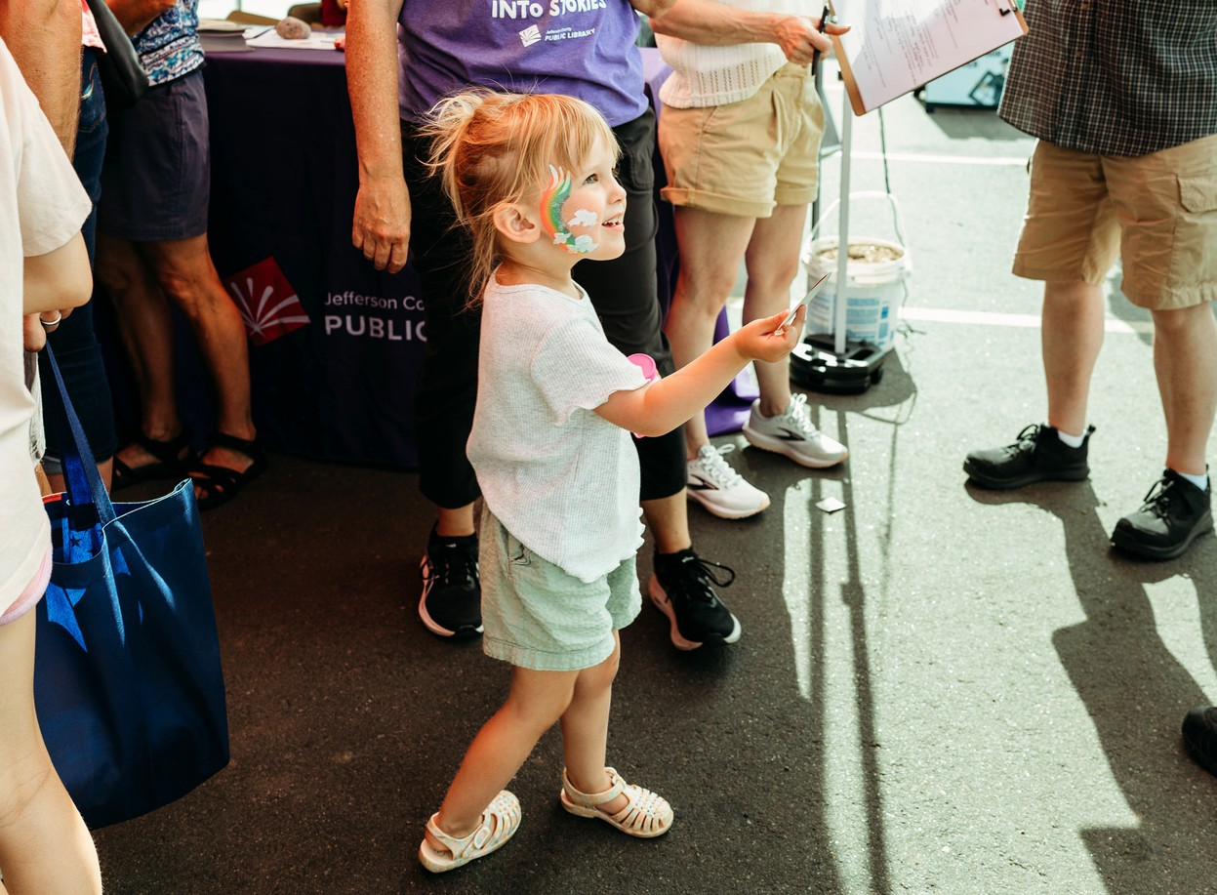
Community Stakeholder Interviews — Summary Document


Wheat Ridge Community Partner Insights Summary
June 2026
Background
With new development opportunities taking shape in Wheat Ridge, Jefferson County Public Library is looking at how to best meet the diverse library needs of the Wheat Ridge community. As part of the effort to engage the community in this important process, JCPL conducted community partner engagement in 2025 and 2026 to gather feedback about library opportunities in Wheat Ridge.

Approach
As part of a broader community listening and engagement strategy, JCPL conducted interviews with prominent community partners, including elected officials, municipal leaders and key community influencers. The interviews were conducted by members of the JCPL leadership team.

Stakeholders engaged as of June 2026:
- Andy Kerr, Jeffco County Commissioner
- Chandra Matthews, Current Seniors Resource Center (SRC) CEO
- Chris Lynn, Former Seniors Resource Center (SRC) CEO
- Dan Larson, Wheat Ridge City Council Member
- Joe Kerby, Jefferson County Manager
- Kat Douglas, Jefferson County Housing, Economic Development and Employment Services Director
- Kate Newman, Jefferson County Deputy County Manager
- Katie McKenna, Archway Communities Housing Development Manager
- Korey Stites, Wheat Ridge Mayor
- Lauren Mikulak, Wheat Ridge Community Development Director
- Paige Piper, Wheat Ridge Local Works Executive Director

- Patrick Goff, Wheat Ridge City Manager

Feedback from these interviews will be included in the Wheat Ridge Library Community Engagement Report, which will be completed in July 2026.

Conversation Starters:
JCPL leadership asked interviewees a variety of conversation starter questions, including:
- What are your thoughts on the current Wheat Ridge Library and how it serves the community?
- What library opportunities or concerns do you see?
- Are there other impacts we should be thinking of?
- Who else should talk to for insights into the library needs of the Wheat Ridge community?

Interview Insights:

Common Themes:
The following common themes regarding Wheat Ridge Library emerged from the stakeholder interviews:
- Strong support exists for library services in Wheat Ridge
  - Strong support for the library and acknowledgement of the importance of maintaining library services in Wheat Ridge
  - Expanded library services desired; multiple comments about the need to enhance or improve existing library services

- Perception that current library does not meet community needs
  - Consistent statements about needed improvements to the size and quality of the existing library
  - Multiple mentions of Wheat Ridge residents using other library locations to access more comprehensive facilities or resources

- Existing Library lease

  - Acknowledgement that the Library’s current lease at SRC has a lengthy term remaining, with lease terms that benefit the Library’s budget
  - Mixed responses about the Library maintaining or amending the existing lease

- Library location challenges and opportunities
  - Current library location/configuration does not align with SRC development needs but there may also be opportunity on that site
  - Opportunities exist for the library to co-locate with planned Wheat Ridge developments
  - Co-location is seen as strategic opportunity for impact and funding leverage and Library viewed as a strategic development anchor
  - Lutheran Legacy Campus mentioned multiple times as an ideal Library location
  - Existing Wheat Ridge sites also suggested as potential location opportunities

- Timing alignment is a critical risk
  - There is desire for the library to decide on and commit to a path forward
  - Library’s decision impacts multiple partner organizations
  - Library and partner organization timelines are not currently aligned
  - There is a time-sensitive window that determines whether key opportunities are captured or lost

