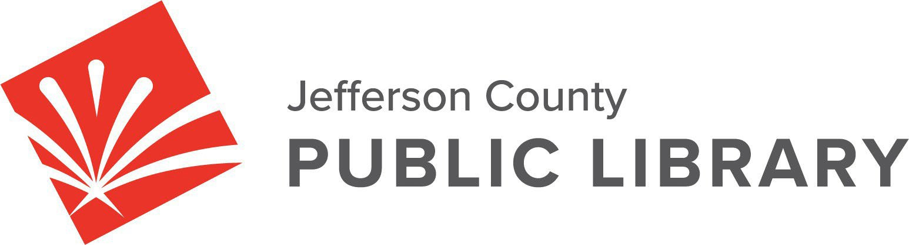

BOARD STUDY SESSION
DATE: June 11, 2026
TIME: 5:30 P.M.
PLACE: Hybrid Public Meeting
Online via ZOOM
In-Person at Lakewood Library meeting room, 10200 W. 20th Avenue, Lakewood 80215

Strategy & Operations - Finance & Budget
- Review DRAFT letter to the Board of County Commissioners certifying the mill levy necessary to maintain and operate the library
- Review DRAFT 2027 5‐Year Capital Plan
- Review DRAFT 2027 Proposed Budget Plan
- Review Golden Urban Renewal Authority Intergovernmental Agreement

Communications & Engagement
- Northwest Jeffco Library Naming

Board Governance
- Nominating Committee

For instructions on how to access the online ZOOM Study Session please go to:
NEXT BOARD STUDY SESSION
https://jeffcolibrary.org/board-of-trustees/2026-study-sessions/

