SPECIAL BOARD MEETING
JEFFERSON COUNTY PUBLIC LIBRARY BOARD OF TRUSTEES
May 14, 2026

  Summer Reading 2026: DinoSOAR Into Stories | 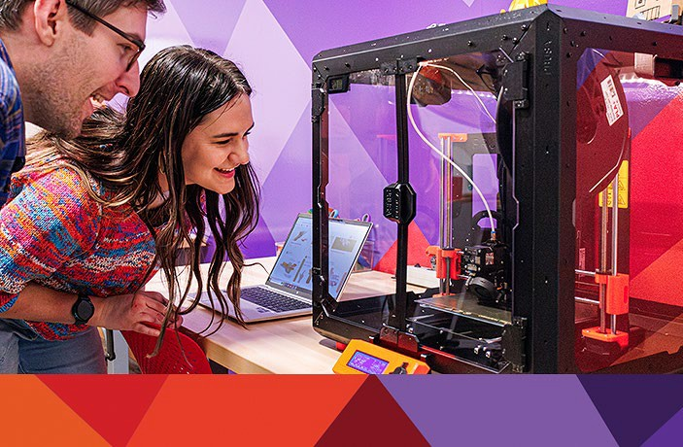  Create Space Lab: Mystery Maker
  Everyday Artificial Intelligence |   Kids Club: Sink or Float Activities



ITEM# / ACTION | Thursday, May 14, 2026 – 5:30 pm – HYBRID MEETING  - UONLINE MEETING VIA ZOOM  - IN-PERSON MEETING AT LAKEWOOD LIBRARY MEETING ROOM
1. | Call to order & attendance (4.5.8)  A. Verbal roll call – Each Trustee announces their presence by stating their name.
2. | Pledge of Allegiance
3. Agenda  Action | Approve Agenda  Chair: Call for motion and second
4. OPERATIONAL UPDATES | People & Culture  Guest: Karen Miller, Bradbury Miller Associates  A. Executive Director Recruitment Hiring Plan
5. EXECUTIVE SESSION | EXECUTIVE SESSION:  Guests Kurt Behn, Eric Butler, County Attorney’s Office  Call for Motion and Second to recess the special meeting of the Library Board of Trustees and reconvene in executive session.  Topics: (1) Executive Director Recruitment. (2) AmeriForce v. TCC Corporation. Statutory citations authorizing an executive session are:  - Pursuant to 24-6-402(4)(e)(I) for discussion of strategy and instructions to negotiators.  - Pursuant to 24-6-402(4)(b) Conferences with an attorney for the local public body for the purposes of receiving legal advice on specific legal questions.
6. Reconvene Special  Meeting | Executive Session Summary
7. Emerging Issues
Action as Needed
8. Board Governance
Action as Needed
9.Suggest Agenda Items  Action as Needed | BOARD SCHEDULE – NEXT MEETINGS –  Location of meetings of the Library Board of Trustees are being determined in cooperation with guidelines from Jefferson County. Information on meeting location will be posted at least one week prior to the scheduled meeting date. 2026 Board Meeting Schedule  - May 21, 2026 – Board Meeting – 5:30 pm Hybrid: Virtual via ZOOM. In-Person Location: Lakewood Library Meeting Room  - June 11, 2026 – Board Meeting – 5:30 pm Hybrid: Virtual via ZOOM. In-Person Location: Lakewood Library Meeting Room  - June 18, 2026 – Study Session – 5:30 pm Hybrid: Virtual via ZOOM. In-Person Location: Lakewood Library Meeting Room  - July 9, 2026 – Board Meeting – 5:30 pm Hybrid: Virtual via ZOOM. In-Person

Location: Lakewood Library Meeting Room
- July 16, 2026 – Study Session – 5:30 pm Hybrid: Virtual via ZOOM. In-Person Location: Lakewood Library Meeting Room
10. ADJOURNMENT | Adjournment

Candidate Pool Presentation*
BMA + Search Committee meet virtually to discuss and review the applicant pool selecting 6-9 candidates for the first round of interviews.
Communication
BMA notifies all applicants on the status of their application and invites selected candidates to continue in the interview process.
Phase 3: Assessment

Phase 1: Discovery
Phase 2: Recruit

Kickoff Meeting* Search Committee + BMA review the process
and approve the timeline.
Information Gathering
BMA uses surveys and select focus groups to gather information about the organization, community, and position.
Job Announcement*
BMA drafts and sends announcement to the Search Committee for review/edits and approval.
Evaluation Rubric
Created to minimize bias, and allow for an equitable and data-driven evaluation of candidates’ skills/abilities that align with the position needs.

Advertising
Job announcement is advertised nationally via professional networks and jobsites.
Recruiting
Candidates are recruited using professional networks and contacts.
Applications Close
Organizing
BMA will organize candidate documents and send to Search Committee for easy perusal.

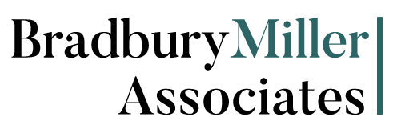
updated 04/2025

Process Outline

Phase 4: Interviews + Final Details

Semifinal Interviews (virtual)*
BMA leads Search Committee through a two-day interview process resulting in 3-4 finalists.
Planning
BMA generates a final interview schedule based on input from the organization. BMA contacts formal references and generates reports.
Travel
Finalists receive travel reimbursement specifics per the organization’s requirements and make arrangements as needed.
Final Interviews (in-person)**
BMA manages a one- or two-day interview process, culminating in interviews with Hiring Authority. BMA facilitates discussion with Hiring Authority.

Offer + Negotiation BMA extends the offer on the Hiring Authority’s
behalf, unless other arrangements are preferred.
Background Investigation
BMA engages an investigative firm to verify candidate credentials and history.
Communication BMA maintains communication with
the finalists and Hiring Authority throughout the process.
Start Date
New hire start date is to be determined.
* Search Committee responsibility
** Hiring Authority responsibility

