SPECIAL BOARD MEETING
JEFFERSON COUNTY PUBLIC LIBRARY BOARD OF TRUSTEES
May 14, 2026

  Summer Reading 2026: DinoSOAR Into Stories | 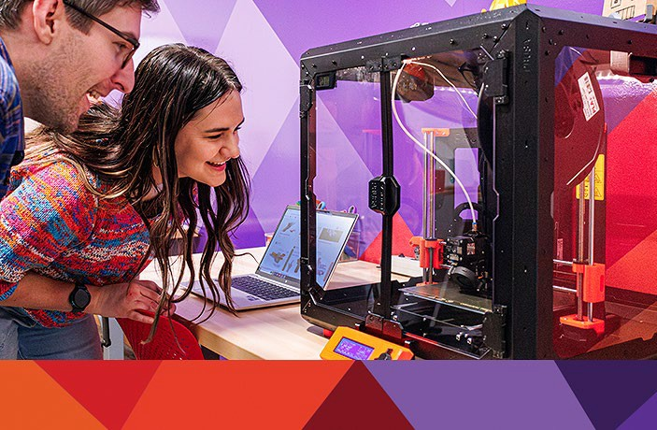  Create Space Lab: Mystery Maker
  Everyday Artificial Intelligence |   Kids Club: Sink or Float Activities



ITEM# / ACTION | Thursday, May 14, 2026 – 5:30 pm – HYBRID MEETING  - UONLINE MEETING VIA ZOOM  - IN-PERSON MEETING AT LAKEWOOD LIBRARY MEETING ROOM
1. | Call to order & attendance (4.5.8)  A. Verbal roll call – Each Trustee announces their presence by stating their name.
2. | Pledge of Allegiance
3. Agenda  Action | Approve Agenda  Chair: Call for motion and second
4. OPERATIONAL UPDATES | People & Culture  Guest: Karen Miller, Bradbury Miller Associates  A. Executive Director Recruitment Hiring Plan
5. EXECUTIVE SESSION | EXECUTIVE SESSION:  Guests Kurt Behn, Eric Butler, County Attorney’s Office  Call for Motion and Second to recess the special meeting of the Library Board of Trustees and reconvene in executive session.  Topics: (1) Executive Director Recruitment. (2) AmeriForce v. TCC Corporation. Statutory citations authorizing an executive session are:  - Pursuant to 24-6-402(4)(e)(I) for discussion of strategy and instructions to negotiators.  - Pursuant to 24-6-402(4)(b) Conferences with an attorney for the local public body for the purposes of receiving legal advice on specific legal questions.
6. Reconvene Special  Meeting | Executive Session Summary
7. Emerging Issues
Action as Needed
8. Board Governance
Action as Needed
9.Suggest Agenda Items  Action as Needed | BOARD SCHEDULE – NEXT MEETINGS –  Location of meetings of the Library Board of Trustees are being determined in cooperation with guidelines from Jefferson County. Information on meeting location will be posted at least one week prior to the scheduled meeting date. 2026 Board Meeting Schedule  - May 21, 2026 – Board Meeting – 5:30 pm Hybrid: Virtual via ZOOM. In-Person Location: Lakewood Library Meeting Room  - June 11, 2026 – Board Meeting – 5:30 pm Hybrid: Virtual via ZOOM. In-Person Location: Lakewood Library Meeting Room  - June 18, 2026 – Study Session – 5:30 pm Hybrid: Virtual via ZOOM. In-Person Location: Lakewood Library Meeting Room  - July 9, 2026 – Board Meeting – 5:30 pm Hybrid: Virtual via ZOOM. In-Person

Location: Lakewood Library Meeting Room
- July 16, 2026 – Study Session – 5:30 pm Hybrid: Virtual via ZOOM. In-Person Location: Lakewood Library Meeting Room
10. ADJOURNMENT | Adjournment

