

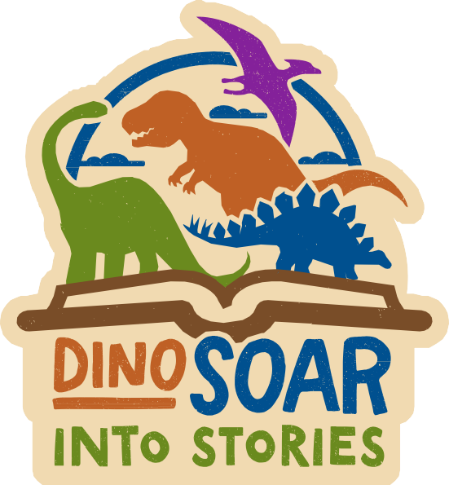
TEEN WRITING CONTEST
RULES & RUBRIC

CONTEST RULES:
- No entry fee is required, and all rights in the story remain the property of the author. All types of fiction are welcome.
- By submitting to the contest, the entrant agrees to abide by all contest rules.
- All entries must be original works by the entrant, in English or Spanish. Plagiarism, which includes the use of third-party poetry, song lyrics, characters or another person’s universe, without written permission, will result in disqualification. Excessive violence or sexual content, as determined by the judges, will result in disqualification. Entries must not have been previously published in professional media.
- To be eligible, entries must be works of prose, up to 5,000 words in length. We regret we cannot consider poetry or other formats at this time.
- The contest is open to Jefferson County residents or students enrolled in a Jefferson County school.
- The contest is open to middle school students in grades 6 – 8 and high school students in grades 9 – 12 for the 2026–27 school year.
- The contest is open only to those who have not professionally published a novel, short novel, more than one novelette or more than three short stories in any medium.
Professional publication is deemed to be payment of at least eight cents per word and at least 5,000 copies or 5,000 hits.
- Entries must be submitted electronically via the library website. Acceptable formats are Word documents, text files or PDFs. Entries must be titled, double-spaced and include page numbers. To facilitate fair, anonymous judging, submissions should not include the author’s name.
- Each entrant may submit only one manuscript that has not been previously submitted to the contest.
- After July 31, all entries are final. No revisions are accepted.
- Entries will be judged by library staff and other qualified individuals. The top five entries will be reviewed by professional authors. The decisions of the judges are entirely their own and are final and binding.
- Each submission is read by at least two reviewers. Submissions will be evaluated using the


TEEN WRITING CONTEST
Contest Rules

following criteria:
  - Addresses theme – The piece reflects the stated contest theme, DinoSOAR Into Stories: “Life will find a way,” from Michael Crichton’s Jurassic Park, though the prompt does not need
to be used directly in the piece. The submission uses specific, relevant details to engage the reader and demonstrates a highly engaging, personal style. The author finds fresh or interesting ways to convey ideas.
  - Plot structure – Enough information is provided to understand the story. Conflict emerges early and builds toward resolution. The sequence of events, dialogue and emotional movements are well crafted. Situations needing resolution are closed. Subtle undercurrents, if any, emerge during the resolution.
  - Character development and dialogue – The characters are relatable and hold the reader’s attention. Actions and interactions are consistent and well motivated. Dialogue shows the characters for who they really are.
  - Language Use – The piece uses writing that reveals an awareness of audience and purpose through description, word choice and varied sentence structure.
  - Organization & Structure – The piece is organized and well structured. The author demonstrates command of grammar, spelling and mechanics. Sentence fluency is smooth and expressive.
- Winners will be individually notified of the results by phone, mail or email.
- This Contest is void where prohibited by law.

TEEN WRITING CONTEST
JUDGING RUBRIC

ENTRY NUMBER:

 | EXCELLENT – 4 | STRONG – 3 | FAIR – 2 | DEVELOPING – 1
ADDRESSES THEME: The extent to which the story and writing reflect the stated theme, “DinoSOAR Into Stories.” The submission uses specific, relevant details to engage the reader and demonstrates a highly engaging, personal style. The author finds fresh or interesting ways to convey ideas.
Idea | Ideas are connected | Ideas are clear and | Ideas are somewhat | Ideas are incomplete
 | to the theme and are | focused, supported by | clear and focused, | and unfocused or
 | clear and focused, | specific relevant details | vaguely supported | undeveloped and not
 | fresh and original, | and connected to the | by details and briefly | supported by details
 | supported by specific | theme. | connect with the | and do not connect to
 | relevant details. |  | theme. | the theme.
Voice | Writing shows a strong | Writing shows | Writing shows | Writing is lifeless and
 | sense of personality, | occasional moments | some but not all: | flat, unable to evoke a
 | individuality, vivid | of personality, | sense of personality, | reader response.
 | expression, emotion, | individuality, | individuality,
 | and has ability to | expression, emotion | expression, emotion
 | evoke a strong reader | and has ability to evoke | and has ability to evoke
 | response. | some reader response. | some reader response.
TOTAL THEME SCORE (8-2 POINTS)

 | EXCELLENT – 4 | STRONG – 3 | FAIR – 2 | DEVELOPING – 1
PLOT STRUCTURE: Enough information is provided to understand the story. Conflict emerges early and builds towards a resolution. The sequence of events, dialog and emotions are well crafted. Situations needing resolution are closed. Subtle undercurrents, if any, emerge during resolution.
Structure | Establishes strong plot/ setting/ characters/point of view. | Establishes plot/ setting/ characters/ point of view. | Some elements of story structure, little blending of dialogue and narration. | Few/no story structure elements present.
Conflict | Clear, purposeful conflict that strongly builds readers’ engagement, drives the plot and is well developed. | Clear, purposeful conflict that drives the plot and is developed. | Some conflict is used throughout the story to drive the plot. | Minimal conflict used in the story.
Sequencing | Clear, purposeful sequence of events that unfold naturally. Uses appropriate transitions. | Clear sequence of events that unfold naturally with transitions. | Attempts to sequence events. The plot is hard to follow in some places. | Unclear sequence of events.
Resolution | Situations needing resolution are closed and subtle  undercurrents emerge during resolution. | Situations needing resolution are closed. | Most situations needing resolution are closed. | Resolution is not achieved.
TOTAL PLOT STRUCTURE SCORE (16-4 POINTS)

TEEN WRITING CONTEST
JUDGING RUBRIC

 | EXCELLENT – 4 | STRONG – 3 | FAIR – 2 | DEVELOPING – 1
CHARACTER DEVELOPMENT & DIALOG: The characters are relatable and hold the reader’s attention. Actions and interactions are consistent and well motivated. Dialogue shows the characters for who they really are.
Characterization | Develops complex characters through dialogue / inner voice, narration and action. | Develops characters through dialogue / inner voice, narration and action. | Some character development. | Characters are not developed.
Actions | Actions and interactions are consistent and well-motivated. | Actions and interactions are consistent. | Actions and interactions are mostly consistent. | Actions and interactions are not consistent.
Dialog / Inner Voice | Dialog or inner voice is presented in a clear manner and shows the characters for who they are. | Dialog or inner voice shows the characters for who they really are. | Dialog or inner voice mostly shows the characters for who they really are. | Dialog or inner voice is disjointed and does not reflect characters.

TOTAL CHARACTER DEVELOPMENT / DIALOG SCORE (12-3 POINTS)

 | EXCELLENT – 4 | STRONG – 3 | FAIR – 2 | DEVELOPING – 1
LANGUAGE: The piece uses writing that reveals an awareness of audience and purpose through description, word choice and variety of sentence structures.
Description/ | Uses creative, concrete | Uses mostly creative, | Some use of creative, | Little use of concrete
Word Choice | language; uses | concrete language | concrete language and | language, lack of
 | literary devices and | and effective word | effective word choices, | varied vocabulary and
 | rich sensory detail | choices, literary | language is accurate | sensory details. Few
 | and precise nouns, | devices, sensory detail, | but not powerful, | effective word choices.
 | descriptive adjectives, | precise nouns and | literary devices are
 | powerful action verbs. | powerful action verbs. | functional but not
 |  |  | descriptive and some
 |  |  | sensory detail.
Story flow | Opening that hooks | Opening is clear, | Opening and | No opening hook
 | the reader’s attention, | logical arrangement | conclusion are | and direction in
 | logical arrangement | of ideas, smooth | present, arrangement | writing ideas are not
 | of ideas and smooth | transitions between | of ideas is mostly in | connected.
 | transitions between | ideas and conclusion | sequence, transitions
 | ideas and paragraphs, | is present. | are rarely used.
 | strong conclusion.
TOTAL LANGUAGE SCORE (8-2 POINTS)

TEEN WRITING CONTEST
JUDGING RUBRIC

 | EXCELLENT – 4 | STRONG – 3 | FAIR – 2 | DEVELOPING – 1
ORGANIZATION & STRUCTURE: The piece is organized and well-structured. Author demonstrates command of grammar, spelling and mechanics. Sentence fluency is smooth and expressive.
Sentence Fluency | Writing flows smoothly due to a variety of sentence structures used throughout. | Writing usually contains a variety of sentence lengths, structure and beginnings. | Writing contains some use of sentence structure variety, sentence lengths and beginnings. | Writing sounds unnatural, has little sentence structure variety, sentence lengths and beginnings.
Grammar | Smooth, fluid error-free punctuation/ grammar. | Mostly correct grammar; errors do not interfere with communication. | Errors occasionally interfere with communication; verb tense errors. | Grammatical errors are awkward and interfere with communication.
Spelling & Words | Writing shows consistent mastery of capitalization, punctuation, spelling, grammar, indentation and complete sentences and enhances the readability and meaning. | Writing contains minor errors in of capitalization,  punctuation, spelling, grammar, indentation and complete sentences but errors do not interfere  with readability and meaning. | Writing contains errors in capitalization, punctuation,  spelling, grammar, indentation and complete sentences and enhances the readability and errors interfere with readability but not meaning. | Writing contains numerous errors in capitalization, punctuation, spelling, grammar, indentation and  complete sentences and enhances the readability and errors interfere with readability and meaning.
TOTAL ORGANIZATION & STRUCTURE SCORE (12-3 POINTS)

ELEMENT | SCORE
Addresses Theme
Plot Structure
Character Development
Language
Organization & Structure
TOTAL SCORE
RANKING:
COMMENTS:
Place all judged entries into order with 1 being assigned to the best entry. Ranking is used
in conjunction with the rubric to place the entries in order to determine a clear winner.

