SPECIAL BOARD MEETING
JEFFERSON COUNTY PUBLIC LIBRARY BOARD OF TRUSTEES

April 9, 2026

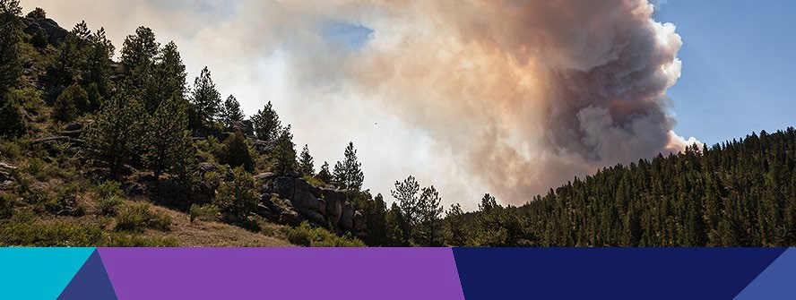  Wildland Fire Management Program presented by JCSO at Deer Creek |   Prom Swap Festival
  Landscape & Color Theory Class |   Learn to Sew: Pet Bandanas



APPROVAL OF AGENDA

ITEM# / ACTION | Thursday, April 9, 2026 – 5:30 pm – HYBRID MEETING  - UONLINE MEETING VIA ZOOM  - IN-PERSON MEETING AT LAKEWOOD LIBRARY MEETING ROOM
1. | Call to order & attendance (4.5.8)  A. Verbal roll call – Each Trustee announces their presence by stating their name.
2. | Pledge of Allegiance
3. Agenda  Action | Approve Agenda  Chair: Call for motion and second
4. OPERATIONAL UPDATES | Strategy and Operations  Facilities and Construction Projects  A. Intergovernmental Agreement (IGA) for Arvada Library Emergency Egress and Maintenance.  Libraries and Inclusion  A. Jefferson County Public Health & JCPL Memorandum of Understanding - Pilot of JCPL Location for Field Delivered Therapy (FDT)
5. EXECUTIVE SESSION | EXECUTIVE SESSION:  Guest Kurt Behn, County Attorney’s Office  Call for Motion and Second to recess the special meeting of the Library Board of Trustees and reconvene in executive session.  Topic: Executive Director Recruitment. Statutory citations authorizing an executive session are:  - Pursuant to 24-6-402(4)(e)(I) for discussion of strategy and instructions to negotiators.  - Pursuant to 24-6-402(4)(b) Conferences with an attorney for the local public body for the purposes of receiving legal advice on specific legal questions.
6. Reconvene Special Meeting | Executive Session Summary
7. Emerging Issues
Action as Needed
8. Board Governance
Action as Needed
9.Suggest Agenda Items  Action as Needed | BOARD SCHEDULE – NEXT MEETINGS –  Location of meetings of the Library Board of Trustees are being determined in cooperation with guidelines from Jefferson County. Information on meeting location will be posted at least one week prior to the scheduled meeting date. 2026 Board Meeting Schedule

- April 16, 2026 – Board Meeting – 5:30 pm Hybrid: Virtual via ZOOM. In-Person Location: Lakewood Library Meeting Room
- May 14, 2026 – Study Session – 5:30 pm Hybrid: Virtual via ZOOM. In-Person Location: Lakewood Library Meeting Room
- May 21, 2026 – Board Meeting – 5:30 pm Hybrid: Virtual via ZOOM. In-Person Location: Lakewood Library Meeting Room
- June 11, 2026 – Board Meeting – 5:30 pm Hybrid: Virtual via ZOOM. In-Person Location: Lakewood Library Meeting Room
- June 18, 2026 – Study Session – 5:30 pm Hybrid: Virtual via ZOOM. In-Person Location: Lakewood Library Meeting Room
10. ADJOURNMENT | Adjournment

Strategy and Operations

Facilities and Construction Projects

TO: Donna Walker, Executive Director

FROM: Kirsten Ruiz, Chief Strategy & Operating Officer Amy Bentz, Assistant Director of Library Design

DATE: April 9, 2026
RE: Arvada Intergovernmental Agreement: Emergency Egress and Maintenance Obligations

Background
Jefferson County Public Library (JCPL) requested an Intergovernmental Agreement (IGA) with the City of Arvada to mitigate an emergency egress issue at the Arvada Library property. The outdoor parcel of 891 square feet on the west side of the Arvada Library location opens into Arvada City Property, commonly known as Arvada Olde Town Square. The existing emergency egress for this area allows patrons to exit the library via two doors along the west outdoor space. This outdoor area is not currently enclosed on the south side so individuals can egress along the west side of the building to the south and access the public sidewalk while fully within the library property. An addition under the Arvada Library redesign will block access to the public sidewalk so one must egress the west outdoor area by passing through Olde Town Square, thus necessitating the IGA to properly egress the building and the outdoor area.

As part of the Arvada Library redesign, JCPL is requesting the city’s permission to add fencing and gates as well as landscaping to existing planters. JCPL will install a new fence and gates on the western side of the property, a fence along the south side of the outdoor area and add landscaping to existing planters. The fence and gates are on the City of Arvada’s Olde Town Square property and existing planters are centered on the property line of the Arvada Library and the City of Arvada. JCPL will be responsible for the construction, maintenance, and care of the gated fence, as well as the installation, maintenance, and care of any landscaping within the planters. City of Arvada will be responsible for the maintenance and care of the existing irrigation system within the planters and shall ensure that the planters receive adequate irrigation.

Budget
There are no unbudgeted costs associated with this agreement.

Requested Action
We are requesting the Board of Trustees authorize the Executive Director to execute an IGA with the City of Arvada for this emergency egress and maintenance obligations at the April 16, 2026 regular Library Board meeting. The City of Arvada will authorize and sign this agreement after Library Board approval. This item will be placed on the consent agenda for the April 16, 2026 board meeting unless otherwise instructed by the Board.

Attachments:
JCPL IGA Agreement
Exhibit A – Legal Description Exhibit B – Site Plan
Exhibit C – Technical Drawings

AN INTERGOVERNMENTAL AGREEMENT BETWEEN THE CITY OF ARVADA AND JEFFERSON COUNTY PUBLIC LIBRARY FOR EMERGENCY EGRESS AND MAINTENANCE OBLIGATIONS RELATING TO THE REDESIGN OF THE ARVADA PUBLIC LIBRARY
- PARTIES. The Parties to this Intergovernmental Agreement (“IGA” or “Agreement”) are the City of Arvada, a Colorado home rule municipal corporation, whose mailing address is 8101 Ralston Road, Arvada, CO 80002 (“Arvada” or the “City”) and Jefferson County Public Library, a governmental agency whose mailing address is 100 Jefferson County Parkway, Golden, CO 80419 (“JCPL”). The Parties may be referred to individually as a “Party” and collectively as the “Parties.”

RECITALS AND PURPOSE.

  - C.R.S. § 29-1-203, as amended, permits and encourages local governments to make the most efficient and effective use of their powers and responsibilities by cooperating and contracting with other local governments in order to provide any lawfully authorized function, service, or facility.

  - Each of the Parties is authorized to establish, maintain, and provide access to its respective properties and facilities to further cooperation for the benefit of the Parties and the community.

  - The Arvada Library is located within the Olde Town Arvada historic district, adjacent to Olde Town Square. It measures approximately 34,200 square feet and was opened in 2006. Since then, it has experienced an increase in number of patrons, program attendance and service requirements.
  - A redesign of the Arvada Library is one of the projects in JCPL’s 2024 Strategic Plan to expand services to meet the needs of the community.

  - As part of the redesign, JCPL is requesting the City’s permission for emergency access to the City of Arvada’s property, commonly known as Arvada Olde Town Square, from a west side entrance to and from the Arvada Public Library. See Exhibit A.
  - Additionally, the proposed redesign includes: (1) JCPL installing landscaping within the existing planters which are centered on the property line of the City and JCPL’s property; and (2) JCPL installing a gated fence on the western side of the planters on the City’s property. See Exhibit B.

  - The Parties wish to cooperate by providing the terms and conditions by which JCPL can access Arvada’s property, as more fully described in Exhibit, and the duties and responsibility of the Parties with regards to the maintenance of the planters and the gated fence.

  - For good and valuable consideration, the receipt and sufficiency of which is expressly acknowledged, the Parties agree as set forth herein.

EXHIBITS.

  - IGA Documents. The IGA Documents shall consist of this IGA together with the following:

Exhibit A: Legal Description; and Exhibit B: Technical Drawings.
All exhibits referred to in this IGA are attached hereto and are, by reference, incorporated herein for all purposes.

  - Interpretation of IGA Documents. In the event any matter, term, provision, or condition that is the subject of this IGA requires clarification or is in dispute, or is the subject of a difference of opinion, then the terms of this IGA shall control, and then the terms of Exhibit A, and then Exhibit B, in that order.

TERM, RENEWAL, AND TERMINATION.
  - Effective date. This IGA will become effective and binding upon execution by the last Party to sign it.

  - Term & Termination. The term of the IGA shall continue uninterrupted unless terminated by the mutual consent of the Parties upon a minimum of 120 days written notice, or unless terminated by Arvada for failure of JCPL to comply with any of its obligations or duties as described herein, after 30 days written notice of a failure to perform is provided by Arvada with opportunity for the JCPL to cure such failure to comply.

OBLIGATIONS OF THE PARTIES.

  - Generally. Both Parties will be responsible for the maintenance and care of their respective properties and facilities.
  - JCPL’s obligations. JCPL will be responsible for the installation, maintenance, and care of any landscaping within the planters and the construction, maintenance, and care of the gated fence.

  - Arvada’s obligations. Arvada will be responsible for the maintenance and care of the irrigation system within the planters. Arvada shall ensure that the planters receive adequate irrigation. Arvada hereby permits JCPL staff to enter Arvada property for purposes of fulfilling JCPL’s obligations in this section. 3

- NECESSARY PERSONNEL, EQUIPMENT, AND FACILITIES. Each Party will maintain the level of personnel, equipment, and facilities necessary to meet its obligations under this Agreement.
  - Except as may otherwise be set forth herein, nothing in this Agreement requires either Party to fund the activities of the other Party.

- NOTICES. Any notice required by this Agreement must be in writing and must be given by certified mail or registered mail, postage and fees prepaid, to the address set forth below, or at such other address as has been previously furnished in writing, to the other Party or Parties. Such notice will be deemed to have been given when deposited in the United States mail.

Arvada: Attn: Director of Economic Development City of Arvada
8101 Ralston Road
Arvada, Colorado 80002

Library: Jefferson County Public Library 100 Jefferson County Pkwy Golden, CO 80419

A Party may designate an employee or volunteer to be responsible for the day-to-day administration of this Agreement. A Party may change the designated day-to-day administrator. Notices that are not required to be sent by U.S. Mail under this Agreement may be sent to the administrator by email.

GENERAL PROVISIONS.

  - Force majeure. Any delays in or failure of performance by either Party of its obligations under this Agreement shall be excused if such delays or failure are a result of acts of God, fires, floods, strikes, labor disputes, accidents, regulations or orders of civil or military authorities, shortages of labor or materials, or other causes, similar or dissimilar, which are beyond the control and such Party.
  - Agreement to cooperate only. The Parties are entering into this IGA understanding that it is intended only to facilitate cooperation between the Parties in the provision of the Services set forth herein. No separate entity is created by this Agreement.

  - Employees to remain the employee of the Party. An employee or volunteer of a Party will remain the employee of that Party for all purposes under this Agreement throughout the term of the initial or any renewal term of this Agreement.

  - Governmental immunity.
    - Each Party shall be responsible for its own negligent or intentional acts or omissions, and for those of its employees and volunteers.

    - The Parties intend that nothing herein shall be deemed or construed as a waiver by either Party of any immunities, rights, benefits, or protections afforded to them under the Colorado Governmental Immunity Act (Section 24-10-101, C.R.S., et seq.).

    - The Parties agree that in the event any claim or suit is brought against either or both Parties by any third party as a result of the operation of this Agreement, both Parties will cooperate with each other and with the insuring entities of both Parties in defending such claim or suit.

    - The Parties enter this Agreement as separate, independent government agencies and maintain that status throughout.
  - Insurance. Each Party must, at its own expense, keep in full force and effect during the term of the Agreement, and during the term of any renewal, extension, or amendment of the Agreement, insurance reasonably sufficient to insure against the liability assumed by that Party under the terms of this Agreement. A Party’s failure to secure and maintain sufficient insurance, including through self-insurance, at any time during the pendency of this Agreement do not relieve that Party of its obligations under this Agreement.

  - Additional documents or action. The Parties agree to take any additional action and execute any additional documents that are necessary to carry out this Agreement.

  - Assignment. This Agreement may not be assigned by either Party without the prior written consent of the other Party.

  - Paragraph captions. The captions of the paragraphs are set forth only for the convenience and reference of the Parties and are not intended in any way to define, limit, or describe the scope or intent of this IGA.

  - Integration, amendment, and severability. The Parties may amend this Agreement at any time. Any amendments must be in writing and will be incorporated into and made a part of this Agreement. If any provision of the Agreement is held invalid or unenforceable, no other provision shall be affected by such holding, and all the remaining provisions of this Agreement shall continue in full force and effect.

  - Default. Time is of the essence. If any payment or any other condition, obligation, or duty is not timely made, tendered, or performed by either Party, then this Agreement, at the option of the Party who is not in default, may be terminated by the non-defaulting Party, in which case, the non-defaulting Party may recover such damages as may be proper. If the non-defaulting Party elects to treat this Agreement as being in full force and effect, the non-defaulting Party shall have the right to an 5 action for specific performance or damage or both.

  - Waiver of breach. A waiver by a Party to this Agreement of the breach of any term or provision of this Agreement shall not operate or be construed as a waiver of any subsequent breach by either Party.
  - Fund availability. Financial obligations of the Parties after the current fiscal year are contingent upon funds for that purpose being appropriated, budgeted, and otherwise made available.

  - Payments to constitute current expenditures. Financial obligations of the Parties, if any, after the current year are contingent on funds for that purpose being appropriated, budgeted and otherwise made available by the governing body of either Party. The Parties’ obligations under the Agreement shall be from year to year only and shall not constitute a multiple-fiscal year direct or indirect debt or other financial obligation of the Parties within the meaning of Article X, Section 20 of the Colorado Constitution.
  - No third-party beneficiaries. It is expressly understood and agreed that enforcement of the terms and conditions of this Agreement, and all rights of action relating to such enforcement, shall be strictly reserved to the Parties, and nothing contained in this Agreement shall give or allow any such claim or right of action to any other third party on this Agreement. It is the express intention of the Parties that any person other than the Parties receiving services or benefits under this Agreement shall be deemed to be an incidental beneficiary only.

  - Entire agreement; Binding effect. This Agreement represents the entire agreement between the Parties and, except for written amendment authorized by the Parties, there are no oral or collateral agreements or understandings. This Agreement shall inure to the benefit of, and be binding upon, the Parties, their respective legal representative, successors, heirs, and assigns; provided, however, that nothing in this paragraph shall be construed to permit the assignment of this Agreement except as otherwise expressly authorized herein.
  - Attorneys' fees, costs, and expenses. In any dispute arising from or relating to this Agreement, the prevailing Party shall be awarded its reasonable attorneys' fees, costs, and expenses, including attorneys' fees, costs, and expenses incurred in collecting or executing upon any judgment, order, or award.

  - Governing law and venue. This Agreement shall be governed by the laws of the State of Colorado. Venue for any action arising under this Agreement or for the enforcement of this Agreement shall be in the appropriate court for Jefferson County, Colorado.

  - Counterpart execution. This Agreement may be executed in several counterparts and by facsimile, each of which shall be deemed an original, and all of which together shall constitute one and the same instrument.

DATED this day of , 2026.
CITY OF ARVADA, a Colorado home rule municipal corporation

Jessica Garner

Director of Economic Development 8101 Ralston Road
Arvada, CO 80002
ATTEST:

City Clerk

APPROVED AS TO FORM:
Rachel A. Morris, City Attorney

By:

JEFFERSON COUNTY PUBLIC LIBRARY

Donna Walker Executive Director,
Donna.walker@jeffcolibrary.org

Exhibit A

AN INTERGOVERNMENTAL AGREEMENT BETWEEN THE CITY OF ARVADA AND JEFFERSON COUNTY PUBLIC LIBRARY FOR EMERGENCY EGRESS AND MAINTENANCE OBLIGATIONS RELATING TO THE REDESIGN OF THE ARVADA PUBLIC LIBRARY

EXHIBIT A SHEET 1 OF 2
LAND DESCRIPTION

A PARCEL OF LAND BEING A PORTION OF LOT 2, ARVADA LIBRARY MINOR SUBDIVISION RECORDED AT RECEPTION NO. 2006103884 LOCATED IN THE SOUTHEAST QUARTER OF SECTION 11, TOWNSHIP 3 SOUTH, RANGE 69 WEST OF THE SIXTH PRINCIPAL MERIDIAN, CITY OF ARVADA,

COUNTY OF JEFFERSON, STATE OF COLORADO BEING MORE PARTICULARLY DESCRIBED AS FOLLOWS:

BEGINNING AT THE SOUTHEAST CORNER OF SAID LOT 2, ALSO BEING THE NORTHERLY RIGHT-OF-WAY LINE OF WEST 57TH AVENUE, FROM WHENCE THE SOUTH QUARTER CORNER OF SECTION 11, BEARS S15°48’45”W A DISTANCE OF 708.41 FEET, SAID POINT ALSO BEING THE POINT OF BEGINNING;
THENCE ALONG THE SOUTHERLY LINE OF SAID LOT 2, AND NORTHERLY RIGHT-OF-WAY LINE OF SAID WEST 57TH AVENUE, S89°45’44”W A DISTANCE OF 8.50 FEET;
THENCE N00°11’20”W ALONG A LINE LYING 8.50 FEET WEST OF AND PARALLEL WITH SAID EASTERLY LINE OF LOT 2, A DISTANCE OF 104.80 FEET TO A POINT ON THE NORTHERLY LINE OF PARCEL 4 AS SHOWN ON ALLEY VACATION ORDINANCE NO. 3964, RECORDED AT REC. NO.
2005068168 AND A POINT ON THE EASTERLY LINE OF SAID LOT 2;
THENCE ALONG SAID EASTERLY LINE THE FOLLOWING TWO (2) CONSECUTIVE COURSES:
- N89°45’44”E A DISTANCE OF 8.50 FEET;
- S00°11’20”E A DISTANCE OF 104.80 FEET TO SAID NORTHERLY RIGHT-OF-WAY LINE, AND TO THE POINT OF BEGINNING;
PARCEL CONTAINS 891 SQUARE FEET OR 0.020 ACRES MORE OR LESS. ALL LINEAL DIMENSIONS ARE IN U.S. SURVEY FEET.
BASIS OF BEARINGS BEARINGS

ARE BASED ON THE WESTERLY LINE OF THE SOUTHEAST QUARTER OF SECTION 11, TOWNSHIP 3 SOUTH, RANGE 69 WEST OF THE SIXTH PRINCIPAL MERIDIAN, ASSUMED TO BEAR S00°11’41”E AND BEING MONUMENTED BY A #6 REBAR WITH 2” ALLOY CAP PLS #27258 IN RANGE BOX AT THE CENTER QUARTER CORNER AND A 2” ALUMINUM CAP PLS #36053 IN RANGE BOX AT THE SOUTH QUARTER CORNER.

RYAN R. BRYSON, PLS COLORADO PLS #38538 FOR AND ON BEHALF OF MARTIN/MARTIN INC.

ADMINISTRATION
l 0200 W. 20th Ave.
Lakewood, CO 80215
303.235.5275

jeffcolibrary.org

Jefferson County


PUBLIC LIBRARY


�----------------lllUSTRAlilOr--1FOR �
EXHIBIT A
PAGl;!:2 OF2
I

EAS7ERI. r LINE CF ,or 2.� SE/4
ARVA10A 1.IBRARr SFC. 11
MINOR StJB0./1/JS/ON
PARC£l

EASTERLY UNE OF LOT�
ARVADAI UBRAIRY MINOR SUBDIVISION
0 10 20 PARCEL
SCALE: 1''=20' ALL LINEAL Dlt.lENSIONS ARE IN
U.S. SURVEY IFEET
I.OT 2 I.OT I
ARVAOA I.IBRARY MVADA f.lBRARY
MINOR SiJBOIV!Sf.ON MINOR SUBOI V!Sf.ON
REC. #2005103884 R£C. $2005103884

PARCEL CONTAINS
(891 SQ. IFT. OR
C/4 COR. S£C. 11, 0.020 ACRES:!:)
T.JS. R69W. 6TH P.U
#6 REBAR W/
2" ALLOY CAP
PLS p7258
IN RANGE BOX -.....

14£ST 57lH AVENUE
(60' PVBLJC RICIH-Of"-W.A Y)
S/4 COR. SEC. n, |  | F'.O.C. • POINT Of COMMENCEMENT  P.0.B. • POINT Of BEGINNINC  FEBRUAIRY 16, 2026
TJS, R69W. fi'TH P.M.  R£8l!R W/  2• ALUM. CAP PLS #.J60SJ IN RANCE BOX |  |   1ngg WestC..lt.o:Aw11ue Lakewood, C..lorad'o M.tlS  ...,.""l'�mal'll•mar1:ln.<om I ]�1A31,6100 I 1n11rtlnmal'lln.,om

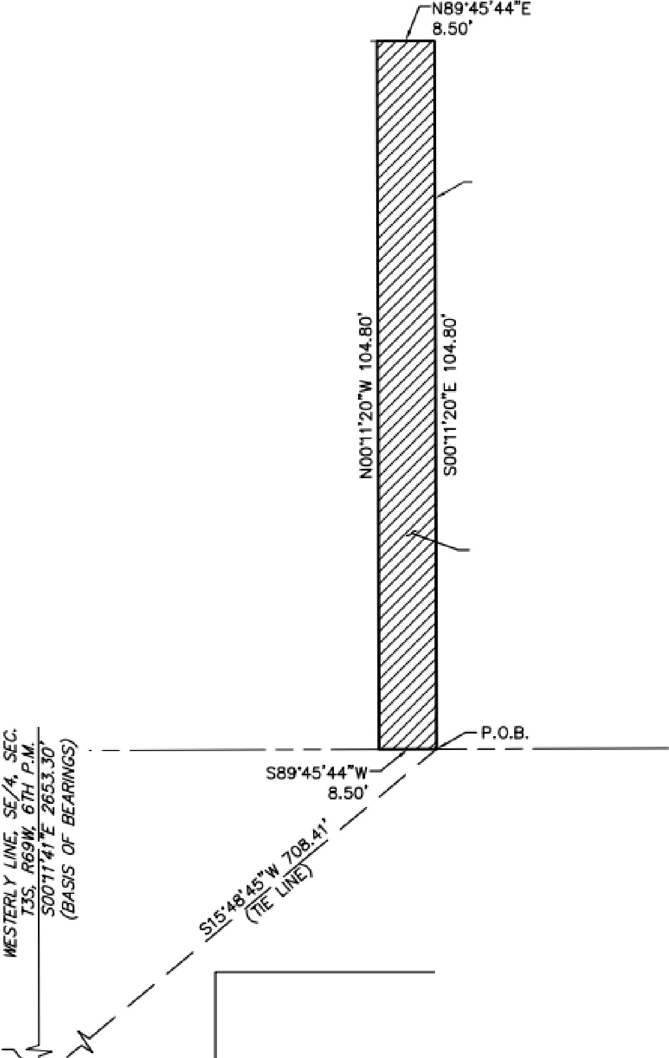

Exhibit B

AN INTERGOVERNMENTAL AGREEMENT BETWEEN THE CITY OF ARVADA AND JEFFERSON COUNTY PUBLIC LIBRARY FOR EMERGENCY EGRESS AND MAINTENANCE OBLIGATIONS RELATING TO THE REDESIGN OF THE ARVADA PUBLIC LIBRARY

Site Plan:
- Pink = highlighting property line (City Olde Town Square on left/west side)
- Yellow = highlighting fence and 2 gates on City property
- Purple = highlighting fence area on JCPL property
- Green = landscaping on City Olde Town Square property

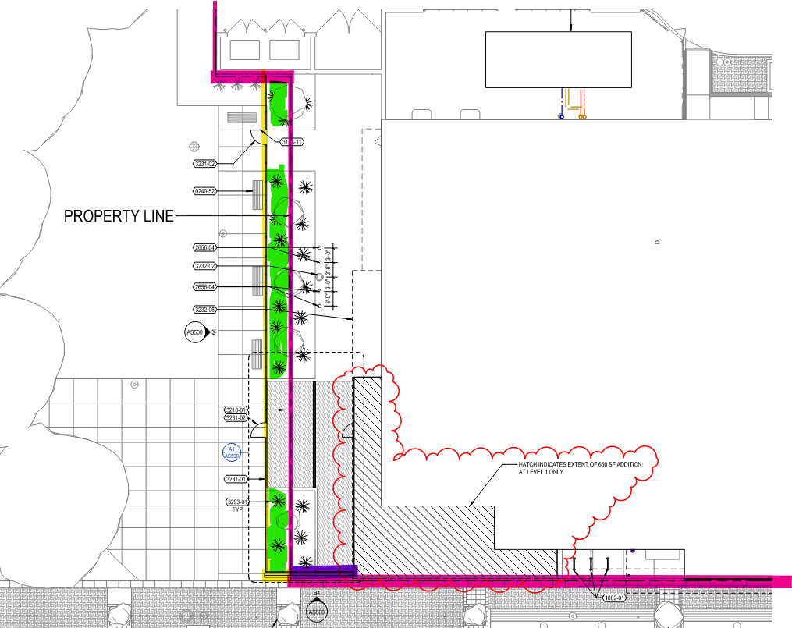

Exhibit C

AN INTERGOVERNMENTAL AGREEMENT BETWEEN THE CITY OF ARVADA AND JEFFERSON COUNTY PUBLIC LIBRARY FOR EMERGENCY EGRESS AND MAINTENANCE OBLIGATIONS RELATING TO THE REDESIGN OF THE ARVADA PUBLIC LIBRARY

Arvada Library Emergency Egress IGA BOT Memo Exhibit C - Technical Drawings.pdf

Libraries and Inclusion

TO: Donna Walker, Executive Director

FROM: Cynthia Kiyotake, Chief Libraries and Inclusion Officer DATE: April 9, 2026
RE: Jefferson County Public Health & JCPL Memorandum of Understanding - Pilot of JCPL Location for Field Delivered Therapy (FDT)

Background:
Jefferson County Public Health (JCPH) currently provides field delivered therapy treatment (FDT) as part of the JCPH Syphilis Elimination Strategic Initiative. Field-Delivered Therapy is the delivery of medication or a prescription in the field to clients, their partner(s) or both, and is an appropriate option for individuals who are at increased risk for STIs, underinsured or uninsured, unable, or unlikely to seek treatment in a timely fashion (Colorado Department of Public Health & Environment , 2026). This treatment requires three appointments to administer medications. For pregnant women, receiving the treatments in a timely fashion is critical. JCPH received grant funding from the CDC, along with other Colorado counties, to eliminate congenital syphilis. This disease has been targeted due to its increase in the last 5-10 years. Untreated syphilis results in long term health implications, for both the woman and child.
JCPH currently works through a variety of sites, including client residences and clinical locations. JCPH also plans to use their new mobile van once it becomes available. The current JCPH mobile vehicle is specific to providing other public health needs and is unsuitable for this type of initiative.
JCPH reached out in early 2026 to ask for use of a Belmar Library study room to conduct a pilot of using Library space for this type of field delivered therapy. JCPH is specifically looking to support populations who are transient or homeless, and who may not have a confidential space to meet. Belmar Library is also on a bus route which provides important access for the targeted population and is close to the future JCPH site at the Emory Campus. JCPH has requested that we partner with them in in the short term to provide space at one library for this work while other options, such as their sexual health mobile van, are in development. Their goal is to increase accessibility and agency for patients, who may not find other types of community or clinical spaces to be accessible or welcoming.
In addition to providing essential library services, our library buildings are an important neutral space for connecting individuals to other needed community resources, including housing and social services. This partnership is a natural extension of community agencies using our spaces to meet patrons where they are and increase access to needed support.

Proposal details:
- The pilot to use Belmar Library will run for 3 months, ideally starting April 2026 through the end of July 2026.
- JCPH will work with JCPL to reserve a Belmar Library study room as they make patient appointments. They anticipate treating a small number of patients onsite monthly.
- JCPH will provide medications as needed onsite in the library’s single-user restroom. Medication delivery typically takes under five minutes.
- JCPH outcomes: To promote patient agency and comfort by offering an option for a neutral space in which to receive treatment.
- JCPL outcomes: The Library will serve as an interim space to support public health needs in Jefferson County. JCPL will better understand if potential future JCPH partnerships where we could offer external spaces for mobile clinical services are desirable and supportable.
The County Attorney’s Office has drawn up a Memorandum of Understanding (MOU), and JCPH has completed their review and approval process.

Total Cost:
There are no costs associated with this agreement.

Next Actions:
We will ask the Library Board of Trustees to authorize the Executive Director to sign the MOU at the April 16, 2026 Board meeting.

