SPECIAL BOARD MEETING
JEFFERSON COUNTY PUBLIC LIBRARY BOARD OF TRUSTEES
March 12, 2026

  Steps to Financial Freedom Workshop |   Make Something: Mandala Stone
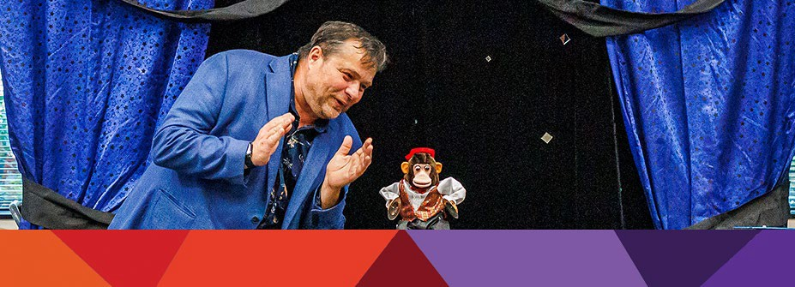  Magic Rob |   Prom Swap Festival



APPROVAL OF AGENDA

SPECIAL BOARD MEETING AGENDA
Jefferson County Public Library Board of Trustees

ITEM# / ACTION | Thursday, March 12, 2026 – 5:30 pm – HYBRID MEETING  - UONLINE MEETING VIA ZOOM  - IN-PERSON MEETING AT LAKEWOOD LIBRARY MEETING ROOM
1. | Call to order & attendance (4.5.8)  A. Verbal roll call – Each Trustee announces their presence by stating their name.
2. | Pledge of Allegiance
3. Agenda  Action | Approve Agenda  Chair: Call for motion and second
4. EXECUTIVE SESSION | EXECUTIVE SESSION:  Guest Kurt Behn, County Attorney’s Office  Call for Motion and Second to recess the special meeting of the Library Board of Trustees and reconvene in executive session.  Topic: Executive Director Position. Statutory citations authorizing an executive session are:  - Pursuant to 24-6-402(4)(f) Personnel Matters.  - Pursuant to 24-6-402(4)(b) Conferences with an attorney for the local public body for the purposes of receiving legal advice on specific legal questions.
5.Reconvene Special Meeting  Action as Needed | Executive Session Summary
6. Emerging Issues
Action as Needed
7. Suggest Agenda Items  Action as Needed | BOARD SCHEDULE – NEXT MEETINGS –  Location of meetings of the Library Board of Trustees are being determined in cooperation with guidelines from Jefferson County. Information on meeting location will be posted at least one week prior to the scheduled meeting date. 2026 Board Meeting Schedule  - March 19, 2026 – Board Meeting – 5:30 pm Hybrid: Virtual via ZOOM. In-Person Location: Lakewood Library Meeting Room  - April 9, 2026 – Study Session – 5:30 pm Hybrid: Virtual via ZOOM. In-Person Location: Lakewood Library Meeting Room  - April 16, 2026 – Board Meeting – 5:30 pm Hybrid: Virtual via ZOOM. In-Person Location: Lakewood Library Meeting Room
8. ADJOURNMENT | Adjournment

