BOARD MEETING
JEFFERSON COUNTY PUBLIC LIBRARY BOARD OF TRUSTEES
February 19, 2026

  After School Hangout |   Black History: Interpretations, Challenges and Hope
  Data Privacy |   Teen Volunteer Hours



APPROVAL OF AGENDA

BOARD MEETING AGENDA - AMENDED
Jefferson County Public Library Board of Trustees

ITEM# / ACTION | Thursday, February 19, 2026 – 5:30 pm – HYBRID MEETING  - UONLINE MEETING VIA ZOOM  - In-Person at Lakewood Library meeting room, 10200 W. 20th Avenue, Lakewood 80215
1. | Call to order & attendance (4.5.8)  A. Verbal roll call – Each Trustee announces their presence by stating their name.
2. | Pledge of Allegiance
3. Agenda  Action | Approve Agenda  Chair: Call for motion and second
4. Public Comment | Public Comment  The Board values public participation. Those who would like to address the Library Board can do so virtually, in-person, or online. The opportunity to address the Library Board does not include a question-and-answer session or response.  Additionally, the Library Board does not respond to anonymous questions or comments. Comments will be acknowledged in the minutes of the meeting.  For more information on public comment policy please refer to Board Governance Policy 4.3.7: Microsoft Word - January 2026 Board Governance Policy Manual
5.CONSENT AGENDA  Action | Approval of Consent Agenda  Chair: Call for motion and second  - Approve Minutes of January 8, 2026 Special Meeting  - Approve Minutes of January 15, 2026 Board Meeting  - HVAC Services Contract
6. Foundation | Foundation Update
7.Operational Updates Action as Needed | Executive Director  - Executive Director Report  - 2026 Annual Plan Update  - JCPL Long Term Fundraising Strategy. Guest: Bridget Beatty, Bridget Beatty Consulting  Strategy & Operations  - 2025 Year End Report Finance and Budget  - Financial Report (January 2026)  - Carryforward Request for Fiscal Year 2026 Budget Amendment  Presented for discussion. Authorization to submit the carryforward budget amendment will be requested at the March meeting.  Facilities and Construction Projects  - Evergreen Roof Change Order Chair: Call for motion and second

BOARD MEETING AGENDA - AMENDED
Jefferson County Public Library Board of Trustees

8.Action as Needed | Items Removed From Consent Agenda (4.3.4): The Board may address and/or vote on any items that were removed from the Consent Agenda
9. Emerging Issues
Action as Needed
10. Ends  Action as Needed | Ends: No items.
11. Board Governance Action as Needed | Board Governance:  - Nominating Committee report to the Board: Proposed Slate of Officers  - Bylaws Committee status update  - Library Board of Trustees Review Policy Governance Monitoring Reports 2.0 to 2.4. Adoption will be on the consent agenda for the March 19, 2026 Board meeting unless otherwise instructed by the Board.
12. Suggest Agenda Items  Action as Needed | BOARD SCHEDULE – NEXT MEETINGS –  Location of meetings of the Library Board of Trustees are being determined in cooperation with guidelines from Jefferson County. Information on meeting location will be posted at least one week prior to the scheduled meeting date. 2026 Board Meeting Schedule  - March 12, 2026 – Study Session – 5:30 pm Hybrid: Virtual via ZOOM. In-Person Location: Lakewood Library Meeting Room  - March 19, 2026 – Board Meeting – 5:30 pm Hybrid: Virtual via ZOOM. In-Person Location: Lakewood Library Meeting Room  - April 9, 2026 – Study Session – 5:30 pm Hybrid: Virtual via ZOOM. In-Person Location: Lakewood Library Meeting Room  - April 16, 2026 – Board Meeting – 5:30 pm Hybrid: Virtual via ZOOM. In-  Person Location: Lakewood Library Meeting Room
13. Discussion | Board Questions or Comments Related to Items on the Meeting Agenda
14. Discussion | Evaluate Board Meeting (4.1.9)
15. Information | Announcements/General Information Sharing  - Report of the Chair – Correspondence, Other  - Other Announcements
16. EXECUTIVE SESSION | EXECUTIVE SESSION:  Call for Motion and Second to recess the regular meeting of the Library Board of Trustees and reconvene in executive session.  Executive Director’s Review. Statutory citation authorizing an executive session for this topic:  - Pursuant to 24-6-402(4)(f) Personnel Matters.
17.Reconvene Regular Meeting  Action as Needed | Executive Session Summary
18. ADJOURNMENT | Adjournment

CONSENT AGENDA

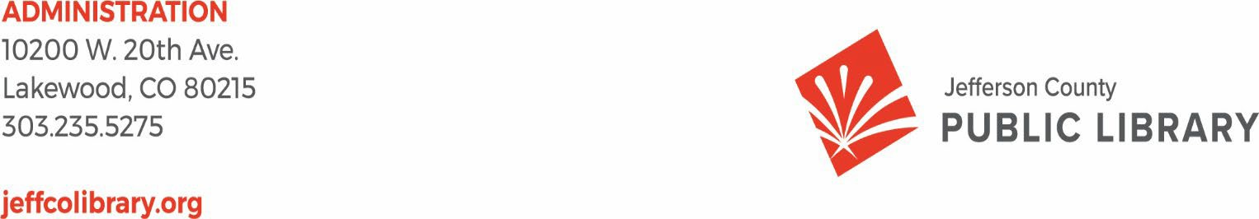

TO: Library Board of Trustees

FROM: Kim Johnson, Chair and Donna Walker, Executive Director DATE: February 19, 2026
RE: Consent Agenda for the February 19, 2026 Board Meeting

- Library Board of Trustees Approve Minutes of the January 8, 2026 Special Board Meeting
- Library Board of Trustees Approve Minutes of the January 15, 2026 Board Meeting
- Library Board of Trustees Approve Haynes HVAC Services Contract

Minutes of the Special Meeting of the JEFFERSON COUNTY PUBLIC LIBRARY
BOARD OF TRUSTEES
January 8, 2026

CALL TO ORDER – SPECIAL MEETING
The special meeting of the Jefferson County Public Library Board of Trustees was held online vial ZOOM and in-person in the Lakewood Library meeting room on January 8, 2026. Library Board of Trustees Chair, Kim Johnson, called the meeting to order at 5:30 p.m.
Other Trustees present: Emelda [Bing] Walker (Vice-Chair), Charles Jones (Secretary), Pam Anderson, Renny Fagan, and Nikki Jain Brown.

Absent: Jill Fellman.
Staff present: Donna Walker, Executive Director; Bernadette Berger, Chief Information Officer; Lisa Smith, Chief People & Culture Officer; Cynthia Kiyotake, Chief Libraries & Inclusion Officer; Elise Penington, Director of Communications and Engagement; Julianne Rist, Library Planning & Policy Senior Advisor; Matt Griffin, Finance & Strategy Consultant; Jessica Paulsen, Assistant Director of Public Services for Customer Experience; Lizzie Gall, Assistant Director of Public Services for Resources and Programs; Amy Bentz, Assistant Director of Library Design Projects and Planning; Brad Green, TDI Systems and Security Manager; Cheryl Murphy, TDI Service Manager; Amber Fisher, Executive Assistant; Katie O’Loughlin, Administrative Coordinator Supervisor; and Ryan Turch, Technology and Innovation Operations Supervisor.
APPROVAL OF AGENDA
MOTION: Emelda Bing Walker moved that the Library Board of Trustees approve the agenda as presented. Seconded by Pam Anderson, the motion passed by unanimous vote of all Trustees present.
Executive Director and Strategy & Operations
- Board Reviews New Global Ends Statements 1.0-1.3
The Executive Director advised the Board that they will be voting on the new Ends Statements at the Board meeting next week. There were no questions from the Board.

- 2026 Annual Plan
The Executive Director introduced the topic and noted that the annual plan is part of policy governance and is the annual performance plan for the Library. The 2026 plan is ambitious and achievable. The plan is in addition to all the other things the Library does every day in service to the public. Projects are grouped under objectives that connect to the Board’s Ends. The plan is flexible with multi-year initiatives built in; as projects shift they can move under

other objectives. The projects have deliverables and some have potential metrics. The draft plan is being presented for Board discussion and input.
Matt Griffin, Finance & Strategy Consultant, provided a recap of the overall strategic plan framework, and how the plan fits together underneath the mission, vision and Board ends. The 2026 Annual Plan reflects the first year of execution under the new strategic plan. It is not exhaustive of all work but the higher level strategic projects that work to meet objectives and ultimately the Board Ends. The Library will bring this topic back next week in a more refined version and have more Board conversation.

Every project has identified deliverables and what they mean; concrete outputs, milestones or major activities JCPL thinks the Board and public want to be aware of with demonstrated progress of work throughout year. There is an accountability question; did JCPL do the work with clear measures of how projects are progressing

There are potential metrics in some projects; data points that the work is expected to influence this year. Results are not always immediate but it is expected that some projects will move data points meant to indicate movement toward an objective. Real time feedback; is the work we’re doing truly influencing the objective we’re setting out to achieve? Is the work moving the needle and the data should give us the answer to that. Some projects will track immediately and some will take time to build the foundation metrics or after the project enters implementation.

Taking all of those together this structure should allow JCPL to have clear line of ends to objective to projects and are they achieving what we want them to achieve.
In response to questions, the Board was advised that:
- The strategic plan structure has remained over the previous few years and the philosophy of organizing projects underneath an objective or initiative has been consistent and organized in a way that shows exactly what each project is working toward. Metrics are a piece new for this year.
- As projects progress we will gain an understanding of those potential metrics that are moving needle the most and where to put resources.
- There will be challenges with overall success measures, how many visitors, collection use in 2026, etc. The Arvada Library will be closed for the whole year and we know fewer people will be using the library. When we add two new libraries those numbers will go up. If we meet these metrics it will show our messaging turning our temporary users to regular users, and we are increasing community use with more new patrons regularly using the library.
- The Communications and Engagement team is developing the patron survey that will measure patron comfort in using the library, access to programs, etc. Part of the project will be making the overall experience better and making sure patrons know all the benefits that come with their library card. We will be trying to reach new people that

just moved to Jeffco, providing a great experience and continuing to learn how we can make a better experience.
- The Library has a careful balance with AI (artificial intelligence) and wants to partner with County where possible. The Library has opportunities for different ways of utilizing AI. County is not teaching patrons and preparing the workforce of the future. The Library has programs and people come to us as a trusted resource and we need to prepare our staff to answer questions. JCPL has been piloting an AI tool. We converse with County constantly and will move forward together and in partnership as much as possible.
The 2026 annual plan reflects the first year of execution under new strategic plan. It is not exhaustive of all work but the higher level strategic projects that work to meet objectives and ultimately ends. The Library will take the Board’s input and bring the 2026 annual plan back in a more refined version for more conversation next week.

- 2026+ Strategic Plan Duration
The Executive Director introduced the topic and noted that the Library has a recommendation for the Board’s consideration on the duration of the 2026+ Strategic Plan.

Matt Griffin advised the Board that the Library is recommending that they adopt a 4-year strategic plan, 2026-2029 ending with 2029 designated as a transition and building year for the next strategic plan. Rationales for this recommendation include the capital project timelines, workforce, and operating realities. A 4-year plan will align with capital project timelines with two significant facilities coming on line in a tight window. A 4-year plan gives time to open, operate and stabilize before looking at strategy again. Although not yet ratified the Collective Bargaining Agreement (CBA) is expected for a 3-year period. The staffing model analysis will run through 2030 and a 4-year duration will provide an overlap so the Library is not doing a new strategic plan and staffing analysis in the same year. This will allow the Library to apply those findings and use 2029 as bridge to build the next strategic plan. The final rationale is the ability to focus in on 3-years living and working in the plan with more data in early year 4 to build a new strategic plan.

In response to a question the Board was advised that updates and progress on capital project deliverables are reported monthly in the Executive Directors report.

The Chair advised the Board that the 2026+ Strategic Plan duration will be brought back to the Board at next week’s meeting.
- Deer Creek Library Additional Architectural Design Services
Amy Bentz, Assistant Director of Library Design Projects and Planning introduced the topic and advised the Board that additional scope items were identified at the completion of the Conceptual Design Phase, requiring additional design fees.

In response to questions the Board was advised that:
  - Part of the additional design fees involved the area where the current meeting room is located and enclosing the area all along the west side to make the children’s area.
  - The $141,600 is the amount the Board previously approved for potential alternates including entitlements, surveying, storm and irrigation. The Library has not needed to utilize those funds yet.

MOTION: Nikki Jain Brown moved that the Library Board of Trustees authorize the Executive Director to amend the contract for additional design services with Eppstein Uhen Architects, Inc. for the Deer Creek Library at a base cost of $104,950. Seconded by Pam Anderson, the motion passed by unanimous vote of all Trustees present.

Communications & Engagement
A. Northwest Jeffco Library Naming
The Chair advised the Board that the Northwest Jeffco Naming agenda item will be brought back next month.

Board Governance
A. Board Reviews Draft Sunshine Resolution LB-01-15-26 for adoption at the January 15, 2026 Board meeting.
The Chair noted that the Board will adopt the Sunshine Resolution next week on the consent agenda.

BOARD SCHEDULE – NEXT MEETINGS
- January 15, 2026 – Board Meeting – 5:30 pm Hybrid: Virtual via ZOOM. In-Person Location: Lakewood Library Meeting Room
- February 12, 2026 – Study Session – 5:30 pm Hybrid: Virtual via ZOOM. In-Person Location: Lakewood Library Meeting Room
- February 19, 2026 – Board Meeting – 5:30 pm Hybrid: Virtual via ZOOM. In-Person Location: Lakewood Library Meeting Room
- March 12, 2026 – Study Session – 5:30 pm Hybrid: Virtual via ZOOM. In-Person Location: Lakewood Library Meeting Room
- March 19, 2026 – Board Meeting – 5:30 pm Hybrid: Virtual via ZOOM. In-Person Location: Lakewood Library Meeting Room
EXECUTIVE SESSION:
At 7:10 pm, the Chair called for a motion to adjourn the special meeting and reconvene in Executive Session.

MOTION: Emelda Bing Walker moved to adjourn the Special meeting of the Library Board of Trustees and reconvene in Executive Session. Topic and Statutory citations authorizing an executive session are:
Collective Bargaining.

  - Pursuant to 24-6-402(4)(e)(I) for discussion of strategy and instructions to negotiators.
  - Pursuant to 24-6-402(4)(b) Conferences with an attorney for the local public body for the purposes of receiving legal advice on specific legal questions.
Seconded by Nikki Jain Brown, the motion passed by unanimous vote of all Trustees present.

The Chair announced a 5 minute short break to allow the Board and staff to clear the room, leave the existing ZOOM meeting and then join the Executive Session.

The Chair called the Executive Session to order at 7:17 pm with the following Trustees present: Kim Johnson, Renny Fagan, Charles Jones, Nikki Jain Brown, Pam Anderson and Emelda (Bing) Walker. Also present were Donna Walker, Executive Director; Eric Butler, County Attorney’s Office; Lisa Smith, Chief People & Culture Officer; Cynthia Kiyotake, Chief Libraries & Inclusion Officer; Matt Griffin, Finance & Strategy Consultant; Bernadette Berger, Chief Information Officer; Elise Pennington, Director of Communications & Engagement; and Amber Fisher, Executive Assistant.

Trustee Renny Fagan left the Executive Session at 7:52 pm.

It is noted that the session was recorded and that the recording will be retained for the required 90 days.
CALL FOR ADJOURNMENT OF EXECUTIVE SESSION

MOTION: Pam Anderson moved to adjourn the executive session. Seconded by Emelda Bing Walker, the motion passed by unanimous vote of all Trustees present.

The Chair adjourned the executive session at 8:14 pm.

It is noted that the Library Board of Trustees met in Executive Session concerning Collective Bargaining. Statutory citations authorizing an executive session for this topic:
- Pursuant to 24-6-402(4)(e)(I) for discussion of strategy and instructions to negotiators.
- Pursuant to 24-6-402(4)(b) Conferences with an attorney for the local public body for the purposes of receiving legal advice on specific legal questions.

The Trustees held those discussions, and this summary is provided as required by Colorado Statute.

Charles Jones, Secretary

Minutes of the Regular Meeting of the JEFFERSON COUNTY PUBLIC LIBRARY BOARD OF TRUSTEES
January 15, 2026
CALL TO ORDER – REGULAR MEETING
The regular meeting of the Jefferson County Public Library Board of Trustees was held online via ZOOM and in-person in the Lakewood Library meeting room on January 15, 2026. Library Board of Trustees Chair, Kim Johnson, called the meeting to order at 5:30 p.m.

Other Trustees present: Emelda Walker (Vice-Chair), Charles Jones (Secretary), Pam Anderson, Renny Fagan and Jill Fellman.

Absent: Nikki Jain Brown.
Note: Trustee Nikki Jain Brown arrived at 5:41pm as noted in the minutes below.
Staff present: Donna Walker, Executive Director; Cynthia Kiyotake, Chief Libraries and Inclusion Officer; Bernadette Berger, Chief Information Officer; Matt Griffin, Financial Strategy Consultant; Lisa Smith, Chief People and Culture Officer; Elise Pennington, Director of Communications and Engagement; Julianne Rist, Library Planning and Policy Senior Advisor; Amy Bentz, Assistant Director of Library Design Projects and Planning; Jessica Paulsen, Assistant Director of Public Services for Customer Experience; Lizzie Gall, Assistant Director of Public Services for Resources and Programs; Padma Polepeddi, Assistant Director of Libraries & Inclusion for Community Outreach; Brad Green, TDI Systems and Security Manager; Cheryl Murphy, TDI Service Manager; Amber Fisher, Executive Assistant; Katie O’Loughlin, Administrative Coordinator Supervisor, Ryan Turch, Technology and Innovation Operations Supervisor.

There were additional Library staff members attending the meeting.

APPROVAL OF AGENDA
MOTION: Jill Fellman moved that the Library Board of Trustees approve the agenda as presented. Seconded by Emelda Bing Walker, the motion passed by unanimous vote of all Trustees present.

The Chair asked that anyone online wanting to provide public comment sign up now by sending a chat message to the meeting host with their name and topic.
PUBLIC COMMENT
The Chair advised the Board that no online form public comments were received and there is no one signed up for in-person or virtual public comment.

The Chair closed the public comment portion of the meeting at 5:34 pm.

APPROVAL OF CONSENT AGENDA
The Chair asked the Trustees if any of the items should be removed from the consent agenda. There were no requests for items to be removed.
Items on the Consent Agenda
- Approve December 11, 2025 Board Meeting Minutes
- Adopt the Sunshine Resolution LB-01-15-26
- Approve Midwest Tape Hoopla Contract Renewal
MOTION: Emelda Bing Walker moved that the Library Board of Trustees approve the items on the consent agenda as presented. Seconded by Renny Fagan the motion passed by unanimous vote of all Trustees present.

FOUNDATION UPDATE
The Chair called on Jo Schantz Hall, Foundation Executive Director. Jo Schantz Hall provided highlights of her report including Library Giving Day on April 1; there are more than $400,000 in grant requests pending The Spring Whale of a Book Sale is May 28-31 at the Jeffco Fairgrounds. Trustees were invited to attend. A pancake breakfast will be provided by the South Jeffco Rotary with a portion of the proceeds going to the Foundation. The Friends Annual Meeting is March 13, at the Wheat Ridge Recreation Center.
Trustee Renny Fagan noted his appreciation for the work of the Foundation and the opportunity to attend holiday gatherings with both the Foundation and Library Boards.

EXECUTIVE DIRECTOR AND STRATEGY & OPERATIONS
- Executive Director Report
The Executive Director advised the Board that her report is still in the old report format and next month’s report will have different look with a request for feedback from the Board on what they are interested in seeing. The administration restrooms will take a little longer and won’t be completed by January 30. The AFSCME vote on the Collective Bargaining Agreement is not expected this week.
The Library and AFSCME are working on red lines and making progress. Note: Trustee Nikki Jain Brown arrived at 5:41pm.
Trustee advocacy opportunities include a Colorado Association of Libraries (CAL) webinar advocating for any and all libraries on January 20. The Executive Director will share more information with Trustees interested in attending. The PLA conference early bird registration is available and Trustees were advised that hotels fill up quickly and it would be helpful to know if anyone is interested by the end of January. The PLA conference is in Minneapolis, Minnesota on April 1-3.

The Chair noted that she loves the mindful space program for teens in Conifer and it is a great

concept.

Trustee Renny Fagan asked to be connected with the Colorado Association of Libraries (CAL) Legislative Committee. The Executive Director will send Trustee Fagan contact information.
- Capital Building Projects Update
  - Arvada Redesign: Working on three things in the written report; Move out, Launch interim services and initiate construction. Move out is complete. Waiting on permits and JCPL is doing what it can to move permitting along.
  - Deer Creek: Communication to the public about the new name went out. The South County Advisory Council meeting is on January 27 at 5:00 pm.
  - Northwest Jeffco: No updates at this time.

The Chair asked the Executive Director to let the Board know if they can help with the Arvada Redesign permitting.
There were no questions from the Board about the Executive Director’s report.
- Adopt Global Ends 1.0-1.3 and Policies 3.4 Monitoring the Executive Director’s Performance and 4.9.5 Library Books & Materials Budget Policy

The Chair noted that the Board reviewed the Global Ends and Policies 3.4 and 4.9.5 at the meeting last week and called for a motion and second.
MOTION: Nikki Jain Brown moved that the Library Board of Trustees adopt the new Board Ends 1.0 through 1.3 and Governance Policies 3.4 and 4.9.5.
Seconded by Jill Fellman the motion passed by unanimous vote of all Trustees present.

- 2026+ Strategic Plan Duration
The Chair noted that the Board reviewed the recommendation on the 2026+ Strategic Plan duration at the meeting last week and called for consensus. There were no questions or discussions and the Board reached consensus on the recommended duration of the 2026-2029 Strategic Plan and for the staff to move forward.

- 2026 Annual Plan
The Executive Director introduced the topic and thanked the Board for their feedback last week. The team has made some adjustments incorporating Board feedback on performance metrics and where projects are placed in the plan. This information is included in the Board’s information packet.
Matt Griffin, Financial Strategy Consultant presented the adjustments to the 2026 Annual Plan with a high level look at the framework and walked through the changes and rationale. A

handout was shared with the Board, and will be included in the information packet, that included the vision, mission, Board ends, strategic objectives and JCPL values. The underlying architecture of the annual plan shows how objectives and ends interact and align, and how the annual projects fit into those objectives. It demonstrates how JCPL approaches business conversation around strategic planning and how they live and connect in a particular year. The plan is viewed as a whole on how resources are distributed and aligned; where staff time, resources, and efforts are going across those objectives. This refined framework/architecture is also included in the memo in the Board packet.

Since last week the most significant changes relate to the placement of capital projects. This is not a change to the projects themselves but more accurately reflects the nature of work in 2026 and impact this year.
  - Deer Creek is repositioned under increased community use of their library reflecting the interim service work happening this year and focused on getting more library users into the system and increasing use in that community. This does not change the trajectory of project work but reflects that the impact this year is around increasing community use of their library.
  - Northwest Jeffco moved under make every visit an exceptional experience. While project planning continues, much of the 2026 work centers on engaging the community. As an example, the location manager is working to shape and bolster connections in the community and reflects the emphasis on that work.
  - Wheat Ridge is being clarified to reflect the focus on shape services and spaces to encourage learning and discovery. The 2026 work is around shaping future services and spaces and primarily listening through engagement and understanding of the Wheat Ridge community. The focus is on what the community wants for services not finishing out the capital project in 2026. The positioning is to align the actual work happening this year.
Other adjustments are to the potential metrics incorporating the Board’s feedback. The refined metrics are integrated throughout the plan and reflected in the Board’s packet. Within the capital projects is an important shift in how potential metrics are framed. Instead of ties to entire projects the metrics are connected to specific interim services or community engagement metrics.
Regarding splitting of interim services and capital projects the outcome the Library came to is to tie those metrics to one interim service and allows the rest of project to continue. The same outcome is applied to community engagement and tied to specific areas of projects. This allows the Library to more clearly track the impact of the work happening this year while also recognizing that the projects span multiple years.
The 2026 annual plan reflects and represents the first year of execution under 2026-2029 strategic plan, reflecting commitments this year and aligns with objectives and allocation of resources. The plan is being presented for Board consensus and upon consensus staff will move forward with the annual plan.

In response to questions, the Board was advised that:
  - Community engagement is formal and specifically facilitated to receive input through a variety of methodologies. Community outreach is similar but less formal. For example with Northwest Jeffco the location manager is doing outreach by going to schools and getting to know the principals and groups in northwest Jeffco. The manager is going to community fairs, back to school events and holding some programs but not in a library space. Another example is the South County Advisory Committee which is considered part of a formal community engagement.
  - For metrics, as an example, the Library will be looking at Arvada interim services and is it telling us something. If not, the Library will bring it back to the Board. The 2026 annual plan is a living document and changes throughout the year but not without informing the Board. JCPL’s data team will have a new Chief Strategy and Operations Officer coming in with their own ideas on measurements and metrics. The Library feels that the potential metrics in the 2026 annual plan are pretty good and we will see how good as we start measuring.
The Chair expressed appreciation to the Library for their work on the 2026 Annual Plan. Trustee Nikki Jain Brown noted that the plan is really well done and makes a lot of sense showing the work and what specifically we will hold ourselves accountable for over the year.

The Chair called for and received Board consensus on the 2026 Annual Plan and for the staff to move forward.
- Financial Report (December 2025)
Matt Griffin, Financial Strategy Consultant addressed the Board and provided an overview of the monthly financials. On Table 1, year-to-date December 2025 the figures reflect preliminary year end results. In and out adjustments will be happening over the next couple of months. Any material changes will be communicated to the Board. Property tax revenue for December has not yet been received. The Library expects this line item to net to zero. On investment income, fourth quarter numbers have not yet been received. To clarify investment income, the figure shown does represent real cash within the JCPL fund balance. It is possible to see reduction based on the quarter’s earnings and this line item as a whole can fluctuate in both directions.
In response to questions, the Board was advised that:
  - The Library does not manage its own investments. They are pooled with all County funds and managed by the County Treasurer’s Office. The Library is not aware of their strategies and does not control the investments. The Library does not determine the percentage of funds invested.
  - The investment income is received quarterly as liquid available to be spent as well as all JCPL fund balance amounts except for the restricted funds.

On Table 2 the salaries and benefits line item is driven by benefits and vacancies and is on trend. Services and charges are under budget due to timing and scope of consulting and professional

fees and legal services. There will be adjustments over the next few months as invoices get closed out. On Table 3 capital year-to- date encumbrances, there is a delay in the financial systems but the Arvada encumbrances will disappear. There will still be adjustments to costs allocated and invoices paid. All items are eligible for carryforward and that will be brought to the Board for discussion in February. This should not be coincided with underspend but what funds are needed to carry forward to continue with the projects. Carry forwards will be discussed in detail next month.

In response to a question the Board was advised that the Library reviews the carry forward eligibility of items in the ARMs to see if they can be carried forward into next year’s ARMs depending on what the funds were for. The Library reviews the intent and purpose of those funds.
ITEMS REMOVED FROM THE CONSENT AGENDA
No items were removed from the consent agenda.
EMERGING ISSUES
No issues.

ENDS
There were no items.
BOARD GOVERNANCE
Chair Appointments:
Bylaws Committee Appointments
The Chair announced the appointments of Nikki Jain Brown and Renny Fagan to serve on the committee to review the By-Laws.
Nominating Committee Appointments
The Chair announced the appointments of Pam Anderson and Kim Johnson to serve on the committee to nominate Board officers. The nominations will be brought to the Board in February and the election of officers will be held in March.
The Chair advised the committees that Amber Fisher will send information about serving on the committees to the committee members.

Foundation Board Trustee Representative Appointment
The Chair announced the reappointment of Trustee Renny Fagan to continue to serve as the Trustee representative on the Foundation Board.
Informational: The 2026 Governance Process Calendar as adopted at the December 11, 2025 Library Board meeting was provided to the Board.

BOARD SCHEDULE – NEXT MEETINGS
2026 Board Meeting Schedule
- February 12, 2026 – Study Session – 5:30 pm Hybrid: Virtual via ZOOM. In-Person Location: Lakewood Library Meeting Room
- February 19, 2026 – Board Meeting – 5:30 pm Hybrid: Virtual via ZOOM. In-Person Location: Lakewood Library Meeting Room
- March 12, 2026 – Study Session – 5:30 pm Hybrid: Virtual via ZOOM. In-Person Location: Lakewood Library Meeting Room
- March 19, 2026 – Board Meeting – 5:30 pm Hybrid: Virtual via ZOOM. In-Person Location: Lakewood Library Meeting Room
ANNOUNCEMENTS/GENERAL INFORMATION SHARING
There were no announcements.

At 6:22 pm, the Chair called for a motion to adjourn the regular meeting and reconvene in Executive Session.
MOTION: Emelda Bing Walker moved to adjourn the regular meeting of the Library Board of Trustees and reconvene in Executive Session regarding:

- Collective Bargaining
  - Pursuant to 24-6-402(4)(e)(I) for discussion of strategy and instructions to negotiators.
  - Pursuant to 24-6-402(4)(b) Conferences with an attorney for the local public body for the purposes of receiving legal advice on specific legal questions.

Seconded by Jill Fellman the motion passed by unanimous vote of all Trustees present.
The Chair announced a 6 minute break to allow the Board and staff time to clear the room, leave the existing ZOOM meeting, and then join the Executive Session in the separate meeting invitation.

The Chair called the Executive Session to order at 6:30 pm with the following Trustees present: Renny Fagan, Pam Anderson, Jill Fellman, Nikki Jain Brown, Charles Jones and Emelda (Bing) Walker. Also present were Donna Walker, Executive Director; Eric Butler, County Attorney’s Office, Bernadette Berger, Chief Information Officer; Lisa Smith, Chief People & Culture Officer; Cynthia Kiyotake, Chief Libraries and Inclusion Officer; Matt Griffin, Financial Strategy Consultant; Elise Penington, Director of Communications & Engagement; and Amber Fisher, Executive Assistant.
It is noted that the session was recorded and that the recording will be retained for the required 90 days.

At 6:48 pm, the Chair called for a motion to adjourn the Executive Session.

MOTION: Nikki Jain Brown moved to adjourn the Executive Session of the Library Board of Trustees. Seconded by Emelda Bing Walker, the motion passed by unanimous vote of all Trustees present.

It is noted that the Library Board of Trustees met in Executive Session regarding Collective Bargaining. The Trustees held those discussions, and this summary is provided as required by Colorado Statute.

Charles Jones, Secretary

TO: Donna Walker, Executive Director

FROM: Steve Chestnut, Director of Facilities and Construction DATE: February 19, 2026
RE: HVAC Services Contract, Long Building Technologies, Inc.

History of Contract:
Our previous HVAC vendor contract had reached its limitations on contract renewal. JCPL published a new RFP for these services and five vendors responded to the proposal.
JCPL Facilities evaluated the proposals to determine which would best serve JCPL. It was our determination that LONG Building Technologies Inc would be the best suited, and JCPL has used them previously and has been satisfied with their support.
Total Cost:
The proposed costs of the RFP responses ranged from $86,712.00 to $199,246.88 per year. LONG Building Technologies’ proposal was the lowest cost at $86,712. That cost covers the base preventative maintenance at all locations for a period of one year. We anticipate that unplanned equipment repairs not covered by the base maintenance fee will bring spending above $100,000. This is within the 2026 budgeted cost of $207,000 for HVAC services.

Next Actions:
We recommend that the Library Board of Trustees authorize the Executive Director to enter a one-year contract, with a base sum of $86,712.00 with the option to renew for four additional one-year terms. This item will be placed on the consent agenda for the February 19, 2026 Library Board meeting unless otherwise instructed by the Board.

Foundation Update


EXECUTIVE DIRECTOR REPORT

FEBRUARY 2026

Jo Schantz Hall, MNM, CFRE, CPC

FRIENDS ANNUAL MEETING
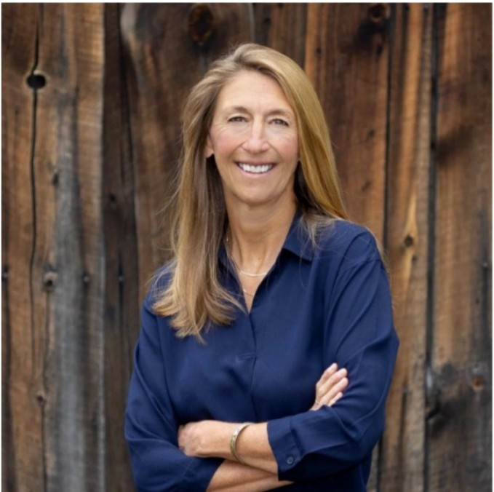
Please join us for our Friends Annual Meeting on Friday, March 13, 11:30 am tol:30 pm at the Wheat Ridge Rec Center in Wheat Ridge.

This year's guest presenter is Shelley Read, author of Go As A River, an international bestseller that has been translated into 34 languages.

SHELLEY READ
Tickets are $35 for Friends, $45 for non-Friends, and $50 for those purchasing a ticket and one-year Friends membership. More information at www.jeffclf.org or call 303-403-5075.

COMMUNITY CONNECTIONS
- Jan. 16 - Meeting with Evergreen Center for the Arts
- Jan. 16 - Lunch with Board member Jeannie Mann
- Jan. 16 - JCLF New Board member orientation
- Jan. 21 - CSU Extension Advisory Board meeting
- Jan. 21 - Lakewood Foothills Rotary Club Board meeting
- Jan. 22 - Meeting with Board member candidate Scott Moore
- Jan. 26 - Meeting with JCPL liaison Bridget Beatty
- Jan. 27 - Presentation to Arvada Sunrise Rotary Club
- Jan. 27 - JCLF Finance Committee meeting
- Jan. 27 - Volunteer recruitment meeting with JCLF staff
- Jan. 28 - JCLF Board of Directors meeting
- Jan. 29 - PEO Chapter FP tour of Amazon Fulfillment Center
- Feb. 2 - Tour at Deer Creek Library
- Feb. 5 - PEO Chapter FP lunch meeting
- Feb. 9 - Virtual meeting with Donna Walker
- Feb. 10 - Wheat Ridge Business Assn. breakfast meeting
- Feb. 10 - Lakewood Foothills Rotary Club dinner
- Feb. 11 - Lakewood Foothills Rotary Club Board meeting
- Feb. 12 - Applewood Business Assn. luncheon
- Feb. 13 - Meeting with JCLF staff member Megan Fessenden
- Feb. 17 - JCLF Finance Committee meeting
- Feb. 18 - Whale of a Used Book Sale meeting
- Feb. 18 - Lakewood Foothills Rotary Club Foundation meeting
- Feb. 19 - PEO Chapter FP lunch meeting
EVENTS CALENDAR
Calendar
l 2 3 4 5
6 | 7 8 | 9 | 10 11 | 12
13 | 14 15 | 16 | 17 18 | 19
�20, 21 22 |  | 23  30 | 24 25  31 | 26

l 28 29

1!11 March 13 - Friends Annual Meeting

1!11 March 24 - ABA Business After Hours at JCLF

1!11 April 1 - Library Giving Day

1!11 April 18 - Shred-a-thon at Jeffco Fairgrounds

1!11 May 28-31 - Whale of a Used Book Sale

1!11 July 17 - Books On Film benefit

1!11 July 31 - Volunteer Appreciation Luncheon


EXECUTIVE DIRECTOR REPORT

FEBRUARY 2026
PACE TWO

L"brary Giving Day

APRIL 1, 2026
-
Q
1mli
Did you know?? There are over 9,000 public libraries that can be found in communities across the nation. And, for all that public libraries provide to these communities, they all have something in common. First, they're accessible to everyone and second, there's no cost to use the library.
BUT. PUBLIC LIBRARIES DEPEND ON YOUR SUPPORT!
Here are key reasons why you should support your public library...

- LIBRARIES PROVIDE ACCESS TO THE INTERNET

100% offer access to the Internet, and nearly 100% offer free WiFi and computer use

- LIBRARIES STRENGTHEN LOCAL ECONOMIES

73% assist with job applications and interviewing skills 68% help patrons use databases to find jobs
48% provide entrepreneurs with business information 36% offer work space for mobile workers
- LIBRARIES MAKE COMMUNITIES HEALTHIER

77% of public libraries offer online health resources 59% provide programs for finding health insurance
- LIBRARIES HELP CHILDREN LEARN

95% provide online homework help and summer reading programs

Sources:
ALA Office for Library Advocacy
ALA Office for Research and Statistics

FUNDING UPDATE
REQUESTS PENDING
- Applewood Community Foundation -- $5,000 for Library Summer Challenge
- Dinsdale Family Foundation --
$25,000 for JCLF general operations
- Applewood Plumbing Community Caring Giveaway --
$5,000 for generar operations
- Colliers -- $1,000 for Friends Community Partnership
- Looking Out Foundation --
$10,000 for 1000 Books Before Kindergarten
- Pinkard Construction -- $2,000 for Friends Community Partnership

FUNDS RECEIVED/APPROVED
- Thrivent -- $500 sponsorship for Books On Film 6enefit
- Lillis Foundation -- $2,000 for 1000 Books Before Kindergarten
- City of Golden -- $1 675 for Friends Community Partnership
- Foothills Vision Center -- $250 spon�orship for Friends Annual Meeting
- Confluence Companies -- $500 for Friends Community Partnership
- FirstBank -- $1,000 for Library Summer Challenge

REQUESTS DENIED
- Mabel Hughes Charitable Trust
-- $25,000 for Early Childhood Literacy

JCLF is
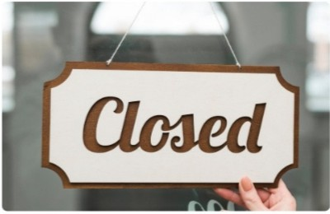
for President's Day Monday, Feb. 16th

Executive Director


ANNUAL PLAN PROGRESS FEBRUARY 2026 EXECUTIVE DIRECTOR REPORT

OBJECTIVE: INCREASE COMMUNITY USE OF THEIR LIBRARY
Jeffco residents feel a genuine pull to regularly use the library. What we offer as the library enriches their lives.
Annual Plan Progress:
  - Radically Welcoming New Patron Experience: Redesign of the welcome brochure and hours and location flyer underway.
  - Deer Creek Library: Finalize Schematic Design and schematic design cost modeling.
Library Initiatives:
  - Winter Reading: Winter Reading is underway now through Feb. 28 with over 1700 patrons registered to participate. Participants explore books and complete activities that match the 16 bingo space descriptions to collect badges and win a finisher prize.
  - Jazz Masters: The Voices that Shaped an Artform Wil Alston & Kool Grooves present a soulful Black History Month performance honoring Nat King Cole, Ray Charles, Gregory Porter, Leslie Odom Jr., Billie Holiday, and Sarah Vaughan. Through music and reflection, the program celebrates how these iconic voices shaped culture, storytelling, and the evolution of jazz. Saturday, Feb 21 from 2-3:30 p.m. at the Belmar Library.
OBJECTIVE: BRIDGE GAPS TO ACCESS
Each element of JCPL service is designed, delivered and promoted to create the opportunity for everyone to participate. Our tax-supported services are provided free of charge.
Annual Plan Progress:
  - Digital Accessibility: Rollout Staff Quick Reference Guides
  - Arvada Redesign: Arvada Balsam Temporary Library is open, and demolition has started at Arvada Library. The demolition permit is secured. Executive Director signed Revocable Licenses on behalf of the Library Board of Trustees.
    - City of Arvada Fence Revocable Encroachment License
    - City of Arvada Canopy Revocable Encroachment License
Library Initiatives:

  - JCPL will welcome the community to a free Spring Author Event, In Conversation with Lisa Gardner, on Saturday, Feb. 21 from 12-4 p.m. at Mile Hi Church in Lakewood. Over 600 people registered to attend in person or online.

OBJECTIVE: MAKE EVERY VISIT AN EXCEPTIONAL EXPERIENCE
We treat patrons as welcome guests at every point of contact, creating experiences and spaces that meet or exceed their needs. Individually and as a community, patrons recommend their library as a safe and trusted resource.
Annual Plan Progress:
  - Northwest Jeffco: Assess schematic design and pricing.
  - Lakewood Library and Administration Refresh: Reopen staff breakroom. Determine next steps in completing Administration restroom renovations.
Library Initiatives:
  - AARP Tax Help provided at JCPL in partnership with AARP IRS-certified volunteers.
OBJECTIVE: SHAPE SERVICES AND SPACES TO ENCOURAGE LEARNING AND DISCOVERY
We approach service and space design with a focus on learning for all ages, backgrounds and abilities. JCPL is known to be a safe place to explore and incubate ideas together.
Annual Plan Progress:
  - Wheat Ridge Library Services: Establish project charter and timeline, contract with community engagement provider, meet with community partners, establish community engagement dates.
  - AI Innovation and Engagement Strategy: Offer AI classes to patrons.
Library Initiatives:
  - Everday AI classes commence for patrons. Five classes offered with three reaching their maximum capacity for registration.
OBJECTIVE: JCPL IS AN EMPLOYER OF CHOICE
JCPL understands and takes action on what draws people to work here. Together, we intentionally build a culture of belonging for all.
Annual Plan Progress:

  - Collective Bargaining Agreement (CBA): Finalize CBA, submit Collective Bargaining BCC Staff Briefing Paper, and conclude ratification votes.
  - Collective Bargaining Agreement (CBA) Implementation: Implement pay plan for represented staff. Build implementation schedule and begin supervisor training. 2026 Budget Analysis for Supplemental Request.
OBJECTIVE: EMPLOYEES ARE EQUIPPED TO DELIVER ON OUR PROMISES TO THE COMMUNITY
JCPL staff are trained, supported and encouraged to succeed in their role, with a team focus on meeting the library’s mission.
Annual Plan Progress:
  - Staffing Analysis: Scheduled in our 6 month pipeline for kickoff.
Library Initiatives:
  - Monthly Staff Trainings on Library Ethics, Story Time Experience, Trama Informed Customer Service, New Employee Orientation, and more.
  - Julianne Rist, Library Planning & Policy Senior Advisor, has been selected as First Vice Chair of the West Metro Chamber of Commerce Advisory Committee.
  - Jenna Markl, ILL/ACQS Associate, and Fallon Purdy, Operations Coordinator, will attend the Colorado Library Consortium (CLiC) Winter Workshop.
  - Erica Cole, Collections Librarian, and Sonya Foutch, Patron Experience Associate, will be attending Colorado Council of the International Reading Association (CCIRA).
  - Four staff members including Matthew Kay, HR Manager, and Lisa Smith, Chief People & Culture Office, will be attending the Annual Mile High Society for Human Resource Management (SHRM).
  - Allie Awe, Creative Technician, is attending “Tech Talks: A.I. Isn't Magic - How Generative
A.I. Actually Works” hosted by Loveland Public Libraries.

EXECUTIVE DIRECTOR SUMMARY OF COMMUNITY ACTIVITIES
  - Attend BCC Hearings
  - Attend BCC Staff Briefing
  - Meeting with Jefferson County Manager
  - Complete New Trustee Orientation
  - Meeting with Library Foundation Executive Director
  - Attend Elected Official/Personnel Board meeting
  - Attend County Training: A Holistic Approach to Crisis Communication for Executives
  - Meeting with Colorado Gives Foundation
  - Attend Jeffco Connections Board meeting
  - Tour Arvada Balsam site

OPPORTUNITIES FOR BOARD ADVOCACY & ENGAGEMENT
  - CALCON 2026 The Colorado Association of Libraries Annual Conference is Colorado’s premier event for library staff from libraries of all types throughout the state. Attendees learn from one another and hear from current experts in trending fields. A Trustee Track is in development. Sept 9-11 Hyatt Regency Aurora. Information provided for planning purposes. Registration is not open yet.
  - 2026 ULC Annual Leadership Forum, September 30-October 2, 2026 | Las Vegas, Nevada. Information provided for planning purposes. Registration is not open yet.
  - The Freedom to Read Foundation (FTRF) is seeking individuals who are willing to sustain and support the Foundation’s mission to express their interest in being slated as a candidate for election to its 2026-2028 Board of Trustees. Election will take place in April 2026. The deadline for nominations or self-nominations is Wednesday, February 18, 2025. Contact Karen Gianni (kgianni@ala.org) with questions or to express interest.




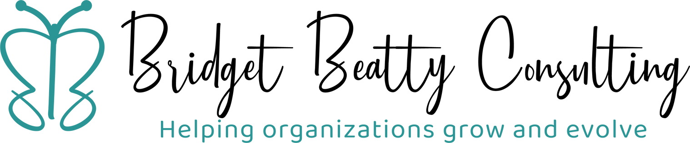

Long - term Fundraising Plan
Fe b rua ry 19 , 20 26



Key Questions

- Should the library pursue fundraising sources other than grants?

- What capacity is needed for long - term fundraising?

- What tools and approaches would improve fundraising?





Input Gathered

Key Informant Interviews
    - JCPL trustees and executive staff
    - Peer library fundraising professionals
    - Community partners

Civic Leaders Survey
    - Elected officials
    - JCPL trustees
    - Library foundation board members
    - Leaders of agency partners

  - Fund Development Planning Committee


What We Heard

Fundraising should not be a core function of the library.

There is a heightened need for public support of libraries.

Civic engagement, library advocacy, and partnerships are critical.



Staffing Options Considered

OR

1.0 FTE
Strategic Partnerships
Contract: Fund Development Consultant

RULED OUT:
1.0 FTE Fund Development Director

Staffing Recommendation

Fund Development Consultant
1.0 FTE Strategic Partnerships



Phase One (2024-27)
Phase Two (2028 and beyond)

2026 JCPL Staffing Analysis




Purchase Grants Software

Prioritize “full cycle” grants management software to increase efficiency and effectiveness

Operational Recommendations

Optimize CRM for Fundraising

Designate JCPL Liaison for Library Foundation
Streamline data requests; coordinate grants and reporting requirements; cultivate and steward donors in collaboration.
Document “friend - raising” interactions in upcoming client
relationship management system.






FUTURE FOCUS:
Build Allies.
Expand Partnerships.

- Publish fundraising priorities in alignment with JCPL Strategic Plan launching in 2026.
- Convene civic leaders to announce strategic plan and fundraising priorities.
- Focus on relationships and success over time versus annual targets.
- Conduct “friend - raising” activities that build public support and ultimately contribute to fundraising.





Thank you.

www.linkedin.com/in/bridget -beatty

Strategy and Operations

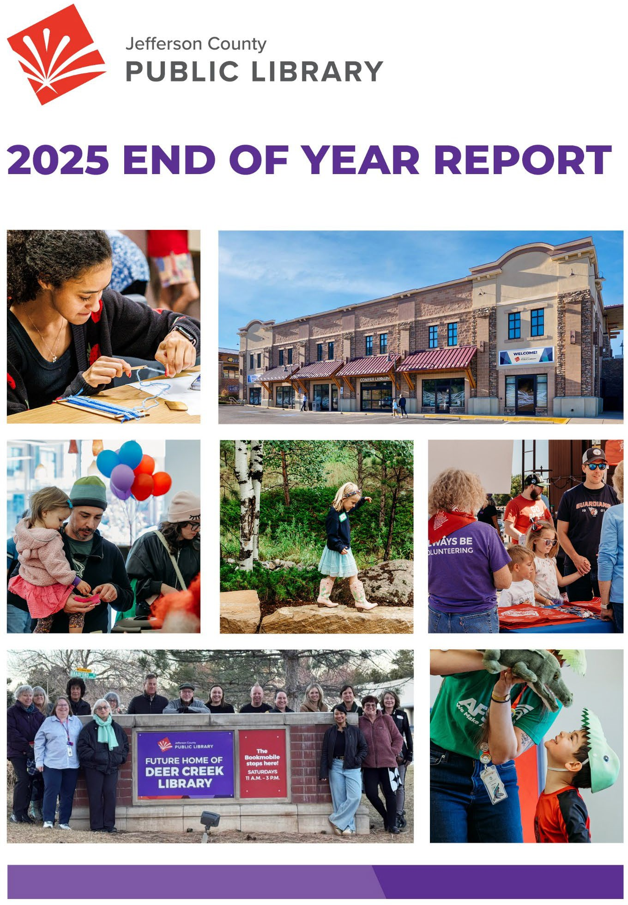

Top Row: Creative Tech bookmark-making, the new Conifer Library. Second Row: Arvada Library closing and redesign celebration, Evergreen Library outdoor reading deck opening, Raise A Reader welcome table. Bottom Row: Deer Creek Library naming, Story Time with puppets.

2020-2025 STRATEGIC PLAN CLOSE-OUT
Between 2020 and 2025, Jefferson County Public Library (JCPL) advanced the vision established in the 2020–2025 Strategic Plan through a combination of planned initiatives, adaptive service models and long-term investments in facilities, people and systems. As this strategic plan concludes, this section provides a high-level overview of key accomplishments delivered across the full period.
KEY ACCOMPLISHMENTS
ACROSS THE 2020–2025 STRATEGIC PLAN
Create Libraries for the Future
- Accelerated the Building Program, completing the Belmar and Evergreen Library redesigns
- Secured locations for Northwest Jeffco and Deer Creek libraries
- Opened a stand-alone library in Conifer
- Created the Express Library West Arvada
- Built and launched a new Bookmobile
- Completed the design for the Arvada Library remodel
- Installed Electric Vehicle charging stations at five Library locations

Reach More People
- Implemented a comprehensive COVID-19 service response
- Installed holds lockers at Columbine, Belmar, Standley Lake and Golden libraries
- Expanded Alternative Services through lockers and return bins at partner locations, including Foothills Park & Recreation District, Mountain Resource Center and Candelas
- Launched curbside services and after-hours phone support
- Launched MyJCPL application and digital library cards
- Implemented hybrid public meetings
- Eliminated fines for overdue materials
- Implemented auto-renewal of library materials

Focus on Building Literacies
- Shifted physical collections strategy and expanded digital content
- Created the Jeffco Workforce laptop lending program
- Launched Dolly Parton’s Imagination Library
- Launched the StoryWalk® service
- Launched Creative Technology Services
- Created the Discover Together Outdoor Adventure Space at Belmar Library
- Created two new Family PlaceTM Libraries at Belmar and Evergreen Libraries
- Expanded digital literacy for underserved communities through the award-winning PowerOn Jeffco Project
- Launched 500 Books Before Middle School
- Launched the Teen Internship Program
- Surpassed the 10 million mark in total collection use

Be the Third Place
- Expanded access to flexible, community-focused spaces through new and redesigned facilities
- Increased opportunities for connection through inclusive programming, technology access and alternative service models
- Activated the Digital Media Studio and Create Space at Belmar Library
- Offered Signature Programs and events in-person and virtually, reaching hundreds of thousands of residents annually
- Partnered with community agencies to make library spaces accessible for government services
- Expanded volunteer program to include over 500 teens and adults
- Launched assistive technology and digitization workstations at five library locations

Grow Sustainably
- Launched a new fundraising development plan
- Completed an organizational staffing assessment and compensation study
- Adopted a new Collection Development Policy
- Implemented enterprise staff systems, including Microsoft Teams and a new document management system
- Established the JCPL Leadership Academy
- Created a Project Management Office
- Established a new Library Design Standard
- Completed replacement of all book sorters

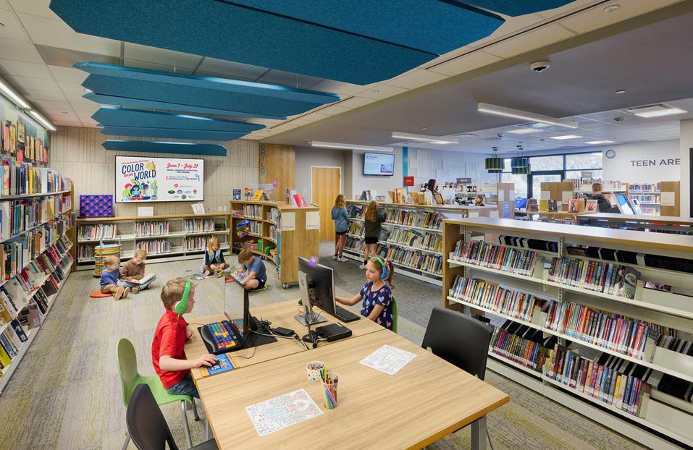

STRATEGIC PROJECT ACCOMPLISHMENTS
2025 Annual Plan Projects
The following section summarizes progress on the strategic projects included in the 2025 Annual Plan, as approved by the Board of Trustees. Each project is presented with its associated deliverables and current status, reflecting work completed, in progress or not completed during the year.
Where applicable, this section also highlights other notable project accomplishments delivered in 2025 that supported the Strategic Plan.
Together, these projects represent the Library’s focused efforts in 2025 to advance the Strategic Plan through defined projects.

Project: Deer Creek Library
- Finalize Program of Service (complete)
- Complete Design Development phase (not started)
- Develop recommendations for interim uses (complete)
- Investigate partnership opportunities (in progress)
- Initiate naming (in progress)
- Other Completed Accomplishments
  - Conceptual Design (complete)
  - Schematic Design (in progress)

Project: Arvada Library
- Finalize Design Development (complete)
- Complete construction drawings with guaranteed maximum price (GMP) (complete)
- Initiate naming opportunities solicitation (complete)
- Implement alternative service options (in progress)
- Begin construction (not started)

Project: Northwest Jeffco Library
- Finalize Program of Service (complete)
- Complete design development phase (not started)

- Investigate partnership opportunities (in progress)
- Initiate grant & naming opportunities solicitation (in progress)
- Other Completed Accomplishments
  - Conceptual Design (complete)
  - Schematic Design (complete)
  - Schematic Design pricing (complete)

Project: Conifer Library
- Finalize construction documents with guaranteed maximum price (GMP) (complete)
- Conclude intergovernmental agreement (IGA) with Conifer High School (complete)
- Finalize grant & naming opportunities solicitation (complete)
- Open new Conifer Library (complete)

Project: Creative Tech Mobile
- Finalize mobile lab design (not started)
- Create mobile STEM curriculum (not started)
- Investigate partnership opportunities (not started)

Program: A Radically Welcoming New User Experience
- Develop standardized new patron onboarding process (in progress)
- Implement new patron onboarding plan (in progress)
- Identify tools for personalized patron experience (complete)
- Implement tools for personalized patron experience (in progress)
- Other Completed Accomplishments:
  - Completed the first project “Develop a Radially Welcoming Patron Strategy”
  - Started the second project “Deploy Radically Welcoming Patron Support Tools”

Project: All Staff Compensation Strategy
- Complete compensation analysis (complete)
- Integrate findings into Collective Bargaining Agreement (CBA) (complete)
- Integrate findings into 2026 budget (complete)

Project: Collective Bargaining Agreement
- Integrate economic impacts into 2026 budget (complete)
- Finalize CBA (in progress)
- Obtain Board of Trustees approval of CBA (not started)
- Obtain Board of County Commissioners’ approval of CBA (not started)

Program: Digital Accessibility
- Create JCPL-specific digital accessibility guidelines (complete)
- Meet 2025 digital accessibility requirements across platforms (in progress)

Program: Fundraising Development
- Complete 2024-2025 Fundraising Plan (complete)
- Develop a 3–5-year fundraising plan (complete)
- Create a fundraising plan for 2026 (complete)

Project: AI Strategy Development
- Finalize AI Strategy (in progress)
- Initiate strategy implementation (in progress)

Project: 2026+ Strategic Plan
- Refined Mission, Vision, and Broad Goals framework (complete)
- Finalize 2026+ strategic plan (complete)

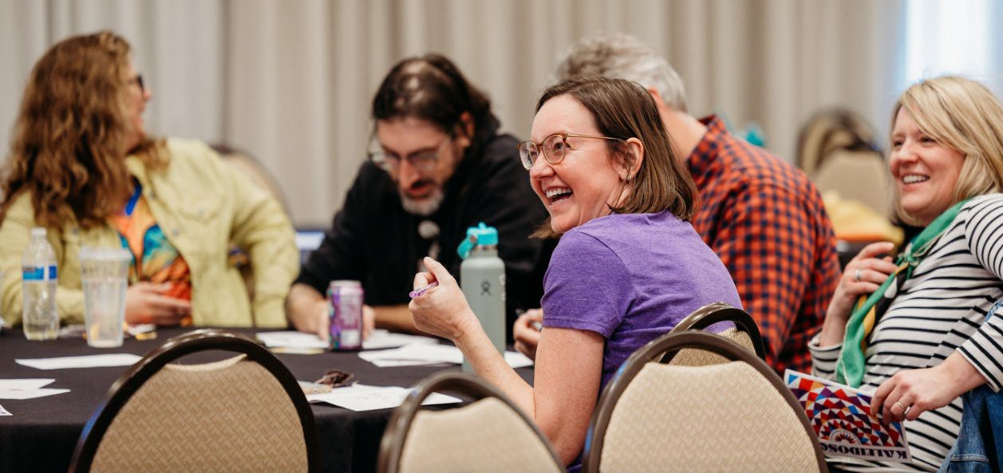

BEYOND THE ANNUAL PLAN
While the Annual Plan projects capture key areas of strategic focus, they do not fully reflect the breadth of work delivered by the organization in 2025. Throughout the year, JCPL continued to provide essential services and resources to the community through its website, physical and digital collections, programs for all ages, a robust volunteer program, 11 library locations, Library To You services and targeted outreach to children, families, teens, adults and diverse populations.

The following section highlights a selection of additional 2025 accomplishments that demonstrate the ongoing, day-to-day impact of JCPL’s services and the dedication of its staff in supporting connection, discovery and creation across Jefferson County.

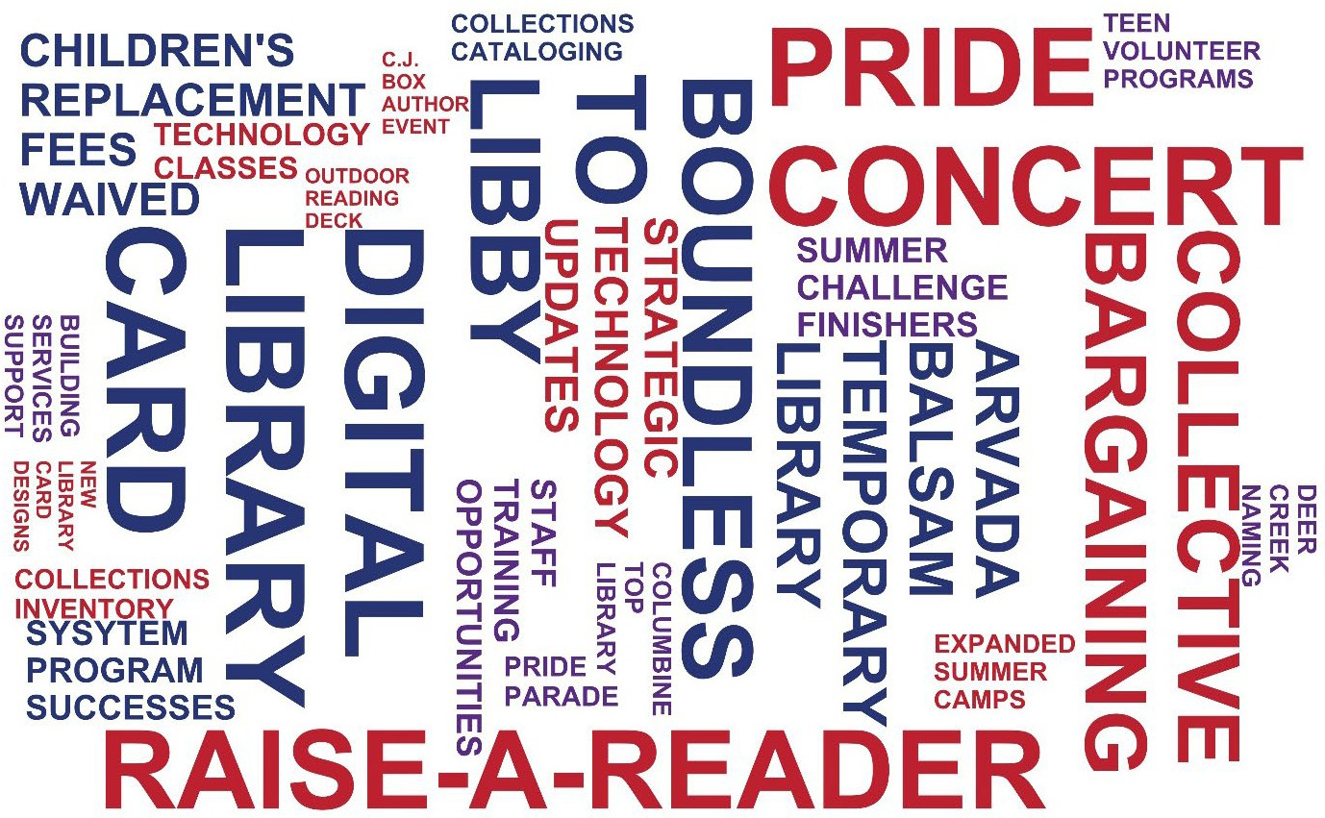

LIBRARY OPERATIONAL MEASURES
Each year, JCPL evaluates alignment between its strategic initiatives, core services and the goals established by the Board of Trustees. This year-end review uses defined success metrics to assess how daily operations advance the Library’s mission and deliver impact for the Jefferson County community.

2025 SUCCESS MEASURES
In 2025, JCPL sustained steady growth in overall use, led by continued expansion of digital services and increased community engagement across the county. Reach and satisfaction remained strong, with market penetration reaching 40%, as well as consistently high patron satisfaction.

Highlights
- Overall use continues to grow, led by digital
  - Total collection use increased 1.1% in 2025 to 10.26 million uses, reflecting continued demand for Library resources.
  - 2025 growth is driven by e-materials circulation (+16.9%), while physical circulation declined 2.1%, indicating an ongoing shift in how patrons access content.
- Digital resource usage trends
  - E-materials circulation has increased nearly 17% since 2024, confirming strong and ongoing adoption of digital collections.
  - Database use declined 10.9% in 2025 compared to 2024.
- In-person use and program participation
  - Visits increased by 1.6% to nearly 2 million, and program attendance continued to grow to 230,632 participants.
  - These trends reinforce the Library’s role as a community hub and destination.
- Reach continues to expand countywide
  - Active households (+2.3%) and active cardholders (+2.6%) both increased in 2025.
  - Market penetration reached 40%, a notable milestone aligned with the priority to reach more residents.
- Patron satisfaction remains exceptionally high
  - Net Promoter Score was 84 in 2025, reflecting relatively stable results year-over-year.

Library Benchmark Measures

Year | 2020 | 2021 | 2022 | 2023 | 2024 | 2025 | % change  2020 to 2025
Total collection use | 8,806,903 | 9,843,592 | 9,593,816 | 9,977,109 | 10,146,31  9 | 10,256,03  8 | 16.45%
Circulation (physical materials) | 5,496,337 | 6,806,488 | 6,624,616 | 6,585,874 | 6,467,737 | 6,329,520 | 15.16%
Circulation (e-materials) | 1,807,144 | 1,798,042 | 1,887,986 | 2,119,889 | 2,334,069 | 2,728,057 | 50.96%
Database use | 1,503,422 | 1,239,062 | 1,081,214 | 1,271,346 | 1,344,513 | 1,198,461 | -20.28%
Program attendance | 55,647 | 41,325 | 143,155 | 203,471 | 223,968 | 230,632 | 314.46%
Visits | 830,615 | 1,242,213 | 1,725,351 | 1,840,473 | 1,951,596 | 1,983,456 | 138.79%
Active households | 100,581 | 113,212 | 91,068 | 91,233 | 95,159 | 97,355 | -3.21%
Active cardholders | 138,477 | 159,313 | 132,171 | 139,689 | 136,032 | 139,598 | 0.81%
Market penetration | 42.29% | 45.55% | 36.29% | 37.84% | 39.46% | 40.0% | -5.41%
Net Promoter Score | 84 | 82 | 84 | 82 | 85 | 84 | 0.00%

PROGRAM IMPACT
Each year, JCPL uses patron surveys to assess the impact of library services and programs on key outcomes, including increased knowledge, confidence, application of new skills, and awareness of available resources. These outcomes are measured across core community engagement areas such as Early Childhood Literacy, Civic and Community Engagement and Education and Lifelong Learning. Surveys are administered following Signature Events to capture consistent, outcome-based feedback.

In 2025, survey results showed strong outcomes across multiple Signature Events. All respondents who attended In Conversation with C.J. Box indicated they would recommend JCPL events to others. Participants in the Library Summer Challenge reported increased engagement, with more than 87% indicating they learned something new and 80% reporting they were more likely to use the library as a result of participation. Among families completing the 1000 Books Before Kindergarten program, 98% reported using additional library resources, and at the program’s midpoint, 93% of respondents indicated they were spending more time reading with their children.

C.J. BOX SPRING AUTHOR EVENT
Objective: Measure a program that provides the opportunity to gain and impart new knowledge and skills and engage in lifelong learning.

A total of 1,344 people attended the Spring Author event, In Conversation with C.J. Box, either in person at Mile Hi Church in Lakewood or via livestream. Post-event survey results (n=409) were strongly positive, with 100% of respondents indicating they would recommend similar JCPL events to others. Sixty percent of attendees traveled fewer than 10 miles to attend.

Feedback highlighted strong interest in the opening panel of local authors and increased awareness of related library collections. Attendance reflected a broad cross-section of the community, including multi-generational families and older adults, demonstrating the event’s broad appeal and accessibility.
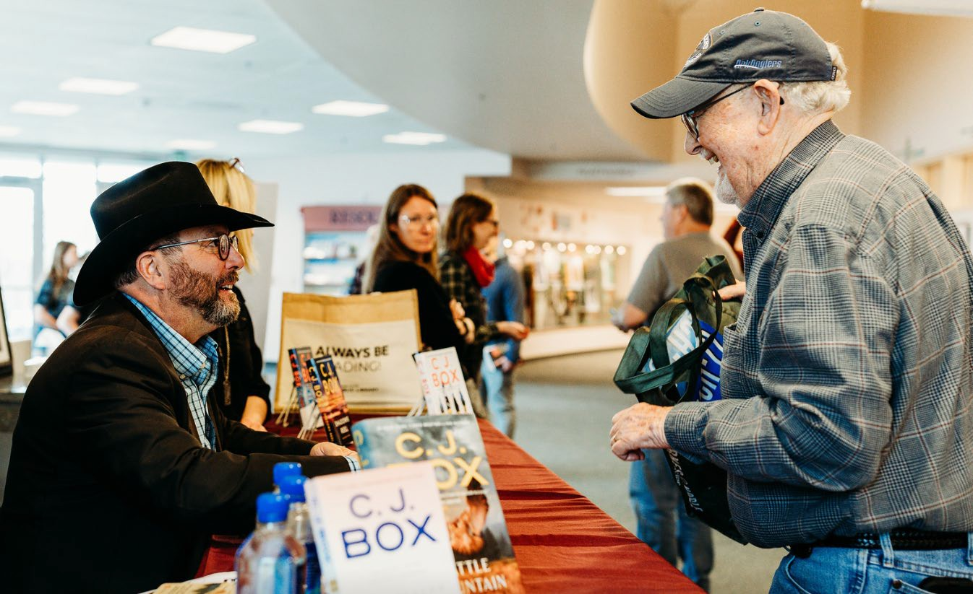

C.J. Box Spring Author Event Mission Moments
“Thank you so much for the C.J.Box event/panel discussion recording! We had to cancel our reservation due to a medical issue and were very disappointed. We are thrilled we got to see it anyway. We are looking forward to more of these events- Livestream participant

This was the first event I've "attended". Thanks for the livestream option! I had not read any of CJ Box's books, but enjoyed hearing from him and the panel of authors! I took notes and have added some new authors to my reading list!

I LOVED this event. I enjoyed the panel of local authors talking about their journeys just as much as the main event. I would attend any event like this to learn about new authors.

We drove 1.5 hours (80 miles) and thoroughly enjoyed the event. It was our first time attending an authors event. Thank you!

This was an EXCELLENT event. Thoroughly enjoyed author panel, and conversation with
C.J. Box. Am a member of Mile Hi Church. Energy in the sanctuary is stimulating for this event. I purchased books fom all the authors to support their craft. From greeters to Boulder Library folks selling books exceptional organization!!! To our outstanding Jefferson County Public Library well done!!! Thank you!!!

We loved the event and it has also made friends we brought to it, who are not big readers, become more excited about authors and reading. Everyone did a great job! Thank you!

LIBRARY SUMMER CHALLENGE
Objective: Measure programs and services that provide continuous reading opportunities for adults, caregivers, teens, and children as part of encouraging lifelong learning.

The Library Summer Challenge supported learning and literacy across Jefferson County, with 24,225 participants in 2025. Survey results (n=316) showed strong outcomes, with over 87% of respondents reporting they learned something new, more than 70% indicating increased motivation to read and over 80% reporting they were more likely to visit the library as a result of participation.

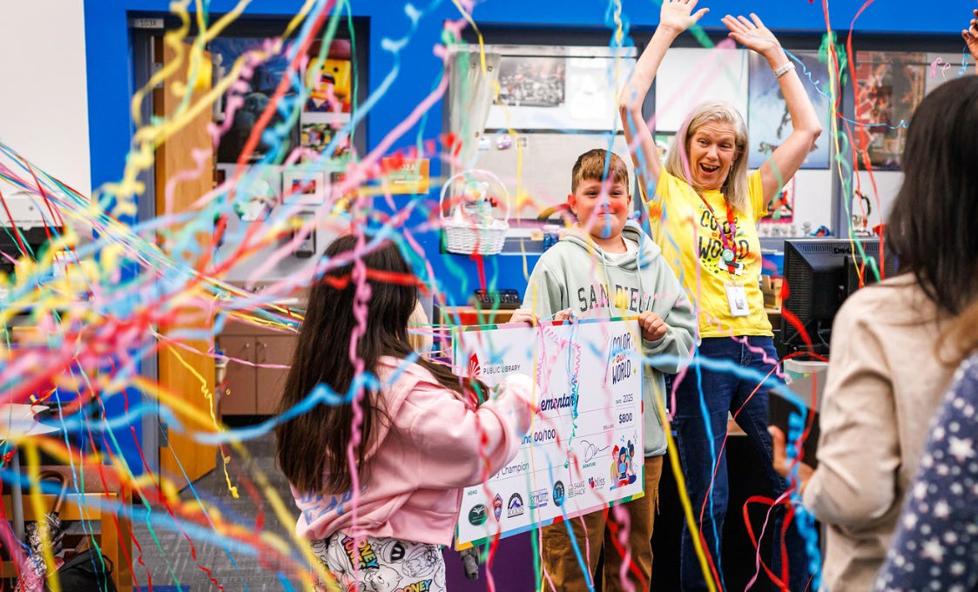

Library Summer Challenge Mission Moments
Both of my kids were so motivated to finish the program & get their prizes! Even though they weren't fully independent readers yet (age 3 & 5), they would spend time looking through books independently and asked me to read to them all the time. They LOVED getting to pick out new books as their prizes.

The incentive to read through all our books at home, get new ones at the library every week and the prizes were a great bonus!

I was also a teen volunteer, and I really enjoyed getting to be a part of the library team. All the prizes are great, and it’s really fun to see kids get excited about reading.

I don't read as much as I did when I was working and had a bus commute, so this is a great incentive to read at least a little bit every day.

I liked participating in the summer reading challenge. I made me realize how much I read, and encouraged me to keep reading and to look for more books at the library.

It is always, always a part of our summer experience. There are lots of incentives for kids (and adults) that my child enjoys and there is lots of support from librarians to find exactly what my child is looking for in that moment.

I like the challenge it offers to people who don’t normally read. My library summer reading program got me excited to read every summer as a child. I want everyone to share my love of books!

The program kept me motivated to try to read every day. It didn't quite happen but I did read more often than I expected. It helped me meet my goal for reading this year which was nice to have a bit of extra help.

1000 BOOKS BEFORE KINDERGARTEN
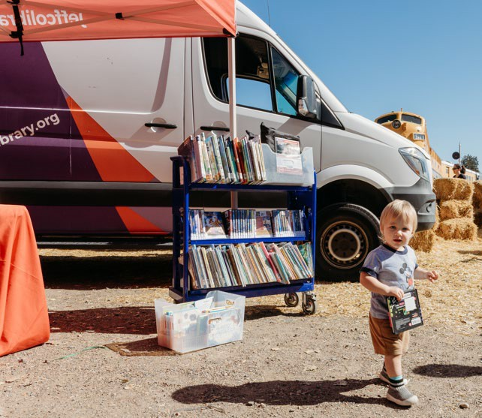
Objective: Measure programs aimed to improve early literacy and learning skills to prepare children ages 0-5 for school readiness.

The 1000 Books Before Kindergarten program supports families with young children (ages 0–5) in building early literacy skills.
Program impact is measured through participant surveys administered at the midpoint and upon completion.

In 2025, the program enrolled 2,050 new
registrants and served 2,017 active readers. Midpoint survey results (n=50) showed strong outcomes, with 92% of respondents reporting they learned something new to share with their children, 88% indicating increased confidence in supporting their child’s learning and over 90% planning to spend more time reading with their children. In addition, 94% reported increased awareness of library resources and services.

Among surveyed program completers (n=45), 87% reported a stronger understanding of the value of early literacy activities, 93% reported spending more time on those activities and 98% indicated they used additional library resources or services as a result of participation.

Participant Comments:
I enjoyed seeing my child really develop of love of being read to. It's a favorite activity.

It built a love of visiting the library and exploring books in my kids from an early age.

The 1000 Books challenge helped me to better understand how many books I should be reading to my child each day to support their development.

He learned to enjoy books without pressure and I learned it doesn't have to be so structured.

RAISE A READER
Objective: Measure programs and services aimed to improve early literacy and learning skills to prepare children ages 0-5 for school readiness.

Raise a Reader is a fantastic program designed to help caregivers and families equip children with essential literacy skills, setting them up for success in reading and school. By engaging in early childhood literacy activities, children ages 0-5 develop critical thinking, vocabulary, language, problem-solving, social, physical and creative skills that are crucial for their future.


In 2025, more than 1,600 people attended Raise a Reader and 102 participants responded to our survey. 85.6% of respondents said they learned something that they can share with their children, and 81.7% said they would spend more time interacting with their children through reading and writing than they did before.

Participant Comments:
We love the summer program and look forward to the raise a reader festival every year. It is a fabulous treat to earn a trip to the train museum while also having a great summer reading and exploring.

Communicates a joy of reading and connects families with resources. And of course the train ride is a huge hit! Kids also loved story time and puppet theater.

One of our favorite yearly events – spreads the joy of learning and reading and gives us a fun family memory!

This is such a unique literacy promotion event! Love all aspects, especially the bubble area!

CONCLUSION
2025 marks the conclusion of Jefferson County Public Library’s 2020–2025 Strategic Plan. Over this period, the Library advanced its strategic priorities through a combination of long-term initiatives, annual plan projects and ongoing services delivered across the county.

As this plan concludes, the Library enters a new 2026–2029 Strategic Plan, building on the work completed over the past six years and continuing to respond to the evolving needs of the Jefferson County community.



FEEDBACK FROM LIBRARY PATRONS

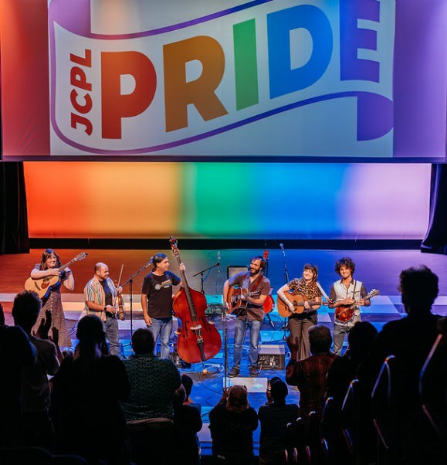
"I absolutely LOVE that the libraries host events like teen pride. It means so much to me and my kids to have events like this available to express ourselves in a judgment free zone. Thank you for putting together inclusive events for the Jeffco community" – Patron on Pride Programming

“I am grateful for the library, it is a great organization. I am pleased that the library has automatically renewed two of my titles after the switch to Libby.
- Bookmobile patron

“The accessibility would be huge! We live in Coal Creek Canyon and this location would be wonderful us. Services like this are the right thing for people and communities!!!”
- Community Feedback on Northwest Jeffco Library

A gentleman in his 90s contacted the Call Center seeking assistance with his electric razor. He was having trouble using it and asked for the manufacturer’s customer service phone number. Since he didn’t have access to a computer or email, our staff went above and beyond to support him. They reached out to the company via online chat to obtain the correct phone number and also secured a digital copy of the razor’s user manual.
Recognizing his limitations, they offered to mail him a printed copy of the manual. The customer was genuinely surprised and delighted by the level of care and service provided, especially given his lack of access to digital resources.

Just having a "challenge" made me want to read more. My brain saw reading to have fun while also pursuing an end goal vs beforehand where I had nothing to motivate me outside of my desire to read. Now that the challenge is over, I still have continued reading daily (as the habit was solidified over 3 months), but I am more excited about when the next reading challenge will be.
- On Summer Challenge

“I am waiting to find out what is good about getting old but you telling me that I did well to get set up on the app makes me feel like a superstar.”

A mom wanted to know if she had to pay to attend a story time. She was so excited and shocked to learn that not only could she attend a story time for free, but that she was also able to come into the building without paying an entry fee.


Even though I live in Denver, I must cross the line and donate something. Belmar Library is a delight! Whatever it is, they have it to share!
They are so helpful and always go out of their way for me.
- Belmar Patron reached out to JCLF with a donation



TO: Donna Walker, Executive Director

FROM: Matt Griffin, Financial Strategy Consultant DATE: February 19 2026
RE: Finance Monthly Report

Budget to Actual Tables – January 2026

Please see the enclosed Budget to Actual Tables for January 2026.
In January, JCPL recorded $0.5 M in Real Property Tax revenue. Year-to-date, 0.8% of the budgeted collection has been received.
JCPL remains on track with its overall budget, with no areas of concern at this time.
In January, the Library Foundation provided funding of $38,154 to JCPL. The Library contributed $7,452 in-kind support in January. Year-to-date, the Library has received $38,154 in funding and provided $7,452 in-kind support to the Foundation, with a ratio of 5.12.

TABLE 1
JEFFERSON COUNTY PUBLIC LIBRARY REVENUE AND EXPENDITURE SUMMARY BUDGET TO ACTUAL

Revenue and Expenditure | 2026 Budget | YTD Actual  01/31/2026 | $ Variance  2026 Budget | % Variance  2025 Budget
Revenues
Property Taxes (net adjustments) | 62,855,736 | 508,921 | 62,346,815 | 1%
Grants, Funds & Donations | 375,000 | 477,330 | (102,330) | 127%
Investment Income | 2,655,549 | 388 | 2,655,161 | 0%
Other Revenue | - | 9,306 | (9,306)
Total Revenues | $ 65,886,285 | $ 995,945 | $ 64,890,340 | 1.5%
Expenditures
Operating | 49,733,628 | 3,654,994 | 46,078,634 | 7%
Financing & Debt Service | - | - | -
Capital Projects | 28,354,962 | 404,016 | 27,950,946 | 1%
Total Expenditures | $ 78,088,590 | $ 4,059,010 | $ 74,029,580 | 5.2%

% Variance 2025 Budget
Total Revenues | 1.5%    0% 100%
Total Expenditures | 5.2%    0% 100%
Operating | 7%    0% 100%
Debt |   0% 100%
Capital | 1%    0% 100%

TABLE 2
JEFFERSON COUNTY PUBLIC LIBRARY OPERATING EXPENDITURES
BUDGET TO ACTUAL

 | 2026 Budget | YTD Actual 01/31/2026 | $ Variance 2026 Budget | % Variance 2026 Budget
Operating Expenditures
Salaries & Employee Benefits
Salaries | 19,581,488 | 1,212,033 | 18,369,455 | 6%
Awards & Bonuses | 275,000 | 370 | 274,630 | 0%
Other | 7,993,435 | 594,712 | 7,398,723 | 7%
Total Salaries & Benefits | $ 27,849,923 | $ 1,807,115 | $ 26,042,808 | 6%
Library Collections
Library Books & Materials | 8,368,421 | 1,020,502 | 7,347,919 | 12%
Library Periodicals | 229,000 | 20,351 | 208,649 | 9%
Total Library Collections | $ 8,597,421 | $ 1,040,853 | $ 7,556,568 | 12%
Supplies and Other
Supplies | 1,935,248 | 87,241 | 1,848,007 | 5%
Services & Charges | 8,048,256 | 525,931 | 7,522,325 | 7%
Interdepartmental Direct Charges | 817,183 | 57,991 | 759,192 | 7%
Treasurers Fees | 946,847 | 7,634 | 939,213 | 1%
Interdepartmental Indirect Charges | 1,538,750 | 128,229 | 1,410,521 | 8%
Total Supplies and Other | $ 13,286,284 | $ 807,026 | $ 12,479,258 | 6%
Total Operating Expenditures | $ 49,733,628 | $ 3,654,994 | $ 46,078,634 | 7.3%

TABLE 3
JEFFERSON COUNTY PUBLIC LIBRARY CAPITAL IMPROVEMENT PROJECTS BUDGET TO ACTUAL

 | 2026  Budget | YTD Actual 01/31/2026 | YTD  Encumbrances | YTD Total Actual + Enc | Remaining 2026 Budget | Total Project  Actual + Encumbrances | Total Project Budget
Capital Expenditures
Annual Replacement & Maintenance
ARM-01 Capital Maintenance | 325,000 | 48,331 | - | 48,331 | 276,669 | n/a | n/a
ARM-02 Furniture & Equipment | 40,500 | - | - | - | 40,500 | n/a | n/a
ARM-03 Computer Replacement Plan | 959,000 | - | - | - | 959,000 | n/a | n/a
ARM-04 Book Sorter Replacement | - | 3,840 | - | 3,840 | (3,840) | n/a | n/a
ARM-05 IT Infrastructure Replacement | 280,000 | 79,450 | 154,085 | 233,535 | 46,465 | n/a | n/a
Capital Projects
South County Library | 17,348,893 | 94,195 | 1,339,015 | 1,433,210 | 15,915,683 | 12,565,854 | 30,849,540
Evergreen Library Roof Repair | - | - | - | - | - | 147,041
Columbine Library Roof Repair | - | - | - | - | - | 670,708
Northwest County Library | 7,651,569 | - | 1,186,009 | 1,186,009 | 6,465,560 | 5,406,667 | 25,970,270
Arvada Library Redesign | - | 76,093 | 177,433 | 253,526 | (253,526) | 1,269,524 | 14,895,781
Conifer Library Tenant Finish | - | 5,458 | - | 5,458 | (5,458) | 2,354,368 | 2,500,400
Lakewood Restrooms | - | 96,649 | 12,703 | 109,352 | (109,352) | 494,068 | 500,000
Admin Office Reconfiguration | - | - | - | - | - | - | 250,000
Library Integrated Library System (ILS) | 1,750,000 | - | - | - | 1,750,000 | - | 3,500,000
Library Interiors Refresh Pilot | - | - | - | - | - | - | 750,000
Total Capital Expenditures | $ 28,354,962 | $ 404,016 | $ 2,869,245 | $ 3,273,261 | $ 25,081,701

TABLE 4
JEFFERSON COUNTY PUBLIC LIBRARY GRANTS, FUNDS & DONATIONS BUDGET TO ACTUAL

 | 2023  Actual | 2024  Actual |  | 2025  Actual |  | 2026  Budget | YTD Actual 01/31/2026 | $ Variance 2026 Budget | % Variance 2026 Budget
JCPL Grants
Books & Materials - American Rescue Plan | - |  | - |  | - | - | - | -
Books & Materials - State | 140,462 |  | 134,124 |  | 14,173 | 150,000 | - | 150,000 | 0%
Columbine Roof Repair - State |  |  | 99,624 |  |  | - | -
Columbine Roof Repair - Federal |  |  | 597,743 |  |  | - | -
Car Charging Station - Evergreen | 16,500 |  | 1,984 |  | - | - | - | -
Car Charging Station - Columbine | - |  | - |  | 30,000 | - | - | -
Car Charging Station - Standley Lake | - |  | - |  | 27,000 | - | - | -
Car Charging Station - Lakewood | - |  | - |  | 30,000 | - | - | -
 |  |  |  |  |  |  |  | -
Total JCPL Grants | $ 156,962 $ |  | 833,475 $ |  | 101,173 | $ 150,000 | - | $ 150,000 | 0%
JCPL Private Donations
Private Donations up to $200 | - |  | 250 |  | 100 | - | - | -
Private Donations $201 - $999 | - |  | - |  | 669 | - | - | -
Rena Fowler | - |  | - |  | 1,000 | - | - | -
Colorado Gives - Naumer Family Fund EV Remodel | 5,000 |  | - |  | - | - | - | -
Anonymous Donor | 2,000 |  | - |  | - | - | - | -
Anonymous Donor | - |  | - |  | - | - | - | -
Anonymous Donor | - |  | - |  | - | - | - | -
Anonymous Donor | - |  | - |  | - | - | - | -
JCLF - Evergreen Library - Naming Rights | - |  | 5,000 |  | - | - | - | -
Colorado Gives - Hard Times Writing |  |  | 24,509 |  | - | - | - | -
Colorado Gives - Early Care & Education |  |  |  |  | 60,000 | - | - | -
El Pomar Foundation |  |  |  |  | 25,000 | - | - | -
Fundraising Target | - |  | - |  | - | - | - | -
Total Private Donations | $ 7,000 $ |  | 29,759 $ |  | 86,769 | $ - | $ - | $ -
Other Funds Received
Payroll Funding - American Rescue Plan | 856,591 |  | - |  | - | - | - | -
E-Rate Reimbursement | 149,901 |  | 111,966 |  | 74,671 | 125,000 | - | 125,000 | 0%
Laptop Lending | 183,427 |  | 33,325 |  | 2,676 | - | - | -
Insurance Recovery - Evergreen Roof | - |  | - |  | 117,581 | - | 439,176 | (439,176)
Stadium Funds - Imagination Library |  |  | 50,000 |  | - | - | - | -
Stadium Funds - Young Authors | - |  | 42,350 |  | - | - | - | -
Total Other Funds Received | $ 1,189,919 $ |  | 237,641 $ |  | 194,928 | $ 125,000 | $ 439,176 | $ (314,176) | 351%
Jefferson County Library Foundation | 127,180 |  | 141,576 |  | 102,614 | 100,000 | 38,154 | 61,846 | 38%
Total Jefferson County Library Foundation | $ 127,180 $ |  | 141,576 $ |  | 102,614 | $ 100,000 | $ 38,154 | $ 61,846 | 38%
Total Grants, Funds & Donations | $ 1,481,061 $ |  | 1,242,451 $ |  | 485,484 | $ 375,000 | $ 477,330 | $ (102,330) | 127%

Other Funds Received Outside of Library Fund
Digital Equity - American Rescue Plan (FD181) | 3,482 | 622,374 | 9,362 | - | - -
Digital Equity - Rescue Plan (FD036) | - | - | - | 50,078 | - 50,078 | 0%

TO: Donna Walker, Executive Director
FROM: Matt Griffin, Financial Strategy Consultant RE: Carryforward Request for Fiscal Year 2026 DATE: February 19, 2026

Carryforward Request for Fiscal Year 2026
As part of the budgeting process, unspent funds from the prior fiscal year may be carried forward into the current year when needed to support planned expenditures. Not all unspent funds are carried forward—only those necessary to meet anticipated financial requirements in the new fiscal year, as determined through JCPL’s review process. Any funds that are not carried forward remain in the JCPL fund balance and are available for future use.
Several projects received funding in 2025 but remained in progress at year-end. To align budget with projected 2026 expenditures, the following unspent funds are requested to be carried forward into the 2026 budget:

Item | Carryforward Request
Lakewood meeting room – Audio Visual | $170,000
IT Incident Management and Inventory | $80,000
Arvada Alternative Services | $56,912
Access Control Upgrades | $78,306
Arvada Family Place Redesign | $27,000
Library Refresh | $750,000
Admin Office Reconfiguration | $151,126
Lakewood Restrooms | $115,284
Evergreen Library Roof Repair | $1,023,959
Arvada Redesign | $13,838,190
Total | $16,290,777

Capital Projects Not Included in Carryforward
Certain capital projects currently underway, most notably the Deer Creek Library and Northwest Jeffco Library projects, are not included in this carryforward request. For these projects, sufficient funding is already appropriated within the approved 2026 budget to cover anticipated expenditures. As a result, no additional carryforward or budget amendment is required at this time. These projects will continue to be monitored and managed within existing 2026 budget.

Next Action:
This item is presented for discussion at the February meeting. Authorization to submit the carryforward budget amendment will be requested at the March meeting.

TO: Donna Walker, Executive Director FROM: Steve Chestnut, Director of Facilities DATE: February 12, 2026
RE: Evergreen Roof Change Order

History of Contract: B & M Roofing: Evergreen Roof Replacement
The Board of Trustees approved entering a contract with B & M Roofing to replace the damaged roof at Evergreen Library. The contract was approved on September 19, 2024.

After the contract had been approved and signed, it was found that updated building codes would require the roofing materials to increase from 16-gauge to 20-gauge copper to accommodate the wind shear possibility in that region. The change in material requires a change order to the contract scope. The change order was submitted to, and the additional cost was approved by the County insurance company.

Total Cost:
Original contracted amount was $1,307,286.00. The cost of the change order is $438,634.92 for a total project cost of $1,745,920.92.

Budget:
It is still anticipated that with our insurance payment, FEMA reimbursement funding, State of Colorado reimbursement funding, and emergency insurance reserves maintained by the County, this project will be completed at no cost to the library. The project can be completed in 2026.

Next Actions:
We recommend that the Library Board of Trustees authorize the Executive Director to sign the change order to the B & M Roofing Replacement Services Evergreen contract in the amount of $438,634.92.

Bylaws for the Jefferson County Public Library Board of Trustees Adopted: April 17, 2025
ARTICLE I: NAME

The name of this organization shall be the Jefferson County Public Library Board of Trustees, (Library Board) and existing by virtue of the provisions of the “Colorado Library Law”, Section 24-90-101 et. Seq. C.R.S., and, established by the action of the Jefferson County Board of County Commissioners (Board of County Commissioners).

ARTICLE II: PURPOSE

The purpose of the Library Board shall be to govern the affairs of the Jefferson County Public Library according to the applicable statutes and laws, and the duties assigned by the Board of County Commissioners to “establish policies, employ an Executive Director, adopt a strategic plan, recommend a budget and dispense funds, and acquire and oversee libraries and library assets.”

ARTICLE III: LIBRARY BOARD
Section 1. Trustees of the Library Board are those who have been duly appointed by the Board of County Commissioners.

Section 2. Ethics. Trustees shall observe these Bylaws, and the Governing Policies of the Library Board, which shall address expectations as to conduct and ethics of the Board.

Section 3. Terms and Reappointments. Length of term and number of terms shall be determined by the Board of County Commissioners.

Section 4. Vacancies. Vacancies shall be filled pursuant to the Colorado Library Law and the policies of the Board of County Commissioners.
Section 5. Removal. A Trustee may be removed only by a majority vote of the Board of County Commissioners and only upon a showing of good cause. Good cause shall include, but not be limited to: Failure to attend, without justification, three consecutive Regular monthly meetings of the Board, or violating the Library Board’s Governing Policies.

ARTICLE IV: OFFICERS
Section 1. Number of Officers. The officers of the Library Board shall be a Chair, Vice Chair, and a Secretary.

ARTICLE V: ELECTION OF OFFICERS

Section 1. Date of Election. The officers shall be elected annually at the regularly scheduled Library Board meeting in March by a majority vote of attending
Trustees. The nominating committee will be appointed at the January Board meeting, and present a slate of officers at the February Board meeting.
Section 2. Term of Office. The Chair and Vice Chair shall assume their duties upon election and shall serve for a term of two years or until their successor is elected.
The Secretary shall assume their duties upon election and shall serve for term of one year or until their successor are elected.

Section 3. Number of Terms of Office. A trustee shall not be eligible to serve more than two consecutive terms in the same officer position, except by an affirmative majority vote of attending Trustees at the meeting at which the election is held.

Section 4. Vacancies. A vacancy occurring in the office of Chair shall be filled by the Vice Chair until the next election of officers. A vacancy occurring in the office of Vice Chair or Secretary shall be filled for the unexpired term by a trustee elected at a Regular meeting, notice of such election having been given five days in advance of the meeting by the highest-ranking officer.

Section 5. Removal of Officer. Any officer may be removed from office for failure to discharge his/her duties by an affirmative majority vote of attending Trustees at a Regular meeting. The Trustees seeking such action shall give written notice to the officer 5 days prior to voting on such issue at a Regular meeting.

ARTICLE VI: DUTIES OF THE OFFICERS

Section 1. Chair. The Chair of the Library Board shall be its chief governing officer. The Chair shall preside at all meetings of the Library Board and shall fulfill
other responsibilities as may be designated from time to time by the Library Board. The Chair shall be the representative of the Library Board to other governmental units on such matters as have been approved and designated by the Library Board; shall submit the annual budget prepared by the Library Board to the Jefferson County Board of

County Commissioners; shall submit an annual report to the Jefferson County Board of County Commissioners.
Section 2. Vice Chair. In the absence of the Chair, or in event of the Chair’s inability or refusal to act, the Vice-Chair shall perform the duties of the Chair and when so acting, shall have all the powers of the Chair and shall be subject to all the restrictions upon the Chair. The Vice-Chair shall perform any other duties as may be prescribed by the Library Board.

Section 3. Secretary. The Secretary shall record, or cause to be recorded, the minutes of all meetings of the Library Board and shall perform such other duties as may be delegated by the Library Board, such as acting as temporary Chair in the absence of the Chair and Vice chair.

Section 4. General Duties. All officers shall perform the duties as prescribed in these Bylaws, and as may be further enumerated in the Library Board’s Governing Policies.

ARTICLE VII: MEETINGS
Section 1. Regular Meetings. Regular meetings of the Library Board shall be held at least once a month online and/or at a place within Jefferson County. The Library Board establishes its schedule of Regular meetings annually. The Regular meeting schedule, meeting notices and agendas will be posted on the Library’s public website. The date, time and place of any Regular meeting of the Library Board may be set or changed by a majority vote of attending Trustees at a Regular meeting. The Library Board may cancel a Regular meeting if no pressing issues warrant a meeting, or in the event of an unforeseen circumstance.

The Chair shall set the agenda in advance for each Regular meeting of the Library Board, adhering to the adopted Governing Policies. A copy will be sent to each Trustee in advance of the Regular meeting. Minutes from previous meetings and documentation supporting agenda items will be sent to each Trustee as part of the agenda packet.

All meetings, votes, and deliberations of the Library Board shall be open to the public, unless otherwise provided by law. The Library Board may determine to hold additional meetings and study sessions. These meetings will be governed by these Bylaws and the Library Board’s Governing Policies. All proceedings and records, including meeting minutes taken at each Library Board meeting will be recorded and made available to the public unless otherwise provided by law.

Section 2. Special Meetings. The Chair, or any three (3) Trustees, may call a Special meeting of the Library Board at any time with no less than 24 hours notice to all Trustees and with adequate advance notice to allow for the public posting of the meeting notice in compliance with CRS 24-6-402(2)(c) full and timely notice to the public. The date, time and place of any Special meeting of the Library Board may be set or changed by a majority vote of attending Trustees at a Regular meeting. The Library Board may cancel a Special meeting if no pressing issues warrant a meeting, or in the event of an unforeseen circumstance.
Section 3. Quorum, Regular Meeting. Four Trustees shall constitute a quorum for the transaction of business at any Regular meeting. Proxy votes will not be allowed.

Section 4. Quorum, Special Meeting. Four Trustees shall constitute a quorum at any Special meeting. Proxy votes will not be allowed.
Section 5. Votes on Motions. Votes on motions shall be recorded in the minutes as approved or disapproved by voice vote or by roll call when requested by a Trustee. All Trustees, including the Chair, may vote on motions.
Section 6. Public Participation. In addition, there will be an agenda item at each Regular Library Board meeting for the public to address the Library Board. The opportunity to address the Library Board does not include a question and answer session or
response. Additionally, the Library Board does not respond to anonymous questions or comments. For Special meetings, an agenda item for the public to address the Library Board may be included when appropriate or required. Participation/Public Comment at Regular or Special meetings will be governed by relevant statutes, these Bylaws and the Library Board’s Governing Policies.

ARTICLE VIII: BOARD COMMITTEES

The Library Board may establish such committees as deemed necessary to assist in its work. The resolution establishing any such committees shall state the purpose, timeline, composition and authority of each such committee. The adopted Governing Policies will guide the establishment and work of all committees. In the absence of any other method of selection in the resolution, the Chair shall make appointments to any committee.

ARTICLE IX: PARLIAMENTARY AUTHORITY
Robert’s Rules of Order, revised, latest edition may be invoked by majority vote of a quorum present at a Library Board meeting, or by the Chair.

ARTICLE X: EXECUTIVE DIRECTOR AND STAFF

Section 1. Executive Director. The Library Board shall employ an Executive Director to serve as chief executive officer of the Jefferson County Public Library. The Executive Director shall supervise the Library’s day-to-day operations in accordance with these Bylaws and the Library Board’s Governing Policies then in effect. The selection, removal, determination of salary and other terms of employment of the Executive Director shall require the affirmative vote of a majority of the Library Board. The Executive Director shall serve as a non-voting member of the Library Board.
Section 2. Staff. As specified in CRS 24-90-109 (1)(c), and the Personnel Rules of Jefferson County, all other Library employees shall be appointed by the Executive Director, in accordance with approved personnel rules and budgeted staffing plans.
ARTICLE XI: POLICIES AND ADMINISTRATION

Section 1. Governing Policies. The Library Board shall adopt and revise, at any Regular meeting, Governing Policies to set forth additional guidelines and values for the Library Board’s own conduct, and to govern the Executive Director in conducting the operational affairs of the Jefferson County Public Library. These policies shall be available to the public.

ARTICLE XII: FINANCES

Section 1: Budget Approval and Management. The Library Board’s Governing Policies shall direct the Executive Director to prepare an annual budget proposal that is consistent with the guidelines adopted by the Board of County Commissioners, and consistent with the objectives and guidelines adopted by the Library Board. The proposed budget schedule will provide for public input and Library Board review and revision, for the Library Board’s resolution. Library Board approval of the proposed budget is required prior to submittal to the Board of County Commissioners. Library Board adoption is required prior to the beginning of a fiscal year.

ARTICLE XIII: AMENDMENTS
Section 1. The Bylaws shall be reviewed annually by a committee appointed by the Chair. Proposed changes will be presented to the Library Board at a Regular, scheduled meeting.

Section 2. Amendment by Vote. The Bylaws may be amended by an affirmative vote of a majority of the Library Board of Trustees. Amendments to these Bylaws shall be submitted to the Trustees at least 14 days prior to their proposed adoption.
Section 3. Automatic Amendment. The Bylaws shall conform to the prevailing governing statutes. Amendments as a result of changes to a governing statute shall be automatic, and the subsequent changes shall be given to the Trustees, in writing, as soon as possible.

Board Governance

GOVERNING POLICY OF THE JEFFERSON COUNTY PUBLIC LIBRARY BOARD OF TRUSTEES

POLICY TYPE: MANAGEMENT LIMITATIONS POLICY 2.0 POLICY TITLE: GENERAL MANAGEMENT CONSTRAINT

MANAGEMENT LIMITATIONS
Initial Monitoring on Policy 2.0: GENERAL MANAGEMENT CONSTRAINT

I hereby present my monitoring report on your Management Limitations policy 2.0 “General Management Constraint”, in accordance with the monitoring schedule set forth in Board policy. I certify that the information contained in this report is true.

Signed: , Executive Director Date:

BROADEST POLICY PROVISION
The Executive Director shall not cause or allow any practice, activity, decision or organizational circumstance that is unlawful, imprudent, or in violation of commonly accepted professional ethics and best practices for public library management.

EXECUTIVE DIRECTOR’S INTERPRETATION: I understand this constraint to include all operational activities that occur within the Library. It does not include activities or decisions occurring or made at the Board level.

I interpret “unlawful” to mean I will not fail to ensure that all operational activities are within legal requirements as imposed by all relevant governing bodies, including federal, state, county and city statutes and ordinances.

In matters of prudence and ethics, the Board has comprehensively interpreted these concerns throughout the “Management Limitations”. In areas where no specific Board policy exists; I will use the test of “reasonable and prudent” to evaluate the circumstances. In addition, I understand that “commonly accepted professional ethics and best practices for public library management” is an additional qualifier of the Board’s intentions. By this, if an issue arises which I believe my response would be judged ethical and prudent but for some reason inconsistent with common practices in public libraries; I would not necessarily have the authority to proceed.

REPORT (COMPLIANT): The implementation of the above measures is incorporated into specific monitoring reports provided to the Board on each of the other Management Limitations policies. I therefore am focusing this response on this policy provision proscribing against any “unlawful” actions or situations.

I can report compliance.

GOVERNING POLICY OF THE JEFFERSON COUNTY PUBLIC LIBRARY BOARD OF TRUSTEES

POLICY TYPE: MANAGEMENT LIMITATIONS POLICY 2.1 POLICY TITLE: TREATMENT OF PATRONS

MANAGEMENT LIMITATIONS
Initial Monitoring on Policy 2.1: TREATMENT OF PATRONS

I hereby present my monitoring report on your Management Limitations policy 2.1 “Treatment of Patrons”, in accordance with the monitoring schedule set forth in Board policy. I certify that the information contained in this report is true.

Signed: , Executive Director Date:

BROADEST POLICY PROVISION
With respect to interactions with patrons, the Executive Director shall not cause or allow conditions or procedures which are unfair, unsafe, disrespectful, unnecessarily intrusive, or which fail to provide confidentiality in use of facilities and resources, and which fail to provide a high level of customer service.

EXECUTIVE DIRECTOR’S INTERPRETATION: I understand this to mean that the Library may not operate without having and enforcing specific policies that clarify patron rights and staff actions toward patrons. The Executive Director, staff and legal counsel review the policies as needed.

REPORT: The Library requires regular reporting from all units on these elements. Initial and follow-up reports are issued to Management for review or action.

- I shall not elicit and maintain patron information for which there is no clear necessity.

EXECUTIVE DIRECTOR’S INTERPRETATION: It is our responsibility to protect the patron’s privacy in their use of the library, its programs and services, neither requesting nor maintaining information (visual, written or otherwise) about our patrons beyond that either required by law or business necessity.
REPORT (COMPLIANT): We are committed to keeping information about an individual’s use of the library only as long as needed in order to provide Library services. Full and current policies for the public will be posted on the JCPL website and updated when and as conditions change.
Colorado State law (CRS 24-90-101 et seq.) requires that we treat as confidential information about materials users check out, information they access, and their use of the library. CRS 24-73-101, 102, 103 requires that we keep patron personally identifiable information secure and properly dispose of this information.

I can report compliance.

GOVERNING POLICY OF THE JEFFERSON COUNTY PUBLIC LIBRARY BOARD OF TRUSTEES

- I shall not collect, review, transmit, store or destroy patron information in a manner that fails to protect against loss of or improper access to that information.

EXECUTIVE DIRECTOR’S INTERPRETATION: It is my interpretation that we must ensure that the documents or online gathering of patron data are handled in a manner, from collection until destruction, that avoids inappropriate access or loss of such data.
REPORT (COMPLIANT): We are committed to keeping information about an individual’s use of the library only as long as needed in order to provide Library services. Full and current policies for the public will be posted on the JCPL website and updated when and as conditions change.
Colorado State law (CRS 24-90-101 et seq.) requires that we treat as confidential information about materials users check out, information they access, and their use of the library. CRS 24-73-101, 102, 103 requires that we keep patron personally identifiable information secure and properly dispose of this information.

I can report compliance.

- I shall not fail to maintain facilities that provide a reasonable level of privacy, both aural and visual, and that are reasonably free from public distraction and disturbance.

EXECUTIVE DIRECTOR’S INTERPRETATION: Our libraries are designed and managed
to serve large populations of users at one time. As such, the library provides many venues for quiet reading and study, computer privacy, individual and group study space, etc. All libraries have spaces and/or equipment to assist with this and staff is instructed to assist patrons with finding a suitable work environment that meets their needs.
REPORT (COMPLIANT): Library programs and services are designed to protect patron privacy in the use of the library. As new technologies and services are added to our program of service, operational activities are vetted between library staff, the Chief Libraries & Inclusion Officer and the Chief Technology & Digital Innovation Information Officer. When space limitations exist, every effort is made to protect as much patron privacy as possible.

I can report compliance.
- I shall not fail to maintain the confidentiality of a patron’s use of the JCPL and patron record except as required by law.

EXECUTIVE DIRECTOR’S INTERPRETATION: Records of patrons’ usage of the Library will not be divulged except when necessary for normal library operations or as provided for in CRS 24-90-119, “Privacy of User Records.” I have been designated “Custodian of Library Records” by the Board and can make reasonable exception to this requirement.
REPORT (COMPLIANT): We are committed to keeping information about an individual’s use of the library only as long as needed in order to provide Library services. Full and current policies for the public will be posted on the JCPL website and updated when and as conditions change.

GOVERNING POLICY OF THE JEFFERSON COUNTY PUBLIC LIBRARY BOARD OF TRUSTEES

Colorado State law (CRS 24-90-101 et seq.) requires that we treat as confidential information about materials users check out, information they access, and their use of the library. CRS 24-73-101, 102, 103 requires that we keep patron personally identifiable information secure and properly dispose of this information.

I can report compliance.

- I shall not fail to ensure that patrons receive prompt, courteous service from competent, well-trained staff.

EXECUTIVE DIRECTOR’S INTERPRETATION: Educational and training requirements
for knowledge, skills and customer service are required and provided to effect useful and respectful service toward our patrons.

REPORT (COMPLIANT): The Library ensures that all hires possess the required education, training and experience for their jobs and have the training required to successfully fulfill their job requirements. Mechanisms are in place for patron complaints and compliments.

I can report compliance.
- I shall not fail to set and convey the policies for the use and circulation of library materials; fines/charges for damaged or lost items; a fee schedule for non-basic Library services; and policies for the use of bulletin boards and meeting/study rooms.
EXECUTIVE DIRECTOR’S INTERPRETATION: Policies are in place that effectively direct public use of materials, resources, and facilities, so that all patrons can use our libraries and resources in a reasonable and responsible manner. We inform patrons of these policies. Staff is also versed in the policies such that they can address and discuss them with patrons.

REPORT (COMPLIANT): All of the library policies regarding library use are reviewed and updated as needed.
I can report compliance.
- I shall not fail to enforce clearly articulated policies regarding content and control standards for Internet use and safety.
EXECUTIVE DIRECTOR’S INTERPRETATION: Internet use policies derive largely from state law, as interpreted by the Library and attorney. Access to internet sites complies with filtering as required by law and Board-directed library policy. Staff and the public are made aware of these policies so that user and staff expectations are clear. Staff is trained to recognize non-compliant use and intervene if necessary.

GOVERNING POLICY OF THE JEFFERSON COUNTY PUBLIC LIBRARY BOARD OF TRUSTEES

REPORT (COMPLIANT): Our principal responsibility is to be compliant with state statute and Library Board direction within the limits of technology.

I can report compliance.

- I shall not fail to convey that parents, guardians or caretakers are responsible for monitoring the activities and library use and controlling the behavior of children or other persons requiring supervision during their library visit.

EXECUTIVE DIRECTOR’S INTERPRETATION: It is my understanding that we have a responsibility to inform parents/guardians/caretakers that it is their responsibility, not the Library’s, to control use and provide reasonable supervision to their children or charges when visiting/using the library. Staff is directed to intervene when inappropriate or illegal behaviors/actions interfere with or disrupt others’ use of the library and its resources.

REPORT (COMPLIANT): Norms and practices in the Library’s Code of Conduct have been developed to assist staff in making these decisions. We also have our Code of Conduct posted on our website and will print it when asked by our public.

I can report compliance.
- I shall not fail to inform patrons, when appropriate, of this policy, and to provide an open, accessible patron comment process.
EXECUTIVE DIRECTOR’S INTERPRETATION: It is my understanding that we must inform patrons of library policies that concern and/or protect their use and rights in the library. As well, we must provide a patron comment process so that patrons have the opportunity to express their concerns to administration and management.

REPORT (COMPLIANT): The library uses several means by which to solicit and engage in patron comment including personal interactions with staff, electronic and print comment
forms, an open-door process for the public to speak with management or administration, electronic and telephone communications and electronic options on the website. We also have our policies posted on our website and will print them when asked by our public.
I can report compliance.

- I shall not fail to take appropriate steps to safeguard the safety of library patrons.

EXECUTIVE DIRECTOR’S INTERPRETATION: I understand that this provision requires me to develop and implement policies and practices to ensure patron safety.

REPORT (COMPLIANT): We strive to maintain a high level of patron safety conditions. To confirm our safety standards, key staff along with local law enforcement conduct safety audits of public use areas. We also maintain and use safety/emergency mechanisms such as fire extinguishers and sprinklers, detection and alarm systems, AEDs and surveillance cameras. As well, each library establishes a working relationship with their local law enforcement agencies. The

GOVERNING POLICY OF THE JEFFERSON COUNTY PUBLIC LIBRARY BOARD OF TRUSTEES

library's Person-In-Charge program trains staff to assist with patron safety be it physical safety, threat or medical.

I can report compliance.

GOVERNING POLICY OF THE JEFFERSON COUNTY PUBLIC LIBRARY BOARD OF TRUSTEES

POLICY TYPE: MANAGEMENT LIMITATIONS POLICY 2.2 POLICY TITLE: TREATMENT OF STAFF

MANAGEMENT LIMITATIONS
Initial Monitoring on Policy 2.2: TREATMENT OF STAFF
I hereby present my monitoring report on your Management Limitations policy 2.2 “Treatment of Staff”, in accordance with the monitoring schedule set forth in Board policy. I certify that the information contained in this report is true.

Signed: , Executive Director Date:

BROADEST POLICY PROVISION
With respect to the treatment of staff and volunteers, the Executive Director shall not cause or allow conditions that are unfair, unsafe, disrespectful or inconsistent with the Jefferson County Personnel Rules, by which the Library abides.

EXECUTIVE DIRECTOR INTERPRETATION: The Board has comprehensively addressed this policy in the provisions below. My interpretations and reporting data are appended below.

Accordingly, pertaining to staff, I shall not:

- Operate without a written personnel manual, which clarifies personnel rules for staff.

EXECUTIVE DIRECTOR INTERPRETATION: The Library must have in place a personnel manual that sets forth the rules and policies regarding employment with the Library.

REPORT (COMPLIANT): The Library uses the Jefferson County Personnel Rules for our personnel manual.

I can report compliance.

- Fail to provide staff with avenues for non-disruptive, internal expression of opinions. EXECUTIVE DIRECTOR INTERPRETATION: I understand this policy to mean that staff must know and be allowed to freely express their support, opposition, and concerns with the Library’s policies and practices without fear of reprisal, and in accordance with the rules and regulations established in SB22-230 and the Collective Bargaining by County Employees Act (COBCA).

REPORT (COMPLIANT): New Library staff members are made aware that open and honest communication is encouraged at Jefferson County Public Library during their orientation process, and long-standing staff members are aware of this through administrative and management messaging. Jefferson County Public Library is an Equal Opportunity Employer and does not tolerate discrimination and harassment. The Library recruits, hires, trains and promotes employees without regard to race, color, religion, sex, national origin, age, disability, sexual orientation or any other status protected by Federal or State law. The Library will not tolerate retaliation for opposing discrimination and harassment. The Library adheres to a formal complaint process, which is

GOVERNING POLICY OF THE JEFFERSON COUNTY PUBLIC LIBRARY BOARD OF TRUSTEES

available to staff, through Jefferson County Personnel Rules. Certain complaints made by employees in the collective bargaining unit may be subject to additional processes involving AFSCME representation.

I can report compliance.

- Fail to acquaint staff with these Federal, State and County laws and Library policies.

EXECUTIVE DIRECTOR INTERPRETATION: It is my responsibility to ensure that all staff is informed of these policies.

REPORT (COMPLIANT): These policies are available online, on the JCPL website, staff intranet or included in the personnel manual and staff has access to them. Staff are required to sign off annually on personnel rules.

I can report compliance.

- Allow staff to be unprepared to deal with emergency situations.
EXECUTIVE DIRECTOR INTERPRETATION: I understand this to mean that staff will be informed and trained on emergency policies and practices and appropriate staff will be trained to deal with emergency situations.
REPORT (COMPLIANT): The Library schedules regular Person-In-Charge (PIC) trainings where staff receives additional training for emergency situations. In turn, all libraries have a trained “Person in Charge” (PIC) on duty during hours of operations. Director-level staff are available to serve as the Senior PIC where immediate assistance and direction is provided to the location/library PIC, staff and law enforcement. Further, all incidents are reported and evaluated, to improve future response. Additional support and training is provided by subject-matter experts as needed to prepare staff to respond to specific circumstances. Staff are required to review and sign off annually on basic safety guidelines training.

I can report compliance.

GOVERNING POLICY OF THE JEFFERSON COUNTY PUBLIC LIBRARY BOARD OF TRUSTEES

POLICY TYPE: MANAGEMENT LIMITATIONS POLICY 2.3 POLICY TITLE: FINANCIAL CONDITION AND ACTIVITIES

MANAGEMENT LIMITATIONS
Initial Monitoring on Policy 2.3: FINANCIAL CONDITION AND ACTIVITIES
I hereby present my monitoring report on your Management Limitations policy 2.3 “Financial Condition and Activities”, in accordance with the monitoring schedule set forth in Board policy. I certify that the information contained in this report is true.

Signed: , Executive Director Date:
BROADEST POLICY PROVISION
With respect to financial condition and activities, the Executive Director shall not cause or allow the development of fiscal jeopardy, or a material deviation of actual expenditures from the Library Board’s Ends priorities.
EXECUTIVE DIRECTOR INTERPRETATION: The Board has comprehensively interpreted this policy in the provisions below. My interpretations and reporting data are appended below.
Accordingly, I shall not:

- Exceed the Library’s total expenditure authorization for operations or capital development.

EXECUTIVE DIRECTOR INTERPRETATION: This requirement prohibits my spending on behalf of the library above the pre-set operations and/or capital development authorizations established by the Library Board and adopted by the Board of County Commissioners during the budget approval process. If circumstances arise where expenditure above the appropriated level is necessary, I must follow the budget transfer process or the supplemental appropriation process, outlined in the Library’s Budget Expenditure policy or the provisions of 4 below.

REPORT (COMPLIANT): The Library’s expenditure is reviewed monthly against the total amount authorized and reported in the financial statement. This report discloses year-to-date and projected expenses to the end of the year and is included in the monthly Board reports for informational and review purposes. It also includes any required requests and processes for budget transfers when circumstances arise that require expenditures above the appropriated amount.

I can report compliance.

- Incur debt (with exception of procurement cards, which are to be paid in full when due).

EXECUTIVE DIRECTOR INTERPRETATION: I understand that no library debt can be incurred without the approval of the Library Board other than short-term procurement card debt, which must always be paid when due. The Library Board can authorize debt as defined in the “Library Law,” or by entering into long-term capital debt by other means.

REPORT (COMPLIANT): Monthly financial statements issued by the Strategy & Operations division demonstrate all outstanding obligations which would show any debt as part of the report.

GOVERNING POLICY OF THE JEFFERSON COUNTY PUBLIC LIBRARY BOARD OF TRUSTEES

These reports are compiled and reviewed monthly by the Library Board. I can report compliance.
- Fail to get Library Board approval for:

  - Use of the Library Fund

EXECUTIVE DIRECTOR INTERPRETATION: Accordingly, expenditures that have not been approved by the Board cannot be made in advance.

REPORT (COMPLIANT): Monthly financial reports regularly report compliance with this limitation. Requests come before the Board when its approval is required for an expense change.

I can report compliance.

  - Use of Fund Balance

EXECUTIVE DIRECTOR INTERPRETATION: This limitation requires Board review and approval before any use of fund balance can take place, with the exception of automatic working capital drawdowns until tax collection proceeds are posted to our fund.
REPORT (COMPLIANT): All use of reserves (and requests for use of reserves) is shown on budget development plans or financial reports, which are reviewed and approved by the Board.

I can report compliance.

- Adding any salaried staff positions. This means that no new standard FTE positions beyond currently authorized positions can be added unless they are recommended by me and approved by the Library Board according to their authority under Colorado Library Law.
EXECUTIVE DIRECTOR INTERPRETATION: This means that no new salaried positions can be added unless they are recommended by me and approved by the Library Board.
REPORT (COMPLIANT): I review and act upon all requests for staffing changes which are in the annual budgeting process.

I can report compliance.

- Authorize transfers of greater than $100,000 among line items and categories within the operational fund.

EXECUTIVE DIRECTOR INTERPRETATION: Budget transfers less than $100,000 between expense lines are allowed without board approval but non-emergency transfers greater than
$100,000 require Board authorization. The Executive Director may authorize transfers in excess of
$100,000 when an emergency situation exists and must inform the Board about all emergency

GOVERNING POLICY OF THE JEFFERSON COUNTY PUBLIC LIBRARY BOARD OF TRUSTEES

transfers as soon as practical.

REPORT (COMPLIANT): All budget transfers follow the above guidelines, and any transfers are reported in the monthly financial statements.

I can report compliance.

- Fail to settle payroll obligations and payables in a timely manner.

EXECUTIVE DIRECTOR INTERPRETATION: This means that we must process all payables in as timely a manner as possible if not in accordance with the vendor’s dictates. Payrolls are processed in accordance with County policy.

REPORT (COMPLIANT): Payables are processed in a timely manner, normally weekly. With regard to payroll, all staff is paid bi-weekly, pay periods end every other Saturday and paydays are every other Friday.

I can report compliance.
- Allow payroll or other tax payments or other government ordered payments or filings to be overdue or inaccurately filed.
EXECUTIVE DIRECTOR INTERPRETATION: The schedules of tax payments to other government units are strictly observed. The principal payment is payroll taxes.

REPORT (COMPLIANT): Payroll taxes are paid by the County as part of normal payroll practice and are reflected in our financial statements.

I can report compliance.
- Expend more on a capital project than the amount previously authorized by the Board.
EXECUTIVE DIRECTOR INTERPRETATION: This means that capital project expenditures greater than approved must not occur without Board approval. However, small transfers (being no more than 10% of the total cost of the project or $100,000, whichever is less) between individual project funds may be necessary, as they are completed.
REPORT (COMPLIANT): Monthly capital projects reports show the comparison between budgeted and actual expense of each project.

I can report compliance.

- Acquire, encumber, lease or dispose of real property.

EXECUTIVE DIRECTOR INTERPRETATION: By statute, the Library Board is the only authority empowered to hold and acquire property. This means that all decisions regarding real property and buildings, whether owned or leased, must be reviewed and approved by the Board.

GOVERNING POLICY OF THE JEFFERSON COUNTY PUBLIC LIBRARY BOARD OF TRUSTEES

REPORT (COMPLIANT): The Library Board holds the authority for acquiring property. The Library Board approves all leases, disposals and acquisitions of real property. The Library Board also approves all issues of debt which could encumber real property.

I can report compliance.

- Accept gifts or grants from sources that are not, in fact and appearance, legal and consistent with the mission and values of the library.

EXECUTIVE DIRECTOR INTERPRETATION: This means that the Library (nor I on behalf of the Library), cannot accept any gifts or grants when they appear to be inconsistent with our mission and role.

REPORT (COMPLIANT): Through the Agreement between the Library and the Jefferson County Library Foundation, some gifts to the Library are processed through the Foundation. These require Library review. Gifts or grants processed through the Library require executive director or designee review. The Library retains the right to specify the disposition of any gift.

I can report compliance.
- Fail to pursue material receivables after a reasonable grace period.
EXECUTIVE DIRECTOR INTERPRETATION: This means that we must take action to recover material receivables. Material receivables are defined as accounts with an accumulation of overdue payables in the amount greater than $500.00 for over 28 days.

REPORT (COMPLIANT): Accounts over $500.00 and over 60 days overdue are notified and informed of the need to submit payment. Accounts past due over 90 days may be sent to collection.
I can report compliance.
- Fail to exercise adequate internal controls over receipts and disbursements to avoid unauthorized payments or material dissipation of assets.
EXECUTIVE DIRECTOR INTERPRETATION: This means that we must have in place a process of checks and balances to maintain accountability both for payments and for inventory control.

REPORT (COMPLIANT): All payments by the Library are subject to multiple reviews by staff so that payments are only made for goods and services that the library has decided upon. If there are discrepancies, processing stops until a review can determine the validity of the claim. Inventories of equipment and supplies are carefully evaluated on a regular basis to ensure proper disposition of those assets.

I can report compliance.

GOVERNING POLICY OF THE JEFFERSON COUNTY PUBLIC LIBRARY BOARD OF TRUSTEES

POLICY TYPE: MANAGEMENT LIMITATIONS POLICY 2.4 POLICY TITLE: ASSET PROTECTION

MANAGEMENT LIMITATIONS
Initial Monitoring on Policy 2.4: ASSET PROTECTION

Signed: , Executive Director Date:

BROADEST POLICY PROVISION
The Executive Director shall not allow the Library’s assets to be unprotected, inadequately maintained or unnecessarily risked.

EXECUTIVE DIRECTOR INTERPRETATION: The Board has comprehensively interpreted this policy in the provisions below. My interpretations and reporting data are appended below.
- I shall not fail to ensure against theft and casualty losses to at least replacement value, including coverage for Library materials, works of art, mechanical systems, computer equipment and systems, property while in transit, donated items, items not owned by the Library on exhibit/display and all Library facilities, including those buildings not open to the public (Administration, the Library Service Center and Support Services).
EXECUTIVE DIRECTOR INTERPRETATION: I understand this provision to mean that the library must have in place a means to ensure against significant loss as expressed in any of the manners above. As well, we must be responsive to the changing value of said items, to changing conditions of risk, and to changes in insurance practices and law.

REPORT (COMPLIANT): The library’s insurance program is part of the County’s Risk Management program, and we contribute to the pool of coverages as specified by that Department. Some of those coverages are self-insured within the pool and some are purchased from agencies, as appropriate. The Library can direct our specific requirements. The Library periodically commissions an independent consulting assessment of our needs and adjusts the county pool coverages as necessary.

I can report compliance.

- I shall not fail to ensure against loss or damage to library facilities by implementing a disaster response plan.

EXECUTIVE DIRECTOR INTERPRETATION: I understand this provision to mean that we must maintain a comprehensive program of disaster response to ensure that the Library facilities are protected from significant loss from natural or man-made disasters.

REPORT (COMPLIANT): The Library has a Continuity of Operations (COOP) plan in place that identifies goals and objectives during emergency situations and clearly defines the roles and responsibilities of each director and each division within the organization during an emergency.
This plan ensures protection of the library’s assets, continuity of operations as well as a rapid response and recovery. The plan identifies resources and establishes back-up systems required to

GOVERNING POLICY OF THE JEFFERSON COUNTY PUBLIC LIBRARY BOARD OF TRUSTEES

maintain internal and external communications, business functions and library operations. The Continuity of Operations Plan (COOP) is updated as personnel changes require but no less than annually. Additionally, the Library is part of the County’s Emergency Operations Center’s plan.

This provision has one associated implication in Monitoring report 2.3 that establishes emergency spending limits in excess of $100,000 for the executive director during a disaster.

I can report compliance.

- I shall not fail to ensure against loss or damage to library computers, technology equipment and systems by implementing a security and replacement plan.

EXECUTIVE DIRECTOR INTERPRETATION: In order to be compliant on this measure, we must have in place a security and replacement plan to ensure against loss or damage to the library’s technological and communication resources and network.

REPORT (COMPLIANT): The Technology & Digital Innovation division has addressed this in the Continuity of Operations Plan (COOP).

I can report compliance.
- I shall not fail to ensure against liability losses to Library Board members, staff and the Library itself, including directors’ and officers’ liability and errors and omissions coverage, in an amount equal to or greater than the average for comparable organizations.
EXECUTIVE DIRECTOR INTERPRETATION: This means maintaining a level of protection for Trustees and staff against liability claims while doing the work of the Library.

REPORT (COMPLIANT): Errors and Omissions coverage is a standard element in the Risk Management pool and provides protection for the Trustees and staff.
I can report compliance.
- I shall not fail to ensure for general comprehensive on the Library’s vehicles.
EXECUTIVE DIRECTOR INTERPRETATION: I understand this to mean that we must have complete insurance protection for all vehicle operations.
REPORT (COMPLIANT): Complete vehicle operations insurance coverage is in place as part of the county pool and includes comprehensive, collision and liability coverage.

I can report compliance.

- I shall not fail to ensure against employee theft and dishonesty.
EXECUTIVE DIRECTOR INTERPRETATION: I understand this to mean that all library employees who handle cash or warrants must pass a sufficient background check prior to employment and that the library will maintain adequate internal controls to prevent or detect fraud.

GOVERNING POLICY OF THE JEFFERSON COUNTY PUBLIC LIBRARY BOARD OF TRUSTEES

REPORT (COMPLIANT): All employees who handle significant amounts of cash or warrants are covered under the County’s crime policy which the Library participates in as part of the Risk Management pool. All library managers and finance staff are responsible for internal controls.

I can report compliance.

- I shall not fail to maintain a system for the management of fixed and controlled assets that provides sufficient information for preparation of financial statements, ensures proper use, and provides for their maintenance, replacement and disposal.

EXECUTIVE DIRECTOR INTERPRETATION: It is my understanding that this provision requires an asset management system that provides a high level of accountability and gives us the necessary information so that we can reflect an accurate value for fixed assets in our financial statements, track material controlled assets, dispose of fixed and controlled assets in conformance with CRS 24-90-109 (1) (i), and make good decisions about the use and management of library assets.

REPORT (COMPLIANT): The Library Strategy & Operations division uses the County’s procedure to track assets. Asset additions and inventory are reviewed annually with County staff. The Library disposes of assets in accordance with County policy. This requirement is covered under our asset management policy, Jefferson County asset valuation and inventory control practices, and CRS 24-90-109 (1) (i).
I can report compliance.

- I shall not fail to maintain and utilize guidelines for the acquisition, lending and de-accession of art.
EXECUTIVE DIRECTOR INTERPRETATION: It is my interpretation that the library must maintain art guidelines covering acquisition, de-accession, lending, maintenance and care.
REPORT (COMPLIANT): JCPL’s Collection Development Policy does not distinguish between material types. The Library’s art guidelines recognize the special nature of the library’s art collection. The Library maintains guidelines for art donations, acquisition, display, de-accession and lending of art.

I can report compliance.

- I shall not fail to employ risk management practices to minimize exposure of the organization, its Board or staff to claims of liability.

EXECUTIVE DIRECTOR INTERPRETATION: It is my interpretation that the library must maintain risk management practices that minimize and / or limit claims of liability against the library itself.

GOVERNING POLICY OF THE JEFFERSON COUNTY PUBLIC LIBRARY BOARD OF TRUSTEES

REPORT (COMPLIANT): Risk management practices that work to reduce liability are part of the service we receive from County Risk Management. We implement those as directed and appropriate.

I can report compliance.

- I shall not allow any purchase wherein normally prudent protection has not been given against conflict of interest.

EXECUTIVE DIRECTOR INTERPRETATION: I take this to mean that we must have practices in place that guard against staff and board members personally profiting from a procurement decision in which they participated.

REPORT (COMPLIANT): The Library’s procurement processes have oversight procedures to minimize the possibility of conflict of interest. Our procurement manual reflects this provision, and it is posted on the Library’s intranet. Also, Jefferson County has as part of the Personnel Rules, a “Conflict of Interest” policy which covers most significant issues of conflict, and which is applicable to all library staff. The library’s Policy Governance practices ensure this same oversight for board members.

I can report compliance.
- I shall not allow for procurement practices which do not serve the best interests of the Library and are not consistent with best practices and Jefferson County Purchasing Guidelines.

EXECUTIVE DIRECTOR INTERPRETATION: This provision requires that significant procurement decisions be competitive or otherwise made in the best interest of the library. Each such decision must demonstrate, as part of the procurement documents, to have been compliant.

REPORT (COMPLIANT): All procurements and purchases conform to this requirement and are documented in the procurement paperwork.
I can report compliance.
- I shall not fail to store and preserve Library records in accordance with a Records Retention schedule and program under the direction of the Jefferson County Records Management department.

EXECUTIVE DIRECTOR INTERPRETATION: The library, as part of its normal practices must carefully preserve its operational history as reflected in its files and records.

REPORT (COMPLIANT): The library works with the County’s Records Management department to develop retention schedules that are consistent with applicable statute and good business practices.

I can report compliance.

GOVERNING POLICY OF THE JEFFERSON COUNTY PUBLIC LIBRARY BOARD OF TRUSTEES

- I shall not fail to protect intellectual property, information and files from loss, improper access or significant damage

EXECUTIVE DIRECTOR INTERPRETATION: I understand this provision to mean that internal documents, files and other operational information must be carefully protected from loss or damage and that access is limited to the terms of public records’ statutes and business practices of confidentiality.

REPORT (COMPLIANT): Operational materials, records and resources are managed under basic business practices of confidentiality and security using available means to do so including locked files, electronic controls, password protection, document and data destruction, etc. Confidential files are kept under careful limits of access. Statutes define much of this process for us and we maintain an active understanding of applicable law.

I can report compliance.

- I shall not receive, process or disburse funds under controls insufficient to meet the County appointed auditor’s standards (as set forth in Management Letter and/or other correspondence).

EXECUTIVE DIRECTOR INTERPRETATION: This means that our financial controls and practices must be conducted in a manner consistent with applicable standards of accountability as required by law and County practices.
REPORT (COMPLIANT): Our financial practices are directed by law and County practices and our Finance division and staff follows these structures accordingly.

I can report compliance.
- I shall not compromise the independence of the financial auditor or the Board’s other external monitoring or advice, such as by engaging parties already chosen by the Board as consultants or advisors.
EXECUTIVE DIRECTOR INTERPRETATION: This provision serves to prevent audit contractors from auditing their own work. This is a practice that can diminish the value and the accuracy of audits and other financial reports. I understand that I must make such financial reporting decisions in a way that ensures independent and accurate audits.

REPORT (COMPLIANT): The County selects our external auditor; auditors that then proceed to evaluate our financial practices under commonly accepted standards and the terms of their contract. We have, from time to time, requested County approval for additional auditing services from the auditors, to help us document the value of some of our practices or to provide the Board with additional information. These requests are made and handled to ensure independent and accurate audits and are not in conflict with this policy provision.

I can report compliance.

GOVERNING POLICY OF THE JEFFERSON COUNTY PUBLIC LIBRARY BOARD OF TRUSTEES

- I shall not endanger the organization’s public image, its credibility, or its ability to accomplish Ends.

EXECUTIVE DIRECTOR INTERPRETATION: The Library’s public image and credibility are among its most valuable assets. I understand that a significant part of my work is protecting that asset, taking into account all of our fiscal, technical, informational, service and public relations activities.

REPORT (COMPLIANT): Much thoughtful work goes into our processes of service and support for the goals the community sets for itself. We can point to service outputs, productive partnerships, invitations to participate and other measures that we promote and maintain a positive image in the community.

I can report compliance.

- I shall not change the organization’s name or substantially alter its identity.

EXECUTIVE DIRECTOR INTERPRETATION: The name of this organization is Jefferson County Public Library. In this provision, the Board has determined that identity changes to the name Jefferson County Public Library of any kind must be reviewed and approved by the Board. I further take this to mean that the naming of individual buildings or significant elements of buildings is the Board’s prerogative.
REPORT (COMPLIANT): We maintain a careful observance of Board-established names and identities, while investigating the value of selective name changes when such changes can enhance the community’s understanding and/or support of our role and our work. In all cases the Library adheres to the Board’s naming policy.

I can report compliance.

