SPECIAL BOARD MEETING
JEFFERSON COUNTY PUBLIC LIBRARY BOARD OF TRUSTEES
January 8, 2026

  Winter Break Fun: Winter Art |   Teen & Tween Winter Break: Harry Potter Movie Marathon
  Nailed It: Cupcake Decorating for Adults |   Northwest Library Book Group: All the Colors of the Dark



APPROVAL OF AGENDA

SPECIAL BOARD MEETING AGENDA
Jefferson County Public Library Board of Trustees

ITEM# / ACTION | Thursday, January 8, 2026 – 5:30 pm – HYBRID MEETING  - UONLINE MEETING VIA ZOOM  - IN-PERSON MEETING AT LAKEWOOD LIBRARY MEETING ROOM
1. | Call to order & attendance (4.5.8)  A. Verbal roll call – Each Trustee announces their presence by stating their name.
2. | Pledge of Allegiance
3. Agenda  Action | Approve Agenda  Chair: Call for motion and second
4. Operational Updates  Action as Needed | Executive Director and Strategy & Operations  A. Board Reviews New Global Ends Statements 1.0-1.3  B. 2026 Annual Plan  C. 2026+ Strategic Plan Duration  D. Deer Creek Library Additional Architectural Design Services Call for motion and second  Communications & Engagement  A. Northwest Jeffco Library Naming
5. Emerging Issues
Action as Needed
6. Ends  Action as Needed | Ends: No items.
7. Board Governance Action as Needed | Board Governance:  A. Board Reviews Draft Sunshine Resolution LB-01-15-26 for adoption at the January 15, 2026 Board meeting.
8. Suggest Agenda Items  Action as Needed | BOARD SCHEDULE – NEXT MEETINGS –  Location of meetings of the Library Board of Trustees are being determined in cooperation with guidelines from Jefferson County. Information on meeting location will be posted at least one week prior to the scheduled meeting date. 2026 Board Meeting Schedule  - January 15, 2026 – Board Meeting – 5:30 pm Hybrid: Virtual via ZOOM. In-Person Location: Lakewood Library Meeting Room  - February 12, 2026 – Study Session – 5:30 pm Hybrid: Virtual via ZOOM. In-Person Location: Lakewood Library Meeting Room  - February 19, 2026 – Board Meeting – 5:30 pm Hybrid: Virtual via ZOOM. In-Person Location: Lakewood Library Meeting Room  - March 12, 2026 – Study Session – 5:30 pm Hybrid: Virtual via ZOOM. In-Person Location: Lakewood Library Meeting Room  - March 19, 2026 – Board Meeting – 5:30 pm Hybrid: Virtual via ZOOM. In-  Person Location: Lakewood Library Meeting Room

SPECIAL BOARD MEETING AGENDA
Jefferson County Public Library Board of Trustees

9. EXECUTIVE SESSION | EXECUTIVE SESSION:  (1) Guests: Eric Butler, County Attorney’s Office  Call for Motion and Second to adjourn the special meeting of the Library Board of Trustees and reconvene in executive session AND adjourn the special Board meeting at the conclusion of the Executive Session.  - Collective Bargaining. Statutory citations authorizing an executive session for this topic:  - Pursuant to 24-6-402(4)(e)(I) for discussion of strategy and instructions to negotiators.  - Pursuant to 24-6-402(4)(b) Conferences with an attorney for the local public body for the purposes of receiving legal advice on specific legal questions.

Executive Director and Strategy & Operations

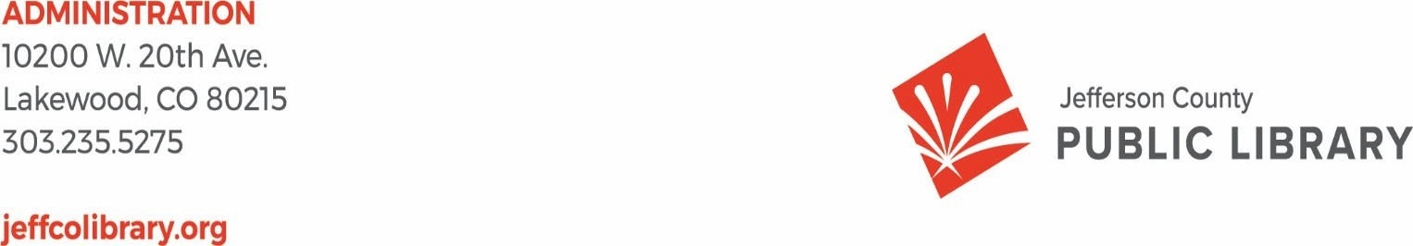

TO: Library Board of Trustees
FROM: Donna Walker, Executive Director RE: Review Global Ends Statements DATE: January 8, 2026

At the beginning of each calendar year the Board reviews their Global Ends Statements - the long-term, broad organizational goals that set direction for the Library - per their governance calendar. This review is a critical step in the strategic planning process.

In 2025 the Board reached consensus on new Global Ends Statements to begin in 2026. The Library recommends that the Board adopt the new Global Ends Statements. These Ends are the foundation of our 2026 Strategic Plan and continue to provide vision and guidance for our priorities, initiatives and projects.
There are two additional policies that require adjustments regarding the Board’s Ends and the Library recommends that the Board also adopt Policies 3.4 Monitoring the Executive Director’s Performance and 4.9.5 Library Books & Materials Budget Policy. The new Global Ends Statements and policies 3.4 and 4.9.5 with the recommended adjustments are attached.

POLICY TYPE: ENDS MISSION, VISION AND BOARD ENDS POLICY 1.0 POLICY TITLE: ENDS POLICIES

Global Ends Statements:

The Jefferson County Public Library helps to build an educated and vibrant community by providing equal access to information and opportunities.

- All Jefferson County residents have equal opportunity to access information, resources, ideas and technology, and they are supported in using these resources.

- All Jefferson County residents have safe, convenient, and radically welcoming places to go to access information and resources and participate in community life.
- Jefferson County Public Library adds value to the community by providing leading-edge services that advance our common goals.
- JCPL maximizes return on shared investment by delivering services of the greatest possible value to Jefferson County residents through effective and efficient use of our resources.

Mission, Vision, and Board Ends

These Board-owned elements establish JCPL’s purpose, future direction, and desired outcomes.

Mission: Jefferson County Public Library enriches lives and our community by providing equitable and free access to information, experiences, and opportunities.

Vision: Jefferson County Public Library is an essential place in our community for connection, learning, discovery, and creation. Everyone belongs. Everyone feels welcome.
Global Ends Statements:

  - Equity of Access
JCPL actively identifies and removes barriers to library services, providing convenient and free access to information and resources for all.

  - Creating Place

Our libraries are safe and accessible spaces that bring people together, encourage discovery, and where everyone belongs.

  - Our People
We empower our team members with the resources, opportunities, and culture to thrive and serve our community.

POLICY TYPE: BOARD–MANAGEMENT DELEGATION POLICY 3.4 POLICY TITLE: MONITORING THE EXECUTIVE DIRECTOR’S PERFORMANCE

The Library Board will systematically and rigorously monitor Executive Director job performance to determine the extent to which Ends are being achieved and whether operational activities fall within boundaries established in Management Limitations policies. Accordingly:

- Monitoring is simply to determine the degree to which Library Board policies are being met. Information that does not address policy compliance will not be considered in the evaluation of Executive Director Performance.
- The Library Board will acquire monitoring data by one or more of three methods:

  - By internal report, in which the Executive Director discloses, in writing, policy interpretations and compliance information to the Library Board
  - By external report, in which an external, disinterested third party selected by the Library Board assesses compliance with Library Board policies
  - By direct board inspection, in which a designated member or members of the Library Board assess compliance with the appropriate policy criteria.

- In every case, the Library Board will judge whether (a) the Executive Director’s interpretation is reasonable, and (b) whether data demonstrate accomplishment of or compliance with the Executive Director’s interpretation.

- In every case, the standard for compliance shall be any reasonable interpretation by the Executive Director of the Library Board policy being monitored. The Library Board is the final judge of reasonableness, and will always judge with a “reasonable person” test (what a reasonably prudent person would do in that context). When judging reasonableness, therefore, interpretations favored by individual board members or by the Library Board as a whole shall not constitute a “reasonable person” test.

- Actions determined to be not compliant with a reasonable interpretation of Library Board policies will be subject to a remedial process agreed to by the Library Board.

- All policies instructing the Executive Director will be monitored at a frequency and by a method chosen by the Library Board. The Library Board may monitor any policy at any time by any method but will ordinarily depend on the following routine schedule.

Policy Method Frequency/Ongoing Schedule
  - General Management Constraint Annually - February
  - Treatment of Patrons Annually – February
  - Treatment of Staff Annually – February
  - Financial Condition and Activities Annually - February
  - Asset Protection Annually - February
  - Financial Planning/Budgeting Annually - August
  - Compensation and Benefits Annually - August

  - Emergency Executive Director Succession
Annually - August

  - Board Awareness and Support Annually - August
  - Materials Selection Annually - August

Global Ends Statements:
The Jefferson County Public Library helps to build an educated and vibrant community by providing equal access to information and opportunities.

    - All Jefferson County residents have equal opportunity to access information, resources, ideas and technology, and they are supported in using these resources.
    - All Jefferson County residents have safe, convenient, and radically welcoming places to go to access information and resources and participate in community life.

    - Jefferson County Public Library adds value to the community by providing leading-edge services that advance our common goals.
    - JCPL maximizes return on shared investment by delivering services of the greatest possible value to Jefferson County residents through effective and efficient use of our resources.

Mission, Vision, and Board Ends

These Board-owned elements establish JCPL’s purpose, future direction, and desired outcomes.
Mission: Jefferson County Public Library enriches lives and our community by providing equitable and free access to information, experiences, and opportunities.

Vision: Jefferson County Public Library is an essential place in our community for connection, learning, discovery, and creation. Everyone belongs. Everyone feels welcome.

Global Ends Statements:

  - Equity of Access

JCPL actively identifies and removes barriers to library services, providing convenient and free access to information and resources for all.

  - Creating Place

Our libraries are safe and accessible spaces that bring people together, encourage discovery, and where everyone belongs.

  - Our People

We empower our team members with the resources, opportunities, and culture to thrive and serve our community.

POLICY TYPE: GOVERNANCE PROCESS POLICY 4.9
POLICY TITLE: POLICIES, STATEMENTS & GUIDELINES

4.9.5 LIBRARY BOOKS AND MATERIALS BUDGET POLICY
Purpose: The Library desires to maintain a responsible level of access to books and materials for Jefferson County residents as defined by demand and use measures of holdings per capita, circulation per capita and annual turnover rate. Each year library staff will establish annual targets for these measures in relation to benchmarks of peer libraries with the aim of reaching the top 75th percentile over time. The annual budget for books and materials will be based on projections developed by the Finance office and Libraries and Inclusion to ensure continual progress toward this goal. The budget for books and materials will ensure that the amount budgeted will move the Library closer to the annual target.
The internal guideline for the budget for Library Books and Materials has been adopted by the Library Board of Trustees to recognize the importance of maintaining the investment in Library Books and Materials.
This guideline serves to ensure that the Library Board of Trustee’s Ends Statement #1 is met each year.
“All Jefferson County residents have equal opportunity to access information, resources, ideas and technology, and they are supported in using these resources.”

“JCPL actively identifies and removes barriers to library services, providing convenient and free access to information and resources for all.”

The Library Board of Trustees reserves the right to modify or adjust the policy each year during the budget process as the Board believes to be in the best interest of the Library.

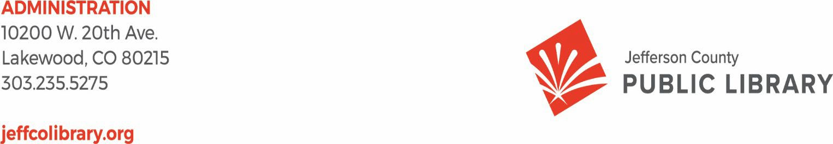

TO: Board of Trustees

FROM: Donna Walker, Executive Director DATE: January 8, 2026
RE: 2026+ Strategic Plan – Duration Recommendation

Purpose

This memo recommends the duration of the upcoming Strategic Plan currently referred to as the 2026+ Strategic Plan.
Recommendation

Staff recommends adopting a four-year Strategic Plan covering 2026–2029, with 2029 serving as a transition and assessment year to inform the next Strategic Plan beginning in 2030.
Rationale

As the organization reviews its active and upcoming commitments and investments—including major capital projects and a Collective Bargaining Agreement—a four-year plan best aligns with capital and operational realities and needs.
Key considerations include:

- Capital Project Delivery and Stabilization
The next several years include the opening and operational ramp-up of significant library facilities:
  - Deer Creek Library – anticipated opening: Early 2028

  - Northwest Jeffco Library – anticipated opening: Late 2028

A four-year plan allows adequate time to operate, stabilize, and evaluate services within these new facilities before initiating a new strategic cycle.
- Collective Bargaining Agreement (CBA)
The forthcoming CBA is anticipated to be a three-year agreement, currently under negotiation and moving toward ratification activities. Aligning the Strategic Plan with this timeframe provides stability while the organization adapts to updated workforce agreements and operational practices.
- Staffing Analysis

In 2026, the organization will complete a staffing analysis modeling workforce needs through 2030. The 2026–2029 Strategic Plan will apply these findings to near-term decisions, with 2029 serving as a transition year to carry the 2030 staffing model into the next Strategic Plan.
- Intentional Planning Reset
Positioning 2029 as a planning and assessment year creates a deliberate runway toward a new Strategic Plan in 2030.
Conclusion

A four-year Strategic Plan (2026–2029) aligns with upcoming capital projects and labor negotiations and allows for a planned transition to the next strategic plan.
Action

This item is presented for Board discussion and potential consensus on a four-year Strategic Plan covering 2026–2029.

TO: Donna Walker, Executive Director

FROM: Steve Chestnut, Director of Facilities and Construction
Amy Bentz, Assistant Director of Library Design and Planning DATE: January 8, 2026
RE: Deer Creek Library Additional Architectural Design Scope - Eppstein Uhen Architects, Inc. (EUA)

Purpose:
To seek Board authorization for the Executive Director to issue a contract modification to Eppstein Uhen Architects, Inc. (EUA) for additional architectural design services related to the Deer Creek Library project.

History of Contract:
The Board of Trustees authorized JCPL to issue a Notice to Proceed to Eppstein Uhen Architects, Inc. (EUA) for the design of the South County Library in April 2025. The cost for the base architectural design services is
$1,502,650 with an alternate that may be issued at a later phase at a cost of $141,600.

Additional scope items were identified at the completion of the Conceptual Design Phase, requiring additional design fees.
The additional scope items include expanding the children’s area, adding a drive-thru book return, expanding parking islands, design of new roof top units, and conducting an entry canopy and skylight/roof openings study.

Total Cost:
The proposed cost for the additional scope items for architectural design services is $104,950. This fee aligns with our budget expectations. Including this change order and the aforementioned potential future alternate of $141,600, the revised contract total will be $1,749,155.

Next Actions:
We would like to ask the Board of Trustees to authorize the Executive Director to amend the contract for additional design services at a base cost of $104,950. Upon approval, the Library will issue the necessary document in accordance with the master contract terms.

Operational Updates Communications and Engagement

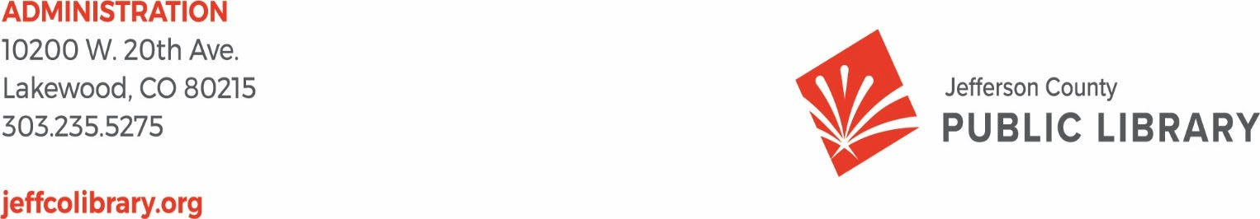
TO: Donna Walker, Executive Director

FROM: Elise Penington, Director of Communications & Engagement DATE: January 8, 2026
RE: Northwest Jeffco Library Naming Discussion

Naming Background
The naming process for the Northwest Jeffco Library has been progressing thoughtfully and deliberately since July 2025, following the steps laid out in our inaugural Library naming process. Following Board discussion in November, staff opted to delay Northwest Jeffco Library naming and consider additional names. At the January 8 Special Meeting, staff will bring forward new name recommendations for Board discussion and feedback.

Next Steps
Staff will incorporate Board feedback before bringing this item back to the Board for a potential vote on Jan. 15, 2026.

We appreciate your time and consideration, and we look forward to the discussion.

Board Governance

TO: Donna Walker, Executive Director FROM: Amber Fisher, Executive Assistant DATE: January 8, 2026
RE: Resolution No. LB-01-15-26 “Sunshine Resolution”

The Library Board of Trustees adopts a resolution annually at their January Board meeting in compliance with C.R.S. 24-6-402, the Colorado Open Meetings or Sunshine law, which requires that the public place or places for posting meeting notices shall be designated annually at the local public body's first regular meeting of each calendar year.

The Library Board of Trustees through this resolution complies with that legal requirement and designates the public website jeffcolibrary.org as the location where notice and agenda information for public meetings of the Board of Trustees of the Jefferson County Public Library will be posted.
The attached resolution is provided to the Board at their January 8, 2026 Special Board meeting and will be placed on the consent agenda for the January 15, 2026 Library Board meeting unless otherwise instructed by the Board.

Attachment: Resolution LB-01-15-26

PROPOSED: 01-08-26

BEFORE THE BOARD OF TRUSTEES
OF THE JEFFERSON COUNTY PUBLIC LIBRARY RESOLUTION NO.: LB 01-15-26
WHEREAS, effective June 1, 1991, the Board of Trustees of the Jefferson County Public Library is subject to the provisions of Senate Bill 91-33 (the "Colorado Sunshine Act"); and

WHEREAS, HB19-1087 was approved by the Governor on April 25, 2019 with an effective date of August 2, 2019. A local public body shall be deemed to have given full and timely notice of a public meeting if the local public body posts the notice, with specific agenda information if available no less than twenty-four hours prior to the holding of the meeting on a public website of the local public body.
and
WHEREAS, the public place in which such notice will be posted must be designated annually.

WHEREAS, the notice must include specific agenda information where possible.
NOW, THEREFORE, BE IT RESOLVED that the Board of Trustees of the Jefferson County Public Library hereby designates the public website jeffcolibrary.org as the location where notice and agenda information for public meetings of the Board of Trustees of the Jefferson County Public Library will be posted.

Date:

This item will be placed on the consent agenda for the January 15, 2026 Library Board meeting unless otherwise instructed by the Board.

