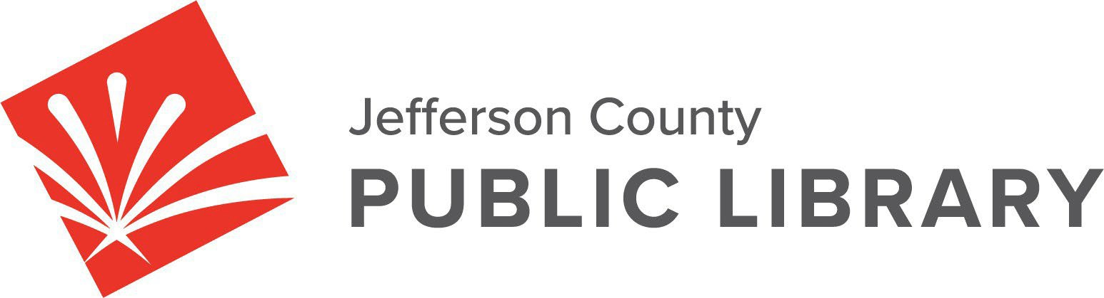

CANCELLED

BOARD STUDY SESSION
DATE: January 8, 2026
TIME: 5:30 P.M.
PLACE: Hybrid Public Meeting - Cancelled

For instructions on how to access the online ZOOM Study Session please go to:
NEXT BOARD STUDY SESSION
https://jeffcolibrary.org/board-of-trustees/2026-study-sessions/

