SPECIAL BOARD MEETING
JEFFERSON COUNTY PUBLIC LIBRARY BOARD OF TRUSTEES
November 13, 2025

  Kids' Club: Marshmallow Engineering |   Indigenous Corporation 5280 Native American Dance
  Labubu Party! |   Evergreen Library Memory Café: Performances by Kinetic Arts Dance Studio

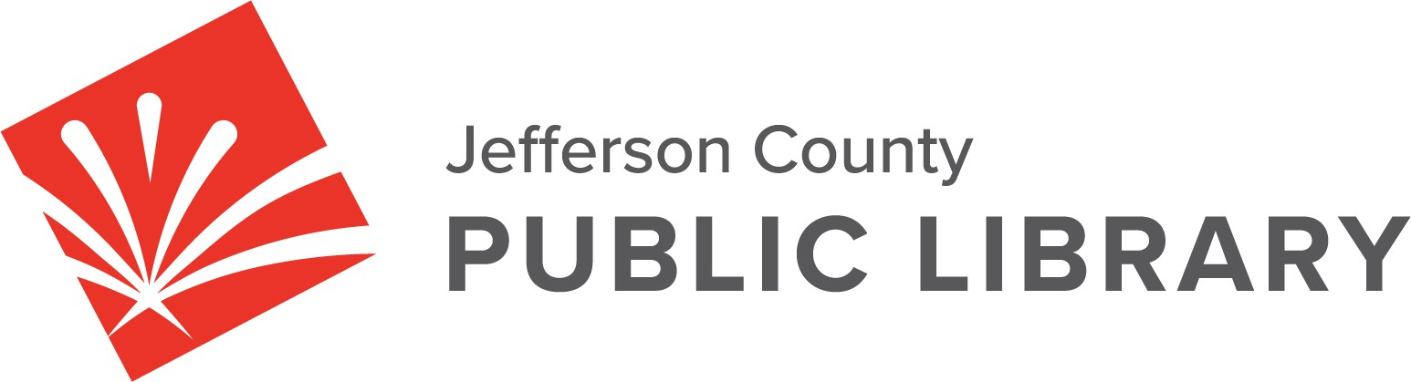

APPROVAL OF AGENDA

SPECIAL BOARD MEETING AGENDA - AMENDED
Jefferson County Public Library Board of Trustees

ITEM# / ACTION | Thursday, November 13, 2025 – 5:30 pm – HYBRID MEETING  - UONLINE MEETING VIA ZOOM  - IN-PERSON MEETING AT LAKEWOOD LIBRARY MEETING ROOM
1. | Call to order & attendance (4.5.8)  A. Verbal roll call – Each Trustee announces their presence by stating their name.
2. | Pledge of Allegiance
3. Agenda  Action | Approve Agenda  Chair: Call for motion and second
4. Operational Updates  Action as Needed | Executive Director and Strategy & Operations  - 2026+ Strategic Plan Presentation  Guest: Greg Bellomo, Government Performance Solutions  Communications & Engagement  - “Northwest Jeffco Library and South County Library Naming” Presentation
5. Emerging Issues
Action as Needed
6. Ends  Action as Needed | Ends: No items.
7. Board Governance  Action as Needed | Board Governance: No items.
8. Suggest Agenda Items  Action as Needed | BOARD SCHEDULE – NEXT MEETINGS –  Location of meetings of the Library Board of Trustees are being determined in cooperation with guidelines from Jefferson County. Information on meeting location will be posted at least one week prior to the scheduled meeting date. 2025 Board Meeting Schedule  - November 20, 2025 – Board Meeting – 5:30 pm Hybrid: Virtual via ZOOM. In-Person Location: Lakewood Library Meeting Room  - December 11, 2025 – Board Meeting – 5:30 pm Hybrid: Virtual via ZOOM. In-Person Location: Lakewood Library Meeting Room
9. EXECUTIVE SESSION | EXECUTIVE SESSION:  (1) Guests: Eric Butler, County Attorney’s Office; and Steven Spirn, Consultant Call for Motion and Second to adjourn the special meeting of the Library Board of Trustees and reconvene in executive session AND adjourn the special Board meeting at the conclusion of the Executive Session.  - Collective Bargaining. Statutory citations authorizing an executive session for this topic:  - Pursuant to 24-6-402(4)(e)(I) for discussion of strategy and instructions to negotiators.  - Pursuant to 24-6-402(4)(b) Conferences with an attorney for the local public  body for the purposes of receiving legal advice on specific legal questions.

Operational Updates
Executive Director & Strategy and Operations

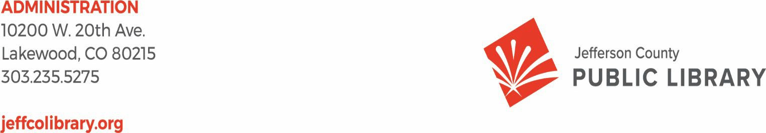
TO: Donna Walker, Executive Director

FROM: Matt Griffin, Chief Strategy & Operating Officer DATE: November 13, 2025
RE: 2026+ Strategic Planning

Purpose:

To present the foundational elements of Jefferson County Public Library’s 2026+ Strategic Plan for Board discussion and consensus.

Overview

Since January 2025, the Library has been engaging the Board of Trustees in the development of a new strategic plan to guide the organization’s work beginning in 2026.

Through a series of workshops and working sessions, the plan’s core components have been refined and we have developed the following framework for consideration.

Mission, Vision, and Board Ends

These elements are owned by the Board of Trustees and represent the Board’s direction for the Library’s purpose, future state, and desired outcomes.

Mission: Jefferson County Public Library enriches lives and our community by providing equitable and free access to information, experiences, and opportunities.

Vision: Jefferson County Public Library is an essential place in our community for connection, learning, discovery, and creation. Everyone belongs. Everyone feels welcome.

Board Ends:

- Equity of Access

JCPL actively identifies and removes barriers to library services, providing convenient and free access to information and resources for all.

Creating Place

Our libraries are safe and accessible spaces that bring people together, encourage discovery, and where everyone belongs.

Our People
We empower our team members with the resources, opportunities, and culture to thrive and serve our community.

Objectives and Animating Language

Based on the above, the Executive Director created the Objectives for the Library, along with supporting Animating Language that brings each to life.

Objectives represent the bridge between governance and operations—they sit beneath each Board End and describe, in more specific and actionable terms, the aspirational impact the Library will work toward to realize the Board’s intent.

Each Board End is supported by two Organizational Objectives that collectively drive alignment between governance and operations.

Equity of Access Objectives:
- Increase Community Use of their Library
Animating Language:
Jeffco residents feel a genuine pull to regularly use the library. What we offer as the library enriches their lives.

Bridge Gaps to Access
Animating Language:
Each element of JCPL service is designed, delivered and promoted to create the opportunity for everyone to participate. Our tax-supported services are provided free of charge.

Creating Place Objectives:

- Make Every Visit an Exceptional Experience
Animating Language:
We treat patrons as welcome guests at every point of contact, creating experiences and spaces that meet or exceed their needs. Individually and as a community, patrons recommend their library as a safe and trusted resource.

Embrace Service Innovation
Animating Language:

A spirit of discovery shapes our services and spaces. We explore and incubate ideas as a community, inclusive of all.

Our People Objectives:

- JCPL is an Employer of Choice
Animating Language:
JCPL understands and takes action on what draws people to work here. Together, we intentionally build a culture of belonging for all.

Employees are Equipped to Deliver on our Promises to our Community
Animating Language:
JCPL staff are trained, supported and encouraged to succeed in their role, with a team focus on meeting the library’s mission.

Organizational Values

In collaboration with all JCPL staff, the organization identified and refined a set of shared Values that express how we work, serve, and lead as a library system.

Following multiple sessions with JCPL staff, the following four values were created:

How you show up at work:
- Integrity
- Collaboration

How you treat others:
- Respect
- Inclusion

Next Steps:

The Board reached consensus on the new Ends in January and on the new Mission and Vision in April. The November 13th Special meeting is designed for Board review of the Strategic Objectives and the strategic framework as a whole.
Following this discussion, staff will incorporate any feedback for consensus at the November 20 meeting.

This detailed 2026 annual plan will be presented for discussion in January.

Operational Updates Communications and Engagement

TO: Donna Walker, Executive Director

FROM: Elise Penington, Director of Communications & Engagement DATE: November 13, 2025
RE: Northwest Jeffco and South County Library Naming Discussion

Naming Background
The naming process for our new South County and Northwest Jeffco Libraries has been progressing thoughtfully and deliberately since July, following the steps laid out in our inaugural Library naming process.

After extensive brainstorming with our internal naming teams, JCPL staff, as well as stakeholders from the Northwest Jeffco and South County communities, were invited to participate in a naming feedback survey. The in-depth responses received through the survey, along with a structured criteria ranking and evaluation process, guided our team in developing a shortlist of recommended names that were presented to the Chief Executive Team (CXO) in September.

The CXO discussion provided further naming insights and guidance on potential names which, combined with an initial review by the County Attorney’s Office to confirm naming availability, resulted in the final names that will be presented to the Board tonight.

Next Steps
The list presented for Board discussion this evening reflects extensive community and historical research, as well as feedback and insights from staff, leadership, community members and Jefferson County’s legal team. Staff will incorporate tonight’s Board feedback before bringing this item back to the Board for final naming selection.

We appreciate your time and consideration, and we look forward to the discussion.

