SPECIAL BOARD MEETING
JEFFERSON COUNTY PUBLIC LIBRARY BOARD OF TRUSTEES
November 13, 2025

  Kids' Club: Marshmallow Engineering |   Indigenous Corporation 5280 Native American Dance
  Labubu Party! |   Evergreen Library Memory Café: Performances by Kinetic Arts Dance Studio



APPROVAL OF AGENDA

SPECIAL BOARD MEETING AGENDA
Jefferson County Public Library Board of Trustees

ITEM# / ACTION | Thursday, November 13, 2025 – 5:30 pm – HYBRID MEETING  - UONLINE MEETING VIA ZOOM  - IN-PERSON MEETING AT LAKEWOOD LIBRARY MEETING ROOM
1. | Call to order & attendance (4.5.8)  A. Verbal roll call – Each Trustee announces their presence by stating their name.
2. | Pledge of Allegiance
3. Agenda  Action | Approve Agenda  Chair: Call for motion and second
4. Operational Updates  Action as Needed | Executive Director and Strategy & Operations  - 2026+ Strategic Plan Presentation  - Library Fund Reserve Policy  Communications & Engagement  - “Northwest Jeffco Library and South County Library Naming” Presentation
5. Emerging Issues
Action as Needed
6. Ends  Action as Needed | Ends: No items.
7. Board Governance  Action as Needed | Board Governance: No items.
8. Suggest Agenda Items  Action as Needed | BOARD SCHEDULE – NEXT MEETINGS –  Location of meetings of the Library Board of Trustees are being determined in cooperation with guidelines from Jefferson County. Information on meeting location will be posted at least one week prior to the scheduled meeting date. 2025 Board Meeting Schedule  - November 20, 2025 – Board Meeting – 5:30 pm Hybrid: Virtual via ZOOM. In- Person Location: Lakewood Library Meeting Room  - December 11, 2025 – Board Meeting – 5:30 pm Hybrid: Virtual via ZOOM. In- Person Location: Lakewood Library Meeting Room
9. EXECUTIVE SESSION | EXECUTIVE SESSION:  (1) Guests: Eric Butler, County Attorney’s Office; and Steven Spirn, Consultant Call for Motion and Second to adjourn the special meeting of the Library Board of Trustees and reconvene in executive session AND adjourn the special Board meeting at the conclusion of the Executive Session.  - Collective Bargaining. Statutory citations authorizing an executive session for this topic:  - Pursuant to 24-6-402(4)(e)(I) for discussion of strategy and instructions to negotiators.  - Pursuant to 24-6-402(4)(b) Conferences with an attorney for the local public  body for the purposes of receiving legal advice on specific legal questions.

Operational Updates
Executive Director & Strategy and Operations

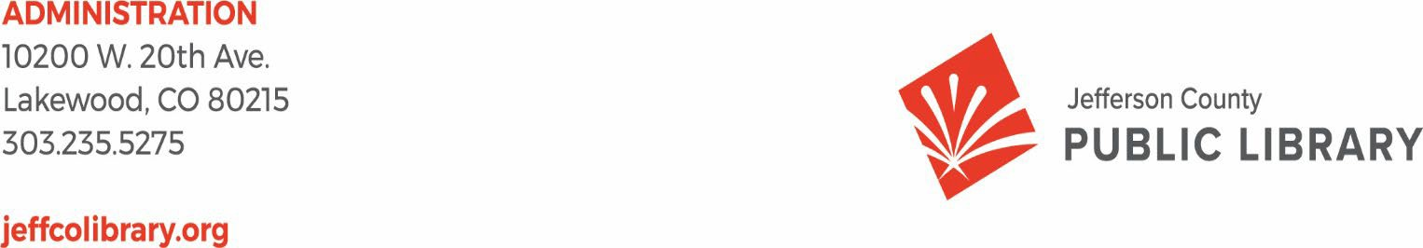
TO: Donna Walker, Executive Director

FROM: Matt Griffin, Chief Strategy & Operating Officer DATE: November 13, 2025
RE: Library Fund Reserve Policy

More information on the 2026+ Strategic Plan Presentation will be provided before the meeting.

TO: Donna Walker, Executive Director

FROM: Matt Griffin, Chief Strategy & Operating Officer DATE: November 13, 2025
RE: Library Fund Reserve Policy

More information on the Library Fund Reserve Policy will be provided before the meeting.

Operational Updates Communications and Engagement

TO: Donna Walker, Executive Director

FROM: Elise Penington, Director of Communications & Engagement DATE: November 13, 2025
RE: Northwest Jeffco and South County Library Naming Discussion

Naming Background
The naming process for our new South County and Northwest Jeffco Libraries has been progressing thoughtfully and deliberately since July, following the steps laid out in our inaugural Library naming process.

After extensive brainstorming with our internal naming teams, JCPL staff, as well as stakeholders from the Northwest Jeffco and South County communities, were invited to participate in a naming feedback survey. The in-depth responses received through the survey, along with a structured criteria ranking and evaluation process, guided our team in developing a shortlist of recommended names that were presented to the Chief Executive Team (CXO) in September.

The CXO discussion provided further naming insights and guidance on potential names which, combined with an initial review by the County Attorney’s Office to confirm naming availability, resulted in the final names that will be presented to the Board tonight.

Next Steps
The list presented for Board discussion this evening reflects extensive community and historical research, as well as feedback and insights from staff, leadership, community members and Jefferson County’s legal team. Staff will incorporate tonight’s Board feedback before bringing this item back to the Board for final naming selection.

We appreciate your time and consideration, and we look forward to the discussion.

