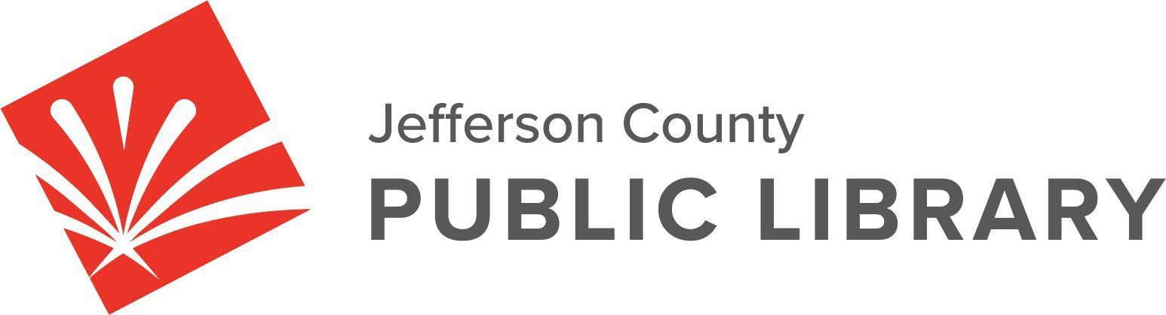

**CANCELLED**

**BOARD STUDY SESSION**

**DATE: October 9, 2025**

**TIME: 5:30 P.M.**

**PLACE: Hybrid Public Meeting - Cancelled**

For instructions on how to access the **online ZOOM Study Session** please go to: [https://jeffcolibrary.org/board‐of‐trustees/2025‐study‐sessions/](https://jeffcolibrary.org/board-of-trustees/2025-study-sessions/)

**NEXT BOARD STUDY SESSION**