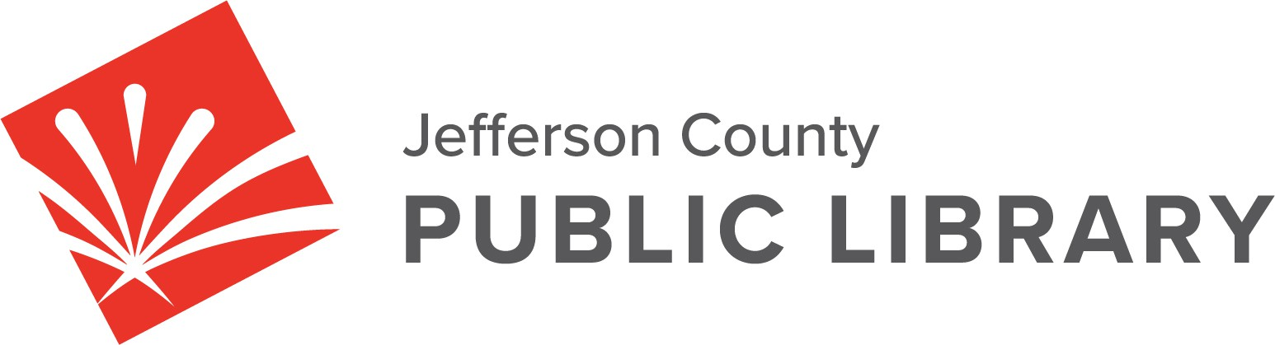

BOARD MEETING - AMENDED

**DATE: September 18, 2025**

**TIME: 5:30 P.M.**

**PLACE: Hybrid Public Meeting**

* **Online via ZOOM**
* **In-Person at Lakewood Library meeting room, 10200 W. 20th Avenue, Lakewood 80215**
* **Executive Session will be held in the Pam Nissler Meeting Room at Library Administration, 10200 W. 20th Avenue, Lakewood 80215**

For instructions on how to access the online ZOOM Board meeting please go to: https://jeffcolibrary.org/board-of-trustees/2025-board-meetings/

**EXECUTIVE SESSION:**

1. Memorandum of Understanding, Proposed County Benefit Changes
   * Pursuant to 24-6-402(4)(e)(I) for discussion of strategy and instructions to negotiators.
   * Pursuant to 24-6-402(4)(b) Conferences with an attorney for the local public body for the purposes of receiving legal advice on specific legal questions.
2. Collective Bargaining. Statutory citation authorizing an executive session for this topic:
   * Pursuant to 24-6-402(4)(e)(I) for discussion of strategy and instructions to negotiators.
3. Executive Director’s Annual Review. Statutory citation authorizing an executive session for this topic:
   * Pursuant to 24-6-402(4)(f) Personnel Matters.

**NEXT BOARD MEETING**