**BOARD MEETING**

JEFFERSON COUNTY PUBLIC LIBRARY BOARD OF TRUSTEES

August 21, 2025

|  |  |
| --- | --- |
| P7C1T1#yIS1  **Demystifying Proteins** | P11C3T1#yIS1  **Intro to Nomad Sculpt: Digital Sculpting Fundamentals** |
| P15C4T1#yIS1  **Art Theft: A Dog Comedy starring Joey & Kira** | P19C6T1#yIS1  **Educator Open House: DTLs & Teachers** |



#### APPROVAL OF AGENDA

|  |  |
| --- | --- |
| ITEM# / ACTION | **Thursday, August 21, 2025 – 5:30 pm – HYBRID MEETING**   * *U***ONLINE MEETING VIA ZOOM** * **IN-PERSON MEETING AT LAKEWOOD LIBRARY MEETING ROOM** * **EXECUTIVE SESSION WILL BE HELD IN PAM NISSLER MEETING**   **ROOM AT LIBRARY ADMINISTRATION** |
| 1. | **Call to order & attendance (4.5.8)**  A. Verbal roll call – Each Trustee announces their presence by stating their name. |
| 2. | **Pledge of Allegiance** |
| 3. Agenda  Action | **Approve Agenda**  Chair: Call for motion and second |
| 4. Public Comment | **Public Comment**  The Board values public participation. Those who would like to address the Library Board can do so virtually, in-person, or online. The opportunity to address the Library Board does not include a question-and-answer session or response.  Additionally, the Library Board does not respond to anonymous questions or comments. Comments will be acknowledged in the minutes of the meeting.  If you choose to make a Public Comment virtually or in-person during a Board meeting, your name will be called in the order it was received, first for virtual guests then for in-person guests.  To address the Library Board of Trustees during Public Comment:   1. In-person: Must sign in on the form provided at the door. 2. Virtually during the public comment portion of the meeting: Send a chat message to the meeting host with name and the comment topic by 5:35pm. 3. Online public comment form: The online form is available at 5:30 pm the Thursday prior to the scheduled Library Board meeting and closes at 1:00 pm the day prior to the scheduled Library Board meeting. 4. People who dial in will not be able to provide public comment during the meeting. 5. Those who failed to sign up or submit the online form, or arrived late, may, at the discretion of the Chair, be allowed to address the Library Board. 6. The Chair has authority to maintain the decorum of the meeting. Conduct or comments that are disruptive to the meeting or its participants are prohibited.   For more information on public comment policy please refer to Board Governance  Policy 4.3.7: [Board Governance Policy Manual (jeffcolibrary.org)](https://jeffcolibrary.org/wp-content/uploads/sites/46/2024/03/March_2024_Board_Governance_Policy_Manual-1.pdf) |
| 5.CONSENT AGENDA  Action | **Approval of Consent Agenda**  Chair: Call for motion and second   1. Approve July 17, 2025 Board Meeting Minutes. 2. Terminate Conifer Library Art Wall Naming Agreement dated March 2, 2025. 3. Authorize the Executive Director to execute an IGA with the Wheat Ridge Urban Renewal Authority, pledging 100% of the Library’s incremental   property tax revenue from the Clearvale URA for a period of 25 years. |

|  |  |
| --- | --- |
|  | D. Authorize the Executive Director to execute an IGA with the Wheat Ridge Urban Renewal Authority, pledging 100% of the Library’s incremental property tax revenue from the Lutheran Legacy Campus URA for a period of 25 years. |
| 6. Foundation | Foundation Update |
| 7.Operational Updates Action as Needed | **Executive Director**   1. Executive Director Report 2. Capital Building Projects Update   **Strategy & Operations**   1. 2025 Midyear Report   Finance and Budget   1. Financial Report (July 2025)   **Facilities and Construction Projects**   1. Lakewood Renovation/Restroom Project Chair: Call for motion and second |
| 8.Action as Needed | Items Removed From Consent Agenda (4.3.4): The Board may address and/or vote on any items that were removed from the Consent Agenda |
| 9. Emerging Issues  Action as Needed |  |
| 10. Ends  Action as Needed | **Ends**: No items. |
| 11. Board Governance Action as Needed | **Board Governance:**   * Adopt Policy Governance Monitoring Reports: 2.5 – 2.9; 3.3 Delegation to the Executive Director; and 4.9.5 Library Books and Materials Budget Policy   Chair: Call for motion and second |
| 12. Suggest Agenda Items  Action as Needed | BOARD SCHEDULE – NEXT MEETINGS –  Location of meetings of the Library Board of Trustees are being determined in cooperation with guidelines from Jefferson County. Information on meeting location will be posted at least one week prior to the scheduled meeting date. 2025 Board Meeting Schedule   * September 11, 2025 – Study Session Hybrid: Virtual via ZOOM. In-Person Location: Lakewood Library Meeting Room * September 18, 2025 – Board Meeting – 5:30 pm Hybrid: Virtual via ZOOM. In- Person Location: Lakewood Library Meeting Room * October 9, 2025 – Study Session Hybrid: Virtual via ZOOM. In-Person Location: Lakewood Library Meeting Room * October 16, 2025 – Board Meeting – 5:30 pm Hybrid: Virtual via ZOOM. In- Person Location: Lakewood Library Meeting Room |

|  |  |
| --- | --- |
| 13. Discussion | Board Questions or Comments Related to Items on the Meeting Agenda |
| 14. Discussion | Evaluate Board Meeting (4.1.9) |
| 15. Information | Announcements/General Information Sharing   * Report of the Chair – Correspondence, Other * Other Announcements |
| 16. EXECUTIVE SESSION | EXECUTIVE SESSION:   * Guests: Kurt Behn, County Attorney’s Office; Eric Butler, County Attorney’s Office; and Steven Spirn, Consultant   Call for Motion and Second to adjourn the regular meeting of the Library Board of Trustees and reconvene in executive session AND adjourn the regular Board meeting at the conclusion of the Executive Session.   1. Library Services for the Wheat Ridge Community    * Pursuant to 24-6-402(4)(b) Conferences with an attorney for the local public body for the purposes of receiving legal advice on specific legal questions.    * Pursuant to 24-6-402(4)(e)(I) for discussion of strategy and instructions to negotiators.    * Pursuant to 24-6-402(4)(a) Concerning the purchase, acquisition, lease, transfer or sale of Property.   (2) Collective Bargaining. Statutory citations authorizing an executive session for this topic:   * Pursuant to 24-6-402(4)(e)(I) for discussion of strategy and instructions to negotiators. |

**CONSENT AGENDA**

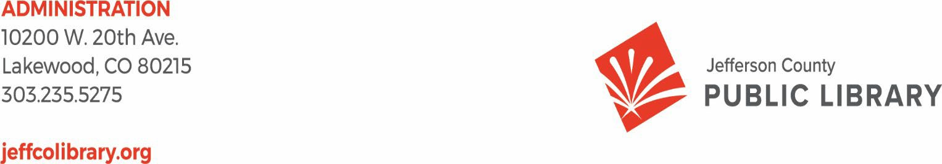

TO: Library Board of Trustees

FROM: Kim Johnson, Chair and Donna Walker, Executive Director DATE: August 14, 2025

RE: Consent Agenda for the August 21, 2025 Board Meeting - **AMENDED**

1. Library Board of Trustees approve minutes of July 17, 2025 Board Meeting
2. Terminate Conifer Library Art Wall Naming Agreement dated March 2, 2025.
3. Authorize the Executive Director to execute an IGA with the Wheat Ridge Urban Renewal Authority, pledging 100% of the Library’s incremental property tax revenue from the Clearvale URA for a period of 25 years.
4. Authorize the Executive Director to execute an IGA with the Wheat Ridge Urban Renewal Authority, pledging 100% of the Library’s incremental property tax revenue from the Lutheran Legacy Campus URA for a period of 25 years.

**Minutes of the Regular Meeting of the JEFFERSON COUNTY PUBLIC LIBRARY**

**BOARD OF TRUSTEES July 17, 2025**

CALL TO ORDER – REGULAR MEETING

The regular meeting of the Jefferson County Public Library Board of Trustees was held online vial ZOOM and in-person in the Lakewood Library meeting room on July 17, 2025. Library Board of Trustees Chair, Kim Johnson, called the meeting to order at 5:31 p.m.

Other Trustees present: Emelda [Bing] Walker (Vice-Chair), Pam Anderson, Renny Fagan and Jill Fellman.

Absent: Charles Jones.

Staff present: Donna Walker, Executive Director; Matt Griffin, Chief Strategy & Operating Officer; Julianne Rist, Library Planning & Policy Senior Advisor; Lisa Smith, Chief People & Culture Officer; Elise Penington, Director of Communications and Engagement; Steve Chestnut, Director of Facilities and Construction Projects; Amy Bentz, Assistant Director of Library Design Projects and Planning; Jessica Paulsen, Assistant Director of Libraries & Inclusion for Customer Experience; Padma Polepeddi, Assistant Director of Libraries & Inclusion for Community Outreach; Brad Green, TDI Systems and Security Manager; Cheryl Murphy, TDI Service Manager; Amber Fisher, Executive Assistant; Katie O’Loughlin, Administrative Coordinator Supervisor; Ryan Turch, Technology and Innovation Operations Supervisor

There were additional Library staff members attending the meeting.

APPROVAL OF AGENDA

**MOTION:** Emelda Bing Walker moved that the Library Board of Trustees approve the agenda as presented. Seconded by Pam Anderson, the motion passed by unanimous vote of all Trustees present.

PUBLIC COMMENT

The Board values public participation. Those who would like to address the Library Board can do so virtually, in-person, or online. The opportunity to address the Library Board does not include a question and answer session or response. Additionally, the Library Board does not respond to anonymous questions or comments. Comments will be acknowledged in the minutes of the meeting. The Chair provided additional information on how to participate in public comment.

The Chair advised the Board that a number online public comments were received and provided to the Trustees. The Chair noted that she also sent emails that were sent to the Executive Director email account and addressed to the Board.

Lauren Seegmiller, Jill Hinn, Sammi Johnson, Jenny Crownover, Brad Bruce, Emily Batista and MaryJo Sobocinski, addressed the Board and provided public comment regarding dress code, library neutrality, disability pride month, history of disability laws, dress code petition and collective bargaining negotiations.

The Chair thanked the public comment participants and closed the public comment portion of the meeting at 5:57 pm.

APPROVAL OF CONSENT AGENDA

The Chair asked the Trustees if any of the items should be removed from the consent agenda. There were no requests for items to be removed.

Items on the Consent Agenda

1. Library Board of Trustees approve minutes of June 12, 2025 Board Study Session
2. Library Board of Trustees approve minutes of June 18, 2025 Board Meeting
3. Library Board of Trustees authorize Midwest Tape Audio/Visual Contract Renewal
4. Library Board of Trustees authorize Xcite Agreement and Purchase for Conifer Community Room Audio/Visual

**MOTION**: Pam Anderson moved that the Library Board of Trustees approve the items on the consent agenda as presented. Seconded by Renny Fagan the motion passed by unanimous vote of all Trustees present.

FOUNDATION UPDATE

Jo Schantz provided an update on the activities of the Foundation and highlighted items from her written report.

EXECUTIVE DIRECTOR REPORT

1. Executive Director Report

The Executive Director addressed the Board and noted she received news yesterday from Bridget Beatty that she had secured a $60,000 grant from the Colorado Gives Foundation for early learning and education. JCPL’s Technology and Digital Innovation team is participating in the 2025 Jeffco Tech Showcase next week. In addition to being nominated for several awards the team will staff a dedicated booth to highlight the wide array of technology resources we offer.

1. Capital Building Projects Update
   * South County: As a result of great outreach efforts, staff were invited to a neighborhood open house. Rene Yaws, South County Manager is doing monthly

outreach story times to day cares and promoting summer challenge and interim services. Great promotions from JCPL’s communications team and staff working behind scenes.

* + Northwest Jeffco. The Executive Director and staff met with Gabe Martinez from Senator Bennet’s office to tour the site and provide information on a grant request for

$600,000 in congressional spending.

* + Arvada Library Redesign. Staff are reviewing bigger ticket design items to evaluate options, like elevators and pricing was received yesterday. Staff are picking out finishes and fixtures and participating in the process is fun for staff.
  + Conifer Library. The Executive Director sends progress picture to the Board every week. Internet service to Conifer is expected soon. Right now it looks like the grand opening is scheduled for September 13 with a VIP event on September 12. The Board will receive invitations.

The Executive Director and Julianne Rist, Library Planning & Policy Senior Advisor met with the City of Wheat Ridge today on some of the planning the City is doing. The Library will be bringing more information to the Board.

There were no questions from the Board.

OPERATIONAL UPDATES

**Strategy and Operations**

Finance and Budget

A. Financial Report (June 2025)

Matt Griffin, Chief Strategy & Operating Officer, addressed the board and provided information on the monthly financial report. Matt Griffin reported on the year-to-date end of June financials and reviewed the close of quarter two, to check for alignment with expectations and forecast into the second part of the year. Property tax revenue is at 98% which comes in earlier in the year and is exactly on trend. Investment income is trending up and is monitored closely as it can fluctuate throughout the year. There is negative reporting within grant funds that is tied to the State grant. This is a temporary timing issue and next month the Board will see that reverse out. Operating expenditures salaries and benefits is trending below slightly and overall is tracking as expected. Total operating is at 47% a strong position for closeout of quarter two. Treasurers’ fees are trending against budget. On Table 3, there are no specific call outs this month and spending is underway.

There were no questions from the Board.

**Strategy & Operations**

A. Resolution Regarding Capital Project Authority to Execute

Matt Griffin, Chief Strategy & Operating Officer, advised the Board that the reason the Library is bringing this resolution forward is that when JCPL does capital projects like

renovations or new buildings there are filings like zoning requests that need to be filed through the city or County as part of the standard design and construction process. The resolution gives the Executive Director ongoing permission to sign routine documents only for capital projects the Board has approved. The resolution does not allow the Executive Director to sign anything that would change who owns the property. Giving this authorization is needed to help keep the capital projects on schedule and still maintains Board authority of major decisions.

In response to questions, the Board was advised that:

* The documents are not dollar related, and no dollar amounts are associated with the documents.
* The number of documents and frequency does depend on the project and the authorities JCPL is working with.
* The types of documents required include the architects’ identifying certain things the cities require and is hard to forecast.
* JCPL currently has two documents related to the resolution; one for Arvada Redesign and one for Northwest Jeffco.
* The documents are public documents.

The Executive Director advised the Board that she would include information on the documents signed under this resolution in her monthly report to the Board.

**MOTION**: Jill Fellman moved that the Library Board of Trustees adopt Resolution LB-07- 17-25 Capital Project Authority to Execute as presented. Seconded by Pam Anderson, the motion passed by unanimous vote of all Trustees present.

ITEMS REMOVED FROM THE CONSENT AGENDA

No items were removed from the consent agenda.

EMERGING ISSUES

No issues.

ENDS

There were no items.

BOARD GOVERNANCE

No items.

BOARD SCHEDULE – NEXT MEETINGS

2025 Board Meeting Schedule

* August 14, 2025 – Study Session Hybrid: Virtual via ZOOM. In-Person Location: Lakewood Library Meeting Room
* August 21, 2025 – Board Meeting – 5:30 pm Hybrid: Virtual via ZOOM. In-Person Location: Lakewood Library Meeting Room
* September 11, 2025 – Study Session Hybrid: Virtual via ZOOM. In-Person Location: Lakewood Library Meeting Room
* September 18, 2025 – Board Meeting – 5:30 pm Hybrid: Virtual via ZOOM. In-Person Location: Lakewood Library Meeting Room

ANNOUNCEMENTS/GENERAL INFORMATION SHARING

The Chair advised the Trustees that there was no correspondence other than the previously noted emails from the Executive Director email account where it does seem the intent was to communicate with the Trustees.

EXECUTIVE SESSION:

At 6:27 pm, the Chair called for a motion to adjourn the regular meeting, reconvene in Executive Session regarding Collective Bargaining and adjourn the regular Board meeting at the conclusion of the Executive Session.

**MOTION**: Pam Anderson moved to adjourn the regular meeting of the Library Board of Trustees, reconvene in Executive Session regarding Collective Bargaining AND adjourn the Regular Board meeting at the conclusion of the Executive Session. Statutory citations authorizing an executive session for this topic are:

* Pursuant to 24-6-402(4)(e)(I) for discussion of strategy and instructions to negotiators
* Pursuant to 24-6-402(4)(b) Conferences with an attorney for the local public body for the purposes of receiving legal advice on specific legal questions.

Seconded by Renny Fagan the motion passed by unanimous vote of all Trustees present.

The Chair announced a ten minute break to allow the Board and staff to clear the room, leave the existing ZOOM meeting and then join the Executive Session.

The Chair called the Executive Session to order at 6:37pm with the following trustees present: Kim Johnson, Pam Anderson, Renny Fagan, Jill Fellman and Emelda (Bing) Walker. Also present were Eric Butler, Deputy County Attorney, Steven (Steve) Spirn; Donna Walker, Executive Director; Lisa Smith, Chief People & Culture Officer; Matt Griffin, Chief Strategy & Operating Officer; Elise Penington, Director of Communications & Engagement; Brad Green, TDI Systems and Security Manager and Amber Fisher, Executive Assistant.

It is noted that the session was recorded and that the recording will be retained for the required 90 days.

CALL FOR ADJOURNMENT OF EXECUTIVE SESSION

**MOTION**: Emelda Bing Walker moved to adjourn the executive session. Seconded by Jill Fellman the motion passed by unanimous vote of all Trustees present.

The Chair adjourned the executive session at 8:04 pm.

It is noted that the Library Board of Trustees met in Executive Session concerning Collective Bargaining pursuant to 24-6-402(4)(e)(I) for discussion of strategy and instructions to negotiators and 24-6-402(4)(b) Conferences with an attorney for the local public body for the purposes of receiving legal advice on specific legal questions. The Trustees held those discussions, and this summary is provided as required by Colorado Statute.

Charles Jones, Secretary

RE: Wheat Ridge Urban Renewal Authority Intergovernmental Agreement (IGA) - Clearvale

**Purpose:**

To request Board authorization for the Executive Director to execute a Tax Increment Revenue Agreement with the Wheat Ridge Urban Renewal Authority d/b/a Renewal Wheat Ridge for the Clearvale Urban Renewal Plan, pledging 100% of the Library’s incremental property tax revenue from the area for the 25-year duration of the Plan.

**Background:**

Under House Bill 15-1348, local taxing entities impacted by an urban renewal plan must be given the opportunity to negotiate the sharing of property tax increment revenues before plan adoption. Renewal Wheat Ridge is advancing the Clearvale Urban Renewal Plan.

The Clearvale Urban Renewal Area (URA) spans approximately 109 acres along the 44th Avenue corridor. Guided by the 44th Avenue Subarea Plan, the redevelopment program includes small-scale retail, light industrial, and streetscape upgrades. These improvements are intended to boost local business activity and enhance the public realm.

The proposed IGA allows Renewal Wheat Ridge to retain 100% of the property tax revenue generated by the Library’s 4.5 mill levy above the base year amount within the designated area, for a 25-year term.

**Next Actions:**

We request the Board of Trustees authorize the Executive Director to execute an IGA with the Wheat Ridge Urban Renewal Authority, pledging 100% of the Library’s incremental property tax revenue from the Clearvale URA for a period of 25 years.

This item will be placed on the consent agenda for the August 21, 2025 board meeting unless otherwise instructed by the Board.

RE: Wheat Ridge Urban Renewal Authority Intergovernmental Agreement (IGA) – Lutheran Legacy Campus

**Purpose:**

To request Board authorization for the Executive Director to execute a Tax Increment Revenue Agreement with the Wheat Ridge Urban Renewal Authority d/b/a Renewal Wheat Ridge for the Lutheran Legacy Campus Urban Renewal Plan, pledging 100% of the Library’s incremental property tax revenue from the area for the 25-year duration of the Plan.

**Background:**

Under House Bill 15-1348, local taxing entities impacted by an urban renewal plan must be given the opportunity to negotiate the sharing of property tax increment revenues before plan adoption. Renewal Wheat Ridge is advancing the Lutheran Legacy Campus Urban Renewal Plan.

The Lutheran Legacy Campus Urban Renewal Area (URA) plan encompasses the 145-acre former Lutheran hospital site. It envisions a mixed-use neighborhood with approximately 1,310 new housing units, retail space, and public open space covering at least 20% of the site. Trail connections will be added, and historic structures such as the Blue House and chapel will be preserved. The design emphasizes walkability and community-focused amenities.

The proposed IGA allows Renewal Wheat Ridge to retain 100% of the property tax revenue generated by the Library’s 4.5 mill levy above the base year amount within the designated area, for a 25-year term.

**Next Actions:**

We request the Board of Trustees authorize the Executive Director to execute an IGA with the Wheat Ridge Urban Renewal Authority, pledging 100% of the Library’s incremental property tax revenue from the Lutheran Legacy Campus URA for a period of 25 years.

This item will be placed on the consent agenda for the August 21, 2025 board meeting unless otherwise instructed by the Board.

##### Foundation Update



IEFFE SO COU TY

**LIB**RA Y OU DA: 10

**AUGUST 2025**

***Executive Director Report***

**by Jo Schantz Hall, MNM, CFRE, GPC**

**UPCOMING EVENTS**

## DINE & DONATE AT 240 UNION CREATIVE GRILLE

Our Foundation is pleased to partner (for the 4th year in a row) with the 240 Union Creative Grille on a Dine & Donate fundraiser. This will be held on Wednesday, September 17.

Diners turn into donors simply by ordering lunch or dinner at: the popular restaurant, and JCLF receives 25% of all food • sales that day. Last year's event generated more than

$2,200 for our Foundation!

The restaurant is located at 240 Union Blvd. in Lakewood. Reservations can be made at: https://240union.com/reservations/

## BARNES & NOBLE BOOKFAIR SEPT. 20TH

Speaking of ongoing partnerships, JCLF is again joining forces with Barnes & Noble Booksellers in Denver West Village for our annual Bookfair on Saturday, Sept. 20.

Shoppers will receive a voucher from staff and volunteers who will greet them during their shopping visits. When checking out with their purchases, customers hand in the vouchers and our Foundation earns a cash donation according to how many sales are made that day.

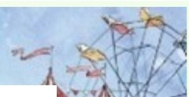Items eligible for the Bookfair include: books, audiobooks, games, puzzles and electronics.

�p.l\ ES & NOBtt: •

**BOOKFAIRS���·T"-Jl�-lr-1**



## OFFICE CLOSURE NOV. 7TH

Veterans Day 2025 will occur on Tuesday November 11th. This year, in observance of Veterans Day, JCLF will be CLOSED on FRIDAY, NOVEMBER 7TH. Our office/warehouse will be open, however, on Columbus Day/Indigenous Peoples Day, on Monday October 13.

## COMMUNITY CONNECTIONS

* July 22 - Meeting with S. Jeffco Rotary Club to discuss pancake breakfast for fall Whale of a Used Book Sale
* July 23 - JCPL Combined Management Team meeting
* July 23 - JCLF Board of Directors meeting
* July 24 - Meeting with representatives from City of Arvada
* July 25 - JCLF Volunteer Appreciation Luncheon
* July 29 - Lakewood Foothills Rotary Club Board meeting
* July 31 - JCLF site visit with new JCPL staff member Cynthia Kiyotake
* Aug. 4 - Meeting with Donna Walker
* Aug. 5 - Meeting with S. Jeffco Rotary Club; visit to Jeffco Fairgrounds
* Aug. 7 - Lunch meeting with grant consultant Bridget Beatty
* Aug. 11 - Meeting with Donna Walker
* Aug. 12 - Wheat Ridge Business Assn. breakfast
* Aug. 12 - Lakewood Foothills Rotary Club dinner
* Aug. 13 - Meeting with Caroline Seals, Boeing Employees Community Fund
* Aug. 13 - Lakewood Foothills Rotary Club Board meeting
* Aug. 13 - Check-in meeting with JCPL Communications staff
* Aug. 14 - Applewood Business Assn. luncheon
* Aug. 16 - JCLF Shred-a-thon!
* Aug. 19 - JCLF Finance Committee meeting
* Aug. 19 - Lakewood Foothills Rotary Club lunch meeting
* Aug. 21 - 2025 Breakfast with the Chief; Arvada Police Foundation

## [WWW.JEFFCLF.0RG](http://WWW.JEFFCLF.0RG/)

TY

**PAGE *2***

**AUGUST 2025**

L 10

***Executive Director Report* FUNDRAISING**

## UPDATE

**FALL 2025 WHALE OF A USED BOOK SALE**

Our Foundation will host its 23rd annual fall Whale of a Used Book Sale October 16 - 19 at the Jefferson County Fairgrounds. And this year we are adding a new twist -- a pancake breakfast that will be available to our shoppers on Sunday morning, Oct. 19 (times TBD).

Recently we reached out to the South Jeffco Rotary Club with the opportunity

to host a pancake breakfast, and this club was eager to jump on board with the idea. This will be a fundraising event tobenefit the Rotary Club and also generate some extra monies for JCLF!

As an added bonus, and on

GRANTS PENDING

* Nathan B. and Florence R. Burt Foundation

-- $5,000 for 1000 Books Before Kindergarten

* Viking Foundation -- $6,000 for Babies First Books
* Kerr Foundation -- $5,000 for 1000 Books Before Kindergarten
* RK Foundation -- $10,000 for 1000 Books Before Kindergarten
* Boeing Employees Community Fund -­

$10,000 for JCLF general fund

* City of Wheat Ridge -- $5,500 for Wheat Ridge Reads program
* BOK Foundation -- $5,000 for 1000 Books

Before Kindergarten

* Howe Foundation -- $5,000 for 1000 Books Before Kindergarten
* Denver Broncos Charities -- $10,000 for

1000 Books Before Kindergarten

**Rotary@**

that same Sunday, Colorado State University Extension

{CSUE) will once again produce its popular and FREE

* + Mabel Hughes Charitable Fund -- $26,208 for Hard Times Writing Workshop
  + Non-County Agencies Program {NCAP) -­

Fall Family Fun Day in the CSUE parking lot adjacent to the

Fairgrounds parking lot. Activities will include a bouncy castle and a Halloween Trunk of Treat for children. Families are invited to attend this free event (times TBD).

� JEFFERSON COUNTY

* + - **COLORADO STATE UNIVERSITY**

## OUR SUMMER NEWSLETTER

$25,000 JCLF general fund

* + Saks Fifth Avenue Foundation -- $26,208 for Hard Times Writing Workshop
  + Sam S. Bloom Foundation -- $5,000 for 1000 Books Before Kindergarten
* • Gorham McGee Fund -- $5,000 for 1000 Books Before Kindergarten
  + Believe in Reading Foundation -- $4,865 for Babies First Books

FUNDING APPROVED/RECEIVED

* + National Renewable Energy Laboratory

Want to know more about JCLF and what's going on this . {NREL) -- $1,000 Friends Community summer? Check out our summer 2025 Footnotes • Partner

newsletter available in hardcopy or online. For the online vetsion, visit https://jeffclf.org/wp-content/uploads/2025

/08/JCLF-2025-Summer-Footnotes-Newsletter.pdf

FUNDING DENIED

* + Bachus & Schanker Cares Foundation -­

$1,000 for Raise A Reader Festival

##### Executive Director Report

**AUGUST 2025** EXECUTIVE DIRECTOR REPORT

##### 2025 Annual Plan Progress in August

###### Portfolio: Service Point Development & Expansion

**Program: New Construction Project: South County Library**

* + - Property master planning and conceptual design
    - Finalize Key Performance Indicators
    - Library naming survey to limited stakeholders

**Project: Northwest Jeffco Library**

* + - Cost modeling for schematic design
    - Investigate sustainability options
    - Finalize Key Performance Indicators
    - Library naming survey to limited stakeholders
    - Submitted re-plat application on behalf of Owner

**Program: Building Redesign Project: Arvada Library**

* + - Signed Minor Modification Application to the City of Arvada on behalf of Owner
    - Initiate construction development drawings
    - Finalize Key Performance Indicators
    - Finalize donor solicitation book

**Program: Tenant Finish Project: Conifer Library**

* + - Obtain Certificate of Occupancy
    - Move out of Conifer High School
    - Begin move into new location

###### Portfolio: Embracing Innovation & Change

**Program: Fundraising Development**

* + - Continue key informant interviews
    - Continue grant research and submissions
    - Investigate improved grant processes

###### Portfolio: Continuous Process Improvement

**Project: Collective Bargaining Agreement**

* + - Continue negotiations



**Project: 2026+ Strategic Plan**

* + - Launch “values” selection with all staff
    - Continue plan development

##### Service Highlights:

**A Back-to-School Boost for Our Educators**

As the new school year kicks off, it’s not just students who need support. Teachers are invited to drop in to an Educator Open House to connect with library staff, explore classroom-ready resources, register for prizes and find the perfect back-to-school read.

##### New Garden at the Belmar Library

Two Alameda International students engaged in the [SOAR](https://www.soarcolorado.org/) [program,](https://www.soarcolorado.org/) working with JCPL staff, led the creation of a new garden on the south side of Belmar Library near the walking path.

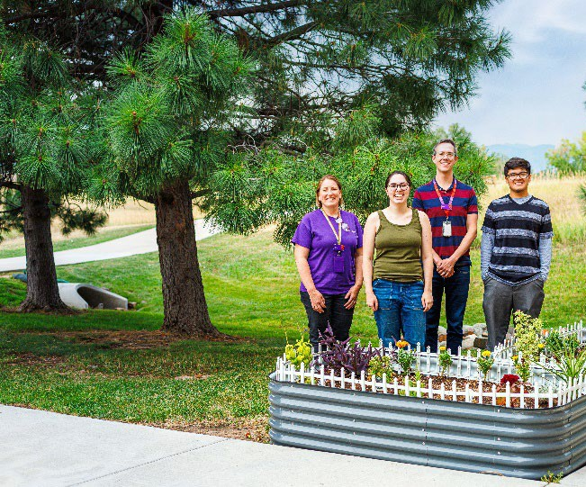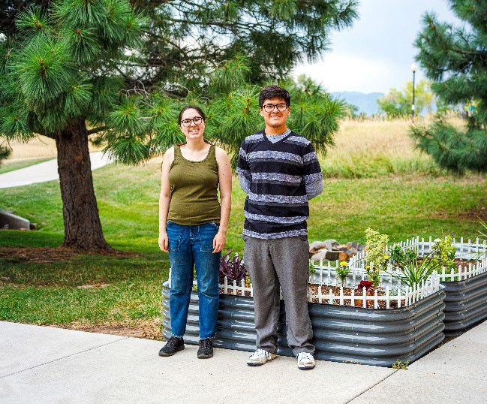

**2025 Conferences: ADVOCACY AND ENGAGEMENT OPPORTUNITY FOR**

##### Trustees

**Urban Libraries Council Annual Leadership Forum** October 22-24, Cincinnati, Ohio. Let Amber Fisher know by September 22 if you plan to attend. Registration is now open. This year’s theme, *Leading with Advocacy: Championing Urban Libraries*, will bring together our dynamic community of CEOs, senior leaders, and partners to explore the bold advocacy strategies needed to secure the future of public libraries.

###### Professional Engagement

Creative Technicians **Allie Awe, Alex Galindo, and Joy Mackey** will attend the Colorado Association of Libraries (CAL) Maker’s Conference.

**Erica Cole**, Collection Development Librarian, will attend Digipalooza.



#### HIGHLIGHTS OF EXECUTIVE DIRECTOR COMMUNITY ACTIVITIES,

AUGUST 2025

* Attend **Colorado Association of Libraries Legislative Committee** meeting
* Attend **ULC Director/CEO** weekly meeting
* Attend **Wheat Ridge Mayor’s** Carnation Festival Reception
* Attend **Jeffco Connections Board** meeting
* Trustee Lunches with **Bing Walker and Kim Johnson**
* Meet with Joe Kerby, **Jefferson County Manager**
* Present 2026 JCPL budget to **Board of County Commissioners**
* Attend **Elected Officials/Personnel Board** meeting
* Calls with city of Wheat Ridge stakeholders
* Meetings with Jo Schantz, executive director, **Jefferson County Library Foundation**
* Tour Conifer site with **donor Laura Coffey**
* Present the **All JCPL Staff Town Hall**
* Attend the **Evergreen Outdoor Reading Deck Opening Event**



##### Operational Updates Strategy and Operations



2025 MID-YEAR REPORT



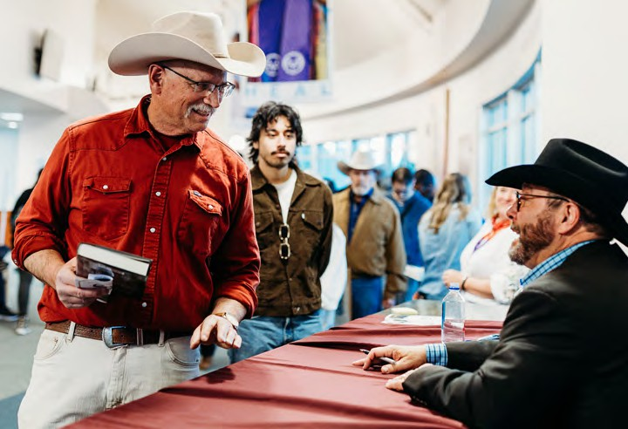

Top Row: Colores del espíritu / Colors of the Spirit at Evergreen Library, Toddler Art at Golden Library Bottom Row: C.J. Box Spring Author Event, Starry Sky Watercolor Art at Evergreen Library

ADMINISTRATION



10200 W. 20th Ave.



Lakewood, CO 80215



303.235.5275

[jeffcolibary.org](http://jeffcolibary.org/)

To: Donna Walker, Executive Director

From: Matt Griffin, Chief Strategy & Operating Officer Re: 2025 Mid-Year Report

Date: August 2025

# 2025 JEFFERSON COUNTY PUBLIC LIBRARY MID-YEAR REPORT

As we reach the midpoint of 2025, I am pleased to present the Mid-Year Report for Jefferson County Public Library (JCPL). This report is designed to provide a detailed overview of the progress made on our Strategic Priorities, Initiatives, Programs and Projects during the period between January 1 and June 30, 2025. Additionally, it highlights the notable achievements across the organization that have significantly impacted the experience of our patrons.

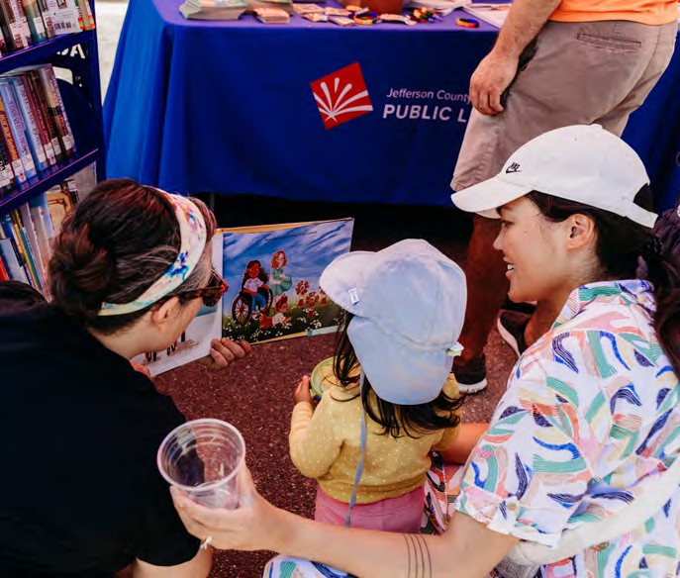This report focuses on concrete outcomes and tangible results, reflecting the efforts and dedication of our teams in driving forward our key initiatives. It presents a transparent assessment

of our project milestones, emphasizing the successful execution of our strategic objectives. Furthermore, the report delves into data on patron usage and activities, offering valuable insights into evolving trends and behaviors as community needs and expectations continue to shift.

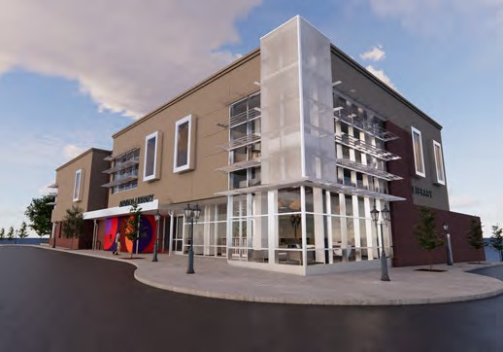

PROJECT PURPOSE

Build a new destination library in the southern region to connect our underserved community to library services. This expansion will provide additional access to information and opportunities for all generations.

2025 MAJOR DELIVERABLES

1. Finalize Program of Service
2. Complete Design Development phase
3. Develop recommendations for interim uses
4. Investigate partnership opportunities
5. Initiate naming

2025 PROGRESS

1. Finalized Program of Service
2. Launched Design Team
3. Developed recommendations for interim uses
4. Launched interim uses

PROJECT PURPOSE

Redesign this urban/suburban library for the future in order to reach more people, focus on building literacies and be the third place in this community.

2025 MAJOR DELIVERABLES

1. Finalize Design Development
2. Complete construction drawings with guaranteed maximum price (GMP)
3. Implement alternative service options
4. Begin construction
5. Initiate naming opportunities solicitation

2025 PROGRESS

1. Finalized Design Development

# 2025 ANNUAL PLAN

Jefferson County Public Library’s priorities and multi-year initiatives guide our decision-making about strategic projects for organizational focus.

PROGRAM

South County

PROJECT

South County Library

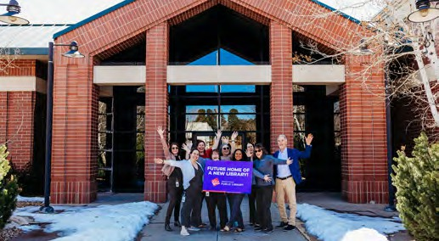

PROGRAM

Building Redesign

PROJECT

Arvada Library

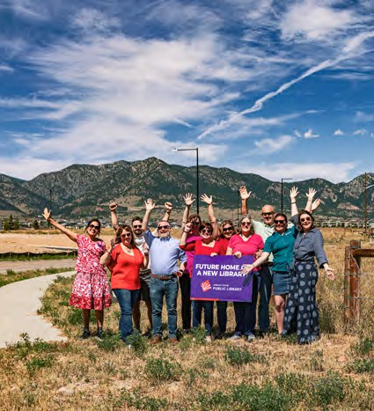

PROGRAM

Tenant Finish

PROJECT

Conifer Library

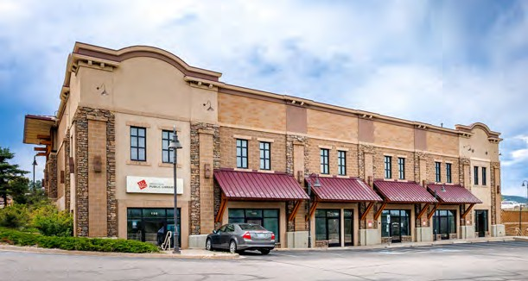

PROJECT PURPOSE

Evaluate and recommend library services for the Conifer area and implement the

recommended services. This project will ensure that JCPL services meet the needs of the Conifer community by providing equal access to information and opportunities, and being the essential destination where all generations connect, discover and create.

2025 MAJOR DELIVERABLES

1. Finalize construction documents with guaranteed maximum price (GMP)
2. Conclude intergovernmental agreement (IGA) with Conifer High School
3. Finalize grant & naming opportunities solicitation
4. Open new Conifer Library

2025 PROGRESS

1. Finalized construction documents with guaranteed maximum price (GMP)
2. Concluded intergovernmental agreement (IGA) with Conifer High School
3. Finalized grant & naming opportunities solicitation

PROJECT PURPOSE

Build a new destination library in the northwest region to connect our underserved community to library services. This expansion will provide additional access to information and opportunities for all generations.

2025 MAJOR DELIVERABLES

1. Finalize Program of Service
2. Complete Design Development phase
3. Investigate partnership opportunities
4. Initiate grant & naming opportunities solicitation

2025 PROGRESS

1. Finalized Program of Service

PROGRAM

New Construction

PROJECT

Northwest Jeffco Library

PROJECT PURPOSE

Analyze the current JCPL compensation plan, create a compensation philosophy and policy, develop a new plan for all JCPL positions and incorporate changes into the 2026 budget.

2025 MAJOR DELIVERABLES

1. Complete compensation analysis
2. Integrate findings into Collective Bargaining Agreement (CBA)
3. Integrate findings into 2026 budget

2025 PROGRESS

1. Completed compensation analysis

PROGRAM

Create a Radically Welcoming JCPL - Staff

PROJECT

All Staff Compensation Strategy

PROJECT PURPOSE

Implement processes and tools that streamline and personalize the user experience for Library patrons.

2025 MAJOR DELIVERABLES

1. Develop standardized new patron onboarding process
2. Implement new patron onboarding plan
3. Identify tools for personalized patron experience
4. Implement tools for personalized patron experience

2025 PROGRESS

1. Identified three projects within the program
2. Launched first project: “Develop a Radically Welcoming Patron Strategy”

PROGRAM

A Radically Welcoming User Experience

PROGRAM

Creative Technologies

PROJECT

Creative Tech Mobile

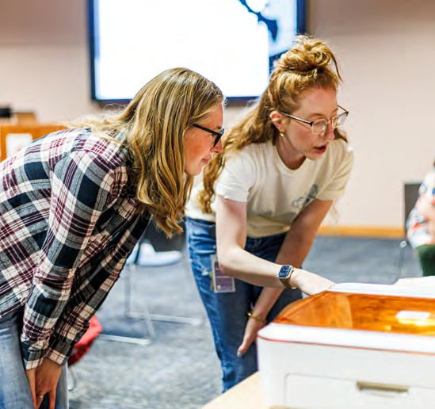

PROJECT PURPOSE

Provide a mobile creative technology lab that fosters innovation, creativity and hands-on learning.

2025 MAJOR DELIVERABLES

1. Finalize mobile lab design
2. Create mobile STEM curriculum
3. Investigate partnership opportunities

PROJECT PURPOSE

Create a Collective Bargaining Agreement (CBA) with AFSCME.

2025 MAJOR DELIVERABLES

1. Integrate economic impacts into 2026 budget
2. Finalize CBA
3. Obtain Board of Trustees approval of CBA
4. Obtain Board of County Commissioners’ approval of CBA

PROGRAM

Collective Bargaining

PROJECT

Collective Bargaining Agreement

PROGRAM

Digital Accessibility



PROJECT PURPOSE

Develop comprehensive digital accessibility guidelines so that digital content produced by the organization is accessible to individuals with disabilities. Create clear, consistent and user-friendly design elements that align with the organization’s branding while adhering to accessibility best practices.

2025 MAJOR DELIVERABLES

1. Create JCPL-specific digital accessibility guidelines
2. Meet 2025 digital accessibility requirements across platforms

2025 PROGRESS

1. Created JCPL-specific digital accessibility guidelines
2. Reviewed accessibility compliance and launched a tracking tool

PROJECT PURPOSE

Create a strategic plan for 2026 and beyond to guide organizational efforts.

2025 MAJOR DELIVERABLES

1. Refined Mission, Vision and Broad Goals framework
2. Finalize 2026+ strategic plan

2025 PROGRESS

1. Refined Mission, Vision and Broad Goals framework

PROGRAM

JCPL Long-Term Plan

PROJECT

2026+ Strategic Plan

PROJECT PURPOSE

Develop a comprehensive AI strategy that enhances library services for both patrons and staff. Integrate AI technologies to improve user experience, staff operations use, support ethical standards and outline

a clear roadmap for integrating AI technologies across business functions and patron experiences.

2025 MAJOR DELIVERABLES

1. Finalize AI Strategy
2. Initiate strategy implementation

2025 PROGRESS

1. Engaged staff through targeted interviews
2. Initiated strategy development

PROGRAM

Artificial Intelligence (AI) Strategy

PROJECT

AI Strategy Development

PROJECT PURPOSE

Contribute to the sustainable growth of JCPL by reducing the amount of property tax funds needed for programs, projects and services. This program will modernize JCPL practices by exploring and implementing a new structure, approach and system for raising outside funds.

2025 MAJOR DELIVERABLES

1. Complete 2024-2025 Fundraising Plan
2. Develop a 3-5 year fundraising plan
3. Create a fundraising plan for 2026

2025 PROGRESS

1. Executing on 2025 fundraising plan
2. Formed Fundraising Development Planning Committee
3. Developed a standard discussion guide and protocol for stakeholder interviews
4. Initiated stakeholder interviews

PROGRAM

Fundraising Development

# TRACKING PROGRESS:

2025 MID-YEAR METRICS AND INSIGHTS

JCPL measures success by evaluating how well the Library meets community needs. We use performance metrics to track trends, understand usage patterns and adjust our services

accordingly. The following highlights reflect library performance from mid-year 2024 through mid-year 2025.

### Highlights and Insights

IN-PERSON VISITS

As of mid-2025, JCPL recorded a 3.9% increase in in-person visits compared to the same point last year.

NET PROMOTER SCORE

JCPL’s NPS rose from 84 to 85 since mid-2024, reflecting consistently high levels of patron satisfaction.

MARKET PENETRATION

The percentage of active JCPL households in Jefferson County increased from 39% to 40%, maintaining steady growth consistent with prior years.

PROGRAM ATTENDANCE

Mid-year program attendance in 2025 is down by 10,559 participants (–8.5%) compared to 2024. However, this decline is largely due to an exceptional spike last year from a single, high-impact event—an author visit with Jacqueline Woodson that drew nearly 21,000 attendees. When excluding that outlier, program attendance levels are stable year over year, with the median attendance per program remaining consistent at 22 participants.

SHIFT TO DIGITAL COLLECTION USE

Digital circulation grew by 13% compared to the previous year, while physical format use saw a slight decline of 0.2%.

Combined, this resulted in a 1.7% overall increase in total collection use. The continued growth in digital formats suggests patrons are increasingly incorporating digital borrowing into their library habits. In contrast, use of library databases declined by 7.9% over the same period.

2025 MID-YEAR SUCCESS MEASURES

JCPL saw growth in several key indicators compared to the same period in 2024:

+ Increase in Active Households

+ Increase in Net Promoter Score

+ Increase in Digital Circulation

+ Increase in Visits

+ Increase in Total Collection Use

At the same time, some measures declined:

* Decrease in Active Cardholders*
* Decrease in Program Attendance (see previous note regarding 2024 Jacqueline Woodson author event)
* Decrease in Physical Circulation
* Decrease in Database Use

|  |  |  |  |  |
| --- | --- | --- | --- | --- |
| MID-YEAR REPORT | MID-YEAR 2024 | MID-YEAR 2025 | UNIT CHANGE | PERCENT CHANGE |
| Active Households | 93,701 | 95,496 | 1795 | 1.92% |
| Active Cardholders* | 131,793 | 126,490 | -5,303 | -4.02% |
| Market Penetration | 39% | 40% | 1% | 2.56% |
| Net Promoter Score | 84 | 85 | 1 | 1.19% |
| Program Attendance | 123,942 | 113,416 | -10,526 | -8.49% |
| Total Collection Use | 5,051,770 | 5,139,900 | 88,130 | 1.74% |
| Physical Circulation | 3,212,436 | 3,205,735 | -6,701 | -0.21% |
| Digital Circulation | 1,143,912 | 1,293,517 | 149,605 | 13.08% |
| Database Use | 695,422 | 640,648 | -54,774 | -7.88% |
| Visits | 968,687 | 1,005,946 | 37,259 | 3.85% |

*Active households and active cardholders typically trend together, but they are measured differently. Active cardholders include any card used during the first half of the year, while active households are measured based on activity status at the end of Q2. As a result, early-year activity can cause the two metrics to show different patterns.

CONCLUSION

Several of the major metrics that we track year to year have changed in opposing directions. Active households increased moderately from June 2024, coinciding with a one (1) percentage point increase in market penetration. Indicators of service usage such as circulation and visits continue to rise (driven by digital materials, while physical materials saw a slight decline from 2024), and program attendance remains healthy following an exceptional previous year.

These insights help Library staff tailor services, allocate resources effectively and remain responsive to evolving community needs. As we enter the second half of the year, we remain focused on delivering high-impact services and advancing major project milestones. Ongoing monitoring of performance and trends continues to guide JCPL’s progress throughout 2025.

# Adult reading to child from picture book at Columbine Library.ADDITIONAL HIGHLIGHTS

### JCPL eliminates all fines for overdue or damaged children’s books and items

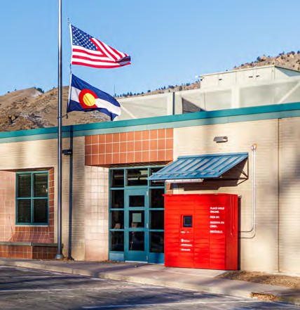As of summer 2025, JCPL stopped charging replacement fees for lost or damaged children’s books. This change applies to all E and J materials in JCPL’s collection and extends a program that began in 2018 with the elimination of overdue fines and fees on children’s materials. Children’s materials circulate in great quantities, and we are aware that our youngest patrons are still learning how to use books. With this, JCPL seeks to foster its goal of inspiring early reading and lifelong

learning. Read the [Eliminating Fines for Damaged](https://jeffcolibrary.org/news/jcpl-elimates-fines-for-childrens-books/)

[Children’s Materials news article](https://jeffcolibrary.org/news/jcpl-elimates-fines-for-childrens-books/) for more information.

### Golden Holds Locker

In January, JCPL welcomed a brand-new Holds Locker to Golden Library! These automated lockers provide patrons with 24/7 access to reserved library materials. The lockers are strategically placed to enhance accessibility for residents and visitors in Golden and its surrounding areas.

### South County Library Community Engagement a Success!

More than 2,400 community members shared their input and vision for the future South County Library through a wide variety of engagement events!

Our official Community Engagement Report was presented to the Board of Trustees in May and will be used to help guide the design of the new library. Read through the [full report on our project page](https://jeffcolibrary.org/south-county/).

### Family petting a bunny at the Magic Rob Summer Challenge program at South County Library.ADDITIONAL HIGHLIGHTS

*CONTINUED*

### South County Interim Services

The future South County Library location at 11100 Bradford Rd. in Littleton is now a regular stop

for [JCPL’s Bookmobile](https://jeffcolibrary.org/locations/bk/). The new South County

Bookmobile stop is available on Saturdays from 11 a.m. to 3 p.m., replacing the former Ken Caryl stop. Additional on-site programming also began in June.

### C.J. Box Spring Author Event

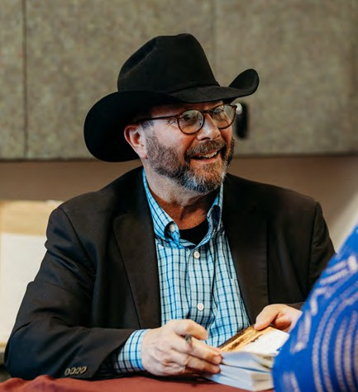More than 1,300 community members enjoyed an exciting afternoon with master storyteller and acclaimed author of suspense and thrilling crime fiction, C.J. Box, at our March 29 Spring Author Event, emceed by Carter Wilson! The event also included a dynamic panel discussion with local authors Barbara Nickless, Manuel Ramos, Emily Littlejohn, Erika T. Wurth and David Heska Wanbli Weiden. Attendees had an opportunity to speak with the authors during an onsite book signing, purchase books and win prizes!

### Pride Month

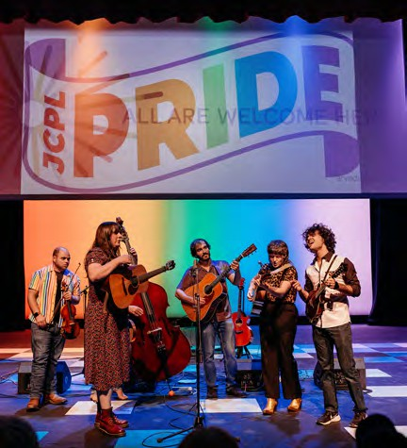JCPL celebrated Pride month by curating LGBTQIA+ programs and books for all ages that honor the vibrant spectrum of identities, experiences and voices in the county. We continued our strong partnership with the

Arvada Center by hosting the incredible Pride in Place: A Colorado Country Concert featuring an evening of free bluegrass and alt-country music. Performances included some of Colorado’s most talented artists in the LGBTQIA+ music community including Morgan Harris, Trace & Baerd, Rosales & Summers and Amy Martin. The library also took part in the annual Edgewater Pride Parade and tabled at the Arvada Center’s first Drag Queen Story Time!

### ADDITIONAL HIGHLIGHTS

*CONTINUED*

### 200th laptop recipient for PowerOn JeffCo smiling while typing on keyboard.PowerOn JPS Award

In June, the Jefferson County School Board honored PowerOn Jeffco for its impactful work in equipping community members with essential digital literacy skills. Since its launch in 2024, this collaborative initiative between Jefferson County Public Library and several community partners has empowered Jeffco residents by providing digital literacy

training in both English and Spanish. Through the PowerOn program, attendees build fundamental computer skills, helping them navigate technology with confidence. As

an added benefit, qualified participants who complete the program receive a

free Chromebook with internet access to help them continue practicing and applying their knowledge beyond the classroom. The recognition from the Jefferson County School Board is a testament to the program’s success in bridging the digital divide, fostering inclusivity in our community and enabling more individuals to thrive in an increasingly connected world.

### New Library Card Designs

Beginning in March, JCPL offered patrons a choice in library card designs when they sign up for a new library card. This new offer is geared towards providing radically welcoming customer service and allowing patrons and families who appreciate a variety of designs a fun selection of cards. Besides the variety, the new cards also have reduced plastic waste per card.



# JCPL staff member smiles during the Edgewater Pride Parade.FEEDBACK

### Net Promoter Score Survey Responses

“I moved from Denver, and I was really hoping Jeffco Libraries were good, but you’re more than good!”

LIBRARY PATRON

“I need your help, and I know from experience you WILL help me with anything.”

LIBRARY PATRON

“No hay otro lugar como la biblioteca en donde me siento bienvenida.”

(There is no other place like the Library, I feel welcome there.)

LIBRARY PATRON

### South County Library Community Feedback

“Thank you for the South County Library. I cannot wait to have a library closer to home!”

LIBRARY PATRON

“Your outreach to the community is exceptional as are the services you provide for those of us who read a LOT of nonfiction material. I honestly don’t mind paying my taxes to Jefferson County because I get such value from the library.”

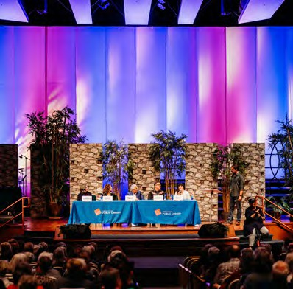LIBRARY PATRON

### C.J. Box Spring Author Event

“Thank you for an excellent author event! It was great. I totally enjoyed the panel and their comments.” EVENT ATTENDEE

“This was a great event! I appreciate the thought that went into showcasing a prolific panel of authors. C.J. Box has been my favorite author since I was a child. I came from Arizona with my books for signing. Thank you JCPL!”

EVENT ATTENDEE

### FEEDBACK

*CONTINUED*

### Pride Month

“I want to say a HUGE THANK YOU to Jefferson County Public Library for celebrating and highlighting Pride Month, and for the really amazingly robust Pride Month program offerings you’ve got going on this month. As a queer person, it’s really heartening to see my libraries not only still supporting my community but doing so far more than any corporations are. I feel like libraries still have our backs, and are truly here

for their community, and that’s so important to me. Thank you and keep it up!!”

LIBRARY PATRON

### Teen in rainbow hat and sweater smiling with friends at Belmar Pride Teen Carnival.Patron uses and iPad to access Jefferson County Public Library online at home.E-Content

I love, love, JCPL!! Thank you SO much for making such a huge and inclusive library available in such an easy way. I’m disabled and it’s difficult for me to go back and forth to the physical location. Plus, with digital content I can make the print as large or small as I need. It makes everything available in large print, not just a select few. It’s also hard for me to hold a book for more than a few minutes. I don’t even have to hold my tablet if I don’t want to. The apps are SO easy to use, and I almost always

find what I am looking for. It’s also easy to find new material I didn’t know about. I can’t say enough positive about it or express enough gratitude that it exists. I feel incredibly privileged to have access to it. I am literally in tears writing this. I discovered that the library was online just

a few years ago. It reignited my love of reading and I’ve been using it ever since. It just keeps getting better. I use all the formats available. I didn’t think I even liked audiobooks until I found you. Now I love them! Keep up the amazing work and know it is deeply appreciated. I’ve told several friends and family members about it and now they’re hooked too. My husband and I will pair two sets of earbuds to my phone and take walks by the lake listening to the same thing. It helps me walk further and longer, which absolutely impacts on my quality of life. Sorry to gush and go on, but it means a lot to me and my loved ones. Thank you.”

LIBRARY PATRON



TO: Donna Walker, Executive Director

FROM: Matt Griffin, Chief Strategy & Operating Officer DATE: August 21, 2025

RE: Finance Monthly Report

**Budget to Actual Tables – July 2025**

Please see the enclosed Budget to Actual Tables for July 2025.

In July, JCPL recorded $0.6M in Real Property Tax revenue. Year-to-date, 93.9% of the budgeted collection has been received.

JCPL remains on track with its budget, with no areas of concern at this time. Financial performance is steady and aligned with expectations.

In July, the Library Foundation provided funding of $10,605 to JCPL. The Library contributed $7,531 in- kind support in July. Year-to-date, the library has received $64,612 in funding and provided $53,424 in- kind support to the Foundation, with a ratio of 1.21.

|  |  |  |  |  |
| --- | --- | --- | --- | --- |
| **Revenue and Expenditure** | **2025 Budget** | **YTD Actual**  **07/31/2025** | **$ Variance**  **2025 Budget** | **% Variance**  **2025 Budget** |
| **Revenues** |  |  |  |  |
| Property Taxes (net adjustments) | 59,744,973 | 58,972,478 | 772,495 | 99% |
| Grants, Funds & Donations | 560,427 | 306,868 | 253,559 | 55% |
| Investment Income | 2,009,000 | 1,946,002 | 62,998 | 97% |
| Other Revenue | 35,000 | 107,254 | (72,254) | 306% |
| **Total Revenues** | **$ 62,349,400** | **$ 61,332,602** | **$ 1,016,798** | **98.4%** |
| **Expenditures** |  |  |  |  |
| Operating | 47,918,946 | 25,480,937 | 22,438,009 | 53% |
| Financing & Debt Service | - | - | - |  |
| Capital Projects | 49,385,963 | 14,060,892 | 35,325,071 | 28% |
| **Total Expenditures** | **$ 97,304,909** | **$ 39,541,829** | **$ 57,763,080** | **40.6%** |

|  |
| --- |
| % Variance 2025 Budget |
| ***98.4%***  **Total Revenues**  **0% 100%** |
|  |
| ***40.6%***  **Total Expenditures**  **0% 100%** |
|  |
| ***53%***  Operating  **0% 100%** |
|  |
| Debt  **0% 100%** |
|  |
| **28%**  Capital  **0% 100%** |

|  |  |  |  |  |
| --- | --- | --- | --- | --- |
|  | **2025 Budget** | **YTD Actual 07/31/2025** | **$ Variance 2025 Budget** | **% Variance 2025 Budget** |
| ***Operating Expenditures*** |  |  |  |  |
| **Salaries & Employee Benefits** |  |  |  |  |
| Salaries | 19,267,433 | 10,155,557 | 9,111,876 | 53% |
| Awards & Bonuses | 275,000 | 34,653 | 240,347 | 13% |
| Other | 7,478,592 | 4,463,325 | 3,015,267 | 60% |
| Total Salaries & Benefits | $ 27,021,025 | $ 14,653,535 | $ 12,367,490 | 54% |
| **Library Collections** |  |  |  |  |
| Library Books & Materials | 7,692,199 | 4,014,223 | 3,677,976 | 52% |
| Library Periodicals | 205,000 | 129,378 | 75,622 | 63% |
| Total Library Collections | $ 7,897,199 | $ 4,143,601 | $ 3,753,598 | 52% |
| **Supplies and Other** |  |  |  |  |
| Supplies | 1,915,452 | 928,793 | 986,659 | 48% |
| Services & Charges | 7,851,593 | 3,547,225 | 4,304,368 | 45% |
| Interdepartmental Direct Charges | 713,165 | 379,111 | 334,054 | 53% |
| Treasurers Fees | 902,081 | 884,587 | 17,494 | 98% |
| Interdepartmental Indirect Charges | 1,618,431 | 944,085 | 674,346 | 58% |
| Total Supplies and Other | $ 13,000,722 | $ 6,683,801 | $ 6,316,921 | 51% |
|  |  |  |  |  |
| **Total Operating Expenditures** | **$ 47,918,946** | **$ 25,480,937** | **$ 22,438,009** | **53.2%** |

**TABLE 3**

**JEFFERSON COUNTY PUBLIC LIBRARY CAPITAL IMPROVEMENT PROJECTS BUDGET TO ACTUAL**

|  |  |  |  |  |  |  |  |
| --- | --- | --- | --- | --- | --- | --- | --- |
|  | **2025**  **Budget** | **YTD Actual 07/31/2025** | **YTD**  **Encumbrances** | **YTD Total Actual + Enc** | **Remaining 2025 Budget** | **Total Project**  **Actual + Encumbrances** | **Total Project Budget** |
| ***Capital Expenditures*** |  |  |  |  |  |  |  |
| **Annual Replacement & Maintenance** |  |  |  |  |  |  |  |
| ARM-01 Capital Maintenance | 418,631 | 325,392 | - | 325,392 | 93,239 | n/a | n/a |
| ARM-02 Furniture & Equipment | 42,000 | 48,918 | - | 48,918 | (6,918) | n/a | n/a |
| ARM-03 Computer Replacement Plan | 720,344 | 269,095 | - | 269,095 | 451,249 | n/a | n/a |
| ARM-04 Book Sorter Replacement | 40,000 | 1,523 | - | 1,523 | 38,477 | n/a | n/a |
| ARM-05 IT Infrastructure Replacement | 450,000 | 250,255 | - | 250,255 | 199,745 | n/a | n/a |
| **Capital Projects** |  |  |  |  |  |  |  |
| Document Management System | - | - | - | - | - | 198,977 | 160,000 |
| South County Library | 13,198,826 | 10,598,954 | 1,642,257 | 12,241,211 | 957,615 | 12,543,031 | 30,849,540 |
| Evergreen Library Redesign | 172,000 | 77,948 | - | 77,948 | 94,052 | 4,873,873 | 5,200,048 |
| Evergreen Library Roof Repair | 1,141,540 | 112,011 | 21,000 | 133,011 | 1,008,529 | 162,471 |  |
| Columbine Library Roof Repair | - | - | - | - | - | 670,708 |  |
| Northwest County Library | 14,589,599 | 307,182 | 1,361,693 | 1,668,875 | 12,920,724 | 5,397,977 | 25,970,270 |
| Arvada Library Redesign | 14,752,433 | 610,417 | 439,578 | 1,049,995 | 13,702,438 | 1,138,975 | 14,895,781 |
| Conifer Library Tenant Finish | 2,360,590 | 1,431,150 | 286,215 | 1,717,365 | 643,225 | 1,857,175 | 2,500,400 |
| Lakewood Restrooms | 500,000 | 28,047 | 16,953 | 45,000 | 455,000 | 45,000 | 500,000 |
| Admin Office Reconfiguration | 250,000 | - | - | - | 250,000 | - | 250,000 |
| Library Interiors Refresh Pilot | 750,000 | - | - | - | 750,000 | - | 750,000 |
| **Total Capital Expenditures** | **$ 49,385,963** | **$ 14,060,892** | **$ 3,767,696** | **$ 17,828,588** | **$ 31,557,375** |  |  |
|  | | | | | |  |  |

**TABLE 4**

**JEFFERSON COUNTY PUBLIC LIBRARY GRANTS, FUNDS & DONATIONS BUDGET TO ACTUAL**

|  |  |  |  |  |  |  |  |  |  |
| --- | --- | --- | --- | --- | --- | --- | --- | --- | --- |
|  | **2022**  **Actual** | **2023**  **Actual** | | **2024**  **Actual** | | **2025**  **Budget** | **YTD Actual 07/31/2025** | **$ Variance 2025 Budget** | **% Variance 2025 Budget** |
| ***JCPL Grants*** |  | |  | |  |  |  |  |  |
| Books & Materials - American Rescue Plan | 181,757 | | - | | - | - | - | - |  |
| Books & Materials - State | 195,797 | | 140,462 | | 134,124 | 144,996 | 14,173 | 130,823 | 10% |
| Car Charging Station - Evergreen | - | | 16,500 | | 1,984 | - | - | - |  |
| Car Charging Station - Columbine | - | | - | | - | - | 30,000 | (30,000) |  |
| Car Charging Station - Standley Lake | - | | - | | - | - | 27,000 | (27,000) |  |
| Car Charging Station - Lakewood | - | | - | | - | - | 30,000 | (30,000) |  |
| **Total JCPL Grants** | **$ 377,554 $** | | **156,962 $** | | **136,108** | **$ 144,996** | **101,173** | **$ 43,823** | **70%** |
| ***JCPL Private Donations*** |  | |  | |  |  |  |  |  |
| Private Donations up to $200 | 340 | | - | | 250 | - | 100 | (100) |
| Private Donations $201 - $999 | - | | - | | - | - | - | - |
| Colorado Gives - Naumer Family Fund EV Remodel | - | | 5,000 | | - | - | - | - |
| Anonymous Donor | - | | 2,000 | | - | - | - | - |
| Anonymous Donor | 58,042 | | - | | - | - | - | - |
| Anonymous Donor | - | | - | | - | - | - | - |
| Anonymous Donor | - | | - | | - | - | - | - |
| JCLF - Evergreen Library - Naming Rights | - | | - | | 5,000 | - | - | - |
| Colorado Gives - Hard Times Writing |  | |  | | 24,509 | - |  | - |
| Colorado Gives - Early Care & Education |  | |  | |  | - | 60,000 | (60,000) |
| El Pomar Foundation |  | |  | |  | - | 25,000 | (25,000) |
| Fundraising Target | - | | - | | - | 150,000 | - | 150,000 |
| **Total Private Donations** | **$ 58,382 $** | | **7,000 $** | | **29,759** | **$ 150,000** | **$ 85,100** | **$ 64,900** | **57%** |
| ***Other Funds Received*** |  | |  | |  |  |  |  |  |
| Payroll Funding - American Rescue Plan | 263,556 | | 856,591 | | - | - | - | - |  |
| E-Rate Reimbursement | 2,602 | | 149,901 | | 111,966 | 165,431 | 53,306 | 112,125 | 32% |
| Laptop Lending | 100,145 | | 183,427 | | 33,325 | - | 2,676 | (2,676) |  |
| Stadium Funds - Imagination Library |  | |  | | 50,000 | - | - | - |  |
| Stadium Funds - Young Authors | - | | - | | 42,350 | - | - | - |  |
| **Total Other Funds Received** | **$ 366,303 $** | | **1,189,919 $** | | **237,641** | **$ 165,431** | **$ 55,982** | **$ 109,449** | **34%** |
| ***Jefferson County Library Foundation*** | 131,894 | | 127,180 | | 141,576 | 100,000 | 64,613 | 35,387 | 65% |
| **Total Jefferson County Library Foundation** | **$ 131,894 $** | | **127,180 $** | | **141,576** | **$ 100,000** | **$ 64,613** | **$ 35,387** | **65%** |
|  | | | | | |  |  |  |  |
| **Total Grants, Funds & Donations** | **$ 934,133 $** | | **1,481,061 $** | | **545,084** | **$ 560,427** | **$ 306,868** | **$ 253,559** | **55%** |

|  |  |  |  |  |  |  |
| --- | --- | --- | --- | --- | --- | --- |
| ***Other Funds Received Outside of Library Fund*** |  | | | | | |
| Digital Equity - American Rescue Plan (FD181) | ***-*** 3,482 | 622,374 | 96,090 | 17,558 | 78,532 | 18% |
| Digital Equity - Rescue Plan (FD036) | - - | - | 205,241 | - | 205,241 | 0% |

##### Operational Updates Facilities and Construction Projects



TO: Donna Walker, Executive Director

FROM: Matt Griffin, Chief Strategy and Operating Officer Steve Chestnut, Director of Facilities and Construction

DATE: August 14, 2025

RE: Lakewood and Administration Restroom Renovation

**Lakewood and Administration Restroom Renovation Project Summary**

As part of our 2025 Capital Improvement Plan the full renovation of the public restrooms on the west end of the Lakewood Library, and the employee restrooms in the Administration wing was proposed and approved. The renovations will promote inclusivity and include upgrades such as:

* Accessibility improvements
* Energy-efficiency upgrades
* Modernized design
* Safety and hygiene upgrades

This project will be performed in two phases:

Phase 1: Administration restrooms closed while renovated and the Lakewood Library restrooms will be open to patrons & building staff.

Phase 2: Completed Administration restrooms to be open to patrons and staff. Lakewood library restrooms to be closed and renovated.

**Request for Proposal Results**

A request for proposal was developed for the above work. The proposal was published as a straight bid proposal for an existing design. There were 13 responses that were evaluated for cost, anticipated schedule and contractors experience with projects of this size. The company chosen to best serve JCPL was TCC Corporation out of Loveland, CO.

**Total Cost and Budget**

The approved 2025 budget for this project is $500,000, based on initial rough order-of-magnitude (ROM) estimates. The current quoted cost is $516,444.97, exceeding the budget by 3.2%. We believe this variance reasonably reflects current market conditions and construction cost escalations. JCPL considers the overage immaterial within the context of our overall capital budget. We do not anticipate any risk in accommodating the additional cost. As such, we recommend proceeding with the project at the quoted amount.

**Next Actions**

We request the Board of Trustees authorize the Executive Director to enter a contract with TCC Corporation with the amount of $516,444.97 for renovation of the Lakewood and Administration restrooms.

##### Board Governance

**POLICY TYPE: MANAGEMENT LIMITATIONS POLICY 2.5 POLICY TITLE: *FINANCIAL PLANNING/BUDGETING***

*MANAGEMENT LIMITATIONS*

**Initial Monitoring on Policy 2.5: *FINANCIAL PLANNING/BUDGETING***

I hereby present my monitoring report on your Management Limitations policy 2.5 “Financial Planning/Budgeting”, in accordance with the monitoring schedule set forth in Board policy. I certify that the information contained in this report is true.

Signed: , Executive Director Date: August 21, 2025

BROADEST POLICY PROVISION

Financial planning for any fiscal year or the remaining part of any fiscal year may not deviate materially from the Board’s Ends priorities, risk financial jeopardy, or fail to be derived from multi-year facilities and operating plans.

**EXECUTIVE DIRECTOR INTERPRETATION:** The Library presents a 5-year capital plan and a 10-year financial forecast for purposes of cash flow projections as part of our annual budget development. These projections are made to ensure our ability to meet operational objectives and Ends in the short term and in future years. As well, I may revise the budget as the fiscal year proceeds within the parameters established by Board policy.

Accordingly, the Executive Director shall not present to the Board for approval, nor operate with, a budget plan that:

1. Does not conform to the County Commissioners’ budget development guidelines or fails to be derived from fiscally responsible five-year revenue projections, including those revenues projected by the County.

**EXECUTIVE DIRECTOR INTERPRETATION:** Budget development is governed by the Library Trustees’ and the Board of County Commissioners’ annual guidelines. Short-term (5-year) revenue projections do not differ from those developed by the County Budget Office and the Library finance models, unless desired by the Library Trustees.

**REPORT (COMPLIANT):** The budget development process proceeds in accordance with County Budget Office guidelines.

I can report compliance.

1. Risks incurring those situations or conditions described as unacceptable in the “Financial Conditions and Activities” Board policy, policy 2.3.

**EXECUTIVE DIRECTOR INTERPRETATION:** I understand this to mean that the Library must operate within the established annual budget and in compliance with the other financial management policies described in Section 2.3.

**REPORT (COMPLIANT):** Monthly financial reports demonstrate compliance.

I can report compliance.

1. Omits credible projection of revenues and expenses, separation of capital and operational items and disclosure of planning assumptions.

**EXECUTIVE DIRECTOR INTERPRETATION:** The Library’s fiscal planning and management must have adequate data to support the credibility of its projections. This data takes the form of a 5-year cash flow projection based on County revenue and expense projections. This reporting is regularly reviewed by staff and the Trustees. Planning assumptions will be included in those reports and special report summaries are developed as necessary.

Library budgeting separates capital and operational expense as required by the County. The Library Board of Trustees’ adopted Reserve Policy recognizes the financial importance of a stable and sufficient level of fund balance. Also, Trustee policy regarding the use of capital reserves (2.3.3B) limits capital project expense.

**REPORT (COMPLIANT):** Projections and assumptions that make up these types of fiscal reporting are reviewed regularly. The Trustees use these reports for budget development and oversight.

I can report compliance in developing projections and communicating and also in maintaining the Board approved Reserve policy.

1. The Executive Director may not fail to ensure that the capital budget provides for the achievement of long-term Ends regarding library service within the County, as well as for construction, maintenance, replacement and financing of facilities.

**EXECUTIVE DIRECTOR INTERPRETATION:** Capital planning for library service, construction, maintenance, replacement and financing of facilities is an ongoing activity that is reflected in the annual budget, in the Library’s annual strategic priorities and in the five-year capital plan.

**REPORT (COMPLIANT):** Ends Statements and Five-Year Strategic Priorities assume the existence and implementation of a capital plan, revised and updated annually in accordance with the Library Board of Trustees’ direction and the Board of County Commissioners’ policy. Also, the library regularly updates its 5 and 10 year financial plan to reflect changes in conditions and priorities.

I can report compliance to the extent of available funding.

1. Plans the expenditure for operations and debt service in any fiscal year according to the actual revenue amount projected to be received in the fiscal year.

**EXECUTIVE DIRECTOR INTERPRETATION:** This means that we must plan for and monitor actual revenues and expenditures against our original budget estimates and adjust estimates as necessary for changes in conditions.

**REPORT (COMPLIANT):** Monthly and annual reports compare actual results with the budget. Transfers or supplemental appropriations are made when necessary per “Financial Conditions and Activities” Board policy 2.3.

I can report compliance.

1. **Provides less for Board activities during the year than is set forth in the Governance Budget policy (*see policy in Governance Process – 4.8*).**

**EXECUTIVE DIRECTOR INTERPRETATION:** I understand this to mean that the Board establishes its budget for what it believes is important to invest in its own governance. The annual budget for the library allocates the amount stated in the Cost of Governance policy for Board functions.

**REPORT (COMPLIANT):** The Board determines its “Governance Budget” for each fiscal year and that amount is incorporated into each year’s budget.

I can report compliance.

**POLICY TYPE: MANAGEMENT LIMITATIONS POLICY 2.6 POLICY TITLE: *COMPENSATION AND BENEFITS***

*MANAGEMENT LIMITATIONS*

**Initial Monitoring on Policy 2.6: *COMPENSATION AND BENEFITS***

I hereby present my monitoring report on your Management Limitations policy 2.6 “Compensation and Benefits”, in accordance with the monitoring schedule set forth in Board policy. I certify that the information contained in this report is true.

Signed: , Executive Director Date: August 21, 2025

BROADEST POLICY PROVISION

The Executive Director will not cause or allow jeopardy to the organization’s fiscal integrity or public image when dealing with employment, compensation and benefits for employees, consultants or contractors.

**EXECUTIVE DIRECTOR INTERPRETATION:** The Board has comprehensively interpreted this policy in the provisions below. My interpretations and reporting data are appended below.

Accordingly, I shall not:

1. Change my own compensation or benefits.

**EXECUTIVE DIRECTOR INTERPRETATION:** I understand this to mean that I cannot nor shall not attempt to change my compensation or benefits. All such changes and /or recommendations for change must be reviewed and approved by the Library Board, per policy 4.3.6.

**REPORT (COMPLIANT):** On my employment anniversary date the Board annually sets my compensation upon review of my response and adherence to the previous year's monitoring reports and my performance in the direction and leadership of the library. The Jefferson County Personnel Board sets the benefits for all county employees and mine are as established

for Executive Officers / appointed and elected officials within the meaning of Jefferson County Government. These benefits can be changed only by the Personnel Board or the Board of County Commissioners. Any such change is overseen by the library’s and county’s Human

Resources departments.

I can report compliance.

1. Unilaterally propose or establish a unique compensation and benefit practice and program that deviate from the library's established compensation practice.

**EXECUTIVE DIRECTOR INTERPRETATION:** I understand this to mean that I cannot nor shall not attempt to change the compensation or benefits of library staff without either a change in the library's established compensation philosophy and/or Trustee approval.

**REPORT (COMPLIANT):** Any and all changes to staff compensation or benefits are

in accordance with the library’s established compensation practice, state and federal regulations, and County Personnel Rules. They are reviewed and approved by the Library Board when required by statute or policy.

I can report compliance.

1. Pertaining to consultants and contract vendors, create obligations over a longer term than revenues can be safely projected, in no event longer than one year.

**EXECUTIVE DIRECTOR INTERPRETATION:** I understand this to mean that we must maintain control over our use of consultants and contract vendors by ensuring that expected revenue meets the financial obligations of any contractual services and by contractually limiting obligations for payments to the current fiscal year.

**REPORT (COMPLIANT):** All contract language includes the financial abilities and obligations of the library and the duration of service. In practice, when it is in the library’s interest to enter into agreements that last longer than the current year, our contracts provide for termination without any cause within a specified number of days or upon a circumstance of non-appropriation**.** Contract language is drafted or reviewed by the County Attorney’s Office when appropriate to ensure adequate controls are established.

I can report compliance.

**POLICY TITLE: EMERGENCY *EXECUTIVE DIRECTOR SUCCESSION***

*MANAGEMENT LIMITATIONS*

**Initial Monitoring on Policy 2.7: *EMERGENCY EXECUTIVE DIRECTOR SUCCESSION***

I hereby present my monitoring report on your Management Limitations policy 2.7 “Emergency Executive Director Succession”, in accordance with the monitoring schedule set forth in Board policy. I certify that the information contained in this report is true.

Signed: , Executive Director Date: August 21, 2025

BROADEST POLICY PROVISION

In order to protect the Board from sudden loss of the Executive Director’s services, the Executive Director shall not fail to ensure that at least two (2) other members of the management team are sufficiently familiar with Board and Executive Director issues and processes to take over with reasonable proficiency as an interim successor.

**EXECUTIVE DIRECTOR INTERPRETATION:** I understand this provision to mean that there are at least two management team members prepared to act in an interim capacity as Executive Director if I am not available so that library operations may continue until I return to work or a permanent replacement is named.

**REPORT (COMPLIANT):** In response to this provision, the positions of Chief Libraries and Inclusion Officer and Chief Strategy and Operating Officer are empowered and qualified to assist with the day-to-day operations and strategic projects of the library as well as to serve as and perform the duties and responsibilities of the Executive Director in the absence of the Executive Director.

I can report compliance.

**POLICY TYPE: MANAGEMENT LIMITATIONS POLICY 2.8 POLICY TITLE: *BOARD AWARENESS AND SUPPORT***

*MANAGEMENT LIMITATIONS*

**Initial Monitoring on Policy 2.8: *BOARD AWARENESS AND SUPPORT***

I hereby present my monitoring report on your Management Limitations policy 2.8 “Board Awareness and Support”, in accordance with the monitoring schedule set forth in Board policy. I certify that the information contained in this report is true.

Signed: , Executive Director Date: August 21, 2025

BROADEST POLICY PROVISION

The Executive Director shall not cause or allow the Board to be uninformed or unsupported in its work.

**EXECUTIVE DIRECTOR INTERPRETATION:** The Board has comprehensively interpreted this policy in the provisions below. My interpretations and reporting data are appended below.

Accordingly, I shall not:

1. Fail to report in a timely manner an actual or anticipated noncompliance with any policy of the Board.

**EXECUTIVE DIRECTOR INTERPRETATION:** I interpret this provision to mean that issues of non-compliance are to be regarded by me as matters of priority. I will judge each issue as it arises and report as appropriate. Some will require immediate attention, and some may wait for the filing of a formal monitoring report. In any case, non-compliance must always be known by the Board.

**REPORT (*COMPLIANT*):** Monitoring reports are submitted annually with reporting of compliance or non-compliance. Matters of immediate attention are made known to the Library Board accordingly.

I can report compliance.

1. Neglect to submit monitoring data required by the Board (see policy on Monitoring Executive Director Performance in *Board-Management Delegation*) in a timely, accurate and understandable fashion, directly addressing provisions of Board policies being monitored.

**EXECUTIVE DIRECTOR INTERPRETATION:** This provision requires that monitoring reports will be submitted to the Board on their approved schedule and in a form that provides the Board with the necessary data.

**REPORT (*COMPLIANT*):** The review calendar has been established and is updated regularly and on schedule. Monitoring data and interpretation is provided according to the calendar schedule.

I can report compliance.

1. Let the Board be unaware of significant incidental information, such as anticipated adverse media coverage, threatened or pending lawsuits, or material external and internal changes. Notification of planned internal changes is to be provided in advance, when feasible.

**EXECUTIVE DIRECTOR INTERPRETATION:** This provision requires timely notification from me to the Board when issues have arisen that significantly affect the Library. Since many such issues arise between normal Board reporting sessions, such as Board meetings, I must implement a process of notification to the Board as these occur.

**REPORT (*COMPLIANT*):** We have implemented a direct reporting process to the Board, via e- mail, that informs them as quickly as necessary on vital issues. The Library’s Executive Director manages the communications process and delegates to the Director of Communications and Engagement, and other staff when appropriate. Such messages will be followed up in the regular meeting support reports, as necessary.

I can report compliance.

1. Fail to advise the Board if, in the Executive Director’s opinion, the Board is not in compliance with its own policies *(Governance Process and Board-Management Delegation*), particularly in the case of Board or Board member behavior that is detrimental to the work relationship between the Board and the Executive Director.

**EXECUTIVE DIRECTOR INTERPRETATION:** I understand that I am required by this provision; to monitor all Board processes to ensure they conform to established policies. In addition, I will be aware to the extent possible, of individual Board members’ activity for compliance with the Board’s policies. My reporting of such issues will be to the Board Chair, unless it is a matter of an individual member. In such cases, I may choose to talk directly to the individual or to the Chair, as appropriate.

**REPORT (*COMPLIANT*):** When I or other Library staff become aware of activity that appears to be out of compliance, I take necessary action.

I can report compliance.

1. Neglect to submit objective decision information required periodically by the Board or let the Board be unaware of relevant trends.

**EXECUTIVE DIRECTOR INTERPRETATION:** I understand that this provision requires me to provide all relevant information to the Board in support of their decision-making to ensure their objectivity. Further, I must have in place an information process that heightens the Board’s ability to understand fundamental library issues and trends.

**REPORT *(COMPLIANT):*** Where the complexity of a topic justifies a special study session, we have implemented a two-stage process to provide the Board with background information and more focused information leading to decision-making. The current practice is to provide the background information at these study sessions, primarily in reports from senior managers. The Board then

questions and debates these issues, and revisions are prepared for the consent agenda at the regular Board meeting in support of a necessary decision. The Board then has the choice of deciding its course of action at that time or to defer its decision to the consent agenda at the next regularly scheduled Library Board meeting. Providing detailed information in the regular meeting packet and providing time for full discussion may be used as an alternative method.

I can report compliance.

1. Present information in unnecessarily complex or lengthy form, or in a form that fails to differentiate among information of three types:
   1. **Monitoring**

**EXECUTIVE DIRECTOR INTERPRETATION:** Monitoring reports must be delivered to the Board according to the annual report schedule established by the Board and in a distinctive format and structure that is easily followed and understood.

***REPORT (COMPLIANT):*** The monitoring report formats are established. I can report compliance.

* 1. Decision preparation (or “action item”)

**EXECUTIVE DIRECTOR INTERPRETATION:** Where the complexity of the decision preparation justifies an in-depth study session, the preparation may follow either process described in #5 above. Both of these processes are reflected in the agendas for each meeting.

**REPORT (COMPLIANT):** Study sessions and regular meetings are used to provide background and additional information that is requested or needed.

I can report compliance.

* 1. Incidental/ “FYI.”

**EXECUTIVE DIRECTOR INTERPRETATION:** I understand that this reporting, typically of items not needing an immediate decision, may be presented by me or others during, after meeting adjournment or outside of scheduled meetings if necessary. If a reported issue later rises to the level of a required action, the procedures outlined in #5 above must be followed.

**REPORT (COMPLIANT):** We have implemented this reporting process and I regard it as effective, primarily in giving the Board the opportunity to discuss incidental issues without making a decision based on what could be insufficient information.

I can report compliance.

1. Fail to provide support for official Board, officer or committee communications and functions, including but not limited to orienting new Board members to Library operations

**and services.**

**EXECUTIVE DIRECTOR INTERPRETATION:** This provision requires me to provide a high level of communications support to official Board activities and functions as the Board goes about its governance business. I must also assist the Board as it develops its new member orientation program. Further, I must prepare and implement an operational orientation program that is consistent with the Board’s own process.

**REPORT (COMPLIANT):** The Chair manages support for official Board communications and the required new member orientation program is in place.

1. Fail, when addressing official Board business, to deal with the Board as a whole except when:
   1. **Fulfilling individual requests for information**

**EXECUTIVE DIRECTOR INTERPRETATION:** I understand this provision to require me to address official Board business with the Board as a whole. When reasonable requests for information come from individual Board members, I will respond according to my best judgment.

**REPORT (COMPLIANT):** Current practice has been for me to keep all members informed equally, unless it is a matter that involves an individual need. I have in the past, and expect in the future, to fulfill most such requests, refer them to the Chair, or supply an individual’s request to the entire Board.

I can report compliance.

* 1. Responding to officers, committees or individuals duly charged by the Board

**EXECUTIVE DIRECTOR INTERPRETATION:** This important provision is in place as a key element in my work as the Executive Director. As the Board proceeds with its governance work, either as a committee as a whole or through such delegations as the Board may determine, it is my task to provide the most useful information and resources ~~a~~vailable.

**REPORT (COMPLIANT):** Processes are in place for the Executive Director and other staff members to supply information as needed or requested.

I can report compliance.

1. Fail to supply for the Board’s consent agenda, along with applicable monitoring information, all decisions delegated to the Executive Director yet required by law, regulation or contract to be Board-approved.

**EXECUTIVE DIRECTOR INTERPRETATION:** I take this to mean that all decisions delegated to me that may be governed by Board policy, Jefferson County policy or state statute be referred to the Board for their action, via the consent agenda.

**REPORT (COMPLIANT):** Processes are in place to bring before the Board, regular decisions that must be reviewed by the Board. An updated copy will be given to the Board after being evaluated by my office or other staff for compliance.

I can report compliance.

**POLICY TYPE: MANAGEMENT LIMITATIONS POLICY 2.9 POLICY TITLE: *MATERIALS SELECTION***

*MANAGEMENT LIMITATIONS*

**Initial Monitoring on Policy 2.9: *MATERIALS SELECTION***

I hereby present my monitoring report on your Management Limitations policy 2.9 “Materials Selection”, in accordance with the monitoring schedule set forth in Board policy. I certify that the information contained in this report is true.

Signed: , Executive Director Date: August 21, 2025

BROADEST POLICY PROVISION

To ensure the retention and preservation of materials with long-term value, the Executive Director shall not fail to ensure continual assessment and evaluation of the Library’s collection.

**EXECUTIVE DIRECTOR INTERPRETATION:** I understand that this provision requires me to have in place written and implemented **policies and** practices that continuously assess the value of our material collections and make item by item decisions about retention and preservation for long- term value.

Accordingly:

1. The Executive Director shall not fail to ensure that the Library collection: Reflects the full spectrum of political, religious and cultural beliefs and practices of the residents of Jefferson County.

**EXECUTIVE DIRECTOR INTERPRETATION:** Decisions about acquisition, deaccession and retention must be directed by **Governing Policy 4.10 Collection Development and 4.10.1 Reconsideration of Library Resources, which includes general criteria to enable** ~~a written set~~ ~~of guidelines~~ the implementation **of said policies** ~~of which will ensure~~ **so** that the library’s materials will reflect a wide range of community interests, readership and intellectual endeavor. These ~~guidelines~~ **policies provide direction** ~~further ensure~~ so that staff decisions will be supported when selection and retention decisions are made in terms of these ~~guidelines~~ **criteria**.

**REPORT (COMPLIANT):** We have in place ~~comprehensive guidelines~~ **Board Policies 4.10 and**

**4.10.1** to address these issues. **These policies are available to the public and staff through our public website and staff intranet**. ~~They~~ **The processes** are managed by the library’s Collections Manager. I regard our collection management **policies and** practices to be fully compliant with **state statute and** demonstrated success through multiple industry-approved data points.

I can report compliance.

1. Offers all library users in the community access to materials and resources that contribute to the free expression of ideas.

**EXECUTIVE DIRECTOR INTERPRETATION:** I understand that equitable access to

resources is the key element in having a materials collection. This means that all resources must be equitably available to all users and that effective systems are in place to ensure efficient and reliable access.

**REPORT (COMPLIANT):** We offer complete access to material and electronic resources both physically and digitally. In addition, we provide cataloging that conforms to current standards making our collection accessible. Daily delivery among our libraries provides timely access to requested materials

I can report compliance.

1. Is offered in those formats that best meet the needs of various ages, reading levels, languages, cultural, informational, and educational interests in the community.

**EXECUTIVE DIRECTOR INTERPRETATION:** This provision requires me to have in place written and implemented ~~guidelines~~ **policies and criteria** to ensure that collection development practices will seek the best format(s) for any item added to the collection.

**REPORT (COMPLIANT):** Our collection development ~~guidelines~~ **policies, approved by the Library Board of Trustees, and** managed by the Collections Manager, are implemented ~~to~~ ~~guarantee~~ **so** that all material formats are represented in the collection, as appropriate. A careful balance is maintained among formats so that print, media, digital and other formats support the complete range of library use and users.

I can report compliance.

1. Supports the principles of intellectual freedom and avoidance of censorship.

**EXECUTIVE DIRECTOR INTERPRETATION:** I understand this to mean that the materials collection, taken together supports the range of subject, content and format that is appropriate to the communities we serve **as described in Governing Policies 4.10 and 4.10.1.**Each item added is a conscious decision regarding the principles of intellectual freedom. Related to that concept is the practice of applying the same principles to a request for removal of an item.

**REPORT (COMPLIANT):** We have **Board** policies in place, as part of our materials selection practices and binding upon all staff who participate in selection, ~~to ensure~~ **so** that material selection decisions satisfy the standards of intellectual freedom. We will consider a request for removal or relocation **based on policy 4.10.1,** but I require that the basic principles be observed and that intimations of censorship not be a factor in selection or requests for reconsideration.

I can report compliance.

**POLICY TYPE: BOARD*–*MANAGEMENT DELEGATION POLICY 3.3 POLICY TITLE: *DELEGATION TO THE EXECUTIVE DIRECTOR***

The Library Board will instruct the Executive Director through written policies that prescribe the organizational Ends to be achieved, and describe organizational situations and actions to be avoided, allowing the Executive Director to use any reasonable interpretation of these policies.

Accordingly:

1. The Library Board will develop and maintain *Ends* policies instructing the Executive Director to achieve certain results, for certain recipients at a specified worth or priority. These policies will be developed systematically from the broadest, most general level to more defined levels. All issues that are not Ends issues as defined here are Means issues.
2. The Library Board will develop and maintain *Management Limitations* policies that limit the latitude the Executive Director may exercise in choosing the organizational means. These policies will be developed systematically from the broadest, most general level to more defined levels. The Library Board will not prescribe organizational means delegated to the Executive Director.
3. As long as the Executive Director uses any reasonable interpretation of the Library Board’s Ends and Management Limitations policies, the Executive Director is authorized to establish all further policies, make all decisions, take all actions, establish all practices and develop all activities. Such decisions of the Executive Director shall have full force and authority as if decided by the Library Board.
4. The Executive Director shall have the authority to enter into contracts in amounts not to exceed

$100,000.00. The Library Board shall approve any contract in excess of this amount. If the Executive Director is unavailable to sign a contract not exceeding $100,000.00, the Chief Libraries and Inclusion Officer and Chief Strategy and Operating Officer shall have the authority to bind the Library.

**3.3.4.1** The Executive Director shall maintain an ‘Authorized Signatory’ list, authorizing specific employees to sign contracts for amounts not exceeding $50,000 and with a duration of less than one year.

1. **Resolution LB-07-17-25 Date: July 17, 2025**

**WHEREAS, the Board of Trustees (the “Board”) of the Jefferson County Public Library (“JCPL”) periodically approves capital projects involving JCPL-owned real property;**

**WHEREAS, in connection with these capital projects, JCPL is often required to execute, submit and/or record land use instruments, such as permit applications, zoning or code modification requests, utility submittals, to local governmental entities;**

**WHEREAS, in order to facilitate the processing of such instruments, the Board wishes to grant JCPL’s Executive Director standing authority to execute, submit and/or record instruments related to approved capital projects involving JCPL-owned real property, provided that such instruments do not affect JCPL’s ownership of the property;**

**NOW, THEREFORE, BE IT RESOLVED that the Board of Trustees of the Jefferson County Public Library:**

1. **Delegates to the Executive Director of the Jefferson County Public Library standing authority to execute, submit, and/or record, as appropriate, permit application, zoning or code modification requests, utility submittals and other land use instruments related to capital projects approved by the Board of Trustees;**
2. **Authorizes the Chair of the Board of Trustees to sign one or more statements of authority or such other instruments as are necessary or beneficial to carry out the foregoing delegation of authority, upon approval as to form by the County Attorney.**
3. The Library Board may change its Ends and Management Limitations policies, thereby shifting the boundary between Library Board and Executive Director domains. By doing so, the Library Board changes the latitude of choice given to the Executive Director. However, as long as any particular delegation is in place, the Library Board will respect and support decisions made by the Executive Director that are compliant with board policy.

**POLICY TYPE: GOVERNANCE PROCESS POLICY 4.9 POLICY TITLE: *POLICIES, STATEMENTS & GUIDELINES***

4.9.5 LIBRARY BOOKS AND MATERIALS BUDGET POLICY

Purpose: The Library desires to maintain a responsible level of access to books and materials for Jefferson County residents as defined by demand and use measures of holdings per capita, circulation per capita and annual turnover rate. Each year library staff will establish annual targets for these measures in relation to benchmarks of peer libraries with the aim of reaching the top 75th percentile over time. The annual budget for books and materials will be based on projections developed by the Finance office and ~~Public Services~~ **Libraries and Inclusion** to ensure continual progress toward this goal. The budget for books and materials will ensure that the amount budgeted will move the Library closer to the annual target.

The internal guideline for the budget for Library Books and Materials has been adopted by the Library Board of Trustees to recognize the importance of maintaining the investment in Library Books and Materials.

This guideline serves to ensure that the Library Board of Trustee’s Ends Statement #1 is met each year.

*“All Jefferson County residents have equal opportunity to access information, resources, ideas and technology, and they are supported in using these resources.”*

The Library Board of Trustees reserves the right to modify or adjust the policy each year during the budget process as the Board believes to be in the best interest of the Library.