**BOARD MEETING**

JEFFERSON COUNTY PUBLIC LIBRARY BOARD OF TRUSTEES

July 17, 2025

|  |  |
| --- | --- |
| P7C1T1#yIS1  **Make Something: Dynamic Dotting** | P11C3T1#yIS1  **Teen Culinary Camp** |
| P14C4T1#yIS1  **Microsoft Excel: Basics** | P17C6T1#yIS1  **The Colorful World of Gardening** |



#### APPROVAL OF AGENDA

**BOARD MEETING AGENDA - AMENDED**

Jefferson County Public Library Board of Trustees

|  |  |
| --- | --- |
| ITEM# / ACTION | **Thursday, July 17, 2025 – 5:30 pm – HYBRID MEETING**   * *U***ONLINE MEETING VIA ZOOM** * **IN-PERSON MEETING AT LAKEWOOD LIBRARY MEETING ROOM** |
| 1. | **Call to order & attendance (4.5.8)**  A. Verbal roll call – Each Trustee announces their presence by stating their name. |
| 2. | **Pledge of Allegiance** |
| 3. Agenda  Action | **Approve Agenda**  Chair: Call for motion and second |
| 4. Public Comment | **Public Comment**  The Board values public participation. Those who would like to address the Library Board can do so virtually, in-person, or online. The opportunity to address the Library Board does not include a question-and-answer session or response.  Additionally, the Library Board does not respond to anonymous questions or comments. Comments will be acknowledged in the minutes of the meeting.  If you choose to make a Public Comment virtually or in-person during a Board meeting, your name will be called in the order it was received, first for virtual guests then for in-person guests.  To address the Library Board of Trustees during Public Comment:   1. In-person: Must sign in on the form provided at the door. 2. Virtually during the public comment portion of the meeting: Send a chat message to the meeting host with name and the comment topic 3. Online public comment form: The online form is available at 5:30 pm the Thursday prior to the scheduled Library Board meeting and closes at 1:00 pm the day prior to the scheduled Library Board meeting. 4. People who dial in will not be able to provide public comment during the meeting. 5. Those who failed to sign up or submit the online form, or arrived late, may, at the discretion of the Chair, be allowed to address the Library Board. 6. The Chair has authority to maintain the decorum of the meeting. Conduct or comments that are disruptive to the meeting or its participants are prohibited.   For more information on public comment policy please refer to Board Governance  Policy 4.3.7: [Board Governance Policy Manual (jeffcolibrary.org)](https://jeffcolibrary.org/wp-content/uploads/sites/46/2024/03/March_2024_Board_Governance_Policy_Manual-1.pdf) |
| 5.CONSENT AGENDA  Action | **Approval of Consent Agenda**  Chair: Call for motion and second   1. Approve Minutes of June 12, 2025 Board Study Session 2. Approve Minutes of June 18, 2025 Board Meeting 3. Authorize Midwest Tape Audio/Visual Contract Renewal 4. Authorize Xcite Agreement and Purchase for Conifer Community Room Audio/Visual |
| 6. Foundation | Foundation Update |

**BOARD MEETING AGENDA - AMENDED**

Jefferson County Public Library Board of Trustees

|  |  |
| --- | --- |
| 7.Operational Updates Action as Needed | **Executive Director**   1. Executive Director Report 2. Capital Building Projects Update   **Strategy & Operations**  Finance and Budget   1. Financial Report (June 2025)   **Strategy & Operations**   1. Resolution Regarding Capital Project Authority to Execute Chair: Call for motion and second |
| 8.Action as Needed | Items Removed From Consent Agenda (4.3.4): The Board may address and/or vote on any items that were removed from the Consent Agenda |
| 9. Emerging Issues  Action as Needed |  |
| 10. Ends  Action as Needed | **Ends**: No items. |
| 11. Board Governance Action as Needed | **Board Governance:**  No Items. |
| 12. Suggest Agenda Items  Action as Needed | BOARD SCHEDULE – NEXT MEETINGS –  Location of meetings of the Library Board of Trustees are being determined in cooperation with guidelines from Jefferson County. Information on meeting location will be posted at least one week prior to the scheduled meeting date. 2025 Board Meeting Schedule   * August 14, 2025 – Study Session Hybrid: Virtual via ZOOM. In-Person Location: Lakewood Library Meeting Room * August 21, 2025 – Board Meeting – 5:30 pm Hybrid: Virtual via ZOOM. In- Person Location: Lakewood Library Meeting Room * September 11, 2025 – Study Session Hybrid: Virtual via ZOOM. In-Person Location: Lakewood Library Meeting Room * September 18, 2025 – Board Meeting – 5:30 pm Hybrid: Virtual via ZOOM. In-   Person Location: Lakewood Library Meeting Room |
| 13. Discussion | Board Questions or Comments Related to Items on the Meeting Agenda |
| 14. Discussion | Evaluate Board Meeting (4.1.9) |
| 15. Information | Announcements/General Information Sharing   * Report of the Chair – Correspondence, Other * Other Announcements |
| 16. EXECUTIVE SESSION | EXECUTIVE SESSION:  (1) Guests: Eric Butler, County Attorney’s Office and Steven Spirn |

**BOARD MEETING AGENDA - AMENDED**

Jefferson County Public Library Board of Trustees

|  |  |
| --- | --- |
|  | Call for Motion and Second to adjourn the regular meeting of the Library Board of Trustees and reconvene in executive session AND adjourn the regular Board meeting at the conclusion of the Executive Session.   1. Collective Bargaining. Statutory citations authorizing an executive session for this topic:    * Pursuant to 24-6-402(4)(e)(I) for discussion of strategy and instructions to negotiators.    * Pursuant to 24-6-402(4)(b) Conferences with an attorney for the local public body for the purposes of receiving legal advice on specific legal questions. |

#### CONSENT AGENDA

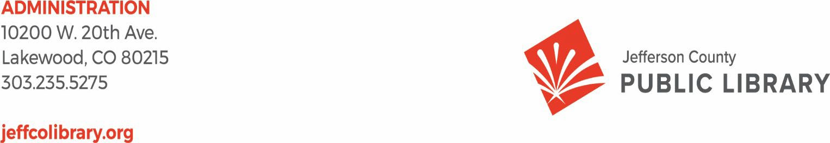

TO: Library Board of Trustees

FROM: Kim Johnson, Chair and Donna Walker, Executive Director DATE: July 10, 2025

RE: Consent Agenda for the July 17, 225 Board Meeting

1. Library Board of Trustees approve minutes of June 12, 2025 Board Study Session
2. Library Board of Trustees approve minutes of June 18, 2025 Board Meeting
3. Library Board of Trustees authorize Midwest Tape Audio/Visual Contract Renewal
4. Library Board of Trustees authorize Xcite Agreement and Purchase for Conifer Community Room Audio/Visual

**Jeﬀerson County Public Library Board of Trustees Study Session**

**June 12, 2025- 5:30pm**

**Hybrid Meeting held online via ZOOM**

**and in-person in the Lakewood Library meeting room.**

TOPICS:

Libraries & Inclusion

* Free of Charge Printing and Copying at JCPL

Strategy & Operations Finance & Budget

* Review DRAFT letter to the Board of County Commissioners certifying the mill levy necessary to maintain and operate the library
* Review DRAFT 2026 5-Year Capital Plan
* Review DRAFT 2026 Proposed Budget Plan

Communications & Engagement

* New Library Naming Process

Facilities & Construction

* South County Construction Management/General Contractor

Call to Order

Kim Johnson, Chair, called the Study Session to order at 5:30 p.m.

**Other Trustees present**: Emelda Walker (Vice-Chair), Charles Jones (Secretary), Jill

Fellman, and Renny Fagan.

**Staﬀ present**: Donna Walker, Executive Director; Julianne Rist, Library Planning & Policy Senior Advisor; Bernadette Berger, Chief Technology & Digital Innovation Oﬃcer; Matt Griﬃn, Chief Strategy & Operations Oﬃcer; Lisa Smith, Chief People and Culture Oﬃcer; Elise Penington, Director of Communications & Engagement, Amy Bentz, Assistant Director of Library Design Projects and Planning; Padma Polepeddi, Assistant Director of Libraries & Inclusion for Community Outreach; Lizzie Gall, Assistant Director of Libraries & Inclusion for Resources and Programs; Jessica Paulsen, Assistant Director of Libraries & Inclusion for Customer Experience; Kelci Rude,

Administrative Coordinator Supervisor; Katie O’Loughlin, Administrative Coordinator

Supervisor; and Ryan Turch, Technology & Digital Innovation Operations Supervisor. There were additional Library staﬀ members attending the meeting.

Libraries and Inclusion: Free of Charge Printing and Copying

Jessica Paulsen, Assistant Director of Libraries & Inclusion for Customer Experience, addressed the Board regarding the proposed change to remove printing and copying service fees at JCPL.

### What We’re Doing Now

* + $00.25/page color
  + $00.10/page black and white
  + 2024 expenses: $84,670
  + 2024 revenue: $114,010
  + 2024 net income: $29,340



* + JCPL currently charges $0.25/page color and $0.10/page black and white.
  + 2024 net income was $29,340.

### The Why

Patron Impact

* + Remove barriers to accessing services, especially for those with lowest financial stability
  + Second most valuable service we provide to Spanish speaking community
  + Aligns with area libraries



Staff Impact

* + Reduce time spent on money processing activities
  + Focus on higher value tasks and more positive interactions
  + Reduce troubleshooting machines



* + - Patrons who use a credit/debit card are subject to a $5 hold. JCPL is not able to remove the hold, and this $5 hold also limits the number of pages that patrons can print in one job. Larger print jobs require patrons to submit multiple jobs, or staﬀ must override this hold.
    - Patrons ﬁnd the current process to be frustrating; staﬀ report that on average they receive comments from patrons between 2-7 times a week about other systems oﬀering this free of charge; or patrons going to other systems to complete these tasks.
    - The Jeﬀerson County Equity Atlas reports that 29% of Jeﬀerson County residents are cost-burdened, and 16.6% of residents are considered low-income; charging for these services creates a barrier for patrons.
    - Fourteen out of twenty-two of the largest Colorado libraries currently oﬀer some form of free of charge printing for their patrons.

Recommendation:

* + - We are recommending moving to free of charge printing and copying services. This has been built into the proposed 2026 budget

2026 Budget Impacts:

### 2026 Budget Impact

Expenses: $83,605 Lost revenue: $114,010



* + - Anticipated expenses $83,605. We expect to see a 10% increase in patron usage in the ﬁrst year based on the feedback from other systems when they made this change. We anticipate that usage will then stabilize after the ﬁrst year.
    - Anticipated lost revenue: $114,010

### Recap

* Remove barriers
* High-impact change for low-impact cost
* Pre-paid service via tax dollars



Trustee Fagan left the Board Study Session at 5:37pm In response to questions the Board was advised that:

* + - JCPL will still have copiers and printers, and we will have a service contract on the equipment.
    - Staﬀ time spent troubleshooting will decrease because they are not completing tasks such as clearing coin jams, overriding fees, etc.

The Board did not have any further questions about this proposed service change.

Strategy & Operations: 2026 Budget

Matt Griﬃn, Chief Strategy and Operating Oﬃcer, addressed the Board about the 2026 draft budget, and provided the following information.

- There have been no material changes to the draft 2026 budget since last month.

Revenue:



2026 Revenue Recap

**Table 1:**

* **5% property tax growth projected for 2026**
  + Assessment year with moderated value increases
  + State legislation impact reduced vs. prior years
  + Conservative estimate given early budgeting timeline
* **Approach supports long-term planning**
  + Aligns with structurally balanced forecast
  + Reﬂects cautious stance amid market uncertainty
* **Investment income forecast remains conservative**
  + Reduced fund balance = lower returns
  + Historical volatility factored in
* **Clariﬁcation: All revenue items are fully captured**
  + Presentation format differs from 2025 annual budget document

3

* + - Table 1 in the Board packet shows a 5% increase in property tax revenue over

2025.

* + - 2026 is an assessment year with moderate value increases anticipated.
    - There is also state legislation which may impact net collections over prior years.
    - Projected tax revenue is somewhat variable at this point in the year. We will come to a more concrete ﬁgure towards the end of the year as assessed values come through.
    - 5% reﬂects a responsible stance, especially as we consider our 10-yr forecast’s

sensitivity to this single revenue stream.

* + - We have a similar conservative approach in investment income. Planned usage in 2025-2026, the available investment amount will shrink due to 2025 and 2026 planned expenditures.
    - Past Board direction has been to be conservative, and we have maintained that approach for 2026 budgeting.
    - Related to a question from May Board meeting: There are diﬀerences in the forecast shown in the Board presentation vs the 2025 annual budget document on the website, but all revenue items were captured in both. The diﬀerence stems from how they are presented. Some expenses are categorized at a higher level in these Board forecasts to provide a more strategic view.



2026 Operating Expenditure Recap

**Table 2:**

* **Overall operating costs up just under 3%**
  + Aligned with long-term forecast trends
* **Salaries & beneﬁts: 1% net increase**
  + Higher-than-expected turnover in 2025
  + Replacements hired at lower pay rates
  + Includes 2.5% CPI-based salary adjustment
* **$30K reduction in interdepartmental charges**
  + Based on updated County ﬁgures
* **Expenditure growth remains measured and sustainable**

4

Expenditures:

* + - Table 2 in the Board packet shows total operating expenses are projected to

increase just under 3%.

* + - Salaries and beneﬁts line shows a 1% net increase. This is driven by a lower starting point in 2026 vs 2025 due to higher than expected turnover. That 1% net increase still includes a 2.5% salary adjustment for 2026 across all positions. 2.5% is grounded in CPI data.
    - $30k reduction in interdepartmental charges



2026 Capital Expenditure Recap

**Table 3:**

* **$28.3M proposed for 2026**
  + Includes ARMs and capital projects
* **$53.6M total CIP over 5 years**
  + Major long-term investment
  + Signiﬁcant impact on ﬁnancial planning
* **Budget timing reﬂects expected cash ﬂow needs**
  + May not align with project completion dates

5

Capital Expenditures, 5 and 10 year Forecast:

* + - * Table 3 in the Board packet.
      * $28.3 million budgeted across projects including ongoing ARMs as well as

capital project work in 2026.

* + - * We have allocated $53.6 million budgeted towards capital over the next 5

years.

* + - * + This is a signiﬁcant investment and key factor that we are accounting for in our revenue and our expenditure forecast.
      * The budget years listed reﬂect when we expect budgets to be spent, not the project completion dates.

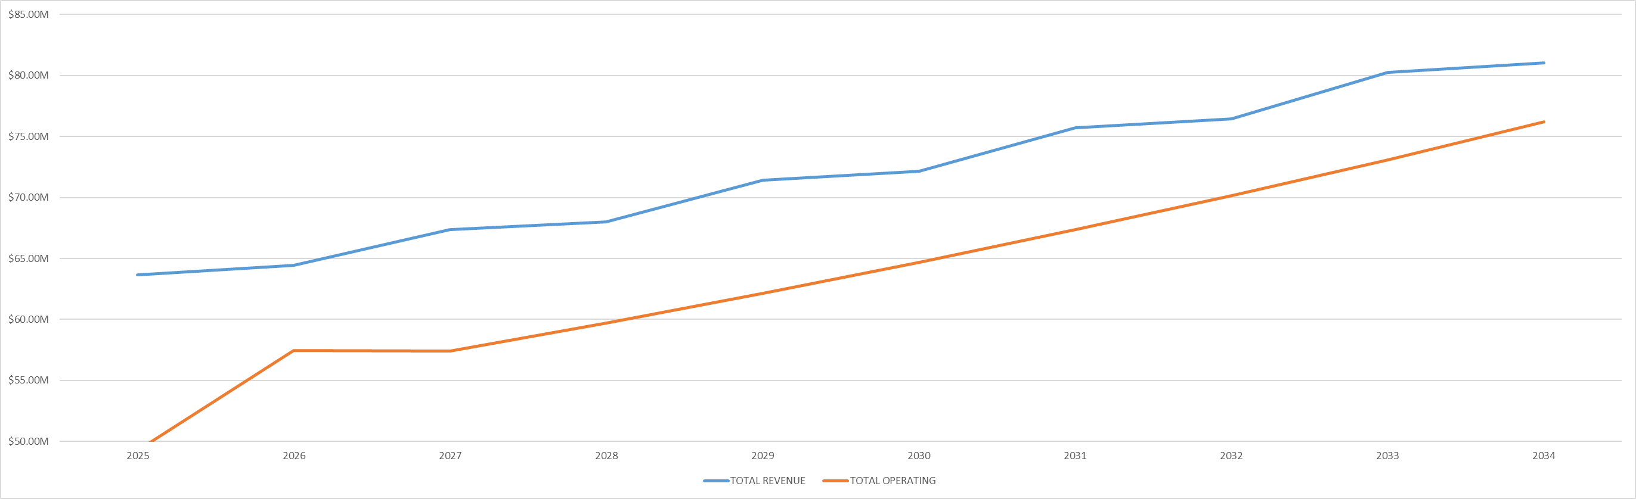

Revenue vs Operating Expenditure

6

* + - Revenue mapped against forecasted operating expenditures indicates that operating expenditures will not exceed revenue over the 10-year period.

Fund Balance over 5 Years

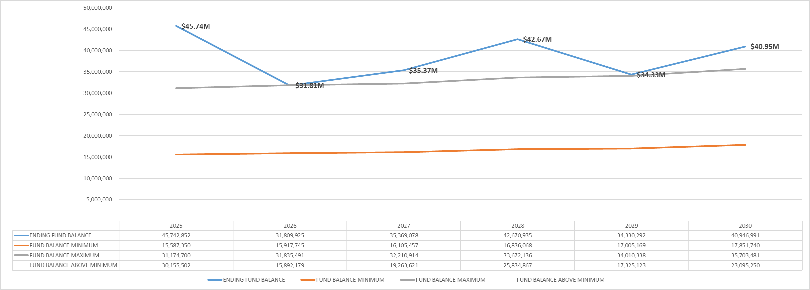

5 Year Fund Balance vs Boundaries

7

* + - Upward shift in ﬁgures from last month driven by a recent update from 2024

revenue with a net increase of $1.7 million. Due to:

* Change to investment income expected around this time each year
* We also received a Columbine roof replacement reimbursement, which we had budgeted and anticipated.
  + - No change to underlying assumptions.
    - Overall trajectory remains the same as last month.

Fund Balance over 10 Years

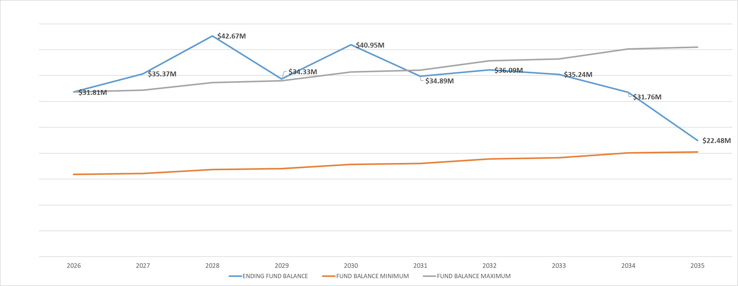

10 Year Fund Balance vs Boundaries

8

* + - Impact over 10 years is shown against established boundaries. The fund balance numbers reﬂect planned projects and show that we still maintain ﬁnancial stability.
    - The 2034 and 2035 drop oﬀs are driven by 10 Year Capital plan projects.

In response to questions the Board was advised that:

* + - The percentage growth for the salaries and beneﬁts is comparing budget to budget.
    - We do not have forecasted actuals to budget for the 2025 salaries and beneﬁts line item at this point in the year.
    - When we build the 2026 budget salaries and beneﬁts line we evaluate position by

position to see what current rates are, add 2.5% to that, and that gives us our

line-item budget.

* + - Diﬀerences primarily reﬂect diﬀerent positions ﬁlled than were in the original budget, or shifts in salaries based on vacancies and hiring rates.
    - We looked at CPI data and historical trends to build that 2.5% percentage increase.

The Board provided the following feedback:

* + - 10-year fund balance slide is concerning in outyears as it indicates that we would fall below the fund balance minimum in 2036. The Board will need to continue to monitor that trend during each annual review.
    - The Board has a ﬁduciary duty to the taxpayers to make sure that the fund balance does not go below the minimum.
    - Any unanticipated increases in operating expenses will accelerate this declining trend line in the fund balance.
    - The Board would like the Revenue vs Operating chart updated before the June 18 Board meeting to provide more clarity for the public when looking at operating expense increases from 2025 to 2026.
    - The Board indicated consensus that they are comfortable with the budget as presented for the June 18 Board Meeting.

Trustee Johnson shared feedback on Trustee Fagan’s behalf regarding the Cover Letter to the Board of County Commissioners (BCC). The Board agreed that Kim Johnson and Donna Walker would edit the letter before the June 18 Board meeting vote to include:

* + - Grammar update.
    - Language recognizing staﬀ.
    - Adding an additional introductory sentence before the bullets.

The Board was advised that the bullets reﬂect the language from the mill levy campaign

and ballot.

Communication & Engagement: New Library Naming Process

Elise Penington, Director of Communications and Engagement, addressed the Board and introduced a proposed process for naming new JCPL libraries.

### Library Naming Process Recommendation

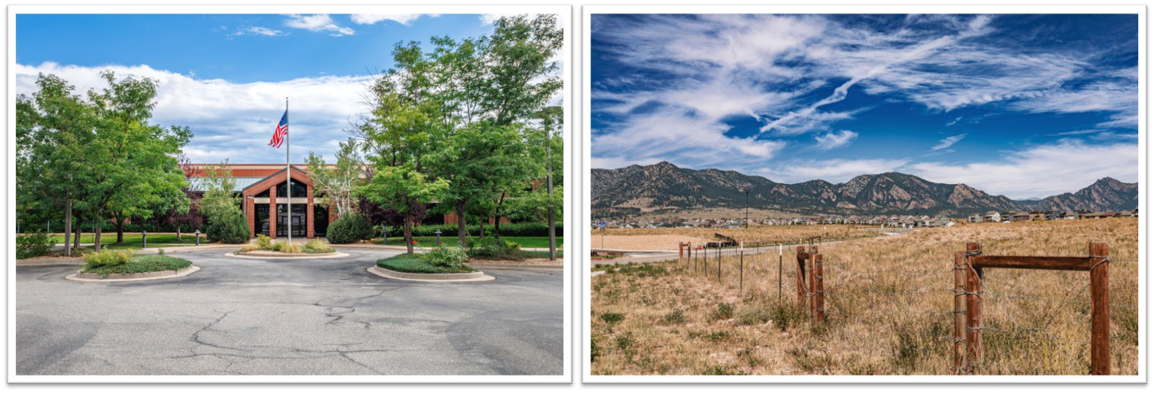

* + - We’d like to establish a consistent and repeatable naming process as we look to open our two new locations.
    - This process will guide us in naming our new libraries and serve as a framework for naming future locations.
    - Selecting names early allows us to start incorporating the oﬃcial names into marketing, community engagement, and other public-facing eﬀorts.
    - Current naming approach is largely based on city or geographic area where they are located.

Phase One:

## *Generate Ideas*

* Create an expansive list of potential names
* Research local geography, history and cultural elements
* Consider different naming categories: geographic, historical, inspirational, descriptive or functional
* Invite staff and stakeholders to share naming ideas



Phase 1: Generate Ideas

* + Generate expansive list of names.
  + Invite staﬀ and stakeholders to share naming ideas through various

engagement avenues.

Phase Two:

## *Evaluate & Shortlist*

* Narrow potential names
* Evaluate against selection criteria
* Test how the name sounds, looks in print and pairs with frequent phrases
* Check legal/logistical viability of top names
* Present recommended names to JCPL leadership for feedback



Phase 2: Evaluate and Shortlist

* + Work to narrow using a variety of methods
  + Evaluate against selection criteria
  + Test visuals
  + Research legal and logistical viability
  + Present recommended names to JCPL leadership for feedback

### Recommended Selection Criteria

|  |  |
| --- | --- |
|  |  |
| **Relevant** | Reflects the community, history or region |
| **Inclusive** | Culturally respectful and inclusive |
| **Unique** | Distinguishable from nearby institutions or other libraries |
| **Strategic** | Aligns with JCPL’s mission, vision, and values |
| **Tone** | Appropriate for a formal public institution |
| **Clarity** | Easy to say, spell and remember |
| **Longevity** | Will age well and remain meaningful |
| **Brand Potential** | Meets JCPL brand voice and tone standards; works well in logos, signage and promotional materials |



* + Recommended selection criteria for evaluating names includes criteria like relevancy, inclusivity, longevity, clarity, and brand potential.

Phase Three:

## *Present Name(s) to Board*

* Top name recommendation(s) presented to the Board of Trustees
* Name(s) shown in designed format for equal comparison
* Trustees select final library name
* Naming announcement plan shared



Phase 3: Present Names to Board

* + Top name recommendations go to Board
  + Name(s) presented in design format
  + Trustees discuss and select ﬁnal name
  + Naming announcement plan shared

Phase Four:

## *Name Rollout*

* New Library name is announced
* Naming announcement plan is implemented (personalized based on location and community)



Phase 4: Rollout

* + New library name announced
  + Naming announcement plan is implemented

The Board provided the following feedback on this process:

* + Appreciate the ﬂexibility in this approach.
  + Like that we are not deﬁning quantities when it comes to shortlist.
  + The Board would like to be sure that they are given the shortlist of names and then vote on the names at two separate meetings to allow for discussion.

In response to questions the Board was advised that:

* + We do not have a set deadline for when a location needs to be named before we open that location. Our general approach is to have the name as early as possible so that we can begin to use it for community engagement and marketing.

Facilities & Construction: South County Construction Management/General Contractor

Matt Griﬃn, Chief Strategy & Operating Oﬃcer, addressed the Board. JCPL ran a competitive bid process for the South County General Contractor.

* + Received thirteen proposals.
  + Completed four interviews.

JCPL is recommending that we contract with Flintco, LLC. We have worked with them previously. The contract is structured in two phases, Phase 1 is $25,000 and includes cost estimating, constructability and value engineering and then at the end of Phase 1 they produce the Guaranteed Maximum Price (GMP) which would come back to the Board.

In response to questions the Board was advised that:

* JCPL is currently working with Flintco on the Arvada Redesign project and the experience has been positive so far.
* We anticipate that the South County design would take one year and we would

receive the South County GMP in summer 2026.

* We will be working in the ﬁeld with Flintco on the Arvada project beginning in December 2025.
* The intent is that we would proceed to Phase 2 services with Flintco, but the contract is written to allow us to only complete one phase with them if we did not want to continue with Phase 2.

The Board provided feedback that:

* They want to be sure we have positive ﬁeld experience with Flintco on the Arvada project before we commit to another large project with them.
* The motion language for the June 18 contract approval will need to be carefully reviewed to reﬂect the Board’s commitment to Phase 1 only.

ADJOURNMENT The Study Session was adjourned at 6:14p.m.

Charles Jones, Secretary

**Minutes of the Regular Meeting of the** JEFFERSON COUNTY PUBLIC LIBRARY **BOARD OF TRUSTEES**

June 18, 2025

CALL TO ORDER – REGULAR MEETING

The regular meeting of the Jefferson County Public Library Board of Trustees was held online via ZOOM and in-person in the Lakewood Library meeting room on June 18, 2025. Library Board of Trustees Chair, Kim Johnson, called the meeting to order at 5:30 p.m.

Other Trustees present: Emelda [Bing] Walker (Vice-Chair), Charles Jones (Secretary), Pam Anderson

Absent: Renny Fagan, Jill Fellman

**Staff present:** Donna Walker, Executive Director; Matt Griffin, Chief Strategy & Operating Officer; Julianne Rist, Library Planning & Policy Senior Advisor; Cynthia Kiyotake, Chief Libraries & Inclusion Officer; Lisa Smith, Chief People & Culture Officer; Elise Penington, Director of Communications and Engagement; Amy Bentz, Assistant Director of Library Design Projects and Planning; Jessica Paulsen, Assistant Director of Libraries & Inclusion for Customer Experience; Dr. Angel Montoya, Edgewater & Diversity, Equity and Inclusion Manager; Kelci Rude, Administrative Coordinator Supervisor; Katie O’Loughlin, Administrative Coordinator Supervisor; Ryan Turch, Technology and Innovation Operations Supervisor

There were additional Library staff members attending the meeting.

APPROVAL OF AGENDA

**MOTION:** Emelda [Bing] Walker moved that the Library Board of Trustees approve the agenda as presented. Seconded by Pam Anderson the motion passed by unanimous vote of all Trustees present.

PUBLIC COMMENT

The Board values public participation. Those who would like to address the Library Board can do so virtually, in-person, or online. The opportunity to address the Library Board does not include a question-and-answer session or response. Additionally, the Library Board does not respond to anonymous questions or comments. Comments will be acknowledged in the minutes of the meeting.

The Chair advised the Board that 29 online public comments were received. The Chair will provide those comments to the trustees immediately after the meeting.

The Chair allowed for 36 minutes for 12 in person public comments, in addition to two (2) online public comments.

* Ian Fetters, Tina Moeinian, Christine Catramados, Brad Bruce, Finnialla Wright, Narey, Asa Farrer, Shullomata, Anna Sparlin, Sammi Johnson, Susan Hall, Katy Conway, Stephen H., and Jill Hinn addressed the Board regarding issues related to dress code concerns. Jill Hinn also addressed the productivity of recent bargaining sessions.

The Chair closed the public comment portion of the meeting at 6:06 pm.

APPROVAL OF CONSENT AGENDA

The Chair asked the Trustees if any of the items should be removed from the consent agenda. There were no requests for items to be removed.

Items on the Consent Agenda

1. Approve Minutes of May 15, 2025 Board Meeting
2. Approve 2026 Governance Budget 4.8.2
3. Adopt 2026 Board Meeting Schedule
4. Authorize the Wheat Ridge Library Lease Amendment
5. Adopt Proposed adjustments to Governing Policies 2.7 Emergency Executive Director Succession and 3.3 Delegation to the Executive Director

**MOTION**: Pam Anderson moved that the Library Board of Trustees approve the items on the consent agenda as presented. Seconded by Emelda [Bing] Walker the motion passed by unanimous vote of all Trustees present.

FOUNDATION UPDATE

Jo Schantz Hall was absent. The Executive Director addressed the Board and shared that she met with Jo last Friday. They will be meeting with a potential donor on the coming Friday. All are encouraged to attend the Books on Film Benefit in July. The Chair advised that the Board could send any questions about the report, and she would share with Trustee Fagan or Jo Schantz Hall.

EXECUTIVE DIRECTOR REPORT

* 1. Executive Director Report

The Executive Director addressed the Board and thanked the Chair, Trustee Jones, and Trustee Fellman for attending the Arvada City Council proclamation for Juneteenth. The Executive Director read a portion of the proclamation: “Be it proclaimed that the Mayor and the Arvada City Council hereby designate June 19, 2025 as Juneteenth in the City of Arvada and commends Jefferson County

Public Libraries for exemplary work encouraging learning and promoting a stronger more united community where all people are welcomed and valued.”

* 1. Capital Building Projects Update

**South County Library**: The Design Kickoff is at the end of the month. We are working on visioning with the team heading into that meeting. René Yaws, our South County Library Manager, continues to offer programming at the site that includes Summer Challenge, a Pride event and Story Times.

Everything is set with improvement agreements after discussion around whether there needs to be a light; the County will be putting in some sort of signal.

**NW Jeffco Library**: Design development continues, as does outreach in the community. Working on getting the contract signed with the general contractor.

**Arvada Library Redesign**: Arvada Library is moving along nicely in design. The page turn was held last week; design pricing is expected next week. We hope to make a safer and more welcoming experience and activated space in the downtown area and that all elements selected can stay included. **Conifer Library**: We recently held a Dusty Boots Tour with Trustee Jones, Trustee Fellman, donors and Jo Schantz Hall in attendance. Construction continues apace.

There were no questions from the Board.

OPERATIONAL UPDATES

Strategy and Operations

Finance and Budget

1. Financial Report (May 2025)

Matt Griffin, Chief Strategy & Operating Officer, addressed the board. There is a total revenue increase of our 2024 actuals of around $3 million. The net increase within that was $1.7 million. This is driven by two key items; $900,000 in investment revenue being accrued back to 2024 and $700,000 insurance reimbursement for the Columbine roof replacement. The remainder of the revenue increase was made up of GASB-driven entries that change how we account for certain line items within building rent and software agreements. There was also an offsetting expenditure for those so there is no net change. The net change to our bottom line was an increase of about $1.7 million, driven by investment and insurance reimbursement.

He then provided information on the May 2025 monthly financials. The Board was advised that:

* + Table 1 – Summary that everything is on view and in line with expected spending this year.
  + Table 2 – We are right where we expect to be at this point in the year. Trending in healthy direction with no surprises.
  + Table 3 – Board authorized submittal of carryforward in February. We see the carry forward requests in this budget. This provides a realistic view of 2025 budget against the project actuals with one correction: $1.1 million budget currently shows against the Columbine roof repair.

That should be against the Evergreen roof repair. That is a manual error that will be updated in next month’s financials. Spending against capital projects is on track and within budget against all lines.

There were no questions from the Board.

1. Letter to the Board of County Commissioners certifying the mill levy necessary to maintain and operate the library

The Chair noted that edits were made to the letter based on discussion from the Study Session.

**MOTION**: Emelda [Bing] Walker moved that the Library Board of Trustees authorize the Chair to sign the letter to the Board of County Commissioners certifying the mill levy necessary to maintain and operate the Library in 2026. Seconded by Pam Anderson the motion passed by unanimous vote of all Trustees present.

1. 2026 5-Year Capital Plan

**MOTION**: Pam Anderson moved that the Library Board of Trustees authorize the Executive Director to submit the 2026 5-Year Capital Plan request to the Board of County Commissioners. Seconded by Emelda [Bing] Walker the motion passed by unanimous vote of all Trustees present.

1. 2026 Proposed Budget Plan

Matt Griffin, Chief Strategy & Operating Officer, addressed the board. He noted there was a question at the Study Session about the jump in operating expenditure. That increase is expected from 2026 into 2027. This is driven by the additional staff requirements for South County Library and Northwest Jeffco and shown based on the anticipated dates of hire in project plans then levels out to a consistent growth pattern.

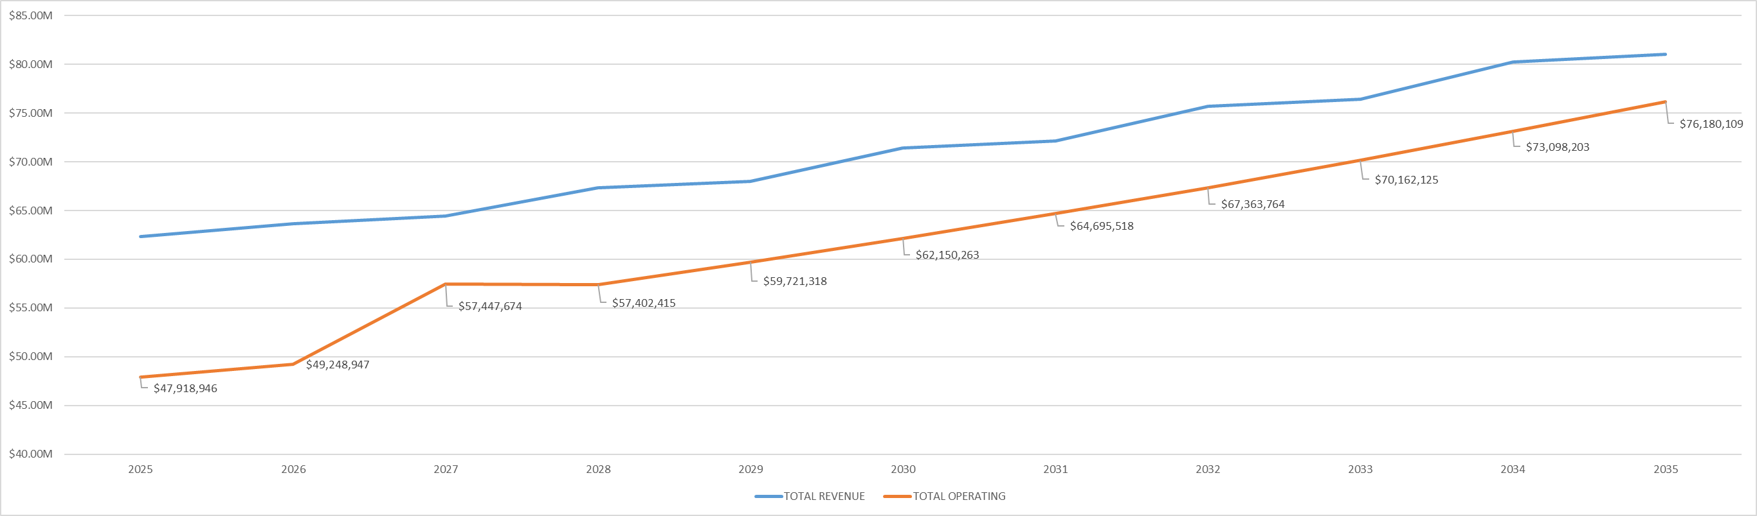

Revenue vs Operating Expenditure

6

There were no questions from the Board.

The Chair advised the Board that while we don’t do proxy voting, she had a conversation with Trustee Fellman who could not attend tonight’s meeting, and she is in support of the budget as it is.

**MOTION**: Emelda [Bing] Walker moved that the Library Board of Trustees authorize the Executive Director to submit the 2026 Proposed Budget Plan to the Board of County Commissioners. Seconded by Pam Anderson the motion passed by unanimous vote of all Trustees present.

Facilities & Construction

1. Authorize contract for Construction Manager/General Contractor Services–South County Library, Flintco, LLC

Matt Griffin, Chief Strategy & Operating Officer, addressed the Board and shared that this is a request to authorize the general contractor. It was discussed at Study Session last week. There were no questions from the Board.

**MOTION**: Pam Anderson moved that the Library Board of Trustees authorize the Executive Director to execute the contract with Flintco, LLC for Phase I of the South County Library project in the amount of the pre-construction fee of $25,000. Seconded by Emelda [Bing] Walker the motion passed by unanimous vote of all Trustees present.

Libraries & Inclusion

1. 2025 JCPL Pride Programming

The Executive Director addressed the Board and shared that we wanted to do a service presentation, and the team chose our Pride programming. Additionally, the Executive Director noted that the Board received items provided by the County; lanyards and buttons were distributed at the meeting.

Dr. Angel Montoya, Edgewater & Diversity, Equity and Inclusion Manager, addressed the Board and thanked them for the opportunity to present.

Pride 2025-Programming

###### 20+ programs across all locations

* + - Pride Nail Party
    - Belmar Pride Carnival
    - Evergreen Rainbow Waffle Palooza
    - Arvada Chappel Roan Party

###### Edgewater Pride Outreach

* June 7

###### Large signature event at Arvada Center

* + - Pride in Place: A Colorado Country Concert June 12



* Pride programming provides opportunities to cultivate space and amplify the voice for the LGBTQI community. This is one of our five focus communities.
* This year we had 20+ programs across locations throughout June.

# Pride 2025 Community Engagement

* Over 50+ Jeffco Schools Genders & Sexualities Alliances (GSA) Visits
* Monthly Teen Pride Nights at Secrest Recreation Center in Arvada
* Jeffco Schools GSA Summit
* Jeffco Pride Prom
* Resilience 1220
* Edgewater Pride Event
  + Over 800 unique contacts
  + Created over 100 library cards



# Talking Points

* 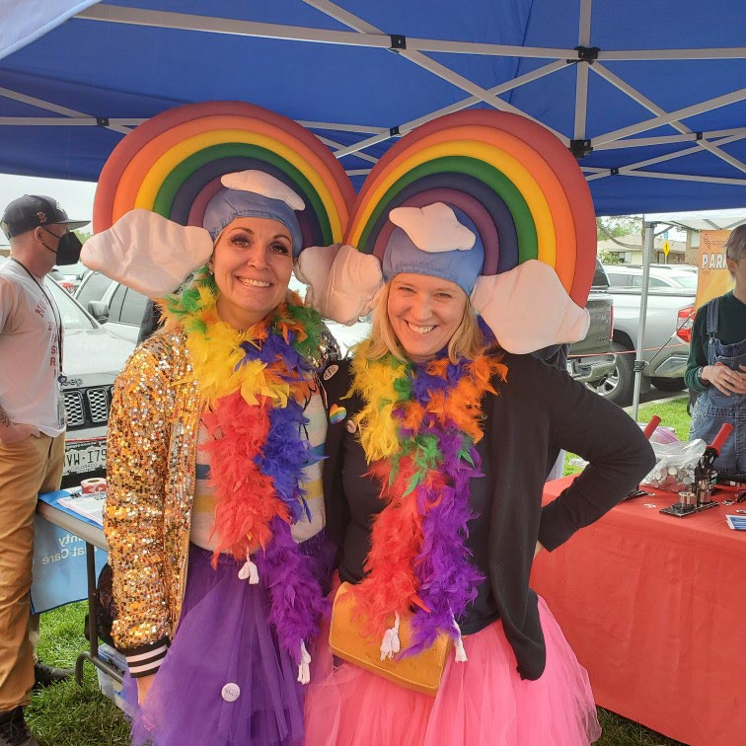Why is pride important?
* Why does the library celebrate Pride?
* Tips for de-escalating hard conversations



* Pride is important to cultivate spaces and amplify voices of the LGBTQI community. To be a welcoming space and be a celebration of the community. It is a chance for the community to learn and grow in diversity, equity and inclusion.
* The Library celebrates Pride because it is a radically welcoming space for all individuals and all patrons; for all to feel seen, heard and valued. It’s important to honor a historically underserved community and provide a space of inclusion.
* Tips for deescalating hard conversations were provided to staff members across locations. The DEI team has helped correspond communication with other locations throughout JCPL whenever there have been concerns, advising on how to navigate those conversations.

# Patron Feedback



Thank you so much for being here, this was an amazing event, and you have the best selection of pride buttons I've ever seen.

The Arvada Library was the first place I have ever seen an inclusive book display. It was so meaningful and why the Arvada Library is my favorite.

Thank you so much for this event! I'm feeling seen and appreciated.

I am so excited that you are offering a Pride Nail Polish Program! I just wanted to thank your staff for always having creative fun ideas and including PRIDE in your activities.



* This feedback is unique to summer 2025. The feedback elevates the point that it’s important to cultivate spaces and opportunities to amplify voices of LGBTQIA+ community.

The Board provided the following feedback:

* This is wonderful work. My adult children found a safe space in the library over the years and it is one of the reasons I serve on this Board. Grateful to the work everyone at JCPL is doing to support that community.
* Amazing. Well done.

The Chair thanked Dr. Angel Montoya. There were no questions from the Board.

ITEMS REMOVED FROM THE CONSENT AGENDA

No items were removed from the consent agenda.

EMERGING ISSUES

No issues. The Chair noted that she will send online public comment forms to the trustees.

ENDS

There were no items.

BOARD GOVERNANCE

No items.

BOARD SCHEDULE – NEXT MEETINGS

2025 Board Meeting Schedule

* July 10, 2025 – Study Session Hybrid: Virtual via ZOOM. In-Person Location: Lakewood Library Meeting Room
* July 17, 2025 – Board Meeting – 5:30 pm Hybrid: Virtual via ZOOM. In-Person Location: Lakewood Library Meeting Room
* August 14, 2025 – Study Session Hybrid: Virtual via ZOOM. In-Person Location: Lakewood Library Meeting Room
* August 21, 2025 – Board Meeting – 5:30 pm Hybrid: Virtual via ZOOM. In-Person Location: Lakewood Library Meeting Room

ANNOUNCEMENTS/GENERAL INFORMATION SHARING

There were no announcements.

EXECUTIVE SESSION:

At 6:29 pm, the Chair called for a motion to adjourn the regular meeting, reconvene in Executive Session regarding Collective Bargaining and adjourn the regular Board meeting at the conclusion of the Executive Session.

**MOTION**: Pam Anderson moved to adjourn the regular meeting of the Library Board of Trustees, reconvene in Executive Session regarding the Collective Bargaining AND adjourn the Regular Board meeting at the conclusion of the Executive Session. Statutory citation authorizing an executive session for these topics are:

* Pursuant to 24-6-402(4)(e)(I) for discussion of strategy and instructions to negotiators

Seconded by Emelda [Bing] Walker the motion passed by unanimous vote of all Trustees present.

The Chair announced a ten-minute break to allow the Board and staff to clear the room, leave the existing ZOOM meeting and then join the Executive Session.

The Chair called the Executive Session to order at 6:37 pm with the following trustees present: Kim Johnson, Pam Anderson, and Emelda (Bing) Walker. Also present were

Steven (Steve) Spirn; Donna Walker, Executive Director; Lisa Smith, Chief People & Culture Officer; Matt Griffin, Chief Strategy & Operating Officer; Elise Penington, Director of Communications & Engagement; Cynthia Kiyotake, Chief Libraries & Inclusion Officer, Kelci Rude, Administrative Coordinator Supervisor.

It is noted that the session was recorded and that the recording will be retained for the required 90 days.

CALL FOR ADJOURNMENT OF EXECUTIVE SESSION

Chair adjourned the meeting at 6:52 pm.

It is noted that the Library Board of Trustees met in Executive Session concerning Collective Bargaining pursuant to 24-6-402(4)(e)(I) for discussion of strategy and instructions to negotiators. The Trustees held those discussions, and this summary is provided as required by Colorado Statute.

Charles Jones, Secretary



TO: Donna Walker, Executive Director

FROM: Cynthia Kiyotake, Chief Libraries and Inclusion Officer

Lizzie Gall, Assistant Director of Libraries & Inclusion for Resources and Programs DATE: July 10, 2025

RE: Third Annual Renewal of Midwest Tape Contract

**History of Contract: Midwest Tape Audiovisual Contract**

In July of 2022 the Board of Trustees authorized Jefferson County Public Library to make Midwest Tape our primary vendor for media, DVDs and audiobooks. The approved contract allows us to renew with Midwest Tape annually for four additional years. This would be the third renewal. Midwest Tape continues to provide us with quality products under the services outlined in the contract and we would like to renew the contract. The third renewal would run from August 14th, 2025 to August 13th, 2026.

**Total Cost:**

The anticipated expenditure for this renewal period is $525,000 and is within the approved 2025 Collections Books and Materials budget. The total amount of the entire contract is not to exceed

$2,000,000.

**Action Requested:**

We request that the Library Board of Trustees authorize the Executive Director to sign a one-year contract renewal with Midwest Tape as our primary physical audiovisual materials vendor. This item will be placed on the consent agenda for the July 17, 2025 board meeting unless otherwise instructed by the Board.



TO: Donna Walker, Executive Director

FROM: Bernadette Berger, Chief Information Officer DATE: July 17, 2025

RE: Xcite Audiovisual, LLC, Agreement for Audiovisual System Services at Conifer Library

**History of Contract: Xcite**

Jefferson County Public Library (JCPL) requires a reliable audiovisual system for daily use by both patrons and staff. In November 2023, JCPL issued a Request for Proposal (RFP) for audiovisual services, and Xcite Audiovisual, LLC submitted the most advantageous proposal. In March 2024, JCPL entered into a master agreement for audiovisual services with Xcite. We contracted Xcite Audiovisual, LLC in 2024 and 2025 to provide audiovisual services for the Evergreen Library, Golden Library, Standley Lake Library, and the Library Service Center, and we are pleased with the quality of their work. We propose to contract Xcite Audiovisual, LLC again for the installation of audiovisual equipment in the community meeting room at Conifer Library, based on their previous satisfactory performance.

**Total Cost:**

Cost is expected to be $115,004.09 to complete the Conifer Library Audiovisual project in 2025.

**Budget**:

This expenditure is within the approved 2025 budget.

**Action Requested:**

We recommend JCPL enter into a contract with Xcite Audiovisual to complete the Conifer Library Audiovisual project in 2025. We request the Library Board of Trustees authorize the Executive Director to sign a contract with Xcite Audiovisuals LLC in the base amount of $115,004.09. This item will be placed on the consent agenda for the July 17, 2025 board meeting unless otherwise instructed by the Board.

##### Foundation Update

   

**Jo Schantz Hall, MNM, CfRE, GPC**

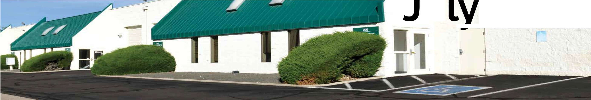

**u**

, **2 0 2 5**

**2025 BOOKS ON FILM BENEFIT**

**COMMUNITY CONNECTIONS**

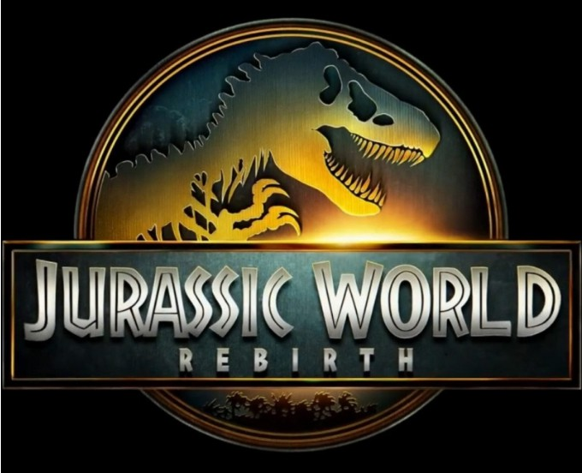July 2nd was the date, 6 pm was the time, and Harkins 14 Cinemas in Arvada was the place. That's when and where we celebrated our 4th annual Books On Film benefit!

This year's big screen picture was a follow-up to the successful Jurassic Park/Jurassic World film

series and as the 6th movie in the franchise's history. The film was Jurassic World Rebirth, starring Scarlett Johansson, Jonathan Bailey and Mahershala Ali.

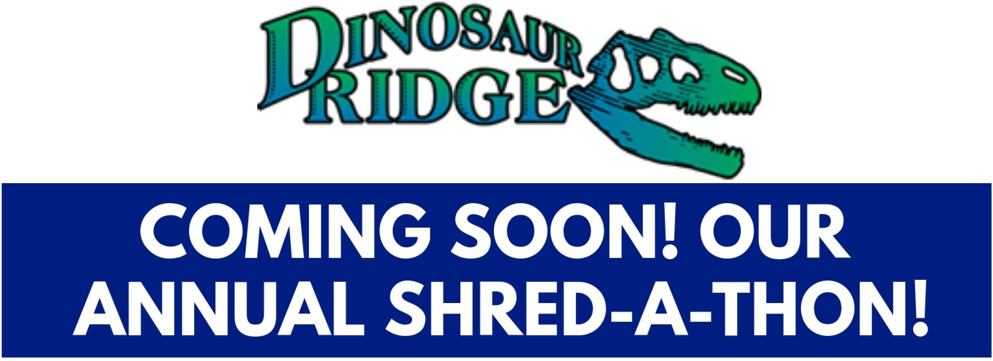In an added twist, JCLF partnered up with the Friends of Dinosaur Ridge to provide a post-film audience interactive discussion about the dinosaurs portrayed in the film and the new dino discoveries at Dinosaur Ridge! Nearly 80 guests were in attendance at this year's event, which was emceed by Nicole Brady, morning news anchor for Denver7.

This summer will mark the 4th year thatJCLF has hosted its popular Shred-a-thon! The event will take place on Saturday, August 16, from 9 am to noon, in the parking lot at Bank of Colorado, 275 Union Blvd. in Lakewood.

We will welcome cars and carloads of sensitive paper documents to be shredded on site -- all for a suggested donation of $20 per car.

Thanks go to our shredding partners, Stericycle, for helping us provide this welcome service to our Jeffco community!

* **June 20** - **major donor meeting with Donna Walker**
* **June 25** - **attended JCPL Combined Mgmt Team meeting**
* **June 26** - **Pre-event meeting with Friends of Dinosaur Ridge**
* **June 30** - **Pre-event tour at Harkins**

**14 Cinemas, Arvada**

* **July 1** - **Meeting with Donna Walker**
* **JulY. 2** - **Books On FIim benefit at Harkins 14 Cinemas, Arvada**
* **July 3** - **Meeting with Briana Francis to dfscuss potenflal garden grant for Arvada Library**
* **July 8** - **Lakewood Foothills Rotary**

|  |  |  |
| --- | --- | --- |
| * **July** | **10** | - **Applewood Business Assn.** |
| * **July** | **14** | - **Meeting with Donna Walker** |
| * **July** | **15** | - **Finance Committee meeting** |
| * **July** | **15** | - **Lakewood Foothills Rotary** |

* **July 16** - **CSU Extension Advisory Comm lttee m eetl ng**
* **July 17** - **Golden Pantry** & **Thrift B o a rd of D** I **re ct o rs m e e tl ng**

|  |  |  |
| --- | --- | --- |
| **WHALE'S TALE RECEIVES AWARD!** | | |
|  | -G | Our Whale's Tale Books Gifts shop in Colorado  Mills Mall was designate |

& d

K

by CommunityVotes Lakewood to receive the PLATINUM (highest)

� award for Best Bookstore in Lakewood!

Congratulations to our hard-working staff and bookstore volunteers!

**VOLUNTEER APPRECIATION LUNCHEON, JULY 25TH**

**FUNDRAISING UPDATE**

JCLF volunteers are invited to join ius n a special celebration luncheon on Friday, July 25th, at the Wheat Ridge Rec Center, 4005 Kipling St., in Wheat Ridge. The event will begin at 11:30 am, followed by the luncheon and awards ceremony.

Our theme this year is "A Day in India," featuring Madhvi Chittoor as our dance and musical entertainment.

Madhvi is a 14 year-old Bharatanatyam dancer. Bharatanatyam is a traditional dance form of the southern state of Tamil Nadu. Madhvi was exposed to dance at the age of five and then started learning rigorously from the age of 10 online and in-person from her teachers in India. She has performed in many places in India

and also in Geneva commemorating the launch of UNGC 26.

Madhvi employs dance to raise environmental awareness. Further, she has also received many awards for her performance and choreography in competitions.

**GRANTS PENDING**

**Jeffco NCAP Funding** -- **$25,000 for general operations**

**Boeing Employees Community Fund**

**$10,000 for general operations**

**Saks Fifth Avenue Foundation** -­

**$26,208 for Hard Times Writing Workshop**

**Mabel Hughes Charitable Fund** -­

**$26,208 for Hard Times Writing Workshop**

**Denver Broncos Charities** -- **$10,000 for 1000 Books Before Kindergarten**

**Gorham-McGee Fund** -- **$5,000 for 1000 Books Before Kindergarten**

**Believe In Reading Foundation** -­

**$4,865 for Babies First Books**

**Sam S. Bloom Foundation** -- **$5,000 for 1000 Books Before Kindergarten**

**BARNES & NOBLE BOOKFAIR ON SEPTEMBER 20TH**

**DINE & DONATE ON SEPTEMBER 17TH**

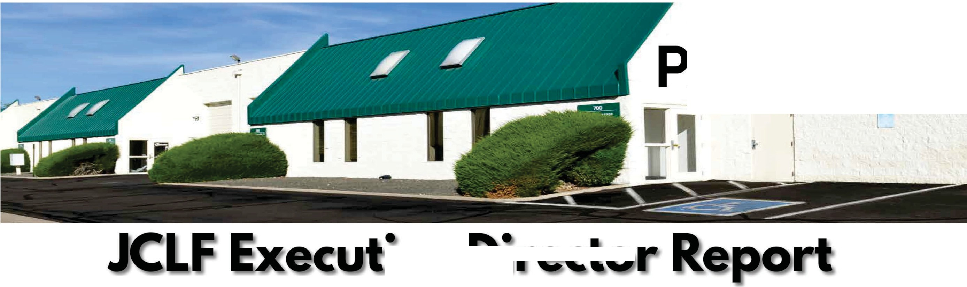

**AGE TWO**

**1,**

**1---=•�,I/!...**

**July 2025**

\\"I\ Es&Noetc As is our tradition, JCLF will

**BOOKFAIR�_-;::;���· �YJ�l** again team up with Barnes&

,•_ Noble Booksellers in Denver



- '9ARNES HOBLC j

**�.-�«·t����;,.i•.-"!!!Mlt��** West Village to produce this

-.......- ........u •._.."., . .'---,.._ ........ _._..."""""'-'"'" year's Bookfair! Shoppers wi11 simply produce a voucher at the bookstore's checkout stations and JCLF will receive a cash-back reward for each item sold, including books, audio books, games and more! The Bookfair runs all day on Saturday, September 20th, and our volunteers will staff an information table with the vouchers.

Another JCLF tradition is our annual Dine & Donate fundraiser

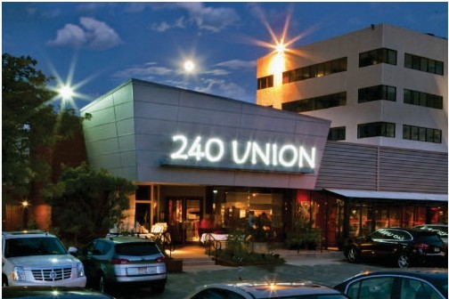at 240 Union Creative Grille in Lakewood.

This year's day-long benefit will take place on Wednesday, September 17. JCLF will receive 25% of all food sales on that date! Reservations can be made at https:/ /240union.com/reservations/

##### Executive Director Report



**JULY 2025** EXECUTIVE DIRECTOR REPORT

##### 2025 Annual Plan Progress in July

###### Portfolio: Service Point Development & Expansion

**Program: New Construction Project: South County Library**

* + Launch design team
  + Finalize Key Performance Indicators and Program of Service
  + Library naming process kick off

**Project: Northwest Jeffco Library**

* + Continue schematic design
  + Contract with General Contractor
  + Investigate sustainability options
  + Finalize Key Performance Indicators
  + Library naming process kick off
  + Submit re-plat application

**Program: Building Redesign Project: Arvada Library**

* + Finalize design development drawings
  + Initiate construction development drawings
  + Finalize Key Performance Indicators

**Program: Tenant Finish Project: Conifer Library**

* + Continue construction
  + Order furniture
  + Contract with new internet provider
  + Plan for move and opening

###### Portfolio: Building Inclusive Community

**Program: Digital Accessibility**

* + Digital Accessibility Guidelines completed and released to all staff

###### Portfolio: Embracing Innovation & Change

**Program: Fundraising Development**

* + Launch Fund Development Planning Committee
  + Key informant interviews



###### Portfolio: Continuous Process Improvement

**Project: Collective Bargaining Agreement**

* + Plan for August negotiation session

**Project: 2026+ Strategic Plan**

* + Continue plan development
  + Launch “values” selection with all staff

##### Service Highlights:

**No More Replacement Fees for Kids' Books!** Accidents happen, and life with kids is unpredictable. That shouldn’t get in the way of your child’s connection to reading. Starting this summer, we’ll no longer charge replacement fees for children’s books. Visit our website

for more information.

**Our Digital Collection is Moving to Libby** Based on community feedback, we’re moving all Boundless e-book and audiobook materials to Libby, by Overdrive by the end of summer. Users can now enjoy a growing selection of audiobooks, in addition to current e-books, magazines and comics. New to Libby? We’re here to make your switch easier.

**2025 Conferences: ADVOCACY AND ENGAGEMENT OPPORTUNITY FOR**

##### Trustees

**CALCON 2025 Colorado Association of Libraries Annual Conference** September 3-5, at Beaver Run Breckenridge, CO. Let Amber Fisher know by August 4 if you plan to attend.

Trustee Track is September 4th.

**Urban Libraries Council Annual Leadership Forum** October 22-24, Cincinnati, Ohio. Let Amber Fisher know by September 22 if you plan to attend.

#### HIGHLIGHTS OF EXECUTIVE DIRECTOR COMMUNITY ACTIVITIES,

###### JULY 2025

* Attend **ULC Director/CEO** weekly meeting
* Attend farewell celebration for Jansen Tidmore, **Jeffco EDC**
* Tour NW Jeffco Library site with staff from **Senator Bennet’s office**
* Trustee Lunches with **Renny Fagan and Pam Anderson**
* Meet with Joe Kerby, **Jefferson County Manager**
* Meet with Jo Schantz, executive director, **Jefferson County Library Foundation**
* Meet with Patrick Goff, **Wheat Ridge City Manager**
* Meet with Kwame Spearman, **ZIM Non-profit**
* Attend **Jefferson County Library Foundation** Volunteer Luncheon
* Attend **Jefferson County Library Foundation** Board meeting

##### Operational Updates Strategy and Operations



TO: Donna Walker, Executive Director

FROM: Matt Griffin, Chief Strategy & Operating Officer DATE: July 17, 2025

RE: Finance Monthly Report

**Budget to Actual Tables – June 2025**

Please see the enclosed Budget to Actual Tables for June 2025.

In June, JCPL recorded $16.0M in Real Property Tax revenue. Year-to-date, 93.1% of the budgeted collection has been received.

JCPL remains on track with its budget, with no areas of concern at this time. Financial performance is steady and aligned with expectations. As of the end of Q2, revenue collection may appear high due to the front-loaded nature of our primary funding sources. This pattern is typical and consistent with prior years.

In contrast, Operating Expenditures will continue at a steady pace throughout the remainder of the year to support ongoing programs, services, and staffing. Capital Expenditures will also proceed as planned and are expected to remain in line with established timelines and budget allocations.

In June, the Library Foundation provided funding of $1,604 to JCPL. The Library contributed $7,479 in-kind support in June. Year-to-date, the library has received $54,007 in funding and provided $45,893 in-kind support to the Foundation, with a ratio of 1.18.

**TABLE 1**

**JEFFERSON COUNTY PUBLIC LIBRARY REVENUE AND EXPENDITURE SUMMARY BUDGET TO ACTUAL**

|  |  |  |  |  |
| --- | --- | --- | --- | --- |
| **Revenue and Expenditure** | **2025 Budget** | **YTD Actual**  **06/30/2025** | **$ Variance**  **2025 Budget** | **% Variance**  **2025 Budget** |
| **Revenues** |  |  |  |  |
| Property Taxes (net adjustments) | 59,744,973 | 58,283,686 | 1,461,287 | 98% |
| Grants, Funds & Donations | 560,427 | (50,015) | 610,442 | -9% |
| Investment Income | 2,009,000 | 1,945,484 | 63,516 | 97% |
| Other Revenue | 35,000 | 97,894 | (62,894) | 280% |
| **Total Revenues** | **$ 62,349,400** | **$ 60,277,049** | **$ 2,072,351** | **96.7%** |
| **Expenditures** |  |  |  |  |
| Operating | 47,918,946 | 22,052,695 | 25,866,251 | 46% |
| Financing & Debt Service | - | - | - |  |
| Capital Projects | 49,385,963 | 13,330,550 | 36,055,413 | 27% |
| **Total Expenditures** | **$ 97,304,909** | **$ 35,383,245** | **$ 61,921,664** | **36.4%** |

|  |
| --- |
| % Variance 2025 Budget |
| ***96.7%***  **Total Revenues**  **0% 100%** |
|  |
| ***36.4%***  **Total Expenditures**  **0% 100%** |
|  |
| ***46%***  Operating  **0% 100%** |
|  |
| Debt  **0% 100%** |
|  |
| **27%**  Capital  **0% 100%** |

**TABLE 2**

**JEFFERSON COUNTY PUBLIC LIBRARY OPERATING EXPENDITURES**

**BUDGET TO ACTUAL**

|  |  |  |  |  |
| --- | --- | --- | --- | --- |
|  | **2025 Budget** | **YTD Actual 06/30/2025** | **$ Variance 2025 Budget** | **% Variance 2025 Budget** |
| ***Operating Expenditures*** |  |  |  |  |
| **Salaries & Employee Benefits** |  |  |  |  |
| Salaries | 19,267,433 | 8,756,591 | 10,510,842 | 45% |
| Awards & Bonuses | 275,000 | 34,653 | 240,347 | 13% |
| Other | 7,478,592 | 3,827,012 | 3,651,580 | 51% |
| Total Salaries & Benefits | $ 27,021,025 | $ 12,618,256 | $ 14,402,769 | 47% |
| **Library Collections** |  |  |  |  |
| Library Books & Materials | 7,692,199 | 3,453,449 | 4,238,750 | 45% |
| Library Periodicals | 205,000 | 109,034 | 95,966 | 53% |
| Total Library Collections | $ 7,897,199 | $ 3,562,483 | $ 4,334,716 | 45% |
| **Supplies and Other** |  |  |  |  |
| Supplies | 1,915,452 | 812,354 | 1,103,098 | 42% |
| Services & Charges | 7,851,593 | 3,042,100 | 4,809,493 | 39% |
| Interdepartmental Direct Charges | 713,165 | 334,031 | 379,134 | 47% |
| Treasurers Fees | 902,081 | 874,255 | 27,826 | 97% |
| Interdepartmental Indirect Charges | 1,618,431 | 809,216 | 809,215 | 50% |
| Total Supplies and Other | $ 13,000,722 | $ 5,871,956 | $ 7,128,766 | 45% |
|  |  |  |  |  |
| **Total Operating Expenditures** | **$ 47,918,946** | **$ 22,052,695** | **$ 25,866,251** | **46.0%** |

**TABLE 3**

**JEFFERSON COUNTY PUBLIC LIBRARY CAPITAL IMPROVEMENT PROJECTS BUDGET TO ACTUAL**

|  |  |  |  |  |  |  |  |
| --- | --- | --- | --- | --- | --- | --- | --- |
|  | **2025**  **Budget** | **YTD Actual 06/30/2025** | **YTD**  **Encumbrances** | **YTD Total Actual + Enc** | **Remaining 2025 Budget** | **Total Project**  **Actual + Encumbrances** | **Total Project Budget** |
| ***Capital Expenditures*** |  |  |  |  |  |  |  |
| **Annual Replacement & Maintenance** |  |  |  |  |  |  |  |
| ARM-01 Capital Maintenance | 418,631 | 233,714 | - | 233,714 | 184,917 | n/a | n/a |
| ARM-02 Furniture & Equipment | 42,000 | 48,918 | - | 48,918 | (6,918) | n/a | n/a |
| ARM-03 Computer Replacement Plan | 720,344 | 269,095 | - | 269,095 | 451,249 | n/a | n/a |
| ARM-04 Book Sorter Replacement | 40,000 | 1,523 | - | 1,523 | 38,477 | n/a | n/a |
| ARM-05 IT Infrastructure Replacement | 450,000 | 239,521 | - | 239,521 | 210,479 | n/a | n/a |
| **Capital Projects** |  |  |  |  |  |  |  |
| Document Management System | - | - | - | - | - | 198,977 | 160,000 |
| South County Library | 13,198,826 | 10,594,459 | 1,642,257 | 12,236,716 | 962,110 | 12,538,536 | 30,849,540 |
| Evergreen Library Redesign | 172,000 | 22,050 | - | 22,050 | 149,950 | 4,817,975 | 5,200,048 |
| Evergreen Library Roof Repair | 1,141,540 | 105,825 | 27,186 | 133,011 | 1,008,529 | 162,471 |  |
| Columbine Library Roof Repair | - | - | - | - | - | 670,708 |  |
| Northwest County Library | 14,589,599 | 209,264 | 1,458,260 | 1,667,524 | 12,922,075 | 5,396,626 | 25,970,270 |
| Arvada Library Redesign | 14,752,433 | 467,287 | 582,709 | 1,049,996 | 13,702,437 | 1,138,976 | 14,895,781 |
| Conifer Library Tenant Finish | 2,360,590 | 1,111,847 | 174,145 | 1,285,992 | 1,074,598 | 1,425,802 | 2,500,400 |
| Lakewood Restrooms | 500,000 | 27,047 | 17,953 | 45,000 | 455,000 | 45,000 | 500,000 |
| Admin Office Reconfiguration | 250,000 | - | - | - | 250,000 | - | 250,000 |
| Library Interiors Refresh Pilot | 750,000 | - | - | - | 750,000 | - | 750,000 |
| **Total Capital Expenditures** | **$ 49,385,963** | **$ 13,330,550** | **$ 3,902,510** | **$ 17,233,060** | **$ 32,152,903** |  |  |
|  | | | | | |  |  |

**TABLE 4**

**JEFFERSON COUNTY PUBLIC LIBRARY GRANTS, FUNDS & DONATIONS BUDGET TO ACTUAL**

|  |  |  |  |  |  |  |  |
| --- | --- | --- | --- | --- | --- | --- | --- |
|  | **2022**  **Actual** | **2023**  **Actual** | **2024**  **Actual** | **2025**  **Budget** | **YTD Actual 06/30/2025** | **$ Variance 2025 Budget** | **% Variance 2025 Budget** |
| ***JCPL Grants*** |  |  |  |  |  |  |  |
| Books & Materials - American Rescue Plan | 181,757 | - | - | - | - | - |  |
| Books & Materials - State | 195,797 | 140,462 | 134,124 | 144,996 | (129,122) | 274,118 | -89% |
| Car Charging Station - Evergreen | - | 16,500 | 1,984 | - | - | - |  |
| Car Charging Station - Columbine | - | - | - | - | - | - |  |
| Car Charging Station - Lakewood | - | - | - | - | - | - |  |
| **Total JCPL Grants** | **$ 377,554** | **$ 156,962** | **$ 136,108** | **$ 144,996** | **(129,122)** | **$ 274,118** | **-89%** |
| ***JCPL Private Donations*** |  |  |  |  |  |  |  |
| Private Donations up to $200 | 340 | - | 250 | - | 100 | (100) |
| Private Donations $201 - $999 | - | - | - | - | - | - |
| Colorado Gives - Naumer Family Fund EV Remodel | - | 5,000 | - | - | - | - |
| Anonymous Donor | - | 2,000 | - | - | - | - |
| Anonymous Donor | 58,042 | - | - | - | - | - |
| Anonymous Donor | - | - | - | - | - | - |
| Anonymous Donor | - | - | - | - | - | - |
| JCLF - Evergreen Library - Naming Rights | - | - | 5,000 | - | - | - |
| Colorado Gives - Hard Times Writing |  |  | 24,509 | - |  | - |
| El Pomar Foundation |  |  |  | - | 25,000 | (25,000) |
| Fundraising Target | - | - | - | 150,000 | - | 150,000 |
| **Total Private Donations** | **$ 58,382** | **$ 7,000** | **$ 29,759** | **$ 150,000** | **$ 25,100** | **$ 124,900** | **17%** |
| ***Other Funds Received*** |  |  |  |  |  |  |  |
| Payroll Funding - American Rescue Plan | 263,556 | 856,591 | - | - | - | - |  |
| E-Rate Reimbursement | 2,602 | 149,901 | 111,966 | 165,431 | - | 165,431 | 0% |
| Laptop Lending | 100,145 | 183,427 | 33,325 | - | - | - |  |
| Stadium Funds - Imagination Library |  |  | 50,000 | - | - | - |  |
| Stadium Funds - Young Authors | - | - | 42,350 | - | - | - |  |
| **Total Other Funds Received** | **$ 366,303** | **$ 1,189,919** | **$ 237,641** | **$ 165,431** | **$ -** | **$ 165,431** | **0%** |
| ***Jefferson County Library Foundation*** | 131,894 | 127,180 | 141,576 | 100,000 | 54,007 | 45,993 | 54% |
| **Total Jefferson County Library Foundation** | **$ 131,894** | **$ 127,180** | **$ 141,576** | **$ 100,000** | **$ 54,007** | **$ 45,993** | **54%** |
|  | | | |  |  |  |  |
| **Total Grants, Funds & Donations** | **$ 934,133** | **$ 1,481,061** | **$ 545,084** | **$ 560,427** | **$ (50,015)** | **$ 610,442** | **-9%** |

***Other Funds Received Outside of Library Fund*** Digital Equity - American Rescue Plan (FD181) Digital Equity - Rescue Plan (FD036)

***-***

-

3,482

-

622,374

-

96,090

205,241

17,384

-

78,706

205,241

18%

0%

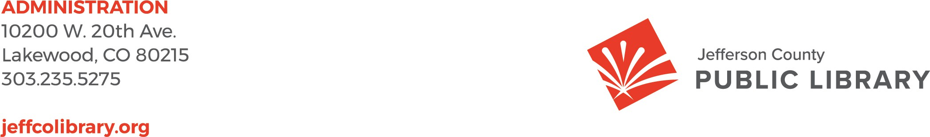

To: Donna Walker, Executive Director

From: Matt Griffin, Chief Strategy & Operating Officer

Re: Resolution Regarding Capital Project Authority to Execute Date: July 17, 2025

**Resolution No.: LB-07-17-25**

Please find attached Resolution No.: LB-07-17-25 authorizing execution of land use instruments related to JCPL capital projects.

This resolution acknowledges the following key points:

* JCPL capital projects often require the submission of land use instruments—such as permit applications, code modification requests, or utility submittals—to local governmental entities.
* These instruments are frequently time-sensitive and administrative in nature, and do not alter JCPL’s property ownership.
* To streamline project timelines, the resolution delegates standing authority to JCPL’s Executive Director to execute, submit, and/or record such instruments related to Board- approved capital projects.

**Summary:**

Resolution No.: LB-07-17-25 authorizes the Executive Director to execute land use-related instruments necessary to support Board-approved capital projects involving JCPL-owned property. This authority excludes any documents affecting property ownership.

**Attachment:** LB-07-17-25

BEFORE THE BOARD OF TRUSTEES

OF THE JEFFERSON COUNTY PUBLIC LIBRARY RESOLUTION NO.: LB-07-17-25

WHEREAS, the Board of Trustees (the “Board”) of the Jefferson County Public Library (“JCPL”) periodically approves capital projects involving JCPL-owned real property;

WHEREAS, in connection with these capital projects, JCPL is often required to execute, submit and/or record land use instruments, such as permit applications, zoning or code modification requests, utility submittals, to local governmental entities;

WHEREAS, in order to facilitate the processing of such instruments, the Board wishes to grant JCPL’s Executive Director standing authority to execute, submit and/or record instruments related to approved capital projects involving JCPL-owned real property, provided that such instruments do not affect JCPL’s ownership of the property;

NOW, THEREFORE, BE IT RESOLVED that the Board of Trustees of the Jefferson County Public Library:

1. Delegates to the Executive Director of the Jefferson County Public Library standing authority to execute, submit, and/or record, as appropriate, permit application, zoning or code modification requests, utility submittals and other land use instruments related to capital projects approved by the Board of Trustees;
2. Authorizes the Chair of the Board of Trustees to sign one or more statements of authority or such other instruments as are necessary or beneficial to carry out the foregoing delegation of authority, upon approval as to form by the County Attorney.

Date: July 17, 2025