**Minutes of the Regular Meeting of the** JEFFERSON COUNTY PUBLIC LIBRARY **BOARD OF TRUSTEES**

June 18, 2025

**CALL TO ORDER – REGULAR MEETING**

The regular meeting of the Jefferson County Public Library Board of Trustees was held online via ZOOM and in-person in the Lakewood Library meeting room on June 18, 2025. Library Board of Trustees Chair, Kim Johnson, called the meeting to order at 5:30 p.m.

Other Trustees present: Emelda [Bing] Walker (Vice-Chair), Charles Jones (Secretary), Pam Anderson

Absent: Renny Fagan, Jill Fellman

**Staff present:** Donna Walker, Executive Director; Matt Griffin, Chief Strategy & Operating Officer; Julianne Rist, Library Planning & Policy Senior Advisor; Cynthia Kiyotake, Chief Libraries & Inclusion Officer; Lisa Smith, Chief People & Culture Officer; Elise Penington, Director of Communications and Engagement; Amy Bentz, Assistant Director of Library Design Projects and Planning; Jessica Paulsen, Assistant Director of Libraries & Inclusion for Customer Experience; Dr. Angel Montoya, Edgewater & Diversity, Equity and Inclusion Manager;Kelci Rude, Administrative Coordinator Supervisor; Katie O’Loughlin, Administrative Coordinator Supervisor; Ryan Turch, Technology and Innovation Operations Supervisor

There were additional Library staff members attending the meeting.

**APPROVAL OF AGENDA**

**MOTION:**  Emelda [Bing] Walker moved that the Library Board of Trustees approve the agenda as presented. Seconded by Pam Anderson the motion passed by unanimous vote of all Trustees present.

**PUBLIC COMMENT**

The Board values public participation. Those who would like to address the Library Board can do so virtually, in-person, or online. The opportunity to address the Library Board does not include a question-and-answer session or response. Additionally, the Library Board does not respond to anonymous questions or comments. Comments will be acknowledged in the minutes of the meeting.

The Chair advised the Board that 29 online public comments were received. The Chair will provide those comments to the trustees immediately after the meeting.

The Chair allowed for 36 minutes for 12 in person public comments, in addition to two (2) online public comments.

* Ian Fetters, Tina Moeinian, Christine Catramados, Brad Bruce, Finnialla Wright, Narey, Asa Farrer, Shullomata, Anna Sparlin, Sammi Johnson, Susan Hall, Katy Conway, Stephen H., and Jill Hinn addressed the Board regarding issues related to dress code concerns. Jill Hinn also addressed the productivity of recent bargaining sessions.

The Chair closed the public comment portion of the meeting at 6:06 pm.

**APPROVAL OF CONSENT AGENDA**

The Chair asked the Trustees if any of the items should be removed from the consent agenda. There were no requests for items to be removed.

Items on the Consent Agenda

1. Approve Minutes of May 15, 2025 Board Meeting
2. Approve 2026 Governance Budget 4.8.2
3. Adopt 2026 Board Meeting Schedule
4. Authorize the Wheat Ridge Library Lease Amendment
5. Adopt Proposed adjustments to Governing Policies 2.7 Emergency Executive Director Succession and 3.3 Delegation to the Executive Director

**MOTION**: Pam Anderson moved that the Library Board of Trustees approve the items on the consent agenda as presented. Seconded by Emelda [Bing] Walker the motion passed by unanimous vote of all Trustees present.

**FOUNDATION UPDATE**

Jo Schantz Hall was absent. The Executive Director addressed the Board and shared that she met with Jo last Friday. They will be meeting with a potential donor on the coming Friday. All are encouraged to attend the Books on Film Benefit in July. The Chair advised that the Board could send any questions about the report, and she would share with Trustee Fagan or Jo Schantz Hall.

**EXECUTIVE DIRECTOR REPORT**

1. Executive Director Report

The Executive Director addressed the Board and thanked the Chair, Trustee Jones, and Trustee Fellman for attending the Arvada City Council proclamation for Juneteenth. The Executive Director read a portion of the proclamation: “Be it proclaimed that the Mayor and the Arvada City Council hereby designate June 19, 2025 as Juneteenth in the City of Arvada and commends Jefferson County Public Libraries for exemplary work encouraging learning and promoting a stronger more united community where all people are welcomed and valued.”

1. Capital Building Projects Update

**South County Library**: The Design Kickoff is at the end of the month. We are working on visioning with the team heading into that meeting. René Yaws, our South County Library Manager, continues to offer programming at the site that includes Summer Challenge, a Pride event and Story Times. Everything is set with improvement agreements after discussion around whether there needs to be a light; the County will be putting in some sort of signal.

**NW Jeffco Library**: Design development continues, as does outreach in the community. Working on getting the contract signed with the general contractor.

**Arvada Library Redesign**: Arvada Library is moving along nicely in design. The page turn was held last week; design pricing is expected next week. We hope to make a safer and more welcoming experience and activated space in the downtown area and that all elements selected can stay included.

**Conifer Library**: We recently held a Dusty Boots Tour with Trustee Jones, Trustee Fellman, donors and Jo Schantz Hall in attendance. Construction continues apace.

There were no questions from the Board.

**OPERATIONAL UPDATES**

**Strategy and Operations**

Finance and Budget

1. **Financial Report (May 2025)**

Matt Griffin, Chief Strategy & Operating Officer, addressed the board. There is a total revenue increase of our 2024 actuals of around $3 million. The net increase within that was $1.7 million. This is driven by two key items; $900,000 in investment revenue being accrued back to 2024 and $700,000 insurance reimbursement for the Columbine roof replacement. The remainder of the revenue increase was made up of GASB-driven entries that change how we account for certain line items within building rent and software agreements. There was also an offsetting expenditure for those so there is no net change. The net change to our bottom line was an increase of about $1.7 million, driven by investment and insurance reimbursement.

He then provided information on the May 2025 monthly financials. The Board was advised that:

* Table 1 – Summary that everything is on view and in line with expected spending this year.
* Table 2 – We are right where we expect to be at this point in the year. Trending in healthy direction with no surprises.
* Table 3 – Board authorized submittal of carryforward in February. We see the carry forward requests in this budget. This provides a realistic view of 2025 budget against the project actuals with one correction: $1.1 million budget currently shows against the Columbine roof repair. That should be against the Evergreen roof repair. That is a manual error that will be updated in next month’s financials. Spending against capital projects is on track and within budget against all lines.

There were no questions from the Board.

1. **Letter to the Board of County Commissioners certifying the mill levy necessary to maintain and operate the library**

The Chair noted that edits were made to the letter based on discussion from the Study Session.

**MOTION**: Emelda [Bing] Walker moved that the Library Board of Trustees authorize the Chair to sign the letter to the Board of County Commissioners certifying the mill levy necessary to maintain and operate the Library in 2026. Seconded by Pam Anderson the motion passed by unanimous vote of all Trustees present.

1. **2026 5-Year Capital Plan**

**MOTION**: Pam Anderson moved that the Library Board of Trustees authorize the Executive Director to submit the 2026 5-Year Capital Plan request to the Board of County Commissioners. Seconded by Emelda [Bing] Walker the motion passed by unanimous vote of all Trustees present.

1. **2026 Proposed Budget Plan**

Matt Griffin, Chief Strategy & Operating Officer, addressed the board. He noted there was a question at the Study Session about the jump in operating expenditure. That increase is expected from 2026 into 2027. This is driven by the additional staff requirements for South County Library and Northwest Jeffco and shown based on the anticipated dates of hire in project plans then levels out to a consistent growth pattern.

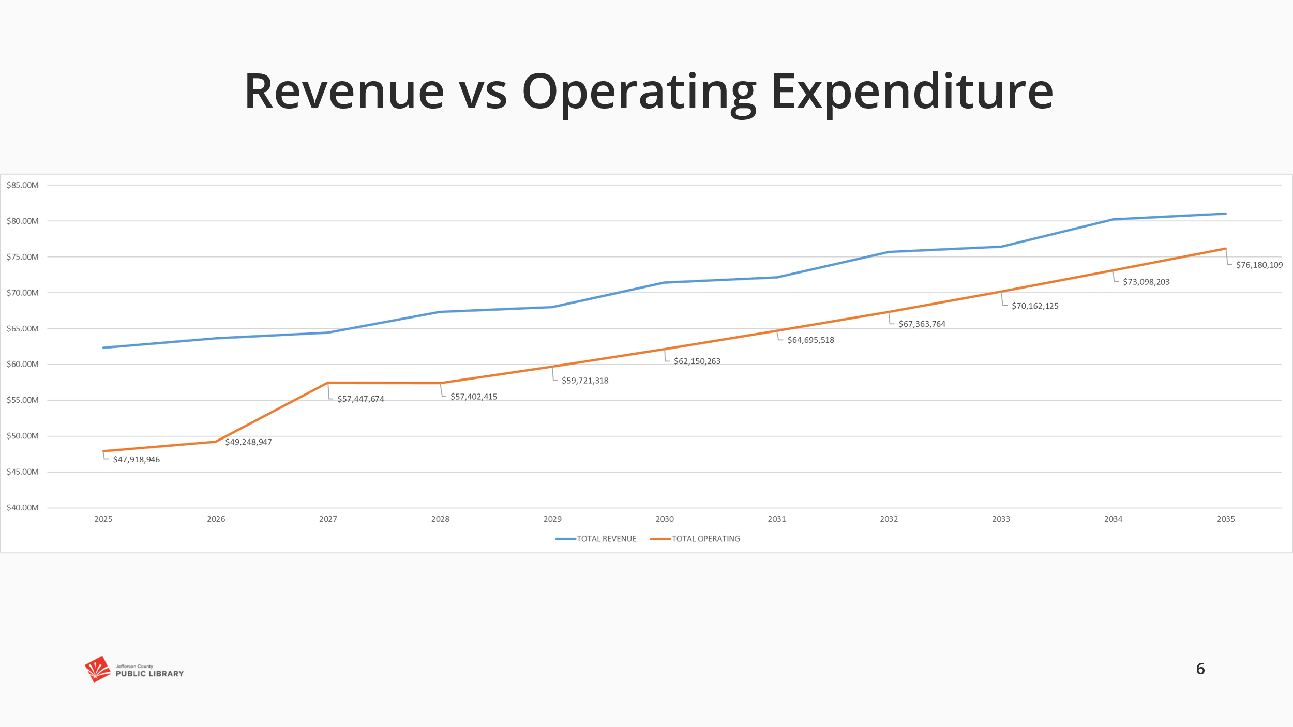

There were no questions from the Board.

The Chair advised the Board that while we don’t do proxy voting, she had a conversation with Trustee Fellman who could not attend tonight’s meeting, and she is in support of the budget as it is.

**MOTION**: Emelda [Bing] Walker moved that the Library Board of Trustees authorize the Executive Director to submit the 2026 Proposed Budget Plan to the Board of County Commissioners. Seconded by Pam Anderson the motion passed by unanimous vote of all Trustees present.

**Facilities & Construction**

1. Authorize contract for Construction Manager/General Contractor Services–South County Library, Flintco, LLC

Matt Griffin, Chief Strategy & Operating Officer, addressed the Board and shared that this is a request to authorize the general contractor. It was discussed at Study Session last week. There were no questions from the Board.

**MOTION**: Pam Anderson moved that the Library Board of Trustees authorize the Executive Director to execute the contract with Flintco, LLC for Phase I of the South County Library project in the amount of the pre-construction fee of $25,000. Seconded by Emelda [Bing] Walker the motion passed by unanimous vote of all Trustees present.

**Libraries & Inclusion**

1. 2025 JCPL Pride Programming

The Executive Director addressed the Board and shared that we wanted to do a service presentation, and the team chose our Pride programming. Additionally, the Executive Director noted that the Board received items provided by the County; lanyards and buttons were distributed at the meeting.

Dr. Angel Montoya, Edgewater & Diversity, Equity and Inclusion Manager, addressed the Board and thanked them for the opportunity to present.

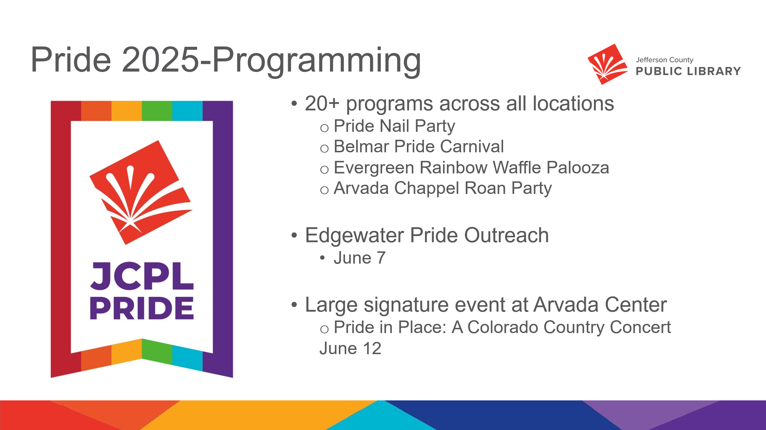

* Pride programming provides opportunities to cultivate space and amplify the voice for the LGBTQI community. This is one of our five focus communities.
* This year we had 20+ programs across locations throughout June.

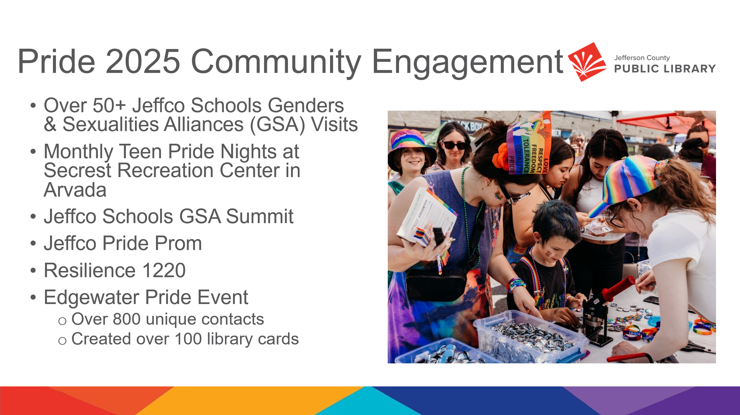

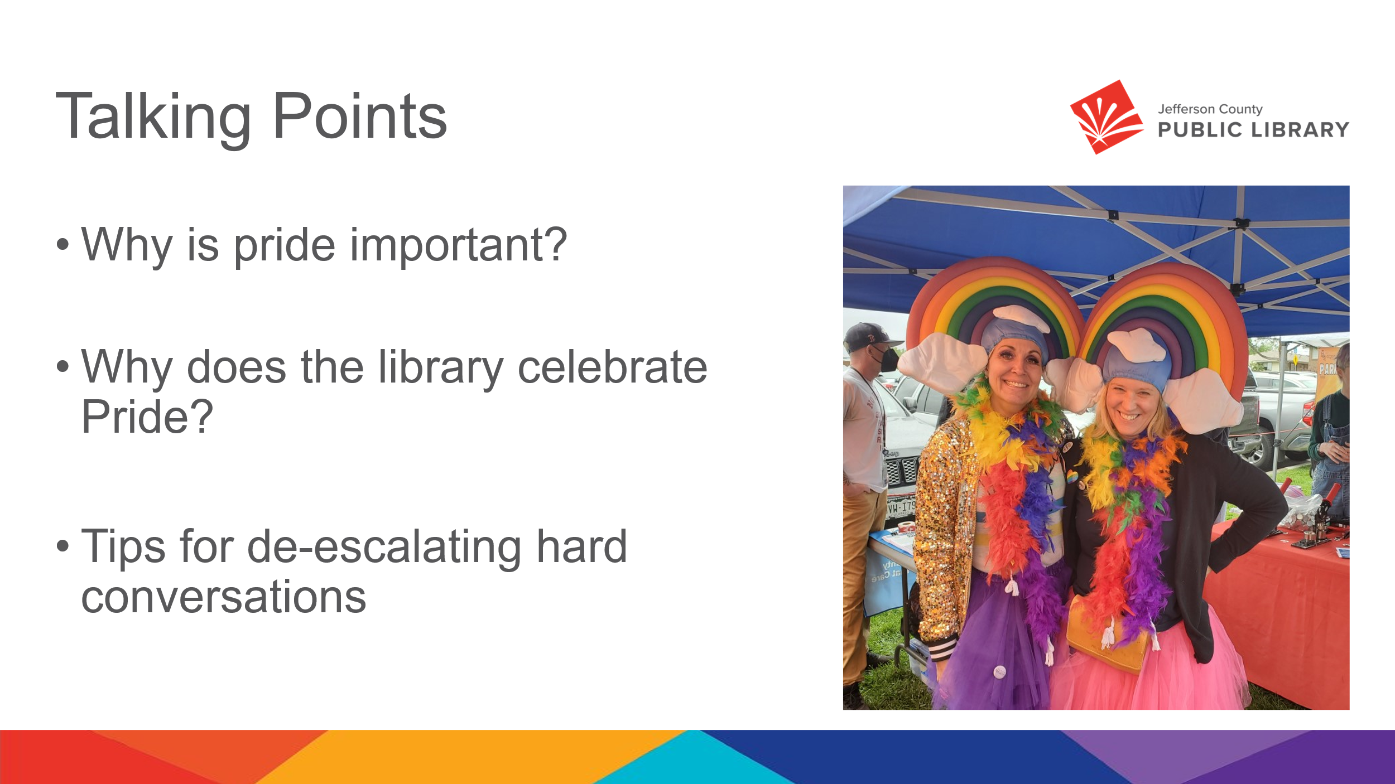

* Pride is important to cultivate spaces and amplify voices of the LGBTQI community. To be a welcoming space and be a celebration of the community. It is a chance for the community to learn and grow in diversity, equity and inclusion.
* The Library celebrates Pride because it is a radically welcoming space for all individuals and all patrons; for all to feel seen, heard and valued. It’s important to honor a historically underserved community and provide a space of inclusion.
* Tips for deescalating hard conversations were provided to staff members across locations. The DEI team has helped correspond communication with other locations throughout JCPL whenever there have been concerns, advising on how to navigate those conversations.

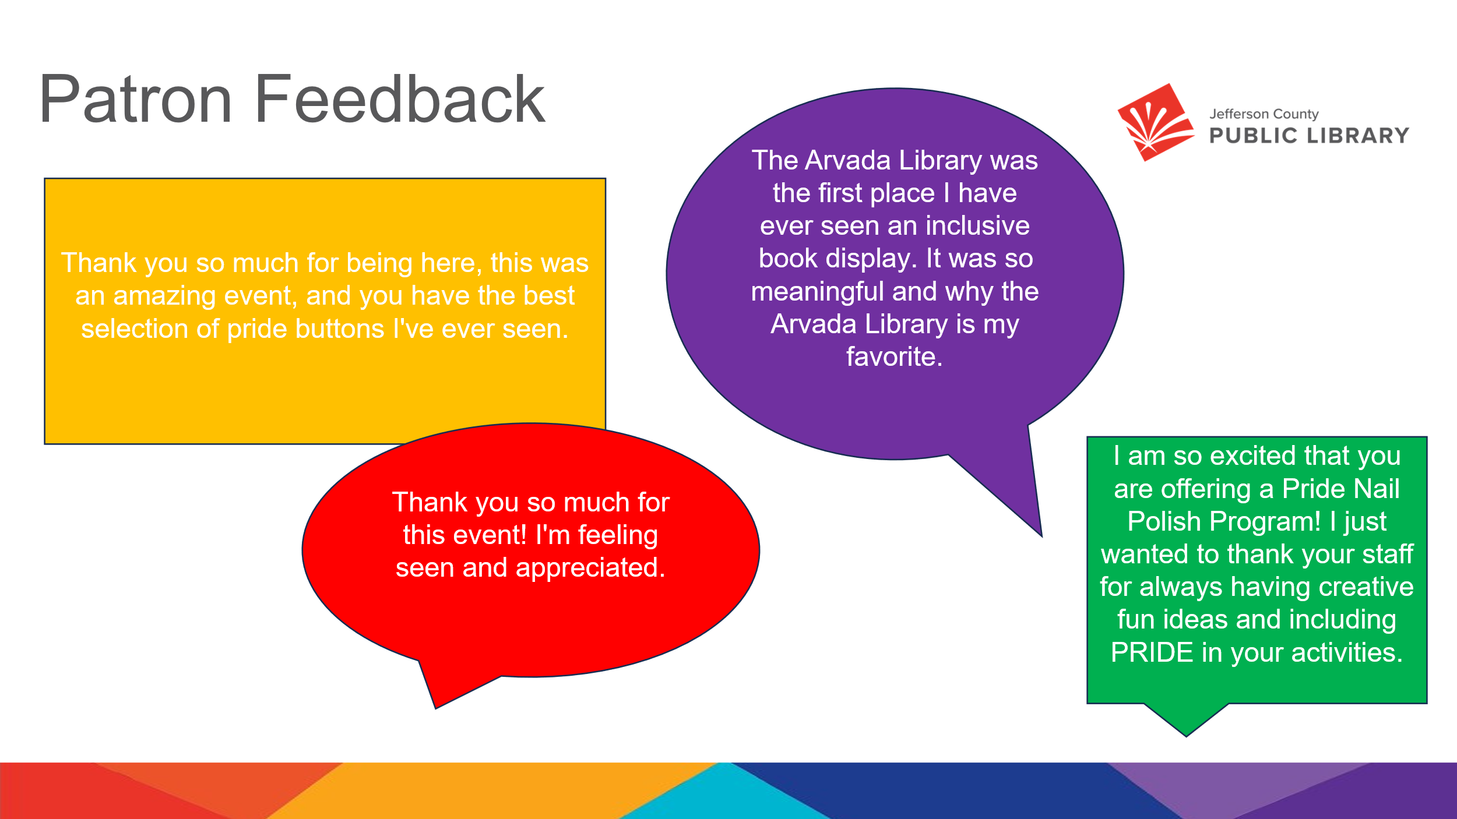

* This feedback is unique to summer 2025. The feedback elevates the point that it’s important to cultivate spaces and opportunities to amplify voices of LGBTQIA+ community.

The Board provided the following feedback:

* This is wonderful work. My adult children found a safe space in the library over the years and it is one of the reasons I serve on this Board. Grateful to the work everyone at JCPL is doing to support that community.
* Amazing. Well done.

The Chair thanked Dr. Angel Montoya. There were no questions from the Board.

**ITEMS REMOVED FROM THE CONSENT AGENDA**

No items were removed from the consent agenda.

**EMERGING ISSUES**

No issues. The Chair noted that she will send online public comment forms to the trustees.

**ENDS**

There were no items.

**BOARD GOVERNANCE**

No items.

**BOARD SCHEDULE – NEXT MEETINGS**

2025 Board Meeting Schedule

* July 10, 2025 – Study Session Hybrid: Virtual via ZOOM. In-Person Location: Lakewood Library Meeting Room
* July 17, 2025 – Board Meeting – 5:30 pm Hybrid: Virtual via ZOOM. In-Person Location: Lakewood Library Meeting Room
* August 14, 2025 – Study Session Hybrid: Virtual via ZOOM. In-Person Location: Lakewood Library Meeting Room
* August 21, 2025 – Board Meeting – 5:30 pm Hybrid: Virtual via ZOOM. In-Person Location: Lakewood Library Meeting Room

**ANNOUNCEMENTS/GENERAL INFORMATION SHARING**

There were no announcements.

# EXECUTIVE SESSION:

At 6:29 pm, the Chair called for a motion to adjourn the regular meeting, reconvene in Executive Session regarding Collective Bargaining and adjourn the regular Board meeting at the conclusion of the Executive Session.

**MOTION**: Pam Anderson moved to adjourn the regular meeting of the Library Board of Trustees, reconvene in Executive Session regarding the Collective Bargaining AND adjourn the Regular Board meeting at the conclusion of the Executive Session. Statutory citation authorizing an executive session for these topics are:

* Pursuant to 24-6-402(4)(e)(I) for discussion of strategy and instructions to negotiators

Seconded by Emelda [Bing] Walker the motion passed by unanimous vote of all Trustees present.

The Chair announced a ten-minute break to allow the Board and staff to clear the room, leave the existing ZOOM meeting and then join the Executive Session.

The Chair called the Executive Session to order at 6:37 pm with the following trustees present: Kim Johnson, Pam Anderson, and Emelda (Bing) Walker. Also present were Steven (Steve) Spirn; Donna Walker, Executive Director; Lisa Smith, Chief People & Culture Officer; Matt Griffin, Chief Strategy & Operating Officer; Elise Penington, Director of Communications & Engagement; Cynthia Kiyotake, Chief Libraries & Inclusion Officer, Kelci Rude, Administrative Coordinator Supervisor.

It is noted that the session was recorded and that the recording will be retained for the required 90 days.

**CALL FOR ADJOURNMENT OF EXECUTIVE SESSION**

Chair adjourned the meeting at 6:52 pm.

It is noted that the Library Board of Trustees met in Executive Session concerning Collective Bargaining pursuant to 24-6-402(4)(e)(I) for discussion of strategy and instructions to negotiators. The Trustees held those discussions, and this summary is provided as required by Colorado Statute.

Charles Jones, Secretary