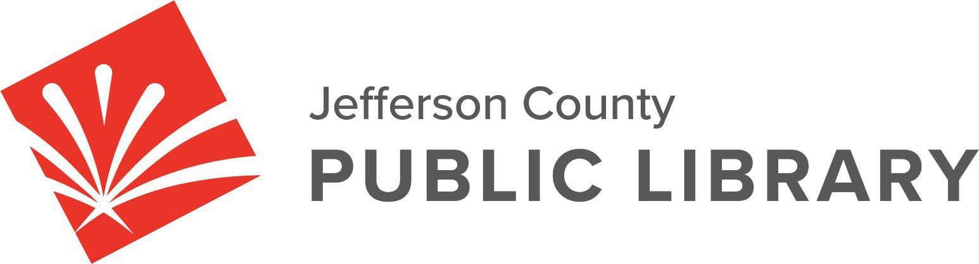

**BOARD STUDY SESSION**

**DATE: June 12, 2025**

**TIME: 5:30 P.M.**

**PLACE: Hybrid Public Meeting**

* **Online via ZOOM**

**In‐Person at Lakewood Library meeting room, 10200 W. 20th Avenue, Lakewood 80215**

**Libraries & Inclusion**

* Free Printing at JCPL

**Strategy & Operations**

* Finance & Budget
* Review DRAFT letter to the Board of County Commissioners certifying the mill levy necessary to maintain and operate the library
* Review DRAFT 2026 5‐Year Capital Plan
* Review DRAFT 2026 Proposed Budget Plan

**Communications & Engagement**

* New Library Naming Process

**Facilities & Construction**

* South County Construction Management/General Contractor

For instructions on how to access the **online ZOOM Study Session** please go to: [https://jeffcolibrary.org/board‐of‐trustees/2025‐study‐sessions/](https://jeffcolibrary.org/board-of-trustees/2025-study-sessions/)

**NEXT BOARD STUDY SESSION**