**Minutes of the Regular Meeting of the** JEFFERSON COUNTY PUBLIC LIBRARY **BOARD OF TRUSTEES**

April 17, 2025

# CALL TO ORDER – REGULAR MEETING

The regular meeting of the Jefferson County Public Library Board of Trustees was held online via ZOOM and in-person in the Lakewood Library meeting room on April 17, 2025. Library Board of Trustees Chair, Kim Johnson, called the meeting to order at 5:30 p.m.

Other Trustees present: Emelda [Bing] Walker (Vice-Chair), Renny Fagan, Jill Fellman, and Charles Jones, Pam Anderson

**Staff present:** Donna Walker, Executive Director; Julianne Rist, Library Planning & Policy Senior Advisor; Steve Chestnut, Director of Facilities and Construction Projects; Bernadette Berger, Chief Technology & Digital Innovation Officer; Matt Griffin, Chief Strategy & Operating Officer; Lisa Smith, Chief People & Culture Officer; Elise Penington, Director of Communications and Engagement**;** Amy Bentz, Assistant Director of Library Design Projects and Planning; Jessica Paulsen, Assistant Director of Libraries & Inclusion for Customer Experience; Padma Polepeddi, Assistant Director of Libraries & Inclusion for Community Outreach; Lizzie Gall, Assistant Director of Libraries and Inclusion for Resources and Programs; Kelci Rude, Administrative Coordinator Supervisor; Katie O’Loughlin, Administrative Coordinator Supervisor; Ryan Turch, Technology and Innovation Operations Supervisor

There were additional Library staff members attending the meeting.

# APPROVAL OF AGENDA

**MOTION:**  Jill Fellman moved that the Library Board of Trustees approve the agenda as presented. Seconded by Renny Fagan the motion passed by unanimous vote of all Trustees present.

# PUBLIC COMMENT

The Board values public participation. Those who would like to address the Library Board can do so virtually, in-person, or online. The opportunity to address the Library Board does not include a question and answer session or response. Additionally, the Library Board does not respond to anonymous questions or comments. Comments will be acknowledged in the minutes of the meeting.

The Chair advised the Board that no online comments were received. Anna Sparlin and Jeny Crownover addressed the Board and provided public comments regarding dress code concerns and the JCPL Mission, Vision, and Values as they relate to dress code.

There were no further public comments, and the Chair closed the public comment portion of the meeting at 5:41 pm.

# APPROVAL OF CONSENT AGENDA

The Chair asked the Trustees if any of the items should be removed from the consent agenda. There were no requests for items to be removed.

Items on the Consent Agenda

1. Approve Minutes of March 20, 2025 Board Meeting
2. Adopt Bylaws for the Jefferson County Public Library Board of Trustees
3. Authorize Kleen-Tech Carpet Cleaning Contract Renewal, 4th Renewal
4. Authorize Lakewood Reinvestment Authority Intergovernmental Agreement (IGA)

**MOTION**: Pam Anderson moved that the Library Board of Trustees approve the items on the consent agenda as presented. Seconded by Renny Fagan the motion passed by unanimous vote of all Trustees present.

# FOUNDATION UPDATE

Jo Schantz Hall was absent; the Chair noted that the Foundation’s report was in the packet. Trustee Fagan, Board liaison to the Foundation, shared that he attended his first Foundation Board meeting and was able to see the sorting operations in their warehouse. The Friends annual event was last Friday.

There were no questions from the Board.

**EXECUTIVE DIRECTOR REPORT**

1. Executive Director Report

The Executive Director advised the Board that last week was National Library week, and we have the Board of County Commissioner proclamation available if they would like to view it. Bridget Beatty, our fundraising consultant, submitted a $600,000 grant application for a Northwest Jefferson County Library solar array. JCPL worked in collaboration with County and secured letters of support from members of the City of Arvada leadership and community. Cynthia Kiyotake will be joining as the new Chief Libraries and Inclusion Officer, and leadership is continuing to transition to the new operating model for our leadership teams.

1. Capital Building Projects Update

**South County Library**: The Board will see the community engagement results at the May Board meeting. René Yaws, our South County Library Manager, is providing building tours for staff groups. The South County Library interim services will begin on May 3; the bookmobile will move from the Ken Caryl parking lot and will begin providing services from our new building as suggested by the Advisory Council. We are planning to bring summer challenge activities to the site.

**NW Jeffco Library**: JCPL is moving through conceptual design. General Contractor interviews were held this week. We are starting our second year of partnership with the Three Creeks K-8 school. Bryan Kratish, our NW Library Manager, is facilitating a 5-week research project with 7th and 8th grade students where they are studying innovative ideas for the new library that will be presented to staff.

**Arvada Library Redesign**: We are moving through design development, and staff will begin looking at finishes in the next few weeks.

**Conifer**: Demolition is complete, and we are waiting on the Building Safety permit to move forward with construction.

In response to questions, the Board was informed that:

* We have a prospective site for our Arvada Library alternative services, but we are waiting for a draft lease agreement that we can review.

1. Core Cooperative Naming Agreement

The Executive Director informed the Board that this is a local business, and we are excited to have one of the businesses in the community be a part of this project.

**MOTION**: Renny Fagan moved that the Library Board of Trustees approve the Donation and Name Recognition Agreement between Core Cooperative, the Jefferson County Library Foundation, Inc., and the Jefferson County Public Library. Seconded by Jill Fellman the motion passed by unanimous vote of all Trustees present.

In response to questions, the Board was advised that:

* Staff cannot recall an example of when a business with a naming agreement has closed or changed names. The naming agreements are for a set limited term. If needed, a change we would be brought back to the Board.

1. 2026+ Strategic Planning

Guest: Greg Bellomo, Government Performance Solutions, Inc

Greg Bellomo addressed the Board and provided an update on progress from the last workshop with the Board and reviewed the Board’s role in this process.

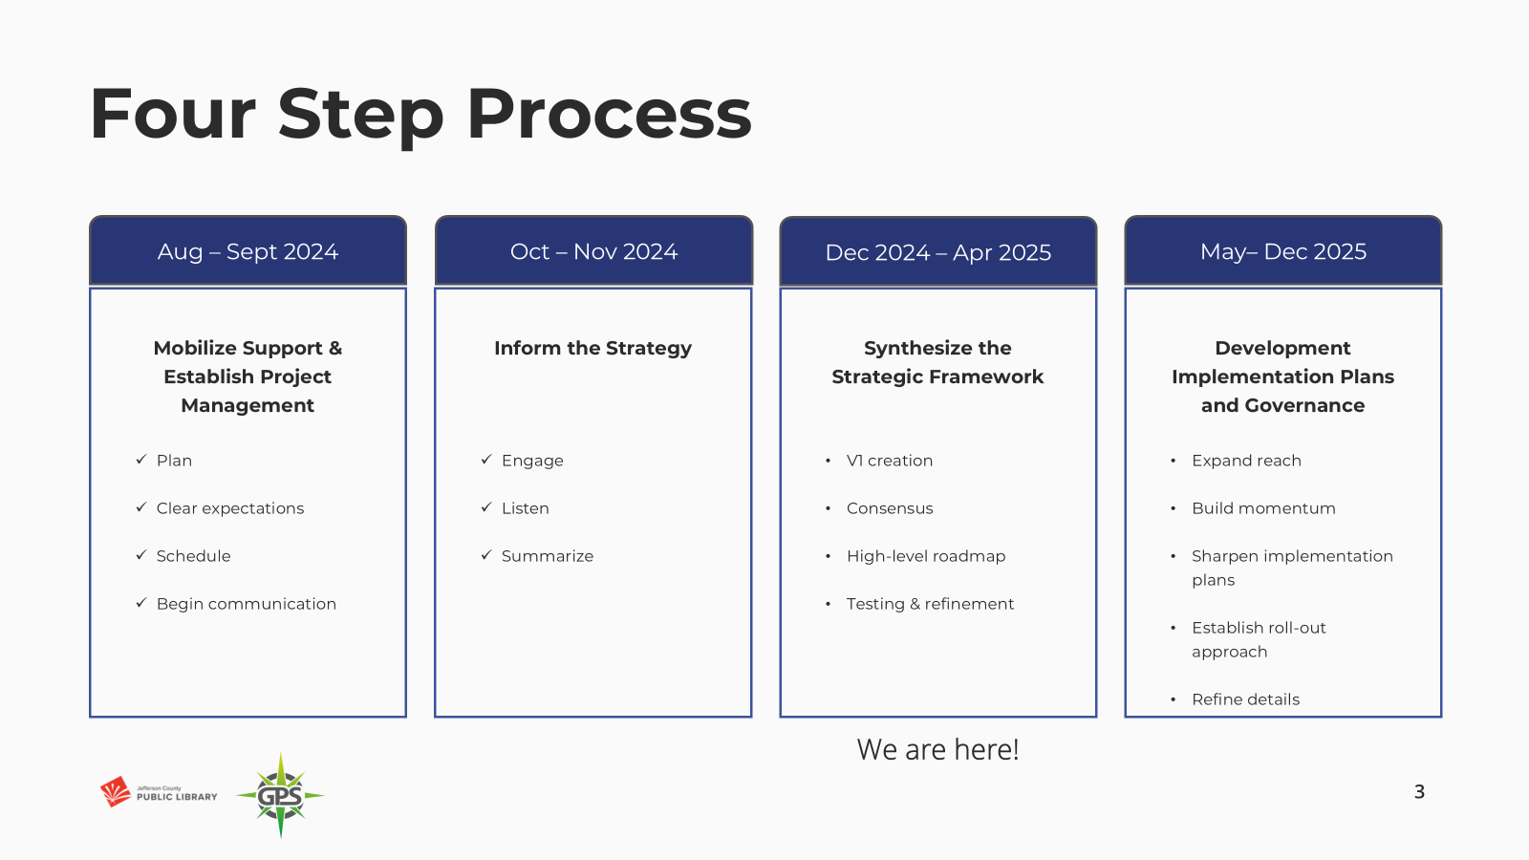

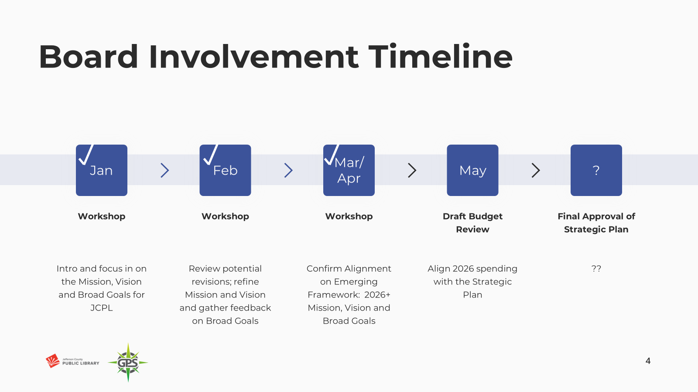

Review of where the Board and leadership are in this work:

* We’re at the end of April.
* We have version 1 of the strategic framework.
* Next piece of work is mobilizing managers and supervisors around ideas for key results and leading measures. That will allow us to broaden our participation in the second half of the year.

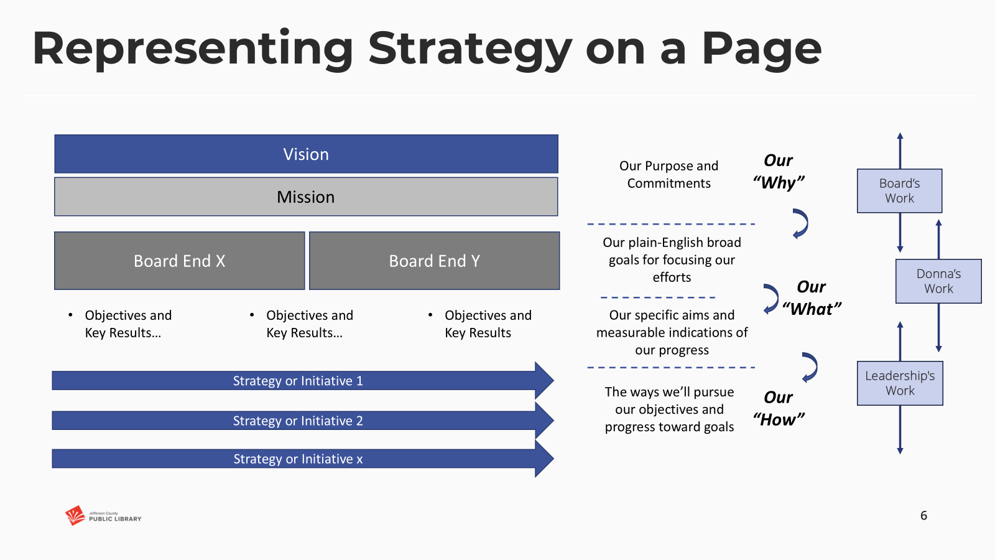

The Executive Director addressed the Board and introduced the proposed new language in the framework, which have been refined to three Ends.

1. Equity of Access

The last feedback from the Board was that we had some wordsmithing to do, but that this continues to be important to our Community and Board.

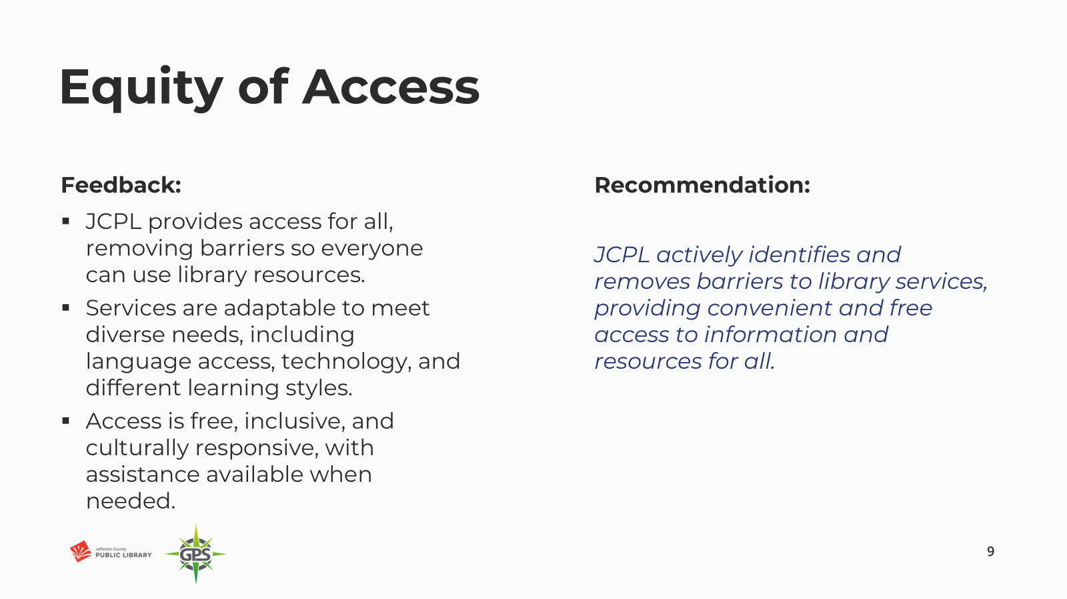

1. Creating Place

Last feedback from the Board was that some of these key words were safe, accessibility, and discovery and belonging.

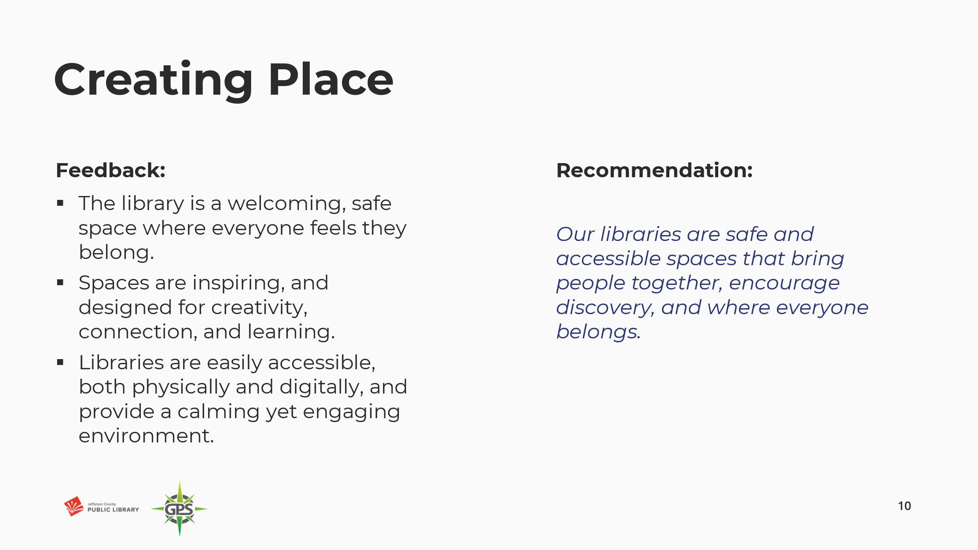

1. Our People

The Board had quite a bit of conversation around this in the last session. Our goal was to capture the feedback and make it reflective.

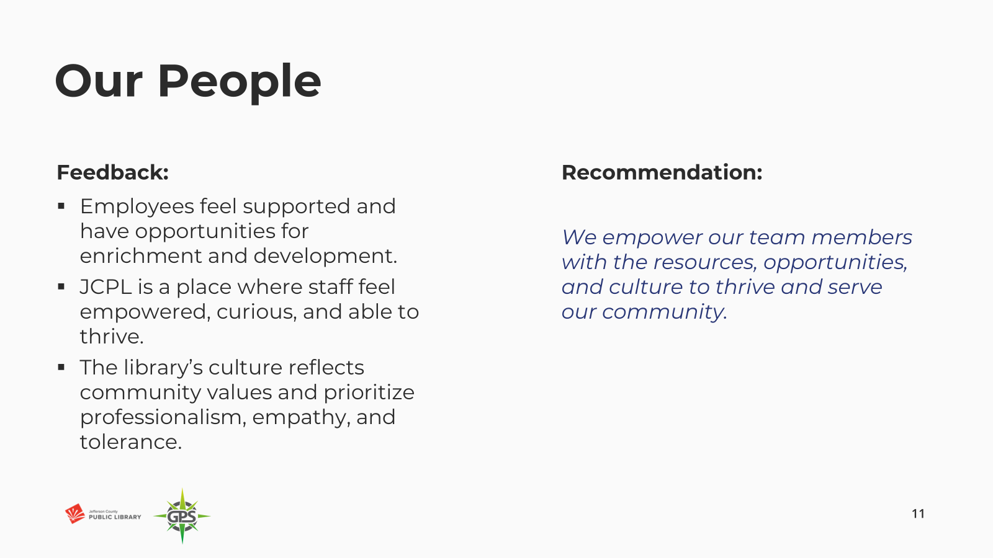

Put all together, this is our 2026 and beyond strategic framework. Reminder that this starts in 2026.

The Executive Director asked the Board to provide feedback on whether this captured how they felt about 2026 and beyond for the next strategic plan, or if there was something missing. The Board provided the following feedback:

* Well put together. There was vast community input that has informed this process and want to be sure that we feel the community will see themselves and their input in these ends. This is important for public trust. When we ask for public involvement, we want them to see that they we listened to and that we’re responding.
* Feels like this resonates with what we heard from the community, and what I see as a patron and community member.
* We may need to help the public connect the dots between the Ends and their input.
* Appreciate the effort and the many hours that went into bringing the comments and feedback together. This brings the mission and vision and everything together now and, in the future, and brings us forward.
* Looks great, looking forward to what the final product will look like.
* Think we have consensus to move forward on these; prefer equitable and free in Mission- complements the way equity of access is written.

In response, the Board was advised that:

* Slide language contained an error in the new Mission. This will be corrected and updated.
* We do feel that this represents the community input. What is resonating and reverberating throughout is connection, being together, welcoming and everyone belongs.
* The Board will see some items in the draft budget that are in response to the community feedback.

Greg Bellomo addressed the Board and reviewed the next steps in this process. This will be brought to the Library’s Combined Management Team meeting for the managers and supervisors to speak about objectives and measures. This engages staff in the ‘how’ of the ‘what’ that has been decided.

There were no questions from the Board about the next steps.

**OPERATIONAL UPDATES**

**Strategy and Operations**

1. Authorize Notice to Proceed for Architectural Design Services - South County Library, Eppstein Uhen Architects, Inc

Amy Bentz, Assistant Director of Library Design Projects and Planning addressed the Board and provided information on this request. The Board of Trustees authorized JCPL to enter a contract with Eppstein Uhen Architects, Inc. (EUA) for the design of the South County Library in September 2021. JCPL wishes to engage EUA for architectural design services for the South County Library project. EUA has evaluated the project scope and provided a cost estimate and schedule. This fee aligns with our budget expectations.

In response to the questions, the Board was advised that:

* We are structuring the pricing and notice to proceed in this way because of potential design alternates. We will not know about the alternates until we get further into design.

**MOTION**: Jill Fellman moved that the Library Board of Trustees authorize the Executive Director to issue a Notice to Proceed for the base architectural design services for the South County Library project at a cost of $1,502,605.00 and alternates that may be issued at a later phase at a cost of $141,600.00. Seconded by Pam Anderson the motion passed by unanimous vote of all Trustees present.

**Finance and Budget**

1. Financial Report (March 2025)

Matt Griffin, Chief Strategy & Operating Officer, addressed the Board and provided information on the March 2025 monthly financials. The Board was advised that:

* March is the end of our first quarter financials, no comments other than one update on carryforwards. On Table 3, carryforwards were approved on Tuesday, they will then go onto consent agenda in a few weeks and then we will process those.

In response to questions the Board was advised that:

* We are not currently seeing volatility in the investment income; this is primarily because the treasurer posts to our financials quarterly and it does lag. We have no cause for concern now based on what we know.

There were no other questions or comments from the Board.

# ITEMS REMOVED FROM THE CONSENT AGENDA

No items were removed from the consent agenda.

# EMERGING ISSUES

No issues.

# ENDS

There were no items.

# BOARD GOVERNANCE

1. Nominating Committee report to the Board: Proposed Slate of Officers

The nominating committee presented the following slate of officers for election:

* Secretary: Charles Jones, for the remainder of the 1-year term (April 2025 to March 2026)

**MOTION**: Emelda Walker moved that the Library Board of Trustees elect Charles Jones for Secretary for the remainder of the one-year term April 2025 to March 2026. Seconded by Jill Fellman the motion passed by unanimous vote of all Trustees present.

**BOARD SCHEDULE – NEXT MEETINGS**

2025 Board Meeting Schedule

* May 8, 2025 –Study Session Hybrid: Virtual via ZOOM. In-Person Location: Lakewood Library Meeting Room
* May 15, 2025 – Board Meeting – 5:30 pm Hybrid: Virtual via ZOOM. In-Person Location: Lakewood Library Meeting Room
* June 12, 2025 – Study Session Hybrid: Virtual via ZOOM. In-Person Location: Lakewood Library Meeting Room
* June 18, 2025 – Board Meeting – 5:30 pm Hybrid: Virtual via ZOOM. In-Person Location: Lakewood Library Meeting Room

**ANNOUNCEMENTS/GENERAL INFORMATION SHARING**

There were no announcements.

# EXECUTIVE SESSION:

At 6:14pm, the Chair called for a motion to adjourn the regular meeting, reconvene in Executive Session regarding Collective Bargaining and adjourn the regular Board meeting at the conclusion of the Executive Session.

**MOTION**: Renny Fagan moved to adjourn the regular meeting of the Library Board of Trustees, reconvene in Executive Session regarding Collective Bargaining AND adjourn the Regular Board meeting at the conclusion of the Executive Session. Statutory citation authorizing an executive session for this topic is:

* Pursuant to 24-6-402(4)(e)(I) for discussion of strategy and instructions to negotiators

Seconded by Jill Fellman the motion passed by unanimous vote of all Trustees present.

The Chair announced a 5-minute break to allow the Board and staff to clear the room, leave the existing ZOOM meeting and then join the Executive Session.

The Chair called the Executive Session to order at 6:20pm with the following other Trustees present: Emelda (Bing) Walker, Charles Jones, Pam Anderson, Jill Fellman, and Renny Fagan. Also present were Donna Walker, Executive Director; Julianne Rist, Library Planning and Policy Senior Advisor; Bernadette Berger, Chief Technology & Digital Innovation Officer; Lisa Smith, Chief People & Culture Officer; Matt Griffin, Chief Strategy & Operating Officer; and Katie O’Loughlin, Administrative Coordinator Supervisor.

Guest: Steven Spirn

It is noted that the session was recorded and that the recording will be retained for the required 90 days.

**CALL FOR ADJOURNMENT OF EXECUTIVE SESSION at 6:47 pm**

**MOTION**: At 6:47pm Jill Fellman moved to adjourn the Executive Session. Seconded by Renny Fagan the motion passed by unanimous vote of all Trustees present.

It is noted that the Library Board of Trustees met in Executive Session concerning Collective Bargaining pursuant to 24-6-402(4)(e)(I) for discussion of strategy and instructions to negotiators. The Trustees held those discussions, and this summary is provided as required by Colorado Statute.

Charles Jones, Secretary