**BOARD MEETING**

JEFFERSON COUNTY PUBLIC LIBRARY BOARD OF TRUSTEES

May 15, 2025

|  |  |
| --- | --- |
| P7C1T1#yIS1  **Family Fun Night – Ahoy! Pirates** | P11C3T1#yIS1  **CLART - Miniatures Painting** |
| P14C4T1#yIS1  **EN MOVIMIENTO: Aventuras de bibliotecas móviles** | P17C6T1#yIS1  **Kalama Polynesian Dancers** |



**APPROVAL OF AGENDA**

## BOARD MEETING AGENDA

Jefferson County Public Library Board of Trustees

|  |  |
| --- | --- |
| ITEM# / ACTION | **Thursday, May 15, 2025 – 5:30 pm – HYBRID MEETING**   * *U***ONLINE MEETING VIA ZOOM** * **IN-PERSON MEETING AT LAKEWOOD LIBRARY MEETING ROOM** |
| 1. | **Call to order & attendance (4.5.8)**  A. Verbal roll call – Each Trustee announces their presence by stating their name. |
| 2. | **Pledge of Allegiance** |
| 3. Agenda  Action | **Approve Agenda**  Chair: Call for motion and second |
| 4. Public Comment | **Public Comment**  The Board values public participation. Those who would like to address the Library Board can do so virtually, in-person, or online. The opportunity to address the Library Board does not include a question-and-answer session or response.  Additionally, the Library Board does not respond to anonymous questions or comments. Comments will be acknowledged in the minutes of the meeting.  If you choose to make a Public Comment virtually or in-person during a Board meeting, your name will be called in the order it was received, first for virtual guests then for in-person guests.  To address the Library Board of Trustees during Public Comment:   1. In-person: Must sign in on the form provided at the door. 2. Virtually during the public comment portion of the meeting: Send a chat message to the meeting host with name and the comment topic 3. Online public comment form: The online form is available at 5:30 pm the Thursday prior to the scheduled Library Board meeting and closes at 1:00 pm the day prior to the scheduled Library Board meeting. 4. People who dial in will not be able to provide public comment during the meeting. 5. Those who failed to sign up or submit the online form, or arrived late, may, at the discretion of the Chair, be allowed to address the Library Board. 6. The Chair has authority to maintain the decorum of the meeting. Conduct or comments that are disruptive to the meeting or its participants are prohibited.   For more information on public comment policy please refer to Board Governance  Policy 4.3.7: [Board Governance Policy Manual (jeffcolibrary.org)](https://jeffcolibrary.org/wp-content/uploads/sites/46/2024/03/March_2024_Board_Governance_Policy_Manual-1.pdf) |
| 5.CONSENT AGENDA  Action | **Approval of Consent Agenda**  Chair: Call for motion and second  A. Approve Minutes of April 17, 2025 Board Meeting |
| 6. Foundation | Foundation Update |
| 7.Operational Updates Action as Needed | **Executive Director**   1. Executive Director Report 2. Capital Building Projects Update |

## BOARD MEETING AGENDA

Jefferson County Public Library Board of Trustees

|  |  |
| --- | --- |
|  | **Strategy & Operations**  Finance and Budget  A. Financial Report (April 2025)  B. Long Term Financial Forecast  C. 5-Year Capital Improvement Projects (CIP)  **Communications & Engagement**  A. South County Community Engagement Report  **Strategy & Operations**  Facilities & Construction  A. Authorize contract for Construction Manager/General Contractor Services– Northwest Jefferson County Library, Swinerton Builders  Chair: Call for motion and second  **Technology & Digital Innovation**  A. Authorize Tier 1 and Tier 2 E-Rate contracts – Sentinel Technologies and Malm Electrical  Chair: Call for motion and second  **Libraries & Inclusion**  A. Authorize the Intergovernmental Agreement for the dissolution of the combined library at Conifer High School  Chair: Call for motion and second |
| 8.Action as Needed | Items Removed From Consent Agenda (4.3.4): The Board may address and/or vote on any items that were removed from the Consent Agenda |
| 9. Emerging Issues  Action as Needed |  |
| 10. Ends  Action as Needed | **Ends**: No items. |
| 11. Board Governance Action as Needed | **Board Governance:**   1. Review 2026 Board Governance Budget (Approval at June Board Meeting Consent Agenda) 2. Review 2026 Board Meeting Schedule (Approval at June Board Meeting   Consent Agenda) |
| 12. Suggest Agenda Items  Action as Needed | BOARD SCHEDULE – NEXT MEETINGS –  Location of meetings of the Library Board of Trustees are being determined in cooperation with guidelines from Jefferson County. Information on meeting location will be posted at least one week prior to the scheduled meeting date. 2025 Board Meeting Schedule   * June 12, 2025 – Study Session Hybrid: Virtual via ZOOM. In-Person Location: Lakewood Library Meeting Room * June 18, 2025 – Board Meeting – 5:30 pm Hybrid: Virtual via ZOOM. In-Person |

## BOARD MEETING AGENDA

Jefferson County Public Library Board of Trustees

|  |  |
| --- | --- |
|  | Location: Lakewood Library Meeting Room   * July 10, 2025 – Study Session Hybrid: Virtual via ZOOM. In-Person Location: Lakewood Library Meeting Room * July 17, 2025 – Board Meeting – 5:30 pm Hybrid: Virtual via ZOOM. In-Person   Location: Lakewood Library Meeting Room |
| 13. Discussion | Board Questions or Comments Related to Items on the Meeting Agenda |
| 14. Discussion | Evaluate Board Meeting (4.1.9) |
| 15. Information | Announcements/General Information Sharing   * Report of the Chair – Correspondence, Other * Other Announcements |
| 16. EXECUTIVE SESSION | EXECUTIVE SESSION:  Guest:   1. Kurt Behn, County Attorney’s Office 2. Steven Spirn   Call for Motion and Second to adjourn the regular meeting of the Library Board of Trustees and reconvene in executive session AND adjourn the regular Board meeting at the conclusion of the Executive Session.   1. Wheat Ridge Library Lease Agreement Amendment. Statutory citation authorizing an executive session for this topic is:    * Pursuant to 24-6-402(4)(b) Conferences with an attorney for the local public body for the purposes of receiving legal advice on specific legal questions.    * Pursuant to 24-6-402(4)(e)(I) for discussion of strategy and instructions to negotiators.   (2) Collective Bargaining. Statutory citation authorizing an executive session for this topic is:   * Pursuant to 24-6-402(4)(e)(I) for discussion of strategy and instructions to   negotiators. |

**CONSENT AGENDA**

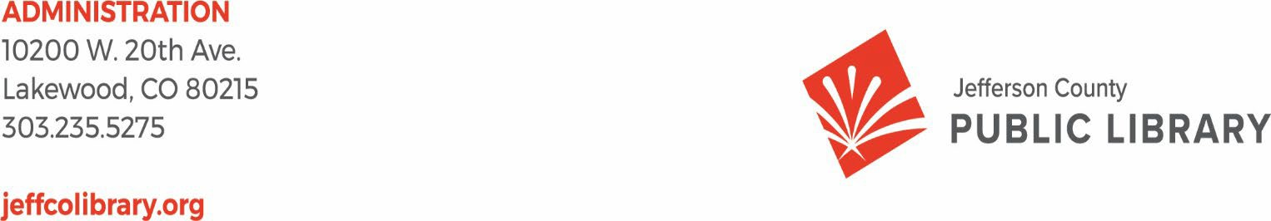

TO: Library Board of Trustees

FROM: Kim Johnson, Chair and Donna Walker, Executive Director DATE: May 15, 2025

RE: Consent Agenda for the May 15, 2025 Board Meeting

A. Approve Minutes of April 17, 2025 Board Meeting

**Minutes of the Regular Meeting of the** JEFFERSON COUNTY PUBLIC LIBRARY **BOARD OF TRUSTEES**

April 17, 2025

###### CALL TO ORDER – REGULAR MEETING

The regular meeting of the Jefferson County Public Library Board of Trustees was held online via ZOOM and in-person in the Lakewood Library meeting room on April 17, 2025. Library Board of Trustees Chair, Kim Johnson, called the meeting to order at 5:30 p.m.

Other Trustees present: Emelda [Bing] Walker (Vice-Chair), Renny Fagan, Jill Fellman, and Charles Jones, Pam Anderson

**Staff present:** Donna Walker, Executive Director; Julianne Rist, Library Planning & Policy Senior Advisor; Steve Chestnut, Director of Facilities and Construction Projects; Bernadette Berger, Chief Technology & Digital Innovation Officer; Matt Griffin, Chief Strategy & Operating Officer; Lisa Smith, Chief People & Culture Officer; Elise Penington, Director of Communications and Engagement**;** Amy Bentz, Assistant Director of Library Design Projects and Planning; Jessica Paulsen, Assistant Director of Libraries & Inclusion for Customer Experience; Padma Polepeddi, Assistant Director of Libraries & Inclusion for Community Outreach; Lizzie Gall, Assistant Director of Libraries and Inclusion for Resources and Programs; Kelci Rude, Administrative Coordinator Supervisor; Katie O’Loughlin, Administrative Coordinator Supervisor; Ryan Turch, Technology and Innovation Operations Supervisor

There were additional Library staff members attending the meeting.

###### APPROVAL OF AGENDA

**MOTION:** Jill Fellman moved that the Library Board of Trustees approve the agenda as presented. Seconded by Renny Fagan the motion passed by unanimous vote of all Trustees present.

###### PUBLIC COMMENT

The Board values public participation. Those who would like to address the Library Board can do so virtually, in-person, or online. The opportunity to address the Library Board does not include a question and answer session or response. Additionally, the Library Board does not respond to anonymous questions or comments. Comments will be acknowledged in the minutes of the meeting.

The Chair advised the Board that no online comments were received. Anna Sparlin and Jeny Crownover addressed the Board and provided public comments regarding dress code concerns and the JCPL Mission, Vision, and Values as they relate to dress code.

There were no further public comments, and the Chair closed the public comment portion of the meeting at 5:41 pm.

###### APPROVAL OF CONSENT AGENDA

The Chair asked the Trustees if any of the items should be removed from the consent agenda. There were no requests for items to be removed.

Items on the Consent Agenda

1. Approve Minutes of March 20, 2025 Board Meeting
2. Adopt Bylaws for the Jefferson County Public Library Board of Trustees
3. Authorize Kleen-Tech Carpet Cleaning Contract Renewal, 4th Renewal
4. Authorize Lakewood Reinvestment Authority Intergovernmental Agreement (IGA)

**MOTION**: Pam Anderson moved that the Library Board of Trustees approve the items on the consent agenda as presented. Seconded by Renny Fagan the motion passed by unanimous vote of all Trustees present.

###### FOUNDATION UPDATE

Jo Schantz Hall was absent; the Chair noted that the Foundation’s report was in the packet. Trustee Fagan, Board liaison to the Foundation, shared that he attended his first Foundation Board meeting and was able to see the sorting operations in their warehouse. The Friends annual event was last Friday.

There were no questions from the Board.

###### EXECUTIVE DIRECTOR REPORT

* 1. Executive Director Report

The Executive Director advised the Board that last week was National Library week, and we have the Board of County Commissioner proclamation available if they would like to view it. Bridget Beatty, our fundraising consultant, submitted a $600,000 grant application for a Northwest Jefferson County Library solar array. JCPL worked in collaboration with County and secured letters of support from members of the City of Arvada leadership and community. Cynthia Kiyotake will be joining as the new Chief Libraries and Inclusion Officer, and leadership is continuing to transition to the new operating model for our leadership teams.

* 1. Capital Building Projects Update

**South County Library**: The Board will see the community engagement results at the May Board meeting. René Yaws, our South County Library Manager, is providing building tours for staff groups. The South County Library interim services will begin on May 3; the bookmobile will move from the Ken Caryl parking lot and will begin providing services from our new building as suggested by the Advisory Council. We are planning to bring summer challenge activities to the site.

**NW Jeffco Library**: JCPL is moving through conceptual design. General Contractor interviews were held this week. We are starting our second year of partnership with the Three Creeks K-8 school. Bryan Kratish, our NW Library Manager, is facilitating a 5-week research project with 7th and 8th grade students where they are studying innovative ideas for the new library that will be presented to staff.

**Arvada Library Redesign**: We are moving through design development, and staff will begin looking at finishes in the next few weeks.

**Conifer**: Demolition is complete, and we are waiting on the Building Safety permit to move forward with construction.

In response to questions, the Board was informed that:

* + - We have a prospective site for our Arvada Library alternative services, but we are waiting for a draft lease agreement that we can review.
  1. Core Cooperative Naming Agreement

The Executive Director informed the Board that this is a local business, and we are excited to have one of the businesses in the community be a part of this project.

**MOTION**: Renny Fagan moved that the Library Board of Trustees approve the Donation and Name Recognition Agreement between Core Cooperative, the Jefferson County Library Foundation, Inc., and the Jefferson County Public Library. Seconded by Jill Fellman the motion passed by unanimous vote of all Trustees present.

In response to questions, the Board was advised that:

* + - Staff cannot recall an example of when a business with a naming agreement has closed or changed names. The naming agreements are for a set limited term. If needed, a change we would be brought back to the Board.
  1. 2026+ Strategic Planning

Guest: Greg Bellomo, Government Performance Solutions, Inc

Greg Bellomo addressed the Board and provided an update on progress from the last workshop with the Board and reviewed the Board’s role in this process.

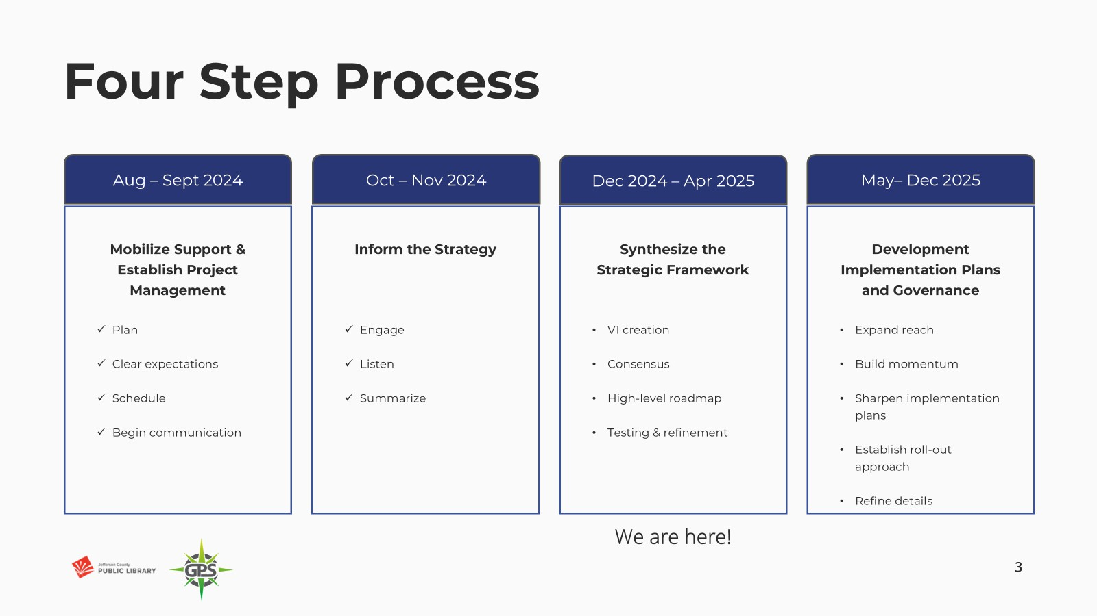

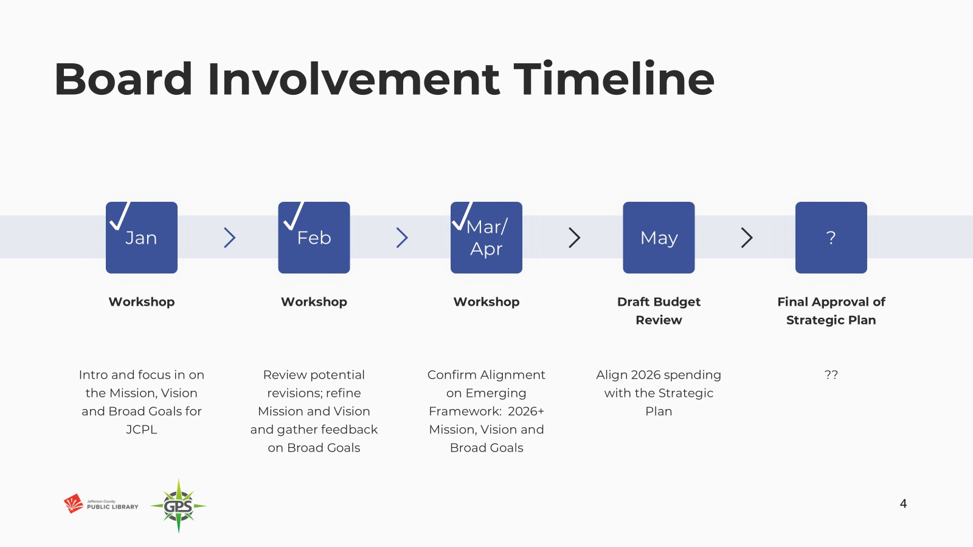

Review of where the Board and leadership are in this work:

* + - We’re at the end of April.
    - We have version 1 of the strategic framework.
    - Next piece of work is mobilizing managers and supervisors around ideas for key results and leading measures. That will allow us to broaden our participation in the second half of the year.

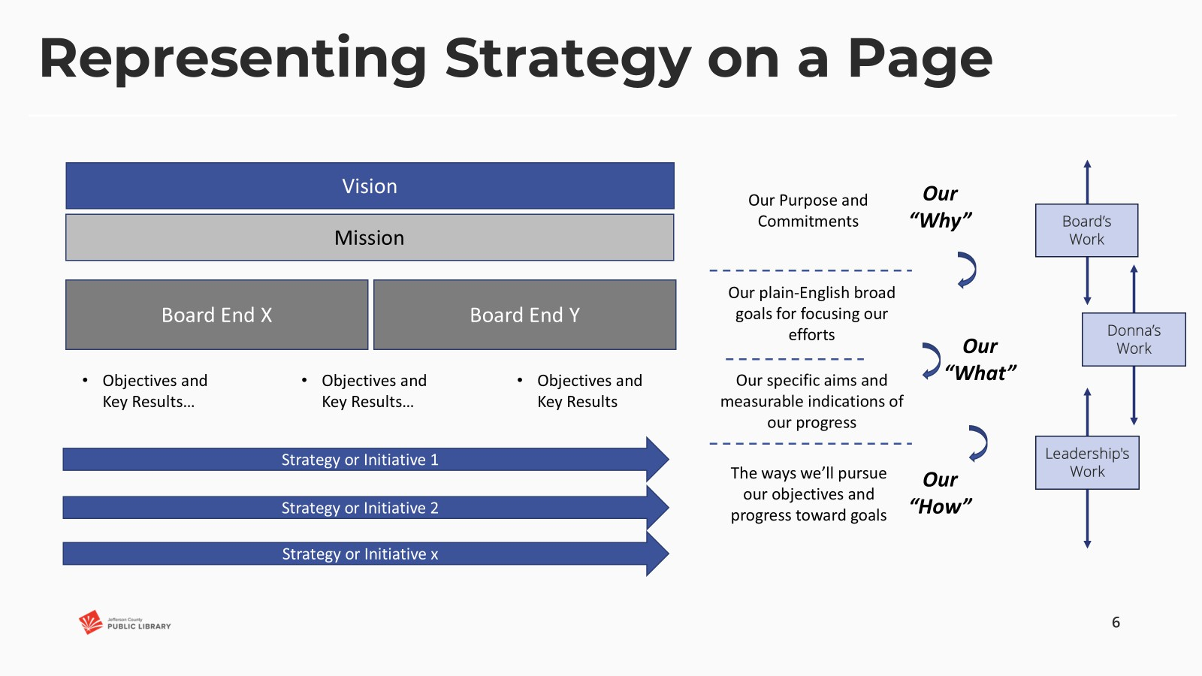

The Executive Director addressed the Board and introduced the proposed new language in the framework, which have been refined to three Ends.

1. Equity of Access

The last feedback from the Board was that we had some wordsmithing to do, but that this continues to be important to our Community and Board.

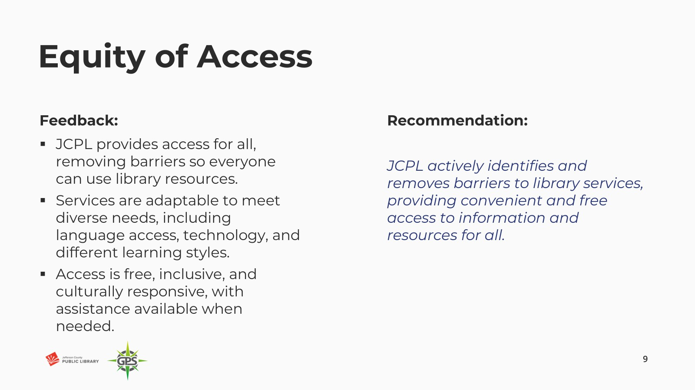

1. Creating Place

Last feedback from the Board was that some of these key words were safe, accessibility, and discovery and belonging.



**Creating Place**

**Feedback:**

* The library is a welcoming, safe space where everyone feels they belong.
* Spaces are inspiring, and designed for creativity, connection, and learning.
* Libraries are easily accessible, both physically and digitally, and provide a calming yet engaging environment.

**Recommendation:**

*Our libraries are safe and accessible spaces that bring people together, encourage discovery, and where everyone belongs.*

**10**

1. Our People

The Board had quite a bit of conversation around this in the last session. Our goal was to capture the feedback and make it reflective.

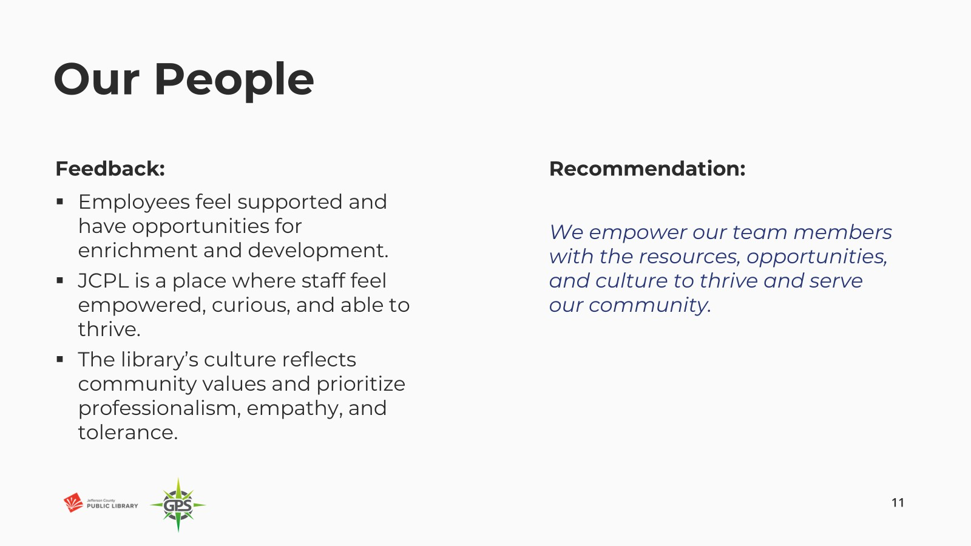

Put all together, this is our 2026 and beyond strategic framework. Reminder that this starts in 2026.

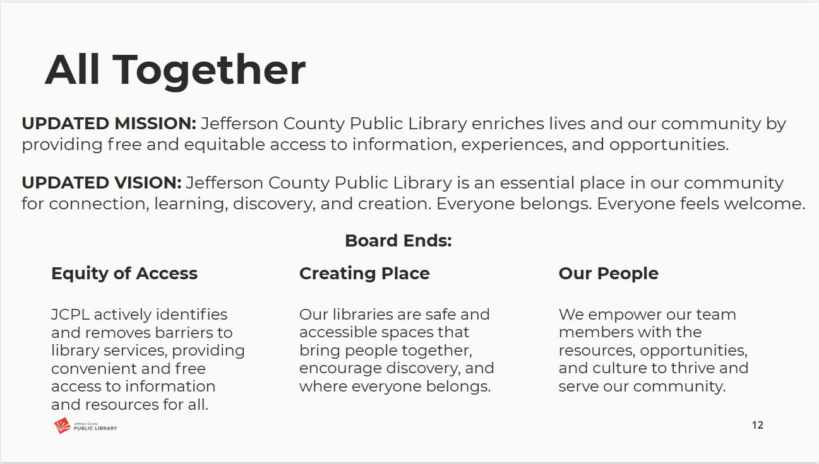

The Executive Director asked the Board to provide feedback on whether this captured how they felt about 2026 and beyond for the next strategic plan, or if there was something missing. The Board

provided the following feedback:

* + Well put together. There was vast community input that has informed this process and want to be sure that we feel the community will see themselves and their input in these ends. This is important for public trust. When we ask for public involvement, we want them to see that they we listened to and that we’re responding.
  + Feels like this resonates with what we heard from the community, and what I see as a patron and community member.
  + We may need to help the public connect the dots between the Ends and their input.
  + Appreciate the effort and the many hours that went into bringing the comments and feedback together. This brings the mission and vision and everything together now and, in the future, and brings us forward.
  + Looks great, looking forward to what the final product will look like.
  + Think we have consensus to move forward on these; prefer equitable and free in Mission- complements the way equity of access is written.

In response, the Board was advised that:

* + Slide language contained an error in the new Mission. This will be corrected and updated.
  + We do feel that this represents the community input. What is resonating and reverberating throughout is connection, being together, welcoming and everyone belongs.
  + The Board will see some items in the draft budget that are in response to the community feedback.

Greg Bellomo addressed the Board and reviewed the next steps in this process. This will be brought to the Library’s Combined Management Team meeting for the managers and supervisors to speak about objectives and measures. This engages staff in the ‘how’ of the ‘what’ that has been decided.

There were no questions from the Board about the next steps.

###### OPERATIONAL UPDATES

**Strategy and Operations**

A. Authorize Notice to Proceed for Architectural Design Services - South County Library, Eppstein Uhen Architects, Inc

Amy Bentz, Assistant Director of Library Design Projects and Planning addressed the Board and provided information on this request. The Board of Trustees authorized JCPL to enter a contract with Eppstein Uhen Architects, Inc. (EUA) for the design of the South County Library in September 2021. JCPL wishes to engage EUA for architectural design services for the South County Library project.

EUA has evaluated the project scope and provided a cost estimate and schedule. This fee aligns with our budget expectations.

In response to the questions, the Board was advised that:

* We are structuring the pricing and notice to proceed in this way because of potential design alternates. We will not know about the alternates until we get further into design.

**MOTION**: Jill Fellman moved that the Library Board of Trustees authorize the Executive Director to issue a Notice to Proceed for the base architectural design services for the South County Library project at a cost of $1,502,605.00 and alternates that may be issued at a later phase at a cost of $141,600.00. Seconded by Pam Anderson the motion passed by unanimous vote of all Trustees present.

**Finance and Budget**

A. Financial Report (March 2025)

Matt Griffin, Chief Strategy & Operating Officer, addressed the Board and provided information on the March 2025 monthly financials. The Board was advised that:

* March is the end of our first quarter financials, no comments other than one update on carryforwards. On Table 3, carryforwards were approved on Tuesday, they will then go onto consent agenda in a few weeks and then we will process those.

In response to questions the Board was advised that:

* We are not currently seeing volatility in the investment income; this is primarily because the treasurer posts to our financials quarterly and it does lag. We have no cause for concern now based on what we know.

There were no other questions or comments from the Board.

###### ITEMS REMOVED FROM THE CONSENT AGENDA

No items were removed from the consent agenda.

###### EMERGING ISSUES

No issues.

###### ENDS

There were no items.

###### BOARD GOVERNANCE

A. Nominating Committee report to the Board: Proposed Slate of Officers

The nominating committee presented the following slate of officers for election:

* Secretary: Charles Jones, for the remainder of the 1-year term (April 2025 to March 2026)

**MOTION**: Emelda Walker moved that the Library Board of Trustees elect Charles Jones for Secretary for the remainder of the one-year term April 2025 to March 2026. Seconded by Jill Fellman the motion passed by unanimous vote of all Trustees present.

###### BOARD SCHEDULE – NEXT MEETINGS

2025 Board Meeting Schedule

* May 8, 2025 –Study Session Hybrid: Virtual via ZOOM. In-Person Location: Lakewood Library Meeting Room
* May 15, 2025 – Board Meeting – 5:30 pm Hybrid: Virtual via ZOOM. In-Person Location: Lakewood Library Meeting Room
* June 12, 2025 – Study Session Hybrid: Virtual via ZOOM. In-Person Location: Lakewood Library Meeting Room
* June 18, 2025 – Board Meeting – 5:30 pm Hybrid: Virtual via ZOOM. In-Person Location: Lakewood Library Meeting Room

###### ANNOUNCEMENTS/GENERAL INFORMATION SHARING

There were no announcements.

###### EXECUTIVE SESSION:

At 6:14pm, the Chair called for a motion to adjourn the regular meeting, reconvene in Executive Session regarding Collective Bargaining and adjourn the regular Board meeting at the conclusion of the Executive Session.

**MOTION**: Renny Fagan moved to adjourn the regular meeting of the Library Board of Trustees, reconvene in Executive Session regarding Collective Bargaining AND adjourn the Regular Board meeting at the conclusion of the Executive Session. Statutory citation authorizing an executive session for this topic is:

* Pursuant to 24-6-402(4)(e)(I) for discussion of strategy and instructions to negotiators

Seconded by Jill Fellman the motion passed by unanimous vote of all Trustees present.

The Chair announced a 5-minute break to allow the Board and staff to clear the room, leave the existing ZOOM meeting and then join the Executive Session.

The Chair called the Executive Session to order at 6:20pm with the following other Trustees present: Emelda (Bing) Walker, Charles Jones, Pam Anderson, Jill Fellman, and Renny Fagan. Also present were Donna Walker, Executive Director; Julianne Rist, Library Planning and Policy Senior Advisor; Bernadette Berger, Chief Technology & Digital Innovation Officer; Lisa Smith, Chief People & Culture Officer; Matt Griffin, Chief Strategy & Operating Officer; and Katie O’Loughlin, Administrative Coordinator Supervisor.

Guest: Steven Spirn

It is noted that the session was recorded and that the recording will be retained for the required 90 days.

CALL FOR ADJOURNMENT OF EXECUTIVE SESSION at 6:47 pm

**MOTION**: At 6:47pm Jill Fellman moved to adjourn the Executive Session. Seconded by Renny Fagan the motion passed by unanimous vote of all Trustees present.

It is noted that the Library Board of Trustees met in Executive Session concerning Collective Bargaining pursuant to 24-6-402(4)(e)(I) for discussion of strategy and instructions to negotiators. The Trustees held those discussions, and this summary is provided as required by Colorado Statute.

Charles Jones, Secretary

**Foundation Update**

# Upcoming Foundation Events

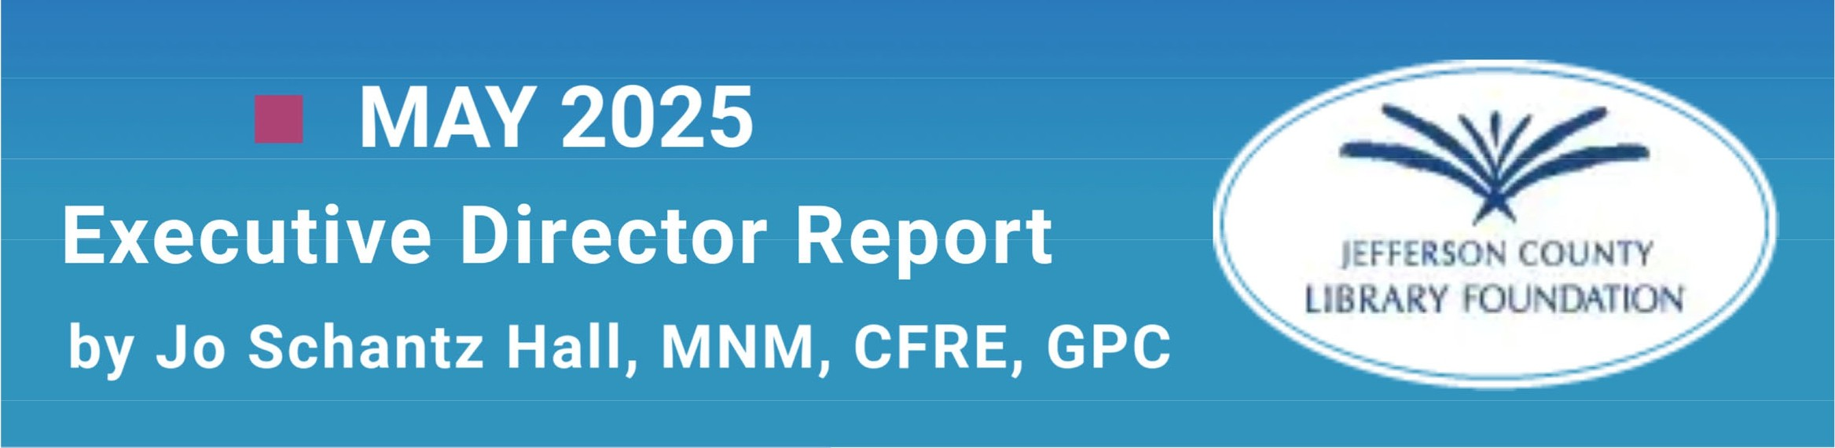

##### MAY 29 - JUNE 1

Spring Whale of a Used Book Sale Jeffco Fairgrounds

Friends Preview Night, May 29, 6-8 p.m. May 30, Early Bird 8-9 a.m.; general admission 9 a.m. to 5 p.m.

May 31, 9 a.m. to 5 p.m.

June 1, 11 a.m. to 3 p.m.

##### JULY2

Books On Film fundraiser featuring Jurassic World Rebirth

6 to 9:30 p.m.

Harkins 14 Theatres, Arvada

$50 per person

Includes beverage & popcorn, door prize drawing

Post-film panel discussion hosted by Friends of Dinosaur Ridge

##### JULY 25

Volunteer Appreciation Luncheon Wheat Ridge Rec Center, Wheat Ridge 11:30 a.m. to 1:30 p.m.

Featuring "A Day in India"

##### AUGUST16

SHRED-A-THON

9 a.m. to noon

Bank of Colorado parking lot Lakewood



Good news from Whale's Tale Books & Gifts in Colorado Mills Mall! As of May 12, we have raised nearly $70,000 in gross sales for the year. That means we are on target for our projected gross sales of $155,000 by the end of 2025!

**COMMUNITY CONNECTIONS**

* April 22 - Finance Committee meeting
* April 22 - Lakewood Foothills Rotary Club meeting
* April 23 - JCPL Combined Management Team meeting
* April 23 - Lunch meeting with 2 JCLF major donors
* April 26 - PEO's Books & Brunch benefit, Arvada Center
* April 30 - Annual joint JCPL/JCLF meeting
* May 1 - Whale Sale Crew Chief meeting
* May 2 - Lunch meeting with major donor
* May 12 - Online meeting with Donna Walker
* May 13 - Presentation to Wheat Ridge Business Assn.
* May 13 - Major donor tour of JCLF
* May 13 -- Lakewood Foothills Rotary Club meeting
* May 14 - Awards breakfast, Golden Civic Foundation
* May 14 - JCPL Communications meeting

# FUNDING UPDATE

GRANTS RECEIVED

Golden Civic Foundation -- $2,600 for Library Summer Challenge at Golden Library

Applewood Community Foundation -- $1,000 for Library Summer Challenge

Bank of Colorado -- $1,000 for Friends Community Partnership

City of Lakewood -- $4,600 for children's outdoor learning accessories at Belmar Library

**GRANTS DENIED**

Ent Credit Union YES Grants -- $10,000 for 1000 Books Before Kindergarten

**GRANTS PENDING**

Gohorm-McGee Early Learning Fund -- $5,000 for 1000 Books Before Kindergarten

Colliers, Inc. -- $1,000 for Friends Community Partnership

Believe in Reading Foundation -- $4,865 for Babies First Books

### Operational Updates Executive Director Report



**MAY 2025** EXECUTIVE DIRECTOR REPORT

### 2025 Annual Plan Progress in May

#### Portfolio: Service Point Development & Expansion

**Program: New Construction Project: South County Library**

* + Present Community Engagement Report
  + Continue Program of Service development
  + General Contractor selection

**Project: Northwest Jeffco Library**

* + Continue schematic design
  + Contract with General Contractor

**Program: Building Redesign Project: Arvada Library**

* + Continue design development
  + Continue lease negotiation for alternative services location

**Program: Tenant Finish Project: Conifer Library**

* + Continue construction
  + Finalize donor recognition plan
  + Dissolution of Intergovernmental Agreement

#### Portfolio: Embracing Innovation & Change

**Program: Artificial Intelligence Strategy**

* + Complete first round of staff interviews

**Program: Fundraising Development**

* + Create Fundraising Action Committee
  + Kick-off Long Term Fundraising project

#### Portfolio: Continuous Process Improvement

**Project: Collective Bargaining Agreement**

* + Continue negotiation sessions



**Project: 2026+ Strategic Plan**

* + Continue strategic framework creation

### Service Highlights:

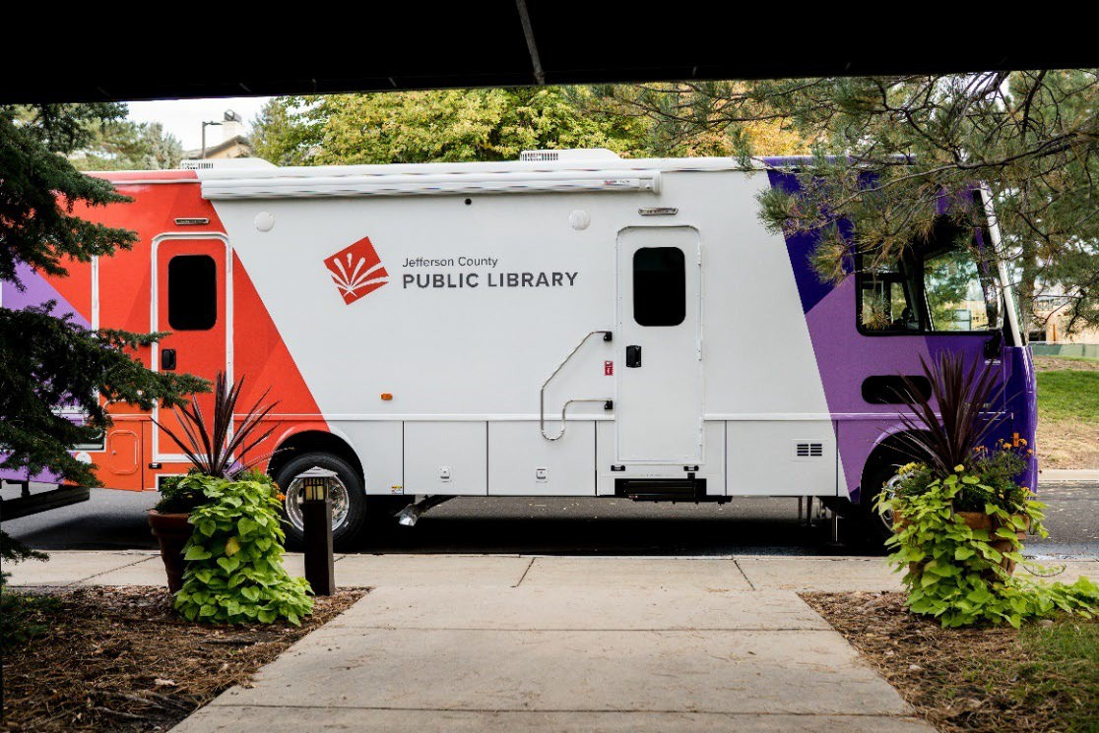

**South County Library Interim Services:**

We are pleased to announce the launch of interim services at the future South County Library site. This initiative is designed to engage the South Jeffco community and familiarize patrons with the future library location.

Starting Saturday, May 3, the South County Library parking lot at 11100 Bradford Rd. will become a regular stop for our Bookmobile from 11 a.m. to 3 p.m.



Summer Challenge [Color Our World](https://jeffcolibrary.org/summer-challenge/): **Registration opens May 1. Challenge runs June 1 - July 31.**



**2025 Conferences: ADVOCACY AND ENGAGEMENT OPPORTUNITY FOR**

### Trustees

**CALCON 2025 Colorado Association of Libraries Annual Conference**

September 3-5, at Beaver Run Breckenridge, CO. Let Katie O’Loughlin know by August 4 if you plan to attend.

**Urban Libraries Council Annual Leadership Forum**

October 22-24, Cincinnati, Ohio. Let Katie O’Loughlin know by September 22 if plan to attend.

### JCPL Professional Engagement:

**Amy Bentz,** Assistant Director Library Projects & Planning, **Natalie Brecheisen,** Operations Supervisor, and **Clarice Ambler,** Community Resources Coordinator, graduated from the year- long Jeffco EDC *Leadership Jeffco* program.

**Nick Taylor**, Manager of Teen Services was elected as Executive Committee Board Co-Chair for the *Communities That Care (CTC) Board*.

**Padma Polepeddi**, Assistant Director of Libraries & Inclusion for Community Outreach, was elected as Recruitment and Community Engagement Workgroup Co-Chair for the *Communities That Care (CTC) Board*.

**Lisa Smith**, Chief People & Culture Officer, **Sarah Leibrandt**, Training and Development Manager, and **Molly Smits**, Human Resources Manager, are attending the *Workhuman Live* conference.

**Bryan Kratish**, NW Jefferson County Library Manager, is attending the *Library Journal Design Institute*.

**Karen Walker**, Kids & Families Librarian, is attending the *Nature Everywhere, Children & Nature Network* conference.

**Several JCPL staff** are attending the CAL Makerspace Interest Group Workshop.

**HIGHLIGHTS OF EXECUTIVE DIRECTOR COMMUNITY ACTIVITIES,**

MAY 2025

* Attend **Colorado Public Library Directors** Annual Retreat
* Attend **CAL Legislative Committee** meeting
* Meet with Colorado Association of Libraries Leadership Institute mentee
* Attend **Jeffco Connections Board** meeting
* Meet with Joe Kerby, **Jefferson County Manager**
* Present about JCPL at the **Edgewater City Council** meeting
* Attend **Urban Libraries Council** Director/CEO meeting



* Meet with Jo Schantz, executive director, **Jefferson County Library Foundation**
* Attend **Jefferson County Library Foundation Board meeting**
* Meet with **Wheat Ridge** city manager



### Operational Updates Strategy & Operations



TO: Donna Walker, Executive Director

FROM: Matt Griffin, Chief Strategy & Operating Officer DATE: May 15, 2025

RE: Finance Monthly Report

**A. Long-Term Financial Planning**

A 5 Year Capital Improvement Plan (CIP) and a 10 Year Financial Forecast will be presented to the Board for discussion to provide background and inform 2026 budget decisions in June. These documents will outline proposed investments in capital improvements over the next five years and project financial performance for the next decade.

Revenue estimates reflect the impacts of recent state legislation—SB21-293 and SB22-238— which modify property tax assessment rates and introduce new valuation caps. These measures add volatility to JCPL revenue forecasts. Our projections adjust for both rate changes and potential state reimbursements.

**Budget to Actual Tables – April 2025**

Please see the enclosed Budget to Actual Tables for April 2025.

In April 2025, Real Property Tax revenue has not yet been recorded. Year-to-date, 40.5% of the budgeted collection has been received.

JCPL is on track with its budget, and there are no areas of concern. Our financial performance remains steady, and in line with expectations.

The Library Foundation provided funding of $5,733 to JCPL. The Library contributed $7,996 in- kind support in April. Year-to-date, the library has received $46,762 in funding and provided

$30,906 in-kind support to the Foundation, with a ratio of 1.5.

**TABLE 1**

**JEFFERSON COUNTY PUBLIC LIBRARY REVENUE AND EXPENDITURE SUMMARY BUDGET TO ACTUAL**

|  |  |  |  |  |
| --- | --- | --- | --- | --- |
| **Revenue and Expenditure** | **2025 Budget** | **YTD Actual**  **04/30/2025** | **$ Variance**  **2025 Budget** | **% Variance**  **2025 Budget** |
| **Revenues** |  |  |  |  |
| Property Taxes (net adjustments) | 59,744,973 | 25,349,033 | 34,395,940 | 42% |
| Grants, Funds & Donations | 560,427 | 71,862 | 488,565 | 13% |
| Investment Income | 2,009,000 | 715,671 | 1,293,329 | 36% |
| Other Revenue | 35,000 | 50,372 | (15,372) | 144% |
| **Total Revenues** | **$ 62,349,400** | **$ 26,186,938** | **$ 36,162,462** | **42.0%** |
| **Expenditures** |  |  |  |  |
| Operating | 48,026,474 | 13,996,125 | 34,030,349 | 29% |
| Financing & Debt Service | - | - | - |  |
| Capital Projects | 37,832,206 | 11,411,039 | 26,421,167 | 30% |
| **Total Expenditures** | **$ 85,858,680** | **$ 25,407,164** | **$ 60,451,516** | **29.6%** |

|  |
| --- |
| % Variance 2025 Budget |
| ***42.0%***  **Total Revenues**  **0% 100%** |
|  |
| ***29.6%***  **Total Expenditures**  **0% 100%** |
|  |
| ***29%***  Operating  **0% 100%** |
|  |
| Debt  **0% 100%** |
|  |
| **30%**  Capital  **0% 100%** |

**TABLE 2**

**JEFFERSON COUNTY PUBLIC LIBRARY OPERATING EXPENDITURES**

**BUDGET TO ACTUAL**

|  |  |  |  |  |
| --- | --- | --- | --- | --- |
|  | **2025 Budget** | **YTD Actual 04/30/2025** | **$ Variance 2025 Budget** | **% Variance 2025 Budget** |
| ***Operating Expenditures*** |  |  |  |  |
| **Salaries & Employee Benefits** |  |  |  |  |
| Salaries | 19,267,433 | 5,295,056 | 13,972,377 | 27% |
| Awards & Bonuses | 275,000 | 27,653 | 247,347 | 10% |
| Other | 7,478,592 | 2,426,529 | 5,052,063 | 32% |
| Total Salaries & Benefits | $ 27,021,025 | $ 7,749,238 | $ 19,271,787 | 29% |
| **Library Collections** |  |  |  |  |
| Library Books & Materials | 7,692,199 | 2,311,317 | 5,380,882 | 30% |
| Library Periodicals | 205,000 | 71,649 | 133,351 | 35% |
| Total Library Collections | $ 7,897,199 | $ 2,382,966 | $ 5,514,233 | 30% |
| **Supplies and Other** |  |  |  |  |
| Supplies | 1,915,452 | 562,753 | 1,352,699 | 29% |
| Services & Charges | 7,959,121 | 2,174,283 | 5,784,838 | 27% |
| Interdepartmental Direct Charges | 713,165 | 207,173 | 505,992 | 29% |
| Treasurers Fees | 902,081 | 380,235 | 521,846 | 42% |
| Interdepartmental Indirect Charges | 1,618,431 | 539,477 | 1,078,954 | 33% |
| Total Supplies and Other | $ 13,108,250 | $ 3,863,921 | $ 9,244,329 | 29% |
|  |  |  |  |  |
| **Total Operating Expenditures** | **$ 48,026,474** | **$ 13,996,125** | **$ 34,030,349** | **29.1%** |

**TABLE 3**

**JEFFERSON COUNTY PUBLIC LIBRARY CAPITAL IMPROVEMENT PROJECTS BUDGET TO ACTUAL**

|  |  |  |  |  |  |  |  |
| --- | --- | --- | --- | --- | --- | --- | --- |
|  | **2025**  **Budget** | **YTD Actual 04/30/2025** | **YTD**  **Encumbrances** | **YTD Total Actual + Enc** | **Remaining 2025 Budget** | **Total Project**  **Actual + Encumbrances** | **Total Project Budget** |
| ***Capital Expenditures*** |  |  |  |  |  |  |  |
| **Annual Replacement & Maintenance** |  |  |  |  |  |  |  |
| ARM-01 Capital Maintenance | 300,000 | 23,155 | - | 23,155 | 276,845 | n/a | n/a |
| ARM-02 Furniture & Equipment | 42,000 | 24,201 | - | 24,201 | 17,799 | n/a | n/a |
| ARM-03 Computer Replacement Plan | 616,000 | 164,660 | - | 164,660 | 451,340 | n/a | n/a |
| ARM-04 Book Sorter Replacement | 40,000 | - | - | - | 40,000 | n/a | n/a |
| ARM-05 IT Infrastructure Replacement | 450,000 | 84,185 | 113,814 | 197,999 | 252,001 | n/a | n/a |
| **Capital Projects** |  |  |  |  |  |  |  |
| Document Management System | - | - | - | - | - | 198,977 | 160,000 |
| South County Library | 6,198,826 | 10,587,795 | 1,644,205 | 12,232,000 | (6,033,174) | 12,533,820 | 30,849,540 |
| Evergreen Library Redesign | - | 14,268 | - | 14,268 | (14,268) | 4,810,193 | 5,200,048 |
| Evergreen Library Roof Repair | - | - | 27,186 | 27,186 | (27,186) | 56,646 |  |
| Columbine Library Roof Repair | - | - | - | - | - | 670,708 |  |
| Northwest County Library | 14,589,599 | 113,756 | 1,553,769 | 1,667,525 | 12,922,074 | 5,396,627 | 25,970,270 |
| Arvada Library Redesign | 14,095,781 | 281,113 | 763,925 | 1,045,038 | 13,050,743 | 1,134,018 | 14,895,781 |
| Conifer Library Tenant Finish | - | 93,890 | 68,903 | 162,793 | (162,793) | 302,603 | 2,500,400 |
| South County Express Library |  | - | - | - | - | - | 595,000 |
| Lakewood Restrooms | 500,000 | 24,016 | 20,984 | 45,000 | 455,000 | 45,000 | 500,000 |
| Admin Office Reconfiguration | 250,000 | - | - | - | 250,000 | - | 250,000 |
| Library Interiors Refresh Pilot | 750,000 | - | - | - | 750,000 | - | 750,000 |
| **Total Capital Expenditures** | **$ 37,832,206** | **$ 11,411,039** | **$ 4,192,786** | **$ 15,603,825** | **$ 22,228,381** |  |  |
|  | | | | | |  |  |

**TABLE 4**

**JEFFERSON COUNTY PUBLIC LIBRARY GRANTS, FUNDS & DONATIONS BUDGET TO ACTUAL**

|  |  |  |  |  |  |  |  |
| --- | --- | --- | --- | --- | --- | --- | --- |
|  | **2022**  **Actual** | **2023**  **Actual** | **2024**  **Actual** | **2025**  **Budget** | **YTD Actual 04/30/2025** | **$ Variance 2025 Budget** | **% Variance 2025 Budget** |
| ***JCPL Grants*** |  |  |  |  |  |  |  |
| Books & Materials - American Rescue Plan | 181,757 | - | - | - | - | - |  |
| Books & Materials - State | 195,797 | 140,462 | 5,002 | 144,996 | - | 144,996 | 0% |
| Car Charging Station - Evergreen | - | 16,500 | 1,684 | - | - | - |  |
| Car Charging Station - Columbine | - | - | - | - | - | - |  |
| Car Charging Station - Lakewood | - | - | - | - | - | - |  |
| **Total JCPL Grants** | **$ 377,554** | **$ 156,962** | **$ 6,686** | **$ 144,996** | **-** | **$ 144,996** | **0%** |
| ***JCPL Private Donations*** |  |  |  |  |  |  |  |
| Private Donations up to $200 | 340 | - | 250 | - | 100 |  |  |
| Private Donations $201 - $999 | - | - | - | - | - |  |  |
| Colorado Gives - Naumer Family Fund EV Remodel | - | 5,000 | - | - | - |  |  |
| Anonymous Donor | - | 2,000 | - | - | - |  |  |
| Anonymous Donor | 58,042 | - | - | - | - |  |  |
| Anonymous Donor | - | - | - | - | - |  |  |
| Anonymous Donor | - | - | - | - | - |  |  |
| JCLF - Evergreen Library - Naming Rights | - | - | 5,000 | - | - |  |  |
| Colorado Gives - Hard Times Writing |  |  | 24,509 |  |  |  |  |
| El Pomar Foundation |  |  |  |  | 25,000 |  |  |
| Fundraising Target | - | - | - | 150,000 | - | 150,000 | - |
| **Total Private Donations** | **$ 58,382** | **$ 7,000** | **$ 29,759** | **$ 150,000** | **$ 25,100** | **$ 124,900** | **17%** |
| ***Other Funds Received*** |  |  |  |  |  |  |  |
| Payroll Funding - American Rescue Plan | 263,556 | 856,591 | - | - | - | - |  |
| E-Rate Reimbursement | 2,602 | 149,901 | 60,471 | 165,431 | - | 165,431 | 0% |
| Laptop Lending | 100,145 | 183,427 | - | - | - | - |  |
| Stadium Funds - Imagination Library |  |  | 50,000 | - | - | - |  |
| Stadium Funds - Young Authors | - | - | 42,350 | - | - | - |  |
| **Total Other Funds Received** | **$ 366,303** | **$ 1,189,919** | **$ 152,821** | **$ 165,431** | **$ -** | **$ 165,431** | **0%** |
| ***Jefferson County Library Foundation*** | 131,894 | 127,180 | 141,576 | 100,000 | 46,762 | 53,238 | 47% |
| **Total Jefferson County Library Foundation** | **$ 131,894** | **$ 127,180** | **$ 141,576** | **$ 100,000** | **$ 46,762** | **$ 53,238** | **47%** |
|  | | | |  |  |  |  |
| **Total Grants, Funds & Donations** | **$ 934,133** | **$ 1,481,061** | **$ 330,842** | **$ 560,427** | **$ 71,862** | **$ 488,565** | **13%** |

***Other Funds Received Outside of Library Fund*** Digital Equity - American Rescue Plan (FD181) Digital Equity - Rescue Plan (FD036)

***-***

-

3,482

-

622,374

-

35,728

205,241

15,802

-

19,926

205,241

44%

0%

### Operational Updates

**Communications & Engagement**



TO: Donna Walker, Executive Director

FROM: Elise Penington, Director of Communications and Engagement DATE: May 15, 2025

RE: South County Library Community Engagement Report Summary

The fully funded South County Library was approved by the JCPL Board of Trustees as part of its Facilities Master Plan (FMP) and is budgeted through the Library’s five-year Capital Improvement Plan. An important project deliverable was to engage library system patrons and the wider South County community around the new library design, services and amenities. JCPL retained Eppstein Uhen Architects (EUA) and Clermont Eliot to partner with our staff on the facilitated community engagement portion of this project.

The next level of community outreach was initiated in 2025, with facilitated community engagement taking place January through March. The goal of these efforts was to gather community and staff feedback to inform the upcoming program of service and design for the new South County Library. Along with offering in-community feedback opportunities, hosting two open houses, and providing a system-wide staff survey, JCPL offered community and teen surveys in Spanish and English, with both paper and online versions available. These efforts helped JCPL gain a comprehensive understanding of community and staff desires for this future location.

The team widely publicized opportunities for community engagement, which resulted in significant overall participation. More than 2,400 voices were heard through open houses, community events, survey responses, one-sentence story contest and more. We gathered in-depth feedback regarding design possibilities for the future library’s indoor and outdoor spaces, as well as preferred programming and services. Common themes heard across JCPL’s engagement efforts include:

**Meaningful Connections & Community:** Strong demand for spaces where people can come together to forge meaningful connections, build a sense of community, and share knowledge and experiences. This includes offering social events and amenities that provide additional reasons to visit, such as café/vending options option and playgrounds.

**Dynamic & Community-Rooted Design:** Envision a dynamic and forward-thinking library that seamlessly connects with local neighborhoods while incorporating contemporary flair alongside traditional library elements. The design should be innovative and rooted in the community to create an inspiring and engaging space.



**Nature & Outdoor Integration:** Seek a library that fosters a connection to outdoor spaces by integrating natural elements and views, as well as offering outdoor reading and programming.

**Accessible, Flexible & Inclusive Design:** Desire for a design that is accessible, safe and flexible with dedicated areas for various age groups. Envision a welcoming environment that is inclusive, educational and resourceful.

We are pleased to share these high-level insights into our community engagement efforts. EUA and Clermont Eliot have used the information gathered to create a comprehensive Community Engagement Report Summary for the South County Library, which will be presented to the Board at the May 15 meeting.

As a formal project deliverable, this report is intended to capture community feedback for JCPL leadership and to engage our Library Trustees in a discussion about community engagement outcomes.

### Operational Updates Strategy & Operations



TO: Donna Walker, Executive Director

FROM: Steve Chestnut, Director of Facilities and Construction DATE: May 15, 2025

RE: Northwest Jeffco Library General Contractor

**Background**

A Request for Proposal (RFP) for the Construction Management/General Contractor (CMGC) services for the construction of Northwest Jeffco Library was put out for proposal. Nine firms responded to the RFP. JCPL interviewed four of the teams that we ranked as our best fit. Interviews, background, and reference checks have been completed. JCPL recommends moving forward with contracting Swinerton to perform construction services for this project.

**Discussion**

This contract will consist of two phases. Phase 1 will be the pre-construction participation by the General Contractor to assist in the development of the design. This work will consist in providing cost estimates, recommending value engineering, reviews for constructability and recommendations on material availability. The cost of those services is $35,000.

Phase 2 will consist of a Guaranteed Maximum Price (GMP) that will reflect the cost of constructing the building and site as designed. The cost of this phase cannot be established until that design and the material specifications are complete. Once the GMP is established, it will need to be approved by our Board and upon approval, it too will become part of the contract documents.

**Action Requested**

I recommend that the Library Board of Trustees authorize the Executive Director to enter a contract with Swinerton Builders for Construction Management and General Contracting for the Northwest Jeffco Library project. The amount of the pre-construction fee is not to exceed $35,000, with the final GMP value to be provided to the Board for approval when developed.

### Operational Updates Technology & Digital Innovation

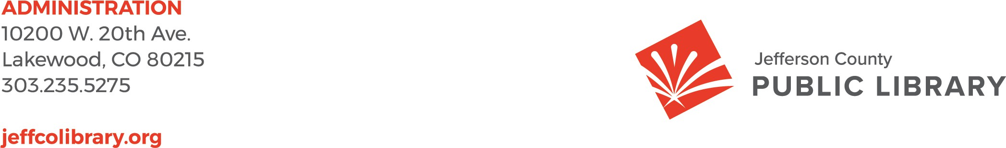

TO: Donna Walker, Executive Director

FROM: Bernadette Berger, Chief Technology & Digital Innovation Officer DATE: May 15, 2025

RE: E-Rate Contracts for Sentinel Technologies and Malm Electrical Contractors, LLC

**Background:**

E-Rate is a detailed and administratively complex system that is funded, coordinated, regulated, and monitored by the Universal Service Administrative Company (USAC) under the direction of the Federal Communication Commission. Its purpose is to “bridge the digital divide” by funding telecommunications infrastructure improvements for schools and libraries. This program saves the library approximately

$125,000 per year in telecommunication costs. All contracts, regardless of their value, must be submitted to the Board of Trustees for approval as a requirement of this program.

The Library’s Technology and Digital Innovation team has applied to the E-Rate program to include:

* Tier 1- Low voltage wiring
* Tier 2- Network Equipment

The network equipment and low voltage wiring will be used to remodel and build new libraries. JCPL received several bids for the equipment with differing levels of support and services. We recommend Sentinel Technologies and Malm Electrical as the vendors that provide the best price and value. The E- Rate guidelines require that these contracts be presented to the Library Board for approval.

The table below contains a breakdown of the projects and vendor selected for each construction project.

|  |  |  |  |
| --- | --- | --- | --- |
| **Vendor** | **Project** | **Contract for** | **Cost** |
| Malm | Conifer | Low voltage | $26,492.95 |
| Sentinel | Conifer | Network equipment | $32,005.72 |



**Budget:**

We anticipate that the Library will receive 50% of the cost back from the E-Rate program for the equipment. These purchases will use the construction budget for the individual projects. The total cost of the contracts with Sentinel Technologies and Malm Electrical is $58,498.67.

**Action Requested:**

We will be asking the Board of Trustees to authorize the Library Executive Director to sign the contracts with Sentinel Technologies and Malm Electrical for E-Rate eligible network equipment and low voltage wiring services in the amount of $58,498.67 at the May 15, 2025 meeting.

### Operational Updates Libraries & Inclusion



TO: Donna Walker, Executive Director

FROM: Julianne Rist, Library Planning and Policy Senior Advisor and

Jessica Paulsen, Assistant Director of Libraries and Inclusion, Customer Experience DATE: May 15, 2025

RE: Intergovernmental Agreement (IGA) for the dissolution of the combined library at Conifer High School.

**Background**

Jefferson County Public Library (JCPL) currently operates the Conifer Library out of the Conifer High School (CHS). We have been co-located in the school since 1996 and have maintained an intergovernmental agreement (IGA) with Jefferson County Public Schools throughout our partnership.

The current IGA was approved by JCPL’s Board of Trustees in October 2023. The Board approved a lease agreement for a new Conifer Library location in July 2024. Since then, the library has been in discussion with the school around how to best dissolve our intergovernmental agreement and complete the transition into our new space. A dissolution agreement has been drafted to formalize the process of moving the Conifer Library out of CHS. The dissolution agreement has been reviewed and approved by legal representatives for both parties. We are working with the school to define a date that aligns with the construction schedule and school calendar.

Construction has begun at the new Conifer Library location. JCPL will continue to work with CHS to limit the impact of moving out of the old Conifer Library location on the next school year.

**Terms:**

The parties agree to dissolve the IGA. The parties agree that the assets outlined in the Move Out List shall be distributed as provided. Any assets not on the Move Out List shall be distributed to the party who purchased and inventoried the asset. Any Library assets remaining at CHS after the Dissolution Date shall become the property of the School District unless a prior written arrangement has occurred. The provisions of the Prior Agreements, except those that are contradicted or superseded by the Dissolution Agreement, shall continue in effect until the effective date.

**Next Actions:**

We will request the Board of Trustees authorize the Executive Director to sign the new intergovernmental agreement for the dissolution of the combined library at Conifer High School at the May 15, 2025 Board meeting.

**Attachments:**

Attachment A- Draft Intergovernmental Agreement for the dissolution of the combined library at Conifer High School

**INTERGOVERNMENTAL AGREEMENT FOR DISSOLUTION OF THE COMBINED LIBRARY AT CONIFER HIGH SCHOOL**

**THIS INTERGOVERNMENTAL AGREEMENT FOR DISSOLUTION OF THE COMBINED**

**LIBRARY AT CONIFER HIGH SCHOOL** (this “Termination Agreement”), dated for reference purposes only this October 15, 2024, is made and entered into by and between the **JEFFERSON COUNTY PUBLIC LIBRARY** (the “Library”) and **JEFFERSON COUNTY SCHOOL DISTRICT**

**NO. R-1** (the “School District”).

**RECITALS**

1. Conifer High School (the “School”) was built and opened in August 1996 in Conifer, Colorado, located at 10441 County Highway 73, Conifer, Colorado 80433. The parties desired to share a combined school and public library (the “Facility”) in the high school to serve their common needs in an economical manner.
2. An Intergovernmental Agreement for Implementation of Joint School/Library Facility (“Implementation Agreement”) was entered into on May 1, 1996, establishing the combined library.
3. The parties entered into a separate Intergovernmental Agreement for operating the combined library at Conifer High School (“Operational Agreement”) in September 1997. The Operational Agreement was renewed and amended on January 1, 2010, and again amended and restated on October 20, 2023.
4. The parties by mutual agreement wish to terminate both the Implementation Agreement and the Operational Agreement (together, the “Prior Agreements”) and provide for the distribution of assets by way of this Termination Agreement.

**AGREEMENT**

In consideration of the covenants and conditions set forth herein, and for other good and valuable consideration, the sufficiency of which is hereby acknowledged, the Library and School District agree as follows:

1. The parties hereby agree to terminate the Prior Agreements effective MONTH DAY, 2025 (“Termination Date”).
2. Notwithstanding any provision of the Prior Agreements, the parties agree that the assets outlined in the Move Out List, attached hereto as Exhibit A, shall be distributed as provided in Exhibit A.
3. In accordance with Exhibit B to the Implementation Agreement and the section titled, “Facility” in the Operational Agreement, any assets not identified in Exhibit A shall be distributed to the party who purchased and inventoried the asset.
4. The School District will provide the Library reasonable access to the Facility in order to review, remove, disassemble, or otherwise prepare its assets for transfer. Any Library assets remaining at the Facility after the Termination Date shall become the property of the School District unless a prior written arrangement has occurred.
5. The provisions of the Prior Agreements, except those that are contradicted or superseded by this Termination Agreement, shall continue in effect until the Termination Date. If there are any

conflicts between the provisions of the Prior Agreements, the Operational Agreement shall control.

1. Each party represents that all procedures necessary to authorize such party’s execution of this Agreement have been performed and that the person signing for such party has been authorized to do so.

The parties hereto have caused this Termination Agreement to be executed.

JEFFERSON COUNTY PUBLIC LIBRARY

By: Donna R. Walker, Executive Director

Date:

APPROVED AS TO FORM:

Kurtis D. Behn

Assistant Deputy County Attorney

JEFFERSON COUNTY SCHOOL DISTRICT R-1

By: Name: Title: :

Date:

Board Governance



TO: LIBRARY BOARD OF TRUSTEES FROM: KIM JOHNSON, CHAIR

DATE: May 15, 2025

RE: PROPOSED 2026 GOVERNANCE BUDGET - POLICY 4.8.2

The Library Board will consciously invest in its ability to govern competently and wisely. Accordingly, costs will be prudently incurred, but sufficient to ensure the development and maintenance of superior governance, including funds sufficient for:

1. Library Board training, including publications and dues.
2. Library Board member travel/reimbursements to annually attend the Colorado Association of Libraries (CAL) annual conference, national conferences, and non-conference travel, as appropriate.
3. Auditing and other third-party monitoring of organizational performance.
4. Surveys focus groups and opinion analysis (included in Communications budget).
5. Library Board-hosted ownership linkage/outreach events.
6. Library Board meeting and retreat costs.

|  |  |  |  |
| --- | --- | --- | --- |
| Spend Category | Account Description | **2026**  Proposed  05-15-25 | **2025**  Budget |
| SC526137 | Office Supplies | 100 | 100 |
| SC526183 | Recognition/Appreciation | 300 | 300 |
| SC526200 | General Supplies | 50 | 100 |
| SC526390 | Food Supplies | 150 | 100 |
| SC526440 | Professional Publications | 200 | 200 |
| SC533090 | Professional & Technical Services (Other) Pine Library Contribution | 2,000 | 2,000 |
| SC535625 | Food/Beverages | 8,200 | 8,000 |
| SC535630 | Professional Dues & Memberships | 750 | 750 |
| SC535635 | Business Meals | 750 | 750 |
| SC535640 | Training and Education | 2,000 | 2,000 |
| SC535660 | Conferences and Trade Shows | 13,200 | 13,200 |
| SC535850 | Mileage | 800 | 1,000 |
|  | **TOTAL** | $28,500 | $28,500 |

State Conference (CAL): 5 @$382 = $1,910; National Conference(s): 2 @$2,620 = $5,240 (ALA Annual Conference) Chicago, IL June 25-30, 2026 or PLA Conference Minneapolis, Minnesota, April 1–3, 2026; 2@$2,620 = $5,240 Urban Libraries Council (ULC). Membership Dues: ALA Trustee Annual Membership $73 each; CAL Trustee Membership Complimentary as part of JCPL Institutional Membership.

Notes:

* Budget increase for SC535625 Food & Beverages is due to increased vendor costs, more meetings and more people attending meetings.
* Budget decrease for SC535850 (Mileage) is due to underspend for multiple years in this line item.



**JEFFERSON COUNTY PUBLIC LIBRARY BOARD OF TRUSTEES**

## PROPOSED (5-15-25) 2026 BOARD MEETING SCHEDULE

Schedule and format are subject to change. Information on virtual participation as well as in-person meeting location will be posted at least one week prior to the scheduled meeting date.

|  |  |
| --- | --- |
| **LIBRARY BOARD STUDY SESSIONS**  **5:30 PM** | |
| Date | Location |
| January 8 | Lakewood Library Meeting Room |
| February 12 | Lakewood Library Meeting Room |
| March 12 | Lakewood Library Meeting Room |
| **April 9 (a)** | Lakewood Library Meeting Room |
| May 14 | Lakewood Library Meeting Room |
| June 11 | Lakewood Library Meeting Room |
| July 9 | Lakewood Library Meeting Room |
| August 13 | Lakewood Library Meeting Room |
| **September 10 (c)** | Lakewood Library Meeting Room |
| October 8 | Lakewood Library Meeting Room |
| November 12 | Lakewood Library Meeting Room |
|  |  |

|  |  |
| --- | --- |
| **LIBRARY BOARD MEETINGS**  **5:30 PM** | |
| Date | Location |
| January 15 | Lakewood Library Meeting Room |
| February 19 | Lakewood Library Meeting Room |
| March 19 | Lakewood Library Meeting Room |
| April 16 | Lakewood Library Meeting Room |
| **May 21 (b)** | Lakewood Library Meeting Room |
| June 18 | Lakewood Library Meeting Room |
| July 16 | Lakewood Library Meeting Room |
| August 20 | Lakewood Library Meeting Room |
| September 17 | Lakewood Library Meeting Room |
| October 15 | Lakewood Library Meeting Room |
| November 19 | Lakewood Library Meeting Room |
| **December 10 (d)** | Lakewood Library Meeting Room |

**(a)Passover (work should be avoided)**

**(b)Shavuot (work should be avoided)**

**(c) Rosh Hashanah (work should be avoided)**

**(d) Chanukah**

|  |  |
| --- | --- |
| **Arvada** Library - 7525 West 57th Avenue, Arvada | **Belmar** Library - 555 S. Allison Parkway, Lakewood |
| **Columbine** Library - 7706 West Bowles Avenue, Littleton | **Edgewater Library** - 1800 Harlan Street, Edgewater (Note: Edgewater Library does not have a meeting room. A meeting may be scheduled in  the Edgewater Civic Center if a room is available for a Board meeting). |
| **Evergreen** Library - 5000 Highway 73, Evergreen | **Golden** Library - 1019 10th Street, Golden |
| **Lakewood** Library – 10200 W. 20th Avenue, Lakewood | **Standley Lake -** 8485 Kipling Street, Arvada |