**BOARD MEETING**

JEFFERSON COUNTY PUBLIC LIBRARY BOARD OF TRUSTEES

April 17, 2025

|  |  |
| --- | --- |
| P7C1T1#yIS1  **Countdown to Kindergarten!** | P11C3T1#yIS1  **Arpilleras: Arte tradicional de Perú** |
| P14C4T1#yIS1  **Gardening Workshops with DUG - Organic Gardening** | P17C6T1#yIS1  **Ukulele Tuesdays** |



#### APPROVAL OF AGENDA

**BOARD MEETING AGENDA**

Jefferson County Public Library Board of Trustees

|  |  |
| --- | --- |
| ITEM# / ACTION | **Thursday, April 17, 2025 – 5:30 pm – HYBRID MEETING**   * *U***ONLINE MEETING VIA ZOOM** * **IN-PERSON MEETING AT LAKEWOOD LIBRARY MEETING ROOM** |
| 1. | **Call to order & attendance (4.5.8)**  A. Verbal roll call – Each Trustee announces their presence by stating their name. |
| 2. | **Pledge of Allegiance** |
| 3. Agenda  Action | **Approve Agenda**  Chair: Call for motion and second |
| 4. Public Comment | **Public Comment**  The Board values public participation. Those who would like to address the Library Board can do so virtually, in-person, or online. The opportunity to address the Library Board does not include a question-and-answer session or response.  Additionally, the Library Board does not respond to anonymous questions or comments. Comments will be acknowledged in the minutes of the meeting.  If you choose to make a Public Comment virtually or in-person during a Board meeting, your name will be called in the order it was received, first for virtual guests then for in-person guests.  To address the Library Board of Trustees during Public Comment:   1. In-person: Must sign in on the form provided at the door. 2. Virtually during the public comment portion of the meeting: Send a chat message to the meeting host with name and the comment topic 3. Online public comment form: The online form is available at 5:30 pm the Thursday prior to the scheduled Library Board meeting and closes at 1:00 pm the day prior to the scheduled Library Board meeting. 4. People who dial in will not be able to provide public comment during the meeting. 5. Those who failed to sign up or submit the online form, or arrived late, may, at the discretion of the Chair, be allowed to address the Library Board. 6. The Chair has authority to maintain the decorum of the meeting. Conduct or comments that are disruptive to the meeting or its participants are prohibited.   For more information on public comment policy please refer to Board Governance  Policy 4.3.7: [Board Governance Policy Manual (jeffcolibrary.org)](https://jeffcolibrary.org/wp-content/uploads/sites/46/2024/03/March_2024_Board_Governance_Policy_Manual-1.pdf) |
| 5.CONSENT AGENDA  Action | **Approval of Consent Agenda**  Chair: Call for motion and second   1. Approve Minutes of March 20, 2025 Board Meeting 2. Adopt Bylaws for the Jefferson County Public Library Board of Trustees 3. Authorize Kleen-Tech Carpet Cleaning Contract Renewal, 4th Renewal 4. Authorize Lakewood Reinvestment Authority Intergovernmental Agreement   (IGA) |

**BOARD MEETING AGENDA**

Jefferson County Public Library Board of Trustees

|  |  |
| --- | --- |
| 6. Foundation | Foundation Update |
| 7.Operational Updates Action as Needed | **Executive Director**  A. Executive Director Report  B. Capital Building Projects Update  C. Core Cooperative Naming Agreement Chair: Call for motion and second  D. 2026+ Strategic Planning  Guest: Greg Bellomo, Government Performance Solutions, Inc  **Strategy & Operations**  A. Authorize Notice to Proceed for Architectural Design Services - South County Library, Eppstein Uhen Architects, Inc  Chair: Call for motion and second  Finance and Budget  A. Financial Report (March 2025) |
| 8.Action as Needed | Items Removed From Consent Agenda (4.3.4): The Board may address and/or vote on any items that were removed from the Consent Agenda |
| 9. Emerging Issues  Action as Needed |  |
| 10. Ends  Action as Needed | **Ends**: No items. |
| 11. Board Governance Action as Needed | **Board Governance:**  A. Trustees Elect Officer:   * Charles Jones for Secretary: Remainder of the one-year term April 2025 to March 2026   Chair: Call for motion and second |
| 12. Suggest Agenda Items  Action as Needed | BOARD SCHEDULE – NEXT MEETINGS –  Location of meetings of the Library Board of Trustees are being determined in cooperation with guidelines from Jefferson County. Information on meeting location will be posted at least one week prior to the scheduled meeting date. 2025 Board Meeting Schedule   * May 8, 2025 – Study Session Hybrid: Virtual via ZOOM. In-Person Location: Lakewood Library Meeting Room * May 15, 2025 – Board Meeting – 5:30 pm Hybrid: Virtual via ZOOM. In-Person Location: Lakewood Library Meeting Room * June 12, 2025 – Study Session Hybrid: Virtual via ZOOM. In-Person Location: Lakewood Library Meeting Room * June 18, 2025 – Board Meeting – 5:30 pm Hybrid: Virtual via ZOOM. In-Person   Location: Lakewood Library Meeting Room |
| 13. Discussion | Board Questions or Comments Related to Items on the Meeting Agenda |
| 14. Discussion | Evaluate Board Meeting (4.1.9) |

**BOARD MEETING AGENDA**

Jefferson County Public Library Board of Trustees

|  |  |
| --- | --- |
|  |  |
| 15. Information | Announcements/General Information Sharing   * Report of the Chair – Correspondence, Other * Other Announcements |
| 16. EXECUTIVE SESSION | EXECUTIVE SESSION:  Guest: Steven Spirn |
|  | Call for Motion and Second to adjourn the regular meeting of the Library Board of Trustees and reconvene in executive session AND adjourn the regular Board meeting at the conclusion of the Executive Session. |
|  | 1. Collective Bargaining. Statutory citation authorizing an executive session for this topic is:    * Pursuant to 24-6-402(4)(e)(I) for discussion of strategy and instructions to   negotiators. |

#### CONSENT AGENDA

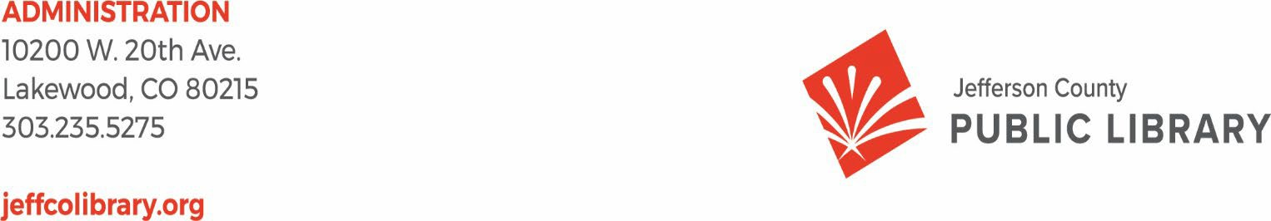

TO: Library Board of Trustees

FROM: Kim Johnson, Chair and Donna Walker, Executive Director DATE: April 17, 2025

RE: Consent Agenda for the April 17, 2025 Board Meeting

1. Approve Minutes of March 20, 2025 Board Meeting
2. Adopt Bylaws for the Jefferson County Public Library Board of Trustees
3. Authorize Kleen-Tech Carpet Cleaning Contract Renewal, 4th Renewal
4. Authorize the Lakewood Reinvestment Authority Intergovernmental Agreement (IGA)

**Minutes of the Regular Meeting of the** JEFFERSON COUNTY PUBLIC LIBRARY **BOARD OF TRUSTEES**

March 20, 2025

CALL TO ORDER – REGULAR MEETING

The regular meeting of the Jefferson County Public Library Board of Trustees was held online via ZOOM and in-person in the Lakewood Library meeting room on March 20, 2025. Library Board of Trustees Chair, Kim Johnson, called the meeting to order at 5:30 p.m.

Other Trustees present: Emelda [Bing] Walker (Vice-Chair), Stanley Harsha (Secretary), Pam Anderson, Renny Fagan, and Charles Jones.

Trustees not present: Jill Fellman.

**Staff present:** Donna Walker, Executive Director; Julianne Rist, Library Planning & Policy Senior Advisor; Steve Chestnut, Director of Facilities and Construction Projects; Bernadette Berger, Chief Technology & Digital Innovation Officer; Matt Griffin, Chief Strategy & Operating Officer; Lisa Smith, Chief People & Culture Officer; Elise Penington, Director of Communications and Engagement**;** Amy Bentz, Assistant Director of Library Design Projects and Planning; Jessica Paulsen, Assistant Director of Public Services for Customer Experience; Amy Bentz, Assistant Director of Library Design Projects & Planning; Padma Polepeddi, Assistant Director of Public Services for Community Outreach; Kelci Rude, Administrative Coordinator Supervisor; Katie O’Loughlin, Administrative Coordinator Supervisor; Ryan Turch, Technology and Innovation Operations Supervisor

There were additional Library staff members attending the meeting.

APPROVAL OF AGENDA

**MOTION:** Emelda Walker moved that the Library Board of Trustees approve the agenda as presented. Seconded by Pam Anderson the motion passed by unanimous vote of all Trustees present.

PUBLIC COMMENT

The Board values public participation. Those who would like to address the Library Board can do so virtually, in-person, or online. The opportunity to address the Library Board does not include a question and answer session or response. Additionally, the Library Board does not respond to anonymous questions or comments. Comments will be acknowledged in the minutes of the meeting.

The Chair advised the Board that no online public comments were received. Jill Hinn pooled time with Katy Conway and Christine Catramados to address the Board, and provided public comment regarding staffing levels, work conditions, sub hours and pay during JCPL location closures, and HR responses to policy concerns. Anna Sparlin and Jasinda Catramados also spoke and provided comments on staffing levels, sub coverage at locations, staff safety, staff pay, and JCPL staff work/life balance.

The Chair closed the public comment portion of the meeting at 5:43 pm.

APPROVAL OF CONSENT AGENDA

The Chair asked the Trustees if any of the items should be removed from the consent agenda. There were no requests for items to be removed.

Items on the Consent Agenda

1. Approve Minutes of February 13, 2025 Study Session
2. Approve Minutes of February 20, 2025 Board Meeting
3. Trustees Adopt Policy Governance: Monitoring Reports 2.0 to 2.4.
4. Serial Subscription Contract - EBSCO Information Services, 1st Renewal
5. Print Materials Contract - Baker & Taylor, 2nd Renewal

**MOTION**: Pam Anderson moved that the Library Board of Trustees approve the items on the consent agenda as presented. Seconded by Charles Jones the motion passed by unanimous vote of all Trustees present.

FOUNDATION UPDATE

Jo Schantz Hall, Foundation Executive Director, provided an update on the Foundation activities. The Friends Annual meeting is on April 11 with Melissa Payne as the presenting author. Library Giving Day is coming up April 1. This has been a successful campaign in previous years and the Foundation hopes it will continue to be this year as well. The Foundation has their new kitchen in suite 1100 fully finished. This was completed by an outside contractor using donated materials from Home Depot. The Foundation Executive Director has been busy attending events and completing outreach activities in the last month. There were several new grants and naming opportunities that came through, there are only three opportunities left for Conifer.

There were no questions from the Board.

Trustee Fagan shared that he and Trustee Fellman have been working to meet so he can learn more about being the Foundation liaison.

EXECUTIVE DIRECTOR REPORT

* 1. Executive Director Report

The Executive Director advised the Board that there are new library card designs and shared samples. Trustees have several engagement opportunities at conferences this year. Early decision about ALA attendance was requested. The signature author event featuring CJ Box is coming up March 29. Seats are available for trustees if they are interested in attending, and there are also several local authors presenting as well. Trustees are invited to attend the BCC meeting on April 8. They will be acknowledging National Library week. JCPL is preparing a message for Library trustees and Foundation Board of Directors interested in advocacy opportunities regarding Executive Orders affecting the Institute for Museum and Library Services.

In response to questions, the Board was advised that trustees should have received a calendar invitation for the BCC meeting.

* 1. Capital Building Projects Update

**South County**: JCPL architect, EUA, is compiling and analyzing the community engagement inputs for a report to the Board in May. The Library is making progress on the plan to bring interim services to this location in early summer.

**NW Jefferson County**: We will be finalizing conceptual design this month. The library manager and creative tech coordinator piloted a creative tech outreach program in the community. Forty- two people came out to see demonstrations of our laser cutter and sublimation printer.

**Arvada**: Schematic Design pricing has come in. We are moving into the next phase which is design development.

**Conifer**: We have received our demo permit and are starting demolition on Monday. Jeffco Building permit review has been completed by Planning and zoning and is under review by Building Safety. We are hoping for the final permit by 3/31.

* 1. Alison J Thayer Naming Agreement

**MOTION**: Charles Jones moved that the Library Board of Trustees approve the Donation and Name Recognition Agreement between Alison J Thayer, the Jefferson County Library Foundation, Inc., and the Jefferson County Public Library. Seconded by Stanley Harsha the motion passed by unanimous vote of all Trustees present.

* 1. Harsha-Kerns Naming Agreement

Trustee Harsha noted that he and the other donors are first time grandparents, and this is in recognition of their first grandchild.

**MOTION**: Pam Anderson moved that the Library Board of Trustees approve the Donation and Name Recognition Agreement between Stanley and Henny Harsha and Candis and Bruce Kerns, the Jefferson County Library Foundation, Inc., and the Jefferson County Public Library. Seconded by Emelda Walker the motion passed, with Trustee Harsha abstaining from voting.

* 1. Facility Master Plan (FMP) Update

Julianne Rist, Library Planning and Policy Senior Advisor addressed the Board. In 2017 JCPL commissioned Group 4 Architecture to prepare a Facilities Master Plan (FMP) to guide planning, decision-making, and capital investment in our facilities over the next two decades. The recommendations contained in that plan were presented to the Board in 2018. The FMP is a flexible, “living” plan designed to be reviewed annually to accommodate changes in need and take advantage of opportunities. The FMP is an integral part of our 2020 – 2025 strategic plan and is an integral component of building the 5-year Capital Improvement Plan and 2026 budget.

The 2018 plan had several key findings and recommendations. The 2022 update performed by Group 4 verified that most of the original findings and recommendations were still valid guideposts for JCPL. We conduct annual reviews of the plan. Our facility master planning is a data- driven process that leverages previous studies with new analysis of the amount, type, and distribution of space needed to provide excellent library service to Jefferson County communities. Some of the data points used to determine those needs are population growth projections, drive time mapping, number of cardholders in a specific area, use data of existing services and potential opportunities to partner with another organization or agency.

2025 Annual Update:

Most items have stayed the same but we are changing recommendations in two places.

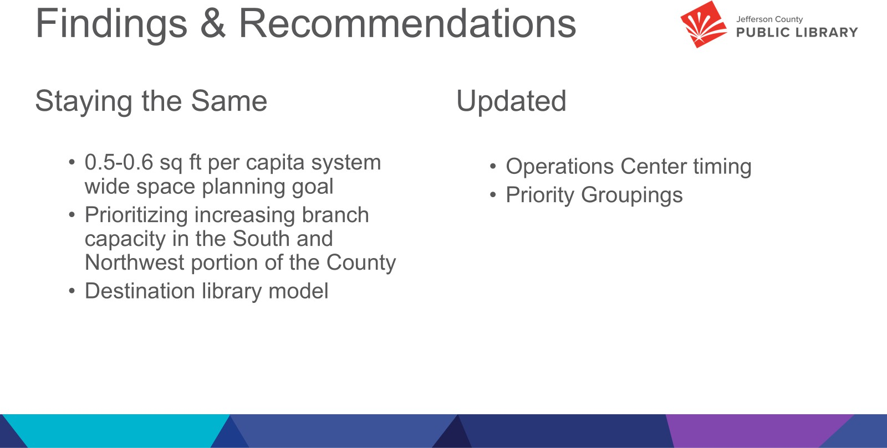

We feel that the system level view of square foot per capital is still a valid measure of if we have enough physical space to provide the services our residents need. When our two new locations are added to JCPL we will move from our current 0.34 sq ft per capita to having 0.46 sq ft per capita. We are planning for future needs with both new locations, as both buildings will be designed so that we will be able to expand the space if needed.

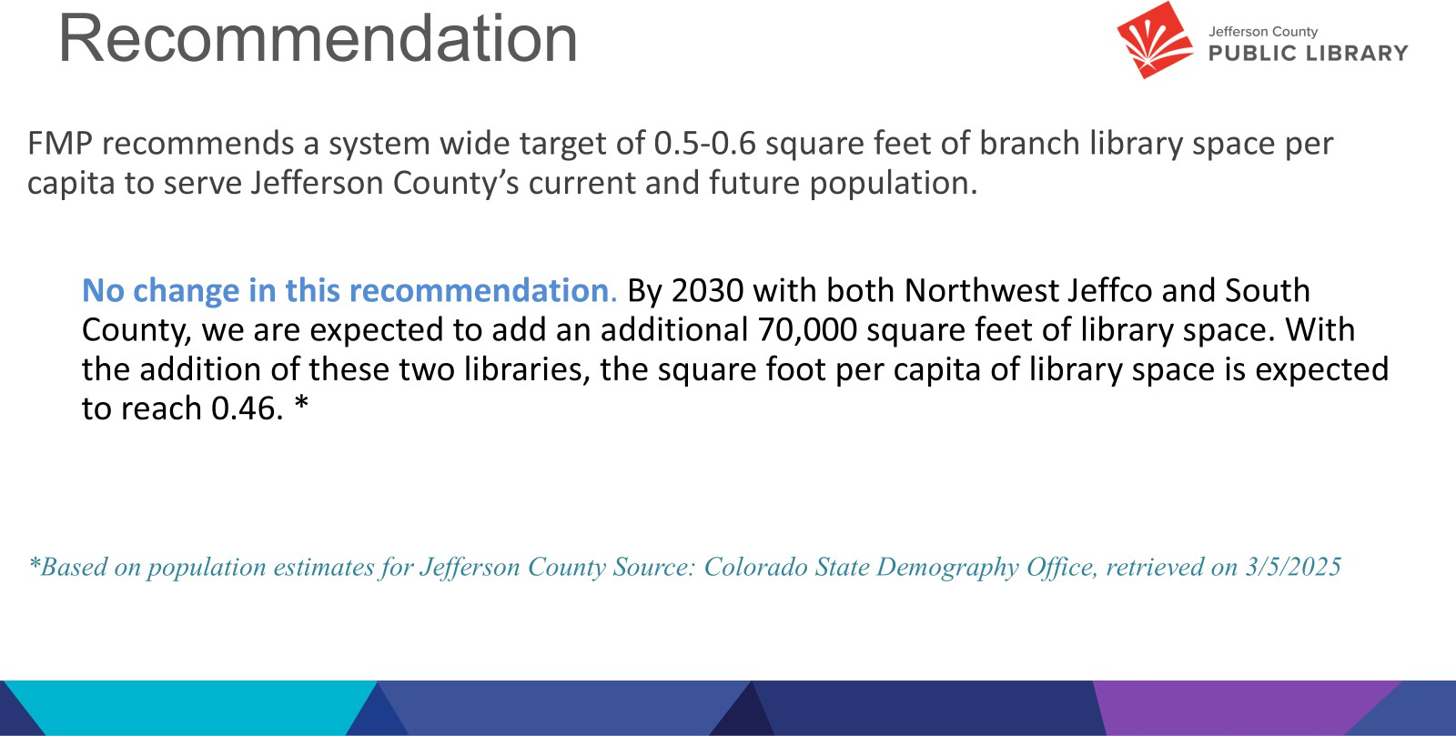

The northern and southern regions of the county are underserved in terms of physical library space. Our commitment to these areas is shown in the two new locations we are currently building. There is no change in this recommendation.

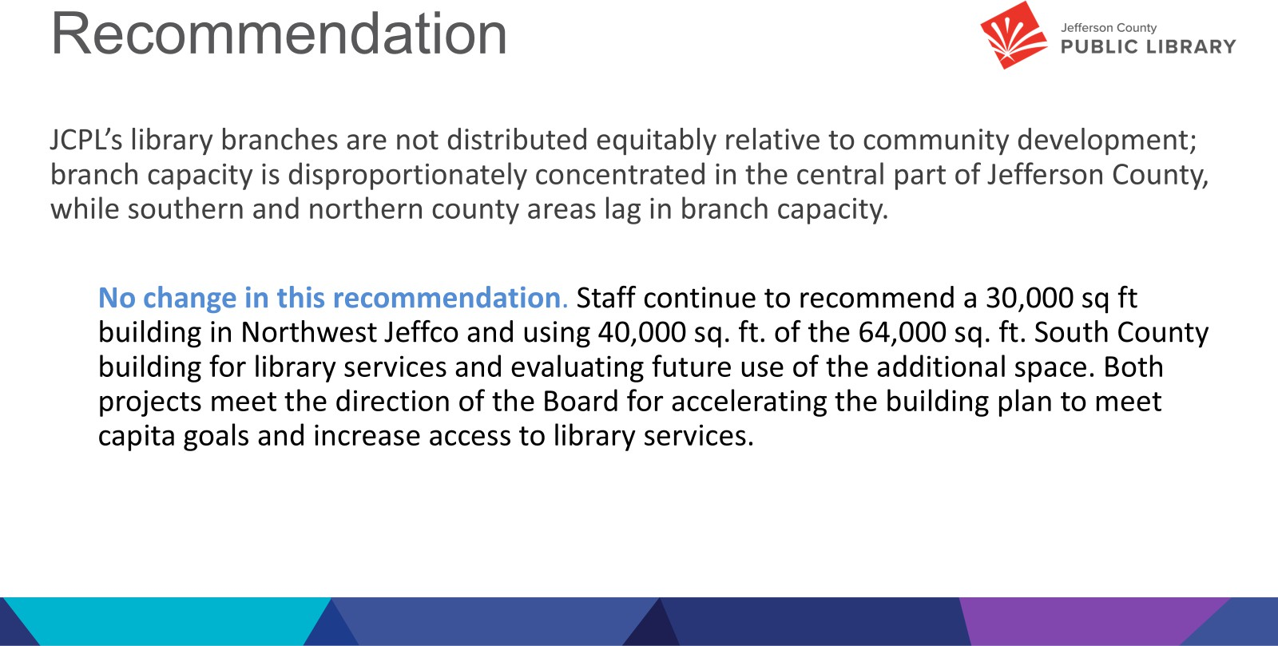

We are continuing our recommendation that an analysis is needed for an operations center, but we are recommending that this analysis should be part of the 2026+ strategic planning process.

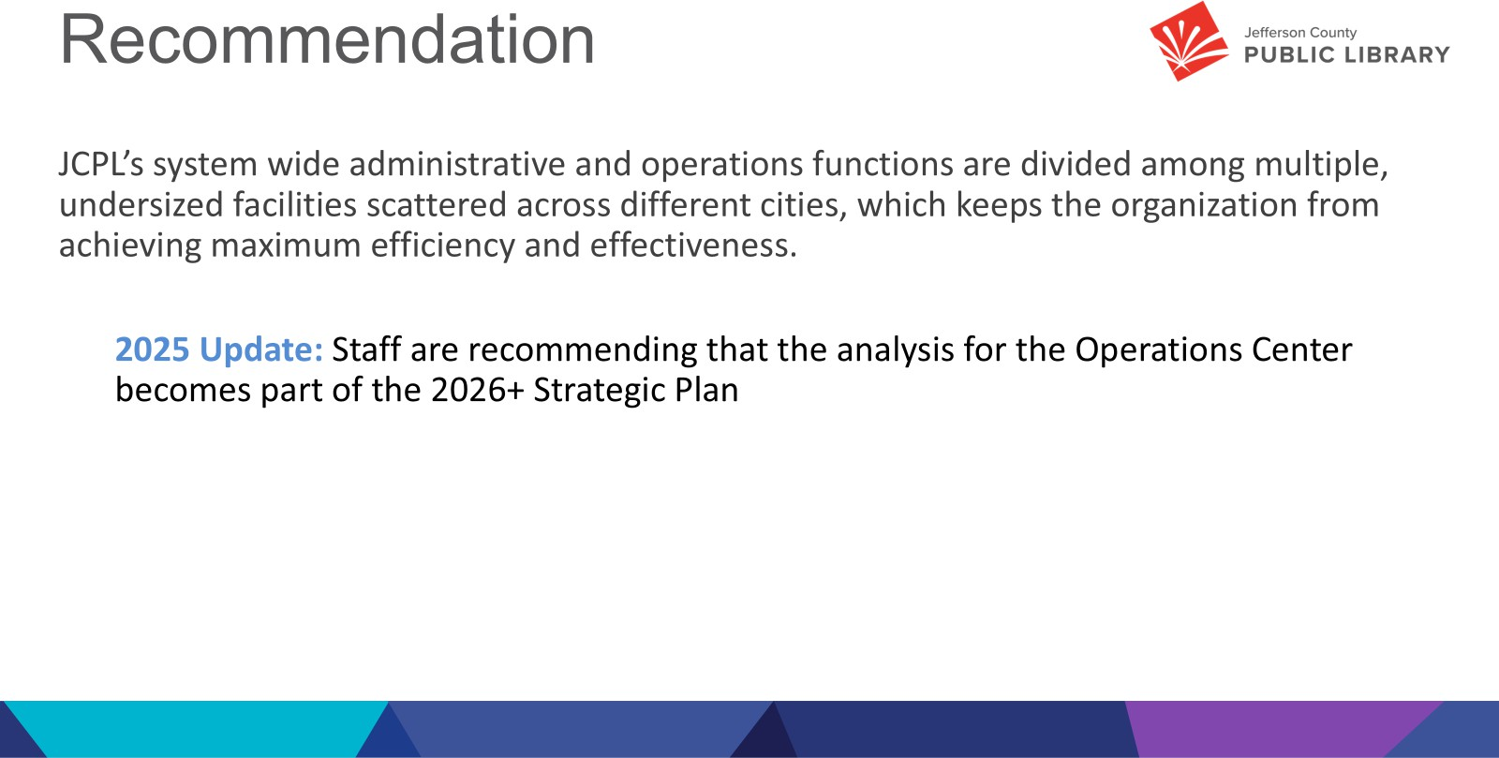

The approach we’ve taken is a combination of adding two new destination libraries in the Northwest and Southern areas of the county; and augmenting underserved areas with offsite services such as hold lockers, material returns, Express Library, van and bookmobile services to ensure equitable access to library services for all Jefferson County residents. Last year we clarified the definition of “destination library” applies to include Northwest Jeffco and South County but does not apply to the redesign or changes to any existing locations. We do not have any changes to this recommendation.

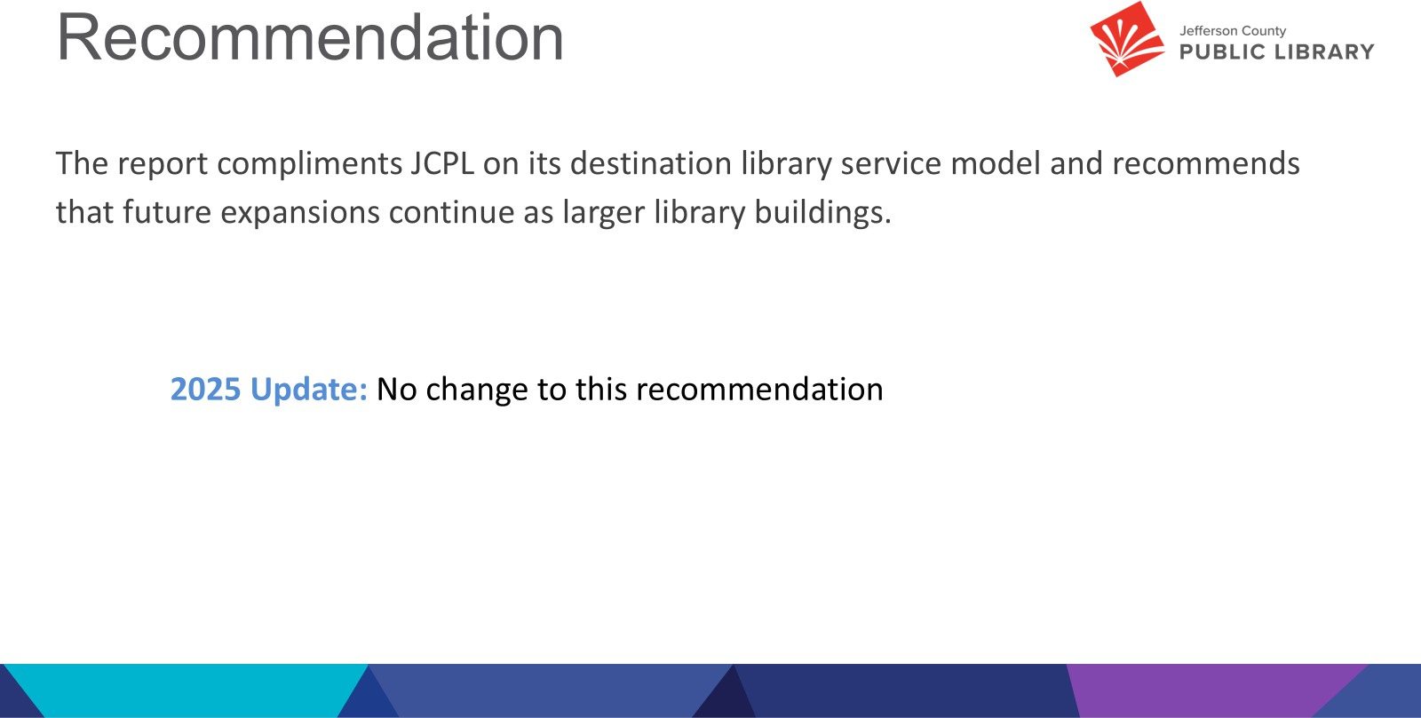

We recommend that JCPL concentrates resources to complete the current capital projects underway to close out Group 1. We recommend removing the Opportunity /Need-Based category and that all remaining locations become part of Group 2.

The City of Golden has redevelopment plans underway for the Clear Creek corridor which could have impacts on this location. The Senior Resource Center, the owner of the Wheat Ridge location, is investigating other uses for their land and buildings. Also, the City of Wheat Ridge has two redevelopment projects underway; the Lutheran Legacy Campus and Improve Wadsworth, which will

have an impact on population growth and the current uses of land. Additionally, Wheat Ridge is expecting to complete a new comprehensive plan this summer (2025) which will include their vision for the city for the next 20 years. The library is in conversation with our community partners and both cities about potential impacts to library services.

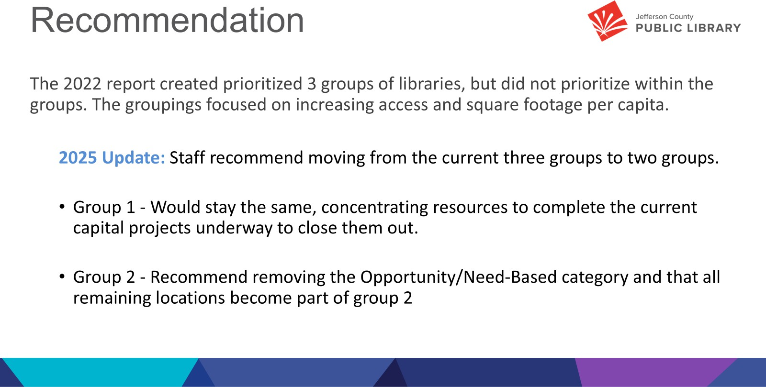

This slide shows the recommended Group 1 locations of Northwest, South County, Conifer, & Arvada. We have removed the South County Express Library from Group 1; as you heard last month we are planning to leverage the newly purchased building on Bradford for interim services.

Group 2 is not in priority order. There are changes in both Golden and Wheat Ridge communities that could affect JCPL plans for these locations. We will continue to assess the value proposition of a new Operations Center and the changes this might have on the Lakewood location. Additionally, we can wait and see the impact of a new location in NW Jeffco before making any plans for changes at Standley Lake.

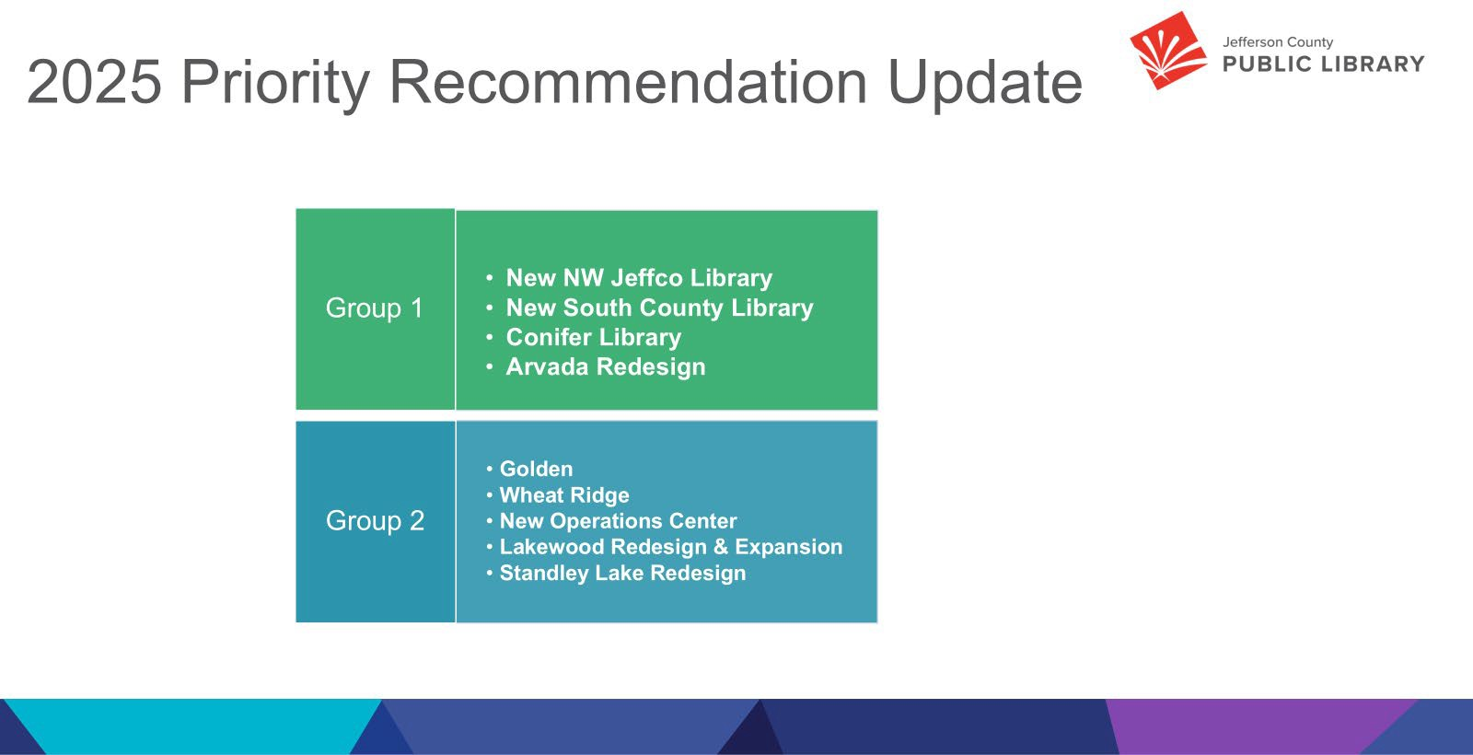

The map shows our existing and future locations. The green circles are our Group 1 projects, the blue circles are Group 2 projects, and the tan circles are completed projects where we do not anticipate any work.

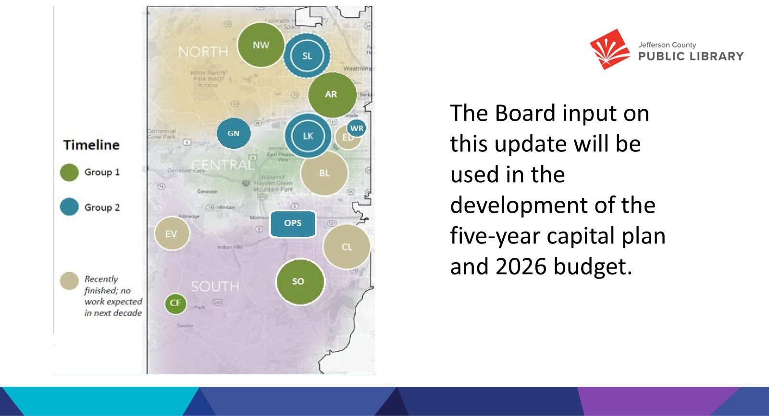

In response to questions, the Board was advised:

* Group 1 projects are priority projects that increase square footage and help us better serve underserved areas.
* Golden/Wheat Ridge were moved out of Needs Based/Opportunities and into Group 2 because there are external factors that will influence what we do with library services in those areas. Those are going to impact us sooner now; they will be priorities for us to figure out what our response will be.
* Both city mayors indicated a desire for us to prioritize those locations in a 5-10 year capital plan. This will be part of the conversation around this FMP so we know what to

put in for our 5 and 10 yr capital planning. This is part of Julianne’s work in her new role as Library Planning and Policy Senior Advisor.

* Libraries may move depending on activities, land use changes, etc. We want to be integrated into the fabric of the community. Wheat Ridge is discussing moving City Hall to Lutheran Legacy campus.
* ‘No Work Expected’ means no capital work anticipated, not that there would not be refreshes or non-capital work completed at these locations.
* Moving projects from Opportunities to Group 2 will show up in the financial mapping the Board will see in May.
* JCPL does consider the Golden Library building to be too small based on community size.

The Board provided the following feedback on the 2025 FMP update:

* We need to be nimble if we are relying on municipalities to be doing things.
* The Ops Center study will take time; it will be nice to have this in the 2026+ strategic plan.
* There has been amazing progress in Group 1; we can see this because we can look at Opportunities more concretely now and have space to move them into Group 2.
  1. 2026+ Strategic Planning

Guest: Greg Bellomo, Government Performance Solutions, Inc

Greg Bellomo addressed the Board and provided an update on progress from the last workshop with the Board. The Board was informed that Donna Walker would provide an update on the Mission and Vision, and then the Board would be asked to provide feedback on the Ends, and work on some animating language.

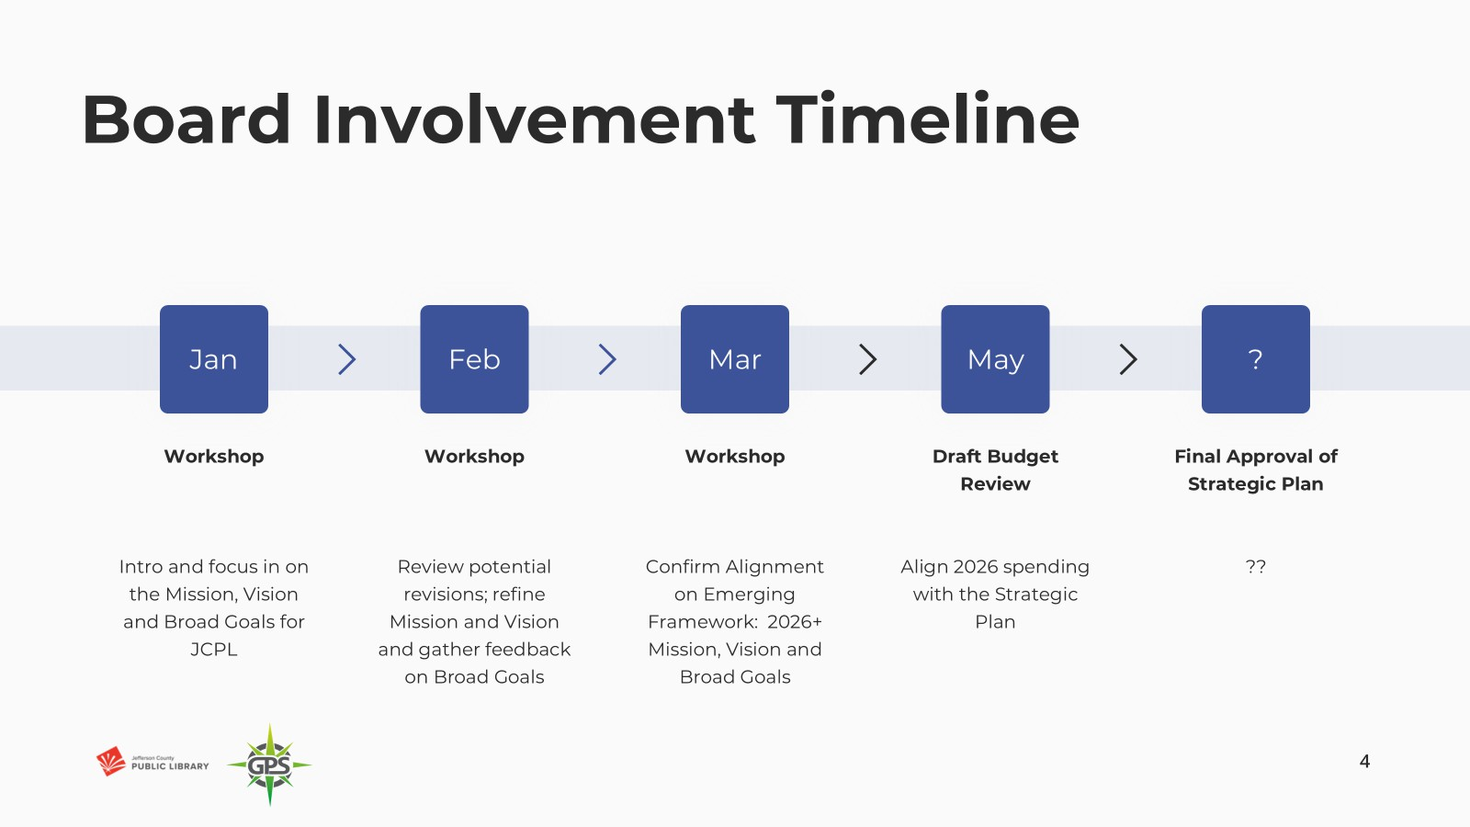

We are synthesizing our framework. The goal is to confirm as much as we can of the strategic framework and get to consensus on the Mission and Vision. The recommendation/goal is to keep the strategy to a single page, and the Board can envision that with the Vision and Mission at the top and then the Ends follow. Objectives and Key results below that, with a lot of initiatives. The Board works at the top: Mission-Vision-Ends. Library leadership and frontline teams figure out the how – those are the initiatives. Board will be adding animating language to Ends.

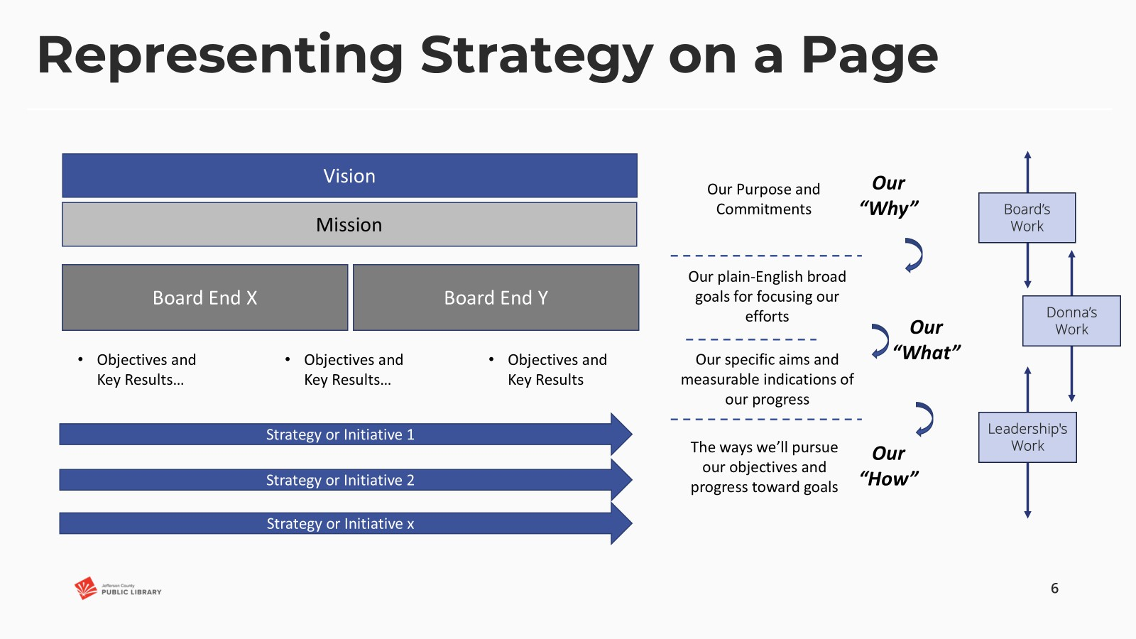

Donna Walker addressed the Board regarding the Mission and Vision work. The foundation for this work was community feedback which indicated that wholesale change in the Mission and Vision was not needed or desired. The community, as represented by the Library Board of Trustees and survey insights, expressed common connection with these concepts specifically related to Mission and Vision:

* + - The library is a place for **connection** and **learning**
    - The library is for **everyone**
    - The library makes the **community better**
    - The library makes **lives better**
    - **Accessibility and equity of access** are essential elements of the public library We are recommending the new Mission statement based on that feedback:

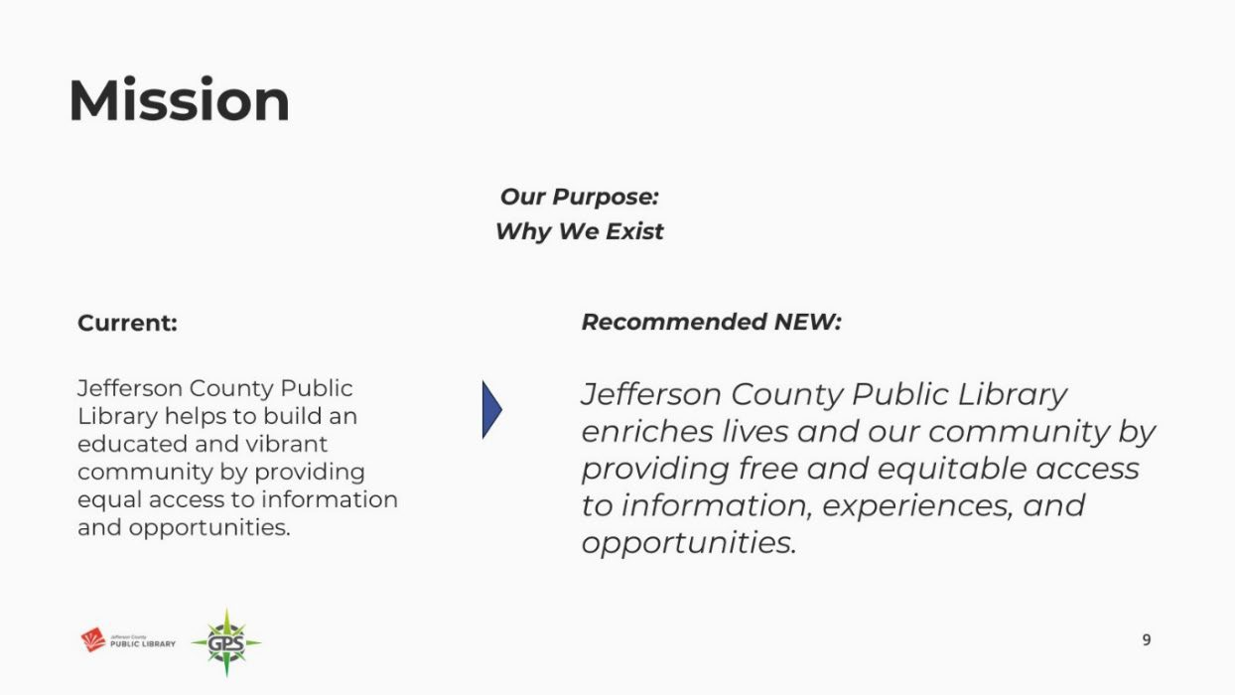

The Board engaged in discussion around the word ‘free’ and provided feedback that it did not sit well for many of them as it seemed not to acknowledge the community investment that taxpayers make in the Library.

In response to the questions the Board was advised that:

* ‘free’ came from the Board’s discussion around unfettered and/or open access, and not necessarily a monetary implication. Some Libraries do charge for programming and camps, and this can be a barrier to access for people. Maintaining free resources at JCPL is what the current JCPL Executive Director is committed to operationally, but a future Board could direct differently. They would most likely update the Mission statement if that was their intent.

The Board provided consensus that they felt more comfortable changing the order of free and equitable so that the new Mission statement reads: *Jefferson County Public Library enriches lives and our community by providing equitable and free access to information, experiences, and opportunities.*

One thing that stood out from the community feedback was the future view and discussion of JCPL as a place. When we look at our old vision, we talk about being an essential destination, in the new proposed Vision, we bring forward that idea of place.

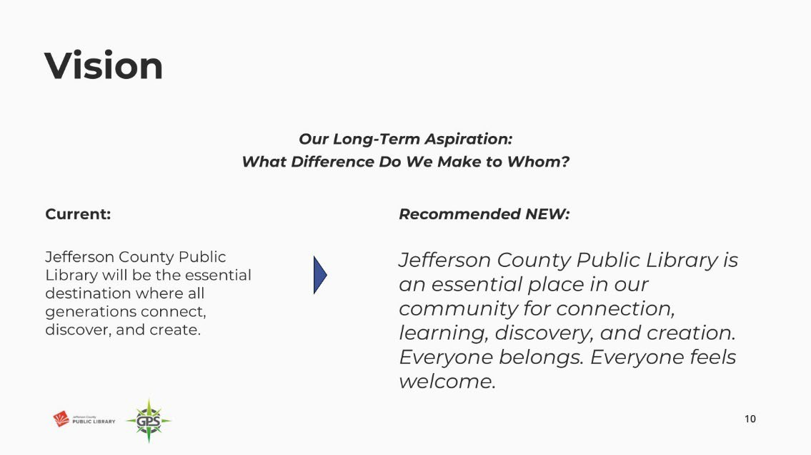

The Board indicated that they had no comments or feedback for improvement. The Board indicated their unanimous consent on the new Vision statement as presented.

Greg Bellomo addressed the Board and introduced the work and topic around the Board Ends. The Board was reminded that the goal was to refine these to as few as possible. We are working with three: Equity of Access, Creating Place, Our People.

The Board was asked to provide edits and suggestions to each so that each End Statement’s animating sentence is powerful and captures the Board’s intentions for the organization.

Equity of Access:

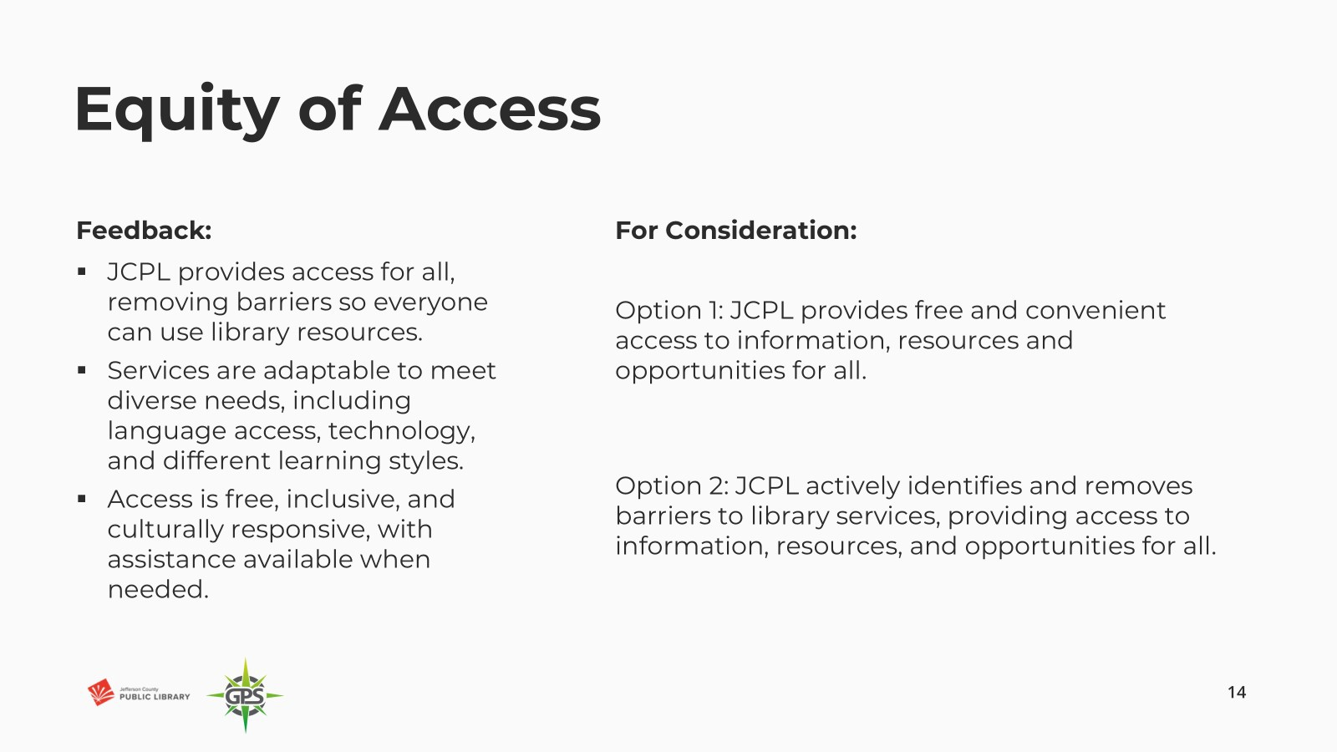

The Board indicated a preference for Option 2, and there was Board discussion around possibly adding ‘free’ before access to Option 2.

Creating Place:

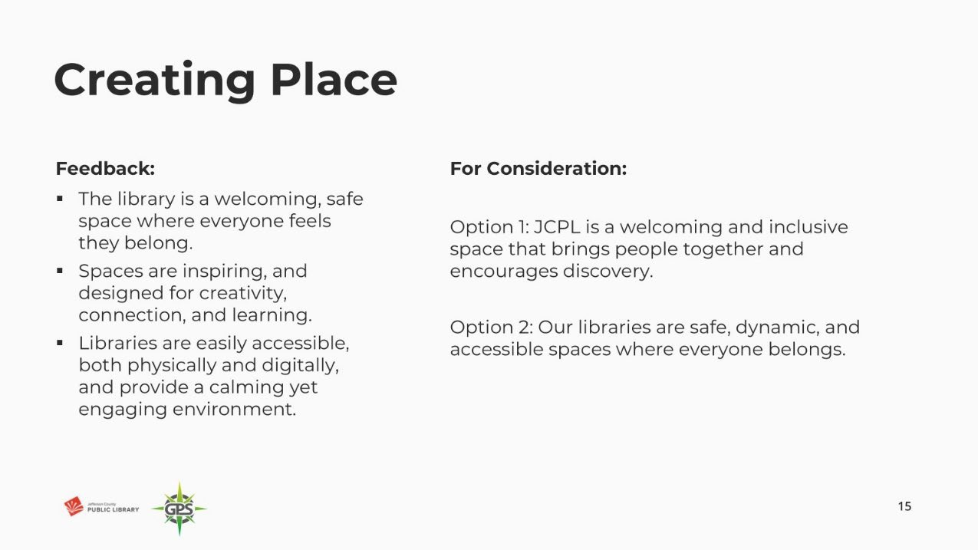

The Board provided mixed feedback on preferences between Option 1 and 2. Comments included:

* Liked ‘discovery’ in 1.
* Like that 2 is action oriented, we are continuously creating space.

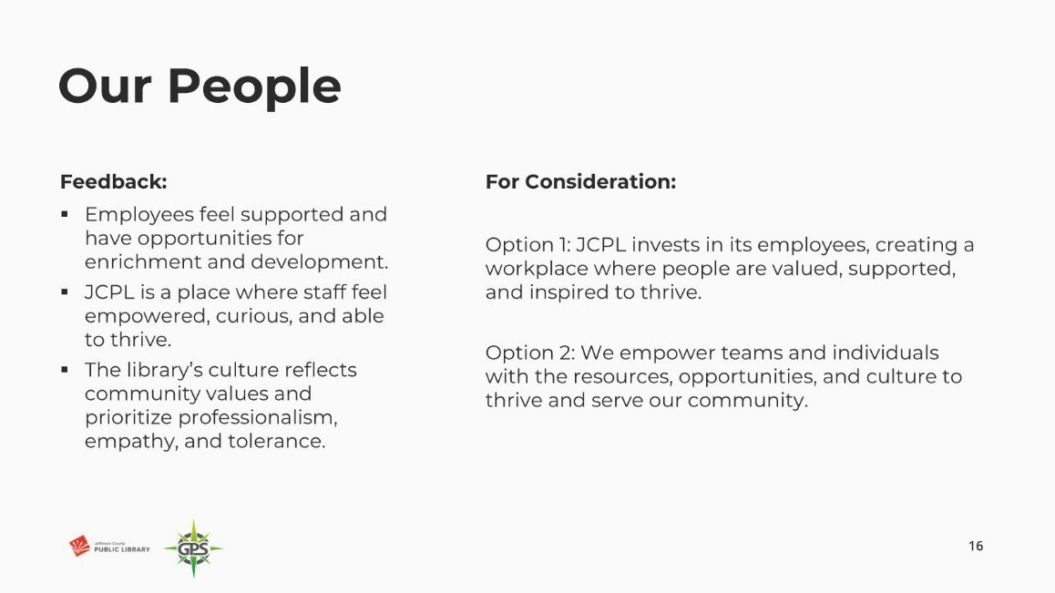Trustees agreed that a new combination of 1 & 2 was the majority consensus and preference. Our People:

The Board indicated a preference for Option 2. There was Board discussion around empower versus invest as language. The Board indicated their consensus on Option 2, with the addition of ‘our’ before ‘teams’.

The Board was advised that the next steps for this work involve bringing the Mission-Vision-and Ends to the April Management Team meeting. Supervisors and managers will engage in this work, and then frontline staff will see these and have a chance to engage.

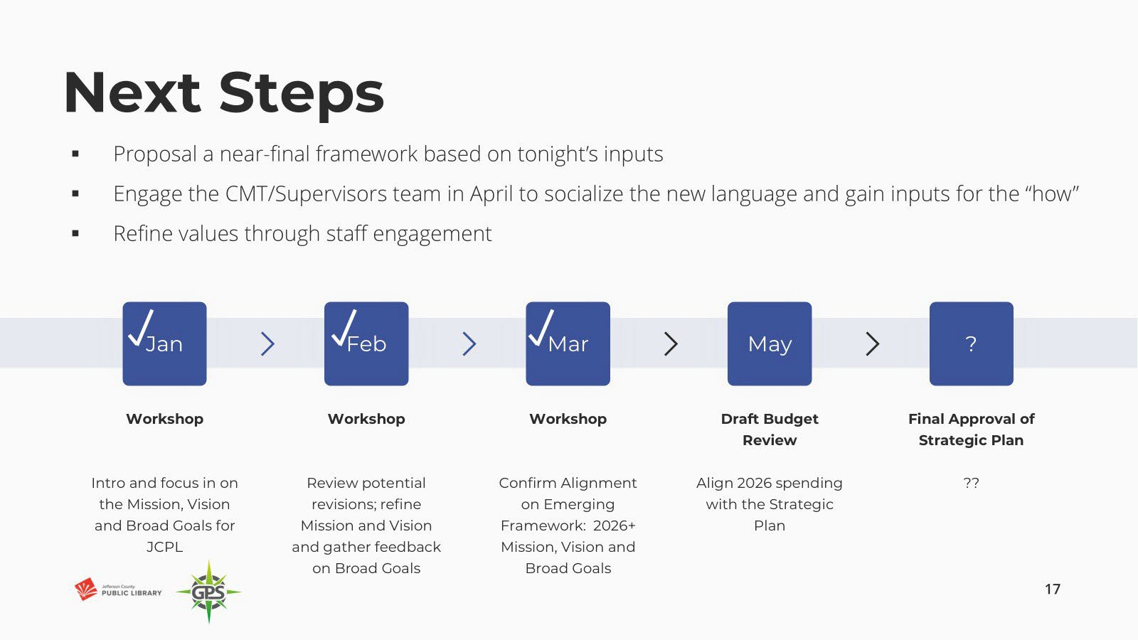

In response to questions, the Board was advised that:

* The Communications and Marketing team is queued up for the storytelling element of how we deliver these to the public. We understand the Board wants the public to see their feedback in action so that we can say “because you said this, we are going to…”.
* Focus groups tend to be expensive and have more feedback value when they are done consistently versus at certain points in time.

OPERATIONAL UPDATES

**Strategy and Operations**

**Finance and Budget**

A. Financial Report (February 2025)

Matt Griffin, Chief Strategy & Operating Officer, addressed the Board and provided information on the February 2025 monthly financials. There were no items of note, we are on track and in line with expectations.

The Board did not have any questions or comments regarding the February financial

statements.

ITEMS REMOVED FROM THE CONSENT AGENDA

No items were removed from the consent agenda.

EMERGING ISSUES

No issues.

ENDS

There were no items.

BOARD GOVERNANCE

A. Nominating Committee report to the Board: Proposed Slate of Officers

The nominating committee presented the following slate of officers for election:

The Chair, Vice-Chair, and Secretary positions are up for election in 2025.

* Chair: Kim Johnson, for the 2-year term April 2025 to March 2027
* Vice-Chair: Emelda (Bing) Walker, for the 1-year term (April 2025 to March 2026).
* Secretary: Stanley Harsha, for the 1-year term (April 2025 to March 2026)

**MOTION**: Pam Anderson moved that the Library Board of Trustees elect Kim Johnson for Chair for a two-year term April 2025 to March 2027; and elect Emelda Walker for Vice-Chair and Stanley Harsha for Secretary for one year terms April 2025 to March 2026. Seconded by Renny Fagan the motion passed by unanimous vote of all Trustees present.

B. Bylaws Committee status update

Bylaws committee member, Emelda Walker, advised the Board that the committee reviewed the Bylaws and there are no recommendations for changes.

BOARD SCHEDULE – NEXT MEETINGS

2025 Board Meeting Schedule

* April 10, 2025 –Study Session Hybrid: Virtual via ZOOM. In-Person Location: Lakewood Library Meeting Room
* April 17, 2025 – Board Meeting – 5:30 pm Hybrid: Virtual via ZOOM. In-Person Location: Lakewood Library Meeting Room
* May 8, 2025 –Study Session Hybrid: Virtual via ZOOM. In-Person Location: Lakewood Library Meeting Room
* May 15, 2025 – Board Meeting – 5:30 pm Hybrid: Virtual via ZOOM. In-Person Location: Lakewood Library Meeting Room

ANNOUNCEMENTS/GENERAL INFORMATION SHARING

There were no announcements.

EXECUTIVE SESSION:

At 7:11 pm, the Chair called for a motion to adjourn the regular meeting, reconvene in Executive Session regarding Collective Bargaining and Urban Renewal Authority and adjourn the regular Board meeting at the conclusion of the Executive Session.

**MOTION**: Pam Anderson moved to adjourn the regular meeting of the Library Board of Trustees, reconvene in Executive Session regarding 1. Collective Bargaining and 2. Urban Renewal Authority AND adjourn the Regular Board meeting at the conclusion of the Executive Session. Statutory citation authorizing an executive session for these topics are:

* Pursuant to 24-6-402(4)(e)(I) for discussion of strategy and instructions to negotiators

Seconded by Emelda Walker the motion passed by unanimous vote of all Trustees present.

The Chair announced a three-minute break to allow the Board and staff to clear the room, leave the existing ZOOM meeting and then join the Executive Session. The break exceeded the three-minute request.

The Chair called the Executive Session to order at 7:17pm with the following Trustees present: Charles Jones, Stanley Harsha, Renny Fagan, and Emelda (Bing) Walker. Also present were Donna Walker, Executive Director; Elise Penington, Director of Communications & Engagement; Julianne Rist, Library Planning and Policy Senior Advisor; Bernadette Berger, Chief Technology & Digital Innovation Officer; Lisa Smith, Chief People & Culture Officer; Matt Griffin, Chief Strategy & Operating Officer; and Katie O’Loughlin, Administrative Coordinator Supervisor.

Guest: Steven Spirn

It is noted that the session was recorded and that the recording will be retained for the required 90 days.

CALL FOR ADJOURNMENT OF EXECUTIVE SESSION at 7:46pm

**MOTION**: At 7:46 pm Emelda Walker moved to adjourn the Executive Session. Seconded by Charles Jones the motion passed by unanimous vote of all Trustees present.

It is noted that the Library Board of Trustees met in Executive Session concerning Collective Bargaining and Urban Renewal Authority pursuant to 24-6-402(4)(e)(I) for discussion of strategy and instructions to negotiators. The Trustees held those discussions, and this summary is provided as

required by Colorado Statute.

Bing Walker, Vice Chair

##### Bylaws for the Jefferson County Public Library Board of Trustees

ARTICLE I: NAME

The name of this organization shall be the Jefferson County Public Library Board of Trustees, (Library Board) and existing by virtue of the provisions of the “Colorado Library Law”, Section 24-90-101 et. Seq. C.R.S., and, established by the action of the Jefferson County Board of County Commissioners (Board of County Commissioners).

ARTICLE II: PURPOSE

The purpose of the Library Board shall be to govern the affairs of the Jefferson County Public Library according to the applicable statutes and laws, and the duties assigned by the Board of County Commissioners to “establish policies, employ an Executive Director, adopt a strategic plan, recommend a budget and dispense funds, and acquire and oversee libraries and library assets.”

ARTICLE III: LIBRARY BOARD

Section 1. Trustees of the Library Board are those who have been duly appointed by the Board of County Commissioners.

Section 2. Ethics. Trustees shall observe these Bylaws, and the Governing Policies of the Library Board, which shall address expectations as to conduct and ethics of the Board.

Section 3. Terms and Reappointments. Length of term and number of terms shall be determined by the Board of County Commissioners.

Section 4. Vacancies. Vacancies shall be filled pursuant to the Colorado Library Law and the policies of the Board of County Commissioners.

Section 5. Removal. A Trustee may be removed only by a majority vote of the Board of County Commissioners and only upon a showing of good cause. Good cause shall include, but not be limited to: Failure to attend, without justification, three consecutive Regular monthly meetings of the Board, or violating the Library Board’s Governing Policies.

ARTICLE IV: OFFICERS

Section 1. Number of Officers. The officers of the Library Board shall be a Chair, Vice Chair, and a Secretary.

ARTICLE V: ELECTION OF OFFICERS

Section 1. Date of Election. The officers shall be elected annually at the regularly scheduled Library Board meeting in March by a majority vote of attending

Trustees. The nominating committee will be appointed at the January Board meeting, and present a slate of officers at the February Board meeting.

Section 2. Term of Office. The Vice Chair and Secretary shall assume their duties upon election and shall serve for terms of one year or until their successors are elected. The Chair shall assume their duties upon election and shall serve for a term of two years or until their successor is elected.

Section 3. Number of Terms of Office. A trustee shall not be eligible to serve more than two consecutive terms in the same officer position, except by an affirmative majority vote of attending Trustees at the meeting at which the election is held.

Section 4. Vacancies. A vacancy occurring in the office of Chair shall be filled for the unexpired term by the Vice Chair. A vacancy occurring in the office of Vice Chair or Secretary shall be filled for the unexpired term by a trustee elected at a Regular meeting, notice of such election having been given five days in advance of the meeting by the highest-ranking officer.

Section 5. Removal of Officer. Any officer may be removed from office for failure to discharge his/her duties by an affirmative majority vote of attending Trustees at a Regular meeting. The Trustees seeking such action shall give written notice to the officer 5 days prior to voting on such issue at a Regular meeting.

ARTICLE VI: DUTIES OF THE OFFICERS

Section 1. Chair. The Chair of the Library Board shall be its chief governing officer. The Chair shall preside at all meetings of the Library Board and shall fulfill

other responsibilities as may be designated from time to time by the Library Board. The Chair shall be the representative of the Library Board to other governmental units on such matters as have been approved and designated by the Library Board; shall submit the annual budget prepared by the Library Board to the Jefferson County Board of County Commissioners; shall submit an annual report to the Jefferson County Board of County Commissioners**.**

Section 2. Vice Chair. In the absence of the Chair, or in event of the Chair’s inability or refusal to act, the Vice-Chair shall perform the duties of the Chair and when so acting, shall have all the powers of the Chair and shall be subject to all the restrictions upon the Chair. The Vice-Chair shall perform any other duties as may be prescribed by the Library Board.

Section 3. Secretary. The Secretary shall record, or cause to be recorded, the minutes of all meetings of the Library Board and shall perform such other duties as may be delegated by the Library Board, such as acting as temporary Chair in the absence of the Chair and Vice chair.

Section 4. General Duties. All officers shall perform the duties as prescribed in these Bylaws, and as may be further enumerated in the Library Board’s Governing Policies.

ARTICLE VII: MEETINGS

Section 1. Regular Meetings. Regular meetings of the Library Board shall be held at least once a month online and/or at a place within Jefferson County. The Library Board establishes its schedule of Regular meetings annually. The Regular meeting schedule, meeting notices and agendas will be posted on the Library’s public website. The date, time and place of any Regular meeting of the Library Board may be set or changed by a majority vote of attending Trustees at a Regular meeting. The Library Board may cancel a Regular meeting if no pressing issues warrant a meeting, or in the event of an unforeseen circumstance.

The Chair shall set the agenda in advance for each Regular meeting of the Library Board, adhering to the adopted Governing Policies. A copy will be sent to each Trustee in advance of the Regular meeting. Minutes from previous meetings and documentation supporting agenda items will be sent to each Trustee as part of the agenda packet.

All meetings, votes, and deliberations of the Library Board shall be open to the public, unless otherwise provided by law. The Library Board may determine to hold additional meetings and study sessions. These meetings will be governed by these Bylaws and the Library Board’s Governing Policies. All proceedings and records, including meeting minutes taken at each Library Board meeting will be recorded and made available to the public unless otherwise provided by law.

Section 2. Special Meetings. The Chair, or any three (3) Trustees, may call a Special meeting of the Library Board at any time with no less than 24 hours notice to all Trustees and with adequate advance notice to allow for the public posting of the meeting notice in compliance with CRS 24-6-402(2)(c) full and timely notice to the public. The date, time and place of any Special meeting of the Library Board may be set or changed by a majority vote of attending Trustees at a Regular meeting. The Library Board may cancel a Special meeting if no pressing issues warrant a meeting, or in the event of an unforeseen circumstance.

Section 3. Quorum, Regular Meeting. Four Trustees shall constitute a quorum for the transaction of business at any Regular meeting. Proxy votes will not be allowed.

Section 4. Quorum, Special Meeting. Four Trustees shall constitute a quorum at any Special meeting. Proxy votes will not be allowed.

Section 5. Votes on Motions. Votes on motions shall be recorded in the minutes as approved or disapproved by voice vote or by roll call when requested by a Trustee. All Trustees, including the Chair, may vote on motions.

Section 6. Public Participation. In addition, there will be an agenda item at each Regular Library Board meeting for the public to address the Library Board. The opportunity to address the Library Board does not include a question and answer session or

response. Additionally, the Library Board does not respond to anonymous questions or comments. For Special meetings, an agenda item for the public to address the Library Board may be included when appropriate or required. Participation/Public Comment at Regular or Special meetings will be governed by relevant statutes, these Bylaws and the Library Board’s Governing Policies.

ARTICLE VIII: BOARD COMMITTEES

The Library Board may establish such committees as deemed necessary to assist in its work. The resolution establishing any such committees shall state the purpose, timeline, composition and authority of each such committee. The adopted Governing Policies will guide the establishment and work of all committees. In the absence of any other method of selection in the resolution, the Chair shall make appointments to any committee.

ARTICLE IX: PARLIAMENTARY AUTHORITY

Robert’s Rules of Order, revised, latest edition may be invoked by majority vote of a quorum present at a Library Board meeting, or by the Chair.

ARTICLE X: EXECUTIVE DIRECTOR AND STAFF

Section 1. Executive Director. The Library Board shall employ an Executive Director to serve as chief executive officer of the Jefferson County Public Library. The Executive Director shall supervise the Library’s day-to-day operations in accordance with these Bylaws and the Library Board’s Governing Policies then in effect. The selection, removal, determination of salary and other terms of employment of the Executive Director shall require the affirmative vote of a majority of the Library Board. The Executive Director shall serve as a non-voting member of the Library Board.

Section 2. Staff. As specified in CRS 24-90-109 (1)(c), and the Personnel Rules of Jefferson County, all other Library employees shall be appointed by the Executive Director, in accordance with approved personnel rules and budgeted staffing plans.

ARTICLE XI: POLICIES AND ADMINISTRATION

Section 1. Governing Policies. The Library Board shall adopt and revise, at any Regular meeting, Governing Policies to set forth additional guidelines and values for the Library Board’s own conduct, and to govern the Executive Director in conducting the operational affairs of the Jefferson County Public Library. These policies shall be available to the public.

ARTICLE XII: FINANCES

Section 1: Budget Approval and Management. The Library Board’s Governing Policies shall direct the Executive Director to prepare an annual budget proposal that is consistent with the guidelines adopted by the Board of County Commissioners, and consistent with the objectives and guidelines adopted by the Library Board. The proposed budget schedule will provide for public input and Library Board review and revision, for the Library Board’s resolution. Library Board approval of the proposed budget is required prior to submittal to the Board of County Commissioners. Library Board adoption is required prior to the beginning of a fiscal year.

ARTICLE XIII: AMENDMENTS

Section 1. The Bylaws shall be reviewed annually by a committee appointed by the Chair. Proposed changes will be presented to the Library Board at a Regular, scheduled meeting.

Section 2. Amendment by Vote. The Bylaws may be amended by an affirmative vote of a majority of the Library Board of Trustees. Amendments to these Bylaws shall be submitted to the Trustees at least 14 days prior to their proposed adoption.

Section 3. Automatic Amendment. The Bylaws shall conform to the prevailing governing statutes. Amendments as a result of changes to a governing statute shall be automatic, and the subsequent changes shall be given to the Trustees, in writing, as soon as possible.



TO: Donna Walker, Executive Director

FROM: Matt Griffin, Chief Strategy and Operating Officer Steve Chestnut, Director of Facilities and Construction

DATE: April 17, 2025

RE: Carpet and Upholstery Cleaning Services, Kleen-Tech Services Corporation, 4th Renewal

**History of Contract: Kleen-Tech Services Corporation – Carpet and Upholstery Cleaning Services**

JCPL is currently under contract with Kleen-Tech Services Corporation to provide carpet and upholstery cleaning services for all JCPL owned properties through May 31, 2025. The Board authorized a one-year contract in 2021, with the option to renew the contract for four additional one-year terms with Board approval. We have been happy with the services provided and would like to renew the contract for an additional year. This will be our fourth and final renewal.

**Budget**:

The base amount for carpet and upholstery cleaning services through Kleen-Tech Services is $124,799.01, and the Library has the ability to request additional services if needed. The annual cost remains unchanged from our previous term. The total cost to the Library will be within the budgeted amount for janitorial services in 2025 of $855,000 which includes standard services.

**Next Actions:**

We request the Board of Trustees authorize the Executive Director to renew the contract with Kleen-Tech Services Corporation for carpet and upholstery cleaning services for one year. This item will be placed on the consent agenda for the April 17, 2025 Library Board meeting unless otherwise instructed by the Board.



TO: Donna Walker, Executive Director

FROM: Matt Griffin, Chief Strategy & Operating Officer DATE: April 17, 2025

RE: Lakewood Reinvestment Authority Intergovernmental Agreement (IGA)

**Purpose:**

To request Board authorization for the Executive Director to execute a Property Tax Increment Revenue Agreement (IGA) with the Lakewood Reinvestment Authority (LRA) for the Bend Urban Renewal Plan, pledging 100% of the Library’s incremental property tax revenue from the area for the 25-year duration of the Plan.

**Background:**

The City of Lakewood and the LRA are advancing The Bend Urban Renewal Plan to support redevelopment of a blighted area into housing. The project will use Tax Increment Financing (TIF) as permitted under Colorado Urban Renewal Law.

The plan includes a 25-year TIF period, during which the incremental increase in property taxes—above the base year amount—will be redirected to the LRA to finance public improvements in the Urban Renewal Area.

Under House Bill 15-1348, local taxing entities like the Library must approve participation in TIF agreements through an intergovernmental agreement.

The proposed agreement allows the LRA to retain 100% of the property tax revenue generated by the Library’s mill levy above the base year amount within the Bend Urban Renewal Area, for a period of 25 years.

The agreement includes standard legal protections and ensures that any future voter-approved mill levy increases will not be subject to the revenue pledge. Only the 4.5 mills currently levied by the Library are included in the agreement.

**Next Action:**

We request the Board of Trustees authorize the Executive Director to execute an IGA with the Lakewood Reinvestment Authority including the 100% pledge of the Library’s incremental property tax revenue from the Bend Urban Renewal Area for a period of 25 years. This item will be placed on the consent agenda for the April 17, 2025 board meeting unless otherwise instructed by the Board.

PROPERTY TAX INCREMENT REVENUE AGREEMENT (JEFFERSON COUNTY PUBLIC LIBRARY)

(The Bend Urban Renewal Plan)

This Property Tax Increment Revenue Agreement (the “Agreement”) is entered into as of DATE (the “Effective Date”) by and between the LAKEWOOD REINVESMENT AUTHORITY, a body corporate and politic of the State of Colorado (the “Authority”), whose address is 480 S. Allison Parkway, and the JEFFERSON COUNTY PUBLIC LIBRARY, a political subdivision of the State of Colorado (the “Library”), whose address is 10200 W. 20th Ave Lakewood, CO 80215. The Authority and the Library are referred to herein individually as a “Party” and collectively as the “Parties.”

RECITALS

The following recitals are incorporated in and made a part of this Agreement. Capitalized terms used herein and not otherwise defined are defined in Section 1 below.

1. Proposed Redevelopment. The Parties have been advised that the real property described in Exhibit A (the “Property”) lying within the corporate limits of the City of Lakewood, Colorado (the “City”) is being studied for designation as an urban renewal area to be redeveloped by one or more developers and/or property owner(s) as a housing development that will eliminate existing blighted conditions which constitute threats to the health, safety and welfare of the community and barriers to development.
2. Urban Renewal and Tax Increment Financing. To accomplish the proposed redevelopment and to provide certain required public improvements, the Authority has recommended inclusion of the Property in a proposed urban renewal plan, entitled the Bend Urban Renewal Plan (the “Plan” or “Urban Renewal Plan”) authorizing and utilizing tax increment financing in accordance with the Colorado Urban Renewal Law, Part I of Article 25 of Title 31, C.R.S. (the “Act”), to pay Eligible Costs of the Improvements. The Library received and reviewed the proposed Plan prepared by Ricker Cunningham dated July 2024 as amended on December 30, 2024 (“Proposed Plan”) that includes the Property. The Parties approved the Proposed Plan in all respects. Provided the final Plan approved by the City Council of the City is the same as the Proposed Plan, the final approved Plan shall be the “Plan” for purposes of this Agreement.
3. Nature of Urban Renewal Project and Purpose of Agreement. The proposed Urban Renewal Project consists of designing, developing, and constructing the Improvements (which includes paying the Eligible Costs of public improvements) necessary to serve the proposed Urban Renewal Area and to comply with §31-25-107(4)(g) of the Act that requires the Plan to afford maximum opportunity, consistent with the sound needs of the municipality as a whole, for the rehabilitation or redevelopment of the Urban Renewal Area by private enterprise. Approval of the Urban Renewal Plan is subject to the Act.
4. Taxing Entity: The Library levies ad valorem property taxes on the properties included within the proposed Urban Renewal Area.
5. Impact Report. The Authority has submitted to the Library a copy of the Impact Report required to be submitted to the County by §31-25-107(3.5) of the Act.
6. Colorado Urban Renewal Law. In accordance with the Act as amended to the date of this Agreement, the Parties desire to enter into this Agreement to facilitate adoption of the Plan and redevelopment of the proposed Urban Renewal Area described therein. The Agreement addresses, among other things, the estimated impacts of the Urban Renewal Plan on Library services associated solely with the Urban Renewal Plan.

AGREEMENT

NOW, THEREFORE, in consideration of the covenants, promises and agreements of each of the Parties hereto, to be kept and performed by each of them, it is agreed by and between the Parties hereto as set forth herein. The recitals above are incorporated into and made part of this agreement.

* 1. DEFINITIONS. As used in this Agreement:
  2. “Act” means the Colorado Urban Renewal Law, Part 1 of Article 25 of Title 31,

C.R.S.

* 1. “Agreement” means this Agreement, as it may be amended or supplemented in

writing. References to sections or exhibits are to this Agreement unless otherwise qualified.

* 1. “Authority” means the Party described in the Preamble to this Agreement, the Colorado Springs Urban Renewal Authority, a body corporate and politic of the State of Colorado.
  2. “Bonds” shall have the same meaning as defined in §31-25-103 of the Act.
  3. “City” shall mean the City of Lakewood, Colorado.
  4. “County” means Jefferson County, Colorado, a political subdivision of the State of Colorado.
  5. “Library Property Tax Increment Revenues” means the portion of Property Tax Increment Revenues generated by the Library’s mill levy received by the Authority from the Jefferson County Treasurer and paid into the Special Fund as specified in Section 3.1.
  6. “Duration” means the twenty-five (25) year period that the tax increment or tax allocation provisions will be in effect as specified in §31-25-107(9)(a) of the Act, the Plan, and the Impact Report. Pursuant to the Act, the base year for calculating Property Tax Increment Revenues is 2024. The last year the assessment roll will be divided for purposes of TIF is 2049 and the last year the Authority is eligible to receive Property Tax Increment Revenues from the Plan area is 2049.
  7. “Eligible Costs” means those costs eligible to be paid or reimbursed from the Property Tax Increment Revenues pursuant to the Act.
  8. “Future Mill Levy” has the meaning set forth in Section 3.2.
  9. “Impact Report” means the impact report dated July 2024 and prepared by Ricker Cunningham analyzing and projecting the burdens and benefits of the Urban Renewal Project on the County, previously submitted to the Library.
  10. “Improvements” means the public improvements and private improvements to be constructed on the Property pursuant to the Plan.
  11. “Party” or “Parties” means the Authority or the Library or both and their lawful

successors and assigns.

* 1. “Plan” means the urban renewal plan defined in Recital B above.
  2. “Project” shall have the same meaning as Urban Renewal Project.
  3. “Property Tax Increment Revenues” means all the incremental property tax revenues derived from ad valorem property tax levies described in §31-25-107(9)(a)(II) of the Act allocated to the Special Fund for the Duration of the Urban Renewal Project.
  4. “Special fund” means the fund described in the Plan and §31-25-107(9)(a)(II) of the Act into which the Property Tax Increment Revenues will be deposited.
  5. “TIF” means the property tax increment portion of the property tax assessment roll described in §3l-25-107(9)(a)(II) of the Act.
  6. “Total Program” means the funding for the School District as determined pursuant to §22-54-104, C.R.S., which represents the financial base of support for public education in the School District.
  7. “Urban Renewal Area” means the area included in the boundaries of the Plan.
  8. “Urban Renewal Plan” means the urban renewal plan defined in Recital B above.
  9. “Urban Renewal Project” means all undertakings and activities, or any combination thereof, required to carry out the Urban Renewal Plan pursuant to the Act.

1. Impact Report. The Parties acknowledge receipt of, and the opportunity to review the Impact Report.
2. RETENTION OF PROPERTY TAX INCREMENT REVENUES. In compliance

with the requirements of the Act, the Parties have negotiated and agreed to the sharing of Library Property Tax Increment Revenues as set forth herein.

* 1. Library Property Tax Increment Revenues. The Library and the Authority agree that the Authority may retain and expend in furtherance of the Urban Renewal Project one hundred percent (100%) of the revenues collected and paid into the Special Fund, as described in

§ 31-25-107(9)(a)(II) of the Act, commencing on the date of approval by the City of the Plan, and lasting until the earlier of: 1) the occurrence of the Duration; or 2) the payment in full of all bonds, loans, advances and indebtedness, if any, incurred by the Authority to pay for the Improvements, including interest thereon and any premiums due in connection therewith in accordance with § 31-25-107(9)(a)(II) of the Act (the “Termination Events”). Upon the earlier of the Termination Events, the entire Library Property Tax Increment Revenues shall be paid by the Jefferson County Treasurer to the County and not to the Authority. The Authority shall annually provide a written report to the Library on progress towards completion of the Improvements. The report shall include information related to any significant changes in project scope or cost, which information will be made readily available to the Library at any time upon request.

* 1. Future Mill Levy Allocation. If the Library’s eligible electors approve a new or increased mill levy for any lawful purpose (“Future Mill Levy”), any revenue derived from the Future Mill Levy shall not be considered part of the Library Property Tax Increment Revenues. Rather, upon approval by the eligible electors of the Library of a Future Mill Levy, the Library shall provide notification of the same to the Authority. From the date of such notice until the Duration has expired, the Authority shall annually deduct from the Property Tax Increment Revenue it receives any revenues attributable to the Future Mill Levy, as applicable, and shall

remit such revenues to the Library.

1. PLEDGE OF PROPERTY TAX INCREMENT REVENUES. The Library

recognizes and agrees that in reliance on this Agreement and in accordance with the provisions of §31-25-109(12) of the Act, the adoption and approval of the Plan includes an irrevocable pledge of all of the Property Tax Increment Revenues, including the Library Property Tax Increment Revenues, to pay the Authority’s Bonds and other financial obligations in connection with the Urban Renewal Project. The Authority has elected to apply the provisions of §11-57- 208, C.R.S., to this Agreement. The Property Tax Increment Revenues, when and as received by the Authority are and shall be subject to the lien of such pledge without any physical delivery, filing, or further act and are and shall be an obligation of the Parties pursuant to §31-25-107(9) of the Act. The Parties agree that the creation, perfection, enforcement and priority of the pledge of the Property Tax Increment Revenues as provided herein shall be governed by §11-57-208,

C.R.S. The lien of such pledge on the Property Tax Increment Revenues shall have priority over any of all other obligations and liabilities of the Parties with respect to the Property Tax Increment Revenues. The lien of such pledge shall be valid, binding and enforceable against all persons having claims of any kind in tort, contract, or otherwise against the Authority, irrespective of whether such persons have notice of such lien.

1. NOTIFICATION OF PROPOSED MODIFICATIONS OF THE PLAN:

AGREEMENT NOT PART OF PLAN. The Authority agrees to notify the Library of any intended modification of the Plan as required by §31-25-107(7) of the Act. This Agreement is not part of the Plan.

1. LIMITATION OF AGREEMENT. This Agreement applies only to the Library Property Tax Increment Revenues, as calculated, produced, collected, and paid to the Authority from the Urban Renewal Area by the Jefferson County Treasurer in accordance with §31-25- 107(9)(a)(II) of the Act and the rules and regulations of the Property Tax Administrator of the State of Colorado, and does not include any other revenues of the City, the Authority, or the Library.
2. MISCELLANEOUS.
   1. Delays. Any delays in or failure of performance by any Party of its obligations under this Agreement shall be excused if such delays or failure are a result of acts of God; fires; floods; earthquake; abnormal weather; strikes; labor disputes; accidents; regulation or order of civil or military authorities; shortages of labor or materials; or other causes, similar or dissimilar, including economic downturns, which are beyond the control of such Party. As soon as any event causing interruption or delay is no longer applicable the Parties shall as soon as practical resume performance of its obligations under this Agreement.
   2. Termination and Subsequent Legislation or Litigation. In the event of termination of the Plan, including its TIF financing component, the Authority may terminate this Agreement by delivering written notice to the Library. The Parties further agree that in the event legislation is adopted or a decision by a court of competent jurisdiction after the Effective Date of this Agreement that invalidates or materially affects any provisions hereof, the Parties will in good faith negotiate an amendment to this Agreement that most fully implements the original intent, purpose, and provisions of this Agreement, but does not impair any otherwise valid contracts in effect at such time.
   3. Entire Agreement. This instrument embodies the entire agreement of the Parties

with respect to the subject matter hereof. There are no promises, terms, conditions, or obligations other than those contained herein; and this Agreement shall supersede all previous communications, representations, or agreements, either verbal or written, between the Parties hereto. No modification to this Agreement shall be valid unless agreed to inwriting by the Parties.

* 1. Binding Effect. This Agreement shall inure to the benefit of and be binding upon the Parties and their successors in interest.
  2. No Third-Party Enforcement. It is expressly understood and agreed that the enforcement of the terms and conditions of this Agreement, and all rights of action relating to such enforcement, shall be strictly reserved to the undersigned Parties and nothing in this agreement shall give or allow any claim or right of action whatsoever by any other person not included in this Agreement. It is the express intention of the undersigned Parties that any person or entity other than the undersigned Parties receiving services or benefits under this Agreement shall be an incidental beneficiary only.
  3. No Waiver of Immunities. Nothing in this Agreement shall be construed as a waiver of the rights and privileges of the Parties pursuant to the Colorado Governmental Immunity Act, §24-10-101, et seq., C.R.S., as the same may be amended from time to time. No portion of this Agreement shall be deemed to have created a duty of care which did not previously exist with respect to any person not a party to this agreement.
  4. Amendment. This Agreement may be amended only by an instrument in writing signed by the Parties.
  5. Parties not Partners. Notwithstanding any language in this Agreement or any other agreement, representation, or warranty to the contrary, the Parties shall not be deemed to be partners or joint venturers, and no Party shall be responsible for any debt or liability of any other Party.
  6. Interpretation. All references herein to Bonds shall be interpreted to include the incurrence of debt by the Authority in any form consistent with the definition of "Bonds" in the Act, including payment of Eligible Costs or any other lawful financing obligation.
  7. Incorporation of Recitals and Exhibits. The provisions of the Recitals and the Exhibits attached to this Agreement are incorporated in and made a part of this Agreement.
  8. No Assignment. No Party may assign any of its rights or obligations under this Agreement.
  9. Section Captions. The captions of the sections are set forth only for the convenience and reference of the Parties and are not intended in any way to define, limit, or describe the scope or intent of this Agreement.
  10. Execution in Counterparts. This Agreement may be executed in several counterparts, each of which shall be deemed an original and all of which shall constitute but one and the same instrument.
  11. Electronic Transactions. The Parties agree that any individual or individuals who are authorized to execute this Agreement on behalf of the Authority or the Library are hereby authorized to execute this Agreement electronically via facsimile or email signature. This agreement by the Parties to use electronic signatures is made pursuant to Article 71.3 of Title 24, C.R.S., also known as the Uniform Electronic Transactions Act. Any electronic signature so

affixed to this Agreement shall carry the full legal force and effect of any original, handwritten signature. The Parties hereto agree that the transactions described herein may be conducted and related documents may be stored by electronic means. Copies, telecopies, facsimiles, electronic files, and other reproductions of original executed documents shall be deemed to be authentic and valid counterparts of such original documents for all purposes, including the filing of any claim, action, or suit in the appropriate court of law.

* 1. Governing Law. This Agreement and the provisions hereof shall be governed by and construed in accordance with the laws of the State of Colorado.
  2. No Presumption. The Parties to this Agreement and their attorneys have had a full opportunity to review and participate in the drafting of the final form of this Agreement. Accordingly, this Agreement shall be construed without regard to any presumption or other rule of construction against the Party causing the Agreement to be drafted.
  3. Notices. Any notice required by this Agreement shall be in writing. All notices, demands, requests and other communications required or permitted hereunder shall be in writing, and shall be (a) personally delivered with a written receipt of delivery; (b) sent by a nationally- recognized overnight delivery service requiring a written acknowledgement of receipt or providing a certification of delivery or attempted delivery; (c) sent by certified or registered mail, return receipt requested; or (d) sent by confirmed facsimile transmission or electronic delivery with an original copy thereof transmitted to the recipient by one of the means described in subsections (a) through (c) no later than 5 business days thereafter. All notices shall be deemed effective when actually delivered as documented in a delivery receipt; provided, however, that if the notice was sent by overnight courier or mail as aforesaid and is affirmatively refused or cannot be delivered during customary business hours by reason of the absence of a signatory to acknowledge receipt, or by reason of a change of address with respect to which the addressor did not have either knowledge or written notice delivered in accordance with this paragraph, then the first attempted delivery shall be deemed to constitute delivery. Each Party shall be entitled to change its address for notices from time to time by delivering to the other Party notice thereof in the manner herein provided for the delivery of notices. All notices shall be sent to the addressee at its address set forth in the Preamble to this Agreement.
  4. Days. If the day for any performance or event provided for herein is a Saturday, a Sunday, a day on which national banks are not open for the regular transactions of business, or a legal holiday pursuant to C.R.S. § 24-11-101(1), such day shall be extended until the next day on which such banks and state offices are open for the transaction of business.
  5. Severability. If any provision of this Agreement is found to be invalid, illegal or unenforceable, the validity and enforceability of the remaining provisions shall not in any way be affected or impaired thereby.
  6. Authority. The persons executing this Agreement on behalf of the Parties covenant and warrant that each is fully authorized to execute this Agreement on behalf of such Party.

[Remainder of page intentionally left blank]

IN WITNESS WHEREOF, the Authority and the School District have caused their duly authorized officials to execute this Agreement effective as of the date herein.

JEFFERSON COUNTY PUBLIC

LIBRARY, a component unit of Jefferson County political subdivision of the State of Colorado

ATTEST:

By:

Signature: By: Title:

LAKEWOOD REINVESTMENT

AUTHORITY, a body corporate and politic of the State of Colorado

ATTEST:

By:

Signature: By: Katie Faltys

Title: LRA Executive Director

Signature: By: Holly Björklund

Title: LRA Treasurer

##### Foundation Update



JEFFfRSO COU TY

LIBRARY OU DATI

* **April 2025**

# JCLF Executive Director Report

**By Jo Schantz Hall, MNM, CFRE, GPC**

# Spring Whale of a Used Book Sale -- May 29 - June 1



The Foundation will host its spring Whale of a Used Book Sale from Thursday evening, May 29, through Sunday, June 1, at the Jeffco Fairgrounds, 15200

W. 6th Avenue in Golden. We already have 30 pallets of books ready to place in all 3 exhibit halls, and the sale promises to be one of our biggest spring sales yet!

On Thursday evening, JCLF will welcome Friends of the Library to the annual Friends-only Preview Night, which offers free admission to current Friends members.

General admission (daily from Friday through Sunday) is $5 per adult over age 18, and children are free.

As is becoming a tradition, JCLF is partnering with the Fairgrounds' nextdoor "neighbor;· Colorado State University Extension (CSUE), on Sunday, the last day of our sale, when CSUE will host an informational open house that will be free to the public. Visitors and Whale Sale shoppers will be welcome to learn more about CSU

Extension and programs such as the Master Gardner program, 4-H, and more!

# JCLF Funding Update

### Requests Pending

* Golden Civic Foundation -- $4,567 for Library Summer Challenge (Golden Library)
* Applewood Community Foundation -- $4,000 for Library Summer Challenge
* Ent Credit Union YES Grant -- $10,000 for 1000 Books Before Kindergarten
* Maverik/Call to Action Foundation -- $5,000 for Library Summer Challenge
* Believe in Reading Foundation -- $4,875 for Babies First Books
* Bank of Colorado -- $2,500 Friends Community Partner
* Colliers International -- $1,000 Friends Community Partner
* Conifer Chamber of Commerce -- $1,000 for Conifer Library's self-service kiosk or computer cart
* City of Lakewood -- $9,000 for Belmar Library Outdoor Adventure Space early learning accessories (Color Splash Panel and Rain Sound Wheel Panel)

### Funds Received

* Dr. Jackie O'Beirne -- $250 sponsorship for Friends Annual Meeting
* Foothills Vision Center -- $250 sponsorship for Friends Annual Meeting
* Taurus Fund -- $250 sponsorship for Friends Annual Meeting

### Requests Denied

* Fred & Jean Allegretti Foundation -- $10,000 for 1000 Books Before Kindergarten
* KeyBank Foundation -- $2,500 Friends Community Partner

 **Da**

We are pleased to announce that this year, more than $2,500 was raised during Library Giving Day (April 1, 2025) and throughout Library Giving Week. In today's turbulent economic times, we are grateful to the special donors who generously supported our Foundation and Jefferson County Public Library during this annual fundraising event.



JEFFfRSO COU TY

LIBRARY OU DATI

* **April 2025 Page2**

**JCLF Executive Director Report**

## COMING JULY 2ND -- BOOKS ON FILM!

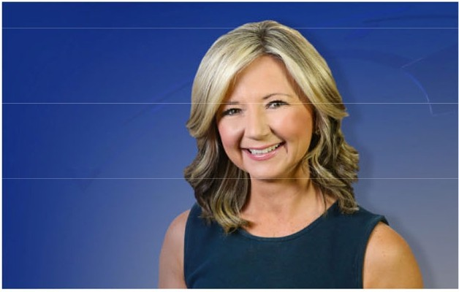JCLF is happy to announce that we will celebrate our 4th annual Books On Film benefit on Wednesday, July 2nd, at Harkins 14 Theatres in Arvada. This year's book-turned-celluloid (based on the 1990 novel Jurassic Park by Michael Crichton and as part of the continuing film series) is Jurassic World Rebirth. The movie stars Scarlett Johansson, Jonathan Bailey, Ed Skrein and Mahershala Ali.

We are delighted that once again, Lisa Hidalgo, chief meteorologist from Denver7, will be our event emcee.

This year, the doors will open at 5:30 pm and the film will begin at 6:10 pm following welcome announcements and introductions of this year's

event sponsors. Tickets are $50 per person and include popcorn and a beverage, entry in the door prize drawing, the private showing for JCLF guests in a reserved theatre and an opportunity to participate in a post-film audience discussion. Corporate sponsorships are also available!

After the movie, and as an added bonus, the nonprofit Friends of Dinosaur Ridge will present a panel of dino experts and paleontologists who will spur an interactive conversation about dinosaurs and and their on-screen portrayals.



## COMMUNITY CONNECTIONS -- MARCH/APRIL

* + March 24 - Meeting and contract discussion with Courtney Dixon, Dream Books
  + March 25 - JCLF Finance Committee meeting
  + March 25 - Lakewood Foothills Rotary Club tour of Jeffco Jail
  + March 26 - Jeffco Library Foundation Board meeting
  + March 27 - Interviews for JCLF Warehouse Assistant
  + March 31 - Webinar, Virginia Hill Foundation grants
  + April 2 - Meeting with Jordan Schultz, Board member, Golden Civic Foundation
  + April 3 - Philanthropic Educational Organization (P.E.O.) meeting
  + April 4 - On-air interview for Denver7's Mile High Living (P.E.O. Books & Brunch)
  + April 4 - Virtual meeting with City of Lakewood Business Development
  + April 8 - Wheat Ridge Business Association breakfast meeting
  + April 8 - Lakewood Foothills Rotary Club meeting
  + April 9 - President-elect meeting, Rotary International
  + April 1o - Applewood Business Association luncheon
  + April 11 - Friends Annual Meeting featuring author Melissa Payne
  + April 11 - On-air interview with Conifer Radio (for support of Conifer Library)
  + April 14 - Teams meeting with Donna Walker
  + April 15 - Lakewood Foothills Rotary Club meeting
  + April 16 - CSU Extension Advisory Board meeting

##### Operational Updates Executive Director Report



**APRIL 2025** EXECUTIVE DIRECTOR REPORT

##### 2025 Annual Plan Progress in April

###### Portfolio: Service Point Development & Expansion

**Program: New Construction Project: South County Library**

* + Finalize Improvements Agreement
  + Contract with architect for design services
  + Continue Community Engagement Report development
  + Continue Program of Service development

**Project: Northwest Jeffco Library**

* + Begin schematic design
  + Interview for General Contractor

**Program: Building Redesign Project: Arvada Library**

* + Continue design development
  + Finalize site search for alternative services location

**Program: Tenant Finish Project: Conifer Library**

* + Obtain Building Safety permit
  + Continue demolition
  + Finalize donor recognition plan
  + Progress on dissolution of IGA

###### Portfolio: Embracing Innovation & Change

**Program: Fundraising Development**

* + Finalize agreement with consultant for Long Term Fundraising Project
  + Kick-off Long Term Fundraising project

###### Portfolio: Continuous Process Improvement

**Project: Collective Bargaining Agreement**

* + Continue negotiation sessions



**Project: 2026+ Strategic Plan**

* + Finalize new Board Ends
  + Gather inputs on tactics from JCPL Combined Management Team and Supervisors
  + Continue creation of strategic framework

##### A black background with blue text AI-generated content may be incorrect. Service Highlights:

The Indie Author Project (IAP) launched on April 1st. More than a writing competition, [IAP contests](https://jeffcolibrary.org/resource/indie-author-project) are an opportunity to help local authors build readership within their communities and establish meaningful partnerships within libraries and beyond. In 2023, Jefferson County Public Library patron [Tasha Christensen won the Colorado](https://jeffcolibrary.org/news/meet-tasha-christensen-winner-of-the-2023-indie-author-project/) [Indie Author Project Contest](https://jeffcolibrary.org/news/meet-tasha-christensen-winner-of-the-2023-indie-author-project/)! This year, the awards will honor the best indie-published ebooks in eight genres**.**

[**Shakespeare in the Parking Lot**](https://jeffcolibrary.bibliocommons.com/v2/events?_gl=1%2Anpspsv%2A_ga%2AODQzMzI3ODAuMTczMjIzMTM2MQ..%2A_ga_G99DMMNG39%2AMTc0NDIyNTk1NS4xMjQuMS4xNzQ0MjI2OTQ1LjAuMC4w%2A_ga_TLER9C9ELE%2AMTc0NDIyNTk1Ni4xMjQuMS4xNzQ0MjI2OTY0LjAuMC4w&q=Shakespeare%20in%20the%20parking%20lot)at Standley Lake and Columbine Libraries. The Denver Center for the Performing Arts brings Shakespeare to you in fun outdoor adaptations. Feel free to bring a camping chair and enjoy watching a talented cast bring the play to life right in front of you.

**2025 Conferences: ADVOCACY AND ENGAGEMENT OPPORTUNITY FOR**

##### Trustees

**American Library Association 2025 Annual Conference**

June 26-30, Philadelphia, Pennsylvania. Registration opens April 19. Let Katie O’Loughlin know by May 26 if you’d like to attend.

**CALCON 2025 Colorado Association of Libraries Annual Conference**

September 3-5, at Beaver Run Breckenridge, CO. Let Katie O’Loughlin know by August 4 if you’d like to attend.



**Urban Libraries Council Annual Leadership Forum**

October 22-24, Cincinnati, Ohio. Let Katie O’Loughlin know by September 22 if you’d like to attend.

##### JCPL Professional Engagement:

**Lizzie Gall,** Assistant Director of Libraries & Inclusion for Resources and Programs, has been appointed to the 2026 Andrew Carnegie Medal of Excellence committee.

6 Libraries & Inclusion staff members are attending the Colorado Teen Lit Conference.

**Jenna Markl**, ILL Acquisition Associate, and **Ryan Case**, ILL Acquisition Associate Lead, are attending the Colorado Resource Sharing conference.

**Brady Niemitalo Woods**, Patron Training Specialist is attending the American Educational Resource Association annual meeting.

#### HIGHLIGHTS OF EXECUTIVE DIRECTOR COMMUNITY ACTIVITIES,

###### APRIL 2025

* Attend **BCC Hearing for National Library Week** Proclamation
* Attend **CAL Legislative Committee** meeting
* Meet with **Jeffco Public Schools**
* Meet with **Trustee Fagan** re: Library Foundation Representative role
* Attend **Jeffco Connections Board** meeting
* Attend **Library Foundation Friends Annual Meeting**
* Meet with Joe Kerby, **Jefferson County Manager**
* Attend **Urban Libraries Council** Director/CEO meeting
* Meet with Jo Schantz, executive director, **Jefferson County Library Foundation**
* Attend **Good News Breakfast**
* Attend Annual Meeting of **Library Foundation and JCPL**



**w** • ..

JEFFERSON COUNTY PUBLIC LIBRARY DONATION AND NAME RECOGNITION AGREEMENT

This Donation and Name Recognition Agreement (''Agreement"), dated for reference purposes only March 3, 2025 , is between Core Cooperative (the "Donor"), the **Jefferson County Library Foundation, Inc.,** a Colorado non-profit corporation (the "Library Foundationj;), and the **Jefferson County Public Library** (the "Library"). The Donor, Library Foundation, and Library are collectively referred to herein as the "parties", and hereby agree as follows:

RECITALS

1. The Donor desires to make a donation in the amount of$ 3,000 (the "Donation") in support of the Technology Access area at Conifer Libraiy (the "Project''); and
2. The Library Foundation and the Library are proud to recognize the Donation by providing name recognition rights to the Donor at the Project, as more fully set forth herein.

AGREEMENT

NOW, THEREFORE, the parties hereto agree as follows:

1. The Donor pledges to make a Donation to the Library Foundation of$ -=--'3,=0-=--00.... ,

payable in one lump sum on or before April 15, 2025 , to aid funding of the Project.

1. Donation payments are to be payable to the Jefferson County Library Foundation, Inc., and mailed or hand delivered to the following address:

Jefferson County Libra1y Foundation, Inc. 10790 W 50th Ave., Suite 200

Wheat Ridge CO 80033.

1. The Donor, Libra1y Foundation, and Libra.i.y agree that the Donation will be used for the Project, and as an expression of appreciation the name Core Cooperative ("Donor Name") shall be displayed at the Project site.
2. The Donation may be invested, commingled, or merged with and become part of the general endowment funds and investment assets of the Library Foundation. Guidelines established by the Library Foundation Board of Trustees from time to time determine the investment, allocation ofretum on investment, and distribution of endowment funds and the allocation of income, loss, fees and expenses associated with endowment funds and securing and administering endowment funds. The Donation and all accounting of the Donation will be subject to these guidelines.

TM14-2489

1. This Agreement is governed by Jefferson County Library's Guidelines for Naming and Name Recognition, which are incorporated herein. By entering into this Agreement, the Donor agrees to all of the terms and conditions contained therein, including the following:
   1. Signage. The sign recognizing the donation will be placed in an appropriate location, and its design shall be consistent with the Library's image and building design requirements. The wording of the sign shall be mutually agreed upon by the Donor and the Executive Director of the Library.
   2. Duration. These name recognition rights will last through April 15, 2030 Donor shall have a right of renewal at the end of the naming period to extend the naming rights for an additional donation and an additional period to be mutually determined by the parties.
   3. Approvals.
      1. All naming acknowledgements will be approved by the Library Board of Trustees.
      2. A re-approval process with input by the Donor shall be necessary in the following situations:
         1. Major renovation of the space;
         2. Sale, destruction, removal or abandomnent of the facility; or
         3. A change in the name, business focus or viability of the Donor entity.
   4. Standards of Conduct. Should the Donor violate acceptable standards of integrity and civic leadership, the Library, in its sole discretion, may elect to remove the Donor's name from the Library.
2. No items recognizing the Donation will be ordered until the full amount of the Donation has been received by the Library Foundation.
3. The Donation shall be nonrefundable unless the Library Board of Trustees does not approve the acknowledgement or the Library or Library Foundation are unable to fulfill their obligations due to some unforeseen circumstances.
4. If, in the opinion of the Library Board of Trustees or the Executive Director of the Library, all or part of the Donation caimot, in the future, be applied usefully to the purposes provided in this Agreement, it may be used for any related purpose which, in the opinion of the Executive Director of the Library will most nearly accomplish the wishes of the Donor as expressed herein.
5. No donations will be refunded for any reason unless the Library or Library Foundation is unable to fulfill its obligations due to unforeseen circumstances.

"" ' ....

1. Miscellaneous Provisions.
   1. Tax Consequences. Donor, and not the Library Foundation nor the Library, is solely responsible for detennining the tax consequences to Donor of the within transaction including, without limitation, any monetary value assigned to the naming right.
   2. Venue and Governing Law. Venue for any and all legal actions regarding this Agreement shall lie in the District Court in and for the County of Jefferson, State of Colorado, and this transaction shall be governed by the Jaws of the State of Colorado.
   3. Invalid Provisions. If any provision of this Agreement is held to be illegal, invalid or unenforceable under present or future Jaws, such provisions shall be fully severable; this Agreement shall be construed and enforced as if such illegal, invalid or unenforceable provision had never comprised a part of this Agreement; and the remaining provisions of this Agreement shall remain in full force and effect and shall not be affected by the illegal, invalid or unenforceable provision or by its severance from this Agreement. Furthennore, in lieu of such illegal, invalid or unenforceable provision, there shall be added automatically as a part of this Agreement a legal, valid, and enforceable provision as similar in tenns to such ilJegal, invalid or unenforceable provision as may be possible.
   4. Amendments to Ag:reement. This written Agreement constitutes the entire Agreement of the parties. No representations, promises, tenns, conditions or obligations regarding the subject matter of this Agreement, other than those expressly set forth herein, shall be of any force and effect. No modification, change or alteration of this Agreement shall be of any force or effect, unless in writing, signed by both parties.
   5. Fmiher Acts. The parties agree to perfonn or cause to be perfonned such further acts as may be reasonably necessary to consummate the transaction contemplated hereby.
   6. Counterparts. This Agreement may be executed in two or more counterparts, each of which shall be deemed to be an original, and all of which counterparts together shall constitute but one and the same instrument.
   7. No Presumption Regarding Drafter. The parties ac!mowledge that they have each been advised by counsel in the drafting of this Agreement, and accordingly hereby agree neither party shall be deemed to be the drafter of this Agreement, and therefore no presumption for or against the drafter shall be applicable in interpreting or enforcing this Agreement.

*[SIGNATURES FOLLOW ON NEXT PAGE]*

**IN WITNESS WHEREOF,** the patties have executed this agreement this day of

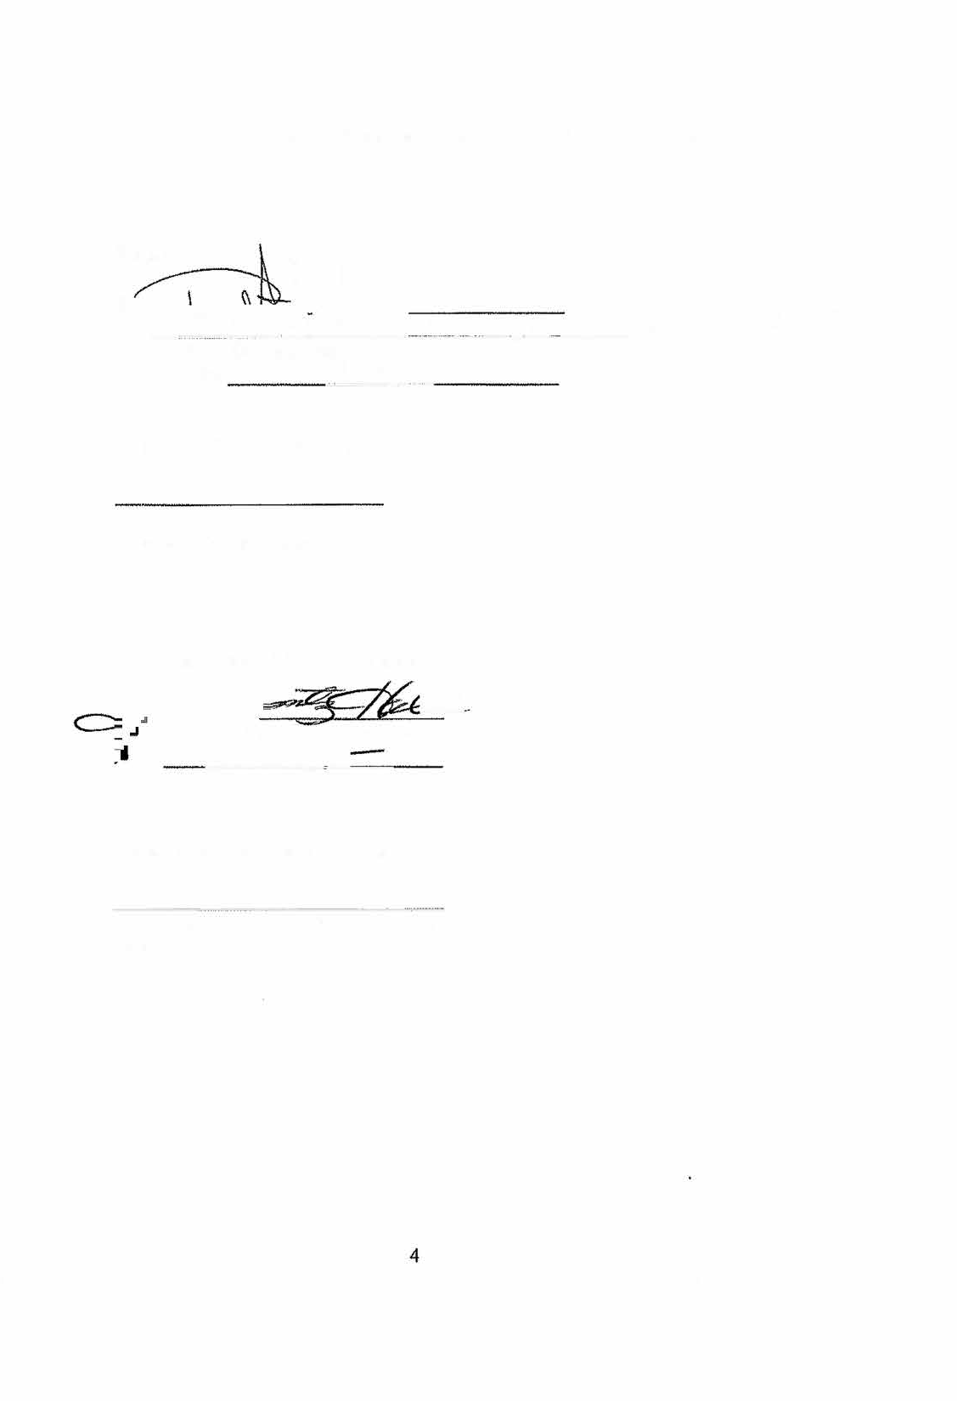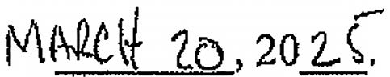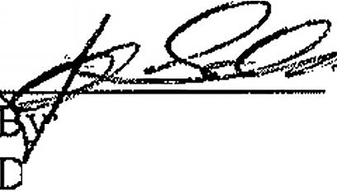

**Donor: �** f\ �

-� *y_)* '--

3\ '2.o_ '2-'s

By:

-"2=:>2�:;-::e;t:-� OS\?;,& - 0 • D,a..&cm(- 60S1'v\t.�1 p..ev1tt\;f,oMl"\ '*{!;)(I-&*

(2t?

(Print Donor's Name) ,,.-

Date: J

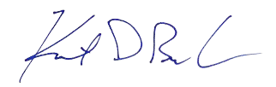APPROVED AS TO FORM:

Assistant Deputy County Attorney

Jefferson County Library Foundation

. 2e:

. Jo Schantz Hall, Executive Director ate: ***3,b-a*** S -

***/:J***

Jefferson County Public Library

By: Donna Walker, Executive Director Date:

TM14-2489 **Revised 1/2025**

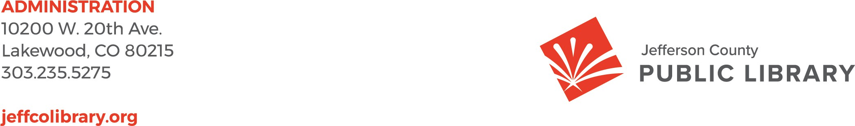

TO: Library Board of Trustees

FROM: Donna Walker, Executive Director DATE: April 17, 2025

RE: 2026+ Strategic Planning – Board Ends

**Purpose**

To come to Board of Trustees consensus on final animating language for the Board Ends.

**Overview**

Extensive community and Board inputs were gathered to guide JCPL in the development of new mission, vision and ends for our 2026+ strategic plan. These listening opportunities brought forward common themes and ideas about the purpose of the library, our long-term aspiration, and broad organizational goals.

At the March meeting, Trustees reached consensus on new mission and vision statements for our 2026+ strategic plan and affirmed the focus on three key areas for Ends: Equity of Access, Creating Place, and Our People. Trustees also offered valuable input on the draft animating statements for these Ends.

Based on this feedback, JCPL has refined the language to reflect a unified and compelling message connecting the Ends to the new mission and vision statements.

**2026+ Strategic Plan New Mission Statement:**

*Jefferson County Public Library enriches lives and our community by providing equitable and free access to information, experiences, and opportunities.*

**2026+ Strategic Plan New Vision Statement:**

*Jefferson County Public Library is an essential place in our community for connection, learning, discovery, and creation. Everyone belongs. Everyone feels welcome.*

**Board Ends for 2026 and Beyond**

As previously discussed, JCPL recommends refining the Board Ends to:

* Equity of Access
* Creating Place
* Our People

These Ends represent our core organizational priorities and reflect both Board direction and community input.



**Next Steps: April Board Meeting**

At the April meeting, we will review the final draft animating language and seek consensus from the Board. These statements will serve as the foundation for JCPL’s strategic direction and public messaging for the 2026+ strategic plan.

**Recommended Animating Statements**

The following draft language reflects Board input and JCPL’s recommendations:

* **Equity of Access**

JCPL actively identifies and removes barriers to library services, providing convenient and free access to information and resources for all.

* **Creating Place**

Our libraries are safe and accessible spaces that bring people together, encourage discovery, and where everyone belongs.

* **Our People**

We empower our team members with the resources, opportunities, and culture to thrive and serve our community.

##### Operational Updates Strategy & Operations



TO: Donna Walker, Executive Director

FROM: Matt Griffin, Chief Strategy and Operating Officer

Amy Bentz, Assistant Director of Library Design and Planning DATE: April 17, 2025

RE: South County Library Architectural Design Services - Eppstein Uhen Architects, Inc. (EUA)

**Purpose:**

To seek Board authorization for the Executive Director to issue a Notice to Proceed to Eppstein Uhen Architects, Inc. (EUA) for architectural design services for the South County Library project.

**History of Contract:**

The Board of Trustees authorized JCPL to enter a contract with Eppstein Uhen Architects, Inc. (EUA) for the design of the South County Library in September 2021.

JCPL wishes to engage EUA for architectural design services for the South County Library project. EUA has evaluated the project scope and provided a cost estimate and schedule.

**Total Cost:**

The proposed cost for the architectural design services is $1,644,205.00. This fee aligns with our budget expectations.

**Next Actions:**

JCPL requests that the Board of Trustees authorize the Executive Director to issue a Notice to Proceed for the base architectural design services for the South County Library project at a cost of $1,502,605.00 and alternates that may be issued at a later phase at a cost of $141,600.00.



TO: Donna Walker, Executive Director

FROM: Matt Griffin, Chief Strategy & Operating Officer DATE: April 17, 2025

RE: Finance Monthly Report

**Budget to Actual Tables – March 2025**

Please see the enclosed Budget to Actual Tables for March 2025.

In March 2025, $4,943,112 of Real Property Tax revenue was recorded. Year-to-date, 40.5% of the budgeted collection has been received.

JCPL is on track with its budget, and there are no areas of concern. Our financial performance remains steady, and in line with expectations.

The Library Foundation provided funding of $13,980 to JCPL. The Library contributed $7,781 in- kind support in March. Year-to-date, the library has received $41,028 in funding and provided

$22,909 in-kind support to the Foundation, with a ratio of 1.79.

**TABLE 1**

**JEFFERSON COUNTY PUBLIC LIBRARY REVENUE AND EXPENDITURE SUMMARY BUDGET TO ACTUAL**

|  |  |  |  |  |
| --- | --- | --- | --- | --- |
| **Revenue and Expenditure** | **2025 Budget** | **YTD Actual**  **03/31/2025** | **$ Variance**  **2025 Budget** | **% Variance**  **2025 Budget** |
| **Revenues** |  |  |  |  |
| Property Taxes (net adjustments) | 59,744,973 | 25,349,033 | 34,395,940 | 42% |
| Grants, Funds & Donations | 560,427 | 41,029 | 519,398 | 7% |
| Investment Income | 2,009,000 | 818 | 2,008,182 | 0% |
| Other Revenue | 35,000 | 39,941 | (4,941) | 114% |
| **Total Revenues** | **$ 62,349,400** | **$ 25,430,821** | **$ 36,918,579** | **40.8%** |
| **Expenditures** |  |  |  |  |
| Operating | 48,026,474 | 10,546,567 | 37,479,907 | 22% |
| Financing & Debt Service | - | - | - |  |
| Capital Projects | 37,832,206 | 11,009,452 | 26,822,754 | 29% |
| **Total Expenditures** | **$ 85,858,680** | **$ 21,556,019** | **$ 64,302,661** | **25.1%** |

|  |
| --- |
| % Variance 2025 Budget |
| ***40.8%***  **Total Revenues**  **0% 100%** |
|  |
| ***25.1%***  **Total Expenditures**  **0% 100%** |
|  |
| ***22%***  Operating  **0% 100%** |
|  |
| Debt  **0% 100%** |
|  |
| **29%**  Capital  **0% 100%** |

**TABLE 2**

**JEFFERSON COUNTY PUBLIC LIBRARY OPERATING EXPENDITURES**

**BUDGET TO ACTUAL**

|  |  |  |  |  |
| --- | --- | --- | --- | --- |
|  | **2025 Budget** | **YTD Actual 03/31/2025** | **$ Variance 2025 Budget** | **% Variance 2025 Budget** |
| ***Operating Expenditures*** |  |  |  |  |
| **Salaries & Employee Benefits** |  |  |  |  |
| Salaries | 19,267,433 | 3,915,431 | 15,352,002 | 20% |
| Awards & Bonuses | 275,000 | 27,653 | 247,347 | 10% |
| Other | 7,478,592 | 1,784,074 | 5,694,518 | 24% |
| Total Salaries & Benefits | $ 27,021,025 | $ 5,727,158 | $ 21,293,867 | 21% |
| **Library Collections** |  |  |  |  |
| Library Books & Materials | 7,692,199 | 1,703,365 | 5,988,834 | 22% |
| Library Periodicals | 205,000 | 54,311 | 150,689 | 26% |
| Total Library Collections | $ 7,897,199 | $ 1,757,676 | $ 6,139,523 | 22% |
| **Supplies and Other** |  |  |  |  |
| Supplies | 1,915,452 | 394,426 | 1,521,026 | 21% |
| Services & Charges | 7,959,121 | 1,724,313 | 6,234,808 | 22% |
| Interdepartmental Direct Charges | 713,165 | 158,151 | 555,014 | 22% |
| Treasurers Fees | 902,081 | 380,235 | 521,846 | 42% |
| Interdepartmental Indirect Charges | 1,618,431 | 404,608 | 1,213,823 | 25% |
| Total Supplies and Other | $ 13,108,250 | $ 3,061,733 | $ 10,046,517 | 23% |
|  |  |  |  |  |
| **Total Operating Expenditures** | **$ 48,026,474** | **$ 10,546,567** | **$ 37,479,907** | **22.0%** |

**TABLE 3**

**JEFFERSON COUNTY PUBLIC LIBRARY CAPITAL IMPROVEMENT PROJECTS BUDGET TO ACTUAL**

|  |  |  |  |  |  |  |  |
| --- | --- | --- | --- | --- | --- | --- | --- |
|  | **2025**  **Budget** | **YTD Actual 03/31/2025** | **YTD**  **Encumbrances** | **YTD Total Actual + Enc** | **Remaining 2025 Budget** | **Total Project**  **Actual + Encumbrances** | **Total Project Budget** |
| ***Capital Expenditures*** |  |  |  |  |  |  |  |
| **Annual Replacement & Maintenance** |  |  |  |  |  |  |  |
| ARM-01 Capital Maintenance | 300,000 | 15,521 | - | 15,521 | 284,479 | n/a | n/a |
| ARM-02 Furniture & Equipment | 42,000 | 24,201 | - | 24,201 | 17,799 | n/a | n/a |
| ARM-03 Computer Replacement Plan | 616,000 | 45,105 | - | 45,105 | 570,895 | n/a | n/a |
| ARM-04 Book Sorter Replacement | 40,000 | - | - | - | 40,000 | n/a | n/a |
| ARM-05 IT Infrastructure Replacement | 450,000 | 67,915 | 104,350 | 172,265 | 277,735 | n/a | n/a |
| **Capital Projects** |  |  |  |  |  |  |  |
| Document Management System | - | - | - | - | - | 198,977 | 160,000 |
| South County Library | 6,198,826 | 10,587,340 | - | 10,587,340 | (4,388,514) | 10,889,160 | 30,849,540 |
| Evergreen Library Redesign | - | 3,600 | - | 3,600 | (3,600) | 4,799,525 | 5,200,048 |
| Evergreen Library Roof Repair | - | - | 27,186 | 27,186 | (27,186) | 56,646 |  |
| Columbine Library Roof Repair | - | - | - | - | - | 670,708 |  |
| Northwest County Library | 14,589,599 | 52,662 | 1,601,275 | 1,653,937 | 12,935,662 | 5,383,039 | 25,970,270 |
| Arvada Library Redesign | 14,095,781 | 157,790 | 887,247 | 1,045,037 | 13,050,744 | 1,134,017 | 14,895,781 |
| Conifer Library Tenant Finish | - | 32,518 | 26,917 | 59,435 | (59,435) | 199,245 | 2,500,400 |
| South County Express Library |  | - | - | - | - | - | 595,000 |
| Lakewood Restrooms | 500,000 | 22,800 | 22,200 | 45,000 | 455,000 | 45,000 | 500,000 |
| Admin Office Reconfiguration | 250,000 | - | - | - | 250,000 | - | 250,000 |
| Library Interiors Refresh Pilot | 750,000 | - | - | - | 750,000 | - | 750,000 |
| **Total Capital Expenditures** | **$ 37,832,206** | **$ 11,009,452** | **$ 2,669,175** | **$ 13,678,627** | **$ 24,153,579** |  |  |
|  | | | | | |  |  |

**TABLE 4**

**JEFFERSON COUNTY PUBLIC LIBRARY GRANTS, FUNDS & DONATIONS BUDGET TO ACTUAL**

|  |  |  |  |  |  |  |  |
| --- | --- | --- | --- | --- | --- | --- | --- |
|  | **2022**  **Actual** | **2023**  **Actual** | **2024**  **Actual** | **2025**  **Budget** | **YTD Actual 03/31/2025** | **$ Variance 2025 Budget** | **% Variance 2025 Budget** |
| ***JCPL Grants*** |  |  |  |  |  |  |  |
| Books & Materials - American Rescue Plan | 181,757 | - | - | - | - | - |  |
| Books & Materials - State | 195,797 | 140,462 | 5,002 | 144,996 | - | 144,996 | 0% |
| Car Charging Station - Evergreen | - | 16,500 | 1,684 | - | - | - |  |
| Car Charging Station - Columbine | - | - | - | - | - | - |  |
| Car Charging Station - Lakewood | - | - | - | - | - | - |  |
| **Total JCPL Grants** | **$ 377,554** | **$ 156,962** | **$ 6,686** | **$ 144,996** | **-** | **$ 144,996** | **0%** |
| ***JCPL Private Donations*** |  |  |  |  |  |  |  |
| Private Donations up to $200 | 340 | - | 250 | - | - | - |  |
| Private Donations $201 - $999 | - | - | - | - | - | - |  |
| Colorado Gives - Naumer Family Fund EV Remodel | - | 5,000 | - | - | - | - |  |
| Anonymous Donor | - | 2,000 | - | - | - | - |  |
| Anonymous Donor | 58,042 | - | - | - | - | - |  |
| Anonymous Donor | - | - | - | - | - | - |  |
| Anonymous Donor | - | - | - | - | - | - |  |
| JCLF - Evergreen Library - Naming Rights | - | - | 5,000 | - | - | - |  |
| Colorado Gives - Hard Times Writing |  |  | 24,509 |  |  |  |  |
| Fundraising Target | - | - | - | 150,000 | - | 150,000 | - |
| **Total Private Donations** | **$ 58,382** | **$ 7,000** | **$ 29,759** | **$ 150,000** | **$ -** | **$ 150,000** | **0%** |
| ***Other Funds Received*** |  |  |  |  |  |  |  |
| Payroll Funding - American Rescue Plan | 263,556 | 856,591 | - | - | - | - |  |
| E-Rate Reimbursement | 2,602 | 149,901 | 60,471 | 165,431 | - | 165,431 | 0% |
| Laptop Lending | 100,145 | 183,427 | - | - | - | - |  |
| Stadium Funds - Imagination Library |  |  | 50,000 | - | - | - |  |
| Stadium Funds - Young Authors | - | - | 42,350 | - | - | - |  |
| **Total Other Funds Received** | **$ 366,303** | **$ 1,189,919** | **$ 152,821** | **$ 165,431** | **$ -** | **$ 165,431** | **0%** |
| ***Jefferson County Library Foundation*** | 131,894 | 127,180 | 141,576 | 100,000 | 41,029 | 58,971 | 41% |
| **Total Jefferson County Library Foundation** | **$ 131,894** | **$ 127,180** | **$ 141,576** | **$ 100,000** | **$ 41,029** | **$ 58,971** | **41%** |
|  | | | |  |  |  |  |
| **Total Grants, Funds & Donations** | **$ 934,133** | **$ 1,481,061** | **$ 330,842** | **$ 560,427** | **$ 41,029** | **$ 519,398** | **7%** |

***Other Funds Received Outside of Library Fund*** Digital Equity - American Rescue Plan (FD181) Digital Equity - Rescue Plan (FD036)

***-***

-

3,482

-

622,374

-

35,728

205,241

15,802

-

19,926

205,241

44%

0%

Board Governance

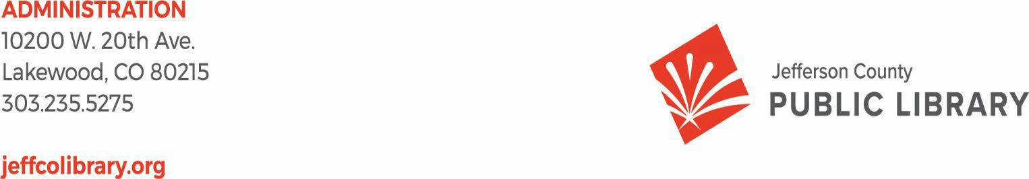

TO: Library Board of Trustees

FROM: Kim Johnson, Library Board of Trustees Chair

Jill Fellman and Pam Anderson, Nominating Committee DATE: April 10, 2025

RE: Slate of Officers for Election at April 17, 2025 Board Meeting

The Secretary position is up for election due to a Board vacancy. The Board Chair and nominating committee present the following officer for election at the April 17, 2025 Board Meeting:

* Secretary: Charles Jones, for the remainder of the 1-year term (April 2025 to March 2026)