**Minutes of the Regular Meeting of the** JEFFERSON COUNTY PUBLIC LIBRARY **BOARD OF TRUSTEES**

March 20, 2025

# CALL TO ORDER – REGULAR MEETING

The regular meeting of the Jefferson County Public Library Board of Trustees was held online via ZOOM and in-person in the Lakewood Library meeting room on March 20, 2025. Library Board of Trustees Chair, Kim Johnson, called the meeting to order at 5:30 p.m.

Other Trustees present: Emelda [Bing] Walker (Vice-Chair), Stanley Harsha (Secretary), Pam Anderson, Renny Fagan, and Charles Jones.

Trustees not present: Jill Fellman.

**Staff present:** Donna Walker, Executive Director; Julianne Rist, Library Planning & Policy Senior Advisor; Steve Chestnut, Director of Facilities and Construction Projects; Bernadette Berger, Chief Technology & Digital Innovation Officer; Matt Griffin, Chief Strategy & Operating Officer; Lisa Smith, Chief People & Culture Officer; Elise Penington, Director of Communications and Engagement**;** Jessica Paulsen, Assistant Director of Public Services for Customer Experience; Amy Bentz, Assistant Director of Library Design Projects & Planning; Padma Polepeddi, Assistant Director of Public Services for Community Outreach; Kelci Rude, Administrative Coordinator Supervisor; Katie O’Loughlin, Administrative Coordinator Supervisor; Ryan Turch, Technology and Innovation Operations Supervisor

There were additional Library staff members attending the meeting.

# APPROVAL OF AGENDA

**MOTION:**  Emelda Walker moved that the Library Board of Trustees approve the agenda as presented. Seconded by Pam Anderson the motion passed by unanimous vote of all Trustees present.

# PUBLIC COMMENT

The Board values public participation. Those who would like to address the Library Board can do so virtually, in-person, or online. The opportunity to address the Library Board does not include a question and answer session or response. Additionally, the Library Board does not respond to anonymous questions or comments. Comments will be acknowledged in the minutes of the meeting.

The Chair advised the Board that no online public comments were received. Jill Hinn pooled time with Katy Conway and Christine Catramados to address the Board, and provided public comment regarding staffing levels, work conditions, sub hours and pay during JCPL location closures, and HR responses to policy concerns. Anna Sparlin and Jasinda Catramados also spoke and provided comments on staffing levels, sub coverage at locations, staff safety, staff pay, and JCPL staff work/life balance.

The Chair closed the public comment portion of the meeting at 5:43 pm.

# APPROVAL OF CONSENT AGENDA

The Chair asked the Trustees if any of the items should be removed from the consent agenda. There were no requests for items to be removed.

Items on the Consent Agenda

1. Approve Minutes of February 13, 2025 Study Session
2. Approve Minutes of February 20, 2025 Board Meeting
3. Trustees Adopt Policy Governance: Monitoring Reports 2.0 to 2.4.
4. Serial Subscription Contract - EBSCO Information Services, 1st Renewal
5. Print Materials Contract - Baker & Taylor, 2nd Renewal

**MOTION**: Pam Anderson moved that the Library Board of Trustees approve the items on the consent agenda as presented. Seconded by Charles Jones the motion passed by unanimous vote of all Trustees present.

# FOUNDATION UPDATE

Jo Schantz Hall, Foundation Executive Director, provided an update on the Foundation activities. The Friends Annual meeting is on April 11 with Melissa Payne as the presenting author. Library Giving Day is coming up April 1. This has been a successful campaign in previous years and the Foundation hopes it will continue to be this year as well. The Foundation has their new kitchen in suite 1100 fully finished. This was completed by an outside contractor using donated materials from Home Depot. The Foundation Executive Director has been busy attending events and completing outreach activities in the last month. There were several new grants and naming opportunities that came through, there are only three opportunities left for Conifer.

There were no questions from the Board.

Trustee Fagan shared that he and Trustee Fellman have been working to meet so he can learn more about being the Foundation liaison.

**EXECUTIVE DIRECTOR REPORT**

1. Executive Director Report

The Executive Director advised the Board that there are new library card designs and shared samples. Trustees have several engagement opportunities at conferences this year. Early decision about ALA attendance was requested. The signature author event featuring CJ Box is coming up March 29. Seats are available for trustees if they are interested in attending, and there are also several local authors presenting as well. Trustees are invited to attend the BCC meeting on April 8. They will be acknowledging National Library week. JCPL is preparing a message for Library trustees and Foundation Board of Directors interested in advocacy opportunities regarding Executive Orders affecting the Institute for Museum and Library Services.

In response to questions, the Board was advised that trustees should have received a calendar invitation for the BCC meeting.

1. Capital Building Projects Update

**South County**: JCPL architect, EUA, is compiling and analyzing the community engagement inputs for a report to the Board in May. The Library is making progress on the plan to bring interim services to this location in early summer.

**NW Jefferson County**: We will be finalizing conceptual design this month. The library manager and creative tech coordinator piloted a creative tech outreach program in the community. Forty-two people came out to see demonstrations of our laser cutter and sublimation printer.

**Arvada**: Schematic Design pricing has come in. We are moving into the next phase which is design development.

**Conifer**: We have received our demo permit and are starting demolition on Monday. Jeffco Building permit review has been completed by Planning and zoning and is under review by Building Safety. We are hoping for the final permit by 3/31.

1. Alison J Thayer Naming Agreement

**MOTION**: Charles Jones moved that the Library Board of Trustees approve the Donation and Name Recognition Agreement between Alison J Thayer, the Jefferson County Library Foundation, Inc., and the Jefferson County Public Library. Seconded by Stanley Harsha the motion passed by unanimous vote of all Trustees present.

1. Harsha-Kerns Naming Agreement

Trustee Harsha noted that he and the other donors are first time grandparents, and this is in recognition of their first grandchild.

**MOTION**: Pam Anderson moved that the Library Board of Trustees approve the Donation and Name Recognition Agreement between Stanley and Henny Harsha and Candis and Bruce Kerns, the Jefferson County Library Foundation, Inc., and the Jefferson County Public Library. Seconded by Emelda Walker the motion passed, with Trustee Harsha abstaining from voting.

1. Facility Master Plan (FMP) Update

Julianne Rist, Library Planning and Policy Senior Advisor addressed the Board. In 2017 JCPL commissioned Group 4 Architecture to prepare a Facilities Master Plan (FMP) to guide planning, decision-making, and capital investment in our facilities over the next two decades. The recommendations contained in that plan were presented to the Board in 2018. The FMP is a flexible, “living” plan designed to be reviewed annually to accommodate changes in need and take advantage of opportunities. The FMP is an integral part of our 2020 – 2025 strategic plan and is an integral component of building the 5-year Capital Improvement Plan and 2026 budget.

The 2018 plan had several key findings and recommendations. The 2022 update performed by Group 4 verified that most of the original findings and recommendations were still valid guideposts for JCPL. We conduct annual reviews of the plan. Our facility master planning is a data-driven process that leverages previous studies with new analysis of the amount, type, and distribution of space needed to provide excellent library service to Jefferson County communities. Some of the data points used to determine those needs are population growth projections, drive time mapping, number of cardholders in a specific area, use data of existing services and potential opportunities to partner with another organization or agency.

2025 Annual Update:

Most items have stayed the same but we are changing recommendations in two places.

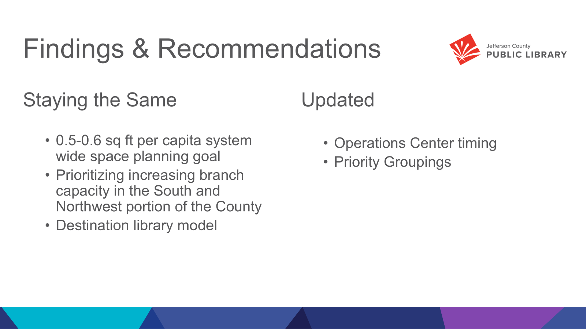

We feel that the system level view of square foot per capital is still a valid measure of if we have enough physical space to provide the services our residents need. When our two new locations are added to JCPL we will move from our current 0.34 sq ft per capita to having 0.46 sq ft per capita. We are planning for future needs with both new locations, as both buildings will be designed so that we will be able to expand the space if needed.

The northern and southern regions of the county are underserved in terms of physical library space. Our commitment to these areas is shown in the two new locations we are currently building. There is no change in this recommendation.

We are continuing our recommendation that an analysis is needed for an operations center, but we are recommending that this analysis should be part of the 2026+ strategic planning process.

The approach we’ve taken is a combination of adding two new destination libraries in the Northwest and Southern areas of the county; and augmenting underserved areas with offsite services such as hold lockers, material returns, Express Library, van and bookmobile services to ensure equitable access to library services for all Jefferson County residents. Last year we clarified the definition of “destination library” applies to include Northwest Jeffco and South County but does not apply to the redesign or changes to any existing locations. We do not have any changes to this recommendation.

We recommend that JCPL concentrates resources to complete the current capital projects underway to close out Group 1. We recommend removing the Opportunity /Need-Based category and that all remaining locations become part of Group 2.

The City of Golden has redevelopment plans underway for the Clear Creek corridor which could have impacts on this location. The Senior Resource Center, the owner of the Wheat Ridge location, is investigating other uses for their land and buildings. Also, the City of Wheat Ridge has two redevelopment projects underway; the Lutheran Legacy Campus and Improve Wadsworth, which will have an impact on population growth and the current uses of land. Additionally, Wheat Ridge is expecting to complete a new comprehensive plan this summer (2025) which will include their vision for the city for the next 20 years. The library is in conversation with our community partners and both cities about potential impacts to library services.

This slide shows the recommended Group 1 locations of Northwest, South County, Conifer, & Arvada. We have removed the South County Express Library from Group 1; as you heard last month we are planning to leverage the newly purchased building on Bradford for interim services.

Group 2 is not in priority order. There are changes in both Golden and Wheat Ridge communities that could affect JCPL plans for these locations. We will continue to assess the value proposition of a new Operations Center and the changes this might have on the Lakewood location. Additionally, we can wait and see the impact of a new location in NW Jeffco before making any plans for changes at Standley Lake.

The map shows our existing and future locations. The green circles are our Group 1 projects, the blue circles are Group 2 projects, and the tan circles are completed projects where we do not anticipate any work.

In response to questions, the Board was advised:

* Group 1 projects are priority projects that increase square footage and help us better serve underserved areas.
* Golden/Wheat Ridge were moved out of Needs Based/Opportunities and into Group 2 because there are external factors that will influence what we do with library services in those areas. Those are going to impact us sooner now; they will be priorities for us to figure out what our response will be.
* Both city mayors indicated a desire for us to prioritize those locations in a 5-10 year capital plan. This will be part of the conversation around this FMP so we know what to put in for our 5 and 10 yr capital planning. This is part of Julianne’s work in her new role as Library Planning and Policy Senior Advisor.
* Libraries may move depending on activities, land use changes, etc. We want to be integrated into the fabric of the community. Wheat Ridge is discussing moving City Hall to Lutheran Legacy campus.
* ‘No Work Expected’ means no capital work anticipated, not that there would not be refreshes or non-capital work completed at these locations.
* Moving projects from Opportunities to Group 2 will show up in the financial mapping the Board will see in May.
* JCPL does consider the Golden Library building to be too small based on community size.

The Board provided the following feedback on the 2025 FMP update:

* We need to be nimble if we are relying on municipalities to be doing things.
* The Ops Center study will take time; it will be nice to have this in the 2026+ strategic plan.
* There has been amazing progress in Group 1; we can see this because we can look at Opportunities more concretely now and have space to move them into Group 2.

1. 2026+ Strategic Planning

Guest: Greg Bellomo, Government Performance Solutions, Inc

Greg Bellomo addressed the Board and provided an update on progress from the last workshop with the Board. The Board was informed that Donna Walker would provide an update on the Mission and Vision, and then the Board would be asked to provide feedback on the Ends, and work on some animating language.

We are synthesizing our framework. The goal is to confirm as much as we can of the strategic framework and get to consensus on the Mission and Vision. The recommendation/goal is to keep the strategy to a single page, and the Board can envision that with the Vision and Mission at the top and then the Ends follow. Objectives and Key results below that, with a lot of initiatives. The Board works at the top: Mission-Vision-Ends. Library leadership and frontline teams figure out the how – those are the initiatives. Board will be adding animating language to Ends.

Donna Walker addressed the Board regarding the Mission and Vision work. The foundation for this work was community feedback which indicated that wholesale change in the Mission and Vision was not needed or desired. The community, as represented by the Library Board of Trustees and survey insights, expressed common connection with these concepts specifically related to Mission and Vision:

* + The library is a place for **connection** and **learning**
  + The library is for **everyone**
  + The library makes the **community better**
  + The library makes **lives better**
  + **Accessibility and equity of access** are essential elements of the public library

We are recommending the new Mission statement based on that feedback:

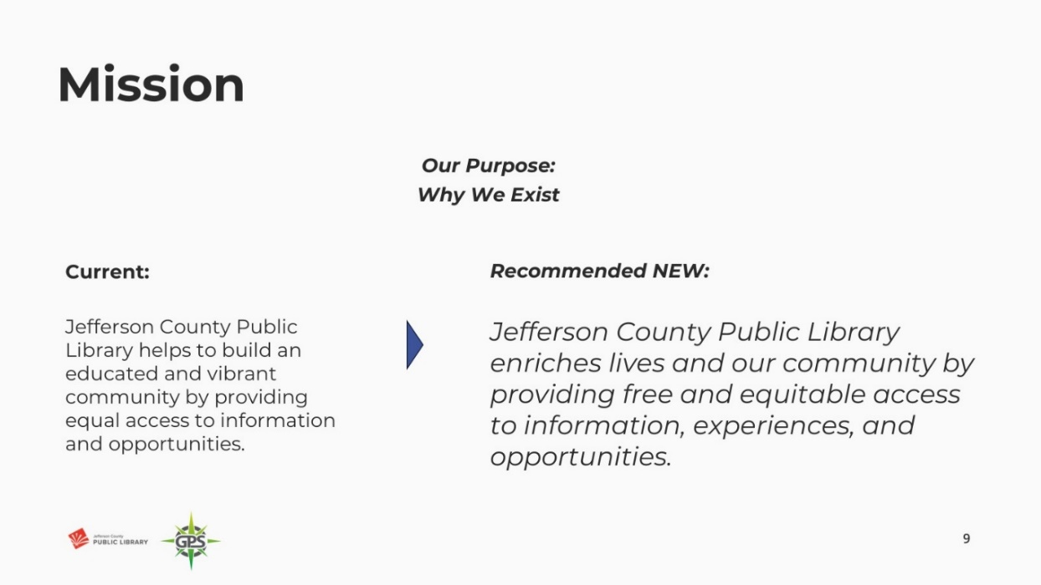

The Board engaged in discussion around the word ‘free’ and provided feedback that it did not sit well for many of them as it seemed not to acknowledge the community investment that taxpayers make in the Library.

In response to the questions the Board was advised that:

* ‘free’ came from the Board’s discussion around unfettered and/or open access, and not necessarily a monetary implication. Some Libraries do charge for programming and camps, and this can be a barrier to access for people. Maintaining free resources at JCPL is what the current JCPL Executive Director is committed to operationally, but a future Board could direct differently. They would most likely update the Mission statement if that was their intent.

The Board provided consensus that they felt more comfortable changing the order of free and equitable so that the new Mission statement reads: *Jefferson County Public Library enriches lives and our community by providing equitable and free access to information, experiences, and opportunities.*

One thing that stood out from the community feedback was the future view and discussion of JCPL as a place. When we look at our old vision, we talk about being an essential destination, in the new proposed Vision, we bring forward that idea of place.

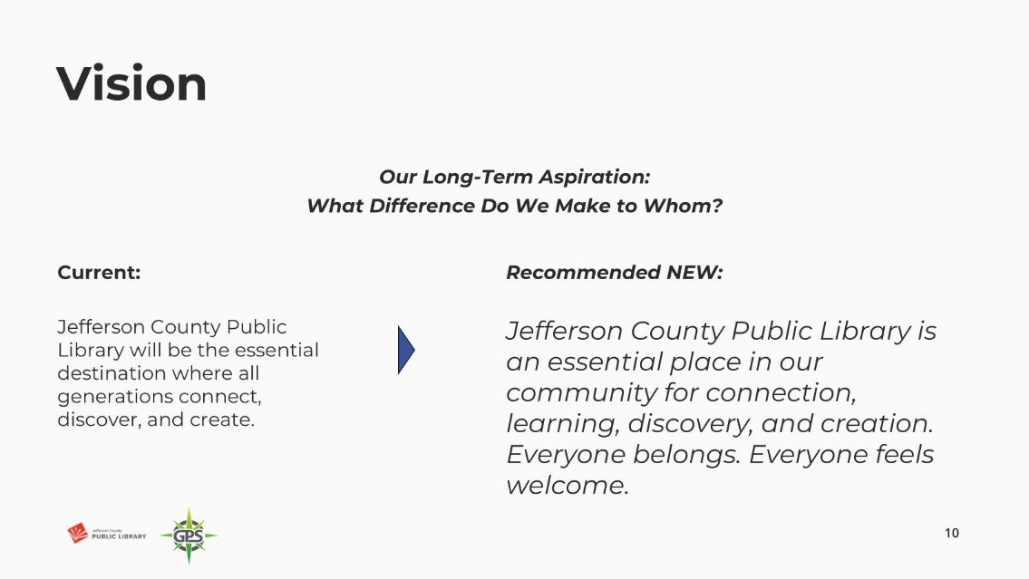

The Board indicated that they had no comments or feedback for improvement. The Board indicated their unanimous consent on the new Vision statement as presented.

Greg Bellomo addressed the Board and introduced the work and topic around the Board Ends. The Board was reminded that the goal was to refine these to as few as possible. We are working with three: Equity of Access, Creating Place, Our People.

The Board was asked to provide edits and suggestions to each so that each End Statement’s animating sentence is powerful and captures the Board’s intentions for the organization.

Equity of Access:

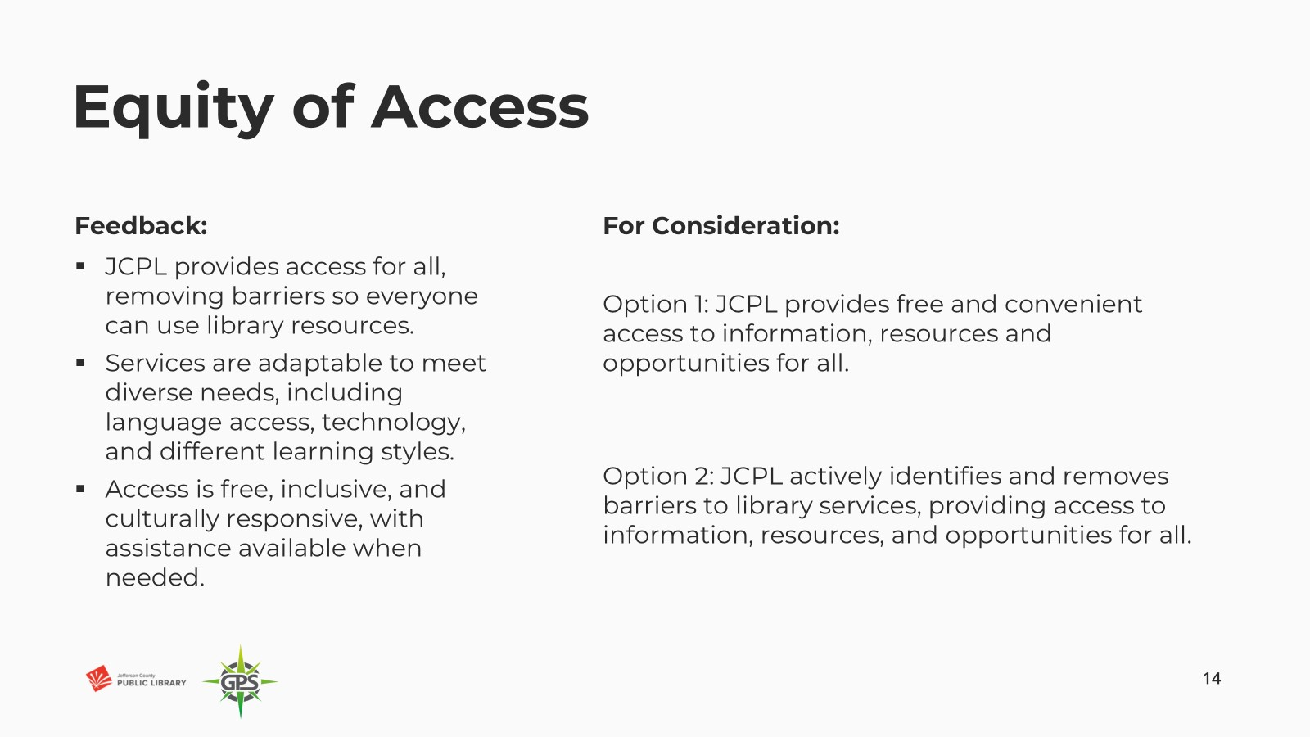

The Board indicated a preference for Option 2, and there was Board discussion around possibly adding ‘free’ before access to Option 2.

Creating Place:

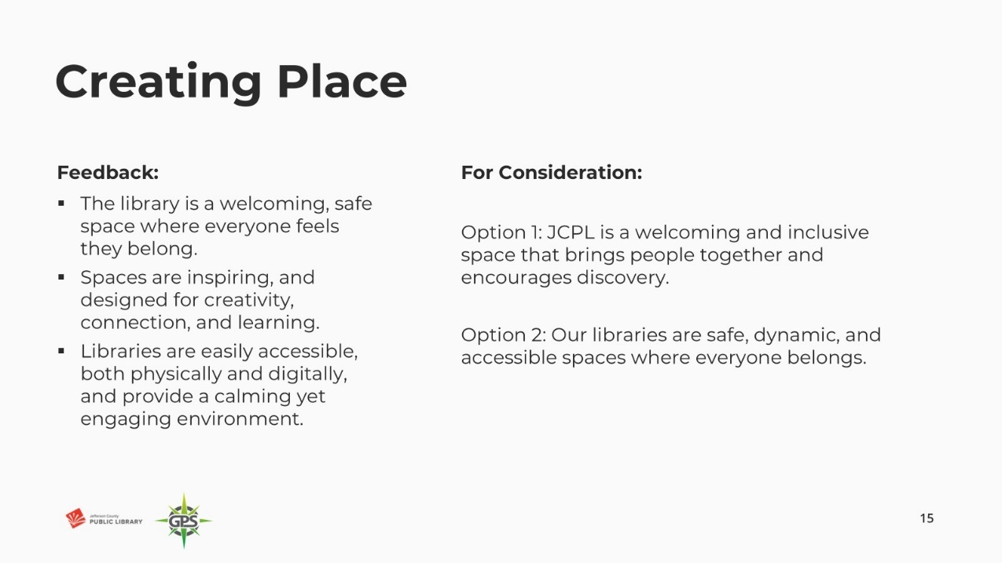

The Board provided mixed feedback on preferences between Option 1 and 2. Comments included:

* Liked ‘discovery’ in 1.
* Like that 2 is action oriented, we are continuously creating space.

Trustees agreed that a new combination of 1 & 2 was the majority consensus and preference.

Our People:

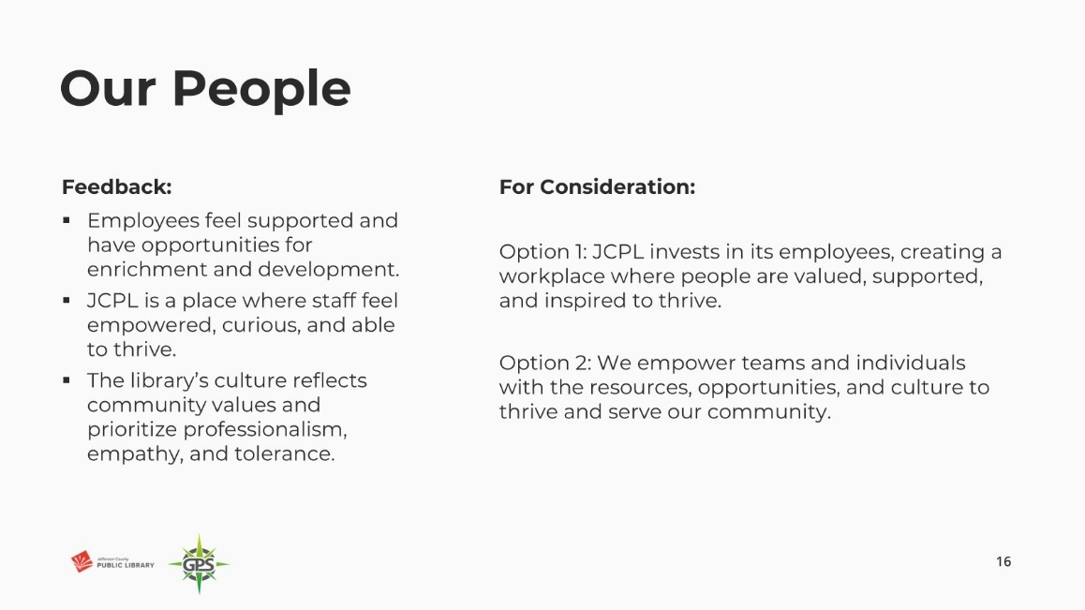

The Board indicated a preference for Option 2. There was Board discussion around empower versus invest as language. The Board indicated their consensus on Option 2, with the addition of ‘our’ before ‘teams’.

The Board was advised that the next steps for this work involve bringing the Mission-Vision-and Ends to the April Management Team meeting. Supervisors and managers will engage in this work, and then frontline staff will see these and have a chance to engage.

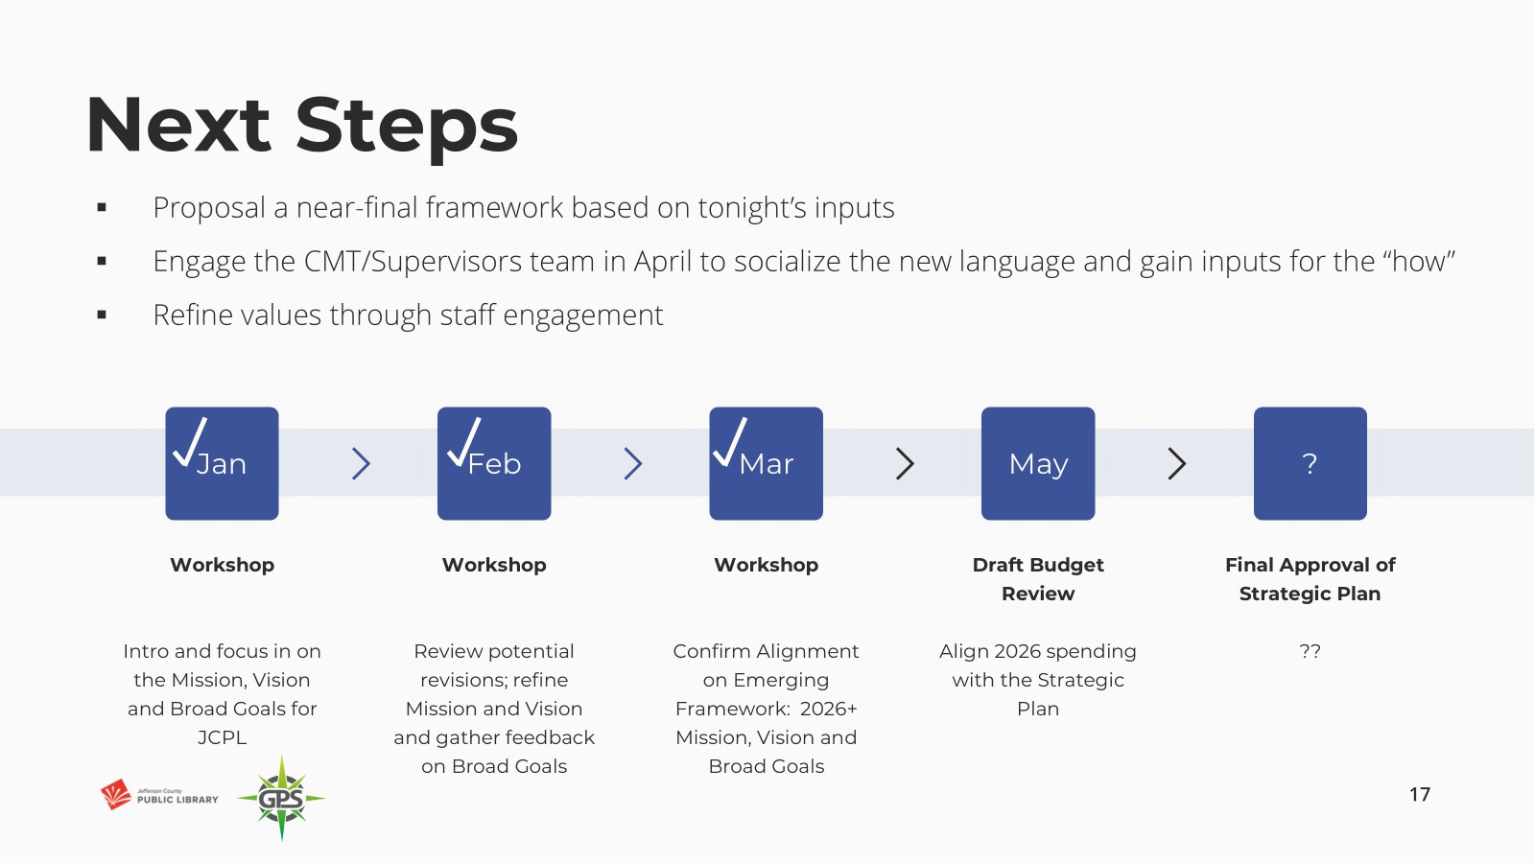

In response to questions, the Board was advised that:

* The Communications and Marketing team is queued up for the storytelling element of how we deliver these to the public. We understand the Board wants the public to see their feedback in action so that we can say “because you said this, we are going to…”.
* Focus groups tend to be expensive and have more feedback value when they are done consistently versus at certain points in time.

**OPERATIONAL UPDATES**

**Strategy and Operations**

**Finance and Budget**

1. Financial Report (February 2025)

Matt Griffin, Chief Strategy & Operating Officer, addressed the Board and provided information on the February 2025 monthly financials. There were no items of note, we are on track and in line with expectations.

The Board did not have any questions or comments regarding the February financial statements.

# ITEMS REMOVED FROM THE CONSENT AGENDA

No items were removed from the consent agenda.

# EMERGING ISSUES

No issues.

# ENDS

There were no items.

# BOARD GOVERNANCE

1. Nominating Committee report to the Board: Proposed Slate of Officers

The nominating committee presented the following slate of officers for election:

The Chair, Vice-Chair, and Secretary positions are up for election in 2025.

* Chair: Kim Johnson, for the 2-year term April 2025 to March 2027
* Vice-Chair: Emelda (Bing) Walker, for the 1-year term (April 2025 to March 2026).
* Secretary: Stanley Harsha, for the 1-year term (April 2025 to March 2026)

**MOTION**: Pam Anderson moved that the Library Board of Trustees elect Kim Johnson for Chair for a two-year term April 2025 to March 2027; and elect Emelda Walker for Vice-Chair and Stanley Harsha for Secretary for one year terms April 2025 to March 2026. Seconded by Renny Fagan the motion passed by unanimous vote of all Trustees present.

1. Bylaws Committee status update

Bylaws committee member, Emelda Walker, advised the Board that the committee reviewed the Bylaws and there are no recommendations for changes.

**BOARD SCHEDULE – NEXT MEETINGS**

2025 Board Meeting Schedule

* April 10, 2025 –Study Session Hybrid: Virtual via ZOOM. In-Person Location: Lakewood Library Meeting Room
* April 17, 2025 – Board Meeting – 5:30 pm Hybrid: Virtual via ZOOM. In-Person Location: Lakewood Library Meeting Room
* May 8, 2025 –Study Session Hybrid: Virtual via ZOOM. In-Person Location: Lakewood Library Meeting Room
* May 15, 2025 – Board Meeting – 5:30 pm Hybrid: Virtual via ZOOM. In-Person Location: Lakewood Library Meeting Room

**ANNOUNCEMENTS/GENERAL INFORMATION SHARING**

There were no announcements.

# EXECUTIVE SESSION:

At 7:11 pm, the Chair called for a motion to adjourn the regular meeting, reconvene in Executive Session regarding Collective Bargaining and Urban Renewal Authority and adjourn the regular Board meeting at the conclusion of the Executive Session.

**MOTION**: Pam Anderson moved to adjourn the regular meeting of the Library Board of Trustees, reconvene in Executive Session regarding 1. Collective Bargaining and 2. Urban Renewal Authority AND adjourn the Regular Board meeting at the conclusion of the Executive Session. Statutory citation authorizing an executive session for these topics are:

* Pursuant to 24-6-402(4)(e)(I) for discussion of strategy and instructions to negotiators

Seconded by Emelda Walker the motion passed by unanimous vote of all Trustees present.

The Chair announced a three-minute break to allow the Board and staff to clear the room, leave the existing ZOOM meeting and then join the Executive Session. The break exceeded the three-minute request.

The Chair called the Executive Session to order at 7:17pm with the following Trustees present: Charles Jones, Stanley Harsha, Renny Fagan, and Emelda (Bing) Walker. Also present were Donna Walker, Executive Director; Elise Penington, Director of Communications & Engagement; Julianne Rist, Library Planning and Policy Senior Advisor; Bernadette Berger, Chief Technology & Digital Innovation Officer; Lisa Smith, Chief People & Culture Officer; Matt Griffin, Chief Strategy & Operating Officer; and Katie O’Loughlin, Administrative Coordinator Supervisor.

Guest: Steven Spirn

It is noted that the session was recorded and that the recording will be retained for the required 90 days.

**CALL FOR ADJOURNMENT OF EXECUTIVE SESSION at 7:46pm**

**MOTION**: At 7:46 pm Emelda Walker moved to adjourn the Executive Session. Seconded by Charles Jones the motion passed by unanimous vote of all Trustees present.

It is noted that the Library Board of Trustees met in Executive Session concerning Collective Bargaining and Urban Renewal Authority pursuant to 24-6-402(4)(e)(I) for discussion of strategy and instructions to negotiators. The Trustees held those discussions, and this summary is provided as required by Colorado Statute.

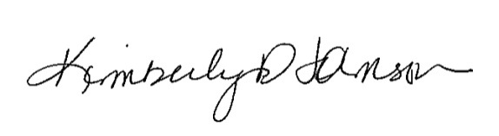

Kim Johnson, Chair