# BOARD MEETING

JEFFERSON COUNTY PUBLIC LIBRARY BOARD OF TRUSTEES

March 20, 2025

|  |  |
| --- | --- |
| P7C1T1#yIS1  **Intro to Inkscape for Laser Design: Celtic Jewelry** | P11C3T1#yIS1  **Teen Advisory Board (TAB)** |
| P14C4T1#yIS1  **Discovery Play** | P17C6T1#yIS1  **Intercambios: Spanish Conversation Table** |



### APPROVAL OF AGENDA

|  |  |
| --- | --- |
| ITEM# / ACTION | **Thursday, March 20, 2025 – 5:30 pm – HYBRID MEETING**   * *U***ONLINE MEETING VIA ZOOM** * **IN-PERSON MEETING AT LAKEWOOD LIBRARY MEETING ROOM** |
| 1. | **Call to order & attendance (4.5.8)**  A. Verbal roll call – Each Trustee announces their presence by stating their name. |
| 2. | **Pledge of Allegiance** |
| 3. Agenda  Action | **Approve Agenda**  Chair: Call for motion and second |
| 4. Public Comment | **Public Comment**  The Board values public participation. Those who would like to address the Library Board can do so virtually, in-person, or online. The opportunity to address the Library Board does not include a question-and-answer session or response.  Additionally, the Library Board does not respond to anonymous questions or comments. Comments will be acknowledged in the minutes of the meeting.  If you choose to make a Public Comment virtually or in-person during a Board meeting, your name will be called in the order it was received, first for virtual guests then for in-person guests.  To address the Library Board of Trustees during Public Comment:   1. In-person: Must sign in on the form provided at the door. 2. Virtually during the public comment portion of the meeting: Send a chat message to the meeting host with name and the comment topic 3. Online public comment form: The online form is available at 5:30 pm the Thursday prior to the scheduled Library Board meeting and closes at 1:00 pm the day prior to the scheduled Library Board meeting. 4. People who dial in will not be able to provide public comment during the meeting. 5. Those who failed to sign up or submit the online form, or arrived late, may, at the discretion of the Chair, be allowed to address the Library Board. 6. The Chair has authority to maintain the decorum of the meeting. Conduct or comments that are disruptive to the meeting or its participants are prohibited.   For more information on public comment policy please refer to Board Governance  Policy 4.3.7: [Board Governance Policy Manual (jeffcolibrary.org)](https://jeffcolibrary.org/wp-content/uploads/sites/46/2024/03/March_2024_Board_Governance_Policy_Manual-1.pdf) |
| 5.CONSENT AGENDA  Action | **Approval of Consent Agenda**  Chair: Call for motion and second   1. Approve Minutes of February 13, 2025 Study Session 2. Approve Minutes of February 20, 2025 Board Meeting 3. Trustees Adopt Policy Governance: Monitoring Reports 2.0 to 2.4. 4. Serial Subscription Contract - EBSCO Information Services, 1st Renewal 5. Print Materials Contract - Baker & Taylor, 2nd Renewal |
| 6. Foundation | Foundation Update |

|  |  |
| --- | --- |
| 7.Operational Updates Action as Needed | **Executive Director**   1. Executive Director Report 2. Capital Building Projects Update 3. Alison Thayer Naming Agreement Chair: Call for motion and second 4. Harsha-Kerns Naming Agreement Chair: Call for motion and second 5. Facility Master Plan Update 6. 2026+ Strategic Planning   Guest: Greg Bellomo, Government Performance Solutions, Inc  **Strategy & Operations**  Finance and Budget   1. Financial Report (February 2025) |
| 8.Action as Needed | Items Removed From Consent Agenda (4.3.4): The Board may address and/or vote on any items that were removed from the Consent Agenda |
| 9. Emerging Issues Action as Needed |  |
| 10. Ends  Action as Needed | **Ends**: No items. |
| 11. Board Governance Action as Needed | **Board Governance:**  A. Trustees Elect Officers:   * Kim Johnson for Chair: Two-year term April 2025 to March 2027 * Emelda Walker for Vice-Chair: One-year term April 2025 to March 2026 * Stanley Harsha for Secretary: One-year term April 2025 to March 2026 Call for motion and second   B. Bylaws Committee Status Update |
| 12. Suggest Agenda Items  Action as Needed | BOARD SCHEDULE – NEXT MEETINGS –  Location of meetings of the Library Board of Trustees are being determined in cooperation with guidelines from Jefferson County. Information on meeting location will be posted at least one week prior to the scheduled meeting date. 2025 Board Meeting Schedule   * April 10, 2025 –Study Session Hybrid: Virtual via ZOOM. In-Person Location: Lakewood Library Meeting Room * April 17, 2025 – Board Meeting – 5:30 pm Hybrid: Virtual via ZOOM. In- Person Location: Lakewood Library Meeting Room * May 8, 2025 –Study Session Hybrid: Virtual via ZOOM. In-Person Location: Lakewood Library Meeting Room * May 15, 2025 – Board Meeting – 5:30 pm Hybrid: Virtual via ZOOM. In-Person   Location: Lakewood Library Meeting Room |
| 13. Discussion | Board Questions or Comments Related to Items on the Meeting Agenda |

|  |  |
| --- | --- |
| 14. Discussion | Evaluate Board Meeting (4.1.9) |
| 15. Information | Announcements/General Information Sharing   * Report of the Chair – Correspondence, Other * Other Announcements |
| 16. EXECUTIVE SESSION WITH ADJOURNMENT OF REGULAR MEETING | EXECUTIVE SESSION:  Call for Motion and Second to adjourn the regular meeting of the Library Board of Trustees and reconvene in executive session AND adjourn the regular Board meeting at the conclusion of the Executive Session.   1. Collective Bargaining. Statutory citation authorizing an executive session for this topic is:    * Pursuant to 24-6-402(4)(e)(I) for discussion of strategy and instructions to negotiators.   (2) Urban Renewal Authority. Statutory citation authorizing an executive session for this topic is:   * Pursuant to 24-6-402(4)(e)(I) for discussion of strategy and instructions to negotiators. |

**CONSENT AGENDA**

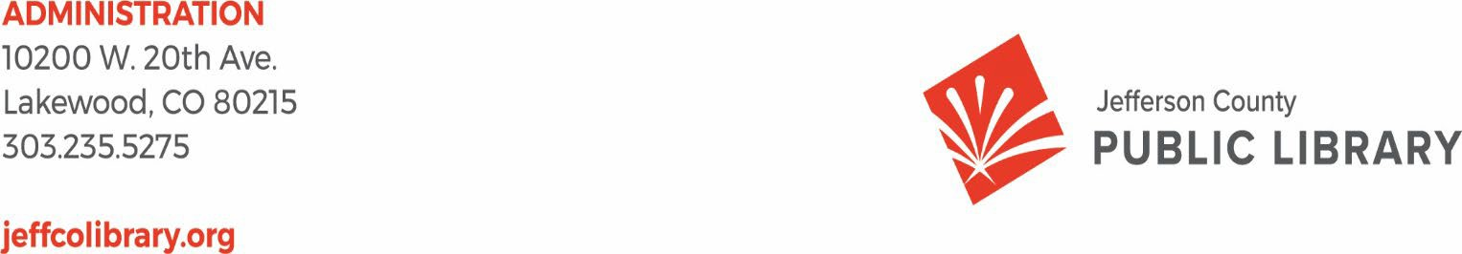

TO: Library Board of Trustees

FROM: Kim Johnson, Chair and Donna Walker, Executive Director DATE: March 20, 2025

RE: Consent Agenda for the March 20, 2025 Board Meeting

1. Approve Minutes of February 13, 2025 Study Session
2. Approve Minutes of February 20, 2025 Board Meeting
3. Trustees Adopt Policy Governance: Monitoring Reports 2.0 to 2.4.
4. Serial Subscription Contract - EBSCO Information Services, 1st Renewal
5. Print Materials Contract - Baker & Taylor, 2nd Renewal

**Jeﬀerson County Public Library Board of Trustees Study Session**

**February 13, 2025- 5:30pm Hybrid Meeting held online via ZOOM**

**and in-person in the Lakewood Library meeting room.**

TOPICS:

Board Governance - Strategy

* + 2026+ Strategic Planning

Guest: Greg Bellomo, Government Performance Solutions, Inc

Board Governance- Policies

* + JCPL Operational Practices for Collection Development and Reconsideration of Materials Policies Update

Guest: Kurt Behn, County Attorney’s Oﬃce

Strategy & Operations

* + Contingency request Budget Transfer
  + LED lighting updates

Contracts & Agreements

* + Standley Lake Library Audiovisuals Contract- Xcite Audiovisuals, LLC

Call to Order

Kim Johnson, Chair, called the Study Session to order at 5:30 p.m.

**Other Trustees present**: Emelda Walker (Vice-Chair), Stanley Harsha (Secretary), Pam Anderson, Jill Fellman, Charles Jones, and Renny Fagan.

**Guests present:** Greg Bellomo, GPS, Inc. & Kurt Behn County Attorney’s Oﬃce

**Staﬀ present**: Donna Walker, Executive Director; Julianne Rist, Library Planning & Policy Senior Advisor; Steve Chestnut, Director of Facilities and Construction; Bernadette Berger, Chief Technology & Digital Innovation Oﬃcer; Matt Griﬃn, Chief Strategy & Operations Oﬃcer; Lisa Smith, Chief People and Culture Oﬃcer; Elise Penington, Director of Communications & Engagement, Amy Bentz, Assistant Director of Library Design Projects and Planning; Padma Polepeddi, Assistant Director of Public Services for Community Outreach; Lizzie Gall, Assistant Director of Public Services for

Resources and Programs; Jessica Paulsen, Assistant Director of Public Services for Customer Experience; Kelci Rude, Administrative Coordinator Supervisor; Katie O’Loughlin, Administrative Coordinator Supervisor; and Joseph Grover, Technical Support Technician Sr.

**Board Governance - Strategy**

Matt Griffin, Chief Business & Strategy Officer, introduced the topic and reminded the Board that they would be building on the work they did in January. The Board will continue to have more sessions after this. Matt Griffin then introduced Greg Bellomo with GPS.

Greg Bellomo addressed the Board and informed them that the purpose of tonight’s work is to begin refining the Mission, Vision, and Broad Goals for the organization. The Board was informed that we are in the 3rd phase of our strategic planning. We’re taking the input information and synthesizing a framework to help us move from mission/vision to clear goals and objectives. The goal for tonight is to get the framework in good shape to share at next month’s study session.

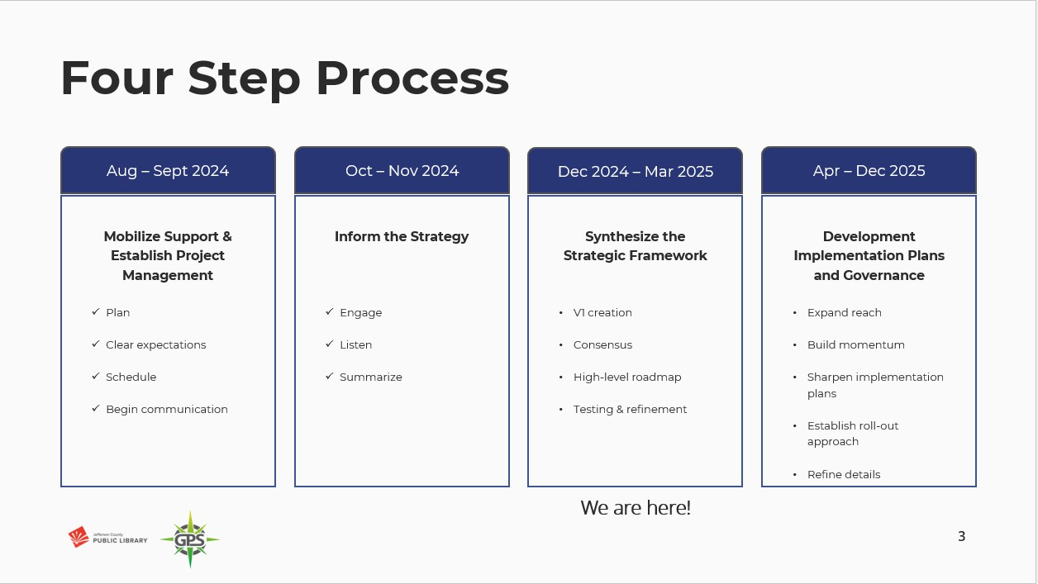

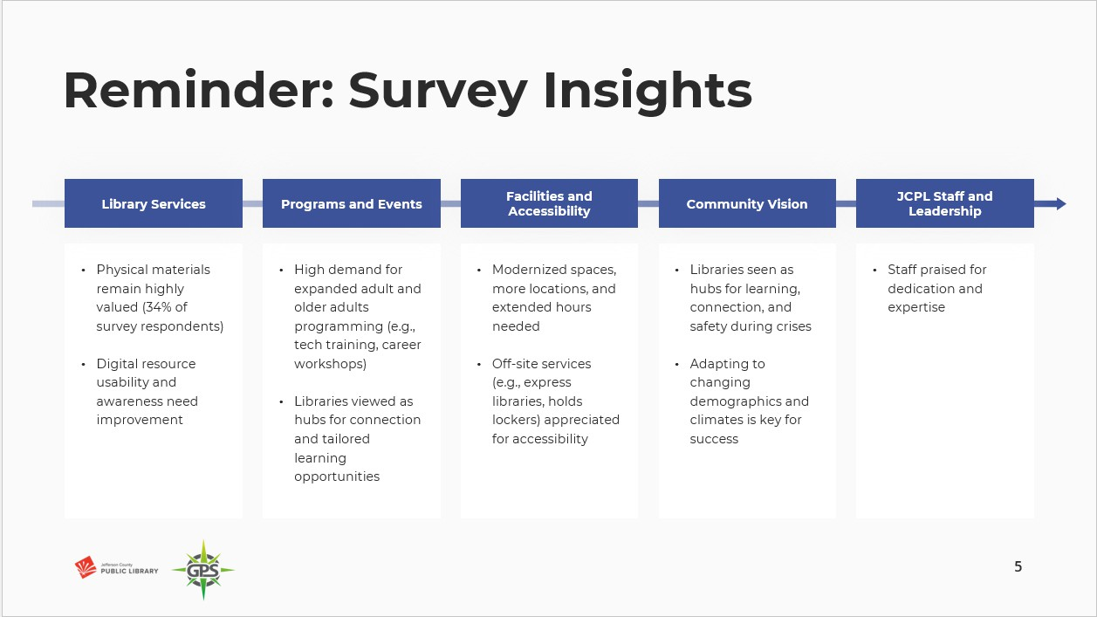

The Board was reminded that the survey had over 8000 responses, and five main themes emerged around what we heard from the community. During the last working session, the Board acknowledged the limitations of the survey. While we were gratified by the number, we recognized that we did not have proportional representation from Spanish speakers. People who respond generally know and use you and people who don’t use the Library probably won’t respond to a survey.

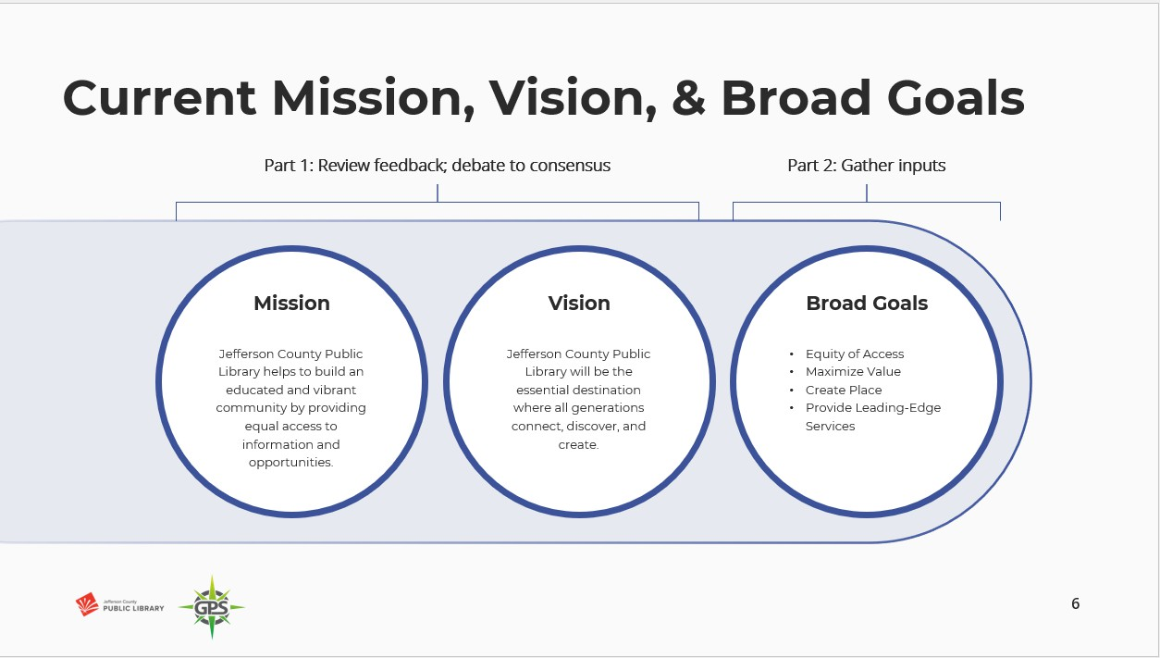

The Board was informed that they would review the current mission and vision, review refinements in language, and see if they can reach consensus.

The Board did not have any questions or discussion on the plan for the Study Session or next steps.

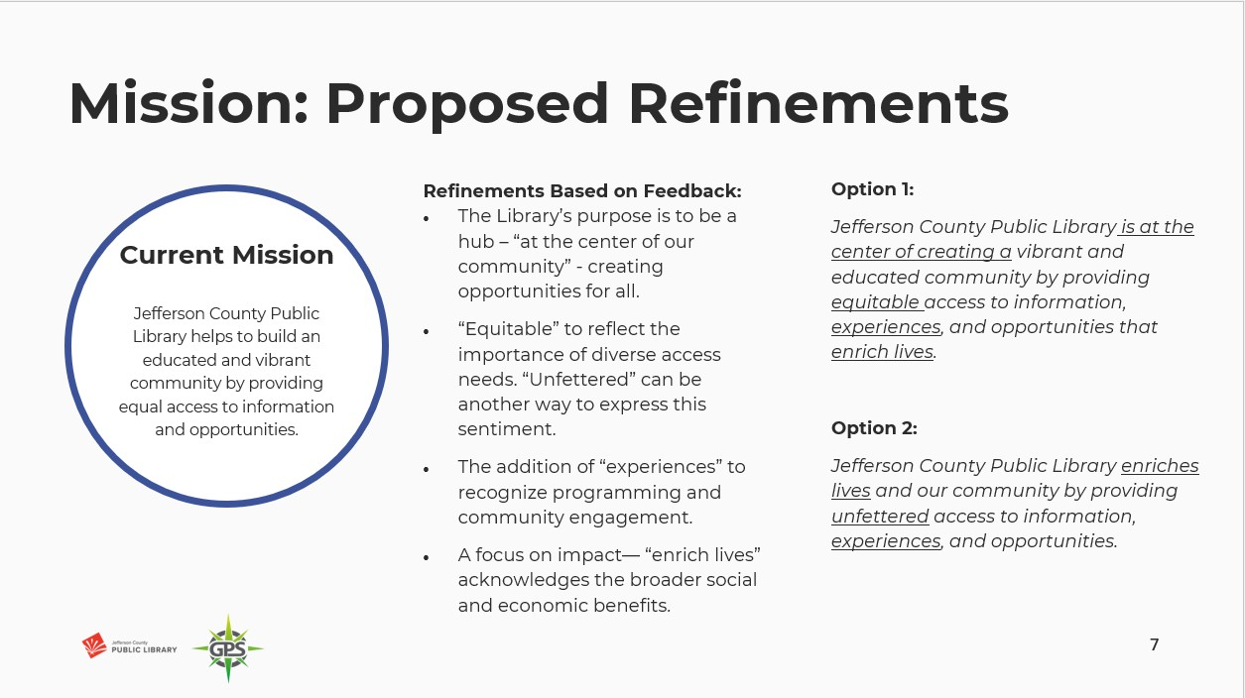

The Board was asked to identify things that they liked, that stood out to them, or areas where they felt like we missed the mark in Mission Options 1 & 2.

Board comments included:

* A preference for the first option, and that the ‘educated community’ language

stood out to them.

* Liked the phrase ‘at the center of creating’. They appreciated the addition of ‘equitable’ and ‘experiences’ and that it includes ‘enrich lives’, as it answers the “to what end?” question. They also felt like that phrase had more impact at the end of the mission statement as opposed to the beginning of the statement as in Option 2.
* A preference for Option 2. They liked that ‘enriches lives’ was centered at the beginning of the statement, and it emphasized that. They liked ‘equitable’ but did not like ‘unfettered’.
* They noted that an organization’s Mission statement language may impact federal

funding and wanted trustees to be aware of that.

* They liked ‘unfettered’ given the current social polarization.
* They liked that JCPL isn’t just at the center of something happening around us, but that Option 2 showed we are taking responsibility for something. They liked the idea of what ‘unfettered’ says, just not the word.

The Board was asked if it is the notion of no barriers that appeals to them. Board members generally affirmed that it was and offered other words such as ‘independent’ or ‘fair’, ‘equitable and free’.

The Executive Director explained that ‘unfettered’ was suggested because of its legal significance; we have seen it used by our County Attorney’s Office before, and seemed to hit upon the value of making sure people’s access wasn’t restricted or controlled. The Executive Director noted that it sounds like the word doesn’t belong in the Mission statement, but that the conversation from the Board around this was appreciated.

Comments included:

* Trustees value that idea, but the word feels too legal and not friendly enough.
* Unfettered is different from equitable- one is what it takes to gain access, and the other is the right to access. Language might be better if it were changed from ‘*providing*…access’ to ‘*ensuring*….access’.

The Board was asked how they felt about bringing the educated community language into Option 2.

* Some indicated that they agreed the statement had value.
* Putting that as a description assumes about the community, and they wanted to note it may not be something the community feels or responds to.

The Board was informed that the team will bring back some revised versions, building off Mission Option 2 for the March Study Session.

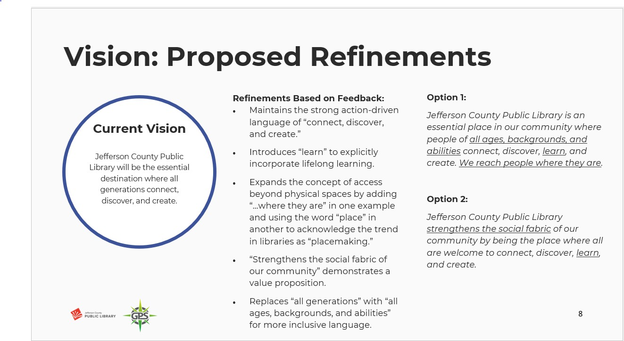

The Board was asked to identify things that they liked, that stood out to them, or areas where they felt like we missed the mark in Vision Options 1 & 2.

Board comments included:

* Both Options read more as Mission statements than Vision statements. A Vision statement should answer the question “What difference does this make and to whom?” Would like to see the team turn these into stating the outcome and where we are headed- not how we get there. Three examples of Vision statements that do this:
  1. Colorado Community College System: CCCS will be the first and best path for all to achieve a more prosperous and fulfilling life.
  2. Colorado Education Initiative: CEI’s long-term vision is that all young people in Colorado exit K-12 education boldly taking their next steps toward hopeful, equitable, and prosperous futures. This requires an education system that delivers on the promise of public education to develop thriving young people and flourishing communities.
  3. Denver Art Museum: At the Denver Art Museum, we work together to build a world where art sparks creativity, and connects, inspires, and empowers people and communities.
* Want to see something that reaches out- information for all or connecting and discovering are good core ideas but there’s still this question of where does that lead us?
* Option 1 was not far from the type of Vision statements that were provided as examples. The ‘…IS an essential place’ language had been a large part of the Board discussion the last time they did this work, and that had been a bold change and statement.
* Option 1 looks forward, but it needs more work.
* Feels important to have the Vision statement be aspirational.
* Option 1 feels like a starting point for the next iteration.
* Want to see more around the outcome and user.

The Executive Director asked the Board about the ‘strengthens the social fabric’ phrase as no one had brought that up. The Board was asked to clarify whether they felt the Vision needed to be refined to apply more to the individual, the community, or both.

Board members expressed differing opinions on whether it should be the individual, the community, or both.

The Executive Director also asked the Board about ‘We reach people where they are’ and

whether the Board felt that was aspirational enough for the Vision statement.

Comments included:

* They felt it was built into ‘all ages, backgrounds, and abilities’.

The Board was informed that the team will bring revised versions building off Vision Option 1 for the March Study Session.

The Board reviewed draft broad Goals. The Board was informed that the Directors Team felt there was an opportunity to add impact and clarity using more animating language. The Board was asked to develop their own animating words and phrases for each broad goal of Equity, People, and Place. Trustees were instructed to send the Chair and Executive Director any other words/phrases that they think of after the meeting that they want included in the next working session. These will need to be received by 2/17 as the Directors Team will be working on these on 2/18.

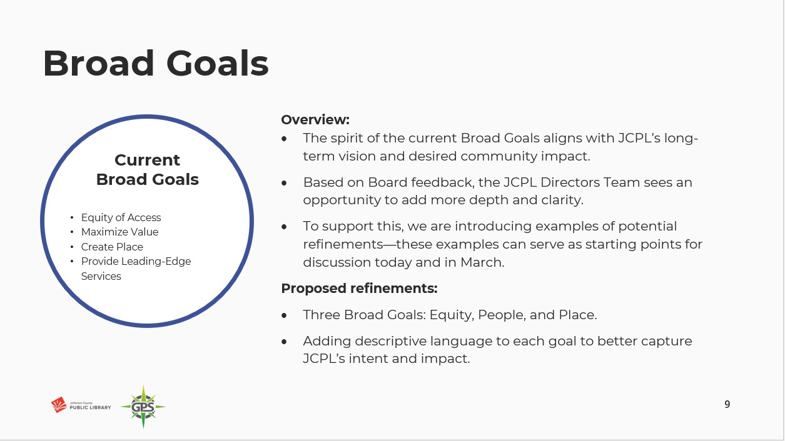

The Board was informed that they will see these again in March.

**Board Governance- Policies**

JCPL Operational Practices for Collection Development and Reconsideration of Materials Policies Update Guest: Kurt Behn, County Attorney’s Oﬃce

The Chair reminded the Board that JCPL has had policies in place for Collection Development and Reconsideration but that due to legal changes they now need to be Board policies.

The Executive Director introduced Julianne Rist, Interim Chief Libraries & Inclusion Oﬃcer, and Lizzie Gall Assistant Director of Public Services for Resources and Programs who shared a presentation with the Board around JCPL’s operational practices for collection development and materials reconsideration.

The Interim Chief Libraries & Inclusion Officer introduced the topic.

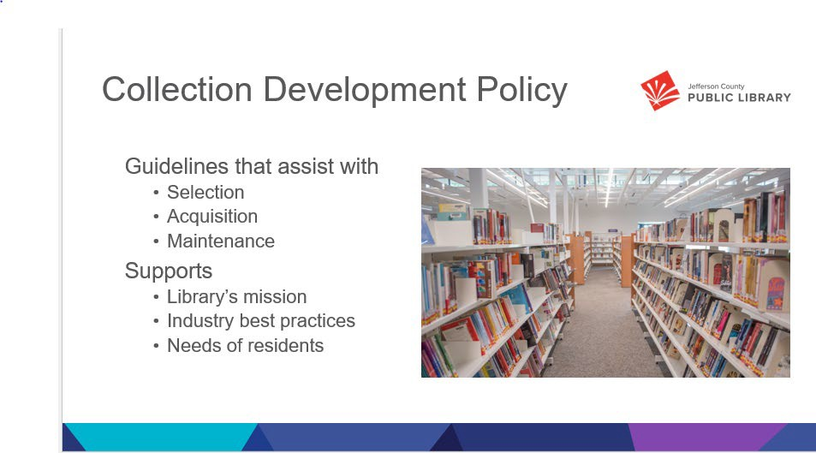

A collection development policy is a written document to assist library staff in selecting, acquiring, and maintain a library’s collection. The policy's purpose is to create a collection that supports the library's mission, industry best practices, and the needs of its users. It ensures the collection aligns with the needs of the community it serves, reflecting the library's mission and objectives by prioritizing relevant and quality resources across different formats.

* *Jefferson County Public Library (JCPL) develops and maintains a materials collection that reflects the changing needs and interests of our community. The purpose of this policy is to guide selection practices to ensure that a wide variety of materials is available in our libraries in formats and quantities that meet the needs of our residents and patrons.*
* *JCPL will make every effort in their selection of materials to provide a balanced collection representing diverse viewpoints and interests.*

The Policy sets the philosophy and expectations for the material formats and titles that we select and deselect. Staff know what the focus is for JCPL and the items we have in our collection, and residents know what to expect to find in our collection as well. We will now talk about the processes that staff go through when selecting, deselecting or responding to a reconsideration request.

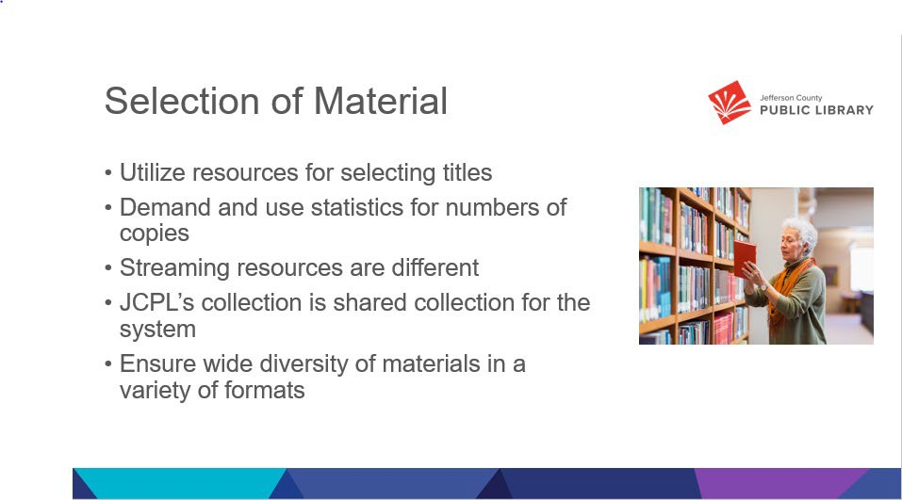

Selection of materials is how our subject matter expert staﬀ determine which items to add to the collection. The Library’s collection development policy guides the selection of materials to build a collection that is of high interest to the community. We have a team of selectors whose focus is on this work.

The selectors utilize resources like current use statistics, collection evaluation tools, and professional review journals to help select titles. They also determine how many of each title to send to each location for physical items. While we do also look to resources like lists developed by vendors or other professionals, at JCPL an expert selector makes the ﬁnal decision on everything we add to the collection.

We use the same practices for developing the physical and digital collections, with the exception of streaming resources and databases where we select the service, not the individual titles. The streaming services are selected for their ease of use and large online catalogs. Our databases provide digital access to magazine and newspaper articles. In both cases, the service is reviewed and evaluated instead of each individual title. That provides access to hundreds of thousands of items not directly curated by JCPL staﬀ. Though we do work with the vendors should any questions or concerns arise.

At JCPL we have what is called a ‘ﬂoating collection’ in library speak. That means that our materials are not assigned to a speciﬁc location. Rather, they ‘ﬂoat’ around the system based on patron use. This practice helps minimize the amount of time materials are in transit, and moves materials to where there is demand for them.

We select a wide diversity of materials in a wide diversity of formats- like launch pads which are curated tables that include apps for learning and growth. Our team evaluates each format to determine if it is a good ﬁt for our collection and community with the same expertise they use to select items or services. Library staﬀ utilize vendor lists, such as New York times best sellers or national book club selection for identifying titles that are popular or have ad campaigns. book reviews, patron suggestions and use data in selecting individual titles or subjects of material.

* + Ratios are utilized in deciding the number of copies needed based on the demand or number of holds placed for a particular title. For every number of holds we purchase another physical book copy
  + JCPL also selects streaming services such as Hoopla to extend our collection. These streaming services have an extensive catalog of titles in a

variety of formats. The streaming services are selected for their ease of use and large online catalogs; hundreds of thousands of items are not curated by JCPL staﬀ. Patrons have a wide selection and diversity of items to choose from, and JCPL is only charged for those items our residents check out.

* + The Diversity audit in 2024 ensures that our collection includes a wide diversity of materials in a variety of formats to meet the needs of our residents.

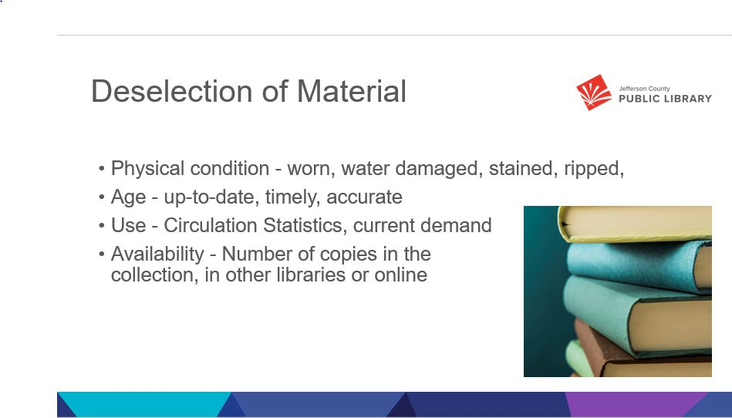

Deselection of materials- or collection maintenance, is essential for libraries. We continually assess our collection to ensure it is what our patrons want, that it is current and that it welcomes all people into our libraries. We have ﬁnite space and strive to be good stewards of it. Items are deselected from the collection for a variety of reasons such as:

* + - Physical condition – items in poor physical condition are removed- this includes water damage, odors, and crayon drawings
    - Items that are out of date and may have incorrect information- like travel books and encyclopedias
    - Items that are no longer of interest to the community- we have guidelines we use when evaluating if an item should remain on the shelf if it has not checked out for a signiﬁcant amount of time. That work is again done by expert staﬀ.
    - Availability- One example is when we purchase a NYT bestseller, initial demand is high so we need a lot of copies to meet the need. Once time has gone by and most people have read it, demand stabilizes and we may no longer need as many copies

Once our staﬀ have made the decision to deselect an item, usable materials are sent to the Foundation for book sales, items that are in poor physical condition are disposed of in the appropriate way for the material

Deselection Criteria include the following items

* Circulation Statistics
* Current demand and frequency of use
* Condition: worn, water damaged, chewed, stained, ripped, mildewed, defaced, etc.
* Information: up-to-date, timely, accurate
* Number of copies in the collection
* Availability of item and/or information in other libraries or online

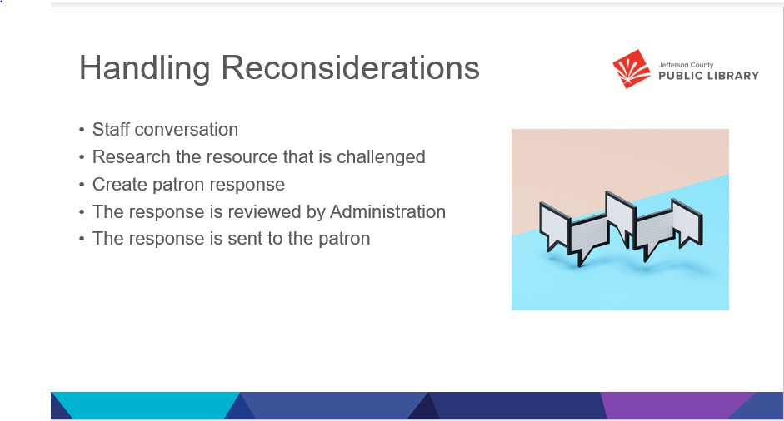

Requests for reconsideration are also an essential part of Collection maintenance. It is an additional data point to help us understand community needs and demand. Challenges to library books and resources do occur at JCPL. Our Collection Development Policy and Reconsideration of Library Resources Policy are in place to outline why we selected the material and how we will assess the challenged title. They support the core of what JCPL is as a public library: a library for all with a wide diversity of materials to support all residents of Jeﬀerson County.

Most reconsideration requests begin with a conversation between a patron and a staﬀ member when a patron asks why an item is in the collection, or how we decided to add it. Usually, that conversation is suﬃcient to answer the patron's question. Occasionally, the conversation doesn’t answer the question and a formal request for reconsideration is desired. When that happens the staﬀ member explains the reconsideration process and how to ﬁll out the form and also informs the patron that you must be a resident of Jeﬀerson County to ﬁle a request.

The same team that selects materials brings their expert knowledge to the reconsideration process. Once a Request for Reconsideration is received, they begin the response process. That includes

* + Checking if the person making the request is a Jeﬀerson County resident
  + Have we received other requests for reconsideration for that title?
  + Look for reviews of the item, and any awards it may have won
  + Verify the intended audience of the item
  + Reviewing or reading a copy of the item – taking particular care with the passages or items of concern, along with the context of the work as a whole
  + A response is written highlighting.
    - The patron’s concerns
    - Results of research on the title
    - Decision by JCPL about the request
  + The response is reviewed by Administration
  + The response is sent to the patron

In most cases that is the end of the interaction. Occasionally the requestor may have a follow-up question. While that is rare, the follow-up questions are treated with the same care as the initial request.

JCPL has averaged under 2 reconsideration requests per year over the last ﬁve years. We

feel this limit will meet our community needs

The Board did not have any questions regarding the presentation, the Collection Development Policy, or Reconsideration of Materials Policies updates.

The Chair reminded the Board that they will be voting on these policies at the February 20 Board meeting. The Chair asked the Board members to review these before the meeting and share any questions/comments with the Chair and Executive Director ahead of time so that they can address those as needed.

The Chair asked trustees if the policy changes addressed their concerns from the November review. Trustees aﬃrmed that the edits included statutory language which they wanted, as they strengthen our rationale and give stronger support for staﬀ decisions.

Trustee Harsha lost his connection and left the meeting at 6:33pm.

**Strategy & Operations**

Matt Griﬃn, Chief Strategy & Operations Oﬃcer introduced the Contingency request Budget Transfer and LED Lighting Update topics. The Board was informed that these two items are working in tandem together. JCPL carries contingency money in the budget each year. There is $500,000 in the budget this year. This number is reviewed each year during budgeting and can change. This year a new item came up due to the

Clean Lighting Act. We feel this project ﬁts the needs of contingency fund use, as we need to act and do not currently have a budget for this work. The costs for the project are just over $118,000, and we do not want to absorb that in a current line item. Using funds for this project would still leave approximately $380,000 in contingency. The last contingency transfer request was 4-5 years ago. We are comfortable with the remaining amount for this ﬁscal year.

There were no questions from the Board regarding the contingency funding request.

Steve Chestnut, Director of Facilities & Construction, provided more information on the project. The law went into eﬀect on January 1, and ﬂuorescent bulbs cannot be sold in Colorado. We still have three locations using ﬂuorescent lighting and now we need to convert them to LED as we will no longer be able to get items for building maintenance.

The Board was informed in response to questions that the project costs are what we will incur right now to retroﬁt the buildings. We do not anticipate seeing increased maintenance costs in the future because of this and may see some small level of savings as LED lighting tends to be more energy eﬃcient.

**Contracts & Agreements**

Standley Lake Library Audiovisuals Contract- Xcite Audiovisuals, LLC

The Executive Director noted that there was a change to this item and that it will not be on the consent agenda next week unless the Chair requests that it be moved there. We moved it to the regular agenda because this contract is part of the carryforward request. The Chair conﬁrmed that it can remain on the regular agenda and the Board will act on it separately.

The Executive Director asked the Board to conﬁrm that they were comfortable with the Collection Development and Reconsideration of Materials policies. There were no questions noted from the Board.

Board comments included:

* + That JCPL has been a model in operational policies, as demonstrated by the alignment with the statutes and are comfortable with the Board accepting the policies as written next week.

ADJOURNMENT The Study Session was adjourned at 6:43 p.m.

**Minutes of the Regular Meeting of the** JEFFERSON COUNTY PUBLIC LIBRARY **BOARD OF TRUSTEES**

February 20, 2025

CALL TO ORDER – REGULAR MEETING

The regular meeting of the Jefferson County Public Library Board of Trustees was held online via ZOOM and in-person in the Lakewood Library meeting room on February 20, 2025. Library Board of Trustees Chair, Kim Johnson, called the meeting to order at 5:31 p.m.

Other Trustees present: Emelda (Bing) Walker (Vice-Chair), Stanley Harsha (Secretary), Jill Fellman, Renny Fagan, and Charles Jones.

Trustees not present: Pam Anderson.

**Staff present:** Donna Walker, Executive Director; Julianne Rist, Library Planning & Policy Senior Advisor; Steve Chestnut, Director of Facilities and Construction Projects; Bernadette Berger, Chief Technology & Digital Innovation Officer; Matt Griffin, Chief Strategy & Operating Officer; Lisa Smith, Chief People & Culture Officer; Amy Bentz, Assistant Director of Library Design Projects and Planning; Jessica Paulsen, Assistant Director of Public Services for Customer Experience; Kelci Rude, Administrative Coordinator Supervisor; Ryan Turch, Technology and Innovation Operations Supervisor

There were additional Library staff members attending the meeting.

APPROVAL OF AGENDA

**MOTION:** Stanley Harsha moved that the Library Board of Trustees approve the agenda as presented. Seconded by Jill Fellman the motion passed by unanimous vote of all Trustees present.

PUBLIC COMMENT

The Board values public participation. Those who would like to address the Library Board can do so virtually, in-person, or online. The opportunity to address the Library Board does not include a question and answer session or response. Additionally, the Library Board does not respond to anonymous questions or comments. Comments will be acknowledged in the minutes of the meeting.

Anna Sparlin and Jill Hinn addressed the Board and provided public comment regarding staffing decisions at Conifer and Evergreen, and work environment and wage increases for staff.

The Chair advised the Board that one online public comment was received. The Chair closed the public comment portion of the meeting at 5:42 pm.

APPROVAL OF CONSENT AGENDA

The Chair asked the Trustees if any of the items should be removed from the consent agenda. There were no requests for items to be removed.

Items on the Consent Agenda

1. Approve Minutes of January 9, 2025 Study Session
2. Approve Minutes of January 16, 2025 Board Meeting

**MOTION**: Jill Fellman moved that the Library Board of Trustees approve the items on the consent agenda as presented. Seconded by Bing Walker the motion passed by unanimous vote of all Trustees present.

FOUNDATION UPDATE

Jo Schantz Hall, Foundation Executive Director, provided an update on the activities of the Foundation. Jo was recently married, and her new name is Jo Schantz Hall. The Foundation Board made the decision to close The Whales Tale 2 bookstore effective February 10, 2025, and focus attention on the bookstore in Colorado Mills. Jo presented naming opportunities at the Conifer Area Council meeting. The Books on Film series will be on July 2, showing Jurassic Park Rebirth. The Foundation is partnering with Dinosaur Ridge to host a post-film talk. Many naming rights have been completed in Conifer Library. There is continued interest and donations towards the permanent reading wall.

The Volunteer Appreciation Lunchion is on July 25 at Wheat Ridge Recreation Center. JCPL Trustees are invited to attend.

There were no questions. As the newly appointed Foundation liaison, Trustee Fagan noted his interest in connecting with Jo to learn more about the Foundation in the future.

EXECUTIVE DIRECTOR REPORT

1. Executive Director Report

The Executive Director informed the Board of a recommended change in annual plan regarding the Express Library - South project. In 2024 the Board authorized a supplemental budget request for JCPL to create an Express Library in South County as a new project. This stemmed from the Arvada Express Library's successful one-year evaluation. With the closing on Bradford Road, the Library studied options and decided to provide services on the property we purchased. The library recommended

removing the Express Library project from the annual plan and instead, implementing interim services on this property as an operational project in the South County Library Program. Funds carried forward for the project will revert back to the fund balance. The Board indicated consensus to remove the project from the annual plan and continue with the new approach.

1. Capital Building Projects Update

NW Jeffco: In response to a question from the Board, the Executive Director advised that the Library decided not to create a NW Jeffco advisory council. Unlike South County, the community is already fully onboard and doesn’t require the same advocacy. The Library has an embedded manager in the community to fill gap with people he’s meeting. Don’t see work for the council to do.

South County: JCPL is continuing community engagement to determine what people want to see in the Library. An engagement opportunity is available this Saturday at the property. Another one is happening on March 1st. Vendors and staff interview people at these events with a questionnaire like the survey. The team is excited about different ways to do engagement and we’re receiving good feedback. The Library would have needed 8 focus groups to get similar engagement.

Arvada: Getting pricing on the schematic design. Flintco, our General Contractor, has joined design team meetings. Meeting with the city in a couple weeks to discuss partnership opportunities to activate the space around library.

Conifer: More to come this evening.

1. Joan Atwater Naming Agreement

The Executive Director noted that the donor lives in Morrisson and is part of the book club in Conifer.

**MOTION**: Jill Fellman moved that the Library Board of Trustees approve the Donation and Name Recognition Agreement between Joan Atwater, the Jefferson County Library Foundation, Inc., and the Jefferson County Public Library. Seconded by Stanley Harsha the motion passed by unanimous vote of all Trustees present.

1. 2024 Year End Fundraising Report and 2025 Plan

Bridget Beatty, Bridget Beatty Consulting, LLC, addressed the Board to recap of previous year fundraising efforts and summarize the year end.

Goals And Objectives

The new model for fundraising is focused on increasing direct funding to JCPL from philanthropic sources. This enhances value to Jeffco residents and delivers more with greater impact.

2024 Recap

During Quarter 1 of last year JCPL, completed a Scope of Work and retained Bridget Beatty. During Quarter 2, parameters were established for this position, which included the pursuit of grants over

$25,000 with philanthropic sources. When 501c3 is required, Jefferson County Library Foundation will participate for a 5% indirect rate for fiscal sponsorship.

Grants Secured

Quarter 3 focused on relationship building and three grants were secured by year end, including Colorado Gives Foundation for Hard Times Workshops, Colorado Gives Foundation for Early Education & Literacy, and El Pomar Foundation for Capital for Conifer. Funds will be booked and spent in 2025. The goal was to raise $75,000 with the new model in 2024. Total raised was $75,799. After 5% indirect rate for fiscal sponsorship of the Colorado Gives Foundation grant, $73,320 was received direct to JCPL.

Highlight

Perspectives gathered from working with the Conifer community were incorporated into multiple funding proposals.

Under Development

JCPL and Bridget Beatty Consulting are continuing to work on internal coordination, noting there are many people involved in grant coordination internally. JCPL established a scheduling liaison for the role to help connect Bridget with staff who own the information internally to improve communication. Another focus area is consistent messaging, as there is a demand to be as in sync when talking to philanthropic partners about unmet needs.

On the Horizon

2024 was a pilot year. Now we’ve expanded to include public sources at the state or federal level.

2025 Prospects

Prospects shown include a decent or strong fit for JCPL’s unmet needs. The list does not indicate that entities have shown interest. The Denver Foundation is underway. We’re building a relationship with Anschutz Foundation. Gates Foundation might fit Hard Times Workshop. Great Outdoors CO could work for outdoor opportunities. CO Gives will have another grant opportunity; we’re prioritizing the Family Place in Arvada in conjunction with JCLF. The fundraising goal for 2025 is $150,000.

There were no questions. The Chair commented that 2024 was a very successful first year and was not even the full year. Even with the Foundation taking 5% indirect rate, she would call it making the goal. The Chair is excited about items identified as potential and shared gratitude for the work that been done.

OPERATIONAL UPDATES

**Strategy and Operations**

A. 2024 End of Year Report

Matt Griffin, Chief Strategy & Operating Officer, addressed the Board and shared that he would be recapping the prior year in his presentation and noted the full report is available in the memo. The presentation provided an overview of strategic projects and accomplishments, reviewed success measures and data points and finished with feedback from patrons.

Project Accomplishments

JCPL had great success in 2024. There was a bias towards action, and this is represented in the packet with a breadth and depth of projects. Examples of accomplishments include strong action within the South County project and forward momentum. All three deliverables for 2024 were met in 2024.

Acquisition of the property was in 2025. Much of the work for Imagination Library happened in Q3 and Q4 2024. The full project was kicked off and closed in 2024. The Talent Pipeline Development was an internal project that included many types of development: DEI training, leadership academies, leadership lunch and learns, book clubs, and an in depth talent pipeline assessment with Directors Team.

Library Benchmark Measures

JCPL had a record-breaking year in key performance indicators. The growth is tangible. Collection use is at an all-time high - 10 million for physical and digital materials. Circulation of e-materials grew by 10.1%. Program attendance was 220,000; a 10% increase from 2023. 20,000 patrons participated in the Jacqueline Woodson event alone. JCPL expanded reach and satisfaction with market penetration up by 4.3%. The Net Promoter Score increased as well.

On the broadest level, more people visited. Library visits climbed by 6% in 2024 versus 2023. The Library is a vital place in the community. This underscores our commitment to deliver what the community wants, and the data says we’re achieving this.

Feedback from Our Patrons

Additional patron feedback and quotes are included within packet. Feedback shows the Library is a community anchor, a safe learning space, and people recognize the detailed work that our team does.

Discussion

In response to a question, the Board was informed that market penetration is calculated using a service called Savannah. It is pulled from active card users based on residents as a percentage of the Jeffco resident total population. This shows the reach and how many people are utilizing the library versus how many have a card. Must be an active user to be counted. JCPL also benchmarks through Savannah software. Julianne Rist noted we’re about 10 points ahead of everyone else.

In response to a question, the Board was informed that the report is included the Board minutes and packet as presented. JCPL is looking at making a more user-friendly version for the website. The Chair noted that this would be wonderful to do, as it includes terrific information. It’s important to make sure we’re sharing with the public in an easy way and in something outside of the minutes. This

creates awareness of how much JCPL does in a year.

The Chair expressed an interest in garnering consensus for how the Board felt JCPL met their annual goals. The Board indicated consensus.

Board comments included:

* JCPL staff are dedicated to surpassing expectations. Their dedication and passion comes through the entire report.
* An amazing report; hopes the public widely reads.
* Thumbs up.
* Impressive.
* Sharing appreciation for the report.
* Expressed gratitude for comments on increasing program attendance; 10% over a year is double digits.
* It’s quite remarkable to see how many items were completed in a year.

The Executive Director noted that there were 58 deliverables for 16 projects. 56 were completed or in progress by the end of year. Only two were not started of the 58 deliverables. Of the 10 million total collection, 6.5 million were physical materials. It is helpful for board to know the number of touches for physical materials. Other notable updates that weren’t mentioned in the report include 2,000 appointments made for Book A Librarian, 50,000 items were checked out from holds lockers, there were 250,000 wireless sessions, we launched the digital library card, answered 54,000 calls, held 8,000 programs - half of which were Story Times, and almost 2 million people walked through our door. In summary, she hoped JCPL met expectations for the annual plan.

In response to a question, the Board was informed that it is difficult to track how many refugees and immigrants come into our libraries to find jobs or learn English. The Executive Director noted that we can get a language preference, but there are certain things we don’t ask. JCPL will take note to determine how to answer this question.

**Libraries and Inclusion**

A. Conifer Library Design Update

Julianne Rist, Library Planning & Policy Senior Advisor, introduced the topic. In conjunction with EUA, the Library shared the design for Conifer Library. Julianne noted that JCPL has valued our partnership with Conifer High School since 1996, but school hours impacted the Library. This prompted a look at library services for the community. JCPL engaged the community and determined the library was a community center and resource for the mountain area. They wanted the same amenities and feel as the other libraries in the system. Julianne introduced Lynsey Grace, Senior Project Manager: Associate, from EUA to walk through the design plans. EUA is the architect for Conifer.

Schedule

The last time EUA attended a JCPL Board meeting, they discussed community engagement. Since

that time, the design team has been producing design documents. Those are currently in for permitting. JCPL is working with Franssen Pittman to finalize price. The plan is to move into construction within the next month.

Recap Community Feedback

There were five key themes. The community is looking for a gathering place with increased hours. Collection materials need to be rethought and be more diverse for the whole community. Services need to be accessible for all patrons; for example, it’s hard to get to the library from the current parking lot. Spaces need to be flexible; provide multiple seating styles and acoustic separation.

Finally, there was an elevated focus for staff inhabiting the space.

Design meets needs

The design meets the needs for community gathering spaces, meeting rooms, study rooms, and a variety of furniture. Staff are working on tailoring the collection. The site provides parking near the entry. Flexible seating throughout the space. There is dedicated staff space to make the space functional.

Design Update

Based on community feedback, the “Into the Forest” concept was developed. The forest contains three zones: Zone 1 – The clearing with bright light, minimal color; Zone 2 - Tree line is transitional with an introduction of color; Zone 3 – located towards back, it represents the forest itself with saturated color and texture.

Floor Plan

Focused on entry progression. Beginning with sliding glass door, new signage and graphic film at vestibule to help identify an entry. The main library is open and flexible with defined zones for children, teens and adults. There is a community room on east side and staff space on the west.

Existing Storefront

The existing storefront was meant to have 3-5 retail spaces that we’re making into one. Plan to create a new entry. There will be a visual cue for where patrons should go. Second cue will be JCPL signage (internally illuminated design). The design will utilize impactful window film in the concept of pine needles, with grey tone towards exteriors and color saturation towards the entry point. Will add new lighting under the canopies. Two existing entrances will be turned into glass windows to define the new entry. Staff entrance on the right. Will keep code-required door for safety.

Interior Entry

Will utilize stacks and kiosks to provide natural separation. The main service point is visually located within the entrance. There is another service point in the adult area. Computers are also available here. There is flexible seating throughout the space; study cubes with high walls, lounge seating in teen area, study rooms and a meeting room that can be broken into smaller rooms.

Entry and Main Library Zone

The green panels in the Children’s area are acoustic panels to keep noise down. There is a power wall for community announcements.

Children’s and Teen Areas

Height of shelves provides enclosure to teen area beyond providing privacy. There is a TV monitor in the area.

Main Movement Axis

Computers are at low tables for children’s use. The grey blue area is study corral. There is a study room on the right. The far back blue wall is within the community room.

Community Room

Key feature: operable wall (letter A). In full form, the room can support 25-30 patrons. Each side can support 12-18 when split. Connection to library was critical; letter C is the connection via glass doors which encourages use of the space.

Community Room

Two monitors are available for when space is subdivided. Wall follows a track. The wall is white board for writing ability.

Staff Work Area

Staff have a dedicated entry. There is one office, a workroom for 2-4 staff, a breakroom, a respite room for nursing mothers or wellness needs, and mechanical and electrical rooms

In response to a question, the Board was informed that when the community room is divided, one side fits 12 people and the other fits 18. This is due to the function of the furniture and how many chairs can fit. If just chairs and no tables were used, the rooms would fit more people than that.

In response to a question, the Board was informed that the Library is planning a material return that’s outside and accessible 24/7, however it won’t be directly in building.

In response to a question, the Board was informed that the grant for Conifer will allow us to put in OpenPlus, to allow for expanded hours for self-service. Conifer could be open more hours than a standard library.

In response to a question, the Board was informed that the awnings will stay in front. There will be additional lighting. Signage will go above the door in the area between bottom of awning and top of the door. EUA is working with JCPL signage person.

In response to a question, the Board was informed that patrons cannot enter the community room from the door. The door is exit only unless there was an event where the door was propped open.

In response to a question, the Board was informed that the study room capacity shows two chairs

however patrons may be able to sit close and fit three people.

Board comments noted that the design looks beautiful. The community is very excited as it continues.

**Strategy and Operations**

A. Notice to Proceed Request for Conifer Library Tenant Improvements

Steve Chestnut, Director of Facilities and Construction Project noted that the next steps in Conifer Library are to get costs for design and do permitting and construction. Fransen Pittman provided a cost of $1,646,742.

The Executive Director advised the Board that we designed the library to JCPL standard, even though we don’t own the building. When we add everything up, including the Guaranteed Maximum Price, it’s trending over budget $111,000. This includes after-hours access. JCPL is still working on bringing the number down. JCPL couldn’t get value engineering done by this meeting. The desire is to move forward and move out of the school on schedule.

In response to a question, the board was informed that JCPL could incur savings down the road in the lighting package. There is a contingency but we don’t want to dip into it. There are pending value engineering savings on a mechanical item. If the Board has concerns about the budget, we can find other furniture to bring in; as presented everything is new. We’re currently trending $100,000 over for the $2.5 million project budget.

The Board commented that the architect and builders are trying to make the library as quality as possible, like other libraries. Residents of Conifer really appreciate that.

**MOTION**: Stanley Harsha moved that the Library Board of Trustees authorize the Executive Director to issue a Notice to Proceed (NTP) to Fransen Pittman LLC under the terms of master contract TM 22-1424, based on the final Guaranteed Maximum Price of $1,646,742. Seconded by Jill Fellman the motion passed by unanimous vote of all Trustees present.

B. Contingency request Budget Transfer There were no questions.

**MOTION**: Jill Fellman moved that the Library Board of Trustees authorize the Executive Director to execute the budget transfer of $118,631 from the Contingency fund to ARM 01. Seconded by Bing Walker the motion passed by unanimous vote of all Trustees present.

C. LED Lighting Contract There were no questions.

**MOTION**: Renny Fagan moved that the Library Board of Trustees authorize the Executive Director to execute a contract with Colorado Lighting, Inc. in the amount of $118,631. Seconded by Jill Fellman the motion passed by unanimous vote of all Trustees present.

**Finance and Budget**

A. Financial Report (January 2025)

Matt Griffin, Chief Strategy & Operating Officer, addressed the Board and provided information on the January 2025 monthly financials. He noted that in the first month of spending in 2025, the Library is on track and in a healthy position. The January Table 1 showing the operating budget at 7% is on track. Capital projects appear like we’re trending above budget but that is not quite the case due to large spending in January against South County acquisition and the 2025 budget doesn’t include carry forward requests here. The budget would increase with carryforward process.

There were no questions.

B. Carryforward Request for Fiscal Year 2025 Budget Amendment

Matt Griffin, Chief Strategy & Operating Officer, addressed the Board and noted that we go through this process every year in February. We look at what was budget but wasn’t spent in 2024. If we need that money in 2025, we can supplement the current budget. Anything not carried forward flows back into fund balance. We identify these projects and amounts to add to 2025 budget to achieve against these projects.

In response to a question, the Board was informed that there is no carryforward for Northwest Jeffco. There is enough in the current 2025 budget to cover plans for the year.

In response to a question, the Board was informed that the $11 million is the unspent funds to bring into 2025. JCPL did not have the total unspent funds available in that moment.

In response to a question, the Board was informed that because of the timing of the South County acquisition in 2025, we always must have funds in the budget to cover that year’s budget. This is difficult for multi-year projects. We’re readjusting for this year’s budget. We need the total budget to cover those needs. The total project budget doesn’t change, just how it’s sifted between years.

The Chair noted that carryforwards have to do with the county needing to know how much we need to spend.

**MOTION**: Charles Jones moved that the Library Board of Trustees authorize the Executive Director to submit the carryforward budget amendment in the amount of $11,435,126. Seconded by Jill Fellman the motion passed by unanimous vote of all Trustees present.

**Technology & Digital Innovation**

A. Xcite Standley Lake Library Audiovisuals Contract There were no questions.

**MOTION**: Stanley Harsha moved that the Library Board of Trustees authorize the Executive Director to sign a contract with Xcite Audiovisuals LLC in the base amount of $104,343.39.

Seconded by Jill Fellman the motion passed by unanimous vote of all Trustees present.

ITEMS REMOVED FROM THE CONSENT AGENDA

No items were removed from the consent agenda.

EMERGING ISSUES

No issues.

ENDS

There were no items.

BOARD GOVERNANCE

1. Nominating Committee report to the Board: Proposed Slate of Officers

Trustee Fellman noted that the information is in the packet. She also voiced appreciation for the Chair, Vice Chair, and Secretary agreeing to serve the community for another year. The Chair thanked Trustee Fellman and Trustee Anderson for their work on the committee meeting.

1. Bylaws Committee status update

Trustee Walker advised the Board that plans are in the works to review the bylaws. They are in a reviewable document. Trustee Walker and Trustee Fagan will reconvene for edits and suggestions of edits will be reviewed. The Chair thanked Trustee Walker for the update and work on the committee.

1. Library Board of Trustees Review Policy Governance Monitoring Reports 2.0 to 2.4. Adoption will be on the consent agenda for the March 20, 2025 Board meeting unless otherwise instructed by the Board

In response to a question, the Board was informed that in regards to word choice in policy 2.1, the Executive Director chose “enable” instead of “ensure.” The word “ensure” implies a guarantee. We want to say that they’re designed to enable patron privacy, but ensure is a step farther – we do everything we can. The Chair noted that she can appreciate not wanting to use “ensure,” however “enable” doesn’t feel quite strong enough. The Executive Director noted that JCPL can provide another edit ahead of time in the packet the week before and move this item to the consent agenda. The Chair encouraged the Board to read through the policies and reach out with questions. Edits can be made before approval in March.

1. Board adopts Governing Policies
   * 4.10 Collection Development

There were no questions.

**MOTION**: Renny Fagan moved that the Library Board of Trustees adopt Governing Policy 4.10 Collection Development as recommended. Seconded by Charles Jones the motion passed by unanimous vote of all Trustees present.

* + 4.10.1 Reconsideration of Library Resources There were no questions.

**MOTION**: Renny Fagan moved that the Library Board of Trustees adopt Governing Policy

4.10.1 Reconsideration of Library Resources as recommended. Seconded by Charles Jones the motion passed by unanimous vote of all Trustees present.

BOARD SCHEDULE – NEXT MEETINGS

2025 Board Meeting Schedule

* March 13, 2025 –Study Session Hybrid: Virtual via ZOOM. In-Person Location: Lakewood Library Meeting Room
* March 20, 2025 – Board Meeting – 5:30 pm Hybrid: Virtual via ZOOM. In-Person Location: Lakewood Library Meeting Room
* April 10, 2025 –Study Session Hybrid: Virtual via ZOOM. In-Person Location: Lakewood Library Meeting Room
* April 17, 2025 – Board Meeting – 5:30 pm Hybrid: Virtual via ZOOM. In-Person Location: Lakewood Library Meeting Room

ANNOUNCEMENTS/GENERAL INFORMATION SHARING

There were no announcements.

No questions or comments or evaluations.

EXECUTIVE SESSION:

At 7:13 pm, the Chair called for a motion to adjourn the regular meeting, reconvene in Executive Session regarding Collective Bargaining and adjourn the regular Board meeting at the conclusion of the Executive Session.

**MOTION**: Jill Fellman moved to adjourn the regular meeting of the Library Board of Trustees, reconvene in Executive Session regarding 1. Collective Bargaining and

2. Urban Renewal Authority AND adjourn the Regular Board meeting at the conclusion of the Executive Session. Statutory citation authorizing an executive session for these topics are:

* Pursuant to 24-6-402(4)(e)(I) for discussion of strategy and instructions to negotiators
* Pursuant to 24-6-402(4)(b) Conferences with an attorney for the local public body for the purposes of receiving legal advice on specific legal questions

Seconded by Charles Jones the motion passed by unanimous vote of all Trustees present.

The Chair announced a five-minute break to allow the Board and staff to clear the room, leave the existing ZOOM meeting and then join the Executive Session.

The Chair called the Executive Session to order at 7:20 pm with the following Trustees present: Charles Jones, Jill Fellman, Stanley Harsha, Renny Fagan, and Emelda (Bing) Walker. Also present were Kurt Behn, Steve Sprin, Donna Walker, Executive Director; Bernadette Berger, Chief Technology & Digital Innovation Officer; Lisa Smith, Chief People & Culture Officer; Matt Griffin, Chief Strategy & Operating Officer; and Kelci Rude, Administrative Coordinator Supervisor.

It is noted that the session was recorded and that the recording will be retained for the required 90 days.

CALL FOR ADJOURNMENT OF EXECUTIVE SESSION

**MOTION**: At 8:04 pm Stanley Harsha moved to adjourn the Executive Session. Seconded by Charles Jones the motion passed by unanimous vote of all Trustees present.

It is noted that the Library Board of Trustees met in Executive Session concerning Collective Bargaining and Urban Renewal Authority pursuant to 24-6-402(4)(e)(I) for discussion of strategy and instructions to negotiators and pursuant to 24-6-402(4)(b) Conferences with an attorney for the local public body for the purposes of receiving legal advice on specific legal questions. The Trustees held those discussions, and this summary is provided as required by Colorado Statute.

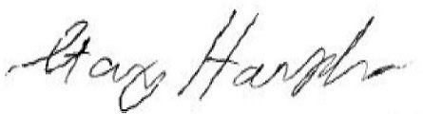

Stanley Harsha, Secretary

GOVERNING POLICIES MANUAL TABLE OF CONTENTS

|  |  |  |  |  |  |  |  |  |  |  |  |  |  |  |  |  |  |
| --- | --- | --- | --- | --- | --- | --- | --- | --- | --- | --- | --- | --- | --- | --- | --- | --- | --- |
| **I** | | | **CATEGORY: ENDS** | | | | | | | **Page** | **Review Date** | | | **Adoption/Revision/**  **Review** | | | |
| 1-4 | | | Global Ends Statements | | | | | | | 2 | Annually - January | | | Adopted January 2020. Reviewed  January 2024 | | | |
| **II** | | | **CATEGORY: MANAGEMENT**  **LIMITATIONS** | | | | | | |  |  | | |  | | | |
|  | 2.0 |  |  | General Management Constraint | | | |  | |  |  | Annually - February |  |  | March 2024 |  | |
|  | 2.1 |  |  | Treatment of Patrons | | |  | | |  |  | Annually – February |  |  | March 2024 |  | |
|  | 2.2 |  |  | Treatment of Staff | |  | | | |  |  | Annually – February |  |  | March 2024 |  | |
|  | 2.3 |  |  | Financial Condition and Activities | | | | |  |  |  | Annually - February |  |  | December 2024 | |  |
|  | 2.4 |  |  | Asset Protection |  | | | | |  |  | Annually - February |  |  | December 2024 | |  |
| 2.5 | | | Financial Planning/Budgeting | | | | | | | 21-23 | Annually - August | | | August 2024 | | | |
| 2.6 | | | Compensation and Benefits | | | | | | | 24-25 | Annually - August | | | August 2024 | | | |
| 2.7 | | | Emergency Executive Director Succession | | | | | | | 26 | Annually - August | | | August 2024 | | | |
| 2.8 | | | Board Awareness and Support | | | | | | | 27-31 | Annually - August | | | August 2024 | | | |
| 2.9 | | | Materials Selection | | | | | | | 32-33 | Annually - August | | | August 2024 | | | |
| **III** | | | **CATEGORY: BOARD-MANAGEMENT**  **DELEGATION** | | | | | | |  |  | | |  | | | |
| 3.0 | | | Governance-Management Connection | | | | | | | 34 | As Needed | | | July 2008 | | | |
| 3.1 | | | Unity of Control | | | | | | | 35 | As Needed | | | July 2008 | | | |
| 3.2 | | | Accountability of the Executive Director | | | | | | | 36 | As Needed | | | January 2009 | | | |
| 3.3 | | | Delegation to the Executive Director | | | | | | | 37 | As Needed | | | December 2023 | | | |
| 3.4 | | | Monitoring the Executive Director’s  Performance | | | | | | | 38-39 | As Needed | | | February 2013 | | | |
| **IV** | | | **CATEGORY: GOVERNANCE PROCESS** | | | | | | |  |  | | |  | | | |
| 4.0 | | | Governance Commitment | | | | | | | 40 | As Needed | | | May 2005 | | | |
| 4.1 | | | Governing Style and Values | | | | | | | 41-42 | As Needed | | | May 2016 | | | |
| 4.2 | | | Board Job Products | | | | | | | 43-44 | As Needed | | | December 2023 | | | |
| 4.3 | | | Agenda Planning | | | | | | | 45-47 | As Needed | | | January 2024 | | | |
| 4.4 | | | Chair’s Role | | | | | | | 48 | As Needed | | | July 2008 | | | |
| 4.5 | | | Board Members’ Code of Conduct | | | | | | | 49-50 | As Needed | | | July 2008 | | | |
| 4.6 | | | Board Committee Principles | | | | | | | 51 | As Needed | | | July 2008 | | | |
| 4.7 | | | Board Committee Structure | | | | | | | 52 | As Needed | | | July 2008 | | | |
| 4.8 | | | Governance Budget | | | | | | | 53 | As Needed | | | May 2006 | | | |
| 4.9 | | | Policies, Statements and Guidelines | | | | | | | 54 | As Needed | | | Adopted March 2021 | | | |
| 4.9.1 | | | Board of Trustees Budget Cover Letter to BCC | | | | | | | 54 | As Needed | | | Adopted March 2021 | | | |
| 4.9.2 | | | Capital & Controlled Asset Management Policy | | | | | | | 55 | As Needed | | | Adopted March 2021 | | | |
| 4.9.3 | | | Library Fund Reserve Policy | | | | | | | 56 | As Needed | | | Adopted March 2021 | | | |
| 4.9.4 | | | Capital Project Funding Internal Guideline | | | | | | | 57 | As Needed | | | Adopted March 2021 | | | |
| 4.9.5 | | | Library Books & Materials Budget Policy | | | | | | | 58 | As Needed | | | Adopted March 2021 | | | |

**POLICY TITLE: *GENERAL MANAGEMENT CONSTRAINT***

*MANAGEMENT LIMITATIONS*

**Initial Monitoring on Policy 2.0: *GENERAL MANAGEMENT CONSTRAINT***

I hereby present my monitoring report on your Management Limitations policy 2.0 “General Management Constraint”, in accordance with the monitoring schedule set forth in Board policy. I certify that the information contained in this report is true.

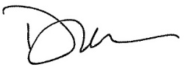

Signed: , Executive Director Date: March 21, 2024

BROADEST POLICY PROVISION

The Executive Director shall not cause or allow any practice, activity, decision or organizational circumstance that is unlawful, imprudent, or in violation of commonly accepted professional ethics and best practices for public library management.

**EXECUTIVE DIRECTOR’S INTERPRETATION:** I understand this constraint to include all operational activities that occur within the Library. It does not include activities or decisions occurring or made at the Board level.

I interpret “unlawful” to mean I will not fail to ~~insure~~ **ensure** that all operational activities are within legal requirements as imposed by all relevant governing bodies, including federal, state, county and city statutes and ordinances.

In matters of prudence and ethics, the Board has comprehensively interpreted these concerns throughout the “Management Limitations”. In areas where no specific Board policy exists; I will use the test of “reasonable and prudent” to evaluate the circumstances. In addition, I understand that “commonly accepted professional ethics and best practices for public library management” is an additional qualifier of the Board’s intentions. By this, if an issue arises which I believe my response would be judged ethical and prudent but for some reason inconsistent with common practices in public libraries; I would not necessarily have the authority to proceed.

**REPORT (COMPLIANT):** The implementation of the above measures is incorporated into specific monitoring reports provided to the Board on each of the other Management Limitations policies. I therefore am focusing this response on this policy provision proscribing against any “unlawful” actions or situations.

I can report compliance.

**POLICY TYPE: MANAGEMENT LIMITATIONS POLICY 2.1 POLICY TITLE: *TREATMENT OF PATRONS***

*MANAGEMENT LIMITATIONS*

**Initial Monitoring on Policy 2.1: *TREATMENT OF PATRONS***

I hereby present my monitoring report on your Management Limitations policy 2.1 “Treatment of Patrons”, in accordance with the monitoring schedule set forth in Board policy. I certify that the information contained in this report is true.



Signed: , Executive Director Date: March 21, 2024

BROADEST POLICY PROVISION

With respect to interactions with patrons, the Executive Director shall not cause or allow conditions or procedures which are unfair, unsafe, disrespectful, unnecessarily intrusive, or which fail to provide confidentiality in use of facilities and resources, and which fail to provide a high level of customer service.

**EXECUTIVE DIRECTOR’S INTERPRETATION**: I understand this to mean that the Library may not operate without having and enforcing specific policies that clarify patron rights and staff actions toward patrons. The Executive Director, staff and legal counsel review the policies as needed.

**REPORT:** The Library requires regular reporting from all units on these elements. Initial and follow-up reports are issued to Management for review or action.

1. I shall not elicit and maintain patron information for which there is no clear necessity.

**EXECUTIVE DIRECTOR’S INTERPRETATION:** It is our responsibility to protect the patron’s privacy in their use of the library, its programs and services, neither requesting nor maintaining information (visual, written or otherwise) about our patrons beyond that either required by law or business necessity.

**REPORT (COMPLIANT):** We are committed to keeping information about an individual’s use of the library only as long as needed in order to provide Library services. Full and current ~~guidelines~~ **policies** for the public will be posted on the JCPL website and updated when and as conditions change.

Colorado State law (CRS 24-90-101 et seq.) requires that we treat as confidential information about materials users check out, information they access, and their use of the library. CRS 24-73-101, 102, 103 requires that we keep patron personally identifiable information secure and properly dispose of this information.

I can report compliance.

1. I shall not collect, review, transmit, store or destroy patron information in a manner that fails to protect against loss of or improper access to that information.

**EXECUTIVE DIRECTOR’S INTERPRETATION:** It is my interpretation that we must ensure that the documents or online gathering of patron data are handled in a manner, from collection until destruction, that avoids inappropriate access or loss of such data.

**REPORT (COMPLIANT)**: We are committed to keeping information about an individual’s use of the library only as long as needed in order to provide Library services. Full and current ~~guidelines~~ **policies** for the public will be posted on the JCPL website and updated when and as conditions change.

Colorado State law (CRS 24-90-101 et seq.) requires that we treat as confidential information about materials users check out, information they access, and their use of the library. CRS 24-73-101, 102, 103 requires that we keep patron personally identifiable information secure and properly dispose of this information.

I can report compliance.

1. I shall not fail to maintain facilities that provide a reasonable level of privacy, both aural and visual, and that are reasonably free from public distraction and disturbance.

**EXECUTIVE DIRECTOR’S INTERPRETATION:** Our libraries are designed and managed to serve large populations of users at one time. As such, the library provides many venues for quiet reading and study, computer privacy, individual and group study space, etc. All libraries have spaces and/or equipment to assist with this and staff is instructed to assist patrons with finding a suitable work environment that meets their needs.

**REPORT (COMPLIANT):** Library programs and services are designed to ~~ensure~~ **~~enable~~ protect** patron privacy in the use of the library. As new technologies and services are added to our program of service, operational activities are vetted between library staff ~~and the Director of Public Services~~, **the Chief Libraries & Inclusion Officer and the Chief Technology & Digital Innovation Officer**. When space limitations exist, every effort is made to ~~ensure~~ **~~enable~~ protect** as much patron privacy as possible.

I can report compliance.

1. I shall not fail to maintain the confidentiality of a patron’s use of the JCPL and patron record except as required by law.

**EXECUTIVE DIRECTOR’S INTERPRETATION:** Records of patrons’ usage of the Library will not be divulged except when necessary for normal library operations or as provided for in CRS 24-90-119, “Privacy of User Records.” I have been designated “Custodian of Library Records” by the Board and can make reasonable exception to this requirement.

**REPORT (COMPLIANT):** We are committed to keeping information about an individual’s use of the library only as long as needed in order to provide Library services. Full and current

~~guidelines~~ **policies** for the public will be posted on the JCPL website and updated when and as conditions change.

Colorado State law (CRS 24-90-101 et seq.) requires that we treat as confidential information about materials users check out, information they access, and their use of the library. CRS 24-73-101, 102, 103 requires that we keep patron personally identifiable information secure and properly dispose of this information.

I can report compliance.

1. I shall not fail to ensure that patrons receive prompt, courteous service from competent, well- trained staff.

**EXECUTIVE DIRECTOR’S INTERPRETATION:** Educational and training requirements

for knowledge, skills and customer service are required and provided to effect useful and respectful service toward our patrons.

**REPORT (COMPLIANT):** The Library ensures that all hires possess the required education, training and experience for their jobs and have the training required to successfully fulfill their job requirements. Mechanisms are in place for patron complaints and compliments.

I can report compliance.

1. I shall not fail to set and convey the policies for the use and circulation of library materials; fines/charges for damaged or lost items; a fee schedule for non-basic Library services; and policies for the use of bulletin boards and meeting/study rooms.

**EXECUTIVE DIRECTOR’S INTERPRETATION:** Policies are in place that effectively direct public use of materials, resources, and facilities, so that all patrons can use our libraries and resources in a reasonable and responsible manner. We inform patrons of these policies. Staff is also versed in the policies such that they can address and discuss them with patrons.

**REPORT (COMPLIANT):** All of the library policies regarding library use are reviewed and updated as needed.

I can report compliance.

1. I shall not fail to enforce clearly articulated policies regarding content and control standards for Internet use and safety.

**EXECUTIVE DIRECTOR’S INTERPRETATION:** Internet use policies derive largely from state law, as interpreted by the Library and attorney. Access to internet sites complies with filtering as required by law and Board**-**directed library policy. Staff and the public are made aware of these policies so that user and staff expectations are clear. Staff is trained to recognize non-compliant use and intervene if necessary.

**REPORT (COMPLIANT):** Our principal responsibility is to be compliant with state statute and

Library Board direction within the limits of technology. I can report compliance.

1. I shall not fail to convey that parents, guardians or caretakers are responsible for monitoring the activities and library use and controlling the behavior of children or other persons requiring supervision during their library visit.

**EXECUTIVE DIRECTOR’S INTERPRETATION:** It is my understanding that we have a responsibility to inform parents/guardians/caretakers that it is their responsibility, not the Library’s, to control use and provide reasonable supervision to their children or charges when visiting/using the library. Staff is directed to intervene when inappropriate or illegal behaviors/actions interfere with or disrupt others’ use of the library and its resources.

**REPORT (COMPLIANT):** Norms and practices in the Library’s Code of Conduct have been developed to assist staff in making these decisions. We also have our Code of Conduct posted on our website and will print it when asked by our public.

I can report compliance.

1. I shall not fail to inform patrons, when appropriate, of this policy, and to provide an open, accessible patron comment process.

**EXECUTIVE DIRECTOR’S INTERPRETATION:** It is my understanding that we must inform patrons of library policies that concern and/or protect their use and rights in the library. As well, we must provide a patron comment process so that patrons have the opportunity to express their concerns to administration and management.

**REPORT (COMPLIANT):** The library uses several means by which to solicit and engage in patron comment including personal interactions with staff, electronic and print comment

forms, an open-door process for the public to speak with management or administration, electronic and telephone communications and electronic options on the website. We also have our policies posted on our website and will print them when asked by our public.

I can report compliance.

1. I shall not fail to take appropriate steps to safeguard the safety of library patrons.

**EXECUTIVE DIRECTOR’S INTERPRETATION:** I understand that this provision requires me to develop and implement policies and practices to ensure patron safety.

**REPORT (COMPLIANT):** We strive to maintain a high level of patron safety conditions. To confirm our safety standards, key staff along with local law enforcement conduct safety audits of public use areas. We also maintain and use safety/emergency mechanisms such as fire extinguishers and sprinklers, detection and alarm systems, AEDs and surveillance cameras. As well, each library establishes a working relationship with their local law enforcement agencies. The

library's Person-In-Charge program trains staff to assist with patron safety be it physical safety, threat or medical.

I can report compliance.

**POLICY TYPE: MANAGEMENT LIMITATIONS POLICY 2.2 POLICY TITLE: *TREATMENT OF STAFF***

*MANAGEMENT LIMITATIONS*

**Initial Monitoring on Policy 2.2: *TREATMENT OF STAFF***

I hereby present my monitoring report on your Management Limitations policy 2.2 “Treatment of Staff”, in accordance with the monitoring schedule set forth in Board policy. I certify that the information contained in this report is true.



Signed: , Executive Director Date: March 21, 2024

BROADEST POLICY PROVISION

With respect to the treatment of staff and volunteers, the Executive Director shall not cause or allow conditions that are unfair, unsafe, disrespectful or inconsistent with the Jefferson County Personnel Rules, by which the Library abides.

**EXECUTIVE DIRECTOR INTERPRETATION:** The Board has comprehensively addressed this policy in the provisions below. My interpretations and reporting data are appended below.

Accordingly, pertaining to staff, I shall not:

1. Operate without a written personnel manual, which clarifies personnel rules for staff.

**EXECUTIVE DIRECTOR INTERPRETATION:** The Library must have in place a personnel manual that sets forth the rules and policies regarding employment with the Library.

**REPORT (COMPLIANT):** The Library uses the Jefferson County Personnel Rules for our personnel manual.

I can report compliance.

1. **Fail to provide staff with avenues for non-disruptive, internal expression of opinions. EXECUTIVE DIRECTOR INTERPRETATION:** I understand this policy to mean that staff must know and be allowed to freely express their support, opposition, and concerns with the Library’s policies and practices without fear of reprisal, and in accordance with the rules and regulations established in SB22-230.

**REPORT (COMPLIANT)**: New Library staff members are made aware that open and honest communication is encouraged at Jefferson County Public Library during their orientation process, and long-standing staff members are aware of this through administrative and management messaging. Jefferson County Public Library is an Equal Opportunity Employer and does not tolerate discrimination and harassment. The Library recruits, hires, trains and promotes employees without regard to race, color, religion, sex, national origin, age, disability, sexual orientation or any other status protected by Federal or State law. The Library will not tolerate retaliation for opposing discrimination and harassment. The Library adheres to a formal complaint process, which is

available to staff, through Jefferson County Personnel Rules. **Certain complaints made by employees in the collective bargaining unit may be subject to additional processes involving AFSCME representation.**

I can report compliance.

1. Fail to acquaint staff with these Federal, State and County laws and Library policies.

**EXECUTIVE DIRECTOR INTERPRETATION:** It is my responsibility to ensure that all staff is informed of these policies.

**REPORT (COMPLIANT):** These policies are available online, on the staff intranet or included in the personnel manual and staff has access to them. **Staff are required to sign off annually on personnel rules.**

I can report compliance.

1. Allow staff to be unprepared to deal with emergency situations.

**EXECUTIVE DIRECTOR INTERPRETATION:** I understand this to mean that staff will be informed and trained on emergency policies and practices and appropriate staff will be trained to deal with emergency situations.

**REPORT (COMPLIANT):** The Library schedules regular Person-In-Charge (PIC) trainings where staff receives additional training for emergency situations. In turn, all libraries have a trained “Person in Charge” (PIC) on duty during hours of operations. Director-level staff are available to serve as the Senior PIC where immediate assistance and direction is provided to the location/library PIC, staff and law enforcement. Further, all incidents are reported and evaluated, to improve future response. Additional support and training is provided by subject-matter experts as needed to prepare staff to respond to specific circumstances. **Staff are required to review and sign off annually on basic safety guidelines.**

I can report compliance.

**POLICY TYPE: MANAGEMENT LIMITATIONS POLICY 2.3 POLICY TITLE: *FINANCIAL CONDITION AND ACTIVITIES***

*MANAGEMENT LIMITATIONS*

**Initial Monitoring on Policy 2.3: *FINANCIAL CONDITION AND ACTIVITIES***

I hereby present my monitoring report on your Management Limitations policy 2.3 “Financial Condition and Activities”, in accordance with the monitoring schedule set forth in Board policy. I certify that the information contained in this report is true.



Signed: , Executive Director Date: March 21, 2024

BROADEST POLICY PROVISION

With respect to financial condition and activities, the Executive Director shall not cause or allow the development of fiscal jeopardy, or a material deviation of actual expenditures from the Library Board’s Ends priorities.

**EXECUTIVE DIRECTOR INTERPRETATION:** The Board has comprehensively interpreted this policy in the provisions below. My interpretations and reporting data are appended below.

Accordingly, I shall not:

1. Exceed the Library’s total expenditure authorization for operations or capital development.

**EXECUTIVE DIRECTOR INTERPRETATION:** This requirement prohibits my spending on behalf of the library above the pre-set operations and/or capital development authorizations established by the Library Board and adopted by the Board of County Commissioners during the budget approval process. If circumstances arise where expenditure above the appropriated level is necessary, I must follow the budget transfer process or the supplemental appropriation process, outlined in the Library’s Budget Expenditure policy or the provisions of 4 below.

**REPORT (COMPLIANT):** The Library’s expenditure is reviewed monthly against the total amount authorized and reported in the financial statement. This report discloses year-to-date and projected expenses to the end of the year and is included in the monthly Board reports for informational and review purposes. It also includes any required requests and processes for budget transfers when circumstances arise that require expenditures above the appropriated amount.

I can report compliance.

1. Incur debt (with exception of procurement cards, which are to be paid in full when due).

**EXECUTIVE DIRECTOR INTERPRETATION:** I understand that no library debt can be incurred without the approval of the Library Board other than short-term procurement card debt, which must always be paid when due. The Library Board can authorize debt as defined in the

“Library Law,” or by entering into long-term capital debt by other means.

**REPORT (COMPLIANT):** Monthly financial statements issued by the ~~Finance~~ **Strategy & Operations** division demonstrate all outstanding obligations which would show any debt as part of the report. These reports are compiled and reviewed monthly by the Library Board.

I can report compliance.

1. Fail to get Library Board approval for:
   1. **Use of the Library Fund**

**EXECUTIVE DIRECTOR INTERPRETATION:** Accordingly, expenditures that have not been approved by the Board cannot be made in advance.

**REPORT (COMPLIANT):** Monthly financial reports regularly report compliance with this limitation. Requests come before the Board when its approval is required for an expense change.

I can report compliance.

* 1. Use of Fund Balance

**EXECUTIVE DIRECTOR INTERPRETATION:** This limitation requires Board review and approval before any use of fund balance can take place, with the exception of automatic working capital drawdowns until tax collection proceeds are posted to our fund.

**REPORT (COMPLIANT):** All use of reserves (and requests for use of reserves) is shown on budget development plans or financial reports, which are reviewed and approved by the Board.

I can report compliance.

* 1. Adding any salaried staff positions. This means that no new standard FTE positions beyond currently authorized positions can be added unless they are recommended by me and approved by the Library Board according to their authority under Colorado Library Law.

**EXECUTIVE DIRECTOR INTERPRETATION:** This means that no new salaried positions can be added unless they are recommended by me and approved by the Library Board.

**REPORT (COMPLIANT):** I review and act upon all requests for staffing changes which are ~~in~~ ~~my monthly reports and~~ in the annual budgeting process.

I can report compliance.

1. Authorize transfers of greater than $100,000 among line items and categories within the operational fund.

**EXECUTIVE DIRECTOR INTERPRETATION:** Budget transfers less than $100,000 between expense lines are allowed without board approval but non-emergency transfers greater than

$100,000 require Board authorization. The Executive Director may authorize transfers in excess of

$100,000 when an emergency situation exists and must inform the Board about all emergency transfers as soon as practical.

**REPORT (COMPLIANT):** All budget transfers follow the above guidelines, and any transfers are reported in the monthly financial statements.

I can report compliance.

1. Fail to settle payroll obligations and payables in a timely manner.

**EXECUTIVE DIRECTOR INTERPRETATION:** This means that we must process all payables in as timely a manner as possible if not in accordance with the vendor’s dictates. Payrolls are processed in accordance with County policy.

**REPORT (COMPLIANT):** Payables are processed in a timely manner, normally weekly. With regard to payroll, all staff is paid bi-weekly, pay periods end every other Saturday and paydays are every other Friday.

I can report compliance.

1. Allow payroll or other tax payments or other government ordered payments or filings to be overdue or inaccurately filed.

**EXECUTIVE DIRECTOR INTERPRETATION:** The schedules of tax payments to other government units are strictly observed. The principal payment is payroll taxes**.**

**REPORT (COMPLIANT):** Payroll taxes are paid by the County as part of normal payroll practice and are reflected in our financial statements.

I can report compliance.

1. Expend more on a capital project than the amount previously authorized by the Board.

**EXECUTIVE DIRECTOR INTERPRETATION:** This means that capital project expenditures greater than approved must not occur without Board approval. However, small transfers (being no more than 10% of the total cost of the project or $100,000, whichever is less) between individual project funds may be necessary, as they are completed.

**REPORT (COMPLIANT):** Monthly capital projects reports show the comparison between budgeted and actual expense of each project.

I can report compliance.

1. Acquire, encumber, lease or dispose of real property.

**EXECUTIVE DIRECTOR INTERPRETATION:** By statute, the Library Board is the only authority empowered to hold and acquire property. This means that all decisions regarding real property and buildings, whether owned or leased, must be reviewed and approved by the Board.

**REPORT (COMPLIANT):** The Library Board holds the authority for acquiring property. The Library Board approves all leases, disposals and acquisitions of real property. The Library Board also approves all issues of debt which could encumber real property.

I can report compliance.

1. Accept gifts or grants from sources that are not, in fact and appearance, legal and consistent with the mission and values of the library.

**EXECUTIVE DIRECTOR INTERPRETATION:** This means that the Library (nor I on behalf of the Library), cannot accept any gifts or grants when they appear to be inconsistent with our mission and role.

**REPORT (COMPLIANT):** Through the Agreement between the Library and the Jefferson County Library Foundation, some gifts to the Library are processed through the Foundation. These require Library review. Gifts or grants processed through the Library require executive director or designee review. The Library retains the right to specify the disposition of any gift.

I can report compliance.

1. Fail to pursue material receivables after a reasonable grace period.

**EXECUTIVE DIRECTOR INTERPRETATION:** This means that we must take action to recover material receivables. Material receivables are defined as accounts with an accumulation of overdue payables in the amount greater than $500.00 for over 28 days.

**REPORT (COMPLIANT):** Accounts over $500.00 and over 60 days overdue are notified and informed of the need to submit payment. Accounts past due over 90 days may be sent to collection.

I can report compliance.

1. Fail to exercise adequate internal controls over receipts and disbursements to avoid unauthorized payments or material dissipation of assets.

**EXECUTIVE DIRECTOR INTERPRETATION:** This means that we must have in place a process of checks and balances to maintain accountability both for payments and for inventory control.

**REPORT (COMPLIANT):** All payments by the Library are subject to multiple reviews by staff so that payments are only made for goods and services that the library has decided upon. If there are discrepancies, processing stops until a review can determine the validity of the claim. Inventories of equipment and supplies are carefully evaluated on a regular basis to ensure proper disposition of

those assets.

I can report compliance.

**POLICY TYPE: MANAGEMENT LIMITATIONS POLICY 2.4 POLICY TITLE: *ASSET PROTECTION***

*MANAGEMENT LIMITATIONS*

**Initial Monitoring on Policy 2.4: *ASSET PROTECTION***



Signed: , Executive Director Date: March 21, 2024

BROADEST POLICY PROVISION

The Executive Director shall not allow the Library’s assets to be unprotected, inadequately maintained or unnecessarily risked.

**EXECUTIVE DIRECTOR INTERPRETATION:** The Board has comprehensively interpreted this policy in the provisions below. My interpretations and reporting data are appended below.

1. I shall not fail to ensure against theft and casualty losses to at least replacement value, including coverage for Library materials, works of art, mechanical systems, computer equipment and systems, property while in transit, donated items, items not owned by the Library on exhibit/display and all Library facilities, including those buildings not open to the public (Administration, the Library Service Center and Support Services).

**EXECUTIVE DIRECTOR INTERPRETATION:** I understand this provision to mean that the library must have in place a means to ensure against significant loss as expressed in any of the manners above. As well, we must be responsive to the changing value of said items, to changing conditions of risk, and to changes in insurance practices and law.

**REPORT (COMPLIANT):** The library’s insurance program is part of the County’s Risk Management program, and we contribute to the pool of coverages as specified by that Department. Some of those coverages are self-insured within the pool and some are purchased from agencies, as appropriate. The Library can direct our specific requirements. The Library periodically commissions an independent consulting assessment of our needs and adjusts the county pool coverages as necessary.

I can report compliance.

1. I shall not fail to ensure against loss or damage to library facilities by implementing a disaster response plan.

**EXECUTIVE DIRECTOR INTERPRETATION:** I understand this provision to mean that we must maintain a comprehensive program of disaster response to ensure that the Library facilities are protected from significant loss from natural or man-made disasters.

**REPORT (COMPLIANT):** The Library has a Continuity of Operations (COOP) plan in place that

identifies goals and objectives during emergency situations and clearly defines the roles and responsibilities of each director and each division within the organization during an emergency. This plan ~~insures~~ **ensures** protection of the library’s assets, continuity of operations as well as a rapid response and recovery. The plan identifies resources and establishes back-up systems required to maintain internal and external communications, business functions and library operations. The Continuity of Operations Plan (COOP) is updated as personnel changes require but no less than annually. Additionally, the Library is part of the County’s Emergency Operations Center’s plan.

This provision has one associated implication in Monitoring report 2.3 that establishes emergency spending limits in excess of $100,000 for the executive director during a disaster.

I can report compliance.

1. I shall not fail to ensure against loss or damage to library computers, technology equipment and systems by implementing a security and replacement plan.

**EXECUTIVE DIRECTOR INTERPRETATION:** In order to be compliant on this measure, we must have in place a security and replacement plan to ensure against loss or damage to the library’s technological and communication resources and network.

**REPORT (COMPLIANT):** The Technology & **Digital** Innovation division has addressed this in the Continuity of Operations Plan (COOP).

I can report compliance.

1. I shall not fail to ensure against liability losses to Library Board members, staff and the Library itself, including directors’ and officers’ liability and errors and omissions coverage, in an amount equal to or greater than the average for comparable organizations.

**EXECUTIVE DIRECTOR INTERPRETATION:** This means maintaining a level of protection for Trustees and staff against liability claims while doing the work of the Library.

**REPORT (COMPLIANT):** Errors and Omissions coverage is a standard element in the Risk Management pool and provides protection for the Trustees and staff.

I can report compliance.

1. I shall not fail to ensure for general comprehensive on the Library’s vehicles.

**EXECUTIVE DIRECTOR INTERPRETATION:** I understand this to mean that we must have complete insurance protection for all vehicle operations.

**REPORT (COMPLIANT):** Complete vehicle operations insurance coverage is in place as part of the county pool and includes comprehensive, collision and liability coverage.

I can report compliance.

1. I shall not fail to ensure against employee theft and dishonesty.

**EXECUTIVE DIRECTOR INTERPRETATION:** I understand this to mean that all library employees who handle cash or warrants must pass a sufficient background check prior to employment and that the library will maintain adequate internal controls to prevent or detect fraud.

**REPORT (COMPLIANT):** All employees who handle significant amounts of cash or warrants are covered under the County’s crime policy which the Library participates in as part of the Risk Management pool. All library managers and finance staff are responsible for internal controls.

I can report compliance.

1. I shall not fail to maintain a system for the management of fixed and controlled assets that provides sufficient information for preparation of financial statements, ensures proper use, and provides for their maintenance, replacement and disposal.

**EXECUTIVE DIRECTOR INTERPRETATION:** It is my understanding that this provision requires an asset management system that provides a high level of accountability and gives us the necessary information so that we can reflect an accurate value for fixed assets in our financial statements, track material controlled assets, dispose of fixed and controlled assets in conformance with CRS 24-90-109 (1) (i), and make good decisions about the use and management of library assets.

**REPORT (COMPLIANT):** The Library ~~Finance~~ **Strategy & Operating** division uses the County’s procedure to track assets. Asset additions and inventory are reviewed annually with County staff. The Library disposes of assets in accordance with County policy. This requirement is covered under our asset management policy, Jefferson County asset valuation and inventory control practices, and CRS 24-90-109 (1) (i).

I can report compliance.

1. I shall not fail to maintain and utilize guidelines for the acquisition, lending and de-accession of art.

**EXECUTIVE DIRECTOR INTERPRETATION:** It is my interpretation that the library must maintain art guidelines covering acquisition, de-accession, lending, maintenance and care.

**REPORT (COMPLIANT):** The Library’s art guidelines recognize the special nature of the library’s art collection. The Library maintains guidelines for art donations, acquisition, display, de- accession and lending of art.

I can report compliance.

1. I shall not fail to employ risk management practices to minimize exposure of the organization, its Board or staff to claims of liability.

**EXECUTIVE DIRECTOR INTERPRETATION:** It is my interpretation that the library must maintain risk management practices that minimize and / or limit claims of liability against the

library itself.

**REPORT (COMPLIANT):** Risk management practices that work to reduce liability are part of the service we receive from County Risk Management. We implement those as directed and appropriate.

I can report compliance.

1. I shall not allow any purchase wherein normally prudent protection has not been given against conflict of interest.

**EXECUTIVE DIRECTOR INTERPRETATION:** I take this to mean that we must have practices in place that guard against staff and board members personally profiting from a procurement decision in which they participated.

**REPORT (COMPLIANT):** The Library’s procurement processes have oversight procedures to minimize the possibility of conflict of interest. Our procurement manual reflects this provision, and it is posted on the Library’s intranet. Also, Jefferson County has as part of the Personnel Rules, a “Conflict of Interest” policy which covers most significant issues of conflict, and which is applicable to all library staff. The library’s Policy Governance practices ensure this same oversight for board members.

I can report compliance.

1. I shall not allow for procurement practices which do not serve the best interests of the Library and are not consistent with best practices and Jefferson County Purchasing Guidelines.

**EXECUTIVE DIRECTOR INTERPRETATION:** This provision requires that significant procurement decisions be competitive or otherwise made in the best interest of the library. Each such decision must demonstrate, as part of the procurement documents, to have been compliant.

**REPORT (COMPLIANT):** All procurements and purchases conform to this requirement and are documented in the procurement paperwork.

I can report compliance.

1. I shall not fail to store and preserve Library records in accordance with a Records Retention schedule and program under the direction of the Jefferson County Records Management department.

**EXECUTIVE DIRECTOR INTERPRETATION:** The library, as part of its normal practices must carefully preserve its operational history as reflected in it files and records.

**REPORT (COMPLIANT):** The library works with the County’s Records Management department to develop retention schedules that are consistent with applicable statute and good business practices.

I can report compliance.

1. I shall not fail to protect intellectual property, information and files from loss, improper access or significant damage

**EXECUTIVE DIRECTOR INTERPRETATION:** I understand this provision to mean that internal documents, files and other operational information must be carefully protected from loss or damage and that access is limited to the terms of public records’ statutes and business practices of confidentiality.

**REPORT (COMPLIANT):** Operational materials, records and resources are managed under basic business practices of confidentiality and security using available means to do so including locked files, electronic controls, password protection, document and data destruction, etc. Confidential files are kept under careful limits of access. Statutes define much of this process for us and we maintain an active understanding of applicable law.

I can report compliance.

1. I shall not receive, process or disburse funds under controls insufficient to meet the County appointed auditor’s standards (as set forth in Management Letter and/or other correspondence).

**EXECUTIVE DIRECTOR INTERPRETATION:** This means that our financial controls and practices must be conducted in a manner consistent with applicable standards of accountability as required by law and County practices.

**REPORT (COMPLIANT):** Our financial practices are directed by law and County practices and our Finance division and staff follows these structures accordingly.

I can report compliance.

1. I shall not compromise the independence of the financial auditor or the Board’s other external monitoring or advice, such as by engaging parties already chosen by the Board as consultants or advisors.

**EXECUTIVE DIRECTOR INTERPRETATION:** This provision serves to prevent audit contractors from auditing their own work. This is a practice that can diminish the value and the accuracy of audits and other financial reports. I understand that I must make such financial reporting decisions in a way that ensures independent and accurate audits.

**REPORT (COMPLIANT):** The County selects our external auditor; auditors that then proceed to evaluate our financial practices under commonly accepted standards and the terms of their contract. We have, from time to time, requested County approval for additional auditing services from the auditors, to help us document the value of some of our practices or to provide the Board with additional information. These requests are made and handled to ensure independent and accurate audits and are not in conflict with this policy provision.

I can report compliance.

1. I shall not endanger the organization’s public image, its credibility, or its ability to accomplish Ends.

**EXECUTIVE DIRECTOR INTERPRETATION:** The Library’s public image and credibility are among its most valuable assets. I understand that a significant part of my work is protecting that asset, taking into account all of our fiscal, technical, informational, service and public relations activities.

**REPORT (COMPLIANT):** Much thoughtful work goes into our processes of service and support for the goals the community sets for itself. We can point to service outputs, productive partnerships, invitations to participate and other measures that we promote and maintain a positive image in the community.

I can report compliance.

1. I shall not change the organization’s name or substantially alter its identity.

**EXECUTIVE DIRECTOR INTERPRETATION:** The name of this organization is Jefferson County Public Library. In this provision, the Board has determined that identity changes to the name Jefferson County Public Library of any kind must be reviewed and approved by the Board. I further take this to mean that the naming of individual buildings or significant elements of buildings is the Board’s prerogative.

**REPORT (COMPLIANT):** We maintain a careful observance of Board-established names and identities, while investigating the value of selective name changes when such changes can enhance the community’s understanding and/or support of our role and our work. In all cases the Library adheres to the Board’s naming policy.

I can report compliance.

RE: Serials Subscription - EBSCO Information Services, 1st Renewal

**History of Contract: EBSCO for Serial Subscriptions**

EBSCO Information Services is the current JCPL vendor for our serial subscriptions. We have been working with EBSCO for serials subscriptions since 2018 and we have a very satisfactory working relationship with them. The current contract will end in June 2025, but we have the option to renew yearly with Board approval, for a total of five years. This would be the first of four possible renewals.

This is being brought before the Board now for approval because our preparations for placing and submitting the EBSCO orders begin in advance of the contract term to ensure JCPL’s serial subscriptions renew without interruption.

**Total Cost:**

The total budgeted amount for serial subscriptions from EBSCO is $140,500. This amount is within the approved 2025 Library Books & Materials budget.

**Next Actions:**

We request that the Library Board of Trustees authorize the Executive Director to sign a one-year contract renewal with EBSCO Information Services for serial subscriptions. This item will be placed on the consent agenda for the March 20th, 2025 board meeting unless otherwise instructed by the Board.

RE: Print Materials - Baker & Taylor, Second Renewal of Contract

**History of Contract: Baker & Taylor - Primary Print Vendor**

In 2023 the Board of Trustees approved a contract with Baker & Taylor for print materials with the option for four additional one-year terms. Our current contract ends on May 31, 2025. Baker & Taylor is the primary vendor of print materials for Jefferson County Public Library. We are satisfied with Baker and Taylor’s performance and would like to initiate the second renewal of the contract. The renewed contract period would be for a one-year term from June 1, 2025 through May 31, 2026. This will be the second of four potential renewals.

**Total Cost:**

The total budget for print materials from Baker & Taylor is $2,350,000 which includes physical items and processing (MARC records, book jackets, barcode, RFID tag, spine label).

**Budget**:

This expenditure is within the approved 2025 Library Books & Materials budget.

**Next Actions:**

We request that the Library Board of Trustees authorize the Executive Director to sign a one-year contract renewal with Baker & Taylor for provision of Print Materials, Process, Cataloging and Selection Services. This item will be placed on the consent agenda for the March 20, 2025 board meeting unless otherwise instructed by the Board.

#### Foundation Update

**MARCH 2025**

Executive Director Report

by Jo Schantz Hall, MNM, CFRE, GPC

**UPCOMING EVENTS**



## FRIENDS ANNUAL MEETING

**JCLF will host its 2025 Friends Annual Meeting on Friday,** : **April 11 from 11:30 am to 1:30 pm at the Wheat Ridge Rec**: **Center, 4005 Kipling St.,** in **Wheat Ridge. Buffet** lunch is • **included.**

Our **author presenter is the award winning writer Melissa** •

**Payne whose books will be available for sale and signing.** •

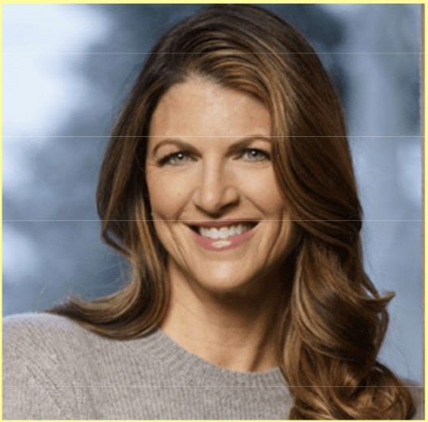**Tickets are $35 for Friends members,**

**$45 for non-members, and for $50 guests can purchase an event ticket and**

**a one-year Friends membership.**

[**Visitwww.jeffclf.org**](http://www.jeffclf.org/) **to**

**purchase tickets or call 303-403-5075.**



Library Givi g D y •

■

The annual Library Giving Day nationwide fundraiser will take: place on Tuesday, April 1. Last year, JCLF raised $7,500 • during this one-day event.

You can donate via our website [atwww.jeffclf.org.](http://www.jeffclf.org/) Just click : on the "Donate Now" button at the top of the home page.



## OUR NEW KITCHEN IN SUITE 1100

Many thanks to Home Depot for supplying our new kitchen with appliances, materials, hardware, flooring and equipment to help build our new kitchen in Suite 1100! The

new space is up and running, giving our staff and volunteers . more room to grab a cup of coffee and enjoy their lunches!

**COMMUNITY CONNECTIONS**



* Feb. 21 - Belmar bookstore volunteer appreciation luncheon
* Feb. 24 - Meeting with Jeff Lamontagne, ED of Friends of Dinosaur Ridge, to discuss partnership for Books On Film benefit
* Feb. 26 - CSU Extension Advisory Board luncheon
* Feb. 27 - Denver7 partner networking event and station tour
* Feb. 28 - Presentation to Evergreen Rotary Club
* March 5 - Presentation to Alameda Connects at West Metro Fire HQ
* March 6 - PEO lunch meeting
* March 11 - Wheat Ridge Business Assn. breakfast meeting
* March 11 - Zoom meeting with Marcus Johnson, Sr. Economic Development Specialist, City of Lakewood
* March 11 - Lakewood Foothills Rotary Club evening meeting
* March 12 - Lakewood Foothills Rotary Club Board of Directors meeting
* March 13 - Applewood Business Assn. lunch meeting
* March 14 - Meeting with Board member/major donor Jeannie Mann
* March 18 - New Board member orientation with Richard Kehmeier and Tyrenny Hidy
* March 19 - Wheat Ridge Business Assn.

**BizMix** hosted by JCLF

* March 20 - Golden Pantry & Thrift Board of Directors meeting
* March 20 - PEO lunch meeting



**PAGE2**

**MARCH 2025**

Executive Director Report

**LENDING OUR SUPPORT**



## DREAM INSPIRATION ACADEMY

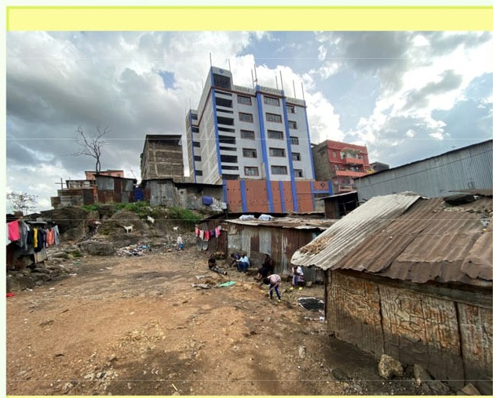"Welcome to The Dream Inspiration Academy (DIA), located right at the

heart of The Mathare Valley Slums. We are committed to breaking

barriers created by extreme poverty. We provide quality education

to the underserved children of this community. We are on a mission of empowering our students with skills and knowledge, fostering a brighter future for every student who walks through our doors.■

This Is one of the organizations (located In **Nairobi,** Kenya) that JCLF Is helping to support via our book donations program. This Is where we contribute excess books and materials to other nonprofit entitles, Including schools, nursing homes, senior centers and more. JCLF Is very proud to help support the Dream Inspiration Academy In Africa.

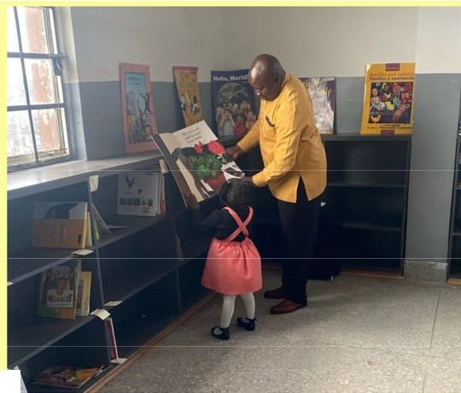

This effort Is being led by Jeffco residents

Max Bryant and his wife, Teresa, who are the founders and Board members for DIA.

JCLF Is pleased to know that thanks to our donation of children's books to DIA, our organization has been acknowledged by a plaque outside the school library!

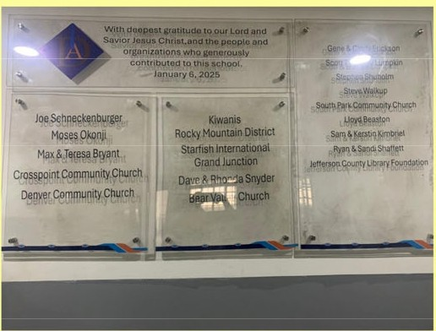

To learn more about Dream Inspiration Academy, please visit [www.DreamlnsplratlonAcademykenya.org.](http://www.DreamlnsplratlonAcademykenya.org/)





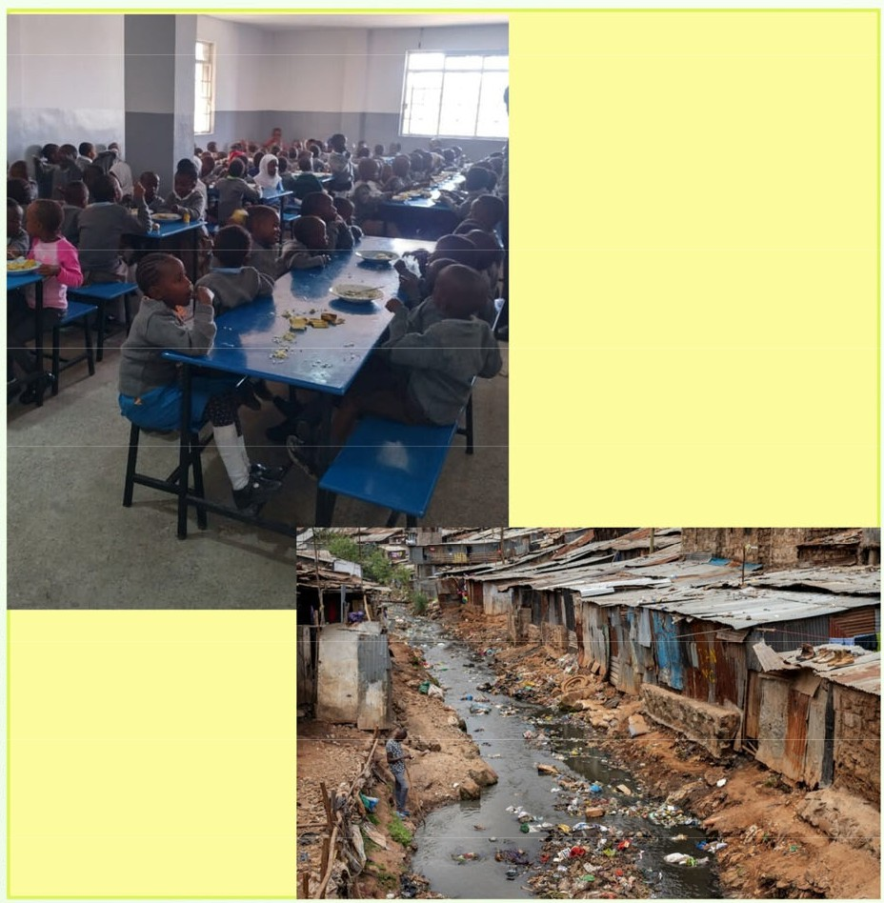

# FUNDING UPDATE

**MONIES RECEIVED OR CONFIRMED**

* + City of Golden -- $2,000, Friends Communty Partnership
  + Pinkard Construction -- $2,000, Friends Community Partnership
* • Denver7 - lnkind advertising, Friends Community Partnership
  + Alison Thayer -- $3,000 for Reading Alcove, Conifer Library

•Harsha/Kerns families -- $3,000 for Art Wall, Conifer Library

* • Core Electric Cooperative -- $3,000 for Conifer Library
  + Confluence Companies -- $500, Friends Community Partnership
* • Dr. Jackie O'Beirne -- $250 for Friends Annual Meeting
* • Foothills Vision Center -- $250 for Friends Annual Meeting
  + Taurus Fund -- $250 for Friends Annual
* Meeting
  + FirstBank -- $1,000 for Library Summer Challenge

#### Operational Updates Executive Director Report

**MARCH 2025** EXECUTIVE DIRECTOR REPORT

#### 2025 Annual Plan Progress in March

##### Portfolio: Service Point Development & Expansion

**Program: New Construction Project: South County Library**

* + - Finalize improvements agreement
    - Finalize architect Scope of Work
    - Set project success measures
    - Begin Program of Service

**Project: Northwest Jeffco Library**

* + - Finalize conceptual design
    - Request for Proposal (RFP) for General Contractor
    - Set project success measures

**Program: Building Redesign Project: Arvada Library**

* + - Assess pricing of schematic design
    - Continue design development
    - Finalize decision on alternative services location

**Program: Tenant Finish Project: Conifer Library**

* + - Obtain permit
    - Begin construction
    - Create donor recognition plan
    - Progress on dissolution of IGA

##### Portfolio: Building Inclusive Community

**Program: Digital Accessibility**

* + - Select consultant for Digital Accessibility Strategy

##### Portfolio: Embracing Innovation & Change

**Program: Artificial Intelligence Strategy**

* + - Begin formal engagement with consultant

**Program: Fundraising Development**

* + - Select vendor for Fundraising projects
    - Kick-off Long-term Fundraising project

##### Portfolio: Continuous Process Improvement

**Project: Collective Bargaining Agreement**

* + - Continue negotiation sessions

**Project: 2026+ Strategic Plan**

* + - Finalize new mission and vision for 2026+
    - Continue creation of strategic framework

#### Service Highlights:

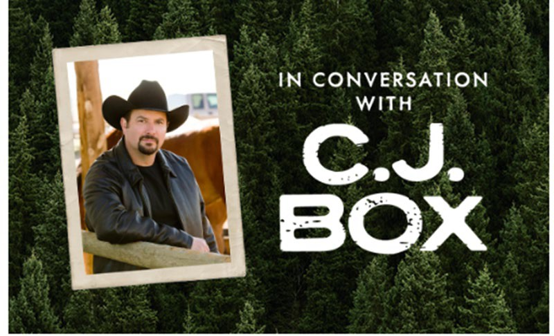I

[In Conversation with C.J. Box](https://jeffcolibrary.org/signature-author-event/)

We're bringing your favorite authors off the page and onto the stage with this spring's Signature Author Event from 12 – 4 p.m. on Saturday, March 29, at Mile Hi Church in Lakewood. The bestselling author will participate in a moderated discussion with celebrated author Carter Wilson about his latest novel, "Battle Mountain" and the thrill of writing the West. Registrants will have the opportunity to submit questions for the Q&A session. This year's event also includes a dynamic panel discussion with local authors Barbara Nickless, Manuel Ramos, Emily Littlejohn, Erika T. Wurth and David Heska Wanbli Weiden.

**2025 Conferences: ADVOCACY AND ENGAGEMENT OPPORTUNITY FOR**

#### Trustees

[National Library Week National Library Week](https://www.ala.org/events/national-library-week-2025) is a celebration highlighting the valuable role libraries, librarians, and library workers play in transforming lives and strengthening our communities from April 6 - 12, 2025.

On **Tuesday, April 8,** the Jefferson County Board of County Commissioners will approve a proclamation declaring April 6-12, 2025 National Library Week in Jefferson County. You’re invited to join JCPL for this agenda item during the Board of County Commissioners meeting at 9 a.m., along with a photo opportunity. This is a great way to continue to build community awareness about the Library's positive impact.

**American Library Association 2025 Annual Conference**

June 26-30, Philadelphia, Pennsylvania. Registration opens March 19. Let Katie O’Loughlin know by May 26 if you’d like to attend.

**CALCON 2025 Colorado Association of Libraries Annual Conference**

September 3-5, at Beaver Run Breckenridge, CO. Let Katie O’Loughlin know by August 4 if you’d like to attend.

**Urban Libraries Council Annual Leadership Forum**

October 22-24, Cincinnati, Ohio. Let Katie O’Loughlin know by September 22 if you’d like to attend.

#### JCPL Professional Engagement:

**Noah Allooh**, Software Systems Administrator, and **Andy Scanlan**, Technology & Digital Innovation Project Manager, are attending the Computers in Libraries Conference.

**Cheryl Murphy**, Technology & Digital Innovation Services Manager, **Kathy Halloran**, ILS Systems Administrator, and **Kensi Vue**, Database Administrator, **Lizzie Gall**, Public Services Assistant Director, and **Kat LeFevre**, Public Services Manager are attending the Innovative Users Group (IUG) Conference.

**Arra Katona**, Teen Services Coordinator, and **Emily Miller**, Acquisitions & Collections Librarian, are attending Children’s and Teen Services (CATS) winter workshop.

**Bailey Wallace**, Public Services Manager, and **Bridget Kiely**, Adult Services Coordinator, are attending the Colorado Public Health Parks and Recreation Collaborative (PHPR) Summit presenting on JCPL partnerships with other services.

**Padma Polepeddi**, Assistant Director of Public Services, is co-presenting at the PLA Membership Monday webinar on the topic of *Present at the PLA Conference*.

### HIGHLIGHTS OF EXECUTIVE DIRECTOR COMMUNITY ACTIVITIES,

MARCH 2025

* Attend South County Library Engagement Capstone meeting
* Meet with City of Arvada planning director
* Attend BCC/Municipalities Breakfast
* Attend BCC Legislative Update
* Attend CAL Legislative Committee meeting
* Meet with Joe Kerby, Jefferson County Manager
* Attend Urban Libraries Council Director/CEO meeting
* Meet with Jo Schantz, executive director, **Jefferson County Library Foundation (JCLF)**
* Attend **Front Range Public Library Directors** meeting
* Attend **Spring Author Event**



**JEFFERSON COUNTY PUBLIC LIBRARY DONATION AND NAME RECOGNITION AGREEMENT**

This Donation and Name Recognition Agreement ("Agreement"), dated for reference purposes only February 25, 2025 , is between Alison J. Thayer (the "Donor"), the **Jefferson County Library Foundation, Inc.,** a Colorado non-profit corporation (the "Library Foundation"), and the **Jefferson CC1,unty Public Library** (the "Library"). The Donor, Library Foundation, and Library are collectively referred to herein as the "parties", and hereby agree as follows:

**RECITALS**

* 1. The Donor desires to make a donation in the amount of$ 3 000 (the "Donation") in support of the Reading Alcove at Conifer Library (the "Project"); and
  2. The Library Foundation and the Library are proud to recognize the Donation by providing name recognition rights to the Donor at the Project, as more fully set forth herein.

**AGREEMENT**

NOW, THEREFORE, the parties hereto agree as follows:

I. The Donor pledges to make a Donation to the Library Foundation of$ 3,000 payable in one lump sum on or before March 31, 2025 , to aid funding of the Project.

1. Donation payments are to be payable to the Jefferson County Library Foundation, Inc., and mailed or hand delivered to the following address:

Jefferson County Library Foundation, Inc. 10790 w 50th Ave., Suite 200

Wheat Ridge CO 80033.

1. The Donor, Library Foundation, and Library agree that the Donation will be used for the Project, and as an expression of appreciation the name Ross, Alison & Annika Pulkrabek ("Donor Name") shall be displayed at the Project site.
2. The Donation may be invested, commingled, or merged with and become part of the general endowment funds and investment assets of the Library Foundation. Guidelines established by the Library Foundation Board of Trustees from time to time determine the investment, allocation of return on investment, and distribution of endowment funds and the allocation of income, loss, fees and expenses associated with endowment funds and securing and administering endowment funds. The Donation and all accounting of the Donation will be subject to these guidelines.

TMl4-2489

1. This Agreement is governed by Jefferson County Library's Guidelines for Naming and Name Recognition, which are incorporated herein. By entering into this Agreement, the Donor agrees to all of the terms and conditions contained therein, including the following:
   1. Signage. The sign recognizing the donation will be placed in an appropriate location, and its design shall be consistent with the Library's image and building design requirements. The wording of the sign shall be mutually agreed upon by the Donor and the Executive Director of the Library.
   2. Duration. These name recognition rights will last through March 31, 2030 Donor shall have a right of renewal at the end of the naming period to extend the naming rights for an additional donation and an additional period to be mutually determined by the parties.
   3. Approvals.
      1. All naming aclmowledgements will be approved by the Library Board of Trustees.
      2. A re-approval process with input by the Donor shall be necessary in the following situations:
         1. Major renovation of the space;
         2. Sale, destruction, removal or abandonment of the facility; or
         3. A change in the name, business focus or viability of the Donor entity.
   4. Standards of Conduct. Should the Donor violate acceptable standards of integrity and civic leadership, the Library, in its sole discretion, may elect to remove the Donor's name from the Library.
2. No items recognizing the Donation will be ordered until the full amount of the Donation has been received by the Library Foundation.
3. The Donation shall be nonrefundable unless the Library Board of Trustees does not approve the acknowledgement or the Library or Library Foundation are unable to fulfill their obligations due to some unforeseen circumstances.
4. If, in the opinion of the Library Board of Trustees or the Executive Director of the Library, all or part of the Donation cannot, in the future, be applied usefully to the purposes provided in this Agreement, it may be used for any related purpose which, in the opinion of the Executive Director of the Library will most nearly accomplish the wishes of the Donor as expressed herein.
5. No donations will be refunded for any reason unless the Library or Library Foundation is unable to fulfill its obligations due to unforeseen circumstances.
6. Miscellaneous Provisions.
   1. Tax Consequences. Donor, and not the Library Foundation nor the Library, is solely responsible for determining the tax consequences to Donor of the within transaction including, without limitation, any monetary value assigned to the naming right.
   2. Venue and Governing Law. Venue for any and all legal actions regarding this Agreement shall lie in the District Court in and for the County of Jefferson, State of Colorado, and this transaction shall be governed by the laws of the State of Colorado.
   3. Invalid Provisions. If any provision of this Agreement is held to be illegal, invalid or unenforceable under present or future laws, such provisions shall be fully severable; this Agreement shall be construed and enforced as if such illegal, invalid or unenforceable provision had never comprised a part of this Agreement; and the remaining provisions of this Agreement shall remain in full force and effect and shall not be affected by the illegal, invalid or unenforceable provision or by its severance from this Agreement. Furthermore, in lieu of such illegal, invalid or unenforceable provision, there shall be added automatically as a part of this Agreement a legal, valid, and enforceable provision as similar in terms to such illegal, invalid or unenforceable provision as may be possible.
   4. Amendments to Agreement. This written Agreement constitutes the entire Agreement of the parties. No representations, promises, terms, conditions or obligations regarding the subject matter of this Agreement, other than those expressly set forth herein, shall be of any force and effect. No modification, change or alteration of this Agreement shall be of any force or effect, unless in writing, signed by both parties.
   5. Further Acts. The parties agree to perform or cause to be performed such further acts as may be reasonably necessary to consummate the transaction contemplated hereby.
   6. Counterparts. This Agreement may be executed in two or more counterparts, each of which shall be deemed to be an original, and all of which counterparts together shall constitute but one and the same instrument.
   7. No Presumption Regarding Drafter. The parties acknowledge that they have each been advised by counsel in the drafting of this Agreement, and accordingly hereby agree neither party shall be deemed to be the drafter of this Agreement, and therefore no presumption for or against the drafter shall be applicable in interpreting or enforcing this Agreement.

*[SIGNATURES FOLLOW ON NEXT PAGE]*

**IN WITNESSWHEREOF,** the parties have executed this agreement thisI Ochday of



**Donor:**

By: .,.,g ,==:d_Sk..:::::::._ll.t:..-S--

(Print Donor's Name) Date: 3(10/.;t o:::z...5

APPROVED AS *TO* FORM:



Assistant County Attorney

**Jefferson County Library Foundation**

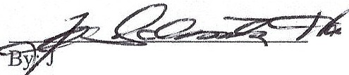- . oSchantz Hall, Execu 1ve Director

Date: ***,11,?,,iec.* /e:-, .J.e:",o1-S--**

**Jefferson County Public Library**

By: Donna Walker, Executive Director Date:

5

*1M14-2489* Revised 1/2025

**Mid Afftih3b5i$ +-tW**

JEFFERSON COUNTY PUBLIC LIBRARY DONATION AND NAME RECOGNITION AGREEMENT

TI1is Donation and Name Recognition Agreement ("Agreement"), dated for reference purposes only March 2, 2025 , is between Stanley and Henny Harsha and Candis and Bruce Kerns (the "Donors"), the **Jefferson County Library Foundation, Inc.,** a Colorado non-profit corporation (the "Library Foundation"), and the **Jefferson County Public Library** (the "Library"). The Donor, Library Foundation, and Library are collectively referred to herein as the "parties", and hereby agree as follows:

RECITALS

1. The Donor desires to make a donation in the amount of$ 3 000 (the "Donation") in support of the Art Wall at Conifer Library (the "Project"); and
2. The Library Foundation and the Library are proud to recognize the Donation by providing name recognition rights to the Donor at the Project, as more fully set forth herein.

AGREEMENT

NOW, THEREFORE, the parties hereto agree as follows:

1. The Donor pledges to make a Donation to the Library Foundation of$ ""3"'0"'0"'-0 _,

payable in one lump sum on or before March 31, 2025 , to aid funding of the Project.

1. Donation payments are to be payable to the Jefferson County Library Foundation, Inc., and mailed or hand delivered to the following address:

Jefferson County Library Foundation, Inc. 10790 W 50th Ave., Suite 200

Wheat Ridge CO 80033.

1. The Donor, Library Foundation, and Library agree that the Donation will be used for the Project, and as an expression of appreciation the name:

Harsha and Kerns families' First grandchild

Amara Ayu Kerns_ ("Donor Name") shall be displayed at the Project site.

1. The Donation may be invested, commingled, or merged with and become part of the general endowment funds and investment assets of the Library Foundation. Guidelines established by the Library Foundation Board of Trustees from tinle to tinle detemline the investment, allocation of return on investment, and distribution of endowment funds and the allocation of income, loss, fees and expenses associated with endowment funds and securing and administering endowment funds. The Donation and all accounting of the Donation will be subject to these guidelines.

I

TM14-2489

1. This Agreement is governed by Jefferson County Library's Guidelines for Naming and Name Recognition, which are incorporated herein. By entering into this Agreement, the Donor agrees to all of the terms and conditions contained therein, including the following:
   1. Signage. The sign recognizing the donation will be placed in an appropriate location, and its design shall be consistent with the Library's image and building design requirements. The wording of the sign shall be mutually agreed upon by the Donor and the Executive Director of the Library.
   2. Duration. These name recognition rights will last through March 31. 2030 Donor shall have a right of renewal at the end of the naming period to extend the naming rights

for an additional donation and an additional period to be mutually determined by the parties.

* 1. Approvals.
     1. All naming acknowledgements will be approved by the Library Board of Trustees.
     2. A re-approval process with input by the Donor shall be necessary in the following situations:
        1. Major renovation of the space;
        2. Sale, destruction, removal or abandonment of the facility; or
        3. A change in the name, business focus or viability of the Donor entity.
  2. Standards of Conduct. Should the Donor violate acceptable standards of integrity and civic leadership, the Library, in its sole discretion, may elect to remove the Donor's name from the Library.

1. No items recognizing the Donation will be ordered until the full amount of the Donation has been received by the Library Foundation.
2. The Donation shall be nonrefundable unless the Library Board of Trustees does not approve the acknowledgement or the Library or Library Foundation are unable to fulfill their obligations due to some unforeseen circumstances.
3. If, in the opinion of the Library Board of Trustees or the Executive Director of the Library, all or part of the Donation cannot, in the future, be applied usefully to the purposes provided in this Agreement, it may be used for any related purpose which, in the opinion of the Executive Director of the Library will most nearly accomplish the wishes of the Donor as expressed herein.
4. No donations will be refunded for any reason unless the Library or Library Foundation is unable to fulfill its obligations due to unforeseen circumstances.

2

TM14-2489 Revised 112025

1. Miscellaneous Provisions.
   1. Tax Consequences. Donor, and not the Library Foundation nor the Library, is solely responsible for detennining the tax consequences to Donor of the within transaction including, without limitation, any monetary value assigned to the naming right.
   2. Venue and Governing Law. Venue for any and all legal actions regarding this Agreement shall lie in the District Court in and for the County of Jefferson, State of Colorado, and this transaction shall be governed by the laws of the State of Colorado.
   3. Invalid Provisions. If any provision of this Agreement is held to be illegal, invalid or unenforceable under present or future laws, such provisions shall be fully severable; this Agreement shall be construed and enforced as if such illegal, invalid or unenforceable provision had never comprised a part of this Agreement; and the remaining provisions of this Agreement shall remain in full force and effect and shall not be affected by the illegal, invalid or unenforceable provision or by its severance from this Agreement. Furthennore, in lieu of such illegal, invalid or unenforceable provision, there shall be added automatically as a part of this Agreement a legal, valid, and enforceable provision as similar in terms to such illegal, invalid or unenforceable provision as may be possible.
   4. Amendments to Agreement. This written Agreement constitutes the entire Agreement of the parties. No representations, promises, terms, conditions or obligations regarding the subject matter of this Agreement, other than those expressly set forth herein, shall be of any force and effect. No modification, change or alteration of this Agreement shall be of any force or effect, unless in writing, signed by both parties.
   5. Further Acts. The parties agree to perform or cause to be performed such further acts as may be reasonably necessary to consummate the trnnsaction contemplated hereby.
   6. Counteroarts. 'This Agreement may be executed in two or more counterparts, each of which shall be deemed to be an original, and all of which counterparts together shall constitute but one and the same instrument.
   7. No Presumption Regarding Drnfter. The parties acknowledge that they have each been advised by counsel in the drafting of this Agreement, and accordingly hereby agree neither party shall be deemed to be the drafter of this Agreement, and therefore no presumption for or against the drafter shall be applicable in interpreting or enforcing this Agreement.

*[SIGNATURES FOLLOW ON NEXT PAGE]*

3

TMl4-2489 Revised 1/2025

IN **WITNESS WHEREOF,** the parties have executed this agreement this 2nd day of March, 2025.

###### Donor:

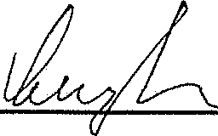

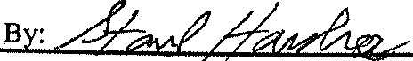

Stanley Harsha

Henny Harsha

**CAr1s** 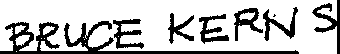

Candis **KemsE'fGN5**

(Print Donors' Name) Date: March 3, 2025

ruce Kerns

APPROVED AS TO FORM:

Assistant County Attorney

###### Jefferson Coun Library Foundation

:Z:Z:C ;,""

y; o Schantz Hall, Executive Director Date: */h-,,2:?;* ***le?***,***, :;P:r-s-***

###### Jefferson County Public Library

By: Donna Walker, Executive Director Date: _

**TM14-2489** 4 Revised 1/2025

TO: Donna Walker, Executive Director

FROM: Julianne Rist, Library Planning & Policy Senior Advisor & Steve Chestnut, Director of Facilities and Construction

DATE: March 20, 2025

RE: 2025 Facility Master Plan Update

**Background:**

In 2017 JCPL commissioned Group 4 Architecture to prepare a Facilities Master Plan (FMP) to guide planning, decision-making, and capital investment in its facilities over the next two decades. The recommendations contained in that plan were presented to the Board in 2018. The FMP is a flexible, “living” plan designed to be reviewed annually to accommodate changes in need and opportunities. JCPL uses the FMP to guide planning, decision-making, and capital investment in its facilities. Below is a timeline for the updates and presentations to the Board.

* 2018 - Facility Master Plan presented to the Board
* 2019 & 2020 March Annual review and update presented to the Board
* 2021
  + March Annual review and update presented to the Board
  + July Presented information and a methodology for accelerating the FMP at the Board’s request
  + September contracted with Group 4 Architecture to reevaluate the 2018 FMP
* 2022 - March Findings of updated FMP presented to the Board
* 2023 & 2024 March Annual review and update presented to the Board

The FMP is an integral part of our 2020 – 2025 strategic plan and is an integral component of building the 5-year Capital Improvement Plan and 2026 budget.

**Process:**

Our facility master planning is a data-driven process that leverages previous studies with new analysis of the amount, type, and distribution of space needed to provide excellent library service to Jefferson County communities. This process also informs the budget preparation for the five-year Capital Improvement Plan.

Some of the data points used to determine those needs are population growth projections, drive time mapping, number of cardholders in a specific area, use data of existing services and potential opportunities to partner with another organization or agency.

Prior FMP findings are summarized below and have been evaluated to determine if there are any changes to recommendations.

**2025 Staff Recommendations:**

**2022 FMP Finding:** Countywide, JCPL’s library branches provide less than 71% of the space needed to serve Jefferson County’s current population and lack the capacity to accommodate future community growth. The FMP recommends a system wide target of 0.5-0.6 square feet of branch library space per capita to serve Jefferson County’s current and future population. The lower end of this range is a threshold below which JCPL will experience space related challenges, while the upper end of the range will further enhance service to the community. This space per capita target is a gross square foot measure, meaning that it includes all staff, support and non-assignable spaces associated with service delivery in branches.

**2024 Recommendation:** The recommendation of a system wide target of 0.5-0.6 square foot per capita was reconfirmed in the 2022 update completed by Group 4 and this target is still appropriate to provide library services and space for our residents.

**2025 – Update:** No change in this recommendation. By 2030 both Northwest Jeffco and South County are expected to add an additional 70,000 square feet of library space. With the addition of these two libraries, the square foot per capita of library space is expected to reach 0.46. *(Based on population estimates for Jefferson County Source: Colorado State Demography Office, retrieved on 3/5/2025)*

**2022 FMP Finding:** JCPL’s library branches are not distributed equitably relative to community development; branch capacity is disproportionately concentrated in central part of Jefferson County, while southern and northern county areas lag in branch capacity.

**2024 Recommendation:** South County and Northwest Jeffco are both ongoing capital projects. Staff recommended a new 40,000 sq. ft. library for the South County and a 30,000 sq. ft. with the ability to expand by 10,000 sq. ft. for Northwest Jeffco.

**2025 – Update:** No change in this recommendation. Staff continue to recommend using 40,000 sq ft of the 64,000 sq. ft. South County building for library services and evaluating future use of the additional space. Both projects meet the direction of the Board for accelerating the building plan to meet per capita goals and increase access to library services.

**2022 FMP Finding:** JCPL’s system wide administrative and operations functions are divided among multiple, undersized facilities scattered across different regions, which keeps the organization from achieving maximum efficiency and effectiveness.

**2024 Recommendation:** Staff are not recommending a change in outcomes to the original recommendation. However, we have delayed the needs analysis for an Operations Center due to a change in priority of addressing the Arvada Redesign in 2025 to align with the Board’s direction and priorities.

**2025 Update:** Staff are recommending that the analysis for the Operations Center becomes part of the 2026+ Strategic Plan

**2022 FMP Finding:** The report compliments JCPL on its destination library service model and recommends that future expansions continue as larger library buildings.

**2024 Recommendation:** The approach we’ve taken is a combination of adding 2 new destination libraries in the Northwest and Southern areas of the county; and augmenting underserved areas with offsite services such as hold lockers, material returns, Express Library, van and bookmobile services to ensure equitable access to library services for all Jefferson County residents. Clarified the definition of “destination library” applies to include Northwest Jeffco and South County but does not apply to the redesign or changes to any existing locations.

**2025 Update:** No change to this recommendation

**2022 FMP Finding**: Update for Priority Sequencing – The 2022 report created prioritized groups of libraries, but did prioritize within the groups. The groupings focused on increasing access and square footage per capita.

**2024 Recommendation:** Prioritize projects within the groups, adjust projects to reflect updated conditions

* Group 1 – Evergreen Redesign, New South County Library, New NW Jefferson County Library, Conifer Opportunity, Arvada Redesign, South County express library.
* Group 2 – Operations Center, Lakewood Expansion, Standley Lake Redesign
* Opportunity/Needs Based – Golden, Wheat Ridge

**2025 Update:** Staff recommend moving from the current three groups to two groups. Group one would stay the same, and we would concentrate resources to complete the current capital projects underway to close it out. Staff recommend removing the Opportunity /Need-Based category and that all remaining locations become part of Group 2.

* Group 1 – Arvada Redesign, Conifer Library, New South County Library, New NW Jefferson County Library
* Group 2 – Golden, Wheat Ridge, Operations Center, Lakewood Expansion, Standley Lake Redesign

Projects underway in 2025

* Arvada Library Redesign
* Conifer Library relocation
* 40,000 sq. ft. destination library in South County
* 30,000 sq. ft. destination library in Northwest County

Completed Projects

* Edgewater Library expansion (not part of the original plan)
* Belmar Library Redesign
* Evergreen Library Redesign
* Offsite Services (listed in chronological order)
  + Ridge Recreation Center holds locker and lending machine
  + Conifer Mountain Resource Center holds locker
  + Candelas Parkview holds locker
  + Green Mountain holds locker
  + Express Library West Arvada
* Location holds lockers at Lakewood, Standley Lake, Belmar, Columbine, Wheat Ridge, Arvada, Evergreen, and Golden

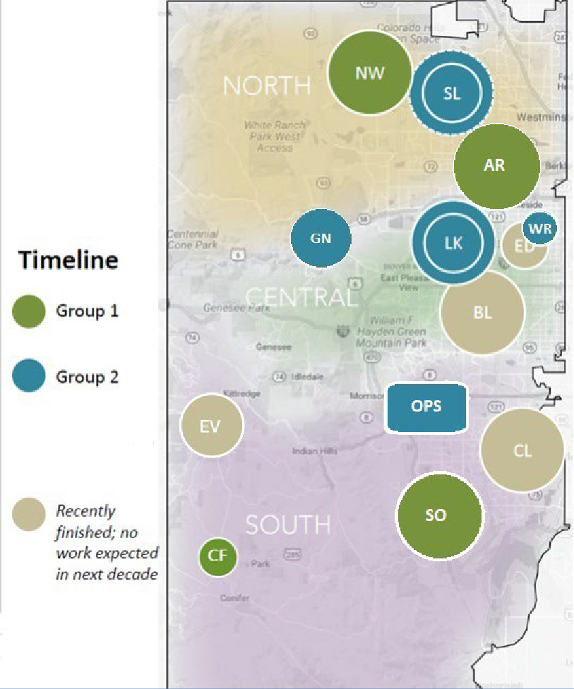

**Next Actions:**

The Board input on this update will be used in the development of the five-year capital plan and 2026 budget.

TO: Library Board of Trustees

FROM: Donna Walker, Executive Director DATE: March 20, 2025

RE: Strategic Planning 2026+ Mission and Vision

**Purpose:** To come to Board consensus on new mission and vision statements for the 2026+ strategic plan.

**Background**: Extensive community and Board inputs have been gathered to guide JCPL in the development of new mission, vision and ends for our 2026+ strategic plan. These listening opportunities brought forward common themes and ideas about the purpose of the library and about our long-term aspiration.

With some exceptions, trustee input was that the current JCPL mission and vision statements already capture important words and ideas and that while there was opportunity for refinement, wholesale change was not anticipated or desired.

In summary, the community, as represented by the Library Board of Trustees and survey insights, expressed common connection with these concepts specifically related to mission and vision:

* The library is a place for connection and learning
* The library is for everyone
* The library makes the community better
* The library makes lives better
* Accessibility and equity of access are essential elements of the public library

**Recommendation**: These inputs and insights have led JCPL to propose the following bold new mission and vision statements that reinforce what we heard.

|  |  |
| --- | --- |
| **JCPL Mission**  ***Our Purpose: Why We Exist*** | |
| **Current:**  Jefferson County Public Library helps to build an educated and vibrant community by providing equal access to information and opportunities. | ***Recommended NEW****:*  *Jefferson County Public Library enriches lives and our community by providing free and equitable access to information, experiences, and opportunities.* |

|  |  |
| --- | --- |
| **JCPL Vision**  ***Our Long-Term Aspiration: What Difference Do We Make to Whom?*** | |
| **Current:**  Jefferson County Public Library will be the essential destination where all generations connect, discover, and create. | ***Recommended NEW:***  *Jefferson County Public Library is an essential place in our community for connection, learning, discovery, and creation. Everyone belongs. Everyone feels welcome.* |

**Next Actions:** JCPL requests Board consensus on the new mission and vision statements at this meeting. New mission and vision statements for our 2026+ strategic plan are inextricably connected to the Board Ends, or broad organizational goals. Further discussion of new Ends will be part of the agenda at the March meeting.

TO: Donna Walker, Executive Director

FROM: Matt Griffin, Chief Strategy & Operating Officer DATE: March 20, 2025

RE: 2026+ Strategic Planning

**Purpose**

This memo prepares the Board of Trustees for our next discussion on refining the Board Ends to align with clear, public-facing language. At the March Board meeting, we will focus on finalizing language that best represents each goal in a compelling and accessible way.

**Overview**

At the February study session, the Board provided valuable insights that helped shape the 2026+ Strategic Plan. Through that discussion, we identified key themes and language that define Equity of Access, Creating Place, and Our People in a way that is clear, inspiring, and reflective of our mission.

As the governing body, the Board of Trustees is responsible for setting Board Ends, which articulate the overarching purpose and intended outcomes of the library for the community. The next step is to refine these concepts into concise, powerful statements that guide JCPL’s future.

**Current Board Ends**

The Board’s existing Board Ends include:

* **Equity of Access**

*All Jefferson County residents have opportunities to access information, resources, ideas, and technology, and they are supported in using these resources.*

* **Maximize Value**

*JCPL delivers services that provide the greatest possible value to Jefferson County residents through effective and efficient use of resources.*

* **Create Place**

*All Jefferson County residents have safe, convenient, and welcoming places to access information, resources, and participate in community life.*

* **Provide Leading-Edge Services**

*Jefferson County Public Library adds value to the community by providing services that advance our shared goals.*

**Proposed Refinement for 2026 and Beyond**

Building on prior discussions around our Mission and Vision, as well as strong input from the community, JCPL proposes refining the Board Ends into three broad organizational goals:

* **Equity of Access**
* **Creating Place**
* **Our People**

**What We Heard**

Through the discussion, three key themes emerged under each Board Ends:

**Equity of Access**

* JCPL provides access for all, removing barriers so everyone can use library resources.
* Services are adaptable to meet diverse needs, including language access, technology, and different learning styles.
* Access is free, inclusive, and culturally responsive, with assistance available when needed.

**Creating Place**

* The library is a welcoming, safe space where everyone feels they belong.
* Spaces are inspiring, and designed for creativity, connection, and learning.
* Libraries are easily accessible, both physically and digitally, and provide a calming yet engaging environment.

**Our People**

* Employees feel supported and have opportunities for enrichment and development.
* JCPL is a place where staff feel empowered, curious, and able to thrive.
* The library’s culture reflects community values and prioritize professionalism, empathy, and tolerance.

**Next Steps: March Board Meeting**

We will review the draft animating statements below and work toward language that effectively communicates these Board Ends. The goal is to align on a clear and compelling way to express what they mean to JCPL and the communities we serve.

To guide the discussion, we have drafted two options for each animating statement.

**Equity of Access**

*Option 1: JCPL provides free and convenient access to information, resources and opportunities for all. Option 2: JCPL actively identifies and removes barriers to library services, providing access to information, resources, and opportunities for all.*

**Creating Place**

*Option 1: JCPL is a welcoming and inclusive space that brings people together and encourages discovery. Option 2: Our libraries are safe, dynamic, and accessible spaces where everyone belongs.*

**Our People**

*Option 1: JCPL invests in its employees, creating a workplace where people are valued, supported, and inspired to thrive.*

*Option 2: We empower teams and individuals with the resources, opportunities, and culture to thrive and serve our community.*

#### Operational Updates Strategy & Operations

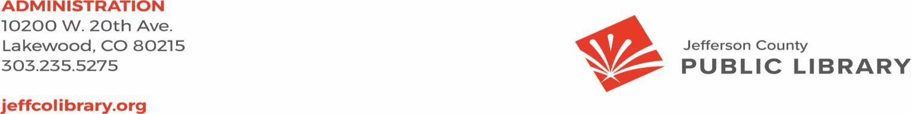

TO: Donna Walker, Executive Director

FROM: Matt Griffin, Chief Strategy & Operating Officer DATE: March 20, 2025

RE: Finance Monthly Report

**Budget to Actual Tables – February 2025**

Please see the enclosed Budget to Actual Tables for February 2025.

In February 2025, $20,414,872 of Real Property Tax revenue was recorded. Year-to-date, 32.6% of the budgeted collection has been received.

JCPL is on track with its budget, and there are no areas of concern. Our financial performance remains steady, and in line with expectations.

The Library Foundation provided funding of $6,401 to JCPL. The Library contributed $7,568 in- kind support in February. Year-to-date, the library has received $27,048 in funding and provided

$15,128 in-kind support to the Foundation, with a ratio of 1.79.

|  |  |  |  |  |
| --- | --- | --- | --- | --- |
| **Revenue and Expenditure** | **2025 Budget** | **YTD Actual**  **02/28/2025** | **$ Variance**  **2025 Budget** | **% Variance**  **2025 Budget** |
| **Revenues** |  |  |  |  |
| Property Taxes (net adjustments) | 59,744,973 | 20,409,274 | 39,335,699 | 34% |
| Grants, Funds & Donations | 560,427 | 20,647 | 539,780 | 4% |
| Investment Income | 2,009,000 | 504 | 2,008,496 | 0% |
| Other Revenue | 35,000 | 32,922 | 2,078 | 94% |
| **Total Revenues** | **$ 62,349,400** | **$ 20,463,347** | **$ 41,886,053** | **32.8%** |
| **Expenditures** |  |  |  |  |
| Operating | 48,026,474 | 7,010,560 | 41,015,914 | 15% |
| Financing & Debt Service | - | - | - |  |
| Capital Projects | 37,832,206 | 10,903,916 | 26,928,290 | 29% |
| **Total Expenditures** | **$ 85,858,680** | **$ 17,914,476** | **$ 67,944,204** | **20.9%** |

|  |
| --- |
| % Variance 2025 Budget |
| ***32.8%***  **Total Revenues**  **0% 100%** |
|  |
| ***20.9%***  **Total Expenditures**  **0% 100%** |
|  |
| ***15%***  Operating  **0% 100%** |
|  |
| Debt  **0% 100%** |
|  |
| **29%**  Capital  **0% 100%** |

|  |  |  |  |  |
| --- | --- | --- | --- | --- |
|  | **2025 Budget** | **YTD Actual 02/28/2025** | **$ Variance 2025 Budget** | **% Variance 2025 Budget** |
| ***Operating Expenditures*** |  |  |  |  |
| **Salaries & Employee Benefits** |  |  |  |  |
| Salaries | 19,267,433 | 2,541,048 | 16,726,385 | 13% |
| Awards & Bonuses | 275,000 | 20,853 | 254,147 | 8% |
| Other | 7,478,592 | 1,154,558 | 6,324,034 | 15% |
| Total Salaries & Benefits | $ 27,021,025 | $ 3,716,459 | $ 23,304,566 | 14% |
| **Library Collections** |  |  |  |  |
| Library Books & Materials | 7,692,199 | 1,079,749 | 6,612,450 | 14% |
| Library Periodicals | 205,000 | 35,855 | 169,145 | 17% |
| Total Library Collections | $ 7,897,199 | $ 1,115,604 | $ 6,781,595 | 14% |
| **Supplies and Other** |  |  |  |  |
| Supplies | 1,915,452 | 213,850 | 1,701,602 | 11% |
| Services & Charges | 7,959,121 | 1,293,973 | 6,665,148 | 16% |
| Interdepartmental Direct Charges | 713,165 | 94,796 | 618,369 | 13% |
| Treasurers Fees | 902,081 | 306,139 | 595,942 | 34% |
| Interdepartmental Indirect Charges | 1,618,431 | 269,739 | 1,348,692 | 17% |
| Total Supplies and Other | $ 13,108,250 | $ 2,178,497 | $ 10,929,753 | 17% |
|  |  |  |  |  |
| **Total Operating Expenditures** | **$ 48,026,474** | **$ 7,010,560** | **$ 41,015,914** | **14.6%** |

**TABLE 3**

**JEFFERSON COUNTY PUBLIC LIBRARY CAPITAL IMPROVEMENT PROJECTS BUDGET TO ACTUAL**

|  |  |  |  |  |  |  |  |
| --- | --- | --- | --- | --- | --- | --- | --- |
|  | **2025**  **Budget** | **YTD Actual 02/28/2025** | **YTD**  **Encumbrances** | **YTD Total Actual + Enc** | **Remaining 2025 Budget** | **Total Project**  **Actual + Encumbrances** | **Total Project Budget** |
| ***Capital Expenditures*** |  |  |  |  |  |  |  |
| **Annual Replacement & Maintenance** |  |  |  |  |  |  |  |
| ARM-01 Capital Maintenance | 300,000 | 10,309 | - | 10,309 | 289,691 | n/a | n/a |
| ARM-02 Furniture & Equipment | 42,000 | 24,201 | - | 24,201 | 17,799 | n/a | n/a |
| ARM-03 Computer Replacement Plan | 616,000 | 45,105 | - | 45,105 | 570,895 | n/a | n/a |
| ARM-04 Book Sorter Replacement | 40,000 | - | - | - | 40,000 | n/a | n/a |
| ARM-05 IT Infrastructure Replacement | 450,000 | 40,098 | 104,350 | 144,448 | 305,552 | n/a | n/a |
| **Capital Projects** |  |  |  |  |  |  |  |
| Document Management System | - | 200 | 7,400 | 7,600 | (7,600) | 206,577 | 160,000 |
| South County Library | 6,198,826 | 10,577,134 | - | 10,577,134 | (4,378,308) | 10,878,954 | 30,849,540 |
| Evergreen Library Redesign | - | 3,600 | - | 3,600 | (3,600) | 4,799,525 | 5,200,048 |
| Evergreen Library Roof Repair | - | - | 27,186 | 27,186 | (27,186) | 56,646 |  |
| Columbine Library Roof Repair | - | - | - | - | - | 670,708 |  |
| Northwest County Library | 14,589,599 | 21,378 | 1,632,559 | 1,653,937 | 12,935,662 | 5,383,039 | 25,970,270 |
| Arvada Library Redesign | 14,095,781 | 144,925 | 900,113 | 1,045,038 | 13,050,743 | 1,134,018 | 14,895,781 |
| Conifer Library Tenant Finish | - | 24,966 | 34,469 | 59,435 | (59,435) | 199,245 | 2,500,400 |
| South County Express Library |  | - | - | - | - | - | 595,000 |
| Lakewood Restrooms | 500,000 | 12,000 | 33,000 | 45,000 | 455,000 | 45,000 | 500,000 |
| Admin Office Reconfiguration | 250,000 | - | - | - | 250,000 | - | 250,000 |
| Library Interiors Refresh Pilot | 750,000 | - | - | - | 750,000 | - | 750,000 |
| **Total Capital Expenditures** | **$ 37,832,206** | **$ 10,903,916** | **$ 2,739,077** | **$ 13,642,993** | **$ 24,189,213** |  |  |
|  | | | | | |  |  |

**TABLE 4**

**JEFFERSON COUNTY PUBLIC LIBRARY GRANTS, FUNDS & DONATIONS BUDGET TO ACTUAL**

|  |  |  |  |  |  |  |  |
| --- | --- | --- | --- | --- | --- | --- | --- |
|  | **2022**  **Actual** | **2023**  **Actual** | **2024**  **Actual** | **2025**  **Budget** | **YTD Actual 02/28/2025** | **$ Variance 2025 Budget** | **% Variance 2025 Budget** |
| ***JCPL Grants*** |  |  |  |  |  |  |  |
| Books & Materials - American Rescue Plan | 181,757 | - | - | - | - | - |  |
| Books & Materials - State | 195,797 | 140,462 | 5,002 | 144,996 | - | 144,996 | 0% |
| Car Charging Station - Evergreen | - | 16,500 | 1,684 | - | - | - |  |
| Car Charging Station - Columbine | - | - | - | - | - | - |  |
| Car Charging Station - Lakewood | - | - | - | - | - | - |  |
| **Total JCPL Grants** | **$ 377,554** | **$ 156,962** | **$ 6,686** | **$ 144,996** | **-** | **$ 144,996** | **0%** |
| ***JCPL Private Donations*** |  |  |  |  |  |  |  |
| Private Donations up to $200 | 340 | - | 250 | - | - | - |  |
| Private Donations $201 - $999 | - | - | - | - | - | - |  |
| Colorado Gives - Naumer Family Fund EV Remodel | - | 5,000 | - | - | - | - |  |
| Anonymous Donor | - | 2,000 | - | - | - | - |  |
| Anonymous Donor | 58,042 | - | - | - | - | - |  |
| Anonymous Donor | - | - | - | - | - | - |  |
| Anonymous Donor | - | - | - | - | - | - |  |
| JCLF - Evergreen Library - Naming Rights | - | - | 5,000 | - | - | - |  |
| Colorado Gives - Hard Times Writing |  |  | 24,509 |  |  |  |  |
| Fundraising Target | - | - | - | 150,000 | - | 150,000 | - |
| **Total Private Donations** | **$ 58,382** | **$ 7,000** | **$ 29,759** | **$ 150,000** | **$ -** | **$ 150,000** | **0%** |
| ***Other Funds Received*** |  |  |  |  |  |  |  |
| Payroll Funding - American Rescue Plan | 263,556 | 856,591 | - | - | - | - |  |
| E-Rate Reimbursement | 2,602 | 149,901 | 60,471 | 165,431 | - | 165,431 | 0% |
| Laptop Lending | 100,145 | 183,427 | - | - | - | - |  |
| Stadium Funds - Imagination Library |  |  | 50,000 | - | - | - |  |
| Stadium Funds - Young Authors | - | - | 42,350 | - | - | - |  |
| **Total Other Funds Received** | **$ 366,303** | **$ 1,189,919** | **$ 152,821** | **$ 165,431** | **$ -** | **$ 165,431** | **0%** |
| ***Jefferson County Library Foundation*** | 131,894 | 127,180 | 141,576 | 100,000 | 20,647 | 79,353 | 21% |
| **Total Jefferson County Library Foundation** | **$ 131,894** | **$ 127,180** | **$ 141,576** | **$ 100,000** | **$ 20,647** | **$ 79,353** | **21%** |
|  | | | |  |  |  |  |
| **Total Grants, Funds & Donations** | **$ 934,133** | **$ 1,481,061** | **$ 330,842** | **$ 560,427** | **$ 20,647** | **$ 539,780** | **4%** |

***Other Funds Received Outside of Library Fund***

Digital Equity - American Rescue Plan

-

3,482

622,374

35,728

15,802

19,926

44%

Board Governance



TO: Library Board of Trustees

FROM: Jill Fellman and Pam Anderson, Nominating Committee DATE: March 20, 2025

RE: Slate of Officers for Election at March 20, 2025 Board Meeting

The nominating committee presents the following slate of officers for election at the March 20, 2025 Board Meeting:

The Chair, Vice-Chair, and Secretary positions are up for election in 2025.

* Chair: Kim Johnson, for the 2-year term April 2025 to March 2027
* Vice-Chair: Emelda (Bing) Walker, for the 1-year term (April 2025 to March 2026).
* Secretary: Stanley Harsha, for the 1-year term (April 2025 to March 2026)