Jefferson County Public Library Board of Trustees
Study Session
February 13, 2025- 5:30pm
Hybrid Meeting held online via ZOOM
and in-person in the Lakewood Library meeting room.

TOPICS:
Board Governance - Strategy
• 2026+ Strategic Planning
Guest: Greg Bellomo, Government Performance Solutions, Inc

Board Governance- Policies
• JCPL Operational Practices for Collection Development and Reconsideration of Materials Policies Update
Guest: Kurt Behn, County Attorney’s Office

Strategy & Operations
• Contingency request Budget Transfer
• LED lighting updates

Contracts & Agreements
• Standley Lake Library Audiovisuals Contract- Xcite Audiovisuals, LLC

Call to Order
Kim Johnson, Chair, called the Study Session to order at 5:30 p.m.

Other Trustees present: Emelda Walker (Vice-Chair), Stanley Harsha (Secretary), Pam Anderson, Jill Fellman, Charles Jones, and Renny Fagan.

Guests present: Greg Bellomo, GPS, Inc. & Kurt Behn County Attorney’s Office

Staff present: Donna Walker, Executive Director; Julianne Rist, Library Planning & Policy Senior Advisor; Steve Chestnut, Director of Facilities and Construction; Bernadette Berger, Chief Technology & Digital Innovation Officer; Matt Griffin, Chief Strategy & Operations Officer; Lisa Smith, Chief People and Culture Officer; Elise Penington, Director of Communications & Engagement, Amy Bentz, Assistant Director of Library Design Projects and Planning; Padma Polepeddi, Assistant Director of Public Services for Community Outreach; Lizzie Gall, Assistant Director of Public Services for Resources and Programs; Jessica Paulsen, Assistant Director of Public Services for Customer Experience; Kelci Rude, Administrative Coordinator Supervisor; Katie O’Loughlin, Administrative Coordinator Supervisor; and Joseph Grover, Technical Support Technician Sr.
Board Governance ‐ Strategy
Matt Griffin, Chief Business & Strategy Officer, introduced the topic and reminded the Board that they would be building on the work they did in January. The Board will continue to have more sessions after this. Matt Griffin then introduced Greg Bellomo with GPS.
Greg Bellomo addressed the Board and informed them that the purpose of tonight’s work is to begin refining the Mission, Vision, and Broad Goals for the organization. The Board was informed that we are in the 3rd phase of our strategic planning. We’re taking the input information and synthesizing a framework to help us move from mission/vision to clear goals and objectives. The goal for tonight is to get the framework in good shape to share at next month’s study session.
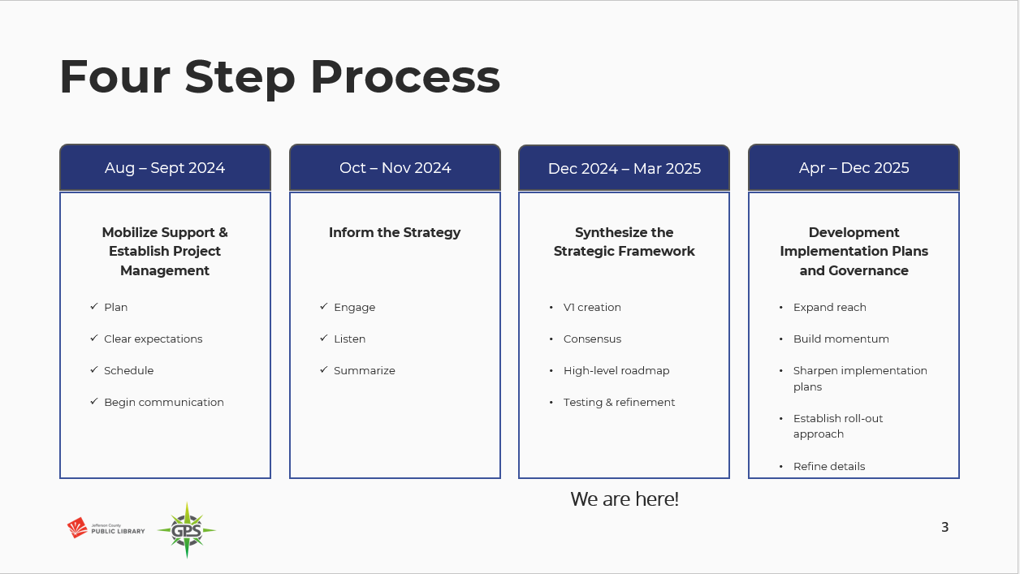
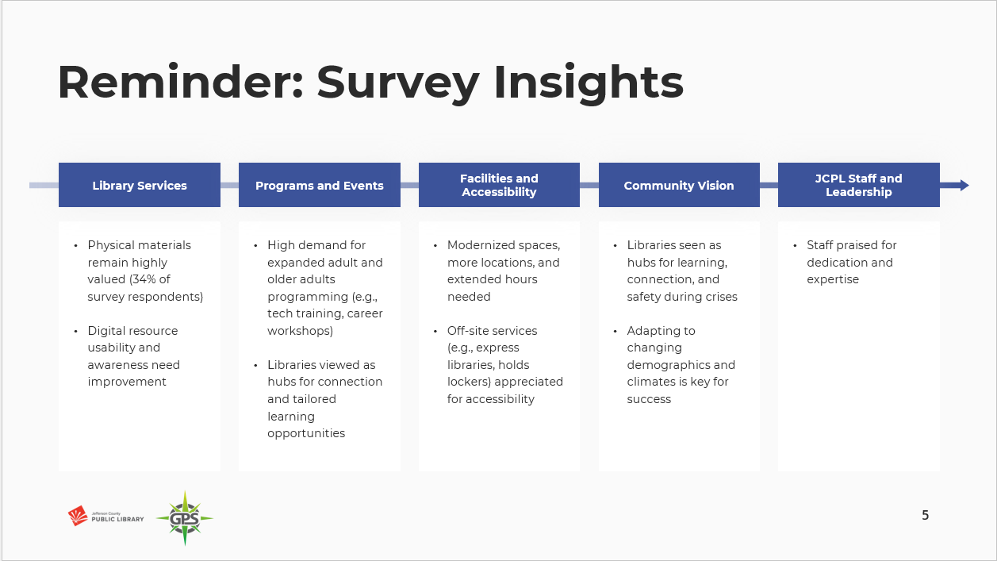
The Board was reminded that the survey had over 8000 responses, and five main themes emerged around what we heard from the community. During the last working session, the Board acknowledged the limitations of the survey. While we were gratified by the number, we recognized that we did not have proportional representation from Spanish speakers. People who respond generally know and use you and people who don’t use the Library probably won’t respond to a survey.
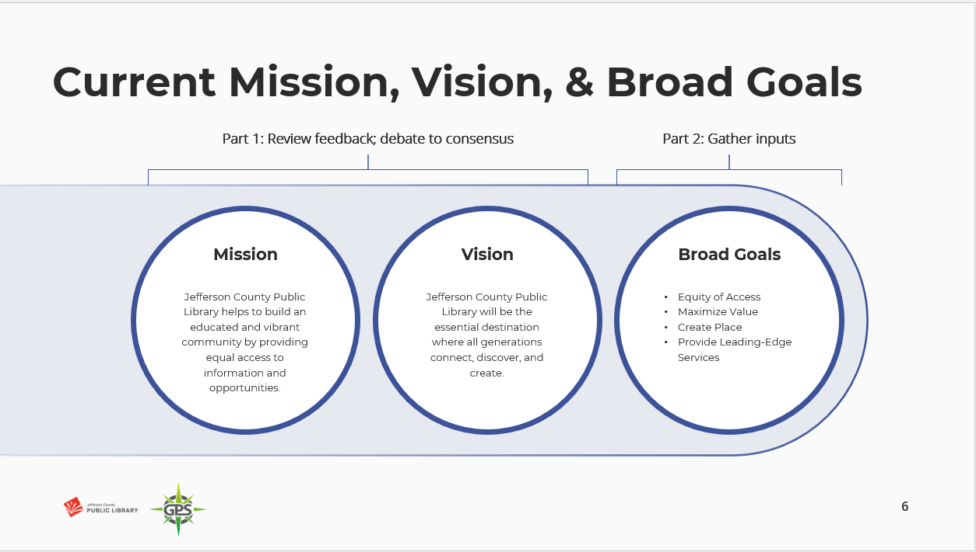
The Board was informed that they would review the current mission and vision, review refinements in language, and see if they can reach consensus.
The Board did not have any questions or discussion on the plan for the Study Session or next steps.
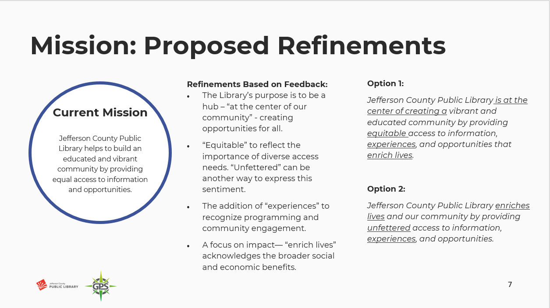
The Board was asked to identify things that they liked, that stood out to them, or areas where they felt like we missed the mark in Mission Options 1 & 2.
Board comments included:
- A preference for the first option, and that the ‘educated community’ language stood out to them.
- Liked the phrase ‘at the center of creating’. They appreciated the addition of ‘equitable’ and ‘experiences’ and that it includes ‘enrich lives’, as it answers the “to what end?” question. They also felt like that phrase had more impact at the end of the mission statement as opposed to the beginning of the statement as in Option 2.
- A preference for Option 2. They liked that ‘enriches lives’ was centered at the beginning of the statement, and it emphasized that. They liked ‘equitable’ but did not like ‘unfettered’.
- They noted that an organization’s Mission statement language may impact federal funding and wanted trustees to be aware of that.
- They liked ‘unfettered’ given the current social polarization.
- They liked that JCPL isn’t just at the center of something happening around us, but that Option 2 showed we are taking responsibility for something. They liked the idea of what ‘unfettered’ says, just not the word.
The Board was asked if it is the notion of no barriers that appeals to them. Board members generally affirmed that it was and offered other words such as ‘independent’ or ‘fair’, ‘equitable and free’.
The Executive Director explained that ‘unfettered’ was suggested because of its legal significance; we have seen it used by our County Attorney’s Office before, and seemed to hit upon the value of making sure people’s access wasn’t restricted or controlled. The Executive Director noted that it sounds like the word doesn’t belong in the Mission statement, but that the conversation from the Board around this was appreciated.
Comments included:
- Trustees value that idea, but the word feels too legal and not friendly enough.
- Unfettered is different from equitable- one is what it takes to gain access, and the other is the right to access. Language might be better if it were changed from ‘providing…access’ to ‘ensuring….access’.
The Board was asked how they felt about bringing the educated community language into Option 2.
- Some indicated that they agreed the statement had value.
- Putting that as a description assumes about the community, and they wanted to note it may not be something the community feels or responds to.
The Board was informed that the team will bring back some revised versions, building off Mission Option 2 for the March Study Session.
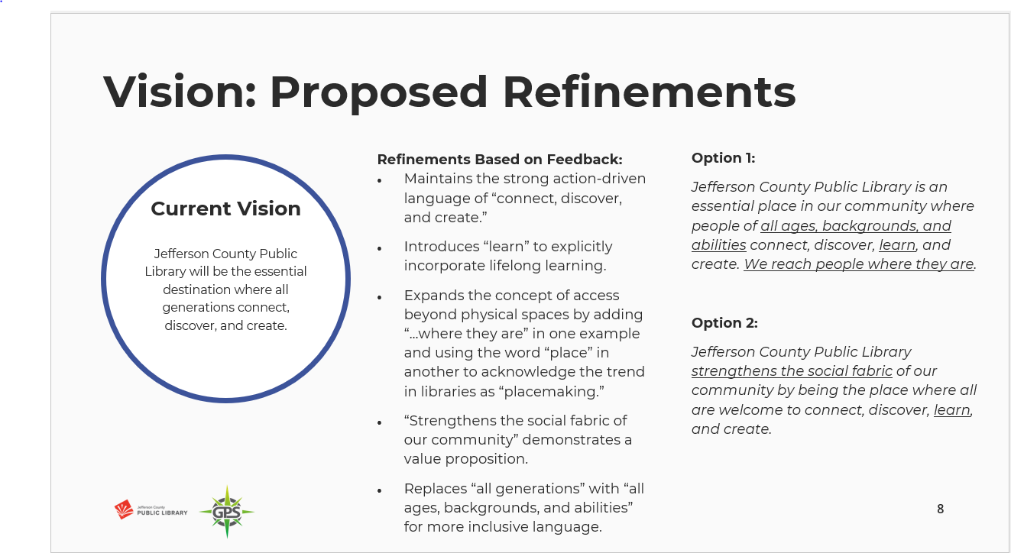 The Board was asked to identify things that they liked, that stood out to them, or areas where they felt like we missed the mark in Vision Options 1 & 2.
Board comments included:
- Both Options read more as Mission statements than Vision statements. A Vision statement should answer the question “What difference does this make and to whom?” Would like to see the team turn these into stating the outcome and where we are headed- not how we get there. Three examples of Vision statements that do this:
- Colorado Community College System: CCCS will be the first and best path for all to achieve a more prosperous and fulfilling life.
- Colorado Education Initiative: CEI’s long-term vision is that all young people in Colorado exit K-12 education boldly taking their next steps toward hopeful, equitable, and prosperous futures. This requires an education system that delivers on the promise of public education to develop thriving young people and flourishing communities.
- Denver Art Museum: At the Denver Art Museum, we work together to build a world where art sparks creativity, and connects, inspires, and empowers people and communities.
- Want to see something that reaches out- information for all or connecting and discovering are good core ideas but there’s still this question of where does that lead us?
- Option 1 was not far from the type of Vision statements that were provided as examples. The ‘…IS an essential place’ language had been a large part of the Board discussion the last time they did this work, and that had been a bold change and statement.
- Option 1 looks forward, but it needs more work.
- Feels important to have the Vision statement be aspirational.
- Option 1 feels like a starting point for the next iteration.
- Want to see more around the outcome and user.
The Executive Director asked the Board about the ‘strengthens the social fabric’ phrase as no one had brought that up. The Board was asked to clarify whether they felt the Vision needed to be refined to apply more to the individual, the community, or both.
Board members expressed differing opinions on whether it should be the individual, the community, or both.
The Executive Director also asked the Board about ‘We reach people where they are’ and whether the Board felt that was aspirational enough for the Vision statement.
Comments included:
- They felt it was built into ‘all ages, backgrounds, and abilities’.

The Board was informed that the team will bring revised versions building off Vision Option 1 for the March Study Session.
The Board reviewed draft broad Goals. The Board was informed that the Directors Team felt there was an opportunity to add impact and clarity using more animating language. The Board was asked to develop their own animating words and phrases for each broad goal of Equity, People, and Place. Trustees were instructed to send the Chair and Executive Director any other words/phrases that they think of after the meeting that they want included in the next working session. These will need to be received by 2/17 as the Directors Team will be working on these on 2/18.
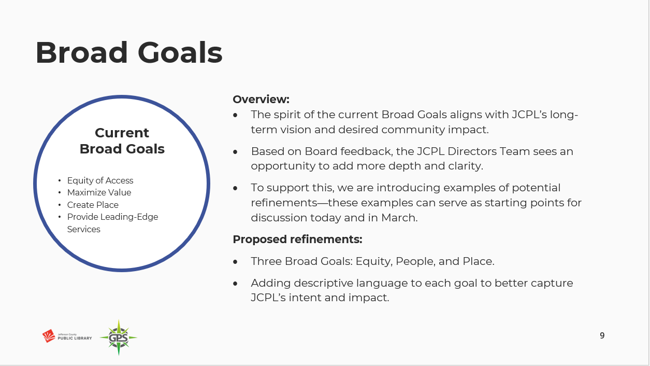
The Board was informed that they will see these again in March.
Board Governance- Policies
JCPL Operational Practices for Collection Development and Reconsideration of Materials Policies Update Guest: Kurt Behn, County Attorney’s Office

The Chair reminded the Board that JCPL has had policies in place for Collection Development and Reconsideration but that due to legal changes they now need to be Board policies.

The Executive Director introduced Julianne Rist, Interim Chief Libraries & Inclusion Officer, and Lizzie Gall Assistant Director of Public Services for Resources and Programs who shared a presentation with the Board around JCPL’s operational practices for collection development and materials reconsideration.

The Interim Chief Libraries & Inclusion Officer introduced the topic.
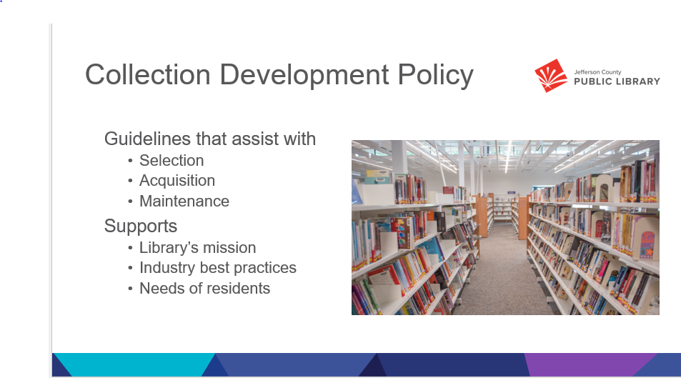
A collection development policy is a written document to assist library staff in selecting, acquiring, and maintain a library’s collection. The policy's purpose is to create a collection that supports the library's mission, industry best practices, and the needs of its users. It ensures the collection aligns with the needs of the community it serves, reflecting the library's mission and objectives by prioritizing relevant and quality resources across different formats.
- Jefferson County Public Library (JCPL) develops and maintains a materials collection that reflects the changing needs and interests of our community. The purpose of this policy is to guide selection practices to ensure that a wide variety of materials is available in our libraries in formats and quantities that meet the needs of our residents and patrons.
- JCPL will make every effort in their selection of materials to provide a balanced collection representing diverse viewpoints and interests.

The Policy sets the philosophy and expectations for the material formats and titles that we select and deselect. Staff know what the focus is for JCPL and the items we have in our collection, and residents know what to expect to find in our collection as well. We will now talk about the processes that staff go through when selecting, deselecting or responding to a reconsideration request.

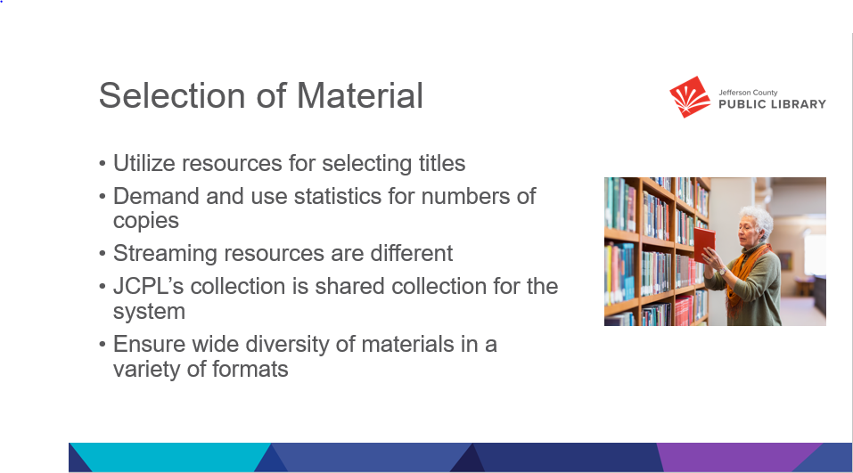

Selection of materials is how our subject matter expert staff determine which items to add to the collection. The Library’s collection development policy guides the selection of materials to build a collection that is of high interest to the community. We have a team of selectors whose focus is on this work.
The selectors utilize resources like current use statistics, collection evaluation tools, and professional review journals to help select titles. They also determine how many of each title to send to each location for physical items. While we do also look to resources like lists developed by vendors or other professionals, at JCPL an expert selector makes the final decision on everything we add to the collection.

We use the same practices for developing the physical and digital collections, with the exception of streaming resources and databases where we select the service, not the individual titles. The streaming services are selected for their ease of use and large online catalogs. Our databases provide digital access to magazine and newspaper articles. In both cases, the service is reviewed and evaluated instead of each individual title. That provides access to hundreds of thousands of items not directly curated by JCPL staff. Though we do work with the vendors should any questions or concerns arise.

At JCPL we have what is called a ‘floating collection’ in library speak. That means that our materials are not assigned to a specific location. Rather, they ‘float’ around the system based on patron use. This practice helps minimize the amount of time materials are in transit, and moves materials to where there is demand for them.

We select a wide diversity of materials in a wide diversity of formats- like launch pads which are curated tables that include apps for learning and growth. Our team evaluates each format to determine if it is a good fit for our collection and community with the same expertise they use to select items or services. Library staff utilize vendor lists, such as New York times best sellers or national book club selection for identifying titles that are popular or have ad campaigns. book reviews, patron suggestions and use data in selecting individual titles or subjects of material.
- Ratios are utilized in deciding the number of copies needed based on the demand or number of holds placed for a particular title. For every ____ number of holds we purchase another physical book copy
- JCPL also selects streaming services such as Hoopla to extend our collection. These streaming services have an extensive catalog of titles in a variety of formats. The streaming services are selected for their ease of use and large online catalogs; hundreds of thousands of items are not curated by JCPL staff. Patrons have a wide selection and diversity of items to choose from, and JCPL is only charged for those items our residents check out.
- The Diversity audit in 2024 ensures that our collection includes a wide diversity of materials in a variety of formats to meet the needs of our residents.
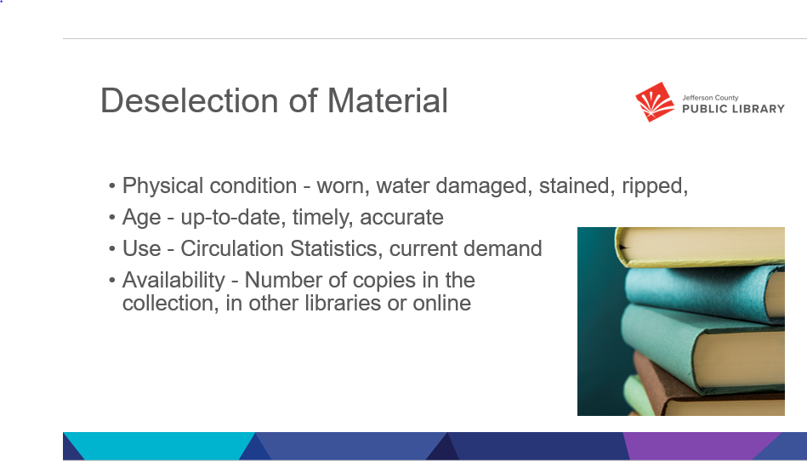
Deselection of materials- or collection maintenance, is essential for libraries. We continually assess our collection to ensure it is what our patrons want, that it is current and that it welcomes all people into our libraries. We have finite space and strive to be good stewards of it. Items are deselected from the collection for a variety of reasons such as:
  - Physical condition – items in poor physical condition are removed- this includes water damage, odors, and crayon drawings
  - Items that are out of date and may have incorrect information- like travel books and encyclopedias
  - Items that are no longer of interest to the community- we have guidelines we use when evaluating if an item should remain on the shelf if it has not checked out for a significant amount of time. That work is again done by expert staff.
  - Availability- One example is when we purchase a NYT bestseller, initial demand is high so we need a lot of copies to meet the need. Once time has gone by and most people have read it, demand stabilizes and we may no longer need as many copies
Once our staff have made the decision to deselect an item, usable materials are sent to the Foundation for book sales, items that are in poor physical condition are disposed of in the appropriate way for the material

Deselection Criteria include the following items
- Circulation Statistics
- Current demand and frequency of use
- Condition: worn, water damaged, chewed, stained, ripped, mildewed, defaced, etc.
- Information: up-to-date, timely, accurate
- Number of copies in the collection
- Availability of item and/or information in other libraries or online

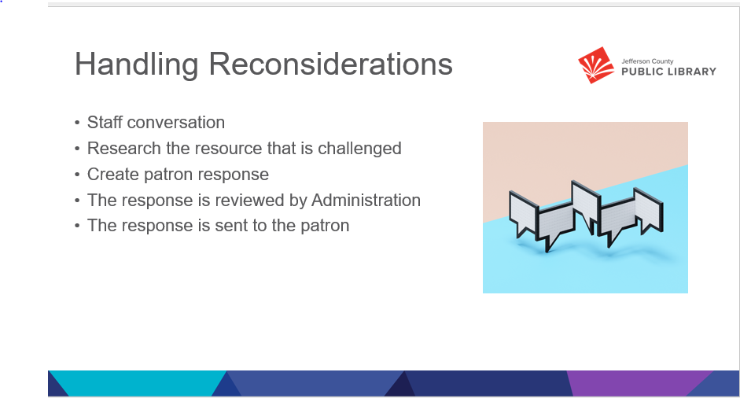

Requests for reconsideration are also an essential part of Collection maintenance. It is an additional data point to help us understand community needs and demand. Challenges to library books and resources do occur at JCPL. Our Collection Development Policy and Reconsideration of Library Resources Policy are in place to outline why we selected the material and how we will assess the challenged title. They support the core of what JCPL is as a public library: a library for all with a wide diversity of materials to support all residents of Jefferson County.

Most reconsideration requests begin with a conversation between a patron and a staff member when a patron asks why an item is in the collection, or how we decided to add it. Usually, that conversation is sufficient to answer the patron's question. Occasionally, the conversation doesn’t answer the question and a formal request for reconsideration is desired. When that happens the staff member explains the reconsideration process and how to fill out the form and also informs the patron that you must be a resident of Jefferson County to file a request.

The same team that selects materials brings their expert knowledge to the reconsideration process. Once a Request for Reconsideration is received, they begin the response process. That includes
  - Checking if the person making the request is a Jefferson County resident
  - Have we received other requests for reconsideration for that title?
  - Look for reviews of the item, and any awards it may have won
  - Verify the intended audience of the item
  - Reviewing or reading a copy of the item – taking particular care with the passages or items of concern, along with the context of the work as a whole
- A response is written highlighting.
  - The patron’s concerns
  - Results of research on the title
  - Decision by JCPL about the request
- The response is reviewed by Administration
- The response is sent to the patron

In most cases that is the end of the interaction. Occasionally the requestor may have a follow-up question. While that is rare, the follow-up questions are treated with the same care as the initial request.

JCPL has averaged under 2 reconsideration requests per year over the last five years. We feel this limit will meet our community needs

The Board did not have any questions regarding the presentation, the Collection Development Policy, or Reconsideration of Materials Policies updates.

The Chair reminded the Board that they will be voting on these policies at the February 20 Board meeting. The Chair asked the Board members to review these before the meeting and share any questions/comments with the Chair and Executive Director ahead of time so that they can address those as needed.

The Chair asked trustees if the policy changes addressed their concerns from the November review. Trustees affirmed that the edits included statutory language which they wanted, as they strengthen our rationale and give stronger support for staff decisions.

Trustee Harsha lost his connection and left the meeting at 6:33pm.

Strategy & Operations
Matt Griffin, Chief Strategy & Operations Officer introduced the Contingency request Budget Transfer and LED Lighting Update topics. The Board was informed that these two items are working in tandem together. JCPL carries contingency money in the budget each year. There is $500,000 in the budget this year. This number is reviewed each year during budgeting and can change. This year a new item came up due to the Clean Lighting Act. We feel this project fits the needs of contingency fund use, as we need to act and do not currently have a budget for this work. The costs for the project are just over $118,000, and we do not want to absorb that in a current line item. Using funds for this project would still leave approximately $380,000 in contingency. The last contingency transfer request was 4-5 years ago. We are comfortable with the remaining amount for this fiscal year.
There were no questions from the Board regarding the contingency funding request.

Steve Chestnut, Director of Facilities & Construction, provided more information on the project. The law went into effect on January 1, and fluorescent bulbs cannot be sold in Colorado. We still have three locations using fluorescent lighting and now we need to convert them to LED as we will no longer be able to get items for building maintenance.

The Board was informed in response to questions that the project costs are what we will incur right now to retrofit the buildings. We do not anticipate seeing increased maintenance costs in the future because of this and may see some small level of savings as LED lighting tends to be more energy efficient.

Contracts & Agreements
Standley Lake Library Audiovisuals Contract- Xcite Audiovisuals, LLC

The Executive Director noted that there was a change to this item and that it will not be on the consent agenda next week unless the Chair requests that it be moved there. We moved it to the regular agenda because this contract is part of the carryforward request.
The Chair confirmed that it can remain on the regular agenda and the Board will act on it separately.

The Executive Director asked the Board to confirm that they were comfortable with the Collection Development and Reconsideration of Materials policies. There were no questions noted from the Board.

Board comments included:
- That JCPL has been a model in operational policies, as demonstrated by the alignment with the statutes and are comfortable with the Board accepting the policies as written next week.

ADJOURNMENT The Study Session was adjourned at 6:43 p.m.

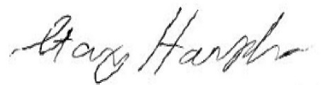

Stanley Harsha, Secretary

