Jefferson County Public Library Board of Trustees
Study Session
January 9, 2025- 5:30pm
Hybrid Meeting held online via ZOOM
and in-person in the Lakewood Library meeting room.

TOPICS:
Board Governance ‐ Strategy
- Board Reviews Global Ends Statements 1.0‐1.4
- Strategic Planning Framework & Process
- 2025 Annual Plan: Strategic Priorities, Initiatives, Programs & Projects
- 2026+ Strategic Planning
Board Governance
- Board Reviews Draft Sunshine Resolution LB‐01‐16‐25
Contracts & Agreements
- Baker & Taylor Boundless Contract Renewal
- Midwest Tape Hoopla Amendment to Extend and Renew Contract
- 2025 Operating Agreement for Digital Literacy Training Partner Site, Jefferson County Public School

Call to Order
Kim Johnson, Chair, called the Study Session to order at 5:30 p.m.

Other Trustees present: Emelda Walker (Vice-Chair), Jill Fellman, Stanley Harsha (Secretary), and Renny Fagan.

Trustees not present: Pam Anderson, Charles Jones

Guests present: Greg Bellomo, GPS, Inc.

Staff present: Donna Walker, Executive Director; Julianne Rist, Director of Public Services; Steve Chestnut, Director of Facilities and Construction; Bernadette Berger, Director of Technology and Innovation; Matt Griffin, Director of Business Strategy and Finance; Lisa Smith, Director of People and Culture; Elise Penington, Director of Communications & Engagement (Virtual), Amy Bentz, Assistant Director of Library Design Projects and Planning; Jessica Paulsen, Assistant Director of Public Services for Customer Experience; Kelci Rude, Administrative Coordinator Supervisor; Katie O’Loughlin, Administrative Coordinator Supervisor; and Ryan Turch, Technology and Innovation Operations Supervisor.

Executive Director Announcement:
The Executive Director informed the Board that our Location & Extent (L&E) was approved last night. There are/were some additional requirements, but they are not related to L&E. The Board Chair signed the closing document for 11100 Bradford Rd, for our new South County Library, this morning.

Board Governance ‐ Strategy
The Executive Director advised the Board that the next three topics are part of the method the Board uses to engage in JCPL’s strategic planning process. The Board will review the ends statements, strategic planning framework and process, the 2025 annual plan and provide input. Once the Library hears inputs from the Board, any adjustments to the plan will be made and next week the Board will be asked if the Library can move forward with the annual plan.
Board Reviews Global Ends Statements 1.0‐1.4
The Global Ends Statements were developed with extensive Board, staff and public input. The Library recommends maintaining the ends statements for this year as the final year of the 2020-2025 plan.

The Board did not recommend any changes to the Ends. The Chair advised the Board that they would be asked for a consensus on these at the next meeting.

Strategic Planning Framework & Process
Matt Griffin, Director of Business Strategy and Finance addressed the Board and provided information on the Library’s strategic planning framework and process. The Board was informed that the Executive Director will ask for consensus on the plan at the 1/16/2025 regular Board meeting. The Board has an opportunity to ask questions tonight on programs/projects/deliverables.

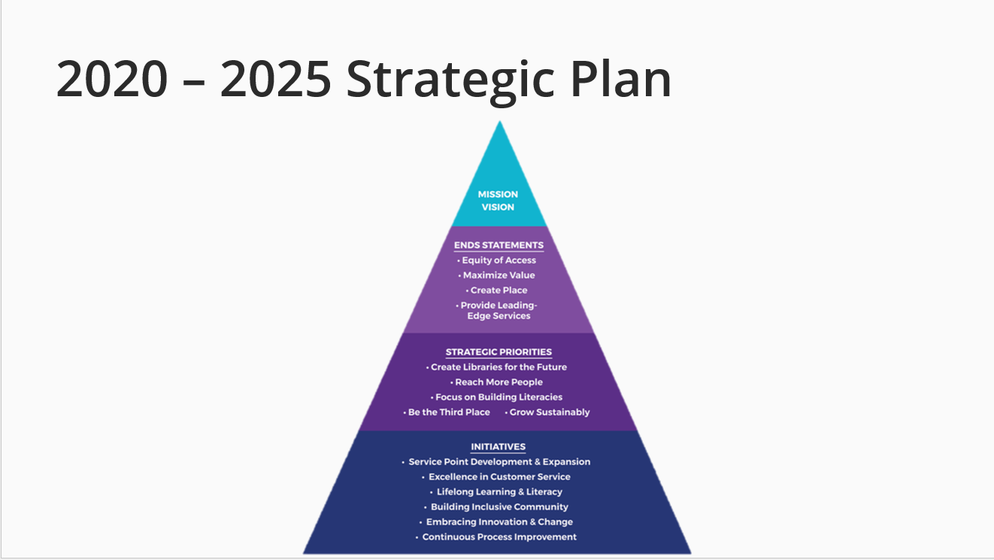

This is in place through end of 2025. Our initiatives are at the bottom of the pyramid; in the project management world we refer to those as portfolios. By organizing under these portfolios, we ensure every effort is tied to a specific initiative and therefore the Mission, Vision, Values.

2025 Annual Plan: Strategic Priorities, Initiatives, Programs & Projects
Heading into 2025, the Library believes that the five strategic priorities set in the 2020-2025 Strategic Plan continue to hold true.
These priorities are to:
CREATE LIBRARIES FOR THE FUTURE
Jefferson County Public Library will create libraries for the future throughout the county via expansion, redesign and construction.

REACH MORE PEOPLE
Jefferson County Public Library will reach more people through strategic partnerships, alternative services, customer experience, inclusion efforts, and community engagement and outreach.

FOCUS ON BUILDING LITERACIES
Jefferson County Public Library will focus on building literacies through patron-interest-focused materials selection, creative technologies, digital literacy services, school and workforce readiness, adulting programs, small business support and financial literacy initiatives.

BE THE THIRD PLACE
Jefferson County Public Library will facilitate civil civic conversation, develop collaborative community discovery spaces, and serve as the place to be for out-of-school time and not-to-miss events.

GROW SUSTAINABLY
Jefferson County Public Library will manage financial resources to meet our planned capital and service build-out within our current mill levy rate of 4.5 and account for a variety of economic conditions.

Similarly, library leadership reviewed and validated our strategic initiatives, high-level actions that set the direction for JCPL’s strategic projects, and further the strategic priorities to reach the ends statements.

These initiatives are:

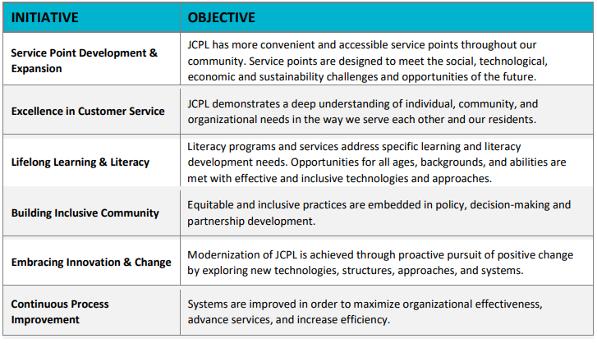
Building on the project management framework introduced last year, we continue to use the program-based structure that organizes related projects into cohesive programs. These programs align with broader portfolios named after our key initiatives, directly connecting each project to its strategic impact.
This approach remains integral to how we manage and prioritize efforts across JCPL, keeping a clear focus on the initiatives outlined in our 2020-2025 Strategic Plan.
Outlined below are the projects that form the 2025 JCPL Annual Plan, along with their anticipated deliverables for the year.

Portfolio: Service Point Development & Expansion
Program: New Construction
Project: South County Library
Deliverables:
- Finalize Program of Service
- Complete Design Development phase
- Develop recommendations for interim uses
- Investigate partnership opportunities
- Initiate naming opportunities solicitation

Portfolio: Service Point Development & Expansion
Program: New Construction
Project: South County Express Library
Deliverables:
- Finalize site location
- Define services
- Complete design
- Initiate construction

Portfolio: Service Point Development & Expansion
Program: New Construction
Project: Northwest Jeffco Library
Deliverables:
- Finalize Program of Service
- Complete Design Development phase
- Investigate partnership opportunities
- Initiate grant & naming opportunities solicitation
In response to questions, the Board was informed that:
- The difference between the Northwest and South County fundraising goals are related to our fundraising consultant’s analysis of where we have funding opportunities. They are recommending focusing on Northwest. The challenges for South County funding are related to both timeline and opportunity.
- The Library will provide a copy of the PowerPoint shown in the meeting to the Board.

Portfolio: Service Point Development & Expansion
Program: Building Redesign
Project: Arvada Library
Deliverables:
- Finalize Design Development
- Complete construction drawings with guaranteed maximum price (GMP)
- Implement alternative service options
- Begin construction
- Initiate naming opportunities solicitation
In response to questions, the Board was informed that:
- Each capital project has a communication plan that is part of the larger project plan. Those are not called out here.
- The Board receives updates on the communication and community outreach through the Executive Director reports that are provided as part of the Board packets.
- The Executive Director will consider how we can inform the Board about our public communications around projects and progress.

Portfolio: Service Point Development & Expansion
Program: Tenant Finish
Project: Conifer Library
Deliverables:
- Finalize construction documents with guaranteed maximum price (GMP)
- Conclude intergovernmental agreement (IGA) with Conifer High School
- Open new Conifer Library
In response to questions, the Board was advised that:
- Naming opportunities solicitation was not included here as so much of that work is current work that is ongoing.
- There are three naming agreements that we are asking for approval on at the 1/16/2025 meeting.
- The Executive Director confirmed that Naming Opportunities Solicitation can be added back as a deliverable.

Portfolio: Excellence in Customer Service
Program: A Radically Welcoming User Experience
Deliverables:
- Develop standardized new patron onboarding process
- Implement new patron onboarding plan
- Identify tools for personalized patron experience
- Implement tools for personalized patron experience
In response to questions, the Board was informed that:
- Trustees will see progress on the Radically Welcoming User Experience program over the course of the year.
Portfolio: Lifelong Learning & Literacy
Program: Creative Technologies
Project: Creative Tech Mobile
Deliverables:
- Finalize mobile lab design
- Create mobile STEM curriculum
- Investigate partnership opportunities

Portfolio: Building Inclusive Community
Program: Create a Radically Welcoming JCPL - Staff
Project: All Staff Compensation Strategy
Deliverables:
- Complete compensation analysis
- Integrate findings into Collective Bargaining Agreement (CBA)
- Integrate findings into 2026 budget
In response to questions, the Board was informed that:
- One of the things we do is to look at the objectives of the initiatives. Building Inclusive Community is around inclusive practices in decision making and policy. We would probably ask to leave these projects where they are instead of shifting them to another portfolio.
- The Compensation Analysis consists of benchmarking against nationwide markets and against specific library positions. We have a third-party company doing this work. We are now in the final piece of this where the company will look at their analysis and at County’s analysis and see where there are gaps. Then, we will analyze where we are and how we can adjust. It will then go to the union, which also propels what happens with non-union employees.
- The compensation analysis also included other governments and Denver Metro Libraries for comparison.
Portfolio: Building Inclusive Community
Program: Digital Accessibility
Deliverables:
- Create JCPL-specific digital accessibility guidelines
- Meet 2025 digital accessibility requirements across platforms
Portfolio: Embracing Innovation & Change
Program: Artificial Intelligence (AI) Strategy
Project: AI Strategy Development
Deliverables:
- Finalize AI Strategy
- Initiate strategy implementation
Bernadette Berger addressed the Board. In response to questions, the Board was advised that:
- We have completed strategy development sessions over the last year. We are working with an outside consultant to guide us along this journey. We want to move with County because we operate with them, and we want to go along with them. It is evolving rapidly. We’ll understand more of the work under this as we build out our strategy.
- We anticipate there will be several aspects to this work that will focus on both staff and patrons.
Portfolio: Embracing Innovation & Change
Program: Fundraising Development
Deliverables:
- Complete 2024-2025 Fundraising Plan
- Develop a 3-5 year fundraising plan
- Create a fundraising plan for 2026

Portfolio: Continuous Process Improvement
Program: Collective Bargaining
Project: Collective Bargaining Agreement
Deliverables:
- Integrate economic impacts into 2026 budget
- Finalize CBA
- Obtain BOT approval of CBA
- Obtain BCC approval of CBA

Portfolio: Continuous Process Improvement
Program: JCPL Long Term Plan
Project: 2026+ Strategic Plan
Deliverables:
- Refined Mission, Vision, and Broad Goals framework
- Finalize 2026+ strategic plan

In response to questions, the Board was informed that:
- We are not yet sure what month we will complete the 2026+ strategic planning. We will make progress on it over the next few months. It is an iterative process. We will be in a good spot by the time we bring the budget to the Board to review, in about the first half of the year.
- Trustees will see when we are making progress towards a deliverable in the Executive Director report.
- Projects and programs may seem to be an appropriate fit under several portfolios. Our process is to identify a single best match portfolio for where these should live.
- It is a project management best principle to only list programs/projects once, rather than having them under several portfolios.
- If there’s something that Trustees want to come to an agenda, they should work with the Chair. The Chair confirmed that Trustees are welcome to provide suggestions or requests for agenda items.
- The Chair confirmed that the goal for Trustees is to provide recommendations for what they’ll see in the budget. Not getting into Operations, but saying ‘This is where we hope Operations go”
- The Chair confirmed that the Executive Director will look for a consensus next week. If you have questions over the week, please share those with the Chair so the Executive Director and her team can come with answers and information next week

2026+ Strategic Planning:
Matt Griffin addressed the Board and introduced the 2026+ Strategic Planning topic.

JCPL is going to begin the process of 2026 and beyond strategic planning. We use plus because we don’t know the duration of this next plan. Greg Bellomo from GPS is with us tonight. He is guiding us through this session and the whole process. Trustee role is to review Mission, Vision, Values and End Statements (broad goals). The internal team will review, and revise based on your input tonight and bring something fresh to the next session.

Greg Bellomo explained that GPS’s role is facilitative; it is not to advise. He will be leading the Trustees through an exercise tonight, and Trustees will engage progressively, beginning with broadest goals today.

In general, strategic planning is a four-step process: Organize- inform strategy- find out what people have to tell you- disciplined process of creating that into a framework. We’re just on the cusp there of informing and moving into a synthesized framework.
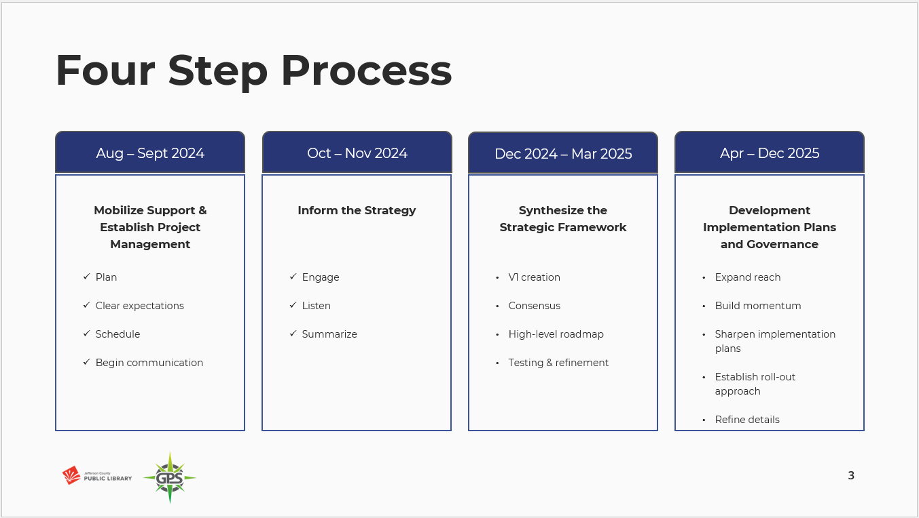
Input Data:
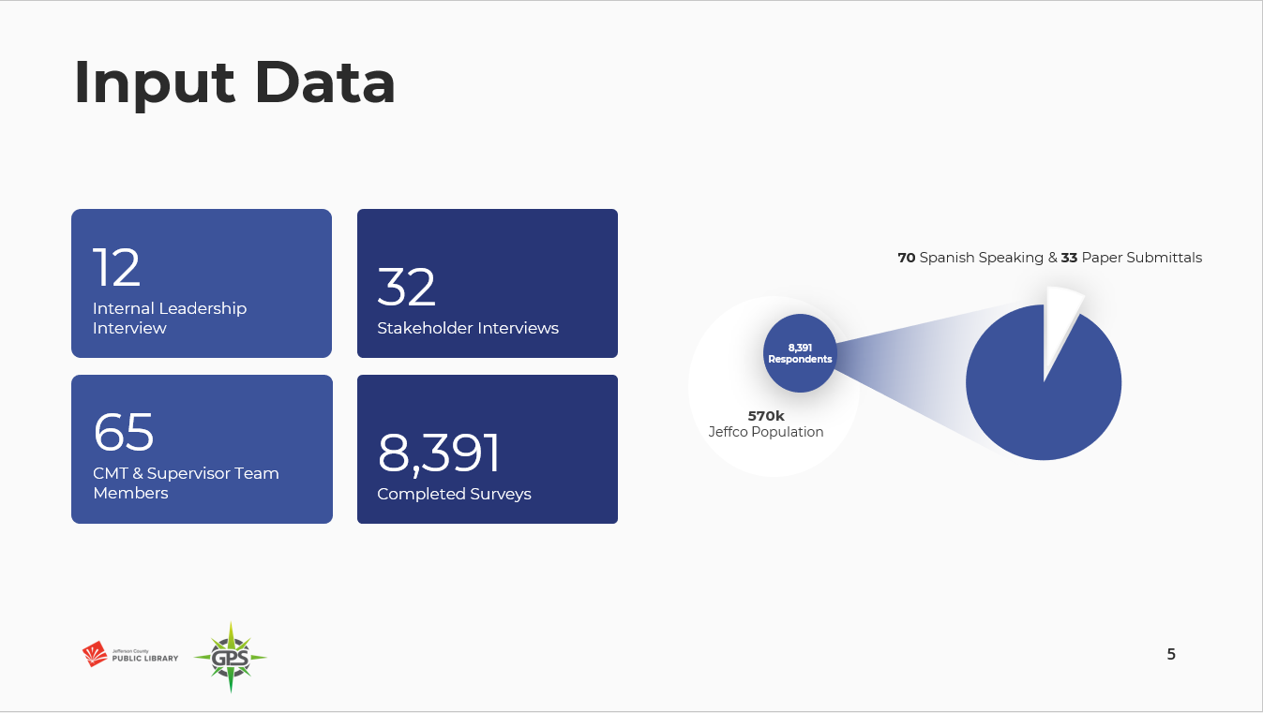
GPS interviewed Directors Team (12), 32 community partners, 65 members of the Supervisory team (CMT), 8391 respondents who completed the survey (10 min survey). 1.5% of Jeffco population- mostly English speaking and they were taken online. 70 in Spanish. This is not representative of Spanish population, but bilingual speakers may take a survey in English. GPS does plan to come back around and look for confirmation on those inputs with staff and community.

Survey insights:
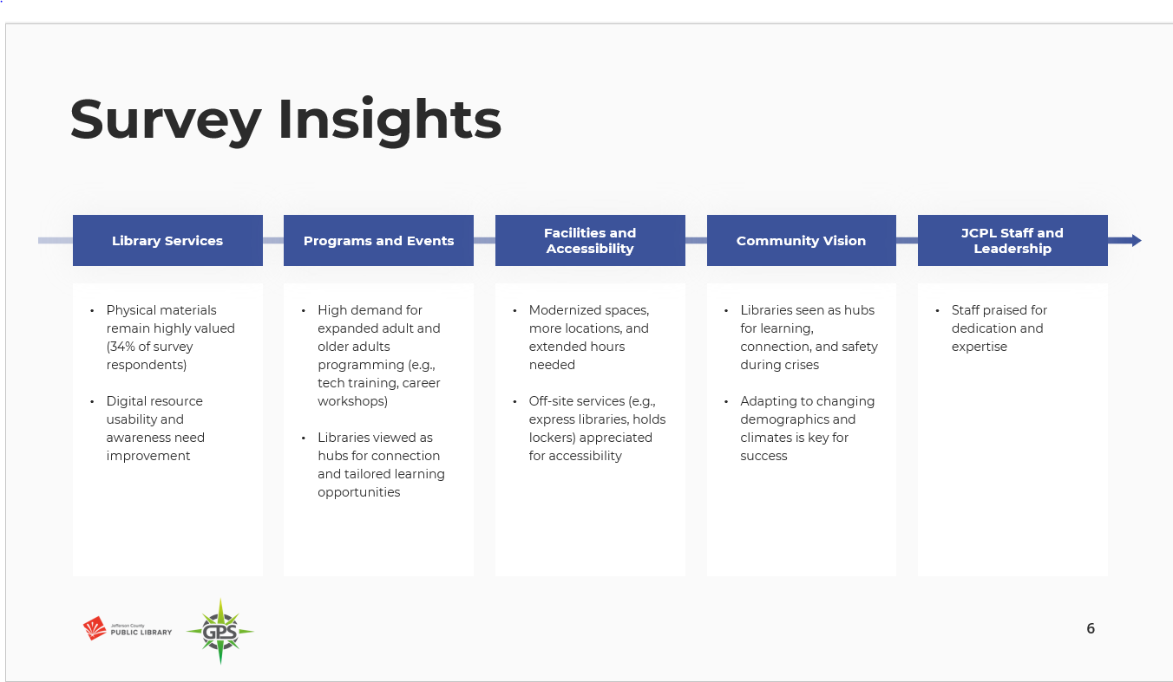
- Programs: whenever someone wants to go somewhere new, they think of the library as pathfinders for them. No shortage of ideas around different learning opportunities.
- Facilities & Construction: validates builds and refreshes. Many respondents said they want more hours and/or something closer to them. The express location, lockers, offsite services and spaces are well appreciated. The Library is on the right track with those
- Community Vision: We had 10-yr vision questions- both open and closed questions, 54% said they envision the library as a place for lifelong learning.
- English speaking respondents said the most valuable thing they wanted more of was physical materials. Spanish speakers said copying/computers/internet – this does require continued dialogue.
- The survey also had an open-ended question on what could be changed. 10% of all responses were positives – perfect/don’t change a thing/like things the way they are

In response to questions the Board was informed that:
- Staff responses were limited to leadership; this did not go out to all staff. Leadership staff responses did not show wide discrepancies from the public survey responses, but staff have a different focus than patrons.
- Some survey respondents (fewer than 90) were non patrons. The quality of the information wasn’t that helpful to get at a broader question of why those folks aren’t coming to a library or using the library.
- JCPL completes an annual trends exercise to help us answer the question of “What else is out there? What are you seeing that’s next?”
- We complete this exercise with leadership staff and then with the Board. The focus is on general culture and looks at many fields, not just libraries.
- Approximately 60% of respondents answered the open-ended question on the survey about what they wanted to see changed at the library. 9-10% of those answers said the library was perfect as is. The other respondents indicated they wanted more hours, libraries closer to them, etc.
- The demographic questions on the survey were location, age, and library user type.
- There were some divergences across age groups. Older more frequent library users like physical materials and spaces and spoke about a need for easier digital access. Younger users wanted hang-out spaces- 14 mentions of coffee shops. Desire for technology was flatter across age groups. JCPL’s data team did build a utility which will allow library leaders to really pinpoint data to get at those differences. Ex: What did older infrequent users say about this thing vs older frequent users?

Exercise Instructions:
During this exercise we will look at our current Mission and Vision, and we’ll use a couple of questions to refine feedback.

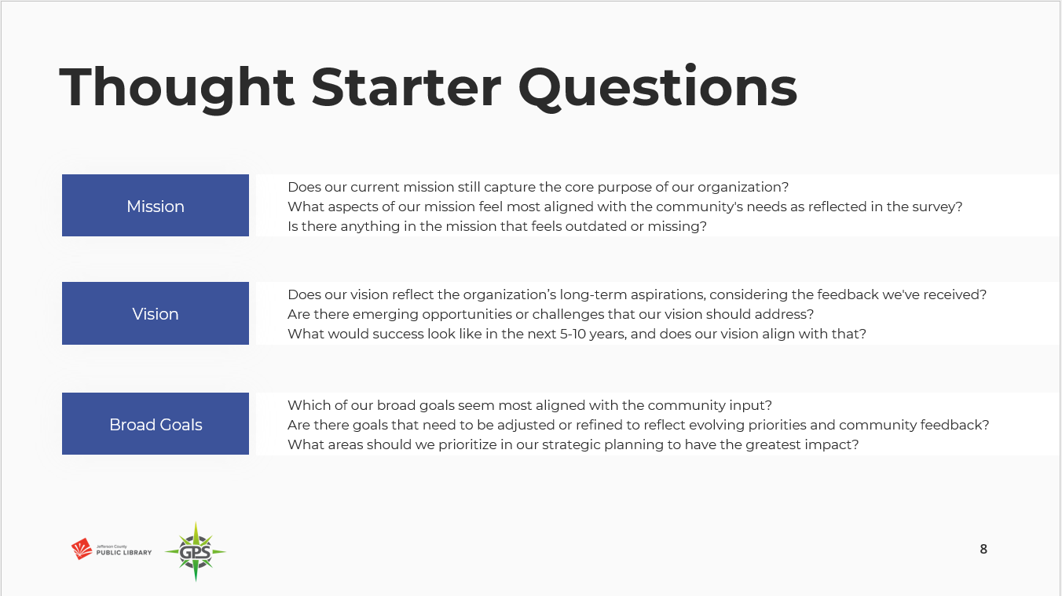

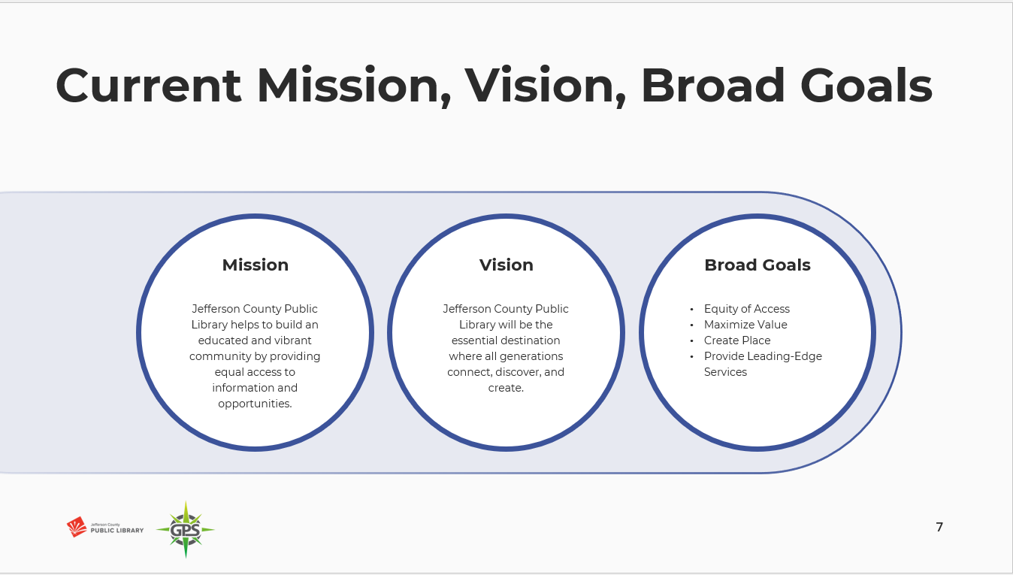

Trustees provided the below feedback:

Mission:
- Some trustees felt the Mission was good as is.
- One trustee noted that the aspect that feels most aligned to community needs is helps to build… equal access.
- One trustee noted that equitable seems more accurate than equal- same concept but a nuance.
- One trustee questioned if we need to add partnerships, related to this idea of more partnerships in the survey.
- One trustee recommended updating this language to ‘providing information, experiences, and opportunities’ .
- Chair noted that there are things people are saying that are missing from mission- would want to ask if they are missing, or if they are captured in Vision and Goals. They should have different longevities.
- One trustee stated that they were looking to see the impact- What in here is the impact the library has on a struggling patron for economic/social? What is the practical impact on taxpayers- how much investment and return are we seeing- and do people of all strata see that?

Vision:
- One trustee noted that they feel we are missing ‘learn’ - all generations learn connect create.
- One trustee noted that the word ‘generations’ does not speak to them. This language feels possibly outdated, and doesn’t show inclusivity of infant to adults.
- One trustee noted that the vision needs to look ahead strategically.
- One trustee noted that the vision statement for an organization can also answer the question of ‘so what?’ or ‘to what end?’. The vision statement explains the point of the work, and recommended looking at Habitat for Humanity’s statement as an example.

Broad Goals:
- One trustee noted that equity of access and providing leading edge services stood out and felt like they will continue to remain relevant.
- The Chair noted that what didn’t come through from the survey respondents is maximizing value. They think that it still needs to be a goal even though it didn’t come through in survey. From a Board perspective, that is their job.
- One Trustee wanted to look at the language in providing leading edge services- breaking that into concept of radically welcoming and everywhere-ness of service.
- The Chair noted that Create Place always stands out to them. We continue to need opportunities to discuss and be with other people. They know that the Library creates place in many ways, but they feel that we need to lean into that
- Fellow trustees affirmed that the Library’s role as a civic forum is very important. We are seeing increased polarization and divisions, and we are situated as a place to bring people together in a non-judgmental way. You know that the person sitting near you may think differently than you, and that is ok. They want JCPL to encourage that and let people seek understanding with one another.

Board Governance
- Board Reviews Draft Sunshine Resolution LB‐01‐16‐25

The Board did not have any questions regarding the proposed Sunshine Resolution.
The Chair advised the Board that this item will go on the consent agenda for next week’s meeting.

Contracts & Agreements
- Baker & Taylor Boundless Contract Renewal
- Midwest Tape Hoopla Amendment to Extend and Renew Contract
- 2025 Operating Agreement for Digital Literacy Training Partner Site, Jefferson County Public School

The Board did not have any questions regarding the three contract renewals. The Chair advised the Board that these items will go on the consent agenda for next week’s meeting.

ADJOURNMENT The Study Session was adjourned at 7:13 p.m.

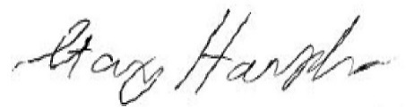

Stanley Harsha, Secretary

