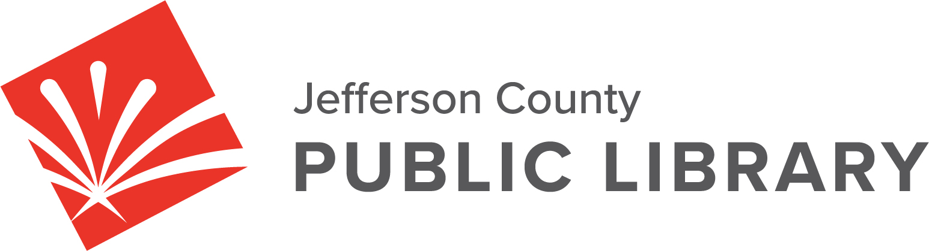

BOARD MEETING

DATE: February 20, 2025
TIME: 5:30 P.M.
PLACE: Hybrid Public Meeting
- Online via ZOOM
- In-Person at Lakewood Library meeting room, 10200 W. 20th Avenue, Lakewood 80215

For instructions on how to access the online ZOOM Board meeting please go to:
https://jeffcolibrary.org/board-of-trustees/2025-board-meetings/

EXECUTIVE SESSION:

- Collective Bargaining. Statutory citation authorizing an executive session for this topic is:
• Pursuant to 24-6-402(4)(e)(I) for discussion of strategy and instructions to negotiators.

(2) Urban Renewal Authority. Guest: Kurt Behn, County Attorney’s Office
Statutory citation authorizing an executive session for this topic is:
• Pursuant to 24-6-402(4)(e)(I) for discussion of strategy and instructions to negotiators.
- Pursuant to 24-6-402(4)(b) Conferences with an attorney for the local public body for the purposes of receiving legal advice on specific legal questions.

NEXT BOARD MEETING

