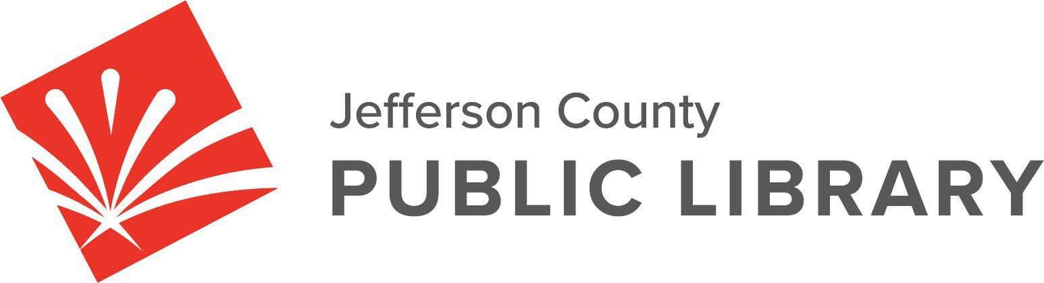

**BOARD STUDY SESSION**

**DATE: February 13, 2025**

**TIME: 5:30 P.M.**

**PLACE: Hybrid Public Meeting**

* **Online via ZOOM**

**In‐Person at Lakewood Library meeting room, 10200 W. 20th Avenue, Lakewood 80215**

**Board Governance - Strategy**

* 2026+ Strategic Planning

Guest: Greg Bellomo, Government Performance Solutions, Inc

**Board Governance- Policies**

* JCPL Operational Practices for Collection Development and Reconsideration of Materials Policies Update

Guest: Kurt Behn, County Attorney’s Office

**Strategy & Operations**

* Contingency request Budget Transfer
* LED lighting updates

**Contracts & Agreements**

* Standley Lake Library Audiovisuals Contract- Xcite Audiovisuals, LLC

For instructions on how to access the **online ZOOM Study Session** please go to: [https://jeffcolibrary.org/board‐of‐trustees/2025‐study‐sessions/](https://jeffcolibrary.org/board-of-trustees/2025-study-sessions/)

**NEXT BOARD STUDY SESSION**