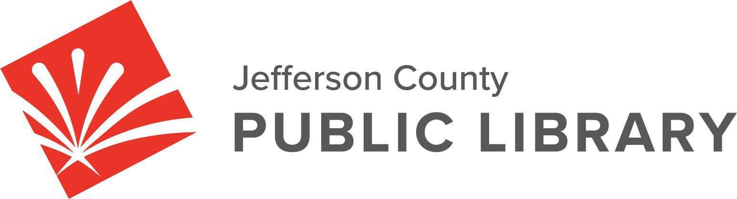

**BOARD STUDY SESSION**

**DATE: January 9, 2025**

**TIME: 5:30 P.M.**

**PLACE: Hybrid Public Meeting**

* **Online via ZOOM**

**In‐Person at Lakewood Library meeting room, 10200 W. 20th Avenue, Lakewood 80215**

**Board Governance ‐ Strategy**

* Board Reviews Global Ends Statements 1.0‐1.4
* Strategic Planning Framework & Process
* 2025 Annual Plan: Strategic Priorities, Initiatives, Programs & Projects
* 2026+ Strategic Planning

**Board Governance**

* Board Reviews Draft Sunshine Resolution LB‐01‐16‐25

**Contracts & Agreements**

* Baker & Taylor Boundless Contract Renewal
* Midwest Tape Hoopla Amendment to Extend and Renew Contract
* 2025 Operating Agreement for Digital Literacy Training Partner Site, Jefferson County Public School

For instructions on how to access the **online ZOOM Study Session** please go to: [https://jeffcolibrary.org/board‐of‐trustees/2025‐study‐sessions/](https://jeffcolibrary.org/board-of-trustees/2025-study-sessions/)

**NEXT BOARD STUDY SESSION**