### Minutes of the Regular Meeting of the

JEFFERSON COUNTY PUBLIC LIBRARY

BOARD OF TRUSTEES

November 21, 2024

**CALL TO ORDER – REGULAR MEETING**

The regular meeting of the Jefferson County Public Library Board of Trustees was held online via ZOOM and in-person in the Lakewood Library meeting room on November 21, 2024. Library Board of Trustees Chair, Kim Johnson, called the meeting to order at 5:30 p.m.

Other Trustees present: Emelda Walker (Vice-Chair), Stanley Harsha (Secretary), Renny Fagan, Jill Fellman and Charles Jones.

Trustees not present:. Pam Anderson.

**Staff present:** Donna Walker, Executive Director; Julianne Rist, Director of Public Services; Bernadette Berger, Director of Technology and Innovation; Elise Penington, Director of Communications and Engagement; Steve Chestnut, Director of Facilities and Construction Projects; Matt Griffin, Director of Business Strategy and Finance; Lisa Smith, Director of People and Culture; Jessica Paulsen, Assistant Director of Public Services for Customer Experience; Lizzie Gall, Assistant Director of Public Services for Resources and Programs; Padma Polepeddi, Assistant Director of Public Services for Community Outreach; Amy Bentz, Assistant Director of Library Design Projects and Planning; Amber Fisher, Executive Assistant, Office of the Executive Director; Kelci Rude, Administrative Coordinator Supervisor; and Ryan Turch, Technology and Innovation Operations Supervisor.

There were additional Library staff members attending the meeting.

**APPROVAL OF AGENDA**

**MOTION:** Jill Fellman moved that the Library Board of Trustees approve the agenda as presented. Seconded by Charles Jones, the motion passed by unanimous vote of all Trustees present.

**PUBLIC COMMENT**

The Board values public participation. Those who would like to address the Library Board can do so virtually, in-person, or online. The opportunity to address the Library Board does not include a question and answer session or response. Additionally, the Library Board does not respond to anonymous questions or comments. Comments will be acknowledged in the minutes of the meeting.

The Chair advised the Board that no online public comments were received. Christine Catramados, Dawn Allbee, Sammi Johnson and Lainie Miller addressed the Board and provided public comment regarding pay, annual increases for all pages, executive pay, onetime bonuses, page turnover, page responsibilities, essential functions and increased duties, annual raises, Edgewater minimum wage, inflation, onetime bonuses and the 2024 wage increase.

There were no further public comments, and the Chair closed the public comment portion of the meeting at 5:47 pm.

**APPROVAL OF CONSENT AGENDA**

The Chair asked the Trustees if any of the items should be removed from the consent agenda. There were no requests for items to be removed.

Items on the November 21, 2024 Consent Agenda:

1. Library Board of Trustees Approve October 17, 2024 Board Meeting Minutes.

**MOTION**: Stanley Harsha moved that the Library Board of Trustees approve the items on the consent agenda as presented. Seconded by Charles Jones, the motion passed by unanimous vote of all Trustees present.

**FOUNDATION UPDATE**

Jill Fellman, Board Liaison to the Foundation provided an update on the activities of the Foundation and noted the report is in the information packet. The Foundation has 10,359 volunteer hours per year. Yesterday at the Foundation Board meeting Julianne Rist, Director of Public Services and Bridget Beatty, JCPL Fundraising Consultant, spoke eloquently about funding priorities and how the Library and Foundation are working together in collaboration to fund those priorities.

**Executive Director Report**

1. Executive Director Report

The Executive Director advised the Board that Tuesday night the youth development program graduation was held at the Belmar Library. It was a beautiful, well-presented event and the teens were awesome. The JCPL team, Padma Polepeddi, Assistant Director of Public Services for Community Outreach, Nick Taylor Belmar and Teen Services Manager and Arra Katona, Teen Services Coordinator worked with the teens on their presentations. Clarice Ambler, Community Resource Coordinator has been invited to be on the interagency advisory Board of Heading Home, a county-wide systemic response for the prevention of homelessness. On Monday the Library held new Trustee orientation with Renny Fagan.

There were no questions about the Executive Director’s report.

1. Capital Building Projects Update

* **South County Library**: JCPL held two more chat with the manager sessions engaging 74 more people. Staff attended the Halloween event at the Ridge Recreation Center and Lizzie Gall did a presentation on the site to the South Jeffco Business Alliance. The South County Advisory Council is being consulted on continuation of their roles.
* **Northwest Jeffco Library**: The community engagement report will be presented to the Board in December. The manager, Bryan Kratish, attended a PTA meeting at Coal Creek Canyon and entered a 5k in the community.
* **Arvada Library Redesign**: The conceptual design review was held today.
* **Conifer Library:** The design development drawing has been sent to the general contractor for pricing and the team is working with the school on a new IGA.

In response to a question, the Board was advised that the timing of the departure from the Conifer High School is anticipated to be Summer 2025.

**EXECUTIVE TEAM OPERATIONAL UPDATES**

**Business Strategy & Finance**

Finance and Budget

1. Financial Tables (October 2024)

Matt Griffin, Director of Business Strategy and Finance provided information on the October financials. The 2025 budget tables are also included in the Board’s information packet. Total revenue at the end of October is trending above budget and it is not unusual to see adjustments in the following fiscal year. The Library will keep an eye on revenues through the end of the year and into next year. On Table 2, Operating Expenditures are on track as expected with healthy spending across the board and will likely come in below budget at the end of the year. On Table 3, Capital, this Board authorized three supplementals, South County Library, Evergreen Library roof repair and Columbine Library roof repair. The supplemental request was presented to County and will go onto their December consent agenda. JCPL will likely see those flow into the Library’s financials in December. On Table 4, JCPL received the Hard Times Writing Grant from Colorado Gives Foundation for just over $24,500.

There were no questions from the Board on the October financials.

1. 2025 Recommended Budget

Matt Griffin provided a brief overview of the annual budgeting process. There are always changes to the budget that was submitted to the Board in June. The Library incorporates those changes and brings those changes back to this Board. The full 2025 County budget, which includes the Library’s budget, did go to the Board of County Commissioners (BCC) on Tuesday, and the 2025 budget was approved. Tonight the Library will present the key changes to the Library’s 2025 budget that occurred between June and November.

Key 2025 Budget Changes

Revenue: Investment income increased $1.8 million. The Library takes a conservative approach on investment income and based the budget on a lower amount. Property tax increased by $2.0 million for a net increase to 2025 revenue of $3.8 million.

Expenditures: Increase to salaries and benefits of $118,000 and interdepartmental charges of $18,000 for a net increase to 2025 expenditures of $136,000.

There were no changes within the 2025 capital budget. It is important to note that ongoing rising construction costs were not built into the 2025 budget and the increase in revenue may help offset those rising costs. Investment income is a forecast, not a guaranteed amount and the Library does not treat it as a realized amount.

Fund Balance vs Boundaries Over Time – 2025 – 2035

The chart below shows the projected ending fund balance, minimum boundary and upper boundary.

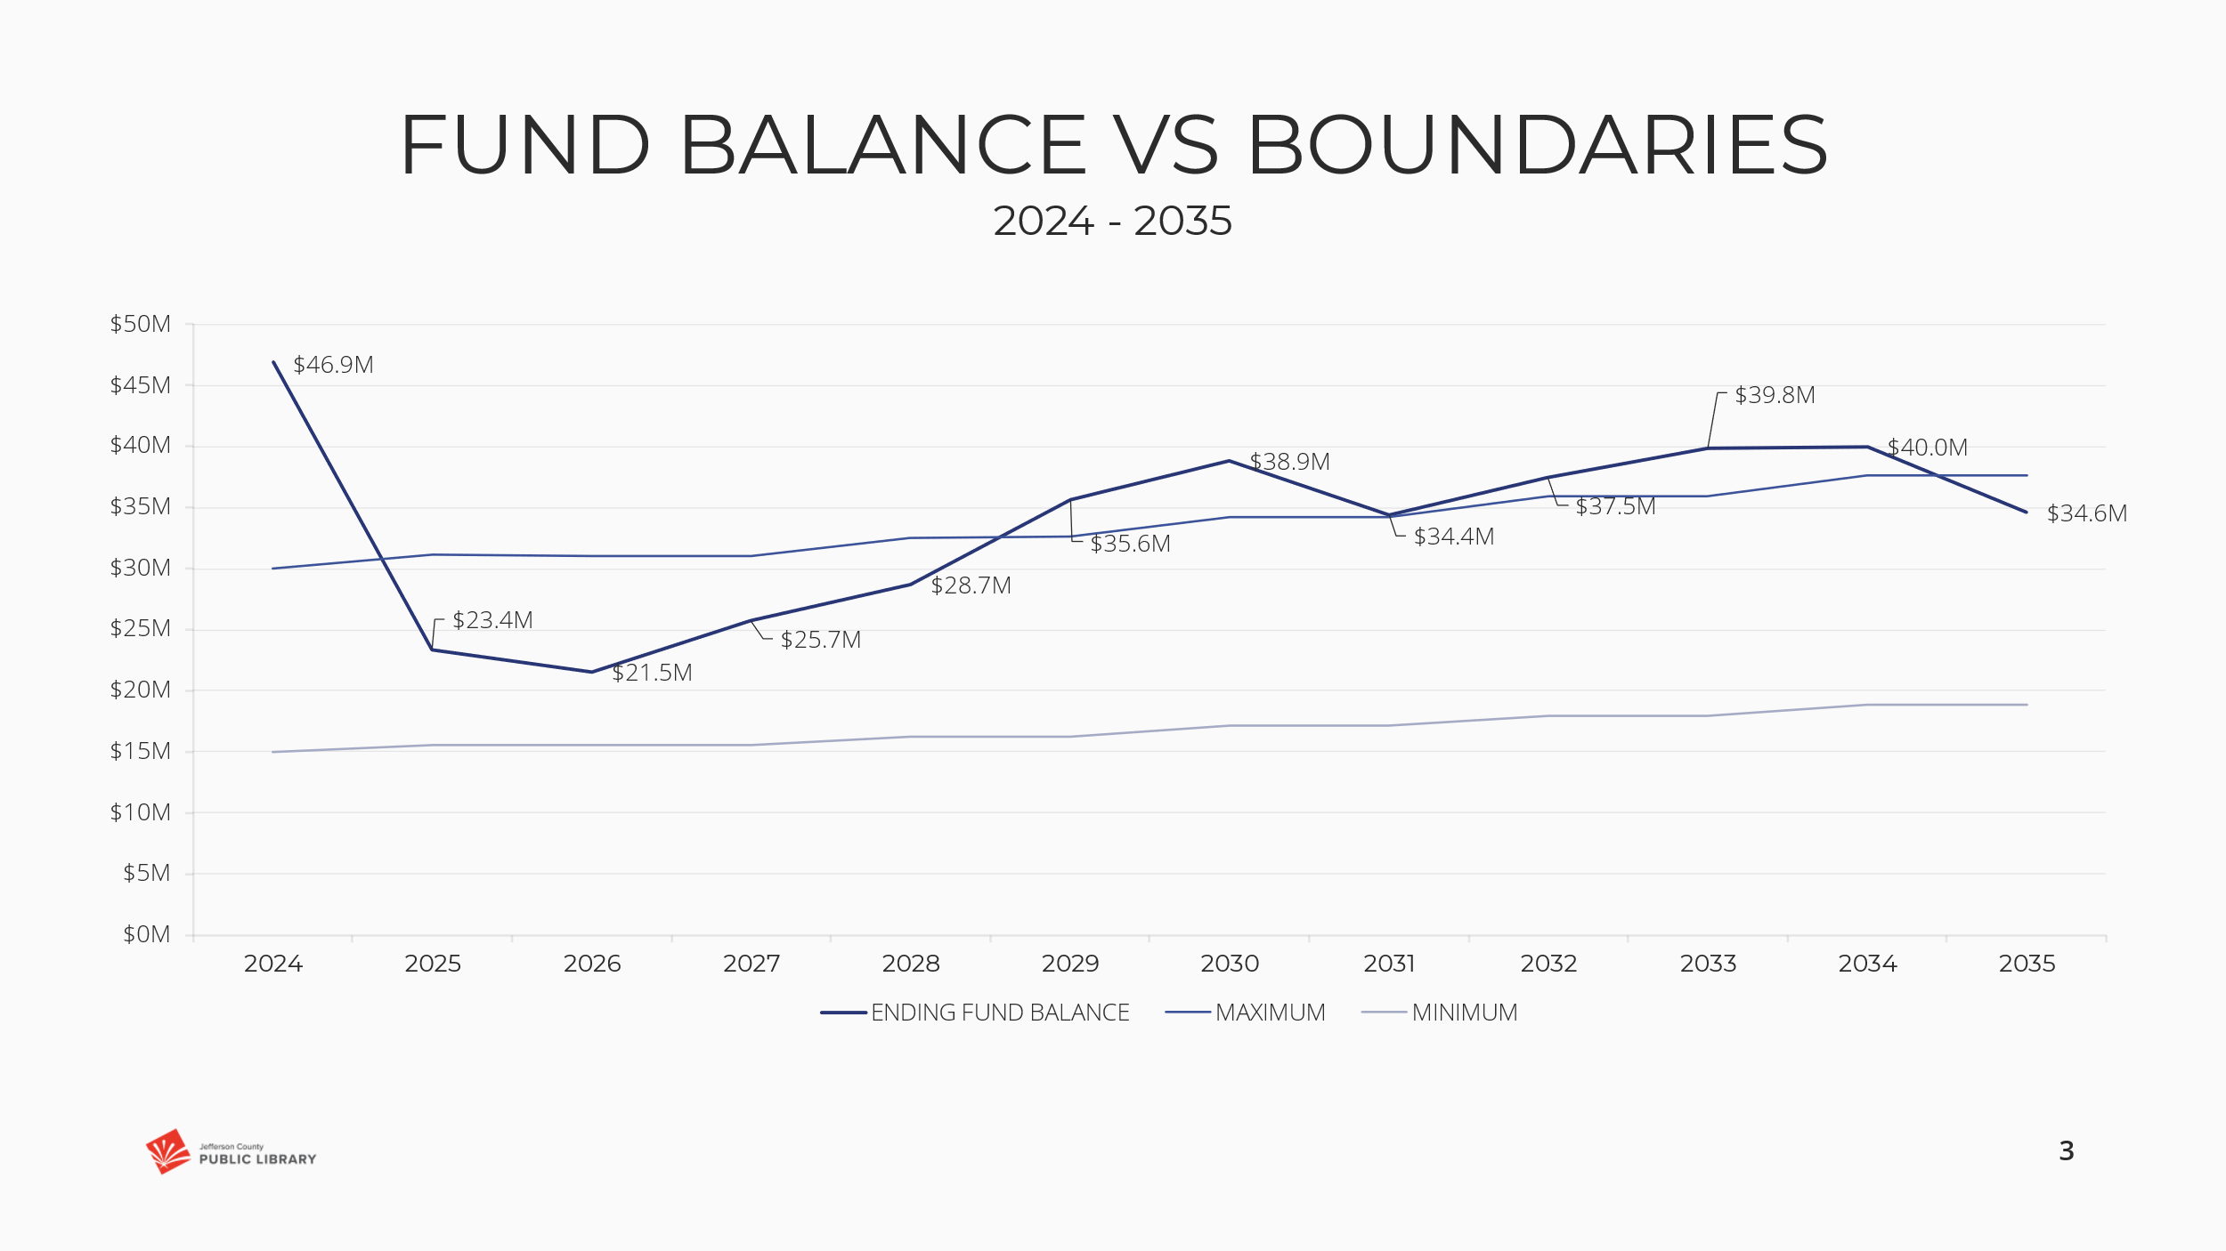

Revenue vs Operating

The chart below shows revenue stays consistent with operating growth.

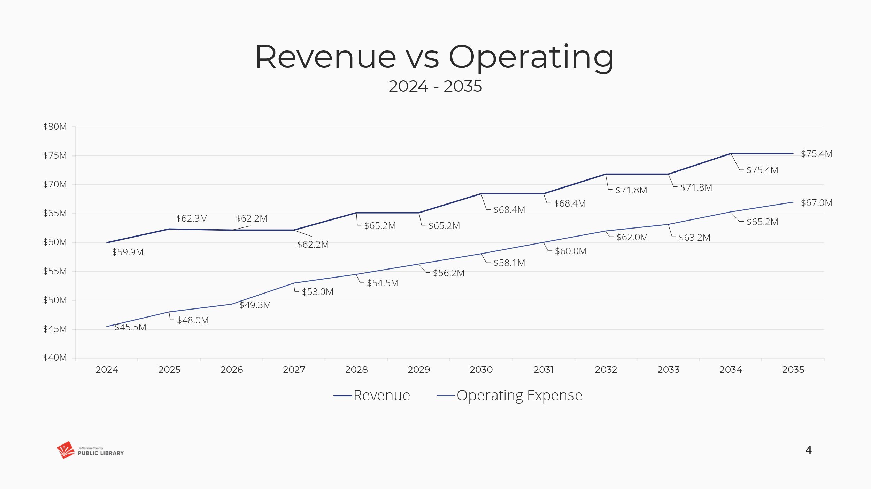

In response to a question, the Board was advised that the fluctuations in the fund balance are primarily the result of capital project and construction expenditures.

The Chair noted that since the time the Board approved the budget for submittal earlier this year, the fund balance did come close to the minimum requirement and this projection gives the Library a little breathing room. There is always uncertainty around property tax revenue. The Chair noted that in the past she did ask the question about the budgeting approach to investment income and the answer is that you can’t spend unrealized income.

The Chair noted that in December the Board will be asked to adopt the 2025 budget and authorize the Executive Director to implement the spending plan. The Board was advised that if there are any questions in the meantime, to please reach out to her or the Executive Director.

**Facilities & Construction**

1. Arvada Library Redesign General Contractor

Steve Chestnut, Director of Facilities and Construction Projects provided information on the contract for the Arvada Library redesign general contractor. JCPL is requesting authorization to enter into contract for the general contractor for the Arvada Library redesign project. The guaranteed maximum price (GMP) can’t happen until further down the road when the Library knows what the design will look like. The general contractor is being brought on to participate in the delivery model and help JCPL, the designer and contractors, and participate in preconstruction. The Library issued a Request for Proposal (RFP) for the Construction Management/General Contractor (CMGC) services and six firms responded. The Library interviewed three firms, ranked the responses and completed background and reference checks. The Library is recommending the Board authorize the contract with FlintCo, LLC for preconstruction development design.

In response to questions, the Board was advised that:

* The Library has not worked with FlintCo before.
* The preconstruction part of the contract the Board is being asked to authorize is approximately $18,000. The Library will come back to the Board with the Guaranteed Maximum Price (GMP).

The Chair noted that getting a general contractor on board now helps the Library get tighter with the GMP.

**MOTION**: Emelda Walker moved that the Library Board of Trustees authorize the Executive Director to enter into a contract with FlintCo, LLC for Construction Management and General Contracting for the Arvada Library redesign. Seconded by Jill Fellman the motion passed by unanimous vote of all Trustees present.

**Public Services**

1. New Collection Development Policy 4.10
2. New Reconsideration of Library Resources Policy 4.10.1
3. Monitoring Report 2.9: Materials Selection

Julianne Rist, Director of Public Services and Lizzie Gall, Assistant Director of Public Services for Resources and Programs, presented information on the new policies.

Kurt Behn, County Attorney’s Office, was also present to answer questions.

New Colorado Law Passed in 2024

Colorado Revised Statute (CRS) 24-90-122:

“Public Libraries – Standard for acquisition, retention, display, utilization, reconsideration of library resources, employee protection definitions”

In broad terms this new law created definitions, requires Board authorization of collection development polices and reconsideration polices, sets standards for the acquisitions, retention, display and reconsideration of library resources, and use of library facilities. The statute prohibits retaliation against employees.

CRS 24-90-122 Definitions

The law defines a library resource in a much wider way. Including things that one might think of as services. Per the statute a resource is not only the traditional items such the physical and digital materials, it also includes programs and exhibits and the standards refer to public meeting spaces.

Library Resource

Materials, both print and non-print, found in a public library that supports curricular or personal information needs. Print items include books, magazines, newspapers, pamphlets, microfiche, or microfilm. Non-print items include films, disc records, filmstrips, slides, prints, audiotapes, videotapes, compact discs, computer software, library programs, and exhibits.

It does not redefine what a public library is but refers to the already existing definition of a public library and it is not being changed or modified.

Public Library

Uses the same definition as in section 24-90-103 (13) of Colorado Library Law, and that is established, operated, or maintained pursuant to Part 1 of CRS 24-90-122.

* Operated and maintained for the free use of the public residing within its legal service area;
* Operated and maintained in whole or in part with money derived from local taxation; and
* Open to the public a minimum number of hours per week in accordance with rules established by the state library.

CRS 24-90-122 Board Requirements

The Library has not previously brought the existing collection development policy before the Board to adopt. One of the major changes for JCPL is the new requirements that the Board establish written policies. This language which comes directly from the statutes shows why the Library is bringing this to the Board to adopt. The statute states the Board of Trustees shall establish written policies. The Library worked with the County Attorney’s office to ensure that the policies comply with this new statute.

* Requires that a board of trustees of a public library shall establish written policies for the acquisition, retention, display, and use of library resources and for the use of a public library facility and comply with the statutes standard for these written policies.
* Requires that a board of trustees of a public library that has established a policy for the reconsideration of library resources that complies with the requirements of standards and that reconsiders library resources in accordance with that policy shall make its reconsideration policy available to the public on its website.

JCPL has had reconsideration of library materials as part of the collection development policy for many years. The statute also requires that if a library wants to offer this to their community, they also need an established policy to ensure that any reconsideration of library resources also follows the standards set in the statutes and requires that the policies are posted on the website, a practice that JCPL already follows.

JCPL’s philosophy reflects many of the standards listed in the statutes.

CRS 24-90-122 Standards

There are 9 standards that broadly cover:

* Full range of resources
* Opportunity for variety of perspectives & experiences
* Not exclude or discriminate
* Removing resources prevents others from enjoying & learning

Information on some of the standards and requirements in the statute was shared with the Board.

* A public library serves as a center for voluntary inquiry and the dissemination of information and ideas;
* The public has the right to access a range of social, political, aesthetic, moral, and other ideas and experiences through a public library;
* Each library resource is provided for the interest, information, and enlightenment of the community and should present diverse points of view in the collection as a whole;
* A public library shall not exclude a library resource because of the ethnic origin, ethnic background, or gender identity of those contributing to the creation of the library resource or because of the topic addressed by the library resource or the opinions expressed in the library resource;
* A public library shall not proscribe or prohibit the circulation or procurement of a library resource because of partisan or doctrinal disapproval of the library resource;
* It is the responsibility of a public library to challenge censorship in the fulfillment of its responsibility to provide information and enlightenment;
* A public library shall consider the perspectives of marginalized groups
* For a public library that provides facilities to the public, the library shall make the facilities available on an equitable basis, regardless of the beliefs or affiliations of individuals or groups requesting their use; and
* A public library shall prohibit discrimination based on age, background, political or religious views, origin, disability, race, color, sex, sexual orientation, gender identity, gender expression, marital status, national origin, or ancestry in the selection, retention, display, use, or reconsideration of library resources and public meeting spaces.
* A public library may remove a library resource from its permanent collection only if the library resource has been reviewed in accordance with an established policy for the reconsideration of library resources… A public library that has not established a policy for the reconsideration of library resources or that has a policy for the reconsideration of library resources that does not comply with the requirement… may not remove a library resource from its permanent collection.
* Provisions do not apply to routine collection maintenance and deaccession in accordance with a public library’s established collection development and maintenance policy.
* The board of trustees of a public library that has established a policy for the reconsideration of library resources that complies with the requirements and that reconsiders library resources in accordance with that policy shall make its reconsideration policy available to the public on its website.
* To make a request for reconsideration of a library resource, the individual making the request must reside in the legal service area for the library in which the request is made.
* A public library shall not reconsider the same library resource more than once every two years; except that a public library’s established policy for the reconsideration of a library resource may specify a period longer than two years during which the public library will not reconsider the same library resource.
* Once a final determination has been made for a library resource that is the subject of a request for reconsideration, the board of trustees shall make the determination and how it comports with the provisions available to the public.
* A public library shall not remove, discontinue, or restrict a library resource as the result of a request for reconsideration until the determination regarding the library resource has been made available to the public
* A written request for reconsideration of a library resource is not a library user record and a written request for reconsideration of a library resource is an open record under the “Colorado Open Records Act”.

CRS 24-90-122 Prohibits Retaliation

The statute offers some protection from retaliation. An individual who is a librarian, media specialist, other employee, contractor, or volunteer at a public library shall not be subject to termination, demotion, discipline, or retaliation for refusing to remove a library resource before it has been reviewed in accordance with the public library’s policy for the reconsideration of library resources or for making displays, acquisitions, or programming decisions that the librarian, media specialist, other employee, contractor, or volunteer believes, in good faith, are in accordance with the standards.

JCPL Policies – What Stayed the Same

JCPL started from a strong place to respond to the statute. The existing JCPL Collection Development Policy already included many of the elements needed for compliance with the new law. When the new law was enacted JCPL was in the middle of a project regarding the collection development policy. The philosophy of the law and JCPL’s philosophy on the standards are very similar. Through the project work, JCPL learned that its existing policy was also aligned with industry standards and trends.

Existing JCPL policy, and the revised policy continue the philosophy that:

* Collection meets community interests & needs
* Collection reflects the community
* Must be a resident of Jefferson County to file a reconsideration
* Public has right to access range of ideas and experiences
* Public Library shall not discriminate in selecting or keeping resources

What Changed

Request for user record may be discoverable through a CORA request. JCPL has not had a limit on reconsideration requests before, but the practice is emerging as a best practice in the industry. JCPL has averaged under two reconsideration requests per year over the last five years. The Library feels this limit of four will meet community needs and JCPL will readdress if needed.

* Two policies instead of one
* Request for Reconsideration is NOT protected as a user record
* JCPL will pilot a limit of four reconsideration requests per person per year

Conclusion

JPCL already had a Collection Development Policy.

* Philosophy and principles are not changing
* Modified practices and added clarity to comply with CRS 24-90-122

Asking the Board to adopt two new polices:

* Collection Development Policy 4.10
* Reconsideration of Resources Policy 4.10.1

The new policies will trigger an update to Policy 2.9 Materials Selection and associated monitoring reports 2.9.1 and 2.9.4

The Executive Director advised the Board that information on the policies is being presented with an opportunity for the Board to ask questions. Kurt Behn, County Attorney’s Office is also in attendance to respond to questions.

In response to questions, the Board was advised that:

* There is no deadline for adoption of the new policies. The issue is that the statute is currently effective, so the Library reconsideration policy is not effective until adopted by the Board. It currently exists but could not be used to remove material until adopted by the Board. JCPL is not out of compliance but has an ineffective collection development policy.

There was discussion regarding the Collection Development Policy and possibly incorporating more of the specific criteria from the statute which is clear and strongly worded to support the rationale for decisions made for the collection. The Executive Director advised the Board that the Library will consider the Board’s conversation and bring the policies back to the Board for further discussion in January.

**ITEMS REMOVED FROM THE CONSENT AGENDA**

No items were removed from the consent agenda.

**EMERGING ISSUES**

No issues.

**ENDS**

There were no items.

**BOARD GOVERNANCE**

The Chair noted that the 2025 Board governance process calendar was provided in the information packet for review and the Board will adopt the calendar in December. The Board was advised to let the Chair know if there are any questions.

**BOARD SCHEDULE – NEXT MEETINGS**

Location of meetings of the Library Board of Trustees are being determined in cooperation with guidelines from Jefferson County. Information on meeting location will be posted at least one week prior to the scheduled meeting date.

2024 Board Meeting Schedule

* December 12, 2024 – Board Meeting – 5:30 pm Hybrid: Virtual via ZOOM. In-Person Location: Lakewood Library Meeting Room

2025 Board Meeting Schedule

* January 9, 2024 – Study Session – 5:30 pm Hybrid: Virtual via ZOOM. In-Person Location: Lakewood Library Meeting Room
* January 16, 2024 – Board Meeting – 5:30 pm Hybrid: Virtual via ZOOM. In-Person Location: Lakewood Library Meeting Room
* February 13, 2024 –Study Session Hybrid: Virtual via ZOOM. In-Person Location: Lakewood Library Meeting Room
* February 20, 2024 – Board Meeting – 5:30 pm Hybrid: Virtual via ZOOM. In-Person Location: Lakewood Library Meeting Room

**ANNOUNCEMENTS/GENERAL INFORMATION SHARING**

**EXECUTIVE SESSION:**

At 6:39 pm, the Chair called for a motion to adjourn the regular meeting, reconvene in Executive Session regarding Collective Bargaining and the South County Library property and adjourn the regular board meeting at the conclusion of the Executive Session.

**MOTION**: Jill Fellman moved to adjourn the Regular meeting of the Library Board of Trustees, reconvene in Executive Session AND adjourn the regular Board meeting at the conclusion of the Executive Session. Statutory citations authorizing an executive session are:

1. Collective Bargaining.

* Pursuant to 24-6-402(4)(e)(I) for discussion of strategy and instructions to negotiators.

1. South County Library Property.

* Pursuant to 24-6-402(4)(a) Concerning the purchase, acquisition, lease, transfer or sale of Property.
* Pursuant to 24-6-402(4)(e)(I) for discussion of strategy and instructions to negotiators.

Seconded by Emelda Walker, the motion passed by unanimous vote of all Trustees present.

The Chair announced a 10 minute break to allow the Board and staff time to leave the existing ZOOM meeting and then join the Executive Session.

The Chair called the Executive Session to order at 6:49 pm with the following Trustees present, Renny Fagan, Jill Fellman, Charles Jones, Emelda Walker and Stanley Harsha. Also present were Donna Walker, Executive Director; Julianne Rist, Director of Public Services; Bernadette Berger, Director of Technology and Innovation; Elise Penington, Director of Communications and Engagement; Steve Chestnut, Director of Facilities and Construction Projects; Matt Griffin, Director of Business Strategy and Finance; Lisa Smith, Director of People and Culture; Steven Sprin, Labor Relations Consultant and Amber Fisher, Executive Assistant, Office of the Executive Director.

The Chair noted that the session would be recorded and that the recording would be retained for the required 90 days.

**CALL FOR ADJOURNMENT OF EXECUTIVE SESSION**

**MOTION**: At 8:00 pm Kim Johnson moved to adjourn the Executive Session. Seconded by Jill Fellman the motion passed by unanimous vote of all Trustees present.

It is noted that the Library Board of Trustees met in Executive Session concerning (1) Collective Bargaining pursuant to 24-6-402(4) (e)(I) for discussion of strategy and instructions to negotiators and (2) South County Library Property pursuant to 24-6-402(4)(a) Concerning the purchase, acquisition, lease, transfer or sale of Property and

Pursuant to 24-6-402(4)(e)(I) for discussion of strategy and instructions to negotiators.

The Trustees held those discussions, and this summary is provided as required by Colorado Statute.

###### Stanley Harsha, Secretary