### Minutes of the Regular Meeting of the

JEFFERSON COUNTY PUBLIC LIBRARY

BOARD OF TRUSTEES

October 17, 2024

**CALL TO ORDER – REGULAR MEETING**

The regular meeting of the Jefferson County Public Library Board of Trustees was held online via ZOOM and in-person in the Lakewood Library meeting room on October 17, 2024. Library Board of Trustees Chair, Kim Johnson, called the meeting to order at 5:30 p.m.

* Congratulations on reappointment of Bing Walker
* Welcome and introductions new Trustee Renny Fagan

Other Trustees present: Emelda Walker (Vice-Chair), Stanley Harsha (Secretary), Pam Anderson, Renny Fagan, Jill Fellman and Charles Jones.

Trustees not present:. All Trustees were present.

**Staff present:** Donna Walker, Executive Director; Julianne Rist, Director of Public Services; Bernadette Berger, Director of Technology and Innovation; Elise Penington, Director of Communications and Engagement; Steve Chestnut, Director of Facilities and Construction Projects; Lisa Smith, Director of People and Culture; Jessica Paulsen, Assistant Director of Public Services for Customer Experience; Lizzie Gall, Assistant Director of Public Services for Resources and Programs; Padma Polepeddi, Assistant Director of Public Services for Community Outreach; Amy Bentz, Assistant Director of Library Design Projects and Planning; Amber Fisher, Executive Assistant, Office of the Executive Director; Kelci Rude, Administrative Coordinator Supervisor; and Margaret Winter, Technical Support Tech Senior.

There were additional Library staff members attending the meeting.

**APPROVAL OF AGENDA**

**MOTION:** Jill Fellman moved that the Library Board of Trustees approve the agenda as presented. Seconded by Pam Anderson, the motion passed by unanimous vote of all Trustees present.

**PUBLIC COMMENT**

The Board values public participation. Those who would like to address the Library Board can do so virtually, in-person, or online. The opportunity to address the Library Board does not include a question and answer session or response. Additionally, the Library Board does not respond to anonymous questions or comments. Comments will be acknowledged in the minutes of the meeting. The Chair advised the Board that one online public comment was received and forwarded to the Board. There were no further public comments, and the Chair closed the public comment portion of the meeting at 5:36 pm.

**APPROVAL OF CONSENT AGENDA**

The Chair asked the Trustees if any of the items should be removed from the consent agenda. There were no requests for items to be removed.

Items on the October 17, 2024 Consent Agenda:

1. Library Board of Trustees Approve September 19, 2024 Board Meeting Minutes.
2. Library Board of Trustees Authorize the Executive Director to renew the contract with Kleen Tech Services LLC.

**MOTION**: Stanley Harsha moved that the Library Board of Trustees approve the items on the consent agenda as presented. Seconded by Pam Anderson, the motion passed by unanimous vote of all Trustees present.

**FOUNDATION UPDATE**

Jill Fellman, Board Liaison to the Foundation provided an update on the activities of the Foundation and noted the report is in the information packet. Jo Schantz, Foundation Executive Director is at the Whale of a Used Books Sale which started tonight and goes through Sunday at the Jefferson County Fairgrounds. The Foundation received $2,600 from the 240 Union Dine and Donate event.

**Executive Director Report**

1. Executive Director Report

The Executive Director advised the Board that the Columbine Library roof that was damaged in the hail storm has been replaced. Strategic planning for 2026 and beyond is underway and a staff and patron survey has been sent out. There are already over 4,200 surveys completed by the public; including over 200 teen responses and 40 completed in Spanish. The Library also solicited responses from the incarcerated population. JCPL is working on ideas to increase outreach to our Spanish speaking community. The Executive Director also met with the Mayor of Lakewood, Wendi Strom, who had some ideas for that effort. The survey is open through October 31. JCPL’s Digital Literacy Program Team, PowerOn Jeffco! has been selected as a Colorado Digital Inclusion Champion for 2024 by the Office of the Future of Work, Colorado Department of Labor and Employment.

There were no questions about the Executive Director’s report.

1. Capital Building Projects Update

* **South County Library**: Steve Chestnut, Director of Facilities and Construction Projects is continuing due diligence work and working on the location and extent application. Tonight the Board will hear information related to the Library’s community engagement efforts related to the location and extent process.
* **Northwest Jeffco Library**: The Library held two in person facilitated community engagement meetings. Over 80 people participated. Patron and staff surveys have been launched. People are excited about the new library.
* **Arvada Library Redesign**: The design team kick off meeting was held this week. Something new about this design team is the inclusion of a member of the Arvada police department on the design team. This individual has experience with designing public buildings for safety and JCPL is excited to have them on the team.
* **Conifer Library:** The schematic design is on track to be completed by the end of October. In alignment with Jo Schantz, Foundation Executive Director, the donor book for naming solicitation is almost ready to go to print. Jo will work on individual donor and naming opportunities. Bridget Beatty, the Library’s fundraising consultant is working on other grant opportunities for the Conifer Library.

In response to a question, the Board was advised that there are no yellow or red flags at this point in the South County Library due diligence process.

**EXECUTIVE TEAM OPERATIONAL UPDATES**

**Business Strategy & Finance**

1. Financial Report (September 2024)

There were no questions from the Board on the September financials. The Executive Director advised the Board that Matt Griffin, Director of Business Strategy and Finance will be returning from leave tomorrow and will begin working with staff and the Board on the 9+3 financial forecasting.

**Communications & Engagement**

1. South County Library Location and Extent Community Engagement Outreach Summary

Elise Pennington, Director of Communications and Engagement, expressed appreciation to the Board for the opportunity to provide an update on South County Library outreach and engagement activities to support the Location and Extent process. Lizzie Gall, Assistant Director of Public Services for Resources and Programs is also available to answer any questions.

Background

The South County Library Purchase and Sale Agreement was signed in August and the due diligence process is underway. As part of this process, JCPL teams have been conducting extensive communication and outreach efforts to build site awareness and encourage community feedback. These efforts support the Location and Extent application to demonstrate community awareness of and support for the proposed library site. As JCPL nears the Location and Extent application submission, the Library wanted to share information about the community outreach efforts and outcomes.

Initial Feedback Efforts

As JCPL moved through the Purchase and Sale Agreement steps, the Library started reaching out to our community for feedback.

* **Stakeholder Check-Ins:** JCPL’s Executive Director reached out to nine community organizations and ten community stakeholders to assess initial support of the proposed location.
* **South County Library Advisory Council Presentation:** A staff team attended the South County Library Advisory Council meeting on August 12 to announce the site location, hear Council feedback and address any potential site concerns. The team also attended the October 14 Advisory Council meeting to share an update on this process.
* **Board of Trustees Meetings:** The South County site selection process and announcement, including the address, were presented at both the August 8 and August 15 Board of Trustees meetings. Public comment was taken at the August 15 meeting, with five members of the Advisory Council speaking in favor of this location. Tonight’s presentation offers an additional opportunity for public comment to the Board of Trustees.

Notification Efforts

Following the Board’s approval to move forward with the Purchase and Sale Agreement, JCPL began a variety of efforts to build general community awareness and gather feedback about this potential Library location.

* Published news items on the JCPL website
* Updated the website project page with site address details
* Posted digital signage in Library locations with a link to building projects
* Announcement on social media with an email address to send feedback which was widely shared by community leaders, community groups and patrons.

In addition, JCPL:

* Sent site selection announcement email to 18,830 patrons on August 20
* Sent second location feedback request email to 18,847 patrons on September 17
* This email list included the South County Library project list, Columbine patrons, and Ridge Recreation Center Hold Locker patrons
* Included an article in the September JCPL eConnect patron newsletter (135,033 recipients)
* Included announcements in the September 4 JEN on the Go (Jeffco Employee newsletter) and September 19 Engage Jeffco newsletters
* A third project email also went out on October 10 to advertise two additional Chat with the Location Manager opportunities, as well as tonight’s opportunity to voice site feedback to the Board
* In all of these efforts, links were included to the South County Library project page and email list, as well as the project email address to share feedback

Community Outreach Events

As JCPL’s Communications and Engagement team was working on community site notifications, Rene Yaws, South County Library Manager and Lizzie Gall were out in the community spreading the word and gathering feedback through community events, meetings with local organizations, PTA and School events, and many more.

Community Outreach:

* As of October 5, JCPL has engaged nearly 2,100 south Jefferson County residents
* This engagement is ongoing, with multiple additional community events scheduled throughout the fall. At the September Summerset event JCPL staff talked to over 700 people.
* In addition, two open-house style “Chat with the South County Location Manager” events will be held at Columbine Library on October 18 and 23, along with an opportunity for the community to give feedback directly to the Library Board tonight.

Email Summary

The Library has been promoting its project email as a way to provide feedback and received 332 emails with feedback about the site. From the emails received, 85% voiced support for this Library site; 12% were either neutral on the site or offered feedback unrelated to the specific site, and 3% voiced opposition to this specific site.

Feedback Summary  
With these extensive communication and outreach efforts, JCPL is confident the public is not only aware of the proposed new library location, but the majority are supportive of this decision and path. During outreach events, many people voiced excitement about the expansion of library services in this part of Jefferson County, including support for the proposed location and the choice to repurpose an existing building. Negative comments, while much lower in number, focused on the potential of increased traffic, concerns with reducing sales tax and/or property tax revenue from this site, and the site not being centrally located.

Feedback Examples

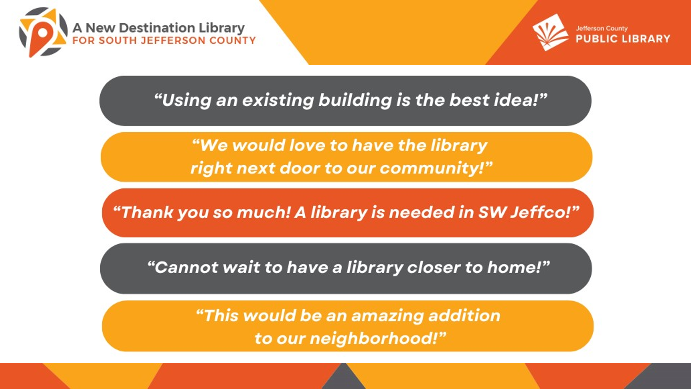

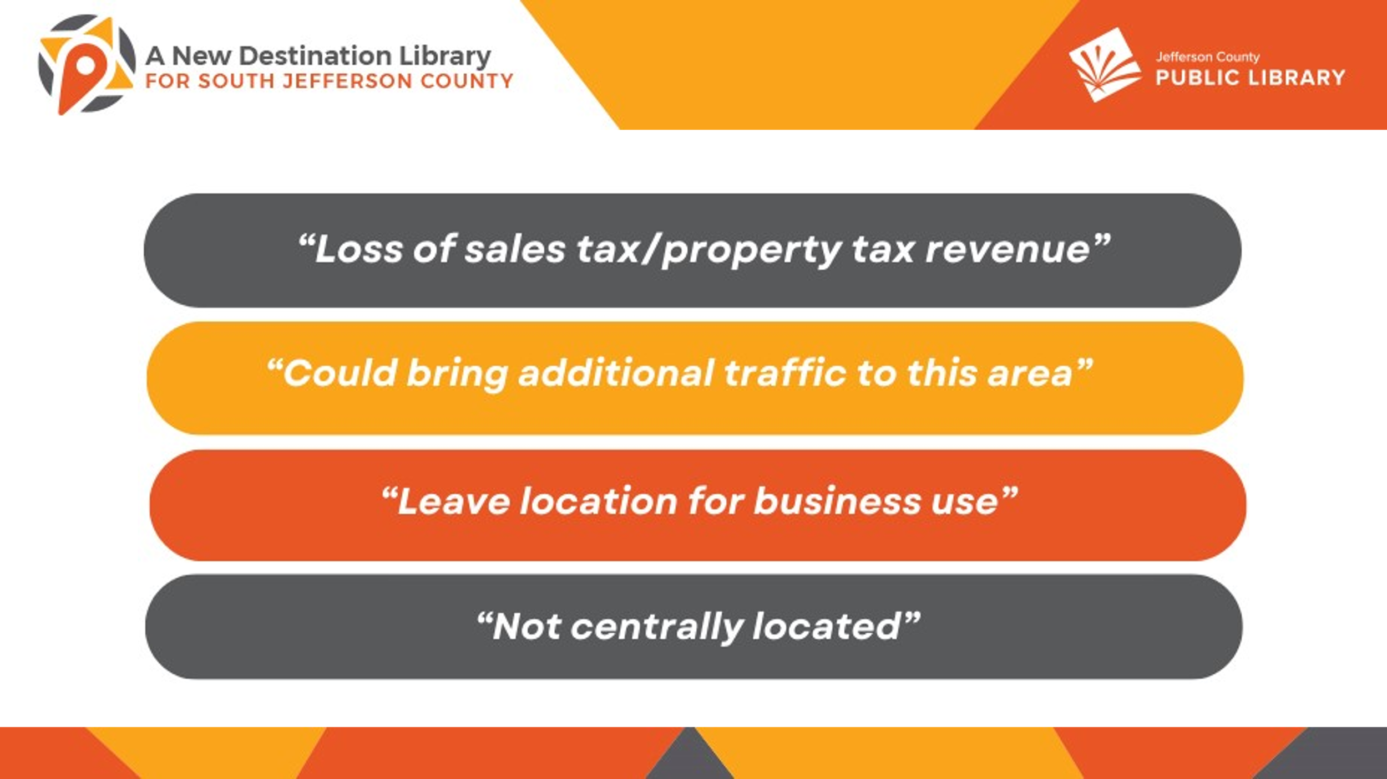

Next Steps

The current outreach process is focused on the site itself and will support the Location and Extent application process. The next step in this process will be to submit the Location and Extent Process Application to Jefferson County Planning and Zoning.

In response to questions, the Board was advised that:

* There were a variety of methods for capturing community input. Attendees were able to express their thoughts with color coded dots and sticky notes where they could write their comments.
* There were many elements of the community engagement process that the Library feels were successful. The South County Advisory Council has been invaluable to the process. They live in the area and asked tough questions. In addition, the Library’s conversations with the Planning and Zoning director and outreach around the location and extent process helped JCPL with outreach to the community. JCPL also hired the manager for this location, Rene Yaws, who is able to devote significant time to personalized community engagement.
* The Library is having conversations about next steps with the South County Advisory Committee.

The Trustees expressed appreciation to the Library for their remarkable and thorough community engagement efforts. The Chair noted that she will have a conversation with the Executive Director on how the Board can express its appreciation to the South County Advisory Council.

**Public Services**

1. Hispanic Heritage Month Presentation

Paola Vilaxa, Diversity Equity and Inclusion and Edgewater Library Manager, addressed the Board and presented information on the Library’s Hispanic Heritage Month activities.

Celebrate Your Community

According to the last census data 15.8% of the population in Jefferson County identifies as Latino or Hispanic. This is over 90,000 people who celebrate Hispanic Heritage Month from September 15 to October 15, a celebration aimed to recognize the contributions of Latinos and Hispanics to our country and celebrate their heritage. This community is also diverse, with roots in Mexico, Central America, South America and even the San Juan Valley. This year, we have seen an increase in new immigrants from Venezuela, adding a variety of flavors and tradition to the growing Hispanic culture in Jeffco.

The Diversity, Equity and Inclusion (DEI) team decided that instead of preparing a system wide approach to Hispanic Heritage month, JCPL wanted to celebrate the different needs and interests of the Latino community. Locations planned a variety of programs and were supported financially and logistically by the DEI Core Service.

Connect with Arts and Culture

The Library presented a variety of programs for all ages and backgrounds, that highlighted the vibrant community JCPL is fostering throughout the county. Thank you to our Communications department for the beautiful logo created to unify all the different programs offered between September 15 and October 15. JCPL has a wide variety of offerings, including an Alebrijes workshop, a music performance by our talented Elisa Garcia, our very own Latino Film Fest at the Belmar Library, and Cine en Español at the Lakewood Library. All the presenters are local and part of the Latino community, an intentional selection to increase representation and equity.

Connect with Resources

The Edgewater Library just hit a record in participation with 200 people attending their Celebración de la Herencia Hispana. Eleven organizations participated in this event, that included food, piñatas and a community resource fair where English and Spanish speakers could find support in the areas of early childhood and lactation, small businesses, mental health, resources navigation and more. Paola Vilaxa highlighted the work of Valeria Carrillo and the bilingual team at Edgewater, as this is their first program, and they just couldn’t be any more successful.

Learn and Explore

Some of JCPL’s libraries joined the celebration by working smarter, and adapted some of their recurring offerings in order to celebrate. The Columbine Library brought presenters, crafts and food to their regular Intercambio program througout the month in order to celebrate Hispanic culture while practicing Spanish. Many libraries have joined with special Cuentacuentos and Storytimes dedicated to celebrate Hispanic heritage and traditions. Overall, it has been a terrific month.

The Board expressed appreciation to Paola and Library staff for the wonderful programs celebrating our Hispanic and Latino communities.

**ITEMS REMOVED FROM THE CONSENT AGENDA**

No items were removed from the consent agenda.

**EMERGING ISSUES**

No issues.

**ENDS**

There were no items.

**BOARD GOVERNANCE**

There were no items.

**BOARD SCHEDULE – NEXT MEETINGS**

Location of meetings of the Library Board of Trustees are being determined in cooperation with guidelines from Jefferson County. Information on meeting location will be posted at least one week prior to the scheduled meeting date.

* 2024 Board Meeting Schedule
* November 14, 2024– Study Session – 5:30 pm Hybrid: Virtual via ZOOM. In-Person Location: Lakewood Library Meeting Room. (Note: Shavuot ends nightfall no work permitted)
* November 21, 2024 – Board Meeting – 5:30 pm Hybrid: Virtual via ZOOM. In-Person Location: Lakewood Library Meeting Room
* December 12, 2024 – Board Meeting – 5:30 pm Hybrid: Virtual via ZOOM. In-Person Location: Lakewood Library Meeting Room

The Chair advised the Board that Amber Fisher will soon be sending 2025 Board meeting invitations. The Board holiday party is scheduled for December 3 and invitations have been sent.

**ANNOUNCEMENTS/GENERAL INFORMATION SHARING**

* Executive Director Evaluation Process Review

The Chair introduced the topic and noted that this is an opportunity for the Board to evaluate and provide feedback on the Executive Director Review Process. Some ideas brought forward included:

* Updating the form to fill out prior to the meeting to provide more guidance.
* Having a contextual introduction before the discussion and what action is expected from the Board.

The Chair advised the Board to reach out if they had any other feedback to share that could be included in next year’s evaluation process.

**EXECUTIVE SESSION:**

At 6:14pm, the Chair called for a motion to adjourn the regular meeting, reconvene in Executive Session regarding Collective Bargaining and adjourn the regular board meeting at the conclusion of the Executive Session.

**MOTION**: Pam Anderson moved to adjourn the regular meeting of the Library Board of Trustees, reconvene in Executive Session regarding Collective Bargaining AND adjourn the regular Board meeting at the conclusion of the Executive Session. Statutory citation authorizing an executive session for this topic is:

* Pursuant to 24-6-402(4)(e)(I) for discussion of strategy and instructions to negotiators

Seconded by Jill Fellman the motion passed by unanimous vote of all Trustees present.

The Chair announced a 5 minute break to allow the Board and staff time to leave the existing ZOOM meeting and then join the Executive Session.

The Chair called the Executive Session to order at 6:22 pm with the following Trustees present, Renny Fagan, Jill Fellman, Pam Anderson, Charles Jones, Emelda Walker and Stanley Harsha. Also present was Donna Walker, Executive Director; Julianne Rist, Director of Public Services; Bernadette Berger, Director of Technology and Innovation; Elise Penington, Director of Communications and Engagement; Lisa Smith, Director of People; Steven Sprin, Labor Relations Consultant and Amber Fisher, Executive Assistant, Office of the Executive Director.

The Chair noted that the session would be recorded and that the recording would be retained for the required 90 days.

**CALL FOR ADJOURNMENT OF EXECUTIVE SESSION**

**MOTION**: At 7:19 pm Pam Anderson moved to adjourn the Executive Session. Seconded by Jill Fellman the motion passed by unanimous vote of all Trustees present.

It is noted that the Library Board of Trustees met in Executive Session concerning Collective Bargaining pursuant to 24-6-402(4)(e)(I) for discussion of strategy and instructions to negotiators. The Trustees held that discussion, and this summary is provided as required by Colorado Statute.

###### Stanley Harsha, Secretary