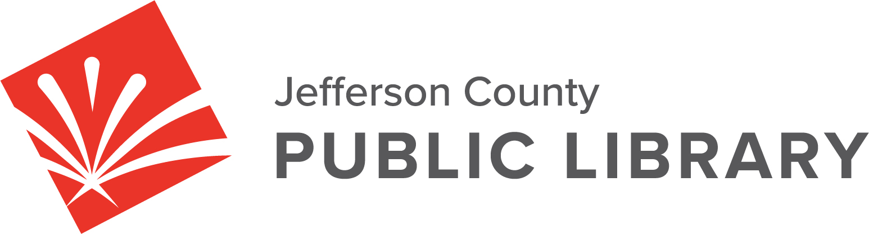

BOARD MEETING

DATE: October 17, 2024

TIME: 5:30 P.M.

PLACE: Hybrid Public Meeting
- Online via ZOOM
- In-Person at Lakewood Library meeting room, 10200 W. 20th Avenue, Lakewood 80215

For instructions on how to access the online ZOOM Board meeting please go to:
https://jeffcolibrary.org/board-of-trustees/2024-board-meetings/

EXECUTIVE SESSION
Collective Bargaining. Statutory citation authorizing an executive session for this
topic is:
- Pursuant to 24-6-402(4)(e)(I) for discussion of strategy and instructions to negotiators.

NEXT BOARD MEETING

