### Minutes of the Regular Meeting of the

JEFFERSON COUNTY PUBLIC LIBRARY

BOARD OF TRUSTEES

September 19, 2024

**CALL TO ORDER – REGULAR MEETING**

The regular meeting of the Jefferson County Public Library Board of Trustees was held online via ZOOM and in-person in the Lakewood Library meeting room on September 19, 2024. Library Board of Trustees Chair, Kim Johnson, called the meeting to order at 5:30 p.m.

Other Trustees present: Emelda Walker (Vice-Chair), Stanley Harsha (Secretary), Jill Fellman, Charles Jones and Jeanne Lomba.

Trustees not present:. Pam Anderson.

**Staff present:** Donna Walker, Executive Director; Julianne Rist, Director of Public Services; Matt Griffin, Director of Business Strategy and Finance; Bernadette Berger, Director of Technology and Innovation; Elise Penington, Director of Communications and Engagement; Steve Chestnut, Director of Facilities and Construction Projects; Jessica Paulsen, Assistant Director of Public Services for Customer Experience; Lizzie Gall, Assistant Director of Public Services for Resources and Programs; Padma Polepeddi, Assistant Director of Public Services for Community Outreach; Amy Bentz, Assistant Director of Library Design Projects and Planning; Amber Fisher, Executive Assistant, Office of the Executive Director; Kelci Rude, Administrative Coordinator Supervisor; Ryan Turch, Technology and Innovation Operations Supervisor; and Aaron Cameron, Technical Support Technician Senior.

There were additional Library staff members attending the meeting.

**APPROVAL OF AGENDA**

**MOTION:** Emelda Walker moved that the Library Board of Trustees approve the agenda as presented. Seconded by Jeanne Lomba the motion passed by unanimous vote of all Trustees present.

**PUBLIC COMMENT**

The Board values public participation. Those who would like to address the Library Board can do so virtually, in-person, or online. The opportunity to address the Library Board does not include a question and answer session or response. Additionally, the Library Board does not respond to anonymous questions or comments. Comments will be acknowledged in the minutes of the meeting. The Chair advised the Board that no public comments were received and there were no online or in-person signups and closed the public comment portion of the meeting at 5:32 pm.

**APPROVAL OF CONSENT AGENDA**

The Chair asked the Trustees if any of the items should be removed from the consent agenda. There were no requests for items to be removed.

Items on the September 19, 2024 Consent Agenda:

1. Library Board of Trustees Approve August 8, 2024 Special Board Meeting Minutes
2. Library Board of Trustees Approve August 15, 2024 Board Meeting Minutes
3. Library Board of Trustees Authorize CoCal Landscape Snow Removal Contract

**MOTION**: Jeanne Lomba moved that the Library Board of Trustees approve the items on the consent agenda as presented. Seconded by Jill Fellman the motion passed by unanimous vote of all Trustees present.

**FOUNDATION UPDATE**

Jill Fellman, Board Liaison to the Foundation provided an update on the activities of the Foundation and noted the report is in the information packet. The Fall Whale of a Used Book Sale begins on October 17 and the Trustees were encouraged to attend.

**Executive Director Report**

1. Executive Director Report

The Executive Director advised the Board that registration is closed for the Urban Libraries Council (ULC) Annual Forum. There are some Trustee engagement opportunities coming up. The Raise a Reader event will be held on September 28 at the Colorado Railroad Museum and Trustees were asked to let Amber Fisher know if they would like to attend. Julianne Rist, Director of Public Services will be at the event and can show Trustees around this wonderful community and family event. The All Staff Conference (ASC) will be held on October 3, at the Arvada Center. Kim Johnson is attending.

The Library has launched an entirely new document management system. The system has been many years in the making and is a huge effort by staff across the entire organization. The project is led by the Technology and Innovation division and over one terabyte of documents have already been migrated to the new system.

JCPL wants to celebrate the first grant received in the JCPL Fundraising Plan for 2024 from Colorado Gives Foundation. Bridget Beatty wrote this grant which required a 501c3 and Jo Schantz submitted the grant for the Library. As agreed, the Library Foundation will take a 5% administrative fee. The $25,799 grant will fund the Hard time Writers workshop in the Health Impact category.

JCPL management and AFSCME representatives met for the second negotiation meeting yesterday. Steven Spirn, the labor relations consultant hired by the Library, is now the chief negotiator for the Library. Lisa Smith, Director of People and Culture, is leading the management team and the Executive Director is not at the negotiation table.

There were no questions from the Board about the Executive Director’s report.

1. South County Library Update

In South County, Rene Yaws, Library Manager is attending back to school nights, attending South Jeffco Business Alliance, COHOPE (Council of HOAs for a Planned Environment); and tabling at local festivals. The JCPL team will host a table at the upcoming Summerset Festival hosted by Foothills Parks & Recreation District. The event is September 21 from 9 a.m. – 5 p.m. at Clement Park. Project update emails are being sent to people who have opted in with social media aligned with these email updates. The Library’s due diligence work is well underway for this location led by Steve Chestnut, Director of Facilities and Construction projects.

1. Northwest Jeffco Library Update

In Northwest Jeffco, Bryan Kratish, Library Manager and JCPL staff are attending two local festivals with our outside community engagement facilitator with engagement activities that involve conversation and opportunities to provide input. Traditional engagements are scheduled for early October. The engagement survey goes live tomorrow; in addition, JCPL’s monthly e-connect newsletter promoted the acquisition. Local organizations included information about the acquisition in their e-newsletters; social media is timed to start in conjunction with in person community engagement meetings in a few weeks. JCPL sent a media release about the closing which wasn't picked up by the media.

1. Conifer Library Update

JCPL requested and received a Location and Extent waiver from the Jeffco Planning and Zoning director for this new location. The waiver was based on the work performed by the library to identify the space and the fact that significant outreach took place to inform the community about the proposed location. The Library is still required to obtain all other permits for any tenant finish that takes place.

**EXECUTIVE TEAM OPERATIONAL UPDATES**

**Public Services and Communications & Engagement**

Guest: Eppstein Uhen Architects (EUA)

1. Arvada Redesign Project

**Market Analysis Report**

Lizzie Gall, Assistant Director of Public Services for Resources and Programs addressed the board and presented information on the market analysis performed for the project.

**Redesign Arvada Library Vision**

The vision for this project is to redesign this urban/suburban library for the future in order to reach more people, focus on building literacies, and be the third place in this community.

**Arvada Library Service Area (LSA)**

JCPL designates individual library service areas as where card holders live and the library they use. These designations are based on current data tracked by JCPL including census tracts, patron’s last active location and patron’s home location. The Arvada LSA is defined by 12 census tracts and represents active, real-time use of the location. JCPL is in the process of designing and building a new library location in Northwest Jefferson County. Once that location is in operation, JCPL may see changes to the Arvada LSA as patrons integrate the new location into their library use.

**Olde Town Arvada Strategic Redevelopment Plan**

Arvada is unique and the City of Arvada’s Olde Town Strategic Reinvestment Plan has been identified and their next step is securing funding.

**Population Growth**

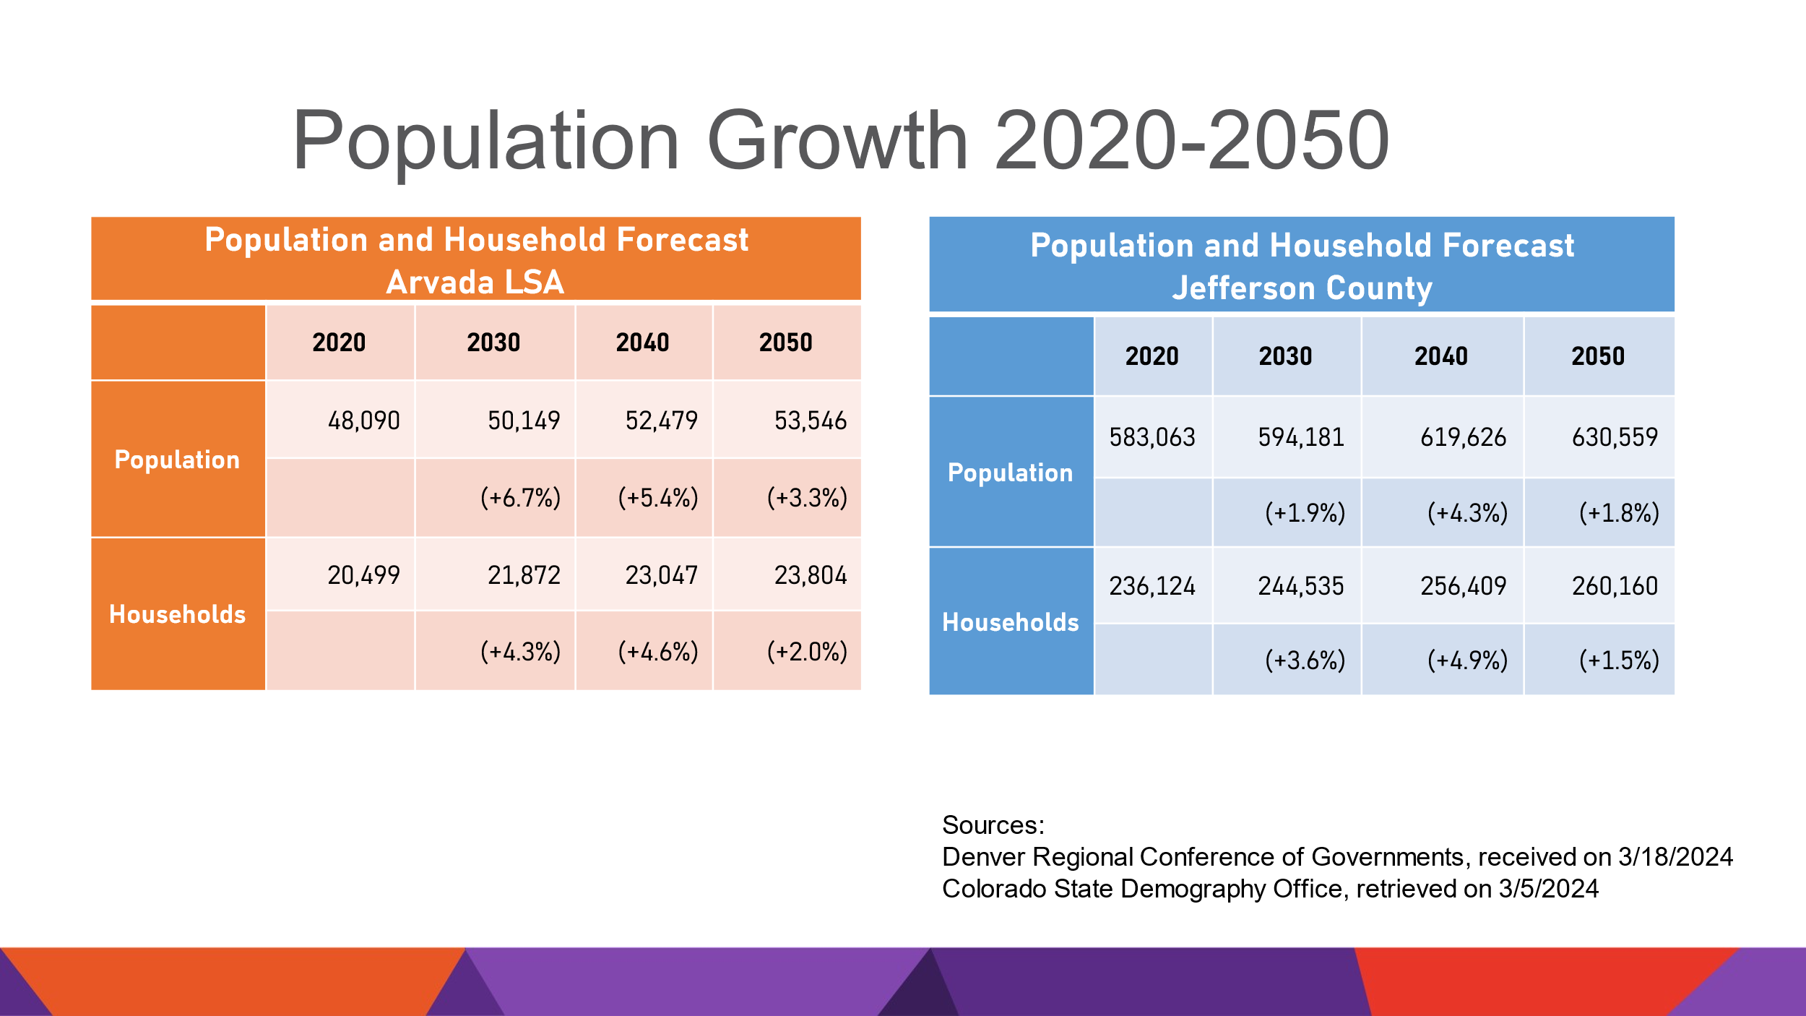

The population of the Arvada LSA is projected to grow faster than the county as a whole into 2050 with Arvada projected at 7% versus Jefferson County as a whole at 2%. Population growth will slow over time with the fastest growth in the 2020s.

**Demographics**

Arvada has a similar age profile to Jefferson County with the median age at 40. The curve trends a bit younger than the County overall. JCPL will consider how that might influence service needs today, and in the next 10 to 20 years.

There is more diversity in the Arvada LSA with over 12% of the population identifying as two or more races. There is also a higher percentage of individuals with Hispanic Ethnicity. The Library also considers these factors and their influence on programming and services for the community.

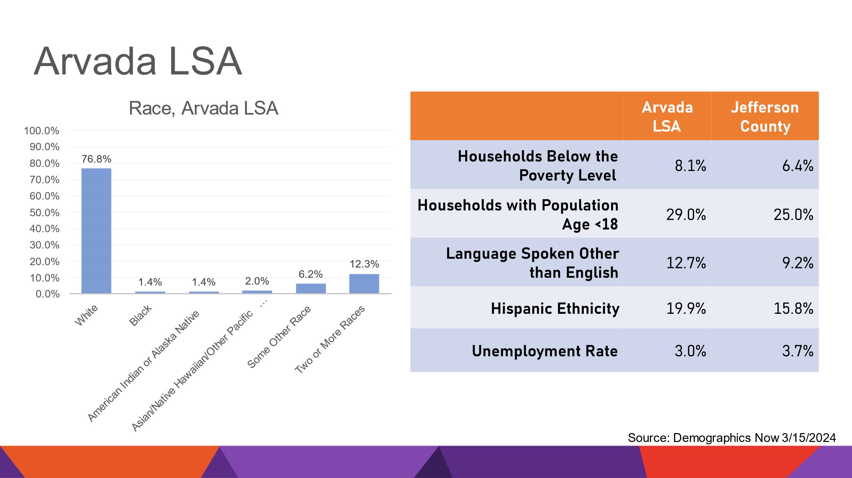

**Market Engagement**

Market engagement calculates the Library’s active reach throughout the community. It is the percentage of households in the Library Service Area (LSA) that have at least one active library card. Arvada is slightly lower in market engagement at 32% than JCPL overall at 40%. JCPL has the opportunity to have a deeper impact into this service population. Over 67% of households do not have a library card- That is 7% higher than our opportunity overall across the county

**Key Learnings**

* Arvada Library LSA is likely to change due to Northwest Arvada Library
* Olde Town neighborhood impacts as the city makes their choices on redesigning that area which is outside JCPL control
* Population growth and demographics
* Market Opportunity

In response to questions the Board was advised that:

* It is a 25 minute drive from the Arvada Library to the Northwest Jeffco Library property.
* JCPL performs market analyses one to two times per year and are usually associated with a library building project.
* JCPL has an in-house research and data management team and engages with partners like the State Demography Office and DRCOG (Denver Regional Council of Governments).
* JCPL develops market engagement plans to increase engagement.
* JCPL has not been informed of the City of Arvada’ specific plans for the parking lot to the east of the Arvada Library other than they want to activate that area.

1. Stakeholder and Community Engagement Report

Elise Penington, Director of Communications and Engagement addressed the Board and noted that JCPL is excited to share the results of the community and stakeholder engagement efforts. JCPL conducted extensive marketing resulting in a high level of engagement through interviews, facilitated community meetings and surveys with a goal of gathering community and staff feedback to inform the upcoming program of service and library design. Eppstein Uhen Architects (EUA) has used the information gathered to create a comprehensive Community Engagement Report for the Arvada Library Redesign. Clermont Eliot did an excellent job facilitating community meetings. Ryan Wallace and Meghan Bentheimer with EUA will present more detailed information.

**Opportunities for Input**

Ryan Wallace addressed the Board and provided information on the results of the Arvada Library Redesign Community Engagement efforts. Opportunities for input included stakeholder interviews, meeting with Library staff, 1 virtual and 2 in-person community meetings and the community survey.

* 15 Stakeholder Interviews
* 25 Staff Attendees
* 23 Meeting Attendees
* 1,095 Community Survey Responses
* Total participants: 1,158

The team also took the opportunity to talk with teens and went to one of their events. Those responses are incorporated in the report.

**Community Meeting Process**

* Language Justice
* Graphic Recording
* Topics of Discussion
  + Site
  + Services
  + Design

**Survey**

The survey was posted for a month online and hard copies were available. Question types included:

* + What do you do at the library?
  + Rating & importance of existing services
  + What would encourage you to visit a library?

**Key Themes**

* Increase focus on enhancing safety and security
* Enhance quality and diversity of the collection
* Improve parking
* Increase community gathering, social events and networking opportunities
* Redesign Children’s area
* Increase classes and activities offerings/flexible spaces

In response to questions, the Board was advised that:

* There are handicapped parking spaces on the street and one in back for staff.
* Arvada has been slower post pandemic in terms of visits than the rest of the system but is still seeing strong programming numbers.

**Survey Results – Participants**

* 98% are library card holders
* 91% reside in Arvada
* 82% use the library at least once per month
* Participants range in age from under <12 to 75+

Over 1,000 surveys were received indicating residents are engaged with the Library. The biggest response was from the 32-60 age group. EUA shared additional information on the results of the survey which is included in the information packet.

**Engagement Meetings**

A summary of the responses and input received during the engagement meetings is included in the chart below:

|  |  |  |  |
| --- | --- | --- | --- |
| **Getting to the Library**   * Designated parking for patrons and staff * Better bike and E-bike parking * 15 minute short term parking | **Exterior Wayfinding Signage**   * Improve wayfinding signage and directions * More obvious exterior entrance signage * Design reflects Olde Town style | **Welcoming Environment**   * Improve entrance and lighting * Bigger entry doors * Improve overall sight lines especially to restrooms * Eliminate outdoor overhang | **Afterhours Access**   * Improve drop off options * Better lighting and access for holds * Improve safety |
| **Outdoor Space**   * Design reflects Olde Town style * Rooftop space, walled garden * Outdoor patio seating | **Entry**   * Welcoming, colorful * Bigger doors, ADA access * Potentially move entry location | **Service Style**   * Self-checkout options including 2nd floor * Relocate holds | **Collection**   * Update physical collection * Wider range of options * Improve layout of physical collection |
| **Support Services**   * Improve restroom safety * Update restrooms and gender neutral options * Improve elevator functionality | **Creation**   * Maker spaces * Hobbies, classes, art | **Library as a Third Place**   * Increase program marketing * Work from home options * Tie programs to Olde Town events | **Design Style**   * Cozy, colorful environment * Transitional design, natural light * Cozy nooks and private areas |
| **Meeting**   * Soundproof meeting rooms * Flexible meeting rooms * Make rooms more a part of overall library | **Children’s Area**   * Enclosed area * Various seating for kids * Interactive activities * Large enough space and stroller parking | **Teen’s Area**   * Enclosed area * More workspaces * Improve visibility, sightlines | **Study**   * Clear sightlines, easily monitored * Various size study rooms |
| **Quiet Reading Room**   * Designated quiet room * Plush inviting seating | **Adult Area**   * Adjustable, comfortable seating * Computer workstations, work from home support * Separate quiet area | **Staff Spaces**   * Modify Workflow * More Workstations * Improve Sorter * Dedicated Patron Experience Meeting Area * Improved Storage Options * Better Lighting and Refresh * How to Improve the Basement Space * Respite Room |  |

The results will help with understanding the community and how to make improvements for the Library’s patrons and staff going forward. There was some discussion on the challenges around parking.

**Facilities & Construction Projects**

1. Evergreen Library Roof Repair Contract

Steve Chestnut, Director of Facilities and Construction Projects addressed the Board and provided a summary of the report included in the Board’s information packet. The Board was informed about the damages to the Evergreen and Columbine roofs. JCPL issued an RFP for the Evergreen Library roof repair. Due to the complexity of the copper and tile roof system, only two responses to the RFP were received. The proposals ranged in cost from $1,307,286 to $1,429,696.00. After evaluation of the vendors, the Facilities team recommended that the Library award the contract to B&M Roofing of Colorado Inc. at a base cost of $1,307,286.00. B&M Roofing installed the original Evergreen Library roof.

**MOTION**: Jill Fellman moved that the Library Board of Trustees authorize the Executive Director to enter into a contract with B&M Roofing of Colorado Inc. for the repairs of the Evergreen Library roof at a base cost of $1,307,286. Seconded by Charles Jones the motion passed by unanimous vote of all Trustees present.

**Business Strategy & Finance**

1. Supplemental Budget Requests

* Roof Repairs for Evergreen and Columbine Supplemental
* South County Library Supplemental

Matt Griffin, Director of Business Strategy and Finance addressed the Board and provided information on the supplemental requests. The premise of the requests are to bring funds into the current fiscal year budget from the fund balance. For the Evergreen and Columbine Library roof repairs, the Library does expect to be reimbursed, however, JCPL needs to have a budget to spend against to do the repairs now. For the South County Library property, the premise is the same, to move funds from the fund balance into the current fiscal year budget. JCPL has the potential to close on the property at the end of this year or early next year and wants to make sure the Library is prepared for that earlier closing. The proposal is to move $5.5 million from the 2026 project budget into the 2024 budget which will take the 2024 South County project budget to $11.2 million for due diligence and acquisition. This does not change the overall project budget and is a net zero on the fund balance. The shifting of funds will increase the 2024 project budget, the 2025 project budget remains the same, and there will be a decrease in the 2026 project budget.

In response to questions, the Board was advised that:

* The timing expected on the reimbursement for the roofs may not happen in 2024 and the Library expects the reimbursements to last months, even years.
* With these supplemental requests, the Library does not expect the fund balance to go below the minimum threshold.
* The reimbursements for the roof repairs will be a combination of insurance and FEMA.

**MOTION**: Jeanne Lomba moved that the Library Board of Trustees authorize the Executive Director to submit supplemental budget requests totaling $1,171,000 for the Evergreen roof repair, $533,823 for the Columbine roof repair and $5,500,000 for the South County Library. Seconded by Jill Fellman the motion passed by unanimous vote of all Trustees present.

1. Financial Report (August 2024)

Matt Griffin, Director of Business Strategy and Finance, addressed the Board and presented information on the August financial tables. Revenue is the same as last month and trending slightly above budget. Operating expenditures are in a perfect spot, slightly below budget coming into the final quarter.

There were no questions from the Board on the August financials.

**Technology & Innovation**

1. Digital Accessibility Program

The Executive Director introduced the topic and advised the Board that digital accessibility is a new program that was added to the 2024 annual plan. The digital accessibility program is extensive, and Bernadette Berger, Director of Technology and Innovation will provide more information.

Bernadette Berger advised the Board that on July 1, JCPL met an important milestone on digital accessibility compliance. Information tonight will include JCPL’s journey to meet this milestone and provide some of the next steps as well as impacts to the Board.

**What is Digital Accessibility and Why is it Important**

It is important to start with a common understanding, digital accessibility is the practice of designing, creating and maintaining digital content and technologies so that people with disabilities can equally navigate and interact with digital resources and services.

Digital accessibility is a major way to further JCPL’s mission of building an educated and vibrant community by providing equal access to information and opportunities. Following the principals of digital accessibility, JCPL can ensure everyone benefits from all the Library has to offer. Additionally, beginning July 1, 2024, all Colorado state and local governments must comply with Colorado Laws For Persons With Disabilities, HB21-1110, including adherence to Web Content Accessibility Guidelines (WCAG) 2.1 AA. Some examples of digital content impacted are included below and there are many more.

* Kiosks and LCDs
* Email
* Social Media
* Video
* Graphics
* Jeffcolibrary.org and The Buzz
* Online Resources and Services
* Public Presentations
* Board of Trustee Meetings
* Programs, Story Times, Online Events
* Internal and External Technologies

**Current Status and Benchmarks**

JCPL has already completed many important things to comply with the new Colorado laws. JCPL established a project team, added an audit of all services to the Library’s work, published an accessibility statement and web inquiry form, as well as built a communications plan, identified tasks and created additional working groups, and coordinated with Jefferson County as a whole to move in sync with our partners.

As this Program evolves, so will the data JCPL is able to report on and collect. As of July 1, 2024:

* Number of Inquiries Received: 0
* Inventory of Digital Platforms Impacted: 138
* Identified PDFs Requiring Remediation:
  + Internal: 1098
  + External: 1127

**Digital Accessibility Report**

The Library has also published the first digital accessibility status report on JCPL’s accessibility website. The Library is required to publish a quarterly report as it measures toward goal. Many of the projects under this strategic program will establish additional Key Performance Indicators (KPIs) for JCPL to measure.

**Next Steps – Accessibility Plan**

JCPL plans to thoughtfully develop the projects with more robust components and deeper dives into areas. Then JCPL will use the plan to continue to identify, prioritize, test and remediate solutions and information as the laws evolve, are tested in the courts and based on patron and staff feedback. Part of this work will be to expand and update that accessibility plan on a quarterly basis which includes:

* + - Self-evaluation results
    - Planned steps to remove accessibility barriers
    - Policies for testing and remediation
    - Adherence to timelines for remediation
    - Providing status updates demonstrating progress
    - Insert accessibility into daily operations

The Library will continue to highlight the process in which customers can request a modification for inaccessible technology or report inaccessible technology.

**Board Impacts**

While JCPL has accomplished a lot to comply with the laws, there is much work still to be done. Ways that work will impact the Board are:

* Update of Library Board of Trustees website
* Accommodations in the public meetings
  + Closed captioning
  + Reconfiguration of certain elements
  + Publishing an Accommodations Statement
* Update of materials including potentially the
  + Agenda
  + Packet
  + Presentations
  + Minutes
  + Governance materials

**Building and Planning Next Steps**

In addition to the work around the Board items, there are still many areas where JCPL needs to continue to build, plan and coordinate:

* Build accessibility guidance for our staff and patrons
* Develop web content development training
* Create a robust training plan to guide staff
* Enhance and improve the remediation process

The assistive technology station at the Evergreen Library is one example of some accommodations.

In response to questions, the Board was advised that:

* Digital accessibility efforts include enhancing access for both patrons and staff.
* Regarding the legal timeline, it depends. After one law became effective, there were then rules written to explain the law. Then there was a Senate bill, then a clarification statement and another last minute legislative effort to address the huge burden on local governments. There are many nuances and JCPL is following compliance with demonstrating gradual improvement over time and publishing a quarterly report.
* For initial resource load, JCPL has pulled together a group of staff to work on digital accessibility as they were able. As the Library built the strategic program additional resources were allocated and the Library will add a consultant to help with that work. The Library is developing a plan on what that will look like and working with the County as a partner.
* Remediation of a PDF document includes making it more easily scanned. In some cases that may not be possible, and it may only be provided through a Word or text document. JCPL staff across all divisions are doing the editing of those PDFs. It is important to note that JCPL already had web accessibility in its sights and the Library is years ahead of a lot of other local governments.

The Board expressed appreciation for the work on digital accessibility and commended the staff.

**ITEMS REMOVED FROM THE CONSENT AGENDA**

No items were removed from the consent agenda.

**EMERGING ISSUES**

No issues.

**ENDS**

There were no items.

**BOARD GOVERNANCE**

There were no items.

**BOARD SCHEDULE – NEXT MEETINGS**

Location of meetings of the Library Board of Trustees are being determined in cooperation with guidelines from Jefferson County. Information on meeting location will be posted at least one week prior to the scheduled meeting date.

2024 Board Meeting Schedule

* October 10, 2024– Study Session – 5:30 pm Hybrid: Virtual via ZOOM. In-Person Location: Lakewood Library Meeting Room. (Note: Shavuot ends nightfall no work permitted)
* October 17, 2024 – Board Meeting – 5:30 pm Hybrid: Virtual via ZOOM. In-Person Location: Lakewood Library Meeting Room
* November 14, 2024– Study Session – 5:30 pm Hybrid: Virtual via ZOOM. In-Person Location: Lakewood Library Meeting Room. (Note: Shavuot ends nightfall no work permitted)
* November 21, 2024 – Board Meeting – 5:30 pm Hybrid: Virtual via ZOOM. In-Person Location: Lakewood Library Meeting Room
* December 12, 2024 – Board Meeting – 5:30 pm Hybrid: Virtual via ZOOM. In-Person Location: Lakewood Library Meeting Room

The Chair noted that she will be sending the Trustees information on the holiday party to try and identify a date and will work with Amber Fisher on additional arrangements.

**ANNOUNCEMENTS/GENERAL INFORMATION SHARING**

**Trustee Lomba Service Acknowledgement**

The Chair advised the Board that this is Trustee Jeanne Lomba’s last meeting. The Chair acknowledged Jeanne and noted that she has appreciated working with Trustee Lomba and is grateful for her volunteer service.

The Board of County Commissioners appointed Jeanne Lomba to the Jefferson County Public Library (JCPL) Board on September 30, 2018. Lomba’s six-year tenure of leadership at JCPL featured an array of challenges and calls to action that required adaptable and progressive guidance. Shortly after her first year of service on the Board, Lomba joined her fellow Trustees in providing a rapid and innovative response to the COVID-19 pandemic. It was thanks to this dependable leadership that JCPL not only managed to successfully navigate such unprecedented times but emerged even stronger on the other side.

Along with helping to return JCPL to pre-pandemic library use, Lomba assisted with the approval of the Library’s 2020-2025 Strategic Plan, the fruits of which we are witnessing today in the completion of the Evergreen Library redesign, the purchase of sites for new libraries in South and Northwest Jeffco, a new leased Library location in Conifer, and the continued progress of the Arvada Library redesign. We are thankful for Jeanne’s dedicated leadership through both challenging and fulfilling times and know her impact will live on through the completion of these projects.

Under Lomba’s leadership, JCPL:

* Expanded and improved access to JCPL physical resources through the creation of offsite self-services. This included the opening of the award-winning Express Library, the completion of a new Bookmobile, and the installation of holds lockers and return bins at strategic locations across Jefferson County.
* Created the Raise a Reader program in 2019.
* Eliminated overdue fines, implemented automatic renewals and expanded Spanish language services to increase equity of access.
* Redesigned the Belmar Library, including the addition of the digital media studio.
* Developed the 2020-2025 Strategic Plan.
* Deployed a remote workforce in 24 hours to respond to the Pandemic in 2020.
* Successfully navigated the Pandemic, returning JCPL to near pre-pandemic numbers by 2022.
* Expanded DEI initiatives in partnership with Jefferson County.
* Welcomed countless authors to inspire our community members and encourage a love of reading.
* Redesigned the Evergreen Library.
* Launched the JCPL fundraising plan.
* Acquired land and gained rezoning approval for the future Northwest Jeffco Library.
* Secured new locations for both South County and Conifer Libraries.
* Continued to make progress with the redesign of the Arvada Library.

Additionally, during her time on the Board of Trustees, Lomba served on the Nominating Committee in 2019, 2021, 2022 and 2023, as well as on the Bylaws Committee in 2020.

On behalf of the Board of Trustees, the Chair acknowledged the progress of JCPL during Jeanne’s tenure. Her dedicated service through such challenging transitions will leave a lasting legacy on JCPL and its patrons.

Jeanne Lomba expressed appreciation to the Board and JCPL staff and noted that she looks forward to staying involved with the Library.

**EXECUTIVE SESSION:**

At 6:58 pm, the Chair called for a motion to adjourn the regular meeting and reconvene in Executive Session.

**MOTION**: Jill Fellman moved to adjourn the regular meeting of the Library Board of Trustees and reconvene in Executive Session pursuant to CRS 24-6-402(4)(f) Personnel Matters to review the Executive Director’s performance and compensation. Seconded by Jeanne Lomba the motion passed by unanimous vote of all Trustees present.

The Chair announced a 5 minute break to allow the Board and staff time to clear the room, leave the existing ZOOM meeting and then join the Executive Session at 7:05 pm.

The Chair called the Executive Session to order at 7:06 pm with the following Trustees present, Jeanne Lomba, Jill Fellman, Charles Jones, Emelda Walker and Stanley Harsha. Also present was Amber Fisher, Executive Assistant, Office of the Executive Director. The Executive Director joined the Executive Session at 8:14 pm.

The Chair noted that the session would be recorded and that the recording would be retained for the required 90 days.

**CALL FOR ADJOURNMENT OF EXECUTIVE SESSION AND TO RECONVENE THE REGULAR MEETING**

**MOTION**: At 8:33 pm Jeanne Lomba moved to adjourn the Executive Session and reconvene the regular meeting. Seconded by Jill Fellman the motion passed by unanimous vote of all Trustees present.

At 8:37 p.m. the Chair reconvened the regular meeting with the following Trustees present: Jeanne Lomba, Jill Fellman, Charles Jones, Emelda Walker and Stanley Harsha. Also, present were Donna Walker, Executive Director; Bernadette Berger, Director of Technology and Innovation; and Amber Fisher, Executive Assistant, Office of the Executive Director.

The Chair provided the following Executive Session Summary:

The Library Board of Trustees met in Executive Session concerning Personnel Matters related to the Executive Director’s performance and compensation. The Trustees held that discussion, and this summary is provided as required by Colorado Statute.

**MOTION**: Jeanne Lomba moved that the Library Board of Trustees authorize a 5% increase to the Executive Director’s base salary and a $5,000 one-time merit bonus. Seconded by Jill Fellman the motion passed by unanimous vote of all Trustees present.

The Board expressed appreciation to the Executive Director for her exceptional leadership.

**ADJOURNMENT**

The meeting was adjourned at 8:38 pm.

###### Stanley Harsha, Secretary

