### Minutes of the Regular Meeting of the

JEFFERSON COUNTY PUBLIC LIBRARY

BOARD OF TRUSTEES

August 15, 2024

**CALL TO ORDER – REGULAR MEETING**

The regular meeting of the Jefferson County Public Library Board of Trustees was held online via ZOOM and in-person in the Lakewood Library meeting room on August 15, 2024. Library Board of Trustees Chair, Kim Johnson, called the meeting to order at 5:34 p.m.

Other Trustees present: Emelda Walker (Vice-Chair), Jill Fellman and Jeanne Lomba.

Trustees not present:. Pam Anderson, Stanley Harsha and Charles Jones.

**Staff present:** Donna Walker, Executive Director; Julianne Rist, Director of Public Services; Matt Griffin, Director of Business Strategy and Finance; Bernadette Berger, Director of Technology and Innovation; Elise Penington, Director of Communications and Engagement; Steve Chestnut, Director of Facilities and Construction Projects; Jessica Paulsen, Assistant Director of Public Services for Customer Experience; Lizzie Gall, Assistant Director of Public Services for Resources and Programs; Padma Polepeddi, Assistant Director of Public Services for Community Outreach; Amy Bentz, Assistant Director of Library Design Projects and Planning; Amber Fisher, Executive Assistant, Office of the Executive Director; Kelci Rude, Administrative Coordinator Supervisor; Ryan Turch, Technology and Innovation Operations Supervisor; and Aaron Cameron, Technical Support Technician Senior.

There were additional Library staff members attending the meeting.

**APPROVAL OF AGENDA**

**MOTION:** Jill Fellman moved that the Library Board of Trustees approve the agenda as presented. Seconded by Jeanne Lomba the motion passed by unanimous vote of all Trustees present.

**PUBLIC COMMENT**

The Board values public participation. Those who would like to address the Library Board can do so virtually, in-person, or online. The opportunity to address the Library Board does not include a question and answer session or response. Additionally, the Library Board does not respond to anonymous questions or comments. Comments will be acknowledged in the minutes of the meeting. The Chair provided public comment instructions.

The Chair advised the Board that one public comment was received via the online form and provided to the Board. Randy Stafford, David Myers, Betsy Holt, Scott Pantall and Lindsey Benhammou, members of the South County Advisory Committee addressed the Board and expressed support for the proposed property for a new South County Library located at 11100 Bradford Road. The Chair expressed appreciation for the comments.

There were no further public comments, and the Chair closed the public comment portion of the meeting at 5:49 pm.

**APPROVAL OF CONSENT AGENDA**

The Chair asked the Trustees if any of the items should be removed from the consent agenda. There were no requests for items to be removed.

Items on the Consent Agenda

1. Library Board of Trustees Approve July 18, 2024 Board Meeting Minutes.
2. Library Board of Trustees Adopt Policy Governance Monitoring Reports: 2.5 – 2.9

**MOTION**: Jeanne Lomba moved that the Library Board of Trustees approve the items on the consent agenda as presented. Seconded by Jill Fellman the motion passed by unanimous vote of all Trustees present.

**FOUNDATION UPDATE**

Jo Schantz, Foundation Executive Director, provided an update on the activities of the Foundation. The Foundation is hosting a shred-a-thon on August 15, the event is free, but the Foundation is asking for a donation of $20. The Foundation has two new employees, a warehouse assistant and a bookkeeper. The Gardner Family Foundation grant for $50,000 for the outdoor reading deck at the Evergreen Library has been approved. The Foundation has been working with Bridget Beatty, the Library’s fundraising consultant, on a $25,000 grant from the Colorado Gives Foundation for early literacy programs.

**Executive Director Report**

1. Executive Director Report

The Executive Director advised the Board that she and Matt Griffin, Director of Business Strategy and Finance, presented the Library’s 2025 budget to the Board of County Commissioners, a formality of the budget approval process. The Take Note event has been cancelled by the sponsor. The Board was reminded of the photo op at 11:00 on Saturday morning at the Northwest Jeffco Library property. The Library will be meeting with the City of Arvada leadership on Monday to provide an opportunity to hear their input on the Arvada Library redesign project.

1. Northwest Jeffco Library Update

The Executive Director advised the Board that the Library has officially closed on the Northwest Jeffco property, and all paperwork is in hand. Community engagement for the Northwest Jeffco Library project is being scheduled for October, pending Board approval of the architect contract.

The Executive Director introduced Lizzie Gall, Assistant Director of Public Services for Resources and Programs, to provide an update on the South County Advisory Council. Lizzie Gall advised the Board that at the South County Advisory Council meeting on Monday there were positive and helpful conversations about the proposed property for the South County Library. The work of the Council was reviewed and how that work was reflected in the steps the Library has taken to date. The next step includes community engagement and outreach. Most of the comments during the meeting were positive including that the proposed building looks like a library, there is lots of natural light and opportunities for partnerships.

The Chair acknowledged the work of the South County Advisory Council and expressed appreciation for their continued input and support in the next phase of community engagement. The Board is very excited about this property and noted that it has been a long time coming.

There were no questions from the Board about the Executive Director’s report.

**EXECUTIVE TEAM OPERATIONAL UPDATES**

**Business Strategy & Finance**

Business Strategy

1. South County Library Property Recommendation and Purchase and Sale Agreement

The Executive Director noted that the Board and South County Advisory Council were informed last week on the South County Library Property Recommendation. After extensive investigation, community engagement, and negotiationJefferson County Public Library is pleased to recommend for purchase the property located at 11100 Bradford Road, Littleton, CO for the creation of a future new library in South Jefferson County. JCPL leadership presents this existing building to repurpose as the most convenient, sustainable, and desirable location for Board consideration.

Background

In 2019 JCPL identified the need for a new library in South County. JCPL has a capital project underway to create a new destination library in the south region to connect our underserved community to library services. In 2023 a new site search strategy was developed, and the South County Advisory Council was formed. The project is fully funded through the fiscal stewardship of the Library Board and taxpayers of Jefferson County.

Site Search Process – Approach

Julianne Rist, Director of Public Services, addressed the Board and provided information on the site search process and approach. The property search area was reevaluated and adjusted based on the updated market analysis. The yellow outline on the map below shows the property search area in proximity to the Columbine Library, which will continue to serve the South Jefferson County community once this new library opens. The Library’s approach was to use this criteria in the site search which included driving tours of the area, working with commercial realtors, pursuing suggestions from the community and advisory council, conversations with community stakeholders, reviewing Jeffco school closures, and pursuing opportunities for partnerships as well as pursuing sites that were not on the market.

Stakeholder Insights on Five Concepts

One of the impacts of the advisory council was advice on five potential concepts during the search. The Board also weighed in on these concepts and, like the advisory council, determined that they all had validity and were worth considering if there were potential sites to explore.

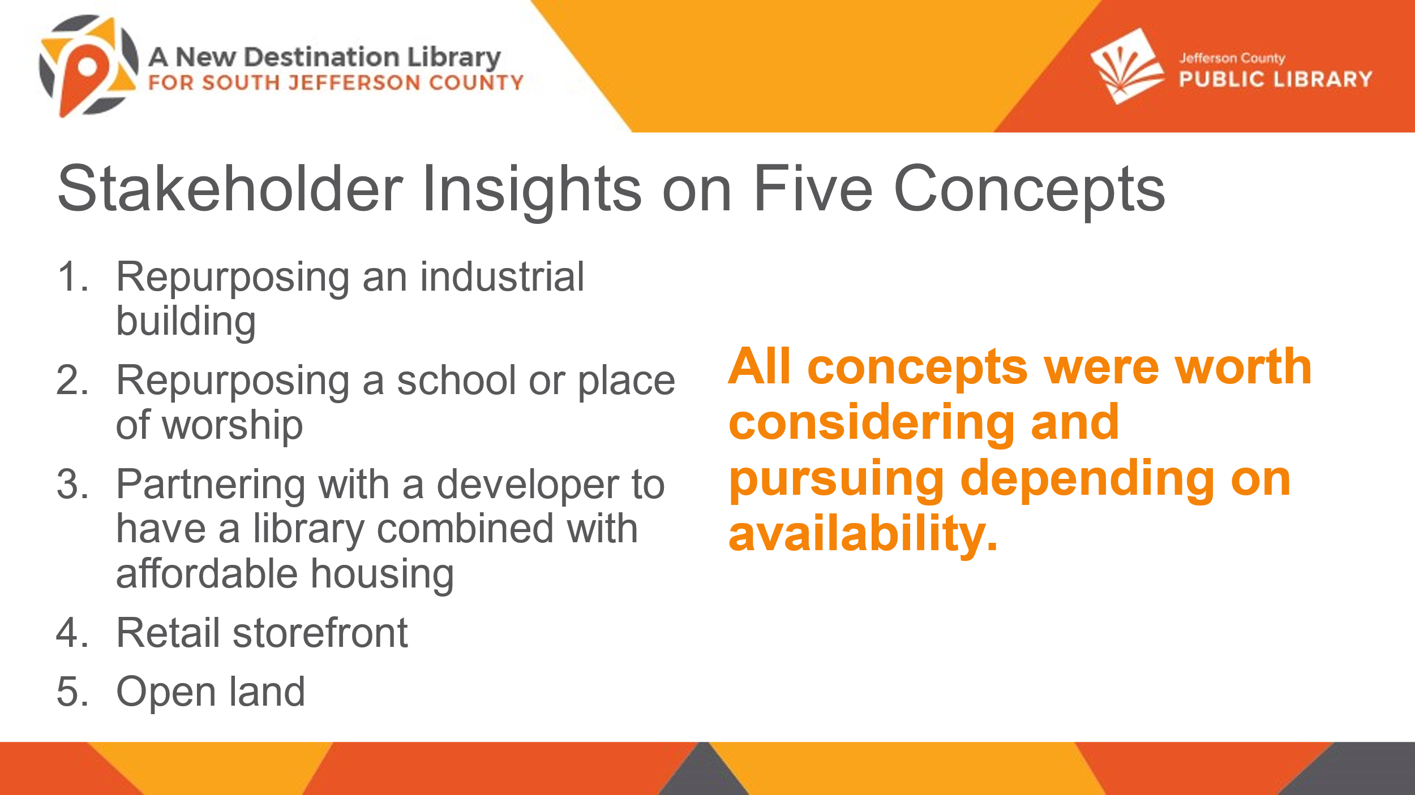

JCPL cast a wider net and over many months investigated 50 properties. While the list included 50 properties, the reality the Library faced, as expected, was the difficulty finding a location that would come close to meeting the criteria and the varied public sentiments related to development of property in this area. JCPL was able to narrow the list and presented the Library Board of Trustees and South County Advisory Council with options to consider.

South County Advisory Council Contributions

The South County Advisory Council has volunteered their time and insights and provided valuable input to JCPL on this project. Besides the concept discussion that was previously discussed, the council members provided comment on the refreshed site criteria, library needs for the community, feedback on talking points and messaging to the community as well as community needs as whole.

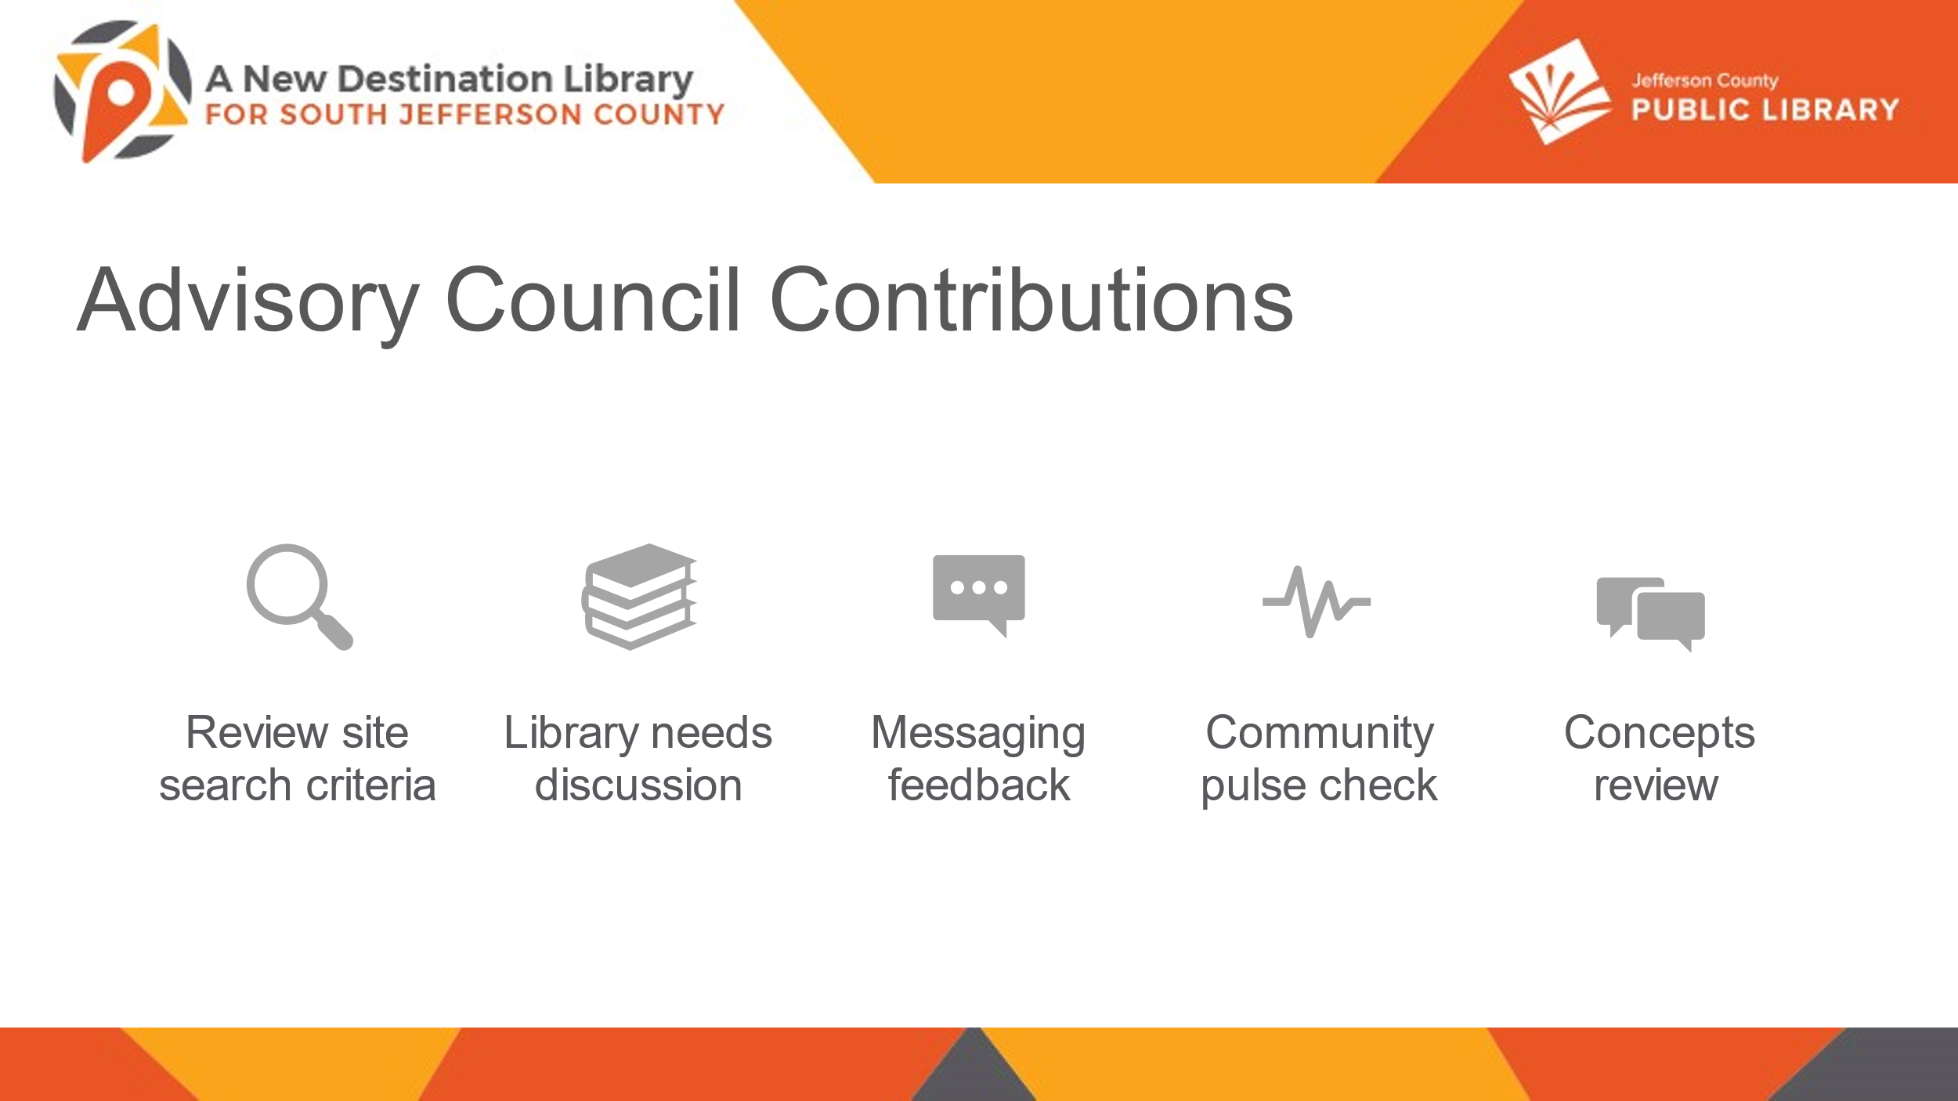

Site Recommendation: Repurposing an Industrial Building

The recommended site embraces the concept of repurposing an Industrial building which was the first choice of the Board when this journey began.

* As expected, this type of building is essentially a big box that offers possibilities for service programming
* It is environmentally friendly; JCPL is not creating more development in an area of the County where residents indicate a desire to preserve undeveloped land
* Repurposing an existing building has a shorter timeline for completion
* It is a more sustainable option than a new build

JCPL has now found a building. Combining this concept with the location presents an opportunity for a destination library that can truly become a community focal point.

Proposed Site: 11100 Bradford Road, Littleton

The site and building at 11100 Bradford Road meet or exceed the search criteria. This location is within the property search area, one block south of Chatfield Avenue, on the corner of Bradford and Shaffer Parkway. It is adjacent to the post office on the west and County services on the east with a new housing development in the location’s back yard.

As the map shows, it is conveniently located close to residential areas and local schools as well as adjacent to major throughfares and on errand routes. It is near other government services and allows for potential co-location of a partner. While not on a specific bus route, the site is within the South Jeffco FlexRide service area for bus service that is operational during library hours Monday through Saturday.

Site Acquisition: Milestones Achieved

Matt Griffin, Director of Business Strategy and Finance, addressed the Board and provided information on the site acquisition.

* Conducted a Rough Order of Magnitude (ROM) Analysis
* Estimated the project's scope and cost.
* Negotiated and Executed a Letter of Intent (LOI)
  + Established initial terms and mutual understanding.
* Negotiated a Purchase and Sale Agreement (PSA)
  + Formalized the terms of the property acquisition.
  + Purchase price $11,000,000

The original project budget was based on a vacant land acquisition. When this property came forward the Library completed the ROM (Rough Order of Magnitude) analysis and recommended continuing to negotiating and executing a non-binding Letter of Intent (LOI) which was an agreement on high level terms. The Library then negotiated a Purchase and Sale Agreement (PSA) with final terms and agreement including the acquisition price of $11,000,000. If the Board authorizes the Library to move to executing the PSA, the Library will enter into a 120 day due diligence, with extension clauses. The next focus will be to kick off the location and extent process with the County Planning Commission, including neighborhood input, gathering feedback on the location and if it meets the community’s needs. A more formal and detailed community engagement will take place later in the process. The physical engineering, construction feasibility and structural investigations will proceed and JCPL retains the right to terminate if results are unsatisfactory. If satisfied with the due diligence, the next step would be to move to closing on the property.

What are we Hearing from the Community?

The Executive Director shared some comments from the community and noted that it is a nice opportunity to see what the Library has heard and shared some additional pictures of the location.

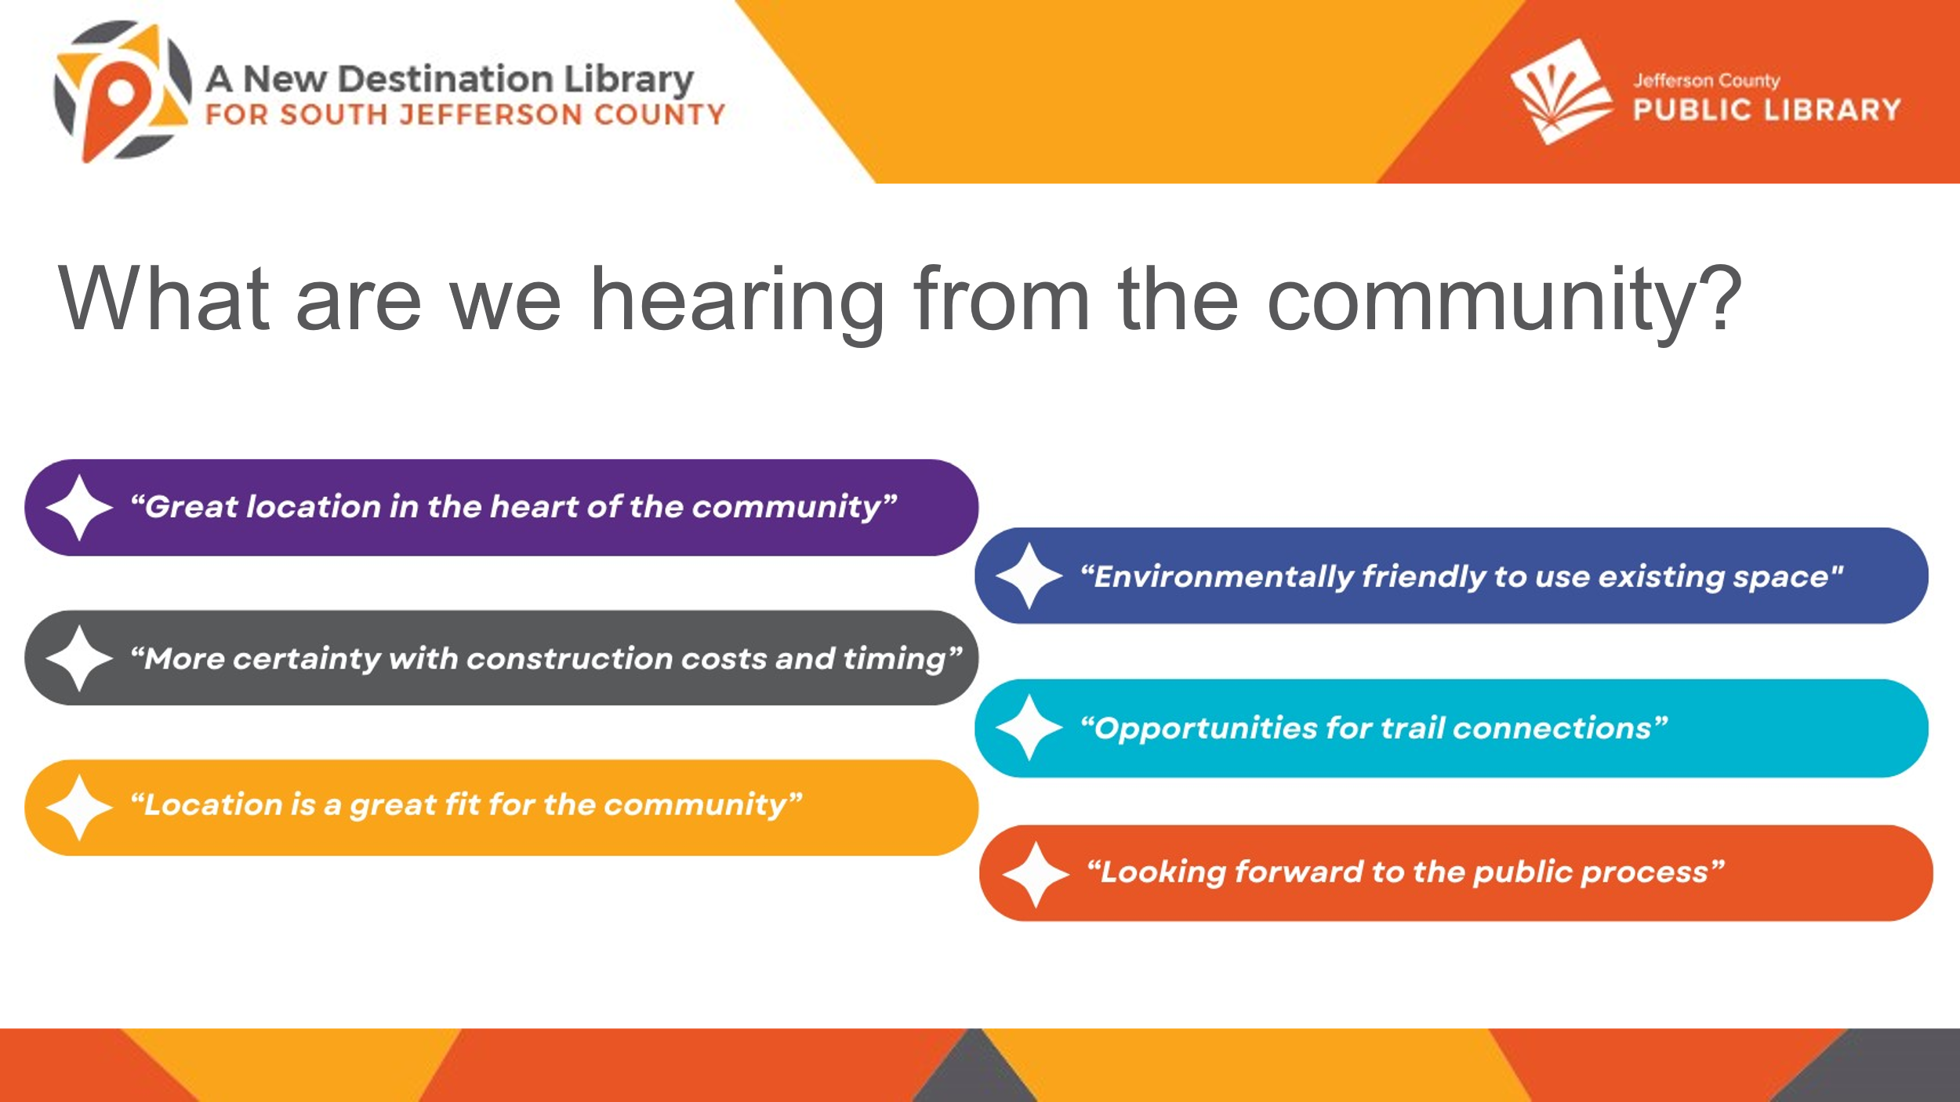

The Chair noted that the Board did have an opportunity to ask legal questions about the property during last week’s executive session. The Chair acknowledged and commended the JCPL team for the work done and transition to a new strategy which has been a herculean effort. The work done gives confidence that this is the best spot to build the library. The Chair noted the importance of continuing to make the community aware that the project is fully funded through the Library’s fund.

**MOTION**: Jeanne Lomba moved that the Library Board of Trustees authorize the Executive Director to sign the Purchase and Sale Agreement between JCA Bradford LLC and the Jefferson County Public Library for the South Jefferson County Library property located at 11100 Bradford Road, Littleton and as described in the Agreement in an amount up to $11,000,000 subject to the terms and conditions contained therein. Seconded by Jill Fellman the motion passed by unanimous vote of all Trustees present.

1. Northwest Jeffco Library Community Engagement & Architectural Design Services Contract Notice to Proceed

Amy Bentz, Assistant Director of Library Design Projects and Planning addressed the Board and provided information on the Northwest Jeffco Library Architect contract. In May 2024 JCPL issued an RFP for architect services for a new library project in Northwest Jeffco. Nine responses were received, and the Library held three interviews. The responses were evaluated on cost, schedule, experience and understanding of JCPL design goals. Based on this evaluation, JCPL requests authorization to engage Anderson Hallas Architects for community engagement and architectural design services for this project. Anderson Hallas Architects has evaluated the project scope and provided a cost estimate and schedule.

In response to a question, the Board was advised that the unique conditions around the Northwest Jeffco Library property, including wind, were addressed in the interviews. Anderson Hallas Architects is aware of the conditions.

**MOTION**: Jill Fellman moved that the Library Board of Trustees authorize the Executive Director to enter into a contract with Anderson Hallas Architects and issue a Notice to Proceed for community engagement and architectural design services for the Northwest Jeffco Library at a cost of $1,804,981. Seconded by Emelda Walker the motion passed by unanimous vote of all Trustees present.

1. 2024 Mid-year Report

The Executive Director advised the Board that the mid-year report is part of the governance process to demonstrate progress on the annual plan.

Matt Griffin, Director of Business Strategy and Finance, addressed the Board and presented highlights on some of JCPL’s mid-year achievements. The Board’s information packet includes the detailed overview of strategic projects, progress against deliverables, comparable analysis of data and comments heard from patrons through feedback. The mid-year report covers achievements from January 1 to June 30, 2024.

Arvada Library Redesign

The project is gaining momentum, moving through planning and scheduling multiple community engagement events and marketing to set the stage for data driven progression through this year and 2025.

Evergreen Library Redesign

The Evergreen Library Redesign was completed earlier this year, and construction and move-in wrapped. The Library and community celebrated this achievement with a grand opening event.

New Collection Development Policy

New collection development policy deliverables include the review and update of library policy and the material reconsideration process. Completed work at mid-year includes the research report and comparative study, draft collection development policy for review and revised collection development policy for review. The project will ultimately allow Jeffco residents access to resources to connect, discover and create.

Digital Accessibility Program

The new addition to the 2024 strategic plan is the Digital Accessibility Program. The team has been hard at work the first half of 2024 and has made significant progress on the impactful deliverables.

All of the Library’s strategic projects, achievements and deliverables are in the Board’s information packet.

Mid-Year Data Review

JCPL is closely monitoring a variety of data points across the system. Some highlights include:

* Database usage is up over 13% with 690,000 uses ytd
* Program attendance has seen a significant rise of 27% with 138,000 attendees ytd
* Digital Circulation is up 11% surpassing 1.1 million
* Total visits are up 6% - even through the Arvada Library closure and Evergreen closure with alternative services
* Cardholders increased by 2,300 a 2.5% increase

JCPL also focuses on trends. For example, digital circulation is up 11% paired with a decrease in physical circulation. These types of trends are monitored and that data is crucial in the way JCPL adapts to the community.

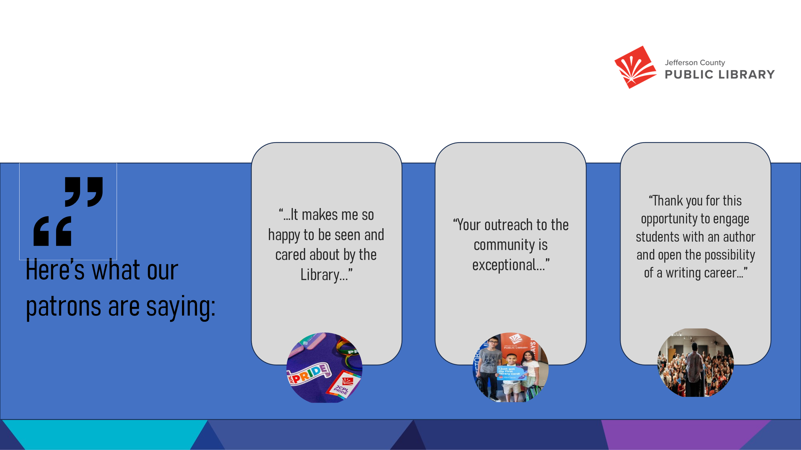

Patron Comments

* Pride month – a powerful reminder how inclusive JCPL’s work is and how welcoming and supportive Library staff is
* Community Outreach - outstanding efforts of the outreach team provides immense value to taxpayers
* Jacqueline Woodson author event – opening students eyes to the possibility of a writing career

Trustee Fellman expressed appreciation to Library staff noting that she loves the report and is impressed with how JCPL overcomes challenges.

The Chair acknowledged Library staff and the incredible achievements. The Chair noted the huge success on fundraising development work and the kick off of collective bargaining. The amount of excellent work that happened in the last six months is astounding. Given the many remarkable achievements over the last 45 days, it’s hard not to acknowledge those accomplishments in this mid-year report. The Chair noted that not only can she say absolutely this is meeting Board goals, the summary is not enough justice for the work the Library has done.

The Executive Director advised the Board that the Mid-Year Report in their packets lists everything through June 30 and there are many more things to celebrate. The Executive Director asked the Board if they had any other expectation in mind for the Library to have met mid-year.

The Chair noted that the Library has exceeded where the Board expected it to be.

1. Long Term Strategic Planning Consultant

Matt Griffin, Director of Business Strategy and Finance, provided information on the long term strategic planning consultant. The Library is currently in the 2020-2025 strategic plan and beginning the process to develop the strategic plan for 2026 and beyond. The Library would like to bring in an outside consultant, Government Performance Solutions (GPS) to support that work. The Library is still in the planning phase and has not yet mapped out details of Board involvement. The cost for the consultant is included in the 2024 and 2025 budgets.

In response to a question, the Board was advised that for the current 2020-2025 strategic plan, the Library did use several consultants and the State Library. That work occurred in 2018/2019.

**MOTION**: Emelda Walker moved that the Library Board of Trustees authorize the Executive Director to move forward with engaging Government Performance Solutions, Inc (GPS) to support the development of the Library’s new long-term strategic plan with a final cost in the amount of $120,000. Seconded by Jill Fellman the motion passed by unanimous vote of all Trustees present.

**Finance and Budget – Monthly Financials**

1. Financial Report (July 2024)

Matt Griffin, Director of Business Strategy and Finance, addressed the Board and presented information on the July financial tables. On Table 1, in July the Library did see $1.1 million in investment income which brings this in line trending toward budget. It continues to be a difficult trend to follow. No revenue was collected and is reflected the same as last month. In Table 3, there is movement in the Northwest Jeffco project, and the acquisition is complete. The Arvada Library Redesign project shows as over budget by $300,000. The project is not over budget. The reason this project shows overbudget is that the Library engaged EUA Architects all the way through 2026, but the cost shows as one encumbrance right now. The purchase order will be paid out over multiple years, but this encumbrance will be reflected in this way for the remainder of this year.

In response to a question, the Board was advised that the $300,000 in expenses for the Arvada Library Redesign project were expected and in the budget.

Table 4 shows a $5,000 naming donation from the Jefferson County Library Foundation for the large study room at the Evergreen Library.

There were no further questions on the monthly financials.

**Technology & Innovation**

1. Digital Accessibility Program

The Chair advised the Board that the Library’s Technology and Innovation team has been dealing with some huge events and this topic will be moved to another meeting. Following on the heels of the CrowdStrike incident the internet lines were cut, and JCPL’s service was out for over 24 hours.

**ITEMS REMOVED FROM THE CONSENT AGENDA**

No items were removed from the consent agenda.

**EMERGING ISSUES**

No issues.

**ENDS**

There were no items.

**BOARD GOVERNANCE**

There were no items.

**BOARD SCHEDULE – NEXT MEETINGS**

Location of meetings of the Library Board of Trustees are being determined in cooperation with guidelines from Jefferson County. Information on meeting location will be posted at least one week prior to the scheduled meeting date.

2024 Board Meeting Schedule

* September 12, 2024 – JOINT LIBRARY BOARD AND BCC – 4:30 pm Hybrid: Virtual via Webex. In-Person Location: BCC Board Room
* September 12, 2024 – Study Session – 5:30 pm Hybrid: Virtual via ZOOM. In-Person Location: To be determined based on Joint Library Board & BCC meeting.
* September 19, 2024 – Board Meeting – 5:30 pm Hybrid: Virtual via ZOOM. In-Person Location: Lakewood Library Meeting Room
* October 10, 2024– Study Session – 5:30 pm Hybrid: Virtual via ZOOM. In-Person Location: Lakewood Library Meeting Room. (Note: Shavuot ends nightfall no work permitted)
* October 17, 2024 – Board Meeting – 5:30 pm Hybrid: Virtual via ZOOM. In-Person Location: Lakewood Library Meeting Room

The Chair advised the Board that she is working with the Executive Director on the agenda for the joint meeting with the BCC. The Chair noted that she will reach out to Commissioner Dahlkemper to see if there is anything the BCC wants the Library Board to cover during the meeting. Logistics are still be worked out. The Board was asked to contact the Chair with any topics for the meeting.

**ANNOUNCEMENTS/GENERAL INFORMATION SHARING**

There were no announcements.

**ADJOURNMENT**

The meeting was adjourned at 6:33 pm.

###### Stanley Harsha, Secretary