### Minutes of the SPECIAL Meeting of the

JEFFERSON COUNTY PUBLIC LIBRARY

BOARD OF TRUSTEES

August 8, 2024

**CALL TO ORDER – SPECIAL MEETING**

The special meeting of the Jefferson County Public Library Board of Trustees was held online via ZOOM and in-person in the Lakewood Library meeting room on August 8, 2024. Library Board of Trustees Chair, Kim Johnson, called the meeting to order at 5:31 p.m.

Other Trustees present: Emelda Walker (Vice-Chair), Pam Anderson, Jill Fellman and Charles Jones.

Trustees not present:. Stanley Harsha and Jeanne Lomba.

**Staff present:** Donna Walker, Executive Director; Bernadette Berger, Director of Technology and Innovation; Matt Griffin, Director of Business Strategy and Finance; Lisa Smith, Director of People and Culture; Elise Penington, Director of Communications and Engagement; Steve Chestnut, Director of Facilities and Construction Projects; Padma Polepeddi, Assistant Director of Public Services for Community Outreach; Jessica Paulsen, Assistant Director of Public Services for Customer Experience; Lizzie Gall, Assistant Director of Public Services for Resources and Programs; Amber Fisher, Executive Assistant, Office of the Executive Director; Kelci Rude, Administrative Coordinator Supervisor; and Ryan Turch, Technology and Innovation Operations Supervisor .

There were additional Library staff members attending the meeting.

**APPROVAL OF AGENDA**

**MOTION:** Emelda Walker moved that the Library Board of Trustees approve the agenda as presented. Seconded by Charles Jones the motion passed by unanimous vote of all Trustees present.

**OPERATIONAL UPDATES**

**Executive Director Report**

1. South County Library Update: South County Library Property Selection

The Executive Director addressed the Board and provided information on the South County Library Property Selection.

After extensive investigation, community engagement, and negotiationJefferson County Public Library is pleased to recommend for purchase the property located at 11100 Bradford Road, Littleton, CO for the creation of a future new library in South Jefferson County. JCPL leadership presents this existing building to repurpose as the most convenient, sustainable, and desirable location for Board consideration.

Background

JCPL has a capital project underway to create a new destination library in the south region to connect our underserved community to library services. This is a new construction project and is budgeted through the Library’s 5-year Capital Improvement Plan. It is fully funded through the fiscal stewardship of the Library Board of Trustees and the taxpayers of Jefferson County.

New Strategy

In April 2023 JCPL brought to the Board a new strategy for the South County Library site acquisition. This new strategy focused on activating a full-fledged campaign to build public support and political will for a new library in this community. Some key activities in the new strategy included:

* Updated market analysis
* Established South County Advisory Council
* Contracted with Genesee Commercial Group
* Initiated our new site search

Site Search Process - Approach

The property search area was reevaluated and adjusted based on the updated market analysis. Our approach was to use this criteria in our site search which included driving tours of the area, working with commercial realtors, pursuing suggestions from the community and advisory council, conversations with community stakeholders, reviewing Jeffco school closures, and pursuing opportunities for partnerships and sites that were not on the market.

Stakeholder Insights on 5 Concepts

JCPL enjoyed working with the South County Advisory Council. One of the impacts of the advisory council was advice on five potential concepts during the property search. The Board also weighed in on these concepts and, like the advisory council, determined that they all had validity and were worth considering and pursuing. Based on feedback, site criteria and market analysis the Library investigated 50 properties. While this list included 50 properties, the reality JCPL faced, as expected, was the difficulty finding a location that met our criteria, especially with public sentiment related to development of property in this part of the County. The Library narrowed down the list and presented options to the Board for consideration.

Recommendation: Repurposing an Industrial Building

The Library’s recommended site embraces the concept of repurposing an industrial building which was the first choice of the Board when the journey began. This building offers possibilities for service programs in the space in an area of the County with the expressed desire to preserve undeveloped land. JCPL feels this is a more sustainable option than a new build with a typically shorter timeline for completion. The Library has now found this building combining this concept with the location for a destination library in this area of the County to become a true community focal point.

Proposed Site

The site and building at 11100 Bradford Road meet or exceed our search criteria. This location is within our property search area, one block south of Chatfield Avenue, on the Corner of Bradford and Shaffer Parkway. The site is adjacent to the post office on the west and County services on the east with a new housing development in the site’s backyard.

Proposed Site: Optimal Size

This property is an optimal size to allow for future expansion and has intuitive entry and parking. The size of the location meets current needs and allows for future opportunities.

Proposed Site: Optimal Location and Convenience

JCPL is very excited about the potential of both the site and the building. The location comes with existing parking and landscaping and provides an opportunity for outdoor spaces. It is conveniently located close to residential areas and local schools as well as adjacent to major throughfares and on errand routes. It is near other government services and allows for potential co-location of a partner. The site is within the South Jeffco FlexRide service area for bus service that is operational during library hours Monday through Saturday for people who would use public transit to get to this library.

Proposed Site: Optimal Technical Requirements

Steve Chestnut, Director of Facilities and Construction Projects, addressed the Board and provided information on the site’s technical requirements. The site is not in a flood plain

has existing parking, mature landscaping and fencing along the back 2/3 of the property.

There are utility connections that will be tested to make sure they meet the Library’s operational needs. The existing sewer and storm systems are sufficient for anticipated uses.

Proposed Site: Optimal Sustainability and Stewardship

In terms of sustainability and stewardship the concept of repurposing a building has many benefits as noted before and is the most sustainable option environmentally. The site and building offers the potential for the library to consider renewable energy options in a repurpose. An existing building also offers the opportunity to reduce construction time, accelerating the capital projects timeline.

Acquisition Milestones Achieved

Matt Griffin, Director of Business Strategy and Finance, addressed the Board and provided information on the property acquisition milestones.

* Conducted a Rough Order of Magnitude (ROM) Analysis
* Estimated the project's scope and cost.
* Negotiated and Executed a Letter of Intent (LOI)
  + Established initial terms and mutual understanding.
* Negotiated a Purchase and Sale Agreement (PSA)
  + Formalized the terms of the property acquisition.

The first step was around cost. The original project budget was based on a vacant land acquisition. When this property came forward the Library reevaluated engineering, technical and other requirements. Based on those requirements and with knowledge this would fit within budget, the Library moved to negotiating the non-binding Letter of Intent (LOI) with the seller. During this phase the Library negotiated high level terms for acquisition. The Library and seller reached agreement on those terms and moved to drafting and bringing forward the Purchase and Sale Agreement (PSA) including the finer details of the acquisition and agreed on all aspects of the acquisition.

Acquisition Milestones Ahead

If the Library moves forward the next milestone ahead would be to execute the Purchase and Sale Agreement (PSA). Upon execution of the PSA the Library would enter the 120 day due diligence period, which is crucial for the Library to conduct its own in-depth research to confirm the building’s feasibility and location. This due diligence includes entitlements, community engagement, physical inspections and appraisal and would involve the location and extent process. This is a critical step with the County Planning Commission and includes neighborhood engagement to make the public aware and provide opportunity to provide input on government acquisition of property and impact on the community. This community engagement would be conducted to focus on the location and seek input and feedback to confirm the location meets the community’s needs. More formal community engagement follows if the Library closes on the property. Included in the due diligence process are physical, environmental, engineering and construction investigations to determine feasibility and make sure the building can be adapted to meet the needs of the Library. The final area is appraisals, where the Library would bring in a third party to confirm the acquisition provides good value to the taxpayers. While conducting due diligence the Library reserves the right to terminate the agreement at its sole discretion if due diligence is unsatisfied. If the results of the due diligence are satisfactory, the Library would finalize acquisition.

What are we Hearing from the Community?

The Executive Director advised the Board that when the South County Library property selection and location was posted on JCPL’s website last Thursday, the Library reached out to the community and key stakeholders in the Ken Caryl and South County area to gauge support for this location. Some of the excitement and support JCPL heard in this preliminary outreach was shared.

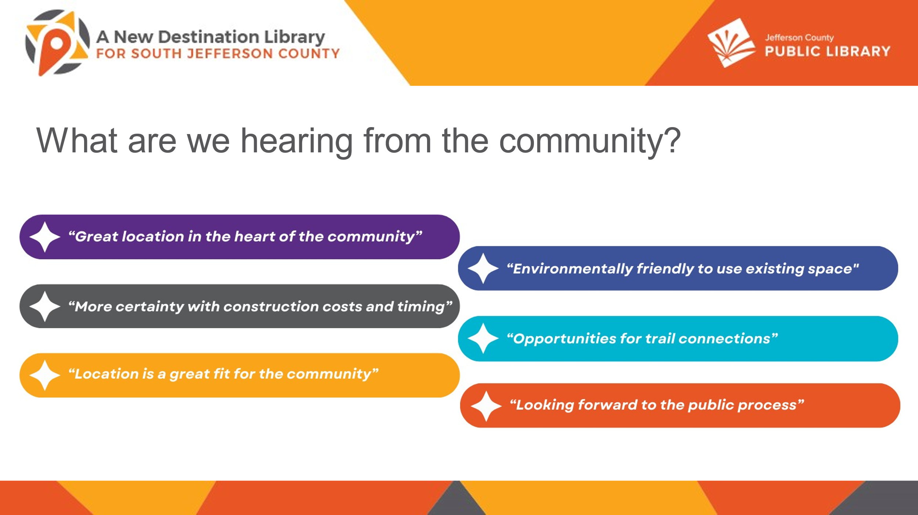

In response to questions, the Board was advised that:

* The Library anticipates that the parking lot will be expanded and there is space for that expansion.
* The Library did hear during the preliminary outreach that the location is further south from the Columbine Library than the previously considered sledding hill location and a great second choice in terms of location.

The Chair noted that the opportunity for outdoor improvements is a clear possibility and it appears that people familiar with this area consider this location to be a part of the community.

**EMERGING ISSUES**

No items.

**ENDS**

No items.

**BOARD GOVERNANCE**

No items.

**BOARD SCHEDULE – NEXT MEETINGS**

Location of meetings of the Library Board of Trustees are being determined in cooperation with guidelines from Jefferson County. Information on meeting location will be posted at least one week prior to the scheduled meeting date.

2024 Board Meeting Schedule

* August 15, 2024 – Board Meeting – 5:30 pm Hybrid: Virtual via ZOOM. In-Person Location: Lakewood Library Meeting Room
* September 12, 2024 – JOINT LIBRARY BOARD AND BCC – 4:30 pm Hybrid: Virtual via Webex. In-Person Location: BCC Board Room
* September 12, 2024 – Study Session – 5:30 pm Hybrid: Virtual via ZOOM. In-Person Location: To be determined based on Joint Library Board & BCC meeting.
* September 19, 2024 – Board Meeting – 5:30 pm Hybrid: Virtual via ZOOM. In-Person Location: Lakewood Library Meeting Room
* October 10, 2024– Study Session – 5:30 pm Hybrid: Virtual via ZOOM. In-Person Location: Lakewood Library Meeting Room. (Note: Shavuot ends nightfall no work permitted)
* October 17, 2024 – Board Meeting – 5:30 pm Hybrid: Virtual via ZOOM. In-Person Location: Lakewood Library Meeting Room

The Chair asked the Trustees to hold the September 12 joint meeting with the Board of County Commissioners (BCC) on their calendars. In response to a question, the Board was advised that the Library is working with the BCC to figure out the logistics for the September 12, joint meeting.

**ANNOUNCEMENTS/GENERAL INFORMATION SHARING**

There were no announcements.

**EXECUTIVE SESSION:**

At 6:00 pm, the Chair called for a motion to adjourn the special meeting, reconvene in Executive Session regarding Collective Bargaining and adjourn the special board meeting at the conclusion of the Executive Session.

**MOTION**: Jill Fellman moved to adjourn the special meeting of the Library Board of Trustees, reconvene in Executive Session regarding **(1)** Collective Bargaining **(2)** South County Library AND adjourn the special Board meeting at the conclusion of the Executive Session. Statutory citations authorizing an executive session for these topics are:

* Pursuant to 24-6-402(4)(b) Conferences with an attorney for the local public body for the purposes of receiving legal advice on specific legal questions.
* Pursuant to 24-6-402(4)(e)(I) for discussion of strategy and instructions to negotiators
* Pursuant to 24-6-402(4)(a) Concerning the purchase, acquisition, lease, transfer or sale of Property.

Seconded by Charles Jones the motion passed by unanimous vote of all Trustees present.

The Chair announced a 5 minute break to allow the Board and staff time to leave the existing ZOOM meeting and then join the Executive Session.

The Chair called the Executive Session to order at 6:05 pm with the following Trustees present, Charles Jones, Jill Fellman, Pam Anderson, and Emelda Walker. Also present were Donna Walker, Executive Director; Tami Culkar Fisher & Phillips LLP, Eric Butler and Kurt Behn, County Attorney’s Office; Bernadette Berger, Director of Technology and Innovation; Matt Griffin, Director of Business Strategy and Finance; Lisa Smith, Director of People and Culture; Elise Penington, Director of Communications and Engagement; Steve Chestnut, Director of Facilities and Construction Projects and Amber Fisher, Executive Assistant, Office of the Executive Director.

It is noted that the session was recorded and that the recording will be retained for the required 90 days.

**CALL FOR ADJOURNMENT OF EXECUTIVE SESSION AND SPECIAL MEETING**

**MOTION**: At 6:57 pm Emelda Walker moved to adjourn the Executive Session and special meeting of the Library Board. Seconded by Jill Fellman the motion passed by unanimous vote of all Trustees present.

It is noted that the Library Board of Trustees met in Executive Session regarding **(1)** Collective Bargaining and **(2)** South County Library concerning strategy and instructions to negotiators and receiving legal advice on specific legal questions with respect to Collective Bargaining and South County Library and concerning the purchase, acquisition, lease, transfer or sale of Property with respect to the South County Library. The Trustees held those discussions, and this summary is provided as required by Colorado Statute.

###### Stanley Harsha, Secretary