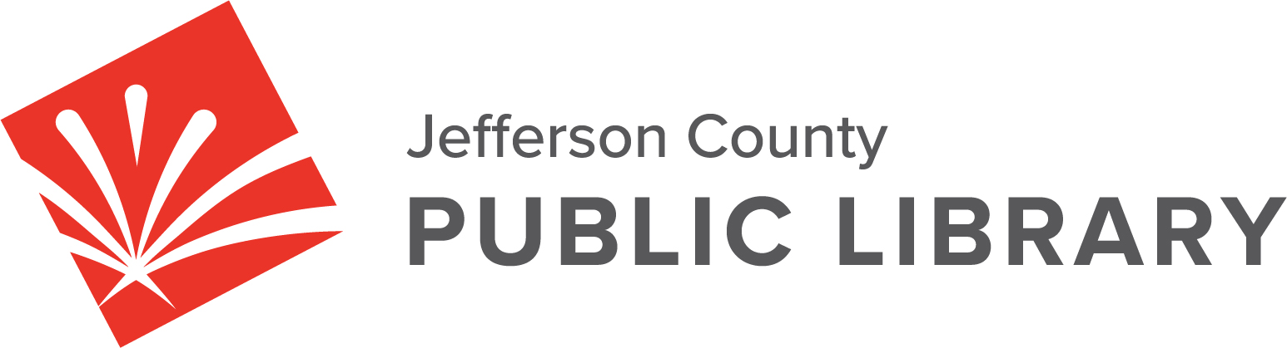

SPECIAL BOARD MEETING

DATE: August 8, 2024

TIME: 5:30 P.M.

PLACE: Hybrid Public Meeting
- Online via ZOOM
- In-Person at Lakewood Library meeting room, 10200 W. 20th Avenue, Lakewood 80215

For instructions on how to access the online ZOOM Board meeting please go to: https://jeffcolibrary.org/board-of-trustees/2024-board-meetings/

EXECUTIVE SESSION:
(1) Collective Bargaining (2) South County Library. Statutory citation authorizing an executive session for these topics are:
- Pursuant to 24-6-402(4)(b) Conferences with an attorney for the local public body for the purposes of receiving legal advice on specific legal questions.
- Pursuant to 24-6-402(4)(e)(I) for discussion of strategy and instructions to negotiators
- Pursuant to 24-6-402(4)(a) Concerning the purchase, acquisition, lease, transfer or sale of Property.

NEXT BOARD MEETING

