### Minutes of the Regular Meeting of the

JEFFERSON COUNTY PUBLIC LIBRARY

BOARD OF TRUSTEES

July 18, 2024

**CALL TO ORDER – REGULAR MEETING**

The regular meeting of the Jefferson County Public Library Board of Trustees was held online via ZOOM and in-person in the Lakewood Library meeting room on July 18, 2024. Library Board of Trustees Chair, Kim Johnson, called the meeting to order at 5:30 p.m.

Other Trustees present: Emelda Walker (Vice-Chair), Stanley Harsha (Secretary), Jill Fellman, and Jeanne Lomba.

Trustees not present: Pam Anderson and Charles Jones.

**Staff present:** Donna Walker, Executive Director; Julianne Rist, Director of Public Services; Matt Griffin, Director of Business Strategy and Finance; Lisa Smith, Director of People and Culture; Bernadette Berger, Director of Technology and Innovation; Elise Penington, Director of Communications and Engagement; Steve Chestnut, Director of Facilities and Construction Projects; Jessica Paulsen, Assistant Director of Public Services for Customer Experience; Lizzie Gall, Assistant Director of Public Services for Resources and Programs; Padma Polepeddi, Assistant Director of Public Services for Community Outreach; Amy Bentz, Assistant Director of Library Design Projects and Planning; Amber Fisher, Executive Assistant, Office of the Executive Director; Katie O’Loughlin, Administrative Coordinator Supervisor; Ryan Turch, Technology and Innovation Operations Supervisor; and Aaron Cameron, Technical Support Technician Senior.

There were additional Library staff members attending the meeting.

**APPROVAL OF AGENDA**

**MOTION:** Jill Fellman moved that the Library Board of Trustees approve the agenda as presented. Seconded by Jeanne Lomba the motion passed by unanimous vote of all Trustees present.

**EXECUTIVE SESSION:**

At 5:32 pm, the Chair called for a motion to adjourn the regular Board meeting and reconvene in Executive Session.

**MOTION:** Emelda Walker moved to adjourn the regular meeting of the Library Board of Trustees and reconvene in Executive Session regarding **(1)** Collective Bargaining and (2) Conifer Library Opportunity Lease. Statutory citations authorizing an executive session for these topics are:

* Pursuant to 24-6-402(4)(a) Concerning the purchase, acquisition, lease, transfer or sale of Property.
* Pursuant to 24-6-402(4)(e)(I) for discussion of strategy and instructions to negotiators

Seconded by Jeanne Lomba the motion passed by unanimous vote of all Trustees present.

The Chair announced a 5 minute break to allow the Board and staff time to leave the existing ZOOM meeting and then join the Executive Session.

The Chair called the Executive Session to order at 5:36 pm with the following Trustees present, Jill Fellman, Stanley Harsha, Jeanne Lomba and Emelda Walker. Also present were Donna Walker, Executive Director; Julianne Rist, Director of Public Services; Matt Griffin, Director of Business Strategy and Finance; Lisa Smith, Director of People and Culture; Elise Penington, Director of Communications and Engagement; Steve Chestnut, Director of Facilities and Construction Projects; Bernadette Berger, Director of Technology and Innovation; and Amber Fisher, Executive Assistant, Office of the Executive Director.

It is noted that the session was recorded and that the recording will be retained for the required 90 days.

**CALL FOR ADJOURNMENT OF EXECUTIVE SESSION AND TO RECONVENE REGULAR BOARD MEETING**

**MOTION**: At 6:07pm Jill Fellman moved to adjourn the Executive Session and reconvene the regular meeting of the Library Board. Seconded by Emelda Walker the motion passed by unanimous vote of all Trustees present.

At 6:11 p.m. the Chair reconvened the regular meeting with the following Trustees present: Emelda Walker (Vice-Chair), Stanley Harsha (Secretary), Jill Fellman, and Jeanne Lomba.

The Chair provided the following Executive Session Summary:

**EXECUTIVE SESSION SUMMARY:**

The Library Board of Trustees met in Executive Session regarding (1) Collective Bargaining and (2) Conifer Library Opportunity Lease concerning the discussion of strategy and instructions to negotiators and concerning the purchase, acquisition, lease, transfer or sale of Property. The Trustees held those discussions, and this summary is provided as required by Colorado Statute.

**PUBLIC COMMENT**

The Board values public participation. Those who would like to address the Library Board can do so virtually, in-person, or online. The opportunity to address the Library Board does not include a question and answer session or response. Additionally, the Library Board does not respond to anonymous questions or comments. Comments will be acknowledged in the minutes of the meeting. The Chair provided public comment instructions.

Punky Kiefer addressed the Board and expressed appreciation to the Board and Library staff regarding the Conifer Library. The Chair expressed appreciation for the comments.

There were no further comments, and the Chair closed the public comment portion of the meeting at 6:16 pm.

**APPROVAL OF CONSENT AGENDA**

The Chair asked the Trustees if any of the items should be removed from the consent agenda. There were no requests for items to be removed.

Items on the Consent Agenda

1. Approve June 13, 2024 Special Board Meeting Minutes
2. Approve June 20, 2024 Board Meeting Minutes
3. Authorize Midwest Tape Audio/Visual Contract Renewal

**MOTION**: Emelda Walker moved that the Library Board of Trustees approve the items on the consent agenda as presented. Seconded by Jill Fellman the motion passed by unanimous vote of all Trustees present.

**FOUNDATION UPDATE**

Jo Schantz, Foundation Executive Director provided an update on the activities of the Foundation. The Volunteer Appreciation lunch is tomorrow. The Foundation welcomed two new Foundation Board members, Jeannie Mann and Alli Mueller and a new employee Diane Major, Belmar bookstore manager. The Foundation hopes to increase volunteers at the Belmar bookstore and open 7 days per week. The Belmar bookstore has gross sales of $54,000 since opening in October 2023. The Foundation will receive a percentage of sales from 240 Union restaurant on September 18. The Foundation’s bookkeeper will be retiring, and the Foundation is looking for a replacement.

**Executive Director Report**

1. Executive Director Report

The Executive Director advised the Board that JCPL management continues to negotiate in good faith with AFSCME, the exclusive representation of staff in the collective bargaining unit. The Library is working with them on the remaining details for the first negotiation meeting scheduled on July 24th. There are two engagement opportunities for the Board, the CALCON conference in Breckenridge in September and the ULC Annual Forum in October. Padma Polepeddi, Assistant Director of Public Services for Community Outreach developed an MOU for a music event in the evening hosted by Take Note Colorado at Standley Lake Library on August 18.

1. South County Library Update

The site search is ongoing, and JCPL is continuing conversations in the community about opportunities for a library location.

1. Northwest Jeffco Library Update

The Arvada City Council unanimously passed JCPL’s request for rezoning and amendment to the comprehensive land use plan amendment for the property on Monday night. Kim Johnson, Library Board Chair, attended the meeting to speak on behalf of the Library. Closing documents have been signed by the Chair. There is some paperwork to complete the closing process within the next week. A robust internal and external communications plan will be activated at that time. An article is coming out in the Arvada Press next week. The Library is scheduling a photo opportunity on the property for Trustees and staff for Saturday, August 17 at 11:00 am. The Trustees were asked to hold this time on their calendars. The Executive Director expressed appreciation to the Board and staff for the tremendous effort to get to this point in the project. JCPL has acquired the land for the destination library in northwest Jefferson County: the data analysis, stakeholder engagement, site search and selection, negotiations, due diligence, project management, rezoning, closing activities, and decision-making all came together to create this historic moment in JCPL history. The Executive Director acknowledged the community support of the site selection.

1. Golden Library Opportunity Update

The Executive Director informed the Board about a decision the Library has made that typically would have come forward for Board consensus. JCPL has been in conversation with the City of Golden about a potential partnership where the library moves to a new location on the east end of Golden to be housed in the same location as a new city hall. The funding for this project is still in flux. City of Golden decisions about other development in the east and central corridors is also not decided yet. That plan is still being developed. In a meeting with the City of Golden staff last month the Library was asked for a commitment - yes or no – is the Library in or out of the City Hall project. The deadline for a decision was this month. This deadline for an immediate decision prompted the Library to assess the risks and opportunities and come to a decision. At this time, JCPL does not feel like it can move forward in partnership with this project.

* The project does not currently align with the Library’s spending plans for 2024 and 2025, and significant investment in design at this stage would be inconsistent with JCPL’s strategic financial plan.
* The Library does not have the time to conduct the usual community engagement that would typically be undertaken for a project that impacts the community to this degree. JCPL is committed to extensive community engagement and the current timing does not allow the Library to perform this process adequately.

The Library will be informing the Golden City Manager of this decision via email tomorrow. The Board is typically informed or consulted before a decision of this nature; however, the timing of the decision meant the Library needed to bring this forward as an information item rather than get Board consensus. The Executive Director asked the Board if they had any questions.

Trustee Fellman expressed appreciation to the Executive Director for being so wise and looking at the big picture. The Chair noted that the timeline for a decision and not having the opportunity for the due diligence process was the issue and not that the Library is not interested in a partnership.

There were no questions from the Board.

1. JCPL Fundraising Plan 2024-2025, Guest: Bridget Beatty

The Executive Director advised the Board that as part of JCPL's 2024 Annual Plan, the Library has a fundraising program with 5 major deliverables. The vision for this program is that JCPL is successful at raising outside funding beyond property tax revenue sources, focusing on opportunities in grant writing over $25,000 and major gifts over $5,000 in order to enhance library programs, projects, and services.

The Library’s vision is that this program will modernize JCPL practices by exploring and implementing a new structure, approach, and systems for raising outside funds. To that end, JCPL is executing specific fundraising activities to increase funds raised and decrease the indirect rate of fundraising.

One of the deliverables was to outsource fundraising counsel. Tonight the Board will hear from Bridget Beatty, the Library’s outside fundraising counsel. The presentation will demonstrate meeting three more of the plan’s deliverables:

* Create a 2-year fundraising plan
* Codify separate fundraising portfolios for JCPL and JCLF; and
* Pilot a foundation relation and grants program

Bridget Beatty addressed the aboard and provided information on JCPL’s fundraising plan for 2024-2025. The scope of this consulting position is fundraising to benefit JCPL.

Objectives

* Increase direct funding to the Library from philanthropic sources
* Enhance value for Jeffco residents

Parameters: Criteria for JCPL-led Fundraising

* Grants: The Library will take the lead on grant requests of $25K or greater. JCLF will continue to pursue grants up to the $25K threshold.
* Major Gifts: Solicitation of individual donors and corporate sponsorships is not included in the two-year 2024-2025 plan.
* JCLF as Fiscal Sponsor: When 501c3 status is required for eligibility. JCPL will take the lead and JCLF will submit on our behalf as fiscal agent.

Priorities: Targeted Funding - Greatest Areas of Need for Philanthropic Support

* Capital: Facilities, fixtures, technology and outdoor opportunities.
* Programs: Vision for JCPL - Continue to look at opportunities to support programming.

Fundraising Priorities: Fundraising will focus on enhancements that support additional opportunities for all generations to connect, discover and create.

* **Conifer Library:**
* Enhance community access beyond staff hours. After-hours access (technology/security system).
* Flexible community gathering spaces.
* Funding to support design of internal spaces
* **Northwest Jeffco Library:**
* Outdoor reading spaces, etc. and art fixtures
* Educational garden
* Early childhood outdoor literacy play space
* **Civic Engagement**
* Family Leadership Training Institute – positive youth development
* Hard Times Writers Workshops. Peer support group to find social connection and enhance literacy.
* **Literacy Building**
* Summer Challenge
* Family Place

Targets: Fundraising goals for 2024-2025

* **Target setting**
* Identified gaps between JCPL wish list and Library Foundation fundraising.
* Alignment of JCPL fundraising priorities with current funding opportunities.
* Current capacity and manageable growth (meet reporting requirements, etc.)

Fundraising Goal

* 2024 – goal $75k
* 2025 – goal $150k

Prospects: High-focus funding sources

**2024 Priority Prospects**

* + T-Mobile Hometown Grants (Conifer self-service extended hours access)
  + El Pomar (Conifer or NW Jeffco)
  + Boettcher Foundation (NW Jeffco)
  + Fidelity Foundation (NW Jeffco)

Work includes starting relationships, and the prospect list is dynamic. The T-Mobile Home Town grant was submitted for a $50k grant to support the Conifer Library focus on increasing community access, strengthening the site as a community hub, and the installation of technology to access the library after staffed hours. This accessibility was piloted at the Express Library in Arvada. This will not replace staff but increase hours beyond when the library is staffed and make meeting space available to support community connectiveness. The Library received community letters of support for this grant including from the Conifer Area Council and Chamber of Commerce.

**2025 Priority Prospects**

* Gates Foundation
* Anschutz Foundation
* Colorado Gives Foundation
* Great Outdoors CO

Possible funding requests

* NW Jeffco: Educational garden, public art or early literacy outdoor space.
* Family Leadership Training Institute
* Hard Times Writer Workshops

For 2025, the Library is looking at the Gates Foundation, Anschutz Foundation, Colorado Gives Foundation and Great Outdoors, CO. Colorado Gives Foundaton just released some funding opportunities focused on supporting Jeffco communities.

Moving Forward

Work on the 2024-2025 fundraising plan has commenced and when new information is received, the plan will be adjusted accordingly.

Additional Plan Elements

* **Partnership**
  + JCPL and the Library Foundation will share grant responsibilities when 501c3 is required for grant eligibility.
  + Indirect rate of 5% included for the Library Foundation when serving as the fiscal sponsor, as allowed.
* **Government Funding**
* 2024-2025 goals are focused on philanthropic grants. Library staff will continue to pursue public grants when applicable.
* Fundraising counsel to explore elevation of JCPL in the County process for Congressionally Directed Spending funds.
* **Staff Time**
  + JCPL leadership committed to allocate staff time in support of grant applications and reporting requirements.
  + Grant budgets will include paid staff time whenever possible.

The 5% fiscal agent indirect rate will be built into the request when that is allowed by the funding source. Government funding is not currently the focus; however, Library staff is already versed in government funding grants. The fundraising counsel position might support those efforts but will not take lead. Elements of the plan include getting more engrained in the County process and congressionally directed funds and opportunities for legislators to advocate for their local communities. Staff time will be required for the success of the fundraising plan and JCPL leadership committed to allocating appropriate staff time for the many administrative activities. The Library will include paid staff time in grant requests when allowed. If there are JCPL employees facilitating a grant funded program, the Library would like to capture that cost. There are ways of tracking staff time that are not in place right now, but the intent is to capture costs that may not be included in the grant budget and continue to increase value.

The Chair expressed appreciation to Bridget and the Library for their work on the fundraising plan.

**EXECUTIVE TEAM OPERATIONAL UPDATES**

**Business Strategy & Finance**

Monthly Financials

1. Financial Report (June 2024)

Matt Griffin, Director of Business Strategy and Finance, addressed the Board and noted two items in the monthly financial tables. At this halfway point in the year, the Library is on track across all categories as expected and is in healthy financial position. On Table 1 revenue collection appears over budget showing 105%. However, two of the line items that feed into revenue are actually charges. Those charges of approximately $3.0 million will come in and revenue will even out toward the end of the year. The Library is not projecting to end revenue above forecast.

There were no questions from the Board on the monthly financials.

**Public Services & Facilities and Construction Projects**

1. Conifer Library Lease Agreement and Location Presentation

The Executive Director introduced the topic and noted that in 2023, the Conifer Library Services opportunity was included as a new capital project in the Library’s budget. One year later, after intensive community engagement, data analysis and site searching, the Library is bringing forward a location for those library services to the Board for decision this evening.

Julianne Rist, Director of Public Services, addressed the Board and noted that JCPL is very pleased to recommend a space to provide services to the Conifer community.

Conifer Library is an existing location, so JCPL has data about how cardholders use this location as well as data from the market analysis and community input. JCPL is using the Conifer Library Service Area (LSA) as the defining boundaries for this project. JCPL does not anticipate a significant change in the population or household numbers for this LSA. Jefferson County’s Conifer 285 Corridor Area plan also recommends to continue low density development.

JCPL learned of the change to Jeffco School hours which would decrease the number of open hours to the public at the high school. The Library accelerated the evaluation of library services for the area and Conifer became a 2023 capital project. The Conifer Opportunity project’s purpose is to evaluate, plan and then implement that plan for library services. This project will ensure that JCPL services meet the needs of the Conifer community by providing equal access to information and opportunities, and being the essential destination where all generations connect, discover, and create.

The following chart is a brief overview of the work and community engagement that previously occurred on this project. A market analysis was completed in April of 2023, and community engagement was conducted. What JCPL learned from this engagement became the recommendations for the service plan that was presented to the Board during the summer of 2023. The plan recommended looking for existing buildings and retail spaces. Part of what was used to guide the site search area was based on the comments from the community input and the County’s Conifer 285 Corridor Area Plan. Both support the idea that a location along the 285 Conifer activity center corridor would be more convenient and visible. In March of 2024 the Library brought an update to the Board about the site search process.

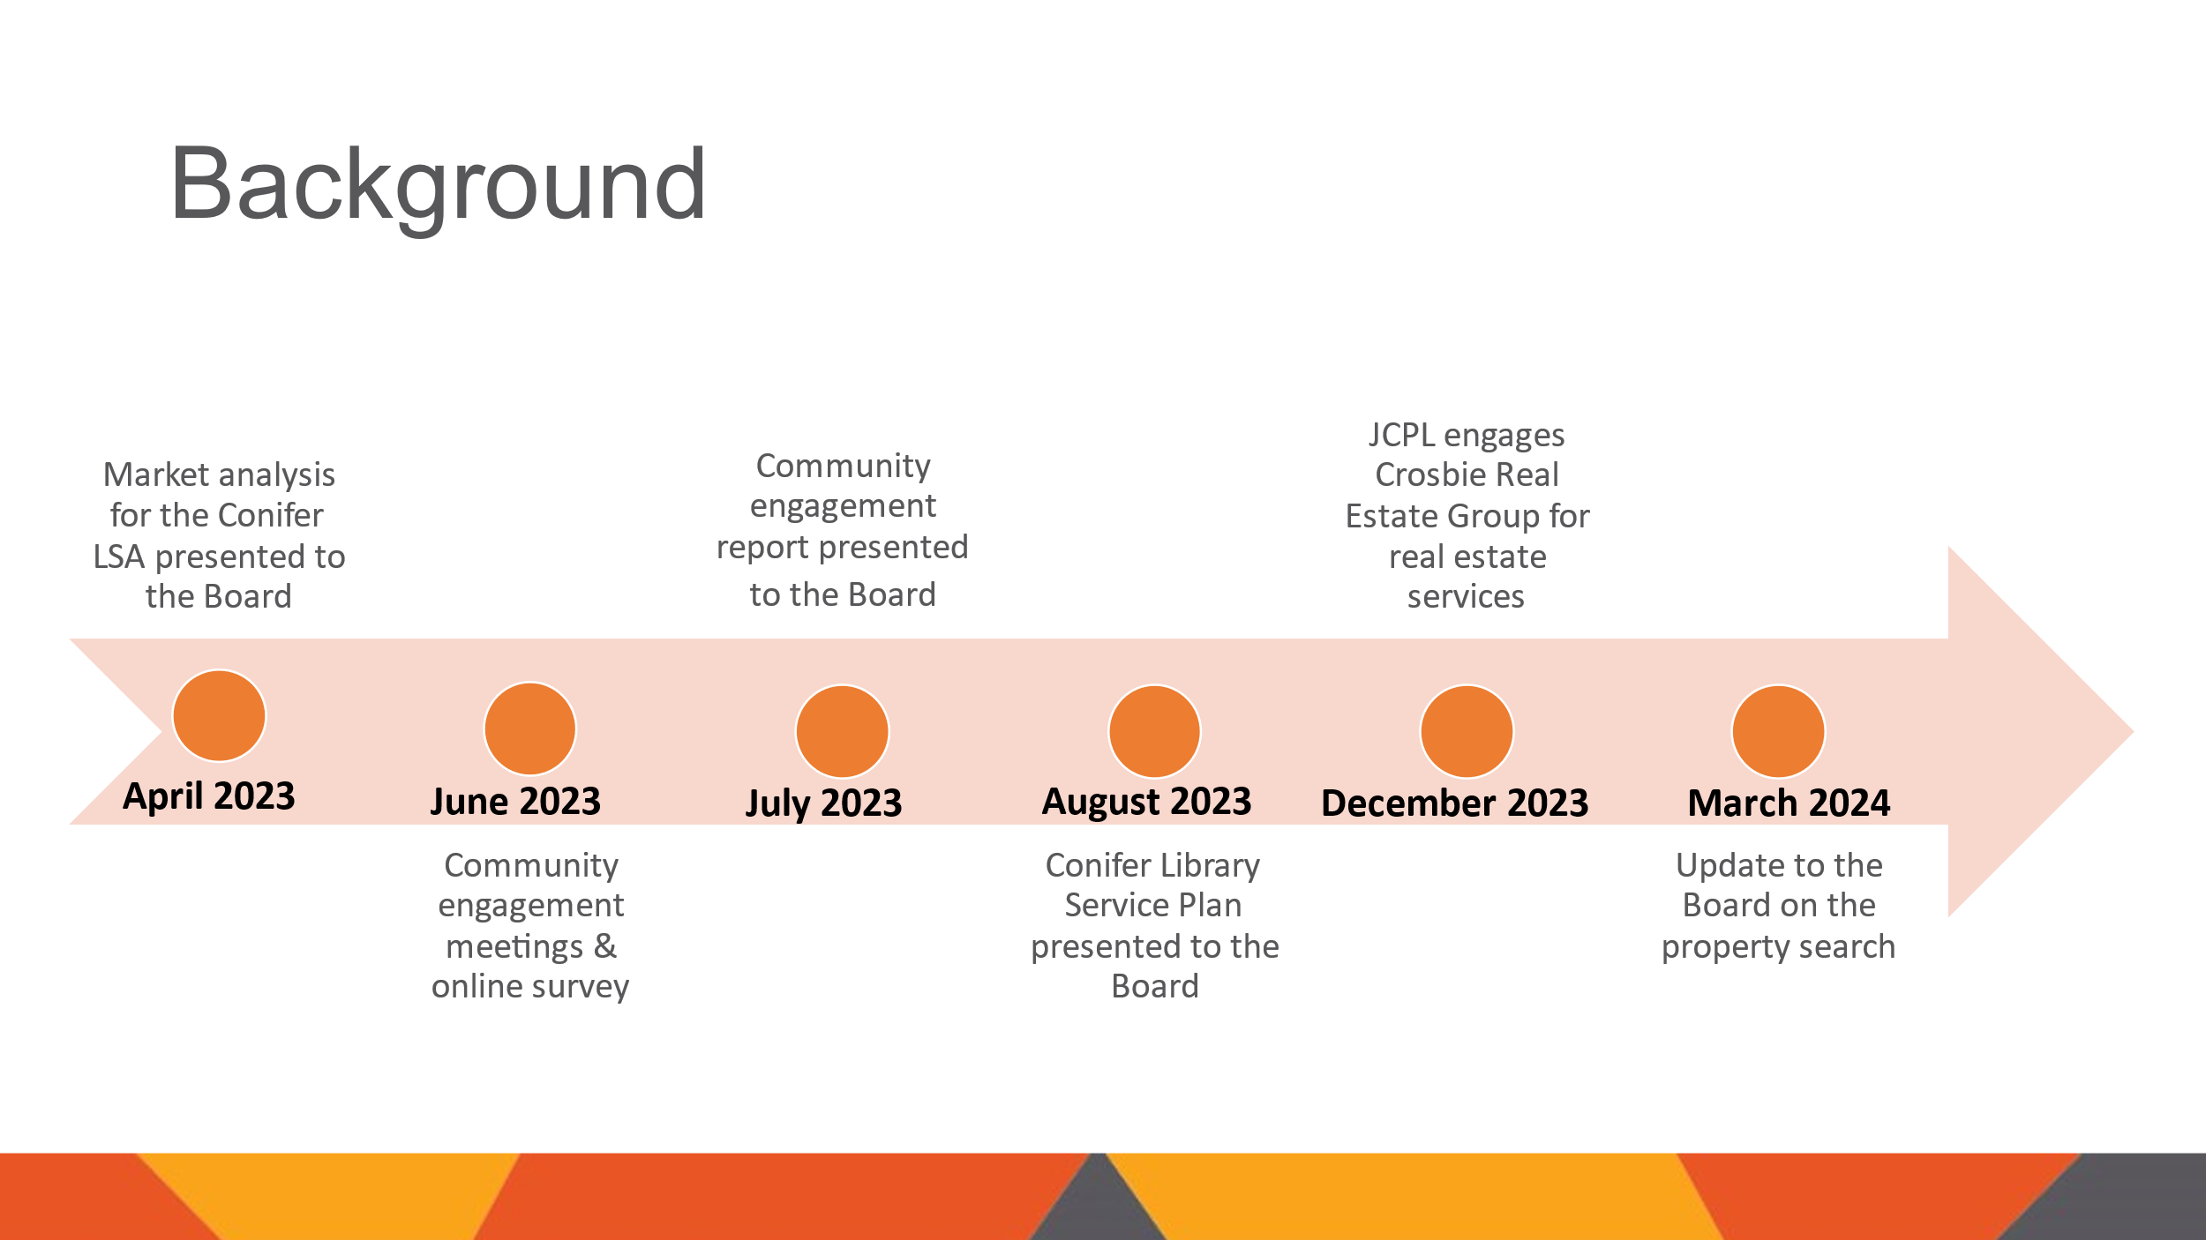

The Board was updated on the site search in March 2024. After hiring Crosbie Realty, the search began with casting a wide net for spaces that might meet the criteria. This included sharing staff and community suggestions with the realtor. Crosbie Realty also utilized their resources and connections to create a list of potential buildings and spaces that were in the library service area with visibility along HWY 285 and that were both on and off the market. The initial list of 63 was reduced to 15 buildings meeting criteria and were assessed by staff and the realtor on a driving tour. Of those 15 buildings, 2 spaces were deemed as possibilities. Staff and the realtor initially walked through these spaces in February. Since then, JCPL has evaluated its top space, and continued to monitor for potential new opportunities.

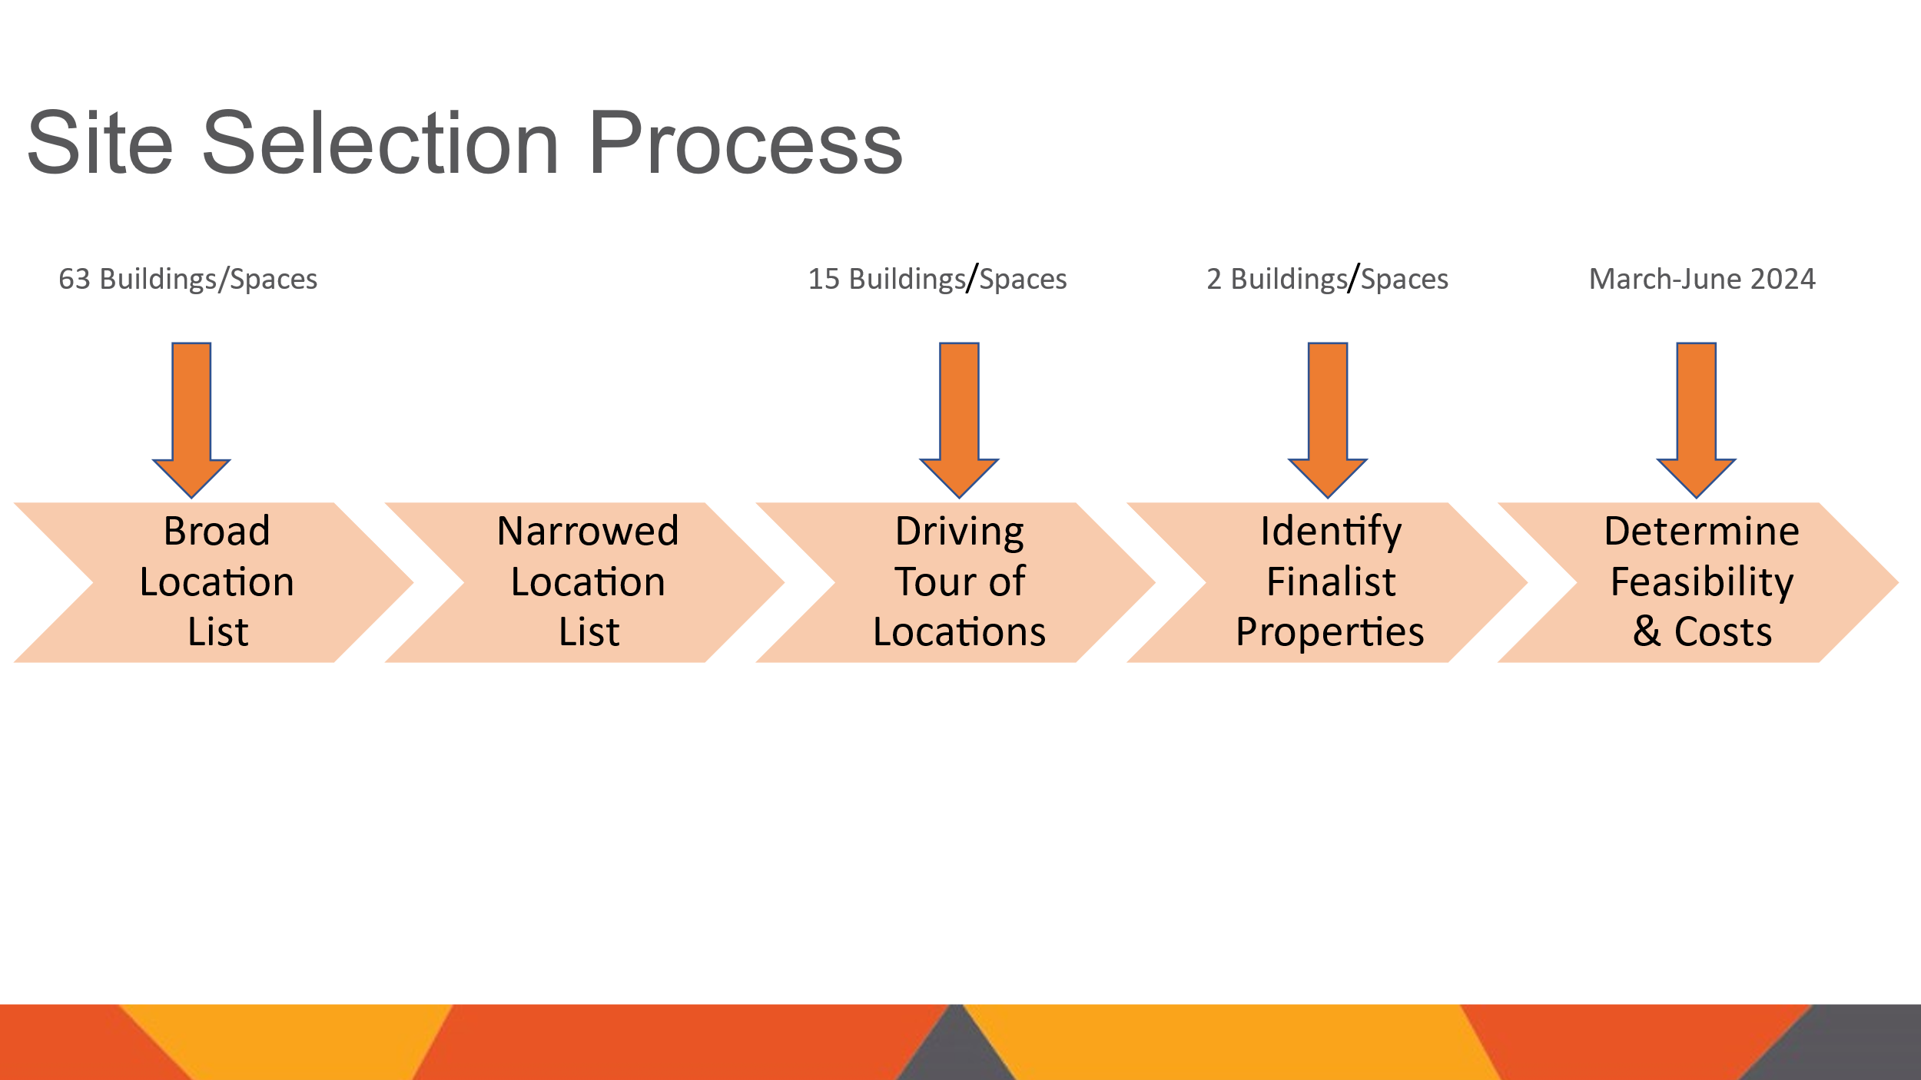

Recommendation

The site JCPL is recommending meets or exceeds pre-established criteria. It offers just over 5,500 square feet of continuous space. The space has large storefront windows across the length bringing in natural light. The location is within Jefferson County’s Conifer 285 area plan activity center. It has easy access in both directions from Highway 285, as well as access to utilities and internet. Being part of an established retail center carries many positives such as:

* Located in an area where people are already going for everyday needs and errands.
* Both the retail center and the Library will benefit with more visibility to visitors. For instance the library will bring visitors to the center and the library will have higher visibility to people who come to the center for errands who may not already be library card holders.
* Size
  + Meets goal .5 to .6 square foot per capita for Conifer Library Service Area
  + One story, continuous space
  + Natural light
* Location
  + Within Conifer 285 Area Plan Activity Center
  + Convenient access north or south from Highway 285
  + Internet and utility access
* Convenience
  + Part of established retail center
  + Good visibility and parking

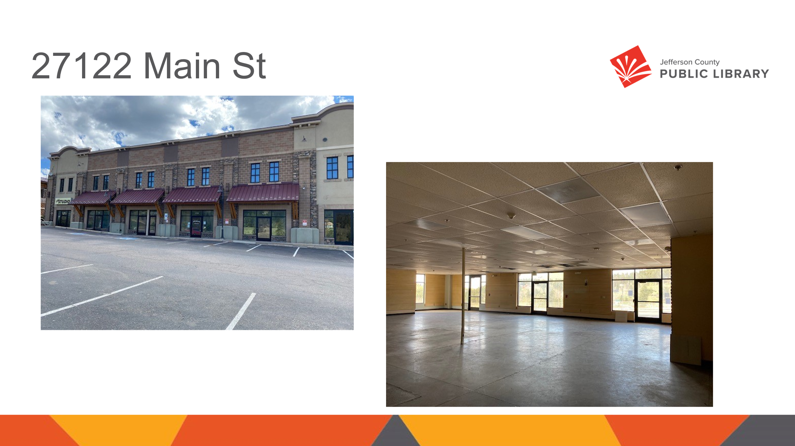

Two of the main concerns the Library heard from the community were inconvenient hours and parking at the Conifer High School location. JCPL will be able to address both of these concerns at this location. The Library will be able to set hours to match the needs of the community and there is parking directly in front of the leased space. The Library will be leasing the entire first floor of the building, which will mean more parking than at the high school and spaces that are just a short walk to the doors of this future location.

Location and Lease Agreement

Steve Chestnut, Director of Facilities and Construction Projects, addressed the Board and provided information on the location and lease agreement. The address is 27122 Main St Unit 100-105 and 110-125, Conifer. This location is in the shopping center that has several anchors such as a Safeway with a Safeway gas station, Natural Grocer’s, and several independent businesses. The lease agreement is for a 10-year term. The anticipated cost of the 10-year lease would be $767,032. This estimated cost includes property tax abatement and a reduction of $31,408 for 8 months of free base rent. As noted in the information packet, these costs are based upon the County Assessor abating the real estate tax burden for the square footage that the library would occupy. The Assessor’s Office has stated that they will do so once JCPL provides them with a signed lease agreement.

Next Steps

JCPL will continue to make it a priority to keep the community informed about the status of this project. The Library will post an update to the Conifer project page on the website early next week, as well as sending an email to those who have signed up for updates either through the website or at the community input meetings. JCPL will continue to work with our partner, Conifer High School, on plans and timelines for the transition of how the library will move out. There is an item on the agenda for tonight to authorize an architect to begin the design of this new space. The Library wanted to bring both the lease agreement and architect to the Board tonight so that the Library can quickly begin the design process to convert this space into the new Conifer Library. With the new location the Library’s goal continues to be ensuring that JCPL services meet the needs of the Conifer community by providing equal access to information and opportunities, and being the essential destination where all generations connect, discover, and create.

In response to questions the Board was advised that:

* The Library will be as efficient as possible in developing the timeline for this project.
* The lease agreement will commence once it is approved and signed by all parties, most likely within 3-4 weeks, possibly sooner.

**MOTION**: Stanley Harsha moved that the Library Board of Trustees authorize the Executive Director to enter into the lease agreement with Khans & Nasir Co. LLC. for the space located at 27122 Main St. Unit 100-105, 110-125, Conifer, CO 80433. Seconded by Jill Fellman the motion passed by unanimous vote of all Trustees present.

**Business Strategy**

1. Conifer Library Services Architect Design Contract Notice to Proceed

Amy Bentz, Assistant Director of Library Design Projects and Planning addressed the Board and provided information on the Conifer Library architect notice to proceed. The Board authorized JCPL to enter a contract with Eppstein Uhen Architects, Inc. (EUA) for the design of the South County Library in September 2021. This contract allows JCPL to use EUA's services for future projects by issuing a Notice to Proceed for each new project. Each Notice to Proceed must specify the scope of services, costs, and schedule for that project.

JCPL wishes to engage EUA for architectural design services for the Conifer Library project. The proposed cost for the architectural services is $173,318. This fee aligns with the Library’s budget expectations.

**MOTION**: Jill Fellman moved that the Library Board of Trustees authorize the Executive Director to issue a Notice to Proceed for architectural design services with Eppstein Uhen Architects, Inc. for the Conifer Library project at a cost of $173,318. Seconded by Jeanne Lomba the motion passed by unanimous vote of all Trustees present.

1. Arvada Library Redesign Architect Contract Notice to Proceed

Amy Bentz addressed the Board and provided information on the Arvada Library Redesign architect notice to proceed. The Board authorized JCPL to enter a contract with Eppstein Uhen Architects, Inc. (EUA) for the design of the South County Library in September 2021. This contract allows JCPL to use EUA's services for future projects by issuing a Notice to Proceed for each new project. Each Notice to Proceed must specify the scope of services, costs, and schedule for that project.

JCPL wishes to engage EUA for architectural design services for the Arvada Library Redesign project. EUA has evaluated the project scope and provided a cost estimate and schedule. The proposed cost for the architectural design services is $1,128,058.00. This fee aligns with the Library’s budget expectations.

In response to questions, the Board was advised that:

* The scope of work includes community engagement which has already started, and includes the entire building, the basement and the surrounding area that is JCPL property.
* JCPL’s Arvada Library property on the north ends approximately two feet from the telephone building in that alley.

**MOTION**: Emelda Walker moved that the Library Board of Trustees authorize the Executive Director to issue a Notice to Proceed for architectural design services with Eppstein Uhen Architects, Inc. for the Arvada Library Redesign project at a cost of $1,128,058.00. Seconded by Jeanne Lomba the motion passed by unanimous vote of all Trustees present.

**ITEMS REMOVED FROM THE CONSENT AGENDA**

No items were removed from the consent agenda.

**EMERGING ISSUES**

No issues.

**ENDS**

There were no items.

**BOARD GOVERNANCE**

No items.

**BOARD SCHEDULE – NEXT MEETINGS**

Location of meetings of the Library Board of Trustees are being determined in cooperation with guidelines from Jefferson County. Information on meeting location will be posted at least one week prior to the scheduled meeting date.

2024 Board Meeting Schedule

* August 8, 2024 – Study Session – 5:30 pm Hybrid: Virtual via ZOOM. In-Person Location: Lakewood Library Meeting Room. (Note: Shavuot ends nightfall no work permitted)
* August 15, 2024 – Board Meeting – 5:30 pm Hybrid: Virtual via ZOOM. In-Person Location: Lakewood Library Meeting Room
* September 12, 2024 – JOINT LIBRARY BOARD AND BCC – 4:30 pm Hybrid: Virtual via Webex. In-Person Location: BCC Board Room
* September 19, 2024 – Board Meeting – 5:30 pm Hybrid: Virtual via ZOOM. In-Person Location: Lakewood Library Meeting Room

The Chair noted that the start time of the September 12, 2024 joint meeting with the BCC is 4:30 pm not 5:30 pm.

**ANNOUNCEMENTS/GENERAL INFORMATION SHARING**

The Chair advised the Board that she has officially heard from Jeanne Lomba that she will not be reapplying to stay on the Board. Applications are open until Monday, July 22. The Library would like to have South County representation.

**ADJOURNMENT**

The meeting was adjourned at 7:12 pm.

###### Stanley Harsha, Secretary